**Phase-mismatch harmonic generation in quantum magnetoplasma**

Shiv Singh and Punit Kumar

Department of Physics, BBD University, Lucknow-226028, India

Department of Physics, University of Lucknow, Lucknow-226007, India

E-mail: sshiv4331@gmail.com

An analytical theory is developed for studying the phenomenon of generation of third harmonic radiation by the propagation of circularly polarized laser beam in homogenous underdense quantum magnetoplasma by using recently developed Quantum hydrodynamic (QHD) model. The effects of quantum Bohm potential, quantum statistical Fermi pressure and electron spin -1/2 have been taken into account. A circularly polarized laser beam propagating through quantum plasma produces density oscillations at second harmonic. The density oscillation combined with the oscillatory velocity produces third order current density, which derives third order harmonic radiation. The field amplitude of third harmonic radiation with reference to the fundamental amplitude of the incident circularly polarized radiation and the conversion efficiency for wave number-mismatch has been analyzed. It is observed that the efficiency of generated third harmonic is affected significantly due to the magnetic field strength, plasma electron density, intensity of circularly polarized laser pulse and quantum diffraction effects.

**Keywords:** Harmonic generation, Quantum plasma, Quantum diffraction effects, QHD model, Electron spin-1/2

**1. Introduction**

**1.1: Plasma:**

In 1920, the Nobel laureate Irving Langmuir pioneered the scientific study of a glowing ionized gas, produced by electric discharge in a tube, gave the name plasma to this fourth state of matter. More than 99%of the known universe is in the plasma state. The plasma physics is one of the rapidly growing fields of science in the present era of energy crisis. It is an interdisciplinary science as it has wide potential applications in laboratory, space and astrophysical scenario. Laboratory plasmas find applications in industry and extractive metallurgy. Surface treatments such as plasma spraying, etching in microelectronics, metal cutting, welding, reduced permeation for nitriding surfaces against corrosion and abrasion are some of the industrial applications of plasma [1]. In astroplasma physics, plasma has application in understanding the formation of dust clusters and structures, molecular clouds, proto-star formation, star formation, cometary tails, nebulae and magnetospheres etc. In addition to this scientists and researchers in the field of plasma physics are making an attempt for the solution of global energy crisis with controlled thermonuclear fusion, using recent experimental device like ITER, JET, Tokomaks and NOVA, for inertial confinement and magnetic confinement of plasma for generation of power.

In general it is not easy to say that all ionized gases are plasmas. A more rigorous definition requires three criterion to be satisfied. Firstly, its dynamics is governed by long range electromagnetic forces rather than force due to local collisions i.e. collective behavior. Secondly, the plasma oscillation frequency must be greater than collision frequency of charged particle to neutrals so that dynamics is still governed by long range force. According to the third criterion, its ability to ‘iron out’ an external electric potential i.e. sparing (shielding out) the bulk of plasma from external field which leads to quasi neutrality condition i.e.  Microscopic variation of quasi-neutrality leads to plasma electron oscillations with a frequency  where  is the electron mass), known as the plasma frequency. This characterizes plasma as an elastic medium [2-4]. The ionic mass is much greater than the electronic mass. Therefore, the ion oscillation frequency is very small as compared to that of the electrons. The ions can therefore be regarded as a stationary immobile background in the plasma system. The ions and electrons have distributions in energy usually characterized by ions temperature  and electrons temperature , which are not necessarily or usually the same. In addition, different ion and electron species can exist in the plasma with different temperatures or different distributions in energy.

**1.2:** **Quantum Plasma:**

Plasma physics is commonly considered to be a purely classical field. However, in the last ten years there has been a renewed interest on plasma systems where quantum effects play crucial role due to its important applications in super dense astrophysical bodies [5] (i.e. the interior of Jupiter and massive white dwarfs, magnetars, and neutron stars), in intense laser-solid density plasma experiments [6-8], and in ultra-small electronic devices (e.g. in microelectronics, semiconductor devices [9], quantum dots, nanowires [10], carbon nanotubes [11], quantum diodes [12], bio photonics [13], ultra cold plasmas [14], and micro-plasmas [15].Quantum mechanics becomes relevant in plasmas when the quantum nature of its particles significantly affects its macroscopic properties. Quantum plasmas composed of ions, degenerate electrons, positrons and charged nano-particles. The degeneracy of lighter plasma species appears at very high densities and relatively low temperatures when the Wigner-Seitz radius  is comparable to or smaller than the De- Broglie thermal wavelength  where  is the mass of the quantum particles (degenerate electrons, ions, nano-charged particles) and  is the thermal speed of quantum particles,  be the temperature,  be the Boltzman constant i.e.  therefore there is a significant overlap of the corresponding wave functions or when temperature  is comparable to or lower than the Fermi temperature  here  be the Fermi energy. When the plasma particles temperature approaches to  then the equilibrium distribution function changes from Maxwell Boltzmann (M. B.) to Fermi Dirac (F. D.) distribution function. Hence, it is useful to define Quantum coupling factor for electron-electron and ion-ion interactions. The electron-electron Coulomb coupling parameter is defined as the ratio of the electrostatic interaction energy  between electrons and electron Fermi energy, where  is the magnitude of electron charge and  is the mean interaction distance. We have  since for metallic plasmas , so it is interested to enquire the role of inter particle collisions on collective process in a quantum plasma. It is noted that Pauli blocking reduces the collisions rate for most practical cases. Because of Pauli blocking only electrons with a shell of thickness  about the Fermi surface suffers collisions. So the electron-electron collision is proportional to 

The new type of physically different effects comes into play, (1) particles are not localised in phase space (2) distribution function changes from M.B. to F.D. (3) some particles like electrons, protons have an intrinsic magnetic moment or spin which interact with magnetic field and affected the dynamics. A collision less quantum plasma regime is relevant for phenomena appearing on the time scale of the order of a femtosecond in a metallic plasma. In the astrophysical atmosphere such as white dwarf stars, the mean distance  between electrons become comparable to the Compton length  and accordingly the speed of an electron on the fermi surface becomes comparable to the speed of light . So one can use the relativistic view. Actually relativistic degenerate electrons are found in the core of massive stars. Since electrons are fermions, so only one electron can occupy a given quantum state (position, spin). One electron will on average occupy a volume. Then by Heisenberg’s uncertainty principle the mean momentum  If electrons are relativistic view then velocity is close to c. Now the electron pressure for simple gas is the momentum is the momentum transfer per unit area.

(momentum)(velocity)(number density)



Quantum effects can be measured by the thermal De-Broglie wavelength, . In classical regime, particle can be considered as point like (tends to 0) and there is no overlapping wave functions. Thus classical and quantum regime may not occur at the same time. But recent studies have revealed that it is possible to observe a phase transition between these two regimes. Quantum correction starts play a crucial role when separation between charged particles is similar or larger than inter particle distance and when temperature is lower than a critical temperature called Fermi temperature.

**1.3: Harmonic Generation:**

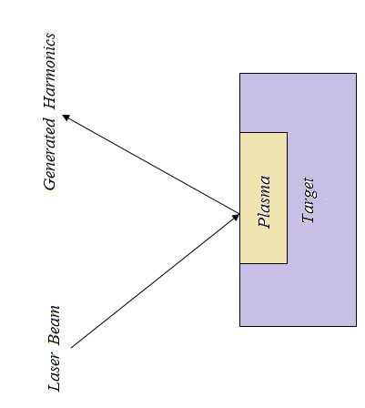

**Figure:** Scheme of harmonic generation in Laser-Plasma interaction.

The interaction of high intensity laser pulse with plasma leading to harmonic generation has been active area of research for last thirty years [16]. The physical phenomenon of interaction of intense laser pulse with plasma leads to number of parametric instabilities and nonlinear effects such as laser wakefield acceleration, inertial confinement fusion, Raman scattering, self phase modulation, ponderomotive self focusing and harmonic radiation generation. Generation of harmonic radiation in laser produced plasma and laboratory plasma is an important subject and also provides considerable potential for plasma diagnostics [17-23]. From few years a great deal of research has been focused on second and third harmonic in laser produced plasma [24-26]. In the process of harmonic generation, two photons of energy and momentum combines to produce a photon of energy  and momentum, where  are the frequency and wave vector of fundamental wave and are the frequency and wave vector of second harmonic wave which satisfy dispersion relation for electromagnetic wave. During third harmonic generation phenomenon, the fundamental laser beams generates a beam of frequency with three times of the fundamental frequency. The interaction of circularly polarized intense laser with homogenous plasma induced transverse nonlinear plasma current, resulting in generation of odd harmonics of laser frequency in forward direction [27]. Although number of high order harmonics generation [28-30] has been analyzed but third harmonic generation [31-33] has its unique place in laser plasma interaction.

All the above work has been done for classical plasma but the plasma where the de-Broglie thermal wavelength associated with the charge carriers is comparable or larger than inter particle distance i.e.  or the temperature T is comparable with or lower than the electron Fermi temperature, degeneracy comes into the picture and plasma particles obey Fermi-Dirac distribution. Here, the quantum degeneracy effects start playing a crucial role and the study of quantum plasma becomes important. During the last decade, there has been growing interest in investigating new aspects of quantum plasma due to its important applications. The harmonic generation in quantum magnetoplasma has been studied by many authors [34-36]. While the phase matched third harmonic generation of laser pulse in high density quantum plasma in presence of wiggler magnetic field has been studied [37]. However to the best of our knowledge, till now, no attempt has been made to study the phase mismatch third harmonic generation by circularly polarized laser in strongly magnetized dense quantum plasmas with electron spin-1/2 effects.

The aim of the present chapter is to take up an analytical study of third harmonic radiation by circularly polarized laser through high dense low temperature quantum plasma. The study proceeds by considering the plasma to be cold so that thermal motion of electron can be neglected. The study has been undertaken in the mildly relativistic regime, using perturbative technique and recently developed QHD model. The quantum hydrodynamic model is a generalization of classical model of plasma where the transport equations are expressed in terms of conservation laws for particles, momentum and energy. The advantages of the QHD model over kinetic ones are its numerical efficiency, the direct use of macroscopic variables of interest such as momentum and energy and the easy way the boundary conditions are implemented. This allows to consider the nonlinear phenomena relatively easier and so the QHD approach is preferred for describing such phenomena in quantum plasma [38,39]. In mildly relativistic regime, the relativistic effect comes into play in higher order velocity components and higher order. This chapter is organized as follows. It is divided into four sections. Sec. 2 is devoted to nonlinear current density of third harmonic radiation generation and conversion efficiency has been analyzed in sec. 3. Finally Sec. 4 devoted with summary and conclusion of the work.

**2: Source Currents:**

Let us take the propagation of a circularly polarized laser pulse of frequency  and wave number  and constant amplitude  in magnetized cold quantum plasma of uniform density  along the direction of static magnetic field  The fields of laser are 

and (1)



We assume that the plasma is cold and there is a fixed ionic background to ensure charge neutrality and fast processes to be considered in quantum plasma. Response of electron to the electromagnetic field is governed by the set of QHD equations,  (2)

 (3)

 (4)

where,  is the rest mass of electron,  is the electron charge,  is the electron density, is the relativistic factor,  is Planck’s constant divided by   is the spin angular momentum with ,  is the Bohr magneton and  represents the Fermi velocity of electrons. On the right hand side of equation (2) the first term represents the Lorentz force, second term is the electron Fermi pressure, third term is the quantum Bohm potential produced due to density fluctuations and the last term denotes the force due to spin magnetic moment of plasma electrons and the classical case may be recovered in the limit of 

On perturbation of eqs. (2) and (4) in orders of radiation field, the first order quiver velocity and density components are found to

 (5)

 (6)

 (7)

 (8)

Spin is an important property of quantum degenerate plasma. It plays a crucial role in exposing the plasma to the external magnetic field, the effect of which can be ascertained in the perturbed spin magnetic moment for plasma electron through the spin angular momentum,

 (9)

 (10)

and

 (11)

By following similar steps for nth harmonic, the velocity, perturbed density and spin magnetic moment for electron can be obtained by substituting  from equations (5)-(11). Hence, the linear part of induced current density for nth harmonic,  can be written as, (12)

where, is the current density due to the spin magnetic moment and is the conventional current. The dispersion relation for nth harmonic is (13)

The laser produces oscillatory velocity of electrons and exerts a ponderomotive force  on them at  which gives rise to oscillatory velocity  which couples with density perturbation at laser frequency through equation of continuity to produce density perturbation at  and  couples with  to produce nonlinear current density at the third harmonic of frequency. The third harmonic velocity and density components are obtained as,

 (14)

 (15)

 (16)

 (17)

 (18)

 (19)

where,

  

  and 

The spin angular momenta also contributes to source current thus we need to evaluate the spin magnetic moment plasma electron at third harmonic,

 (20)

 (21)

 (22)

where,

 

and 

The third harmonic source current is

 (23)

where,  and  are the magnetization due to spin effect of electron and conventional current density,



and



**3: Third harmonic efficiency:**

The non-linear component of the third source current  can be used with the wave equation, to analyze the growth of harmonic radiation,

 (24)

The amplitude for phase mismatched third harmonic is obtained by assuming the harmonic field to vary as  Assuming that  which means that  changes appreciably larger than the wavelength  we obtain the normalized amplitude for phase-mismatched third harmonic, (25)

where,  is the wave vector. The third harmonic conversion efficiency is obtained as

 (26)

where,



 and 

From eq. (26), it is found that the harmonic oscillate in magnitude due to the dephasing between pump laser and the radiation harmonics. The third harmonic radiation is proportional to the plasma electron density, propagation distance and the intensity of laser pulse. The conversion efficiency of third harmonic radiation changes dramatically.

In Figure 1, the conversion ratio of third harmonic amplitude with respesct to fundamental amplitude of pump laser assumed with intensity around  W/cm2 and frequency  is plotted as a function of  for different values of magnetic field strength. The solid line is shows for  and the dotted line is for  The figure demonstrates that the conversion ratio of third harmonic amplitude increases with increased in the magnetic field strength.

The variation of conversion efficiency  for third harmonic is shown with normalized plasma electron density for different values of magnetic field strength in figure 2. The figure shows that for a constant magnetic field, harmonic radiation grows with increase in the plasma density until saturation. The saturation value of plasma density depends on the applied magnetic field and is more for weaker magnetic field.

Figure 3, shows the variation of second harmonic conversion efficiency as a function of intensity of the laser pulse for different values of normalized plasma density. The solid line is for while the dotted line is for. The efficiency initially increases with the intensity of laser pulse because the increment in the intensity imparts higher oscillatory velocity to the electrons, therefore the stronger ponderomotive force will enhance the conversion efficiency process. However conversion efficiency saturates at large value of intensity of laser pulse.

The conversion efficiency of third harmonic radiation with the classical case is plotted in Fig. 4 for parameters and . The dashed line is for presence of quantum effects and the solid line for absence of quantum effects (in the limit ). It is noted that the efficiency of third harmonic is more by about 12.5% due to presence of quantum effects in magentoplasma because quantum diffraction effects play a crucial role by modifying the efficiency of third harmonic of laser pulse.

In figure 5 the efficiency of third harmonic is shown as a function of plasma density. The dashed line is for presence of electron spin effect and the solid line for absence of electron spin effect. It is noted that the efficiency of third harmonic is more by about 10% due to presence of spin effects in magentoplasma because the electron spin modify the plasma current density and introduce correction terms in the harmonic field amplitude.

4: **Summary and conclusion:**

The study of third harmonic generation resulting from propagation of circularly polarized laser pulse through homogenous high density quantum magnetoplasma has been analyzed. The static magnetic field applied for magnetization is in the longitudinal direction. The interaction mechanism has been built using the recently developed quantum hydrodynamic (QHD) model. We have preceded with the self-consistent field approximation of the QHD equations. The effects of Fermi statistical pressure, the quantum Bohm potential and the spin of electron have been taken into account. The quiver and third order velocities along with electron densities and the spin angular momenta have been obtained through the perturbative expansion of QHD equations. The electron has two main quantum corrections, a quantum force produced by density fluctuations and a force considered through magnetization energy. The quantum effects and the electron spin modify the plasma current density and introduce correction terms in the harmonic field amplitude. The quantum diffraction effects contribute and enhance the nonlinear third harmonic radiation generation. It has been found that the third harmonic generation grows with the plasma density and the magnetic field up to the respective saturation values. The harmonic generation stops beyond saturation. The saturation of plasma density occurs earlier for increasing magnetic field. This is due to the polarization field effect in strongly magnetized dense plasma. It is also noticed that the efficiency of third harmonic radiation is more by about 12.5% in quantum plasma due to presence of diffraction ( Bohm potential, spin effect) effects compared to classical plasma i.e. absence of quantum diffraction effects and electron spin effects also contribute to the harmonic generation by about 10% in quantum plasma. The increase in the third harmonic efficiency can serve as a diagnostic tool for presence of clusters and measurement of their size during laser plasma interaction with gas jet in clustered plasma.

**References:**

[1] F. F. Chen, Phys. Plasmas **2**, 2164 (1995).

[2] P. M. Bellan, Fundamental of Plasma Physics, Cambridge University Press (2006).

[3] S. Eliezer and Y. Eliezer, The Fourth State of Matter, Institute of Physics Publishing

(2001).

[4] F. F. Chen, Introduction to Plasma Phys. and Controlled Fusion, Springer (1984).

[5] Y. D. Jung, Phys. Plasmas **8**, 3842 (2001).

[6] D. Kremp, Th. Bornath, M. Bonitz and M. Schlanges, Phys. Rev. E **60**, 4725 (1999).

[7] A. V. Andreev, JETP Lett. **72**, 238 (2000).

[8] M. Marklund and P. K. Shukla, Rev. Mod. Phys. **78**, 591 (2006).

[9] P. A. Markowich, C. A. Ringhofer and C. Schmeiser, Springer-Verlag, New York,

(1990).

[10] G. V. Shpatakovskaya, J. Exp. Theor. Phys. **102**, 466 (2006).

[11] L. Wei and Y. N. Wang, Phys. Rev. B **75**, 193407 (2007).

[12] L. K. Ang, T. J. Kwan and Y. Y. Lau, Phys. Rev. Lett. **91**, 208303 (2003).

[13] W. L. Barnes, A. Dereux and T. W. Ebbesen, Nature **424**, 824 (2003).

[14] T. C. Killian, Nature **441**, 298 (2006).

[15] K. Becker, A. Koutsospyros, S. M. Yin, C. Christodoulatos, N. Abramzon, J. C.

Joaquin and G. B. Marino, Plasma Phys. Control. Fusion **47**, B513 (2005).

[16] P. Gibbon, IEEE J. Quantum Electron **33**, 1915 (1997).

[17] L. M. Goldman, W. Seka, K. Tanaka, R. Short and A. Simon, Can. J. Phys. **64**, 969 (1986).

[18] C. Yamanaka, T. Yamanka, T. Sasaki, J. Mizui and H. B. Kang, Physcal Rev. Lett **32**, 1038

(1974).

[19] D. P. Tiwari and V. K. Tripathi, Phys. Rev. A **21**, 1698 (1979).

[20] R. Dragila, J. Appl. Phys**. 53**, 865 (1982).

[21] C. Grebogi, V. K. Tripathi and H. H. Chen, Phys. Fluid **26**, 1904 (1983).

[22] C. Liao, P. Bundman and G. I. Stegeman, J. Appl. Phys. 54, 6813 (1985).

[23] [Xu Zhizhan](https://aip.scitation.org/author/Zhizhan%2C+Xu)*,*[Xu Yuguang](https://aip.scitation.org/author/Yuguang%2C+Xu)*,*[Yin Guangyu](https://aip.scitation.org/author/Guangyu%2C+Yin)*,*[Zhang Yanzhen](https://aip.scitation.org/author/Yanzhen%2C+Zhang)*,*[Yu Jiajin](https://aip.scitation.org/author/Jiajin%2C+Yu)and[P. H. Y. Lee](https://aip.scitation.org/author/Lee%2C+P+H+Y), J.

Appl. Phys. **54**, 4902 (1983).

[24] P. Jha, R. K. Mishra, G. Raj and A. Upadhyay, Phys. Plasma **14**, 053107 (2007).

[25] M. Mori, E. Takahashi and K. Kondo, Phys. Plasma **9**, 2812 (2002).

[26] N. Wadhwani, P. Kumar and P. Jha, Phys. Plasmas **9**, 263 (2002).

[27] W. B. Mori, C. D. Decker and W. P. Leemans, IEEE Trans. Plasma Sci. **21**, 110 (1993).

[28] E.Esarey, A. Ting, P. Sprangle, D. Umstadter, X. Liu, IEEE Trans. Plasma Sci. **21**, 95

(1993).

[29] W. B. Mori, C. D. Decker and W. P. Leemans, IEEE Trans. Plasma Sci. **21**, 110 (1993).

[30] [B. Dromey](https://www.nature.com/articles/nphys338#auth-1), [M. Zepf](https://www.nature.com/articles/nphys338#auth-2), [A. Gopal](https://www.nature.com/articles/nphys338#auth-3), [K. Lancaster](https://www.nature.com/articles/nphys338#auth-4), [M. S. Wei](https://www.nature.com/articles/nphys338#auth-5), [K. Krushelnick](https://www.nature.com/articles/nphys338#auth-6), [M.](https://www.nature.com/articles/nphys338" \l "auth-7)

[Tatarakis](https://www.nature.com/articles/nphys338" \l "auth-7), [N. Vakakis](https://www.nature.com/articles/nphys338#auth-8), [S. Moustaizis](https://www.nature.com/articles/nphys338#auth-9), [R. Kodama](https://www.nature.com/articles/nphys338#auth-10), [M. Tampo](https://www.nature.com/articles/nphys338#auth-11), [C. Stoeckl](https://www.nature.com/articles/nphys338#auth-12), [R. Clarke](https://www.nature.com/articles/nphys338#auth-13), [H.](https://www.nature.com/articles/nphys338" \l "auth-14)

[Habara](https://www.nature.com/articles/nphys338" \l "auth-14), [D. Neely](https://www.nature.com/articles/nphys338#auth-15), [S. Karsch](https://www.nature.com/articles/nphys338#auth-16) and [P. Norreys](https://www.nature.com/articles/nphys338#auth-17) Nat. Phys. **2**, 456 (2006).

[31] S. Banerjee, A. R. Valenzuela, R. C. shah, A. maksimchuk and D. Umstadter, Phys. Plasmas

**9**, 2393 (2002).

[32] R. P. Singh, S. L. Gupta and R. K. Thareja Phys. Plasmas **22**, 123302 (2015).

[33] J. M. Rax and N. J. Fisch, IEEE Trans. Plasma Sci. **21**, 105 (1993).

[34] N. Gupta and A. Singh, Contribution to Plasma Physics **56**, 1 (2016).

[35] P. Kumar, S. Singh and N. Ahmad, Laser and Particle Beams **37**, 5 (2019).

[36] P. Kumar, S. Singh, and A. Kumar Singh, [AIP Conference Proceedings](https://www.researchgate.net/journal/1551-7616_AIP_Conference_Proceedings) **1728**, 020173

(2016).

[37] N. S. Rathore and P. Kumar, Am. J. Mod. Phys. **5**, 154 (2016).

[38] P. K. Shukla and B. Eliasson, Usp. Fiz. Nauk **180**, 55 (2010).

[39] P. K. Shukla et al. Phys. Plasma **13**, 112111 (2006).

**Figure captions**

**Figure 1.** The phase mismatch third harmonic amplitude variation as a function of  for

plasma parameters 

**Figure 2.** Variation of conversion efficiency as a function of  for,

and different value of 

**Figure 3.** Variation of conversion efficiency against normalized fundamental laser intensity

for various values of .

**Figure 4.** Variation of conversion efficiency as a function of  (i) solid line in absence

of quantum effects and (ii) dashed line in presence of quantum effects.

**Figure 5.** Variation of conversion efficiency as a function of  (i) solid line in absence

of spin effect and (ii) dashed line in presence of spin effect.

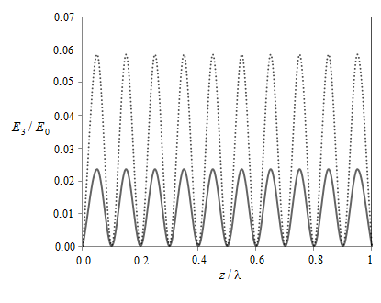

**Fig. 1**

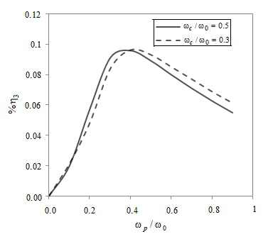

**Fig. 2**

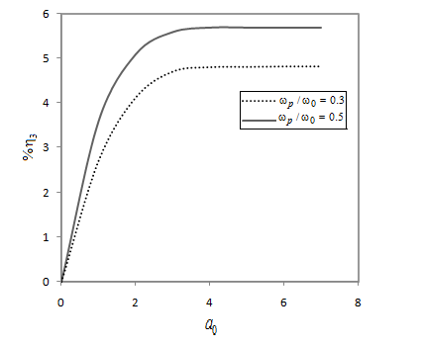

**Fig. 3**

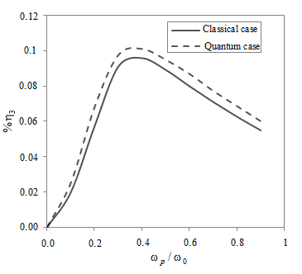

**Fig. 4**

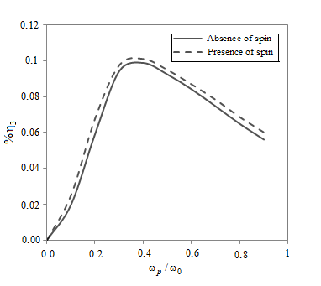

**Fig. 5**