Experimental Study on Light Transmission Concrete
1 K.Shankar,2 L.Amshumathi,3 S.Kiran,4 P.Jagan,5 D.Manoj

¹Professor,Department of Civil Engineering, Kamala Institute of Technology and sciene,Huzurabad,
Karimnagar,Telangana,India

²Assistant Professor, Department of Civil Engineering, Kamala Institute of Technology and sciene,Huzurabad,
Karimnagar, Telangana, India

³Assistant Professor, Department of Civil Engineering, Kamala Institute of Technology and sciene,Huzurabad,
Karimnagar, Telangana, India

⁴Assistant Professor, Department of Civil Engineering, Kamala Institute of Technology and sciene,Huzurabad,
Karimnagar, Telangana, India

⁵Assistant Professor, Department of Civil Engineering, Kamala Institute of Technology and sciene,Huzurabad,
Karimnagar, Telangana, India

⁴

ABSTRACT
Arranging optical fibers with high content in the light transmitting concrete (LTC) helps to enhance the light transmission ability of this material. To develop thinner LTC panels with higher light transmittance, simultaneous improvement of mechanical strength and fiber content is a crucial issue. In addition, since LTC is a material that helps to reduce the environmental impacts, the use of eco-friendly raw materials in the LTC production should also be considered. This study aims to (i) develop the 80 MPa grade LTC with high content of optical fibers and eco-friendly raw materials, (ii) limit the phenomenon of strength reduction with increasing fiber content as in previous studies, and (iii) clarify the effect of temperature, light source distance and fiber diameter on light transmittance of LTC. A series of experiments is conducted to optimize the concrete mixture composition and clarify the mechanical strength, light transmission of LTC samples. The results show that the mixture composition with high workability can be used to develop the 80 MPa grade LTC with an optical fiber volume content of up to 7.1 %. The Scanning Electron Microscope observation results show no significant gaps around optical fibers in the highest content case. The diameter, content, and orientation of the optical fibers do not significantly affect the compressive and flexural strength of LTC. In addition, the results of scattering characteristics of light passing through optical fibers show that the LTC with small diameter fiber suits for wide area illumination and the one with the larger diameter fiber suits for illuminating high-intensity light in a narrow region.

Keywords:
Light transmitting concrete, Optical fiber,80 MPa grade,Concrete mixture design High work-ability,
Light transmission ability

INTRODUCTION
The rapid urbanization process has amounted to the increasing need for artificial lighting inside buildings, which has significant effects on the process of global warming. The lack of natural light inside the buildings also affects the health of people living and working there. To solve these problems, architectural and material solutions that help harvest natural light inside buildings have become a leading topic in the field of construction. A novel material, the light transmitting concrete (LTC), has been proposed as a potential solution. The optical fibers are arranged in parallel orientation inside the concrete to create the lines for transmitting.
Some recent studies on self-compacting concrete without fiber reinforcement [16] or self-leveling concrete with steel fiber [17] have been conducted to ensure both the fresh concrete mixture’s workability and the concrete’s strength after curing. These are valuable references in the design of concrete mixtures for LTC. However, in the manufacturing process of LTC, the optical fiber is arranged in the formwork before casting the concrete. This is different from other conventional fiber-reinforced concretes (FRC), where the fibers are mixed freely into the fresh concrete mixture. That is, the type and content of fibers do not affect the workability of the concrete mixture before it is cast into the formwork to create LTC.
In addition, previous studies on FRC indicate that the higher the fiber content is, the higher the strength of FRC concrete is. However, for LTC, the fiber content in the formwork increases, the narrower the distance between the fibers is. So it is required higher workability of the concrete mixture, as well as a higher probability of void appearance between the fibers and the concrete. This causes the LTC strength to decrease further, contrary to the trend of conventional FRC.

Meanwhile, LTC can be used for a part of walls or floors that needs to be transmitted light in the buildings or other constructions. Currently, the use of reinforcements is unsuitable for the LTC panels because that affects the arrangement of optical fibers inside the concrete. Therefore, ensuring simultaneously high light transmission ability and high strength is extremely important for developing the LTC panels without the reinforcements. In the case of panel applications without reinforcements, the compressive strength of concrete need to reach about 60–80 MPa [18]. In addition, it is necessary to develop LTC with a higher fiber content than previous studies to improve the light transmittance of concrete, thereby increasing the applicability of this material. Therefore, ensuring simultaneously high light transmission ability and high strength is extremely important for developing the LTC panels without the reinforcements, and the concrete mixture proportion design plays a key role. That is, the water/binder mass ratio needs to be reduced to ensure both the strength of the concrete, and the workability of fresh concrete should be sufficient to compact the extremely narrow spaces between the optical fibers in a case with a higher content arrangement. In addition to the technical challenges above, since LTC is a material that helps to reduce the environmental impacts, the use of ecofriendly raw materials in the LTC production should also be considered. The use of Ground granulated blast furnace slag (GGBS) and fly ash (FA) to partially replace cement to develop more eco-friendly concrete has been widely studied recently . However, their use in large amounts in LTC fabrication has not been thoroughly investigated in previous studies. Moreover, since LTC mainly works in environments exposed to artificial light or sunlight, the polymer optical fibers subjected to the warm temperature may be deformed, then the light transmission ability of LTC may be affected. Therefore, it is also meaningful to investigate the initially effects of warm temperatures as well as optical fiber arrangement and light source on the light transmission ability of LTC to accumulate the data base for lighting calculations of actuual design in the future
In fig 1To fill these gaps, the primary purpose of this study is (i) Developing the 80 MPa grade LTC with higher content of optical fibers and eco-friendly raw materials; (ii) Limiting the phenomenon of intensity reduction with increasing fiber content or diameter; (iii) Clarifying the effect of temperature, light source distance and fiber diameter on light transmittance of LTC. These purposes are novelty compared to previous studies and have important significance for developing the high-performance LTC in terms of both strength and light transmittance, towards the future production of LTC panels. To achieve these purposes, the concrete mixture with fine sand, Portland cement, ground granulated blast furnace slag, fly ash and superplasticizer, is firstly designed based on the experimental results of the workability and strength of various mixture compositions. Then, the experiments on the mechanical strength, microstructure, and light transmission are conducted to clarify the properties of the LTC samples with the optimal composition. The experimental parameters, including diameter, content, and orientation of optical fibers are investigated. Scanning Electron Microscope (SEM) observations are also carried out to examine the microstructure of the concrete matrix in the surrounding region of the optical fiber. The light transmission ability of LTC samples with various conditions of optical fiber arrangement, temperature, and light source are also examined.

EASE OF USE:
Used as a light transmission, reduces electricity consumption and for architectural appearance

MATERIALS

2.1Materials used in preparation of litracon cubes:
Cement: Cement is a binder, a substance that sets and hardens as the cement dries and also reacts with carbon dioxide in the air dependently, and can bind other materials together. Portland cement is the most common type of cement in general use around the world, used as a basic ingredient of concrete, mortar, stucco, and most non speciality grout. The OPC was classified into three grades namely, 33 grade, 43 grade and 53 grade depending upon the strength of the cement at 28 days when tested as per IS 4031-1988. The cement used in this experimental works is “Koromandal King 53 Grade Ordinary Portland Cement”. The specific gravity of cement was 3.14. The initial and final setting times were found as 51 minutes and 546 minutes respectively. Standard consistency of cement was 40%.
Fine aggregate: Fine aggregate is the inert or chemically inactive material, most of which passes through a 4.75 mm IS sieve and contains not more than 5 per cent coarser material. The specific gravity 2.75 and fineness modulus of 2.80were used as fine aggregate. The loose and compacted bulk Density values of sand are1600 and 1688 kg/m3 respectively, the water absorption of 1.1%. The fine aggregates serve the purpose of filling all the open spaces in between the coarse particles. Thus, it reduces the porosity of the final mass and considerably increases its strength. Usually, natural river sand is used asa fine aggregate. However, at places, where natural sand is not available economically, finely crushed stone may be used as a fine aggregate.
Optical Fiber: Optical fiber is a wave guide, made of transparent dielectric (glass or plastics) in cylindrical form through which light is transmitted by total internal reflection. It guides light waves to travel over long distances without much loss of energy. Optical fiber consists of an inner cylinder made of glass or plastic called core of very high refractive index. The core is surrounded by a cylindrical shell of glass or plastic of lower refractive index called cladding. The cladding is covered by a jacket which protects the fiber from moisture and abrasion.

2.2Preparation of casting moulds with plywood
- The dimensions of concrete mould are 100*100*100mm.
- So, the inner dimensions of the casting mould would be same as dimensions of LITRACON cube.
- One frame consists of three cubes which are casted together.
- Step 1: fig2 Cutting plywood
Cutting the whole plywood fame of size 5*5 feet into three different shapesSuch that one is the base, second one is the sides of the frame, third the smaller one is the inside partition in the casting mould that the cubes can be separated.
- Step 2: Drilling of Holes
In this step the main process is to drill the holes to the plywood piece that can be used as sides of the frame. There are 6 frames in total such that each 2 frames will have a different proportion of holes drilled in it. One frame consists of six partition pieces such that 12 pieces should be drilled for 2 frames. Each 2 frames have different arrangement pattern so that they are 3 types :4*4, 5*5, 6*6 spaced in an equal proportion.

Step 3: Fixing of plywood
In this final step we actually fixup different plywood pieces into a one complete frame with the help of star screws of 1 inch. Checking the space among the plywood such that the inner dimensions of the mould would be 100*100*100.

Step 4: Fixing Fibers
Fig 2 (b) shows that fibers are placed either in organic distribution or in layered distribution.Holes are driven on the wooden or steel plates through which optical fibers are allowed to pass through.

Step 5: Concreting
The thoroughly mixed concrete is poured carefully and slowly without causing many disturbances to the previously laid optical fibers. The concrete is filled in smaller or thinner layers and is agitated with the help of vibrating tables to avoid the void formation and mix proportion used is 1:4

Step 6: De-Moulding
After 24 hrs, remove the screws of the mould. The casted mould was kept undisturbed on the levelled platform. Then it was de-moulded carefully after 24 hours from casting. Immediately after de-moulding, the cube specimens were marked by their respective identification mark/numbers (ID).
- Step 7: Cutting and polishing:
Cut the extra-long fibers same as thickness of panel. Polish the panel surface by using polishing paper or using sand paper. Fibers are placed either in organic distribution or in layered distribution. Holes are driven on the wooden or steel plates through which optical fibers are allowed to pass through.

TESTS AND RESULTS

3.1COMPRESSIVE STRENGTH
By definition, the compressive strength of a material is that value of uniaxial compressive stress reached when the material fails completely. The compressive strength is usually obtained experimentally by means of a compressive test. The compressive strength of the concrete is determined by cast the cubes of size 100mm x100mm x 100mm.
The compressive strength for mortar cubes with and without Optical fibers has been calculated for 7,14 and 28 days. From the test results, it is observed that compressive strength for 7,14 and 28 days with Optical fibers is 4.5 N/mm2, 8.8 N/mm2 and 12 N/mm2 respectively. That for Conventional concrete is 9.56 N/2, 13.02 N/mm2 and 23.24 N/mm2 respectively.
The compressive strength for nominal mortar cubes of age 7 , 14, 28 days showed the results such as 4,9,17 N/mm^2 which are quite higher than the strength of LITRACON cubes yet not so much difference in the strength parameters.
3.2ULTRASONIC PULSE VELOCITY TEST

An ultrasonic pulse velocity (UPV) test is an in-situ, non-destructive test to check the quality of concrete and natural rocks. In this test, the strength and quality of concrete or rock is assessed by measuring the velocity of an ultrasonic pulse passing through a concrete structure or natural rock formation.
This test is conducted by passing a pulse of ultrasonic through concrete to be tested and measuring the time taken by pulse to get through the structure. Higher velocities indicate good quality and continuity of the material, while slower velocities may indicate concrete with many cracks or voids.
The ultra sonic pulse velocity test determines the quality of the material without destructing the test specimens. When this test is performed on LITRACON cubes the results observed that overall pulse velocity for the cubes of 1mm and 1.5 mm optical fibers are 222m/s,216m/s

So, the results states that the optical fiber which used with larger diameter i.e 1.5mm shows less pulse velocity than 1mm size of optical fiber.

3.3LIGHT METER
Light meter test is done for measuring the light intensity. In our test light meter is used to determine the capacity of the LITRACON cube to transmit the light measured in LUX or lumens. Cut the extra-long fibers same as thickness of panel. Polish the panel surface by using polishing paper or using sand paper.
Light meter is a test conducted to test the potential of the LITRACON cubes when a hight intensity of light is passed through one end of the cubes i.e 1800 lux. The cubes are tested at another end with the use of light meter for 4*4,5*5,6*6 grid sizes of 1 and 1.5 mm diameter optical fibers used. The test stated the results as 5 , 6 , 8 lux for 1mm diameter optical fiber and 8, 14, 16 lux for 1.5 mm diameter optical fiber.
The light intensity got increased with increased diameter of optical fiber and with more percentage of optical fiber in the mortar cube.

CONCLUSION

- A novel architectural material called transparent concrete can be developed by adding optical fiber of large diameter glass fiber in the concrete mixture. The transparent concrete has good light guiding property and the ratio of optical fiber volume to concrete is proportional to transmission. The transparent concrete does not lose the strength parameter when compared to regular concrete and also it has very vital property for the aesthetical point of view. It can be used for the best architectural appearance of the building. It can also be used in areas, where the natural light cannot reach with appropriate intensity. This new kind of building material can integrate the concept of green energy saving with the usage self sensing properties of functional materials
- Both the LTC and control specimens reached the design compressive strength at 7 and 28 days. All LTC specimens had lower compressive strength than the control specimens at 7 days of curing. The compressive strength remained almost same when the fibre diameter increased from 1.0 mm to 1.5 mm . Nevertheless, the incorporation of optical fibres had no significant effect on the compressive strength of the concrete.
- The smaller the fibre spacing, the lower the compressive strength of the LTC due to the smaller distances for the microcracks to propagate under compression load. Nevertheless, the effect of the fibre spacing on the compressive strength is considered insignificant when compared with the fibre diameter.
- The inclusion of optical fibre did not significantly affect the homogeneity and concrete quality of LTC. The velocity from the UPV test results for almost all the LTC specimens were above 200 m/s regardless of the direction of optical fibre, indicating excellent concrete quality of LTC during casting work
- The light transmittance of LTC increased with larger fibre diameter and smaller fibre spacing. It is noteworthy that the effect of fibre spacing on light transmittance performance becomes statistically insignificant when the fibre diameter is decreased to 1mm. From the analysis, it can be concluded that the fibre diameter has a greater influence on the light transmittance of LTC than the fibre spacing.
- The light transmittance performance of LTC decreased with the increase in the light incidence angle. At 30◦, the fibre spacing shows an insignificant effect on light transmittance of LTC because 30◦ is at the boundary of the acceptance angle of optical fibre, and at that point most of the light is outside the acceptance cone which causes refraction instead of total internal reflection. Hence, less light is being transmitted even with smaller fibre spacing. However, it was noticed that in LTC with a fibre diameter of 1.5 mm, there is a significant difference in light transmittance performance as compared to the other fibre diameters. This could be because the larger fibre diameter transmitted more light through total internal reflection even at a light incidence angle of 30◦, resulting in higher light transmittance.

List of figures

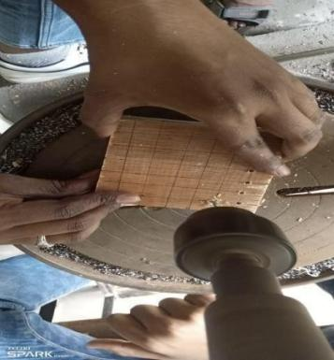  fig 2(a) | 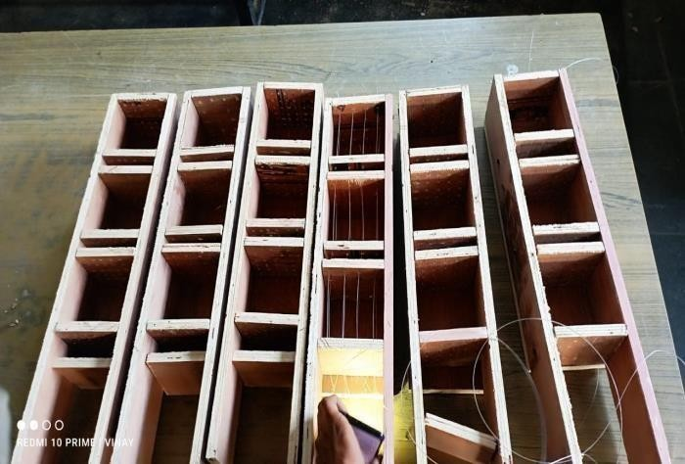  fig 2 (b)
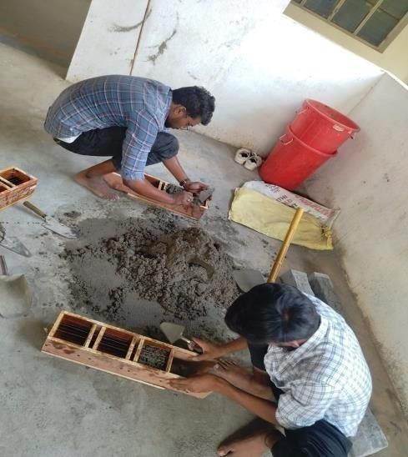  fig 2 (c) | 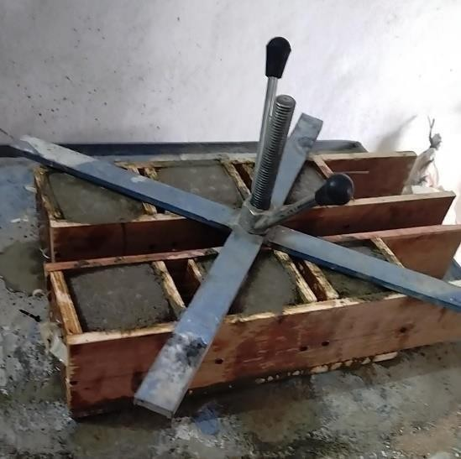  fig 2 (d)
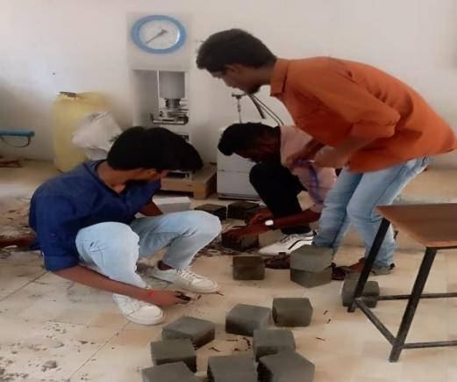  fig 2(e) | 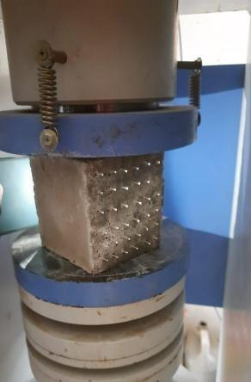  fig 2 (f)

List of tables:

TABLE 1: DIAMETER
GRID SIZES | 7DAYS (N/mm²) | 14DAYS(N/mm²) | 28DAYS(N/mm²)
4*4 | 4.5 | 6.5 | 10
5*5 | 3.25 | 7 | 12
6*6 | 4 | 8 | 14

TABLE 2 : COMPRESSIVE STRENGTH FOR LIGHT TRANSMISSION CUBES OF 1.5 MM DIAMETER

GRID SIZES | 7DAYS (N/mm²) | 14DAYS(N/mm²) | 28DAYS(N/mm²)
4*4 | 4 | 9 | 10
5*5 | 4.25 | 7.5 | 12
6*6 | 5.5 | 10 | 14

TABLE 3 COMPRESSIVE STRENGTH OF NOMINAL CONCRETE CUBES

AGE OF CONCRETE CUBES OF 100*100*100 MM | COMPRESSIVE STRENGTH ( N/mm²)
7 DAYS | 4
14 DAYS | 9
28DAYS | 17

TABLE 4: TEST CONDUCTED ON LITRACON CUBES OF 1MM DIAMETER

GRID SIZE | M/S | STRENGTH(N/mm²)
4*4 | 215 | 27.9
5*5 | 218 | 27.5
6*6 | 233 | 25.8

TABLE5 : TEST CONDUCTED ON LITRACON CUBES OF 1.5 MM DIAMETER

GRID SIZE | M/S | STRENGTH
4*4 | 223 | 26.9
5*5 | 219 | 27.4
6*6 | 207 | 29.0

TABLE 6: TEST CONDUCTED ON LITRACON CUBES OF 1.5 MM DIAMETER

GRID SIZE | M/S | STRENGTH
4*4 | 223 | 26.9
5*5 | 219 | 27.4
6*6 | 207 | 29.0

TABLE 7: LIGHT TRANSMISSION TEST ON LITRACON CUBE OF 1.5MM DIAMETER

GRID SIZES | TOTAL LIGHT PASSED(LUX) | LIGHT REFRACTED (LUX)
4*4 | 1800 | 8
5*5 | 1800 | 14
6*6 | 1800 | 16

REFERENCES :

- Soumyajit Paul, Avik Dutta\\\"Translucent Concrete\\\", International Journal of Scientific and Research Publications, Volume 3, Issue 10, “2013”, pp.
- Aashish Ahuja, Khalid Mosalam, Tarek Zohdi\\\"Computational Modeling of Translucent Concrete Panels\\\", American Society of Civil Engineers, 2014”.
- [R. Pradheepa,S. Krishnamoorthi\\\"An Experimental Study on Translucent Concrete\\\", International Journal for Scientific Research & Development, Vol. 3,Issue 03, 2015”, pp. 174- 177
- Saber Rahimi \\\"Investigating the Use of Fibre Optic Sensors in Ferro concrete Structures\\\", Technical Journal of Engineering and Applied Sciences, 2013”, pp. 2796-2798
- Bhavin Kashiyani, Varsha Raina, Jayeshkumar Pitroda, Bhavnaben Shah\\\"A Study on Transparent Concrete: A Novel Architectural Material to Explore Construction Sector\\\", International Journal of Engineering and Innovative T echnology (IJEIT), Volume 2, Issue 8,2013”, pp. 83-87
[6] Anurag Shukla, Trushik Poriya, Jigar Zala \\\"An Experimental Work on Light Transmitting Concrete\\\", International Journal of Advance Engineering and Research Development (IJAERD) Volume 1, Issue 5, 2014

