Eco-friendly synthesis of zinc oxide nanoparticles using Aegle Marmelos leaf extract and evaluation of its antibacterial activity
L.V. Chaudhari¹ Government Vidharbh Institute Of Science And Humanities Amravati,Amravati.
Department of Chemistry, Amravati (India)
- mail mangeshfate1994@gmail.com
Dr. D.P.Gulwade² Government Vidharbh Institute Of Science And Humanities Amravati,Amravati
Department of Chemistry,Amravati (India)
- mail dpgulwade@gmail.com
Abstract
Green synthesis of zinc oxide nanoparticles (ZnO NPs) using plant extracts provides an eco-friendly and promising substitute to conventional methods of chemical synthesis. The present study focuses on the fabrication of nano-sized ZnO particles by using zinc acetate as a precursor molecule and leaf extract of Aegle Marmelos as a reducing and capping agent. The morphology and structural properties of these ZnO NPs were characterized by UV-Visible (UV-Vis) Spectrophotometry, X-Ray Diffraction (XRD) analysis, Scanning Electron Microscope (SEM), and Fourier-Transform Infrared (FT-IR) Spectroscopy. The nanoparticles have a particle size of 51.17 nm and were in the hexagonal wurtzite phase which was confirmed by XRD analysis. and SEM analysis confirmed that the nanoparticles were irregularly spherical. The antibacterial properties of the nanoparticle against Staphylococcus aureus and Escherichia coli.This method of synthesis of ZnO NPs from Aegle marmelos is simple, eco-friendly, cost-effective, and convenient and, therefore, is expected to have applications in bio-remediation, drug deliveries, catalysis, and other medical fields.
Keywords: Zinc oxide nanoparticles; Aegle marmelos; leaf extract; green synthesis; antibacterial activity.
I. Introduction
Nanoparticles exhibit better physical, chemical as well as biological properties than their bulk counterparts because of which they have gained significant interest in the research field (1). Some of these properties include better biocompatibility, UV-blocking properties, absorption of solar radiations, lower melting points, ability to form suspensions, superparamagnetism in magnetic materials, easy diffusion at elevated temperatures, and better electrical conductivity (2). This has augmented research on the synthesis that allows desirable control of the size and shapes at the nanoscale for various industrial, environmental, chemical, biological, and medical applications. Some of these applications include drug and gene delivery using nanoconjugates, tissue engineering, bio-sensing, bio-labeling, use as antimicrobial agents, detection of pathogens, hyperthermia tumor destruction, bone regeneration due to migration, proliferation, and adhesion capabilities, medical imaging, phagokinetic studies, synthesis of nanocomposites, nanomedicines, nanoceramics and nanopolymers (3,4). Ionic metal oxide nanoparticles, particularly zinc oxide nanoparticles have kindled much interest due to their wide variety of physical and chemical properties and also their antimicrobial properties (5-10). Among the metal oxide nanoparticles, ZnO nanoparticles have allured researchers due to their broad spectrum of antibacterial activity and easily tuneable chemical behaviors. ZnO NPs have potential implementations as bacteriostatic agents, coating agents, ZnO-coated carbon nanotubes (CNTs), ZnO nanowires, bio-imaging, and also in catalysis, drug and gene delivery systems and cosmetics (11,12). ZnO NPs exhibit some special characteristic properties like high photocatalytic activity, excellent thermal and chemical stability, and UV filtering, anti-corrosive and luminescence properties (13). In this study, plant leaf extracts of Aegle marmelos having remarkable therapeutic properties are used as surface stabilizing agents for the 'green synthesis' of ZnO NPs having antibacterial properties. The structural properties of the synthesized NPs have also been analyzed using standard characterization experiments.
II. Materials and methods
A. preparation of plant extracts
Fresh leaves of Aegle marmelos were collected and washed thoroughly with running tap water followed by distilled water. The leaves were air-dried and crushed using a sterile pestle and mortar. These crushed leaves (10 g) in 100 mL of distilled water stirred for 2 hr on a magnetic stirrer with a hot plate. The extract was filtered in a separate conical flask.
- Preparation of ZnO NPs
50 mL of 0.01 M zinc acetate solution was prepared to which 10 mL of the obtained plant extract was added. This mixture was stirred for 3-4 hours at 800 rpm and 60˚C using a magnetic stirrer until the color of the mixture gradually changed from white to light yellow. Add sodium hydroxide dropwise with constant stirring. After stirring, the solution was centrifuged at 5000 rpm for 5 min. The supernatant was discarded and the pellet obtained was washed and dried in a hot air oven for 2 days at 80˚C. The dried pellet was collected in a sample bottle and used for characterization.
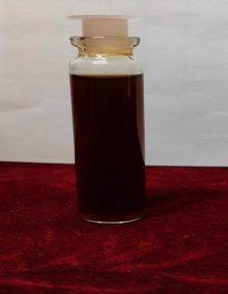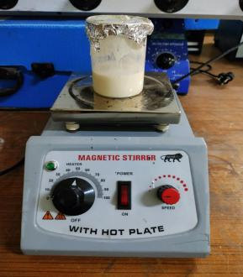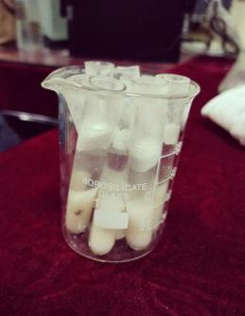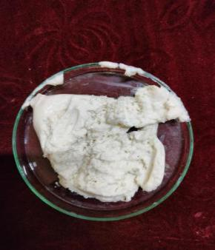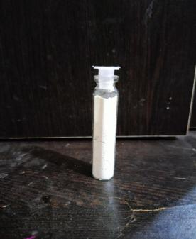
(1) (2) (3) (4) (5)
Fig.1.(1) Aegle marmelos leaves extract. (2) stirring at hot plate (3) After centrifugation. (5) transferred in petry dish (5) ZnO powder.
III. Results and Discussions
A. UV-Visible Spectral Analysis
The absorption spectra of ZnO NPs were recorded using double-beam UV-Vis Spectrophotometer Fig 2. The absorption spectrum for the sample was recorded in the range of 200-800 nm. The absorption maximum was obtained at 350 nm which confirms the synthesis of ZnO nanoparticles. The band gap, energy was calculated using equation Eg = 1240/λeV and found to be 3.54 for ZnO nanoparticles synthesized from using Aegle marmelos leaves extract.
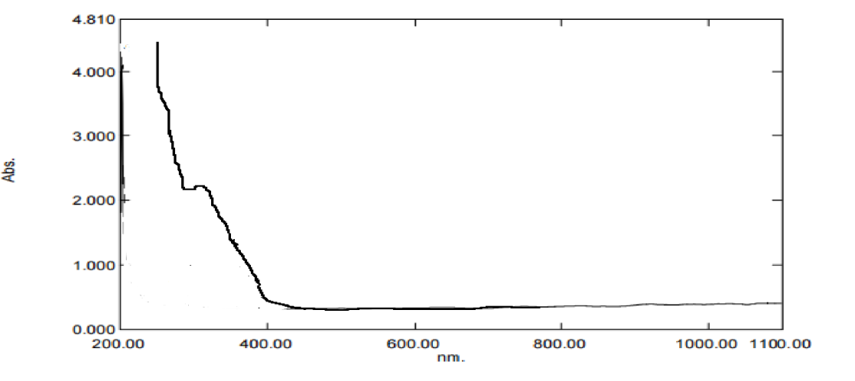
Fig.2. UV-Vis spectrum of synthesized ZnO NPs
B. Fourier Transform Infrared (FT-IR) Spectroscopy
FT-IR Spectroscopy was used to identify the chemical bonds present in the synthesized NPs. An FT-IR Spectrometer operating in the percent transmittance (%T) mode at a resolution of 4000-400 cm-1 was used to obtain the IR spectrum. The presence of ZnO NPs is indicated by the absorption peak at 460.99 cm-1 due to the stretching vibrations of Zn-O. The other chemical bonds present in the nanoparticle are depicted in the graph Fig.3. The broad stretch of the absorption band at 3319.49 cm-1 corresponds to the O-H stretching of alcohol or phenolics from the plant extract. The absorption at 2922.16 cm-1 is attributed to C-H stretching from the aliphatic functional groups from the phytochemicals. The other peaks depicted correspond to the other functional groups present in the phytochemicals from the plant extract. The presence of prominent peaks from the phytochemicals leads to the conclusion that the phytochemicals successfully act as capping agents for the ZnO NPs. These phytochemicals interact with the surface of the NPs and aid in their stabilization. Similar results have also been previously reported where ZnO NPs have been synthesized using Solanum torvum L. (14) and Bauhinia tomentosa (9) leaf extracts.
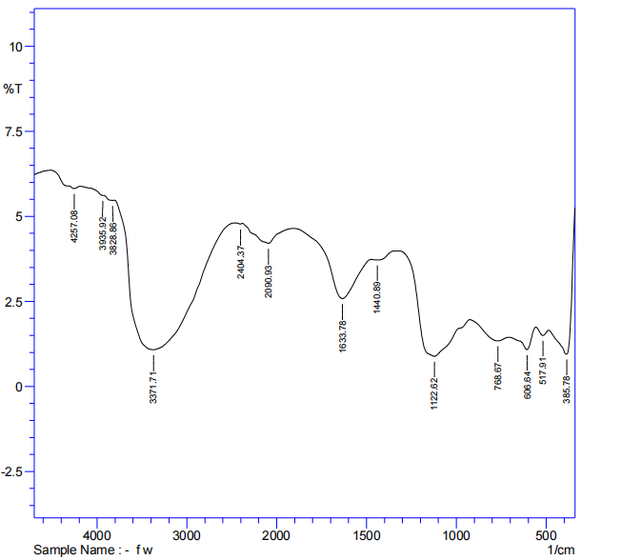
Fig.3. FT-IR Spectra of synthesized ZnO NPs
- X-Ray Diffraction (XRD) Analysis
XRD spectrum of the synthesized NPs was obtained for 2θ values ranging from 20-90˚ using an X-Ray Diffractometer at λ=1.5406 A˚. The prominent peaks were observed at 2θ values with lattice planes at 32.714º (100), 34.491˚(002), 35.85˚(101), 45.61˚(102), 59.57˚(110), 62.78˚(103), 68.77˚(112), 69.89˚(201)Fig.4.The sharp diffraction peaks obtained indicate a good degree of crystallinity of the NPs. The absence of other prominent diffraction peaks other than those attributed to those of the NPs indicates the good degree of purity of the synthesized ZnO NPs (15). The crystallite size of the NPs was calculated as 27.43 nm which was obtained using the Debye-Scherrer formula.
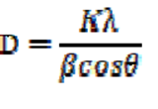
where k is a constant equal to 0.90, λ is the wavelength of the incident X-ray, β is the FWHM in radians, D is the crystallite size and θ is the Bragg's angle in radians. According to previous literature, a crystallite size of less than 100 nm produces broadened diffraction peaks in the case of NPs since such particles have very less parallel diffraction planes. Peak broadening is a common phenomenon in small crystallite-sized NPs and this crystallite size calculated is the measure of the smallest precise regions or coherently diffracting domains present in the individual crystal. Particle size is the total size of the particle comprising all the crystals (16).
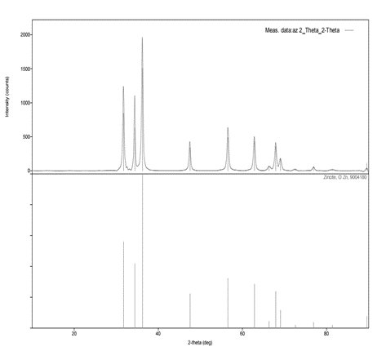
(Fig 4) XRD Spectrum of synthesized ZnO NPs
- Scanning Electron Microscope (SEM) analysis
The external morphology of the synthesized NPs was examined using SEM. The SEM image Fig 5 revealed that most of the synthesized NPs were irregularly spherical. the NPs interact with each other through Van der Waals interactions which causes them to come relatively close to each other, leading to aggregation. This aggregation of NPs also affects their stability. A similar aggregation effect has also been observed in previous literature where ZnO NPs have been synthesized using Cardiospermum halicacabum leaf extracts (17).
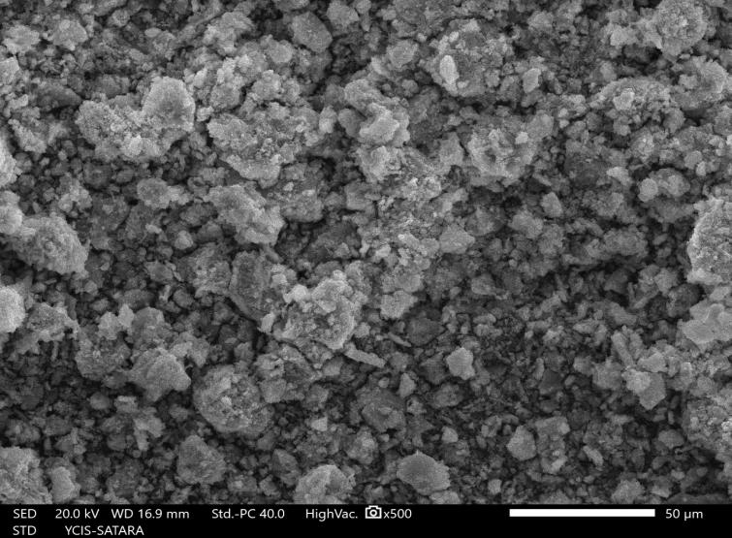
Fig.5. SEM image of the synthesized ZnO NPs
- Antibacterial activity
The antibacterial activity of synthesized zinc oxide nanoparticles against pathogenic microbes was shown in Table 1. The zone of inhibition increases with concentrations of 25, 50, and 100 µg/ml. The highest zone of inhibition was observed at 100 µg/ml with Escherichia coli, and Staphylococcus aureus.

Table 1: Zone of inhibition (mm) at different concentrations of ZnO nanoparticles

Sr. No. | Name of bacterial species | 25 µg/ml | 50 µg/ml | 100 µg/ml | Control 10 µg/ml
1 | Staphylococcus aureus | 3 mm | 5 mm | 8 mm | 9 mm
2 | Escherichia coli | 2 mm | 4 mm | 7 mm | 10 mm

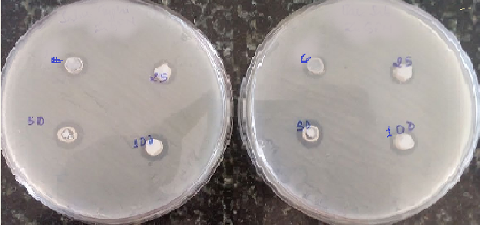
Fig.6. Antibacterial activity of ZnO nanoparticles.
4. Conclusion
The biosynthesis of zinc oxide nanoparticles using leaf extract of Aegle marmelos proves to be a cost-effective and eco-friendly method for the synthesis of nanoparticles. The synthesized zinc oxide nanoparticles were characterized using UV-Vis Spectrophotometer, FT-IR, XRD, and SEM. SEM analysis showed that the nanoparticles are irregularly spherical. FT-IR analysis shows that the peak at 460.99 cm-1 is the characteristic absorption of the zinc oxide (Zn-O) bond which confirms the formation of zinc oxide nanoparticles. XRD analysis confirms the formation of nanoparticles with a crystallite size of 27.43nm and in the hexagonal wurtzite phase which is the form with the highest stability of zinc oxide at ambient conditions. The anti-bacterial property of the synthesized nanoparticles against Escherichia coli and Staphylococcus aureus. The nanoparticles synthesized using this method are expected to have more extensive applications in bioremediation, catalysis, drug delivery systems, and other medical fields.
Acknowledgments
The author would like to thank the Government Vidharbh Institute of Science and Humanities,Amravati. for providing the apparatus and lab to carry out the research work.
References
[1] F.J. Heiligtag, M. Niederberger, The fascinating world of nanoparticle research, Mater. Today. 16 (2013) 262–271. doi:https://doi.org/10.1016/j.mattod.2013.07.004.
[2] I. Khan, K. Saeed, I. Khan, Nanoparticles : Properties , applications and toxicities, Arab. J. Chem. (2017). doi:10.1016/j.arabjc.2017.05.011.
[3] O. V Salata, Applications of nanoparticles in biology and medicine, J. Nanobiotechnology. 2 (2004) 3. doi:10.1186/1477-3155-2-3.
[4] S. Hasan, A Review on Nanoparticles : Their Synthesis and Types, Res. J. Recent Sci. Res . J . Recent . Sci . Uttar Pradesh ( Lucknow Campus ). 4 (2014) 1–3.
doi:10.3233/978-1-61499-057-4-57.
[5] N. Matinise, X.G. Fuku, K. Kaviyarasu, N. Mayedwa, M. Maaza, ZnO nanoparticles via Moringa oleifera green synthesis: Physical properties & mechanism of formation, Appl. Surf. Sci. 406 (2017) 339–347. doi:https://doi.org/10.1016/j.apsusc.2017.01.219.
[6] M.A. Chougule, S. Sen, V.B. Patil, Facile and efficient route for preparation of polypyrrole-ZnO nanocomposites: Microstructural, optical, and charge transport
properties, J. Appl. Polym. Sci. 125 (2012) E541–E547. doi:10.1002/app.36475.
[7] A. Hatamie, A. Khan, M. Golabi, A.P.F. Turner, V. Beni, W.C. Mak, A. Sadollahkhani, H. Alnoor, B. Zargar, S. Bano, O. Nur, M. Willander, Zinc Oxide NanostructureModified Textile and Its Application to Biosensing, Photocatalysis, and as Antibacterial Material, Langmuir. 31 (2015) 10913–10921. doi:10.1021/acs.langmuir.5b02341.
[8] B.A. Çakır, L. Budama, Ö. Topel, N. Hoda, Synthesis of ZnO nanoparticles using PS-bPAA reverse micelle cores for UV protective, self-cleaning and antibacterial textile applications, Colloids Surfaces A Physicochem. Eng. Asp. 414 (2012) 132–139. doi:https://doi.org/10.1016/j.colsurfa.2012.08.015.
[9] G. Sharmila, C. Muthukumaran, K. Sandiya, S. Santhiya, R.S. Pradeep, N.M. Kumar, N. Suriyanarayanan, M. Thirumarimurugan, Biosynthesis, characterization, and antibacterial activity of zinc oxide nanoparticles derived from Bauhinia tomentosa leaf extract, J. 17 Nanostructure Chem. 8 (2018) 293–299. doi:10.1007/s40097-018-0271-8.
[10] M. Ramesh, M. Anbuvannan, G. Viruthagiri, Green synthesis of ZnO nanoparticles using Solanum nigrum leaf extract and their antibacterial activity, Spectrochim. Acta Part A Mol. Biomol. Spectrosc. 136 (2015) 864–870. doi:https://doi.org/10.1016/j.saa.2014.09.105. [20] A. B. Djurišić, X. Chen, Y. Leung, A.M.C. Ng, ZnO nanostructures: Growth, properties and applications, 2012. doi:10.1039/C2JM15548F.
[11] A. B. Djurišić, X. Chen, Y. Leung, A.M.C. Ng, ZnO nanostructures: Growth, properties and applications, 2012. doi:10.1039/C2JM15548F.
[12] A. Król, P. Pomastowski, K. Rafińska, V. Railean-Plugaru, B. Buszewski, Zinc oxide nanoparticles: Synthesis, antiseptic activity and toxicity mechanism, Adv. Colloid Interface Sci. 249 (2017) 37–52. doi:https://doi.org/10.1016/j.cis.2017.07.033.
[13] S.S. Kumar, P. Venkateswarlu, V.R. Rao, G.N. Rao, Synthesis, characterization and optical properties of zinc oxide nanoparticles, Int. Nano Lett. 3 (2013) 30.
doi:10.1186/2228-5326-3-30.
- K.M. Ezealisiji, X. Siwe-Noundou, B. Maduelosi, N. Nwachukwu, R.W.M. Krause, Green synthesis of zinc oxide nanoparticles using Solanum torvum (L) leaf extract and evaluation of the toxicological profile of the ZnO nanoparticles–hydrogel composite in Wistar albino rats, Int. Nano Lett. 9 (2019) 99–107. doi:10.1007/s40089-018-0263-1.
- [15] S. Hajiashrafi, N. Motakef-Kazemi, Green synthesis of zinc oxide nanoparticles using parsley extract, Nanomedicine Res. J. 3 (2018) 44–50. doi:10.22034/nmrj.2018.01.007.
[16] E. PURUSHOTHAM, N.G. KRISHNA, X-ray determination of crystallite size and effect of lattice strain on Debye–Waller factors of platinum nano powders, Bull. Mater. Sci. 36 (2013) 973–976. doi:10.1007/s12034-013-0553-1.
[17] K. Nithya, S. Kalyanasundharam, Effect of chemically synthesis compared to biosynthesized ZnO nanoparticles using aqueous extract of C. halicacabum and their
antibacterial activity, OpenNano. 4 (2019) 100024.

