Role of diet in inflammatory bowel disease.

Abstract:- The condition of inflammatory bowel disease (IBD) is steadily rising in Western as well as in developing countries paralleling the increase of westernized diets, characterized by high protein and fat as well as high sugar intake, with less vegetables and fiber. An interesting hypothesis is that environmental (food-) triggered changes of the intestinal microbiome might cause a proinflammatory state preceding the development of IBD.Inflammatory bowel diseases (IBDs) are closely connected to nutrition.The latest research indicates that diet and nutrition are significantly involved in the etiopathogenesis of the disease, although their specific role throughout its clinical course still remains unclear. This study reviewed how diet and nutrition are linked with IBD development and management. Even though particular diets have been shown to bring about affirmative outcomes, there is currently no scientific consensus regarding an appropriate diet that would benefit all IBD patients. I suggest only that individualized dietary recommendations are of the greatest significance and that diets should be planned to provide individual IBD patients with perticular nutrient requirements while keeping all the clinical aspects of the patients in mind. .

Keywords: inflammatory bowel disease,Diet, Nutrition.FODMAP.

Introduction:-Inflammatory bowel diseases (IBDs) are distinguished by chronic and relapsing inflammation of different segments in the gastrointestinal tract. The etiology is not yet fully understood and the course of the disease is characterized by time periods of exacerbation and remission. A multifactorial etiology has been confirmed. An interaction between environmental factors and gut microbiota in genetically susceptible individuals may cause a dysregulation of both the innate and adaptive immune responses. The environmental factors include stress, pollution, breastfeeding, smoking, use of antibiotics, chemical products and diet[6]. Some of these risk factors are potentially reversible, such as smoking, use of antibiotics and diet.Some studies point to the link of the incidence of IBD with dietary excess or even a deficit of several nutrients. Additionally, dietary constituents are involved in dysbiosis on the intestinal mucosa, which can become lighter and more permeable to pathogens and antigens, leading to a low-grade, but persistent inflammation. IBD is associated with intestinal dysbiosis, which is characterized by a generalized alteration in the diversity and abundance of bacterial species.

What is Inflammation ?:- In easy words, when your body activates your immune system, it sends out inflammatory cells. These cells attack bacteria or heal damaged tissue. If your body sends out inflammatory cells when you are not sick or injured, you may have chronic inflammation. Inflammation is a symptom of many chronic diseases, such as arthritis or Alzheimer’s disease. When your body encounters an offending agent (like viruses, bacteria or toxic chemicals) or suffers an injury, it activates your immune system. Your immune system sends out its first responders to inflammatory cells and cytokines (substances that stimulate more inflammatory cells) cells begin an inflammatory response to trap bacteria and other offending agents or start healing injured tissue. The consequence can be pain, swelling, bruising or redness. But inflammation also influences body systems.

There are two types of inflammation:-

1-Acute inflammation:-
The response to sudden body harm, such as cutting your finger. To heal the cut, your body sends inflammatory cells to the injured area. These cells start the healing process.Acute inflammation may cause-
Flushed skin at the place of the injury,
Pain or tenderness,Swelling,Heat.

2-Chronic inflammation:-
Your body continues sending inflammatory cells even when there is no outside danger. For example, in rheumatoid arthritis inflammatory cells and substances attack joint tissues leading to an inflammation that comes and goes and can cause severe harm to joints with pain and deformities.Chronic inflammation symptoms may be harder to spot than acute inflammation symptoms. Signs of chronic inflammation can include,Abdominal pain,Chest pain,Fatigue, (example: systemic lupus)
Fever,(example: tuberculosis) Joint pain or stiffness. (example: rheumatoid arthritis)
Mouth sores. (example: HIV infection)
Skin rash. (example: psoriasis).
Chronic inflammation is involved in the disease process of many conditions, including- Alzheimer’s disease, Asthma,Cancer,Heart disease.
Rheumatoid arthritis (RA) and ankylosing spondylitis (AS),type 2 diabetes.I nflammation in both kinds of intestine.

The most common reasons for chronic inflammation :-
Autoimmune disorders, such as lupus, where your body assaults healthy tissue,Exposure to toxins, like pollution or industrial chemicals.Untreated acute inflammation, such as from an infection or injury,Some lifestyle factors also contribute to inflammation in the body. You may be more likely to help to develop chronic inflammation if you drink alcohol in excess.Have a high body mass index (BMI) that falls within the ranges for obesity, unless that is a result of being very muscular.Exercise at your highest intensity too frequently, or you don’t exercise enough.Experience chronic stress.Smoke. Fast food etc.

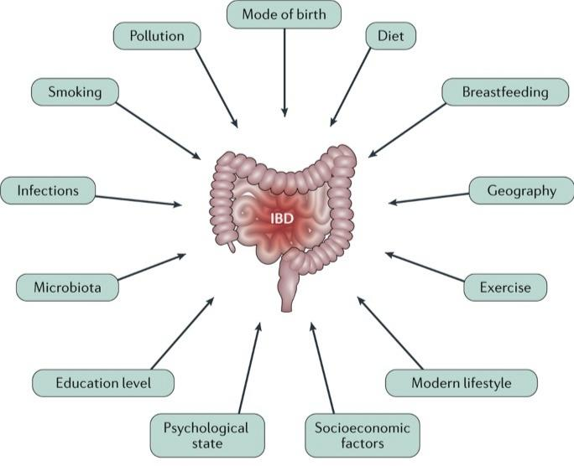

What is inflammatory bowel disease:-

inflammatory bowel diseases (IBD) are chronic inflammatory diseases involving potentially the entire gastrointestinal tract. Most often, the onset of IBD is during young adulthood, but in 15-20% of patients the disease starts before their 18th anniversary. Based on clinical, endoscopic, but also immunological and biological parameters, different phenotypes of IBD can be identified . Usually, the presence of granulomatous lesions and/or the involvement of the tiny bowel with typical ulcerations orientate towards the diagnosis of Crohn's disease (CD), while isolated continuous colonic involvement is in favor of ulcerative colitis (UC). The recent Correction of the Porto criteria for the diagnosis of pediatric IBD provides a helpful tool in the diagnostic workup and classification of children/adolescents with IBD. IBD is defined in two ways as:-

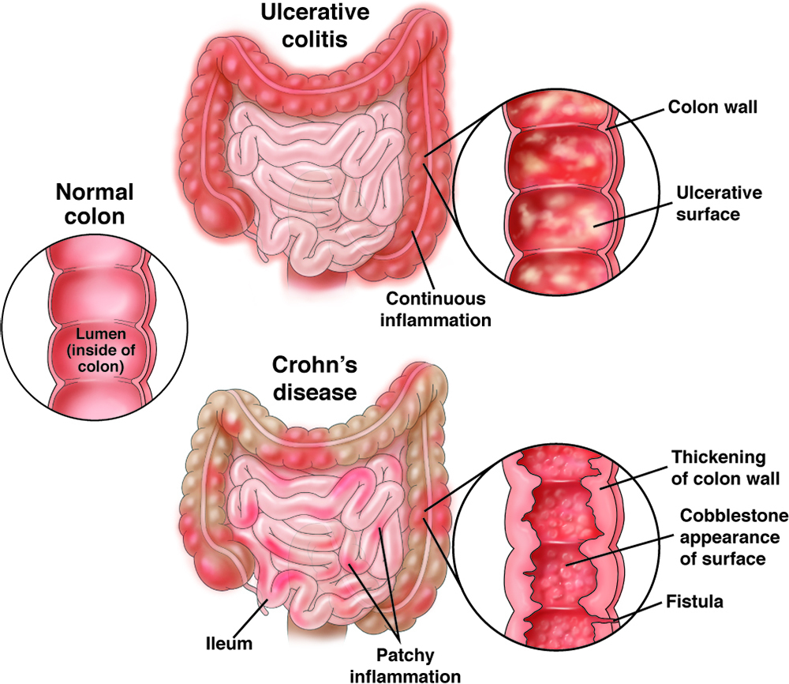

1.Crohn's disease :-Crohn's disease is a chronic inflammatory disease of unknown cause that can involve any portion of the digestive tract. Inflammation can develop entirely through the intestinal wall, often consequently in diarrhea, strictures (narrowing), fistulas (abnormal opening), malabsorption and the need for surgical resections of portions of the digestive tract.

Symptoms:-Crohn's disease can cause abdominal pain, diarrhea, weight loss, anemia and fatigue. Some people may be symptom-free most of their lives, while others can have severe chronic symptoms that never go away.Pain in the abdomen, lower abdomen, or rectum.Pain types can be mild or severe.Gastrointestinal,bloating, blood in stool, bowel obstruction, diarrhoea, nausea, vomiting, or flatulence.Whole body fatigue, fever, or loss of appetite.Also common,anal fissure, cramping, depression, flare, mouth ulcer, slow growth, or weight loss.

2.Ulcerative colitis :-Ulcerative colitis is an inflammatory disease of the colon, or large intestine, which is often accompanied by bloody diarrhea. This inflammation does not go through the entire wall of the intestines and therefore does not result in fistulas. However, extensive inflammation may eventually requisite surgery for removal of the affected area.

Symptoms:- Symptoms include rectal bleeding, bloody diarrhoea, abdominal cramps and pain.Pain in the abdomen, joints, or rectum. Pain types can be intermittent in the abdomen. Gastrointestinal , abdomen bloating, blood in stool, diarrhoea, inability to empty bowels, leaking of stool, or urgent need to defecate.Whole body anemia, fatigue, fever, or loss of appetite also very common a cramping or weight loss.

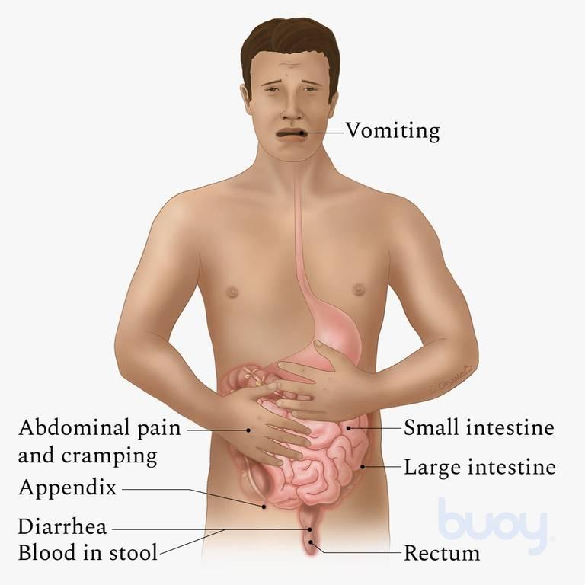

Role of Food/Diet in the Treatment of IBD:-

The best and strongest evidence for the potential to treat IBD with a particular nutritional intervention comes from the use of enteral nutrition (EN) as induction therapy for CD (Crohn's disease). Initially, EN was used as supplemental nutritional therapy in undernourished adult patients prior to resection surgery for CD. This nutritional intervention was revealed to be very efficacious and to have anti-inflammatory effects, finally making surgery unnecessary in some patients' cases. It rapidly became clear that EN, used on an exclusive basis, is a potent anti-inflammatory treatment, greatly efficacious to induce remission in patients with CD . However, patients with UC seem not to respond to exclusive enteral nutrition (EEN). Other nutritional interventions are currently discussed and tested, since more and more patients are interested in controlling their IBD with nutritional interventions instead of using immunosuppressive agents for treatment.

Dietary Management of IBD:-

Information regarding dietary treatments for IBD is often confusing. Many people receive information telling them to avoid entire food groups or specific foods. However, there is no need to avoid foods unless they worsen your symptoms. It is best to restrict as some foods as possible to increase the chances that you are getting a balanced, nutritious diet. This is important for maintaining the function of your digestive tract and your overall health.No specific diet has been shown to prevent or treat IBD. However, some nutritional diet strategies help control Symptoms.

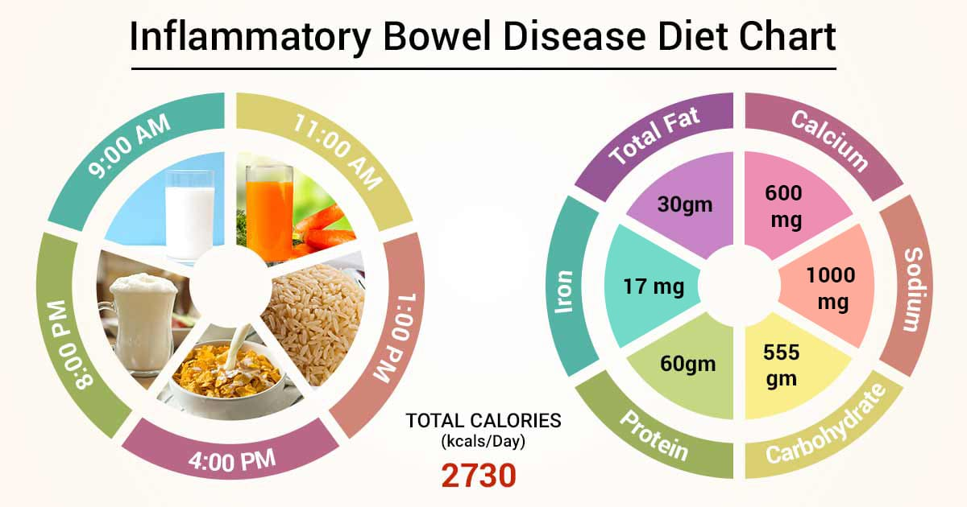

Diet Recommendations for Ulcerative Colitis Flare:-
Follow a low residue diet to relieve abdominal pain and diarrhea.
Avoid foods that may increase stool output such as fresh fruits and vegetables, prunes and caffeinated beverages.
Decrease concentrated sweets in your diet, such as juices, candy and soda, to help decrease amounts of water pulled into your intestine, which may contribute to watery stools.Decrease alcohol consumption.Try to incorporate more omega-3 fatty acids in your diet. These fats may have an anti-inflammatory effect. They are found in fish, including salmon, mackerel, herring and sardines.
Patients often find that smaller, more frequent meals are better tolerated. This eating pattern can help to increase the mass of nutrition you receive in a day.
Consider taking nutritional supplements if appetite is poor and solid foods are not tolerated well.

Diet Recommendations for Crohn's Disease Flare:-
Follow a low residue diet to relieve abdominal pain and diarrhea.
If you have strictures, it is especially necessary to avoid nuts, seeds, beans and kernels.Avoid foods that may upgrade stool output such as fresh fruits and vegetables, prunes and caffeinated beverages. Cold foods may help reduce diarrhea.If you have lactose intolerance, follow a lactose-free diet. Lactose intolerance causes gas, bloating, cramping and diarrhea 30 to 90 minutes after eating milk, ice cream or large amounts of dairy. A breath hydrogen test may confirm suspicions of lactose intolerance.
If you have oily/faty and foul-smelling stools, you may have fat malabsorption. Treat fat malabsorption by following a low-fat diet/food. Discuss these symptoms with your doctor or nutritionist.Smaller, more frequent meals are better tolerated and can maximize nutritional intake.If your appetite is decreased and solid foods not tolerated well, consider taking nutritional supplements.

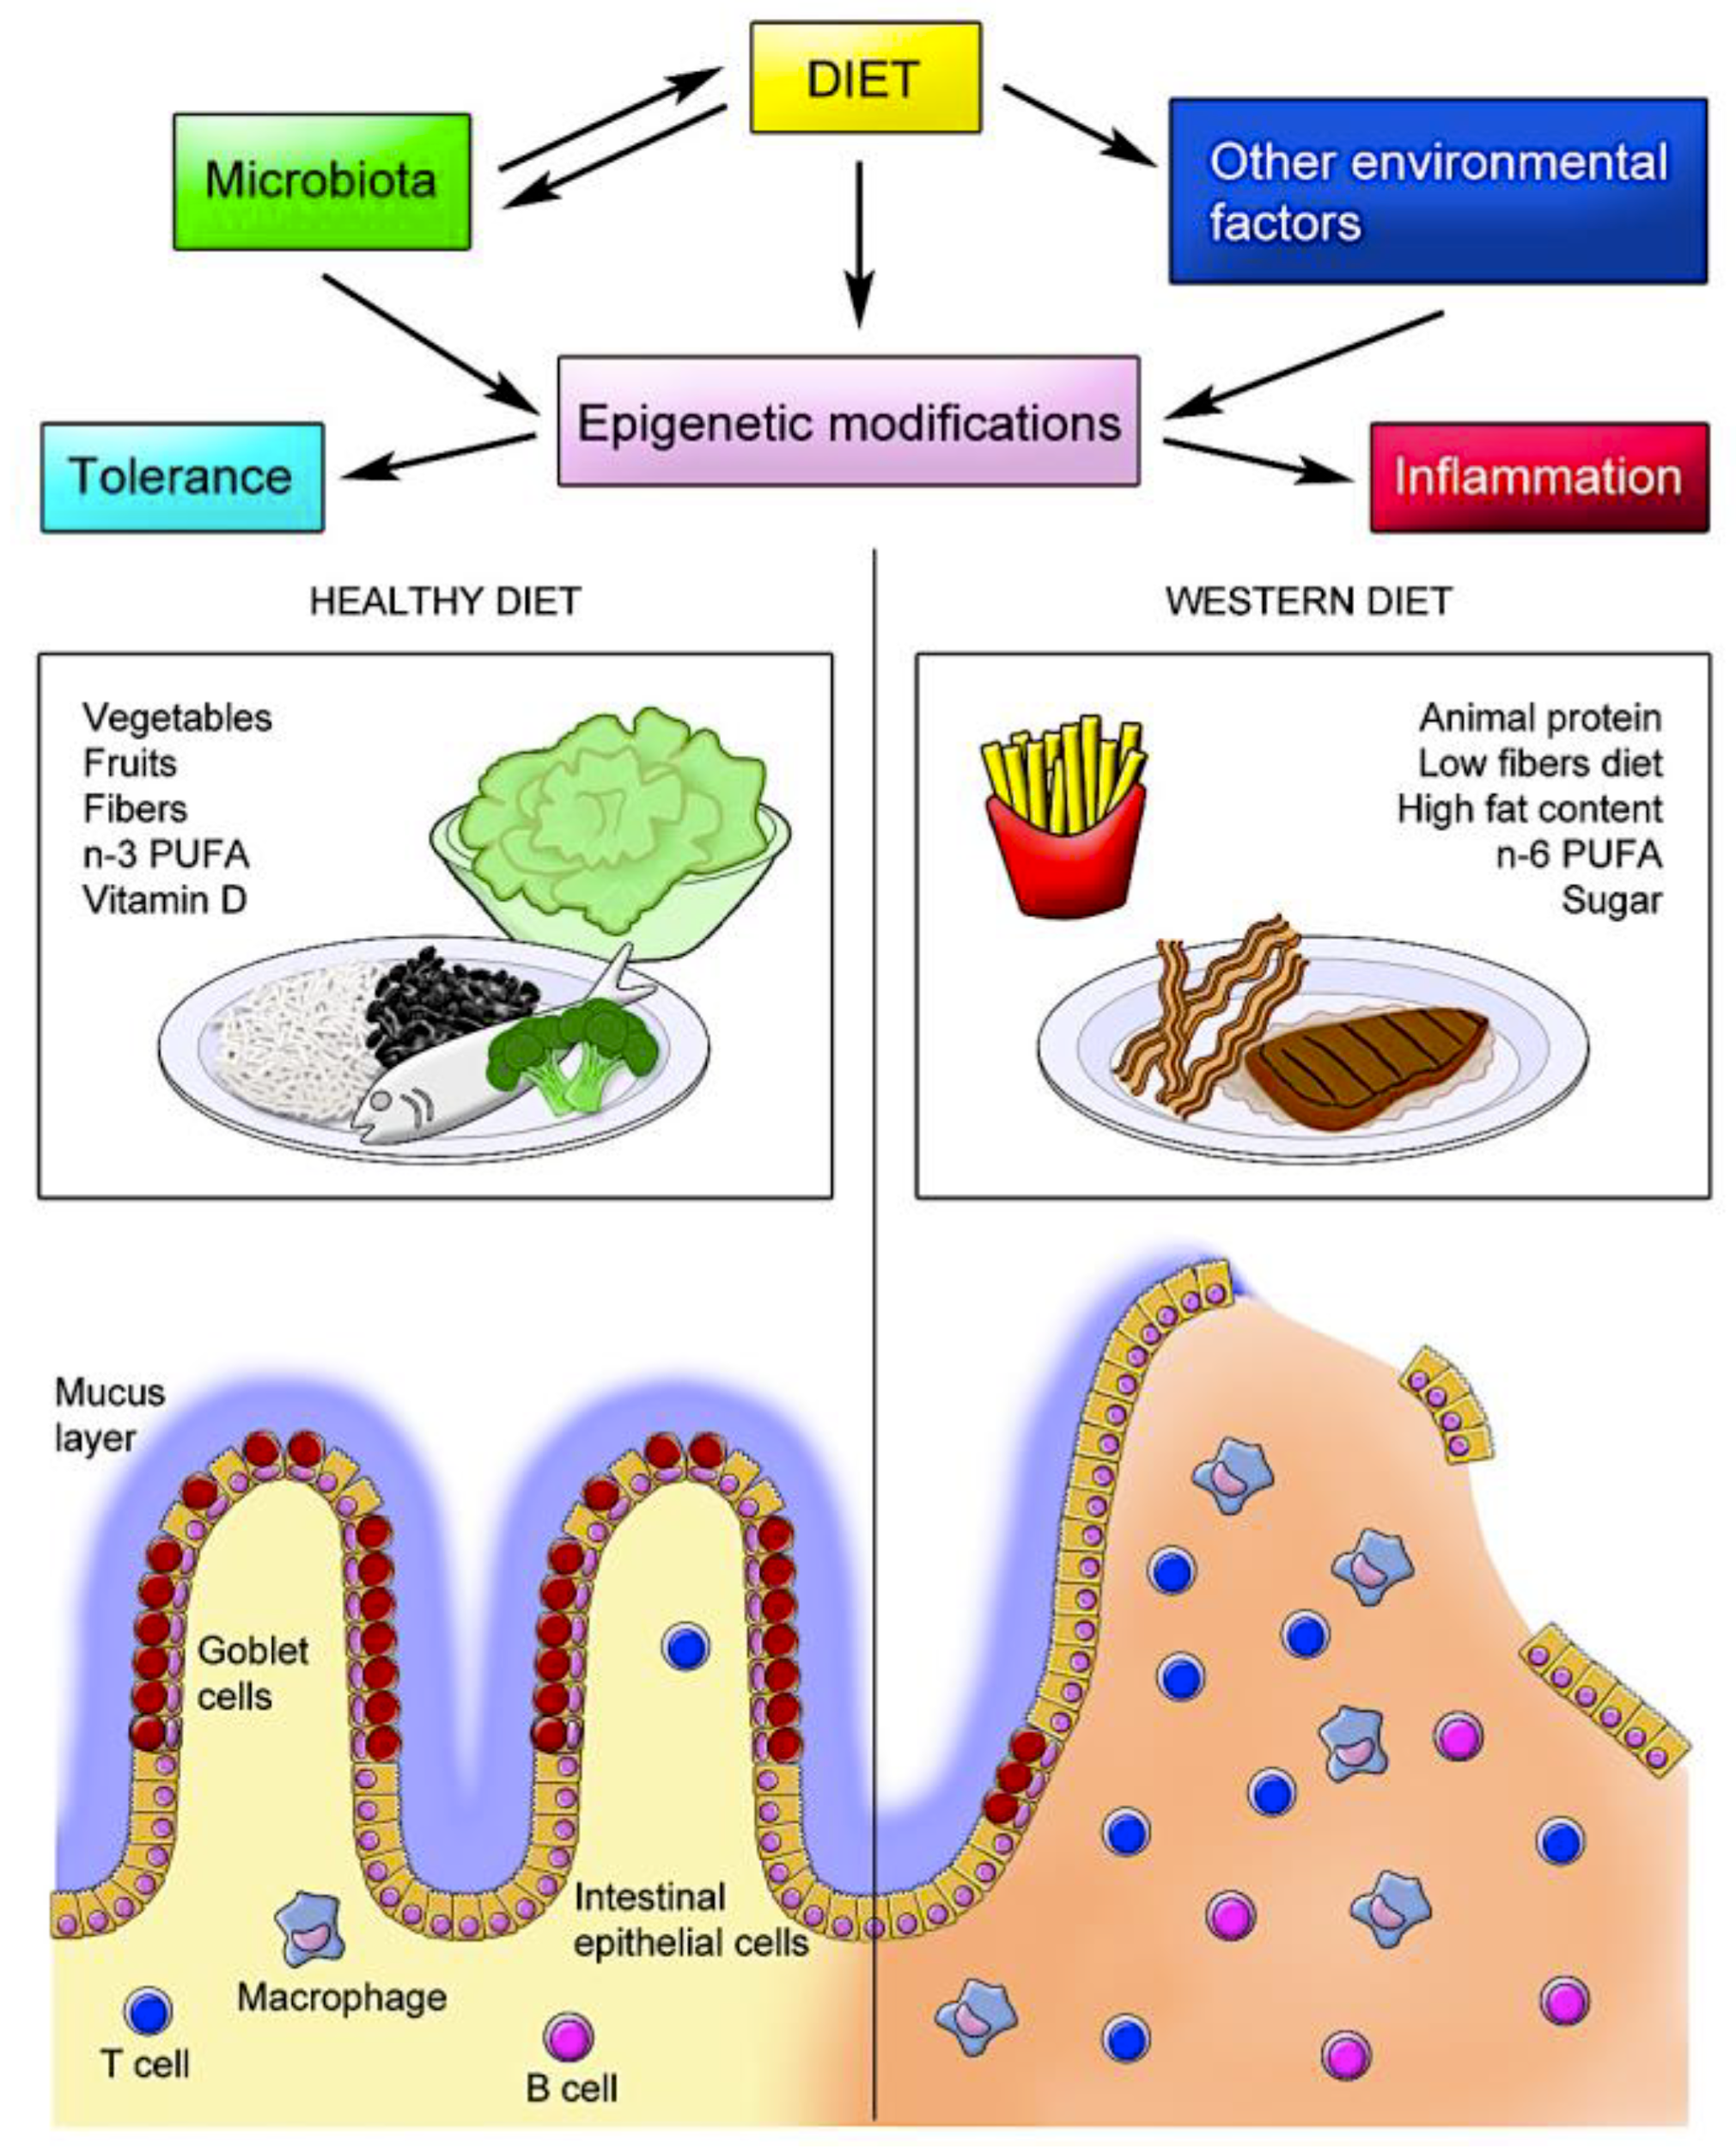

How is simple/chronic inflammation treated?
Simple inflammation does not always require treatment. For acute inflammation, rest, ice and good wound care, a nutrition diet often relieves the discomfort in a few days.

1.Supplements: Certain vitamins (vitamin A, vitamin C, vitamin D) and supplements (zinc) may reduce inflammation and enhance repair. For example, your healthcare provider may prescribe a fish oil supplement or vitamin(s). Or you may use spices with anti-inflammatory properties, such as turmeric, ginger ,garlic,tulsi,and curry leaves .

2.Nonsteroidal anti-inflammatory drugs (NSAIDs): These over-the-counter medicines lower inflammation. Your healthcare provider may recommend ibuprofen (Advil®), aspirin (Bayer®) or naproxen (Aleve®).

3. Anti-Inflammatory Diet:-The anti-inflammatory diet for IBD (IBD-AID) is derived from the SCD and was developed by a group at the University of Massachusetts Medical School. This diet was proposed for patients who are refractory to pharmacological therapy. The treatment was not as beneficial as required and its goal was to obtain and maintain remission with a decreased frequency and severity of flares.
The IBD consists of five components, The first includes the modification of carbohydrates, such as lactose and refined or processed to complex carbohydrates. The second incorporates the ingestion of prebiotics and probiotics.The third modifies dietary fat acids. The fourth detects the overall dietary pattern and missing nutrients, and identifies intolerances, and the fifth component modifies the food texture according to 4 phases. Beginning with soft or pureed foods if in active flare,or based on the symptoms reported. Patients often advanced to a more whole food diet according to the improvement of their symptoms.You may choose to follow an anti-inflammatory diet. Some research shows that people who follow a Mediterranean diet have lower levels of inflammation in their bodies.The things you eat and drink can also play an important action in inflammation. An anti-inflammatory diet focuses on fresh fruits and vegetables. Many plant-based foods are good sources of antioxidants. Some foods, however, can trigger inflammation for example include foods that people fry in repeatedly heated cooking oil, over cook or refrigerated foods. .For an anti inflammatory diet, include foods that may have anti-inflammatory property like:-

- Oily fish, such as mackerel, salmon or sardines.
- Leafy greens like spinach and kale.
- Olive oil.
- Tomatoes.
- Tomatoes.
- Olive oil.
- Leafy green vegetables (spinach, collards).
- Nuts (almonds, walnuts).
- Fatty fish (salmon, tuna, sardines).
- Fruits (berries, oranges).
- Start with a low-fiber or liquid diet until the situation resolves. Avoid identified trigger foods.
- Eat a low-fiber diet. Limit foods such as seeds, nuts, beans, fruit and bran.
- Try a low “FODMAP” diet. FODMAP stands for fermentable, oligo-, di-, monosaccharides and polyols. This type of diet cuts back on a group of sugars that can be poorly absorbed through your gastrointestinal tract. This includes foods containing fructose, lactose, sugar polyols, such as sorbitol and mannitol, fructans, which are found in garlic, leeks, artichokes, and wheat,and galacto-oligosaccharides, which are found in lentils, chickpeas, and green peas.
- Drink water to stay hydrated for a long.

The specific carbohydrate diet (SCD) is an exclusion diet composed predominantly of monosaccharides, hard proteins, and fats, with an essential feature of a primarily modified carbohydrate diet excluding complex carbohydrates.An underlying concept is that monosaccharides are absorbed in the proximal small intestine, unlike disaccharides and polysaccharides, which may leave undigested products that stimulate bacterial overgrowth and perpetuate inflammation or inflammatory disease.

4.-Diet you should avoid :-Eating too much of certain foods may increase inflammation. If you have chronic inflammation, you may feel better if you avoid what written below.These things can trigger inflammation, so avoid them as much as you can.

- Fried foods, including many fast/junk food items.
- Cured meats with nitrates, such as hot dogs.
- Highly refined oils and trans fats.
Refined carbohydrates, such as
sugar, pastries or white bread.
- Refined carbohydrates (white bread).
- Fried foods (French fries/pakode).
- Sugary drinks (soda/ cold drinks).
- Red and processed meats (beef, hot dogs).
- Margarine, shortening, and lard.

5. Prevention:-You may decrease your risk of chronic inflammation by developing a healthy lifestyle to adopt good habits Some of these habits include-

- Achieving and maintaining a healthy body weight.
- Avoiding or quitting smoking.
- Exercising three to five times per week at least (daily exercise is best).
- Limiting your alcohol intake (maximum 2 ounces per day) or no alcohol .
- Managing stress with healthy tools such as meditation,journaling, writing,yog, traveling, music etc.

Conclusion:-Your diet does not cause inflammatory bowel disease, or induce a flare. However, modifying your diet/ food intake can manage symptoms during a flare.While several specialized diets may help certain patients, no plan has been proven to prevent or control inflammatory bowel disease, except for enteral nutrition, which is delivered in a nutrient-rich formula. Following a food diary is a great way to manage flare-ups. A dietitian specializing in inflammatory bowel disease may recommend a particular diet based on your symptoms.

References

1.Jostins L, Ripke S, Weersma RK, Duerr RH, McGovern DP, Hui KY, et al: Host-microbe interactions have shaped the genetic architecture of inflammatory bowel disease. Nature 2012;491:119-124.

2.Nagalingam NA, Lynch SV: Role of the microbiota in inflammatory bowel diseases. Inflamm Bowel Dis 2012;18:968-984.

3.Pfeffer-Gik T, Levine A: Dietary clues to the pathogenesis of Crohn's disease. Dig Dis 2014;32:389-394.

4.Ruemmele FM, Garnier-Lengline H. Transforming growth factor and intestinal inflammation: the role of nutrition. Nestle Nutr Inst Workshop Ser 2013;77:91-98.

5.Amre DK, D'Souza S, Morgan K, et al. Imbalances in dietary consumption of fatty acids, vegetables, and fruits are associated with risk for Crohn's disease in children. Am J Gastroenterol 2007;102:2016-2025.

6.Frank M. Ruemmele
Ann Nutr Metab:Role of Diet in Inflammatory Bowel Disease ,Subject Area: Endocrinology , Further Areas , Nutrition and Dietetics , Public Health
2016 ;68: 32–41.

7.Inflammatory Bowel Disease: Treatment, Procedure, Cost and Side Effects https://www.lybrate.com/topic/inflammatory-bowel-disease.Nov 01, 2019.

8.Ruemmele FM, Roy CC, Levy E, Seidman EG: Nutrition as primary therapy in pediatric Crohn's disease: fact or fantasy? J Pediatr 2000;136:285-291.

9.Lochs H, Dejong C, Hammarqvist F, Hebuterne X, Leon-Sanz M, Schutz T, et al: ESPEN Guidelines on enteral nutrition: gastroenterology. Clin Nutr 2006;25:260-274.

10. de Souza HSP. Etiopathogenesis of inflammatory bowel disease: today and tomorrow. Curr Opin Gastroenterol . 2017;33:222–229.

11. Legaki E, Gazouli M. Influence of environmental factors in the development of inflammatory bowel diseases. World J Gastrointest Pharmacol Ther . 2016;7:112–125.

12. Mokry M, Middendorp S,et.al. Many inflammatory bowel disease risk loci include regions that regulate gene expression in immune cells and the intestinal epithelium. Gastroenterology . 2014;146:1040–1047.

13. Loh G, Blaut M. Role of commensal gut bacteria in inflammatory bowel diseases. Gut Microbes . 2012;3:544–555

14. Bischoff SC, Escher J,et.al. ESPEN practical guideline: Clinical Nutrition in inflammatory bowel disease. Clin Nutr . 2020;39:632–653.

15. Agus A, Denizot J, et.al. Western diet induces a shift in microbiota composition enhancing susceptibility to Adherent- Invasive E. coli infection and intestinal inflammation. Sci Rep . 2016;6:19032.

16. Darfeuille-Michaud A, et.al. High prevalence of adherent-invasive Escherichia coli associated with ileal mucosa in Crohn's disease. Gastroenterology . 2004;127:412–421.

17. Ott SJ, Musfeldt M, et.al. Reduction in diversity of the colonic mucosa associated bacterial microflora in patients with active inflammatory bowel disease. Gut . 2004;53:685–693.

18. Morgan XC, Tickle TL,et al. Dysfunction of the intestinal microbiome in inflammatory bowel disease and treatment. Genome Biol . 2012;13:R79.

19. Cohen SA, Gold BD,et.al. Clinical and mucosal improvement with specific carbohydrate diet in pediatric Crohn disease. J Pediatr Gastroenterol Nutr . 2014;59:516–521.

20.Benchimol EI, Fortinsky KJ,et.al. Epidemiology of pediatric inflammatory bowel disease: a systematic review of international trends. Inflamm Bowel Dis 2011;17:423-439.

21.Auvin S, Molinie F, et al: Incidence, clinical presentation and location at diagnosis of pediatric inflammatory bowel disease: a prospective population-based study in northern France (1988-1999). J Pediatr Gastroenterol Nutr 2005;41:49-55.

22.Ruemmele FM: Pediatric inflammatory bowel diseases: coming of age. Curr Opin Gastroenterol 2010;26:332-336.

23.Levine A, Koletzko S, et al: The ESPGHAN revised porto criteria for the diagnosis of inflammatory bowel disease in children and adolescents. J Pediatr Gastroenterol Nutr 2014;58:795.

24.https://www.ucsfhealth.org/education/nutrition-tips-for-inflammatory-bowel-disease,2003-2004.

Dr. Sandhya
Assistant professor
Department of Home science
Jananayak chandrashekhar university,
Ballia, uttar pradesh.

