Community analysis of Nematodes, Modeling of population dynamics in relation with crop performance, data interpretation and system simulation
Manisha*, Ramavath Abhi, Vinit Kumar Meena¹ and Santosh K. Meena^{2**}
Research Scholar, Department of Nematology, MPUAT, Udaipur
¹Assistant Professor, Department of Agriculture, Vivekananda Global University, Jaipur
^{**2}Senior Research Fellow, SKN College of Agriculture, SKNAU, Jobner

Corresponding Author’s E-mail: **msantosh674@gmail.com, *manishameena4361@gmail.com

ABSTRACT
Community analysis of plant nematodes is an important criterion for assessment of their pathogenic potential in a particular region and identification of hotspots of nematode attack. Soil nematode communities have the potential to provide unique insights into many aspects of soil processes. Since most nematodes are active in soil throughout the year, they can potentially provide a holistic measure of the biotic and functional status of soils. In contrast to other soil microbial groups, representative samples of soil nematode communities are relatively easy to obtain. However, most current nematode ecological information has been survey-based or purely observational in nature, with a persistent focus on detailed taxonomic analysis of nematode communities. The development of a Maturity Index, MI, represents a significant advance in classifying communities and it continues to be refined and developed. But, to develop a wide capacity to use soil nematode information for diagnostic and predictive purposes, particularly for agricultural soils, we need a new, more robust approach, which does not require extensive taxonomic skill and includes more functional criteria. One of the key attributes of nematodes is the relationship between structural form (principally oesophagal feeding apparatus) and function (i.e. trophic group). Nematode form is readily determinable by direct observation of extracted nematodes and high-level taxonomic skills are not needed to assign the major community components to their different trophic and ecological groups. Consequently, the trophic structure of nematode communities is relatively easy to determine and can provide an integrated measure of the status of the other groups on which they feed. Similarly, population numbers and proportions of juveniles and adults can be readily determined, permitting calculation of relative biomass and dynamics of population growth. Nematodes have been successful in adapting to every ecosystem, from soils to freshwater to marine ecosystem, and they have been reported from polar regions to the tropics and are found from highest to lowest elevations, even in oceanic trenches and also within the earth’s lithosphere (Borgonie et al., 2011). Recently, Shatilovich et al. (2018) have reported the viable soil nematodes from the samples of Pleistocene permafrost deposits of the Kolyma River Lowland that corresponds to 30000-40000 years

COMMUNITY ANALYSIS OF NEMATODE

Terminologies to be acquainted

Population: a group of organisms of the same species occupying a particular area.

Community: an assemblage of population living in a area/habitat.
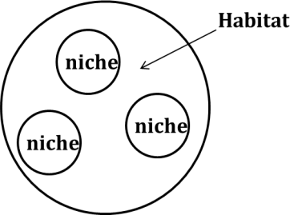
Apart from their morphological distinction, nematodes can be grouped into various trophic groups based on their feeding habit: herbivore (ecto, endo-sedentary/ migratory, semiendo), fungivore, bacteriovore, omnivore, predator, substrate ingestor etc. Since the abundance of different food types is related to the ecological conditions in the microcosms, the relative abundance of different functional groups or taxa of nematodes provides an estimation of nematode biodiversity in a given habitat.

Nematode community structure

Nematode communities are usually polyspecific in nature. The numerical proportions of the trophic groups and population densities of different species vary from place to place. The type of available food sources, organic matter composition, microflora and fauna, temperature, moisture, aeration, pH, salinity (edaphic factors), plant type, level of disturbance by internal (competing microbes) and external factors (tillage, fertilization, soil fumigation or pesticide application) determine species or taxa composition in a given habitat. Therefore, in forest soils nematode community structure differs from that under perennial orchards, annual crops, fallow land, marshes, desert, frozen areas etc. For example, root-knot and reniform nematode proportions gradually increase in dicot crops while stunt, root-lesion, lance and spiral nematode populations increase in monocot plants.

The microbivorous nematodes such as cephalobids, diplogasterids increase in numbers in fresh decomposing organic matter-rich habitats; Aphelenchids dominate in decomposed matter due to fungal growth. Nematode species are commonly classified into r-selection (colonizers) and K-selection (persisters) types. Their ratios are related to the level of environmental stability and disturbance. The colonizers are more abundant in frequently disturbed and unstable communities while the persisters prevail more in less disturbed stable habitats. Typically, the colonizers have high rate of reproduction, high fecundity, short life span and high amplitude of oscillation in population density. By contrast, persisters have lower reproduction rate, low fecundity, long life cycle with narrower fluctuation in population density. A stable community has larger number of species with narrow differences in their relative densities, whereas in unstable communities there are fewer species with one or few species dominating.

CP scale

CP1: short generation time, explosive population growth in food rich condition, from dauer larvae. E.g. Rhabditid, Diplogasterid, Panagrolaimid.

CP2: short generation time, high reproduction, no dauer larvae, thrive in both food rich and food poor condition, tolerant to pollutant and other stress. E.g. Aphelenchid, Anguinid, Cephalobid, smaller tylenchid.

CP3: Intermediate between CP2 and CP4, longer generation time, sensitive to stress. E.g. larger Tylenchid, Chromadorid.

CP4: permeable cuticle, sensitive to pollutants. E.g. smaller Dorylaimid, Trichodorid.

CP5: long life span, low reproduction rate, very sensitive to pollutants and stress. E.g. larger Dorylaimid, predatory omnivores.

Among the fauna, nematodes are ubiquitous inhabitants of soil. Numerically, they are the most abundant soil metazoans, with densities varying from 7.6 x 10⁵ to 290 x 10⁵/ m². They are easy to sample and observe, many taxa belonging to various trophic groups can be found in a soil sample from an area, can be easily identifiable by their morphological characters.

Numerical analysis of nematode community structure

The relative abundance and distribution of nematodes are generally measured in terms of absolute and relative frequencies, densities and importance values of different species encountered (Norton, 1978).

Absolute frequency = (No. of samples containing the species/No. of samples collected) × 100

Relative frequency = (frequency of the species/sum of frequency of all spp. present in the samples) × 100

Absolute density = (No. of specimens of the species in the sample/volume or mass of the sample)

Relative density = (No. of specimens of the species/total number of individuals of all spp.) × 100

Biomass = a²b/16 × 10⁶ µg

a = average greatest body width of the particular species in µm

b = average body length in µm

Prominence value = Relative density × (Relative frequency)^{0.5}

Importance value = Relative frequency + Relative density + Relative biomass.

Example :
Species | Abs. Freq.* | Abs. Den.** | Rel. Freq. | Rel. Den. | Prom. value | Rel. Pro. Val.
Tylenchorhynchus | (8/10)×100  = 80 | 400 | (80/400)×100 = 20 | (400/1200)×100= 33.3 | 33.3×√20  = 148.92 | 32.26
Helicotylenchus | 60 | 100 | 15 | 8.33 | 8.33×√15  = 32.26 | 6.98
Hoplolaimus | 70 | 100 | 17.5 | 8.33 | 8.33×√17.5  = 34.85 | 7.55
Cephalobus | 100 | 400 | 25 | 33.3 | 33.3×√25  = 166.5 | 36.07
Dorylaimus | 90 | 200 | 22.5 | 16.67 | 16.67×√22.5  = 79.07 | 17.13
Total | 400 | 1200 | 100 | 100 | 461.6 | 100
*10 samples were collected from different habitats.
**250 cc soil was uniformly collected from each habitat

ECOLOGICAL INDICES
Apart from these simple indices, the biodiversity of nematode communities is measured using several additional indices to assign any advance weightage to the role of different species in a specific community. Some of these indices include the Shannon Weiner Index, indices of evenness, richness, dominance and diversity.
Species/Community measures
Species Richness Index
SR = S-1/log_{e}N
(S= no. of taxa identified; N= no. of individuals identified)
i) S=31, N=1000, SR= 31-1/log₁₀10³ = 30/3 = 10
ii) S=21, N=1000, SR= 21-1/log₁₀10³ = 20/3 = 6.6
Evenness Index:
J’= H⁄/ H⁄ max,
Where, H⁄ = Shannon Weiner index and
H⁄ max is log_{e} S Nematode channel ratio:
NCR = B/(B+F)
B=bacterivore, F=fungivore
Diversity measures
Trophic diversity :
T=1/ Σ p ²
i i
Where, p is the proportion of trophic group i in the nematode community.
Shannon Weiner Index:
H⁄ = -Σ p_{i} log_{e}p_{i}
It is a species diversity index that gives more weight to the rare species, a higher index indicates greater diversity.
Simpson’s (Dominance) Index:
D = Σ p ²
i
The index gives greater weight to common species, a lower index indicates dominance of few species.
Maturity (Bonger’s) Index
MI = Σ p_{i} f_{i}
p_{i} = CP value on scale 1-5; f_{i} = frequency of the i^{th} taxon Lower index indicates disturbance.

Examples :
Species | Abs. Freq.* | Abs. Den.** | Freq. X Den. | H’ | D | MI
Tylenchorhynchus | (8/10)×100  = 80 | 400 | 32000 | 0.31Xlog0.31  =-0.16 | 0.096 | 0.93
Helicotylenchus | 60 | 100 | 6000 | 0.06Xlog0.06  =-0.07 | 0.0036 | 0.18
Hoplolaimus | 70 | 100 | 7000 | 0.07Xlog0.06  =-0.08 | 0.0049 | 0.21
Cephalobus | 100 | 400 | 40000 | 0.39Xlog0.39  =-0.159 | 0.1521 | 0.39
Dorylaimus | 90 | 200 | 18000 | 0.17Xlog0.17  =-0.13 | 0.0289 | 0.68
Total | 400 | 1200 | 103000

Index of Similarity :

IS_{J} (Jaccard, 1912) = C/(A+B+C);
ISs (Sorenson, 1948) = 2C/(A+B)
A= number of species only present in community
A B= number of species only present in community B
C= number of species commonly present in both community A and B
Example
Species/habitat | Habita A  Brinjal | Habita B  Caster | Habita C  Cowpea | Habita D  Tomato | Habita E  Mango
Meloidogyne | 200 | 0 | 10 | 200 | 0
Tylenchorhynchus | 100 | 120 | 40 | 90 | 20
Haplolaimus | 110 | 130 | 91 | 96 | 40
Rotylenchulus | 100 | 109 | 104 | 20 | 0
Xiphinema | 40 | 10 | 0 | 0 | 0
ISs:
Habitat | A | B | C | D | E
A |  | (4x2)/(5x4)=8/9 | 8/9 | 8/9 | 4/7
B |  |  | 6/8 | 6/8 | 4/6
C |  |  |  | 8/8 | 4/6
D |  |  |  |  | 4/6
E
Important considerations
Diversity is equated with numbers of taxa and most commonly with species. However, it can be applied to other taxonomic levels like genus, family or trophic groups. For free-living nematodes, it is more common to apply a diversity index to taxonomic levels above species as the identification based on morphology is difficult.
Appropriate caution is required when applying diversity indices at trophic levels as trophic classification is inferred by morphology only and not by actual experiments on feeding. For example, Tylenchus spp. is often considered as fungal feeders in ecological studies although several species are known to be root feeders.
The method of extraction may also affect the proportion of trophic groups obtained. For example, Cobb’s sifting and gravity method with multiple sieves recovers a larger proportion of total nematodes, than elutriation with a single sieve.
The Shannon Weiner Index H⁄ is commonly used to assess diversity, but as it may be dominated by abundant taxa or the overall number of taxa, both evenness and richness are calculated. Besides the differences in calculation, factors that affect index values include texture, seasonal patterns, type of vegetation and rotations, prey predator interactions and microsites (row and inter-row samples).
After a severe disturbance and reintroduction of higher plants, the nematode population restores after some time, unlike with free-living nematodes. Life strategy of plant-parasites is different from that of non-parasites. Therefore, the term plant-parasitic index (PPI) was proposed with a different cp scale.
Modelling of Population Dynamics in Relation with Crop Performance
Nematode Damage :-
The nematode, the host and the environment are the three interacting variables influencing the extent of yield loss in infested soils. An understanding of the mechanisms and principles involved in these interacting relationships is basic to being able to predict yield reductions from estimates of pre-planting nematode population densities (Pi).
Damage models
When modeling damage caused to plants by root-feeding nematodes certain basic principles apply. These are:
- Damage is proportional to the nematode population density.
- The degree of damage is influenced by environmental factors.
The yield harvested is determined by the amount of light intercepted by the crop, by how efficiently the intercepted light is converted into dry matter, and finally by how that dry matter is partitioned into non-harvested and harvested yield. For some crops significant variations in moisture content will also affect final yield.
The above principles can be simply stated but are more complex in practice. Damage may be proportional to the nematode population density, but there are several qualifications of this statement. The relationship is usually curvilinear, increasing numbers of nematodes having proportionally diminishing effects. There is some evidence that at low densities the host plant can repair the damage and that growth may even be slightly stimulated. Seinhorst (1965) termed the population density (Pi) at which damage first became apparent as the tolerance limit (T).
Equally, at very high values of Pi, increasing numbers of nematodes may not further reduce dry matter productivity. Seinhorst termed this the minimum yield (m). There are various reasons why m may occur; there may be some growth before attack starts or after it finishes, and a significant biomass may be planted (e.g. potato tubers). However, m applies to total dry matter and because of effects on partitioning, the harvest value of m may be greater or less than that for total dry matter.
The third parameter in the Seinhorst equation is z, a constant slightly less than one. The equation is:
for Pi>T
y=1 where Pi£ T, where, y is the yield.
An important qualification is that y is expressed as a proportion of the nematode-free yield. Hence, according to Seinhorst, the greater the yield potential the greater the loss in tonnes per hectare for any value of Pi.
- Population Dynamics:
Population dynamics is the study of changes in nematode population size and structure over time. Knowledge of population dynamics is essential to predict nematode population growth and to anticipate nematode damage. Nematodes cannot migrate readily from site to site during a growing season.
Therefore, it is possible to predict the final nematode population size (Pf) from the initial population size (Pi) present within a site, without complications from migration. Pf can be measured at harvest of a crop, or after ome specified time interval.
Many of these are based on classical models that are well known from population ecology and modified for application to nematology. Simulation models, some of which are based on classical population models, are used to update population estimates through a series of time intervals.. Simulated time increments may range from seconds to years depending on the situation.
Yield losses are influenced by the pathogenicity of the species of nematode involved, by the nematode population density at planting, by the susceptibility and tolerance of the host and by a range of environmental factors.
Nematode population dynamics are also density dependent and are influenced by host growth, the reproductive potential of the species and by various environmental factors. Consequently, modelling nematode population dynamics is an equally impressive science. Again, good field data are required but the complicating effects of biological control agents, host susceptibility differences and environmental factors, and errors associated with measuring initial population densities, may mean it is practically impossible to predict reliably the multiplication rates of most nematodes, especially those with several generations per season.
2. Classical Models
- Theoretical Models:- Relatively simple classical models have been used to describe population growth for a variety of organisms and these are applicable nematode populations as well.
- Exponential growth
- Logistic growth
- Exponential decline
- Exponential growth :-
Exponential growth, which is independent of population size, is a special case that applies only when environmental conditions are optimal and the food supply is unlimited. Under these conditions,
Pf = Pi e"
Where, Pf= final population size after a specified time interval, Pi= initial population size. = the time interval between Pi and Pf. r= the intrinsic rate of increase of the population (a constant), and e= the natural logarithm base. According to this model, population size increases exponentially over time. An equivalent form of
Pf = In Pi + n
Note that if In Pf is plotted against In Pi, the graph is linear for a constant time interval. While the assumption of an unlimited food source is unrealistic, a large root system is an almost limitless resource to a single microscopic nematode. Therefore, low nematode numbers in highly favorable biotic and abiotic environments may increase exponentially, as observed on several occasions.
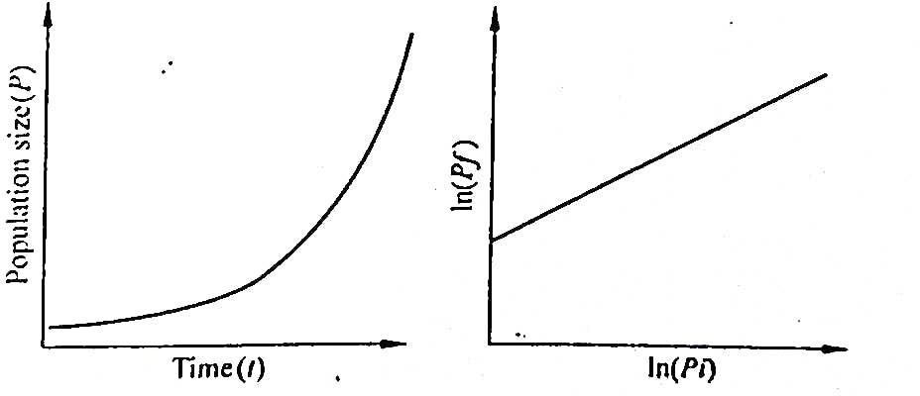
Exponential growth (A) Increase in population size over time, (B) Relationship between Pf and Pi.
Life tables can be most easily constructed and used if the population can be divided into cohorts, or groups of individuals of similar age. Therefore this approach may be more useful with nematodes that deposit large numbers of t eggs at once and have synchronized generations, rather than with nematodes that have overlapping generations and deposit a few eggs at a time over several weeks.
b) Logistic Growth:-
In reality, food sources become limited as populations grow, and so the logistic growth model, used to describe density-dependent population growth. is often applied to nematode population growth (Tsoularis and Wallace. 2002; Seinhorst, 1966). According to the logistic model:
dp/dr = rp E-P/E
Where, P population size, dP/dr = change in population density with time (i.e.. growth rate of the population), r= intrinsic rate of increase, and E equilibrium density.
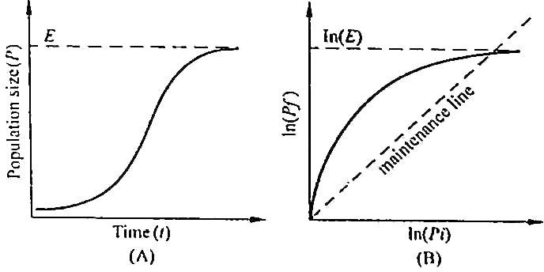
(A) Increase in population size over time. E = equilibrium density. (B) Relationship between Pf and Pi, shape varies with host. Pf Pi on the maintenance line.
c). Exponential decline :
Although the previous models are descriptive of population growth, nematode populations can be expected to decline on non host crops, during clean fallow, or during winter. In these instances, an exponential decline equation may be appropriate
Pf = a e ^{bt}.
Where, Pf population size, = time, and a and b are constant, for a particular set of conditions, with b< 0. Population size decreases over time.
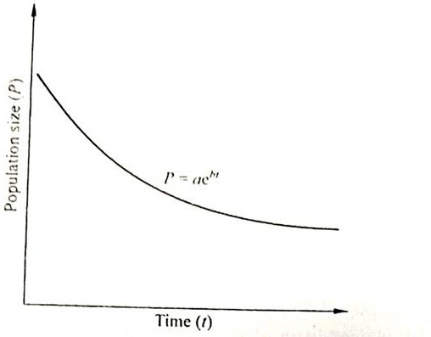
Figure : Exponential decline of population size over time, with b <0.

- Application of classical models :-
- Critical point models relating pf and pi
- Simulation models
- Design of cropping system
- Critical point models relating pf and pi:-
Critical point models are those in which Pf is forecast from an initial estimate of Pi (Ferris, 1981), Relationships such as that shown in are fundamental in estimating Pf from Pi for specific nematodes on specific crops. At high values of Pi, populations are likely to reach E and at extremely high nematode densities, root damage may be so severe that E cannot be maintained. In most situations, however, the relationship between Pf and Pi at low to moderate Pi is particularly useful in evaluating plant host status and the potential for population increase under field conditions.
b). Simulation model :-
Simulation models use iterative algorithms to predict conditions at a sequence of points in time. Sequence intervals may be any length, from an instant to years. Thus, critical point models that are used in algorithms to predict nematode population change during a multi-year crop rotation cycle (described below) are components of simulation model. However, a distinct advantage of modeling shorter time intervals than occur with successive crops is that various factors known to affect populations can be incorporated in the models. Theoretically. model that simulates the influence of temperature, soil moisture, soil oxygen, root growth, etc.
Simulation models can be used to understand nematode biology and to identify aspects amenable to management intervention. Examination of forecasts from a temperature driven model of Heterodera schachtii population development reveal uncertainty about the effects of some physical factors on root and nematode development, about distribution of nematodes and roots in the soil profile, about hatching and survival rates of eggs in relation to their position in the cyst, and about movement of nematodes between soil strata.
c). Design of cropping system:-
If models for forecasting Pf from Pi are available for a nematode on a particular crop. Then note that Pf at harvest of that crop will become Pi for a crop planted immediately after harvest. In this way, nematode population levels in a sequence of crops can be linked and modeled over time. This approach can be used to design cropping systems and crop sequences for optimal nematode management. For example, it has provided a convenient means to evaluate the effects of various three- year sequences of maize (Zea mays), Resistant soybean (Glycine max) and susceptible soybean on Meloidogyne incognita populations (Kinloch, 1986), or of cotton (Gossypium hirsutum) and soybean on Hoplolaimus columbus.
- Issues in population dynamics:-
- Sample variability and forecasting
- Population dynamics and pest management strategies
- Population dynamics and sustainable agriculture
- Toward sustainable management : potato cyst nematode
Population forecasts may be derived from simulation models, classical models. Critical point Pf/Pi models, or simply based on data from previous experiments. Regardless of the source of nematode population estimates, a variety of important issues affects their quality and use.
a). Sample variability and forecasting :-
Population dynamics models and nematode forecasts are almost always based on an initial estimate of Pi, obtained by sampling in the field. Unfortunately, highly irregular horizontal dispersion is typical of nematode populations in the field. ). This causes difficulty in sampling and results in a high degree of error (lack of precision) in estimates of Pi.
b). Population dynamics and pest management strategies :-
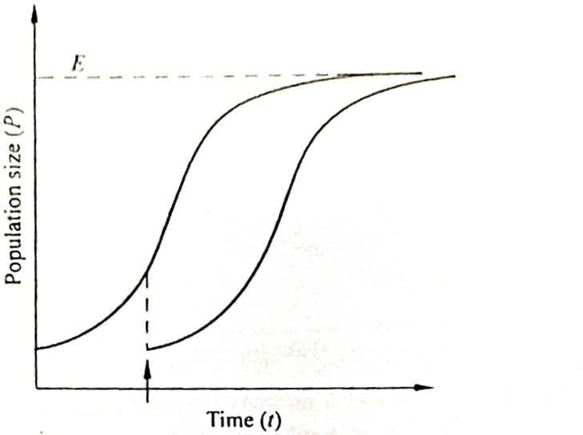
The logistic model of population growth over time provides a basic frame of reference in which the effects of pest management strategies and tactics over time can be examined . For example, if a growing nematode population is treated with a nematicide at one point in time, a rapid decrease in population size might be expected.
Figure :- Effect of population reduction on logistic growth. A nematicide applied at the point indicated by the arrow reduces population size to a lower level and shifts the logistic growth curve in time.
c). Population dynamics and sustainable agriculture:-
Sustainable agriculture is an evolving paradigm designed to maintain food production at necessary levels with minimal environmental degradation and resource depletion, by developing methods to reduce inappropriate or overuse of agricultural resources. Application of these principles for pest control is called integrated pest management (IPM). Simply put. IPM consists of:
(1) Assessing pest population densities and determining whether densities need to be reduced below economic an threshold.
(2) Effecting the necessary changes with the most appropriate available tactic(s).
(3) Continually developing new tactics compatible with economic and environmental requirements.
d). Toward sustainable management: potato cyst nematode :-
Nematode management in potato provides some clear examples of competing issues in sustainable agriculture and purposeful development of IPM. In the United Kingdom, traditional rotations of potato with non-host crops permitted potato to be grown for one year in eight and maintained population densities below damaging levels. Although crop rotation can be a highly effective management tactic, available agricultural land is insufficient to produce adequate quantities of potatoes while relying exclusively on rotation.
Therefore, growers shorten the traditional rotations by integrating the use of additional management tactics that include use of nematicides, resistant potato varieties and trap crops. The adoption of multiple tactics was the impetus for increased reliance on modeling to help design the most profitable cropping systems, and more recently to minimize environmental risk from overuse of nematicides.
References
Borgonie, G., Garcıa-Moyano, A., Litthauer, D., Bert, W., Bester, A., Van-Heerden, E., Moller, C., Erasmus, M. and Onstott, T. C. 2011. Nematoda from the terrestrial deep sub-surface of South Africa. Nature, 474 : 70-82.
Ferris,1985. Density-dependent nematode seasonal multiplication rates and overwinter survivorship: a critical point model. Journal of Nematology, 17(2) : 93-100.
Norton, D.C. 1978. Ecology of Plant parasitic Nematodes. John wiley & Sons, New York, 268pp.
Seinhorst, J.W. 1965. The relation between nematode density and damage to plants. Nematologica, 11:137-154.
Seinhorst, J.W. 1966. The relationship between population increase and population density in plant parasitic nematodes. I. Introduction and migratory nematodes. Nematologica 12 : 157-169.
Shatilovich, A.V., Tchesunov, A.V., Neretina, T.V., Grabarnik, I.P., Gubin, S.V., Vishnivetskaya, T.A., Onstott, T.C. and Rivkina, E.M. 2018. Viable Nematodes from Late Pleistocene Permafrost of the Kolyma River Lowland, Doklady. Biological Science, 480 : 100-102.
Tsoularis, A. and Wallace, J. 2002. Analysis of logistic growth models, Math Biosci. 179(1) : 21-55.

