Cognitive Commerce: Exploring AI's Influence on Business Management
Neelam Sunda
Assistant Professor
Kanoria PG Mahila Mahavidhayalya , Jaipur

Shilpa Pareek
Assistant Professor
Kanoria PG Mahila Mahavidhayalya , Jaipur

Ms. Sweta Pareek
Assistant Professor
University of Engineering & Management, Jaipur

Abstract
AI's influence on today's business management is undeniable, as it continues to reshape the way companies operate and make decisions. From data-driven decision-making to personalized customer experiences and supply chain optimization, AI has become an indispensable tool for modern businesses. Embracing AI technologies and leveraging their capabilities will be crucial for businesses to stay competitive and thrive in an ever-evolving market. As AI continues to advance, its potential to drive innovation and efficiency in business management will only grow, presenting new opportunities and challenges for organizations worldwide. Combining the strengths of AI and human support can lead to a truly exceptional and personalized customer service experience. On the other hand, it is advisable that businesses embracing AI technologies with ethical principles and data privacy considerations can harness the full potential of cognitive commerce, creating a sustainable competitive advantage and delivering exceptional customer experiences in the fast-evolving market.

Introduction
Cognitive commerce, driven by Artificial Intelligence (AI), is revolutionizing the way businesses operate, interact with customers, and optimize their supply chains. The integration of AI technologies into various aspects of business management has opened up new opportunities for growth, efficiency, and personalized customer experiences. As AI technologies continue to advance, businesses that embrace and harness its potential responsibly will gain a competitive edge and drive innovation in the dynamic and rapidly evolving marketplace. With ethical considerations and responsible adoption, AI presents unprecedented opportunities for businesses to excel, succeed, and shape a sustainable future.This chapter explores the impact of AI in business management, focusing on how cognitive commerce is reshaping sales, marketing, supply chain management, and customer service.

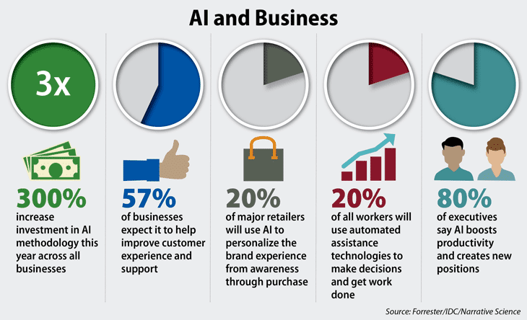

I. AI-Powered Sales and Marketing
AI technologies have transformed the sales and marketing landscape, enabling businesses to gain deeper insights into customer preferences and behavior. Through advanced analytics and machine learning algorithms, companies can analyze vast amounts of data from multiple sources, including social media, browsing history, and transaction records, to identify patterns and predict customer needs.

Key components of AI-Powered Sales and Marketing:
Data Analysis and Insights: AI can process and analyze vast amounts of data from various sources, including customer behavior, preferences, and interactions. This data-driven approach helps identify patterns, trends, and customer segments, enabling businesses to make informed decisions and develop targeted marketing strategies.
Personalization: AI allows marketers to deliver highly personalized content and experiences to individual customers. By understanding customer preferences and behavior, AI systems can tailor marketing messages, product recommendations, and offers, increasing the likelihood of conversion.
Chatbots and Customer Support: AI-powered chatbots can handle routine customer inquiries and support, providing quick responses and assistance 24/7. They can help improve customer satisfaction by addressing queries promptly and efficiently.
Predictive Sales Analytics: AI can forecast sales trends, demand patterns, and customer behavior, aiding in inventory management, pricing strategies, and overall sales planning.
Natural Language Processing (NLP): NLP allows AI systems to understand and interpret human language, enabling sentiment analysis, social media monitoring, and better customer engagement through text-based interactions.
Recommendation Engines: AI-powered recommendation systems analyze customer preferences and past behavior to offer personalized product or content suggestions, increasing cross-selling and upselling opportunities.
Social Media and Sentiment Analysis: AI can track and analyze social media conversations to gauge customer sentiment, gather feedback, and identify potential brand opportunities or challenges.
AI-Powered Sales and Marketing aims to optimize the customer journey, enhance customer experiences, and improve overall business performance by leveraging the capabilities of artificial intelligence. It's worth noting that the specific applications and technologies within AI-Powered Sales and Marketing may continue to evolve rapidly as AI advances and new innovations emerge.
II. Enhancing Supply Chain Management with AI
Businesses are leveraging AI to enhance supply chain management in various ways, revolutionizing traditional processes and improving overall efficiency, visibility, and responsiveness. Some key ways AI is being used to enhance supply chain management include:
Demand Forecasting: AI can analyze historical sales data, market trends, and external factors like weather patterns or economic indicators to make accurate demand forecasts. This helps businesses optimize inventory levels, reduce stockouts, and avoid excess inventory costs.
Inventory Optimization: AI algorithms can optimize inventory levels by considering demand forecasts, lead times, production schedules, and storage costs. This ensures that inventory is maintained at optimal levels, reducing carrying costs and freeing up working capital.
Supply Planning and Sourcing: AI can assess suppliers, track their performance, and identify alternative sourcing options. It helps businesses make data-driven decisions on sourcing strategies, considering factors like cost, lead times, and supplier reliability.
Real-Time Tracking and Visibility: AI and IoT (Internet of Things) technologies enable real-time tracking of goods throughout the supply chain. This enhances visibility, allowing businesses to monitor the movement and condition of products, identify potential delays, and take proactive actions to maintain on-time delivery.
Risk Management: AI can analyze supply chain data and external factors to assess potential risks, such as supplier disruptions, geopolitical issues, or natural disasters. Businesses can then develop contingency plans and mitigate potential disruptions.
By integrating AI technologies into supply chain management, businesses can achieve greater agility, responsiveness, and cost-effectiveness, ultimately leading to improved customer satisfaction and competitive advantage in the market.

III. Personalized Customer Service with AI
Organizations are adopting AI to deliver tailored and individualized customer support experiences. It involves leveraging AI algorithms, data analysis, and natural language processing to understand customer preferences, behavior, and needs, enabling businesses to offer customized solutions, recommendations, and interactions.

Key elements of Personalized Customer Service with AI:
Chatbots and Virtual Assistants: AI-powered chatbots and virtual assistants can engage with customers in real-time, providing immediate responses to their queries and concerns. These AI systems can understand natural language, learn from interactions, and offer personalized solutions based on the customer's history and preferences.
Personalized Product Recommendations: AI algorithms can analyze customer data, past purchases, and browsing behavior to offer personalized product recommendations. This enhances cross-selling and upselling opportunities, increasing customer satisfaction and loyalty.
Dynamic Content Delivery: AI can personalize content on websites, mobile apps, or emails based on customer preferences, demographics, or past interactions. This ensures that customers receive relevant information and offers, increasing engagement and conversion rates.
Personalized Pricing and Offers: AI can analyze customer data and external factors to provide personalized pricing or offers that align with individual preferences and purchasing behavior.
Customer Journey Optimization: AI can analyze customer interactions across multiple touchpoints to optimize the customer journey. By identifying pain points and areas of improvement, businesses can enhance the overall customer experience.
Proactive Customer Engagement: AI can send personalized notifications, reminders, or follow-ups to customers based on their preferences and behavior, increasing engagement and reducing churn.

Conclusion:
The chapter discusses how AI's advanced analytics and machine learning algorithms empower businesses to gain deeper insights into customer behavior and preferences. By analyzing vast amounts of data from diverse sources, including social media and transaction records, AI enables data-driven customer segmentation and personalized marketing campaigns. While AI can handle many customer service tasks, human agents are still crucial for handling complex issues, building emotional connections, and handling sensitive matters. Combining the strengths of AI and human support can lead to a truly exceptional and personalized customer service experience.
The chapter concludes by underlining the critical importance of responsible AI adoption in cognitive commerce. It is advisable that businesses embracing AI technologies with ethical principles and data privacy considerations can harness the full potential of cognitive commerce, creating a sustainable competitive advantage and delivering exceptional customer experiences in the fast-evolving market.

