Emerging Trends In Fashion Marketing: A Bibliometric Analysis
Riya Wadhwa
Research Scholar
Institute of Management Studies and Research, MDU, Rohtak

Dr Sherry
Assistant Professor
Institute of Management Studies and Research, MDU, Rohtak

Abstract: Fashion Marketing is a wing of marketing that deals with the advertising of clothing and accessories to a specific target market and it associates with understanding consumer behaviour and preferences to create products that will be in high demand. This also explores the connection between fashion design and marketing aspects of fashion. The fashion sector is one of the largest sectors that keeps on evolving rapidly and is closely related to fashion trends as well as styles of outfits. It is a process of researching, designing as well as distributing fabric to different consumers. This is one of the highly competitive and emerging aspects of marketing which brings the newest designs every season to promote their clothing brand to a specific audience. So, the researcher has considered various innovations in fashion marketing. Bibliometric analysis has been taken into consideration for checking the newer innovations. For the literature database, the Scopus database was analysed and the researcher found 285 research papers after refining and limiting the years from 2000 to 2023. The selected papers are open-access and in the final stage. The latest trends as well as recent innovations are also demonstrated in this paper on fashion marketing.
Keywords: Fashion, Innovations, Trends, Marketing
Introduction

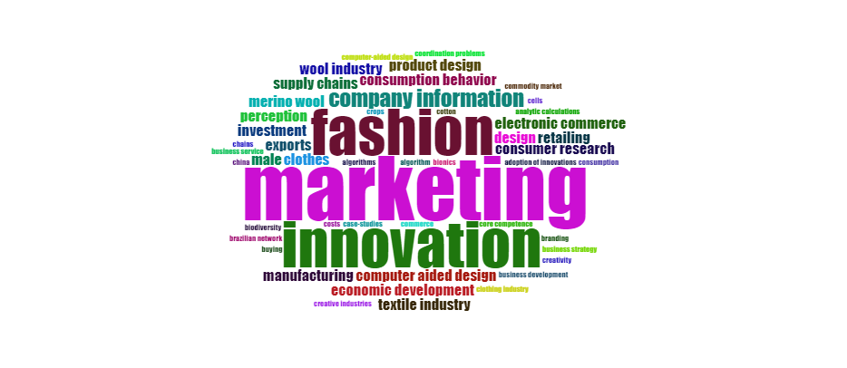
An esoteric field of marketing engrossed on selling fashion items in addition to clothing, accessories and jewellery is called as the fashion marketing and in this marketing many of the fashion marketers work to fabricate divulgate campaign that allures to a target audience and enthral their hearts towards our brand. This marketing especially involves generation of strategic partnerships with designers, influencers, celebrities and retailers to devise awareness for the latest fashion or fashion items. Lots of professionals are being employed as well as strategies are assimilated so, that this market can amplify more every day. This marketing is very crucial marketing as seen as the trendsetters, coming up with the new ideas to market products and services in an ever changing industry. These experts possess a unique understanding of how fashion trends work and how to use them to their advantage. Marketers are in charge of all the latest creativity as well as innovations in their products as well as services that can stand out in the fashion world. Fashion marketing is an extraordinarily broader area which includes everything from fashion design to customer experience and it is an end-to-end process of selling clothing, accessories, foot wears and other fashions. Fashion brands have no choice but to be creative in order to be successful and fashion marketing is becoming more awesome day by day. Fashion is a form of art and for many people the clothes they wear are big section of their identity. So, fashion marketing comes up with the designers that helps in this creation and puts them in front of the right people and these days fashion is at huge level and expected to grow more in coming years shockingly. Many people are gratifying many of the benefits and showing their complimentary response towards this innovation. So, it is assumed that it will expect to rise superbly by 2025 year.

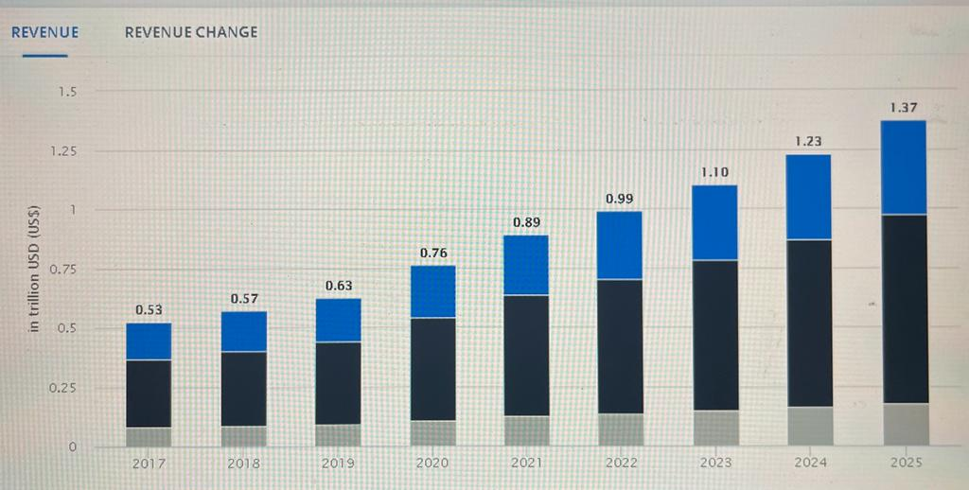
Source: Statista

Latest trends and innovations in Fashion Marketing
1.Artificial Intelligence: In modern era, brands are using AI for ameliorating the shopping experience for their consumers by using chatbots and touchscreens so, that they can also give customized product suggestions. It helps them in analysing data, increasing sales and forecasting the trends. This intelligence uses lots of algorithms for tracking the customers journey for matching them with the right products.
2. Collaborations: This is newest craze in marketing world where people collaborate their work to attract more consumers and to reach new markets. For winning in today’s competitive market you need to work together as this has the calibre to reach at a global level. Various brands are taking the huge advantage of this collaboration to promote their brand and to increase their market share like Nike and off white, H&M and Kari Lagerfeld.
2. Celebrity Endorsements: These days celebrity endorsement is very trending and imperative as this also helps to create awareness of your brand at global level as these celebrities have a good amount of followers and most of the people admire them a lot so, this can became the great opportunity for attracting newer customers towards your brand.
3. News Jacking, fashion marketing trends: This is one of the greatest and latest marketing strategies used by most of the brands to ascendancy trending topics as well as breaking news in such a way which can help them to attract more consumers towards their product. For becoming famous many of the brand ambassadors utilize this technique in today’s market.
4. Live to Stream: A live stream can help a fashion brand reach millions of potential customers in a quick time. With this streaming everyone can easily watch the particular event in real time from their devices. These days, many of the people establish their own official Livestream channels. This can attract
5. Social media: This media is most trending in marketing which provides lots of platforms to various people to promote their brand. Everyone can use their favourite platform to attract their customers by using different features. Moreover, we can easily target our audience and track their interest towards our brand. Various different platforms are Facebook, YouTube, Whatsapp etc.
6. Giveaways, Fashion Marketing Trends: Giveaways helps people in creating brand awareness and growing the customer base. Additionally, through this people generates tons of leads which can further nurtured and cornered into customers. This is the excellent way for fashion marketers to gain new customers for a brand as well as to keep the existing ones. You can also create awareness about the latest products through giveaways.

Methodology
A bibliometric analysis was the main grail of this research through the plan of action of the trend topics and co-occurrence network of innovations in fashion marketing. This investigation helps to scruitnize the group of documents of identical pattern as well as to check the whole scenario. Co-occurrence analysis is the analysis that helps to check the meter of similarity of words or terms that are being used in pairs in a given province and allows them to see the soaring trends in the scientific field. Following method has been followed for this analysis.
The data were collected in a CSV format from the chronicles catalogued in the Scopus database from 2013 to 2023 years by using the forage criteria the operators innovations in fashion and, correlation Marketing. 50 were the selected units for our research and that were analyzed and processed and then BibExcel tool was used to add up the frequency of trending topics and co-occurrence keywords were also analysed. For graphic representation co-occurrence by index keywords was used to especially check the most frequently terms used as well as correlation between those terms.
Data Refinement
Articles Retained
(N= 105)
Data Mapping
Articles identified through keyword search
(N= 285)

Data Included
Articles selected for the analysis
(N=50)
Data Evaluation
Eligible Articles
(N=50)

Data

Analysis and Results

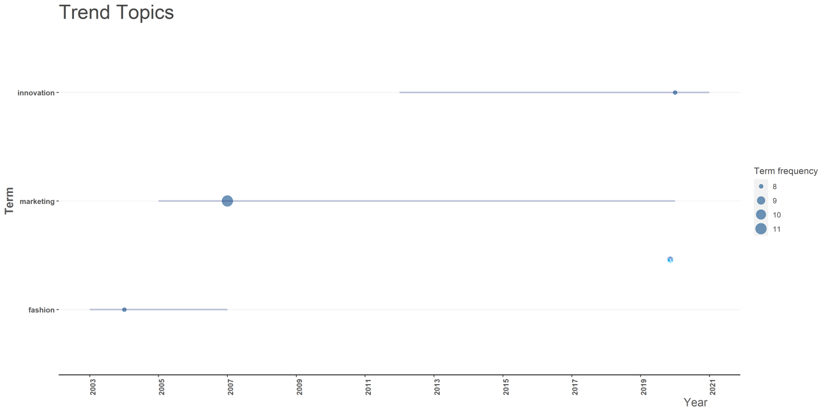
Figure 1

This figure is representing the trend topics of today’s world. On x axis we have 3 terms i.e. fashion, innovation and marketing and on y axis we have years from 2003 to 2021. Fashion is very admired word from the starting itself and this reveals the frequency of 8 from 2003 to 2007 years and with the time this ameliorate and becomes the fashion marketing where latest fashion products and services reaching to their customers and lots of strategies were used to promote the products as well as the brands and fashion shows the frequency 11 from 2005 to 2020. By the 21 Century, everything is progressing so, this phrase is also enhancing and coming up with the innovations in fashion marketing and this is the hottest topic which tries to bring the latest things and making marketing more innovative and its frequency is 8 in the year 2021 onwards.

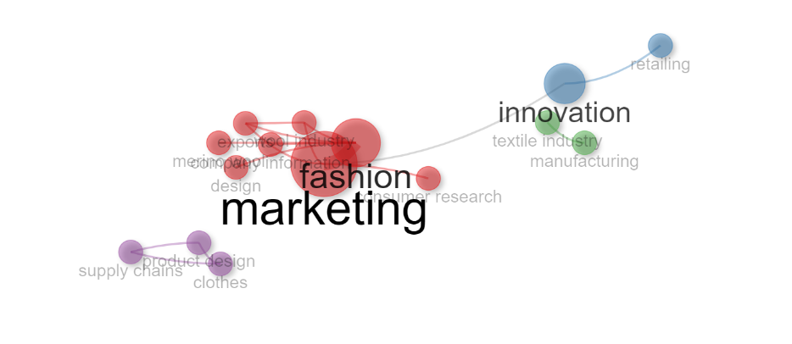
Figure 2
This figure is exposing the different phrases which are directly connected with each other in the field of innovations in fashion marketing and they are represented as the clusters. Mainly, there are 4 clusters i.e. purple, red, green and blue. The purple cluster is explaining the relation between clothes, design of products and the way of supply. Means how a particular product is manufactured and reaches to their customers as it is very necessary. Green clusters is shows the relation of manufacturing and textile industry. Blue cluster represents the innovations in retailing and red clusters is one of the broad clusters which expose the relation between many of the things like marketing, fashion, consumer reach, designs, exports, wool industry and company information. All terms are correlated with each other and lead to enhance the fashion marketing day by day.

Conclusion
The 21 century is full of innovations and many more great things and this wide-ranging phrase fashion marketing is also evolving swiftly with covering extensive range of brands from thrifty to luxurious. They all target their audience and try to enthralled their hearts towards their brand or product. Fashion marketing is the lucrative branch of the fashion industry because it comes up with the creations and visions of the designer to life. For influencing and connecting their targeted customers they use various strategies trends and approached and all these are performed in a virtuous way so that it helps in lending huge profits as well as growth of their enterprise. For a designer, it is vital to be successful and set good trends for themselves as this helps in ameliorating the goodwill of the business. In this marketing, we are required to stay on top of consumer trends, find the best one among all, and strategically apply them for future marketing efforts. People having creative minds bring more innovations in designing and differentiating the styles and types of fabrics in a greater way as it is an art of designing and giving natural beauty to clothing and its accessories according to the customers. Customized products always make customers more happy and more satisfied with a particular brand. Through bibliometric analysis we can sum up that fashion marketing is a broader area that includes many of the styles, trends, fabrics, and marketers who work with different departments and in various ways to get things done in the right way. In fashion, there is a need to work with visual merchandisers to present the products in a specific way as well as to ensure all the buyers that the correct products are available for sale.

