Effect of Maha-Mrityunjay Mantra and Yogic Breathing on Mindfulness of University Students

Dissertation
For the Degree of Master of Science in YOGA
Dept Of Yogic Art and Science
By
Mr. Apu Chakma
Guided by
Ms. Parichiti Saha, Assistant Professor

Department of Yogic Art & Science
Vinaya Bhavana
Visva-Bharati
(A Central University of National Importance)
Santiniketan -731235, West Bengal, India

ACKNOWLEDGEMENT
First and foremost I would like to thank to my sentient being for helping, and guiding me throughout my study.
I convey my deep sense of gratitude to Ms. Parichiti Saha, Assistant Professor, for the able guidance in acquainting experimenting experience and completion of the project.
I am greatly indebted to my guide, for the help rendered in the completion of the study.
I express my thanks to all the other staff Members of Yogic Art and Science for providing me timely guidance for the project.
I would like to thank all the Subjects who participated in the study without whom I would not have been able to accomplish my project goals.
I would like to thank all my Batchmates at Department of Yogic Art and Science for their insightful comments, support, and encouragement

Apu Chakma

CERTIFICATE
This is to certify that the project of “EFFECT OF MAHAMRITYUNJAY MANTRA AND YOGIC BREATHING ON MINDFULNESS OF UNIVERSITY STUDENTS” has been carried out by the candidate under my direct supervision and the findings have been checked thoroughly.
I am satisfied with the work of Mr. Apu Chakma and Reg. No: VB-0593 of 2018-19 is submitted to Visva-Bharati, Santiniketan, West Bengal, INDIA.
It is further certified that Mr. Apu Chakma has undergone the prescribed course of studies leading to Masters of Science Degree Examinations in accordance with the university regulations.

Date:
Guide: Ms. Parichiti Saha, Assistant Professor

Transliteration:
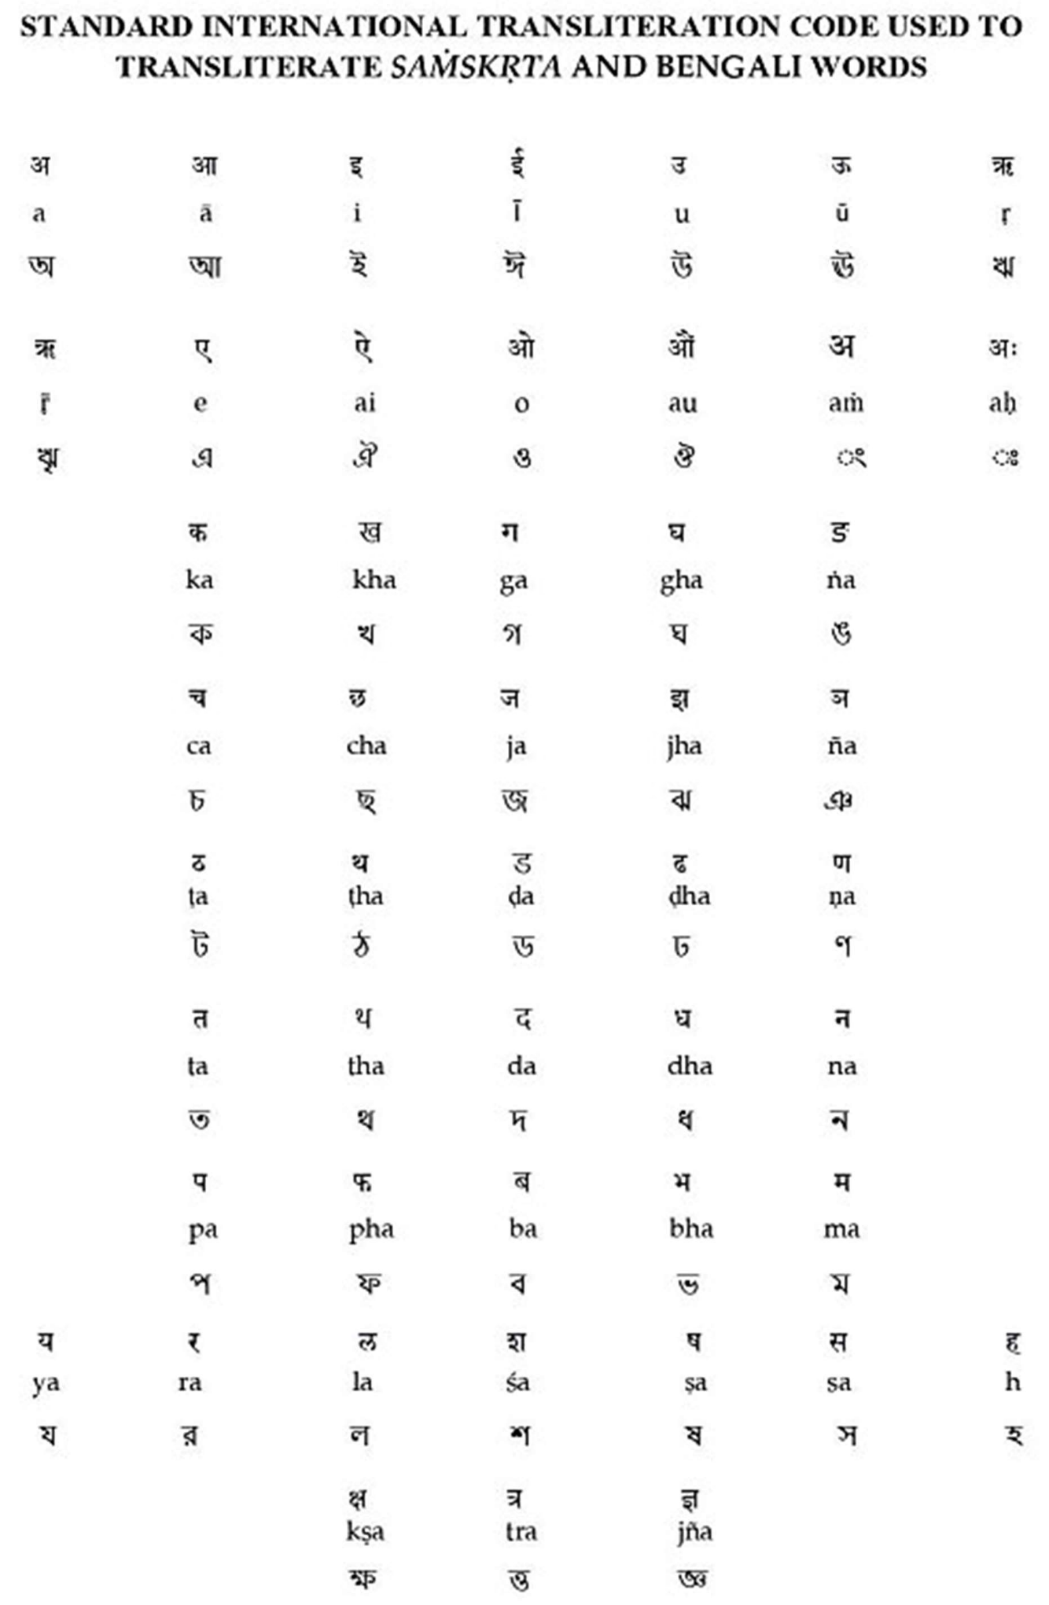

CONTENTS
S.N.O. | TITLE | PAGE NO.
 | Chapter- 1:- Introduction:--------------------------------------  1.2. Mahamrityunjay Mantra:------------------------------------  1.3. Yogic Breathing:----------------------------------------------  1.4. Anatomy of Breathing:---------------------------------------  1.5. Mindfulness:---------------------------------------------------  1.5.1. According to Buddha:-------------------------------  1.5.2. According to Yoga:---------------------------------  1.5.3. According to Jainism:-------------------------------  1.5.4. Benefits of mindfulness:----------------------------  1.6. Role in Life:---------------------------------------------------  1.7. Yogic techniques:---------------------------------------------  1.8. benefits of mantra: -------------------------------------------  1.9. Prana:-----------------------------------------------------------  1.10. Need for the Study:------------------------------------------ | 1-8  1-2  2-3  3-4  5-8  5  6  7  7-8  8  8  8  8  8
 | Chapter-2:- LITERATURE REVIEW:-----------------------  2.1 Ancient Literature Review:-----------------------------------  2.1.1. Mindfulness:-----------------------------------------  2.1.1.1. Bhagavad Gita:------------------------------------  2.1.1.2. Gherand Samhita:---------------------------------  2.1.1.3. Patanjali Yoga Sutras:----------------------------  2.1.2. Dharana:----------------------------------------------  2.1.3. Dhyana:-----------------------------------------------  2.1.4. Samadhi:----------------------------------------------  2.1.5. Samyama:---------------------------------------------  2.1.6.Concept of Prana:------------------------------------  2.1.7. How Prana effects the Mind?----------------------  2.1.8. Maha-Mrityunjay Mantra:--------------------------  2.2 Modern Literature Review:----------------------------------- | 9-14  9-12  9  9  9-10  10  10  11  11-12  12  12  12  12  12-14
 | Chapter-3:- AIM AND OBJECTIVE:------------------------  3.1.1. Aim:---------------------------------------------------  3.1.2. Objectives:--------------------------------------------  Research Question and Hypotheses:--------------------------------  3.2.1. Research Question:----------------------------------  3.2.2 Hypothesis:--------------------------------------------  3.2.2.1. Althernate Hypothesis:------------------  3.2.2.2. Null Hypothesis:-------------------------- | 15  15  15  15  15  15  15  15
 | Chapter-4:- MATERIALS AND METHODS:--------------  4.1. Methodology:--------------------------------------------------  4.1.1. Sample:------------------------------------------------  4.2. Sampleing technique:-----------------------------------------  4.3. Inclusion Criteria:---------------------------------------------  4.4. Exclusion Criteria:--------------------------------------------  4.5. Intervention:---------------------------------------------------  4.6. Duration:-------------------------------------------------------  4.7. Assessment tools:---------------------------------------------  4.8. Informed Consent:--------------------------------------------  4.9. Data Analysis:------------------------------------------------- | 16-17  16  16  16  16  16  16  16  16  16  17  17
 | Chapter-5:- RESULTS:----------------------------------------- | 18
 | Chapter-6:- DISCUSSION:------------------------------------ | 19
 | Chapter-7:- CONCLUSSION:--------------------------------- | 20
 | Chapter-8:- APPRAISALS:------------------------------------  8.1. Strength and Limitation:------------------------  8.2. Future Direction:-------------------------------- | 21-22  21  22-22
 | Chapter-9:- REFERENCES:----------------------------------- | 23-24
 | Chapter-10:- ANNEXURE:------------------------------------ | 25-28

ABSTRACT
AIM: The study aimed to investigate the effect of Mahamrityunjay Mantra and Yogic breathing on mindfulness among university students in Bolpur. The objectives were to study the effect of each intervention separately on mindfulness based on the Five Facet Mindfulness Questionnaire (FFMQ).
METHODS: The study used a sample of 34 university students ranged between 18-24 years of age, who were physically healthy and did not have any psychological disorders. The sample was selected using a convenient sampling technique, and the study design was a single group pre-post design.
RESULTS: The results showed a significant positive change in mindfulness scores from before to after the intervention. The mean score for post-FFMQ was higher than the mean score for pre-FFMQ, indicating a positive change in mindfulness scores. The paired samples t-test showed a statistically significant difference between the pre-FFMQ and post-FFMQ scores, with a t-value of -4.032 and a p-value less than 0.001.
CONCLUSIONS: The results indicate that the 1 month intervention of Mahamrityunjay Mantra and Yogic breathing had a significant positive effect on the mindfulness of university students.
KEYWORDS:Mahamrityunjay mantra, Yogic breathing, Mindfulness, Five Facet Mindfulness Questionnaire (FFMQ)

Chapter-1:- Introduction

1. Introduction:
Mindfulness comprises two core components: awareness and acceptance. It involves directing attention to inner processes and present experiences. Acceptance entails observing and embracing thoughts without judgment or avoidance. (1)(Kabat-Zinn, 2013)
A defining perspective on mindfulness is introduced almost incidentally by Kabat-Zinn in his 1994 work "Wherever You Go, There You Are": mindfulness is "paying attention in a certain way on purpose, in the present moment and non-judgmentally." (2)(Creswell, 2017) This practice involves open, active awareness of thoughts, feelings, bodily sensations, and the surroundings, without judgment or distraction. Mindfulness means being curious, accepting, and open to the present, detached from past ruminations or future concerns.
Mindfulness yields a host of benefits for mental and physical health. Extensively studied and practiced, it reduces stress, anxiety, and depression, while enhancing overall well-being. (3)(Kwee, 1995) An essential aspect is its non-judgmental approach, enabling practitioners to observe thoughts and sensations without reactivity. This accepting attitude aids in managing challenging emotions.
Remaining focused on the present moment is another critical facet. By engaging fully in the here and now, mindfulness counters the inclination to dwell on past events or future worries. This fosters clarity, creativity, productivity, and deeper connections with self and others.
Mindfulness is a potent tool for mental and physical health, accessible through meditation, yoga, and conscious breathing. Consistent practice cultivates mindfulness in daily life, fostering tranquility, joy, and fulfillment. (4)(Carlson, 2012)
- 1.2. Mahamrityunjay Mantra:
The Mahamrityunjay mantra makes its initial appearance in Rigveda 7.59.12, a composite hymn attributed to Vasiṣṭha Maitrāvaruṇ. The concluding four verses, containing the Mahamrityunjay Mantra, are later additions to the hymn and pertain to the Sākamedha, a culminating four-month ritual. This ritual concludes with an invocation to Rudra Tryambaka, hence the final quartet of stanzas is directed towards Tryambaka. (5)(Mantras Words of Power by Swami Sivananda Radha, n.d.) The Mahamrityunjaya Mantra is a powerful
Sanskrit chant believed to offer divine protection and healing. Maha Mrityunjaya Mantra is also known as Triyambakam Mantra. Here is the Mahamrityunjaya Mantra in Sanskrit:
ॐ त्र्यम्बकं यजामहे सुगन्धिं पुष्टिवर्धनम् । उर्वारुकमिव बन्धनान्मृत्योर्मुक्षीय माऽमृतात् ॥
And here is the English translation of the mantra: "We worship the three-eyed (Lord Shiva) who perfumes and nourishes all beings; may He free us from death for immortality, as a cucumber is split without effort. The Mahamrityunjaya Mantra is believed to have the power to expel negative energies and promote physical, mental and emotional well-being. It is often chanted during meditation or during times of physical or mental stress. Mantra is also considered a powerful tool for spiritual transformation and awakening.
- 1.3. Yogic Breathing:
Sectional or yogic breathing is a type of breathing that involves focusing on specific parts of the body while breathing. It is an excellent way to develop greater awareness and control over the breath, as well as to bring more oxygen to specific parts of the body. This type of breathing is commonly used in yoga classes and meditation practices, and can be practiced on its own or as part of a larger yoga practice.
The practice of sectional or yogic breathing involves a series of deep inhales and exhales, with each inhale focusing on a specific area of the body. The areas commonly focused on in this practice include the abdomen, chest, and collarbones. As you breathe in, you focus on expanding each area of the body, and as you exhale, you focus on contracting each area. (6)(S-VYASA, 2000)
The first step in practicing sectional or yogic breathing is to find a comfortable seated position with your back straight and your feet on the ground. Once you're comfortable, begin by taking a few deep breaths, inhaling deeply through your nose and exhaling fully through your mouth. This helps to calm the mind and prepare the body for the practice of yogic breathing.
Next, you can begin to focus on the specific areas of the body. Start with the abdomen, inhaling deeply and feeling your belly expand outward as you inhale, and then contract inward as you exhale. This type of breathing is known as abdominal breathing or diaphragmatic breathing, and can help to increase lung capacity and improve digestion.
After focusing on the abdomen, move on to the chest. Inhale deeply and feel your chest expand outward as you inhale, and then contract inward as you exhale. This type of breathing can help to improve respiratory function and increase oxygen intake.
Finally, focus on the collarbones. Inhale deeply and feel your collarbones rise upward as you inhale, and then lower as you exhale. This type of breathing can help to improve posture and increase oxygenation to the upper chest.
Repeat this sequence a few times, focusing on each area of the body with each inhalation and exhalation. As you practice, you may find that you're able to breathe more deeply and fully, which can help to calm the mind and reduce stress. (7)(G & B. N., 2013)
In conclusion, sectional or yogic breathing is a powerful tool for developing greater awareness and control over the breath. It can help to increase lung capacity, improve respiratory function, and reduce stress and anxiety. By incorporating this practice into your daily routine, you can experience the many benefits of yogic breathing and improve your overall health and wellbeing.
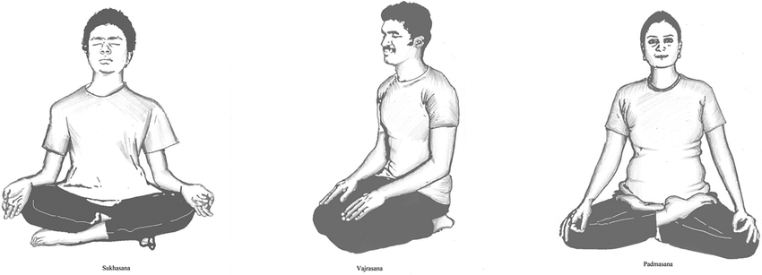
Figure-1
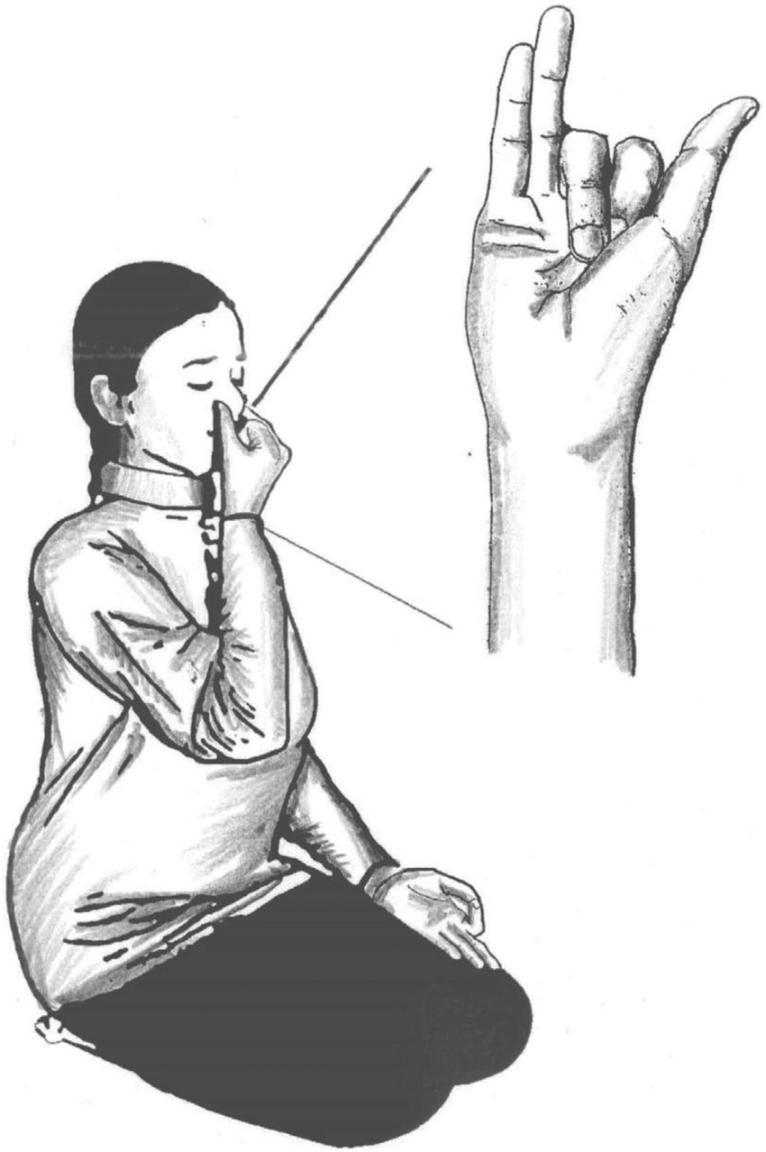
Figure-2

- 1.4. Anatomy of Breathing:
The anatomy of respiration encompasses vital structures facilitating gas exchange: nasal cavity, pharynx, larynx, trachea, bronchi. Pharynx links nasal cavity, mouth to larynx. Lungs, cone-shaped chest organs, shielded by ribcage. Diaphragm, dome muscle under lungs, crucial for breathing. Its contraction lowers pressure, drawing air in; relaxation raises pressure, expelling air. Chest muscles between ribs expand/contract chest, altering cavity volume. Respiration involves airways, lungs, diaphragm, intercostals, enabling gas exchange. Complex coordination of muscles, nerves, organs. Diaphragm flattens during contraction, raising chest volume, drawing air. Intercostals expand chest. Lungs expand/contract due to pressure changes. Inhaling: chest volume up, lung pressure down, air flows in. Exhaling: chest volume down, lung pressure up, air flows out. Respiratory center in brain stem regulates, aided by chemoreceptors detecting oxygen, CO2, pH levels. (8)(Loukas et al., 2010)
In summary, the biomechanics of breathing involves the coordinated action of the diaphragm, intercostal muscles, lungs and brainstem respiratory center to create a pressure gradient that allows air to flow in and out of the lungs.

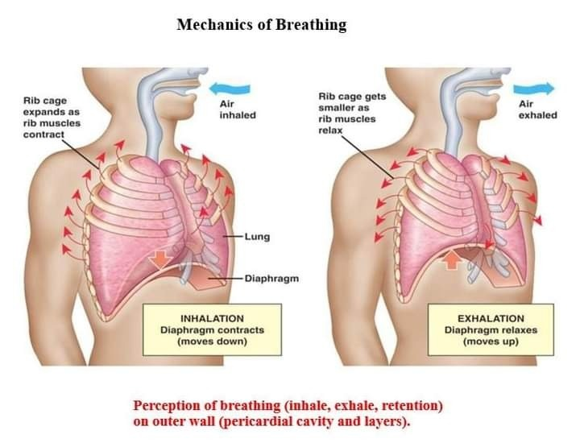

Figure-3

  - Mindfulness:

- 1.5.1. According to Buddha:
Mindfulness is a central aspect of Buddhist teachings and is an integral part of the Four Noble Truths and the Eightfold Path, which are considered the foundation of Buddhist practice. According to the Buddha, mindfulness involves being fully present and aware of one's thoughts, feelings, bodily sensations, and the surrounding environment in a non-judgmental and accepting way.

In Buddhist teachings, mindfulness is considered an essential tool for achieving liberation from suffering and attaining enlightenment. By cultivating awareness and acceptance of one's experiences, practitioners can develop insight into the impermanence and interconnectedness of all things, and ultimately come to understand the true nature of reality.

The Buddha taught that mindfulness can be practiced in a variety of ways, including through formal meditation, as well as through daily activities such as walking, eating, and working. He emphasized the importance of bringing mindfulness to all aspects of one's life, not just during formal practice.

Overall, the Buddha saw mindfulness as a key component of spiritual practice, and as a means of developing wisdom, compassion, and inner peace. His teachings on mindfulness continue to inspire and guide practitioners around the world today.(9)(Hart, 1987)

Figure-4

- 1.5.2. According to Yoga:
In the practice of yoga, mindfulness is known as "sati," which is derived from the Pali language and is often translated as "awareness" or "mindfulness." Similar to Buddhist teachings, yoga also emphasizes the importance of being fully present and aware of one's thoughts, feelings, bodily sensations, and surroundings. Which is a spiritual and physical practice that originated in ancient India. In yoga, mindfulness is referred to as "dharana," which is one of the eight limbs of yoga outlined in the Yoga Sutras of Patanjali.
Mindfulness is a fundamental aspect of yoga practice, and is often referred to as "mindful movement" or "mindful yoga". In yoga, mindfulness involves being fully present and aware of one's thoughts, feelings, bodily sensations, and breath, while moving through a series of physical postures (asanas) and practicing breathing exercises (pranayama).

Yoga teaches that mindfulness is a key to achieving a state of inner peace and balance, and is an essential part of the path towards self-realization and enlightenment. By cultivating awareness and presence in the present moment, practitioners can develop a deeper connection with themselves and their surroundings, and ultimately experience a greater sense of joy, contentment, and fulfillment.

In yoga, mindfulness is also seen as a means of promoting physical health and well-being. By paying close attention to the body and breath during practice, practitioners can improve their posture, flexibility, and strength, as well as reduce stress, anxiety, and other physical and mental ailments.

Overall, mindfulness is a core principle of yoga practice, and is seen as a powerful tool for achieving greater self-awareness, inner peace, and overall health and well-being.(10)(Vivekananda, 2021)

Figure-5

- 1.5.3. According to Jainism:
Mindfulness, or "samyak smriti," is an important aspect of Jainism, an ancient Indian religion that emphasizes non-violence, compassion, and spiritual purity. According to Jain teachings, mindfulness involves being fully present and aware of one's thoughts, feelings, and actions in the present moment, without attachment or aversion.

Jainism teaches that the ultimate goal of life is to achieve spiritual liberation, or "moksha," through the cultivation of right knowledge, right faith, and right conduct. Mindfulness is considered a key component of right conduct, as it helps individuals to live in accordance with Jain principles and to avoid actions that cause harm to themselves or others.

Jain mindfulness practice involves self-reflection, introspection, and meditation, and encourages practitioners to observe their thoughts and emotions without judgment or attachment. By cultivating mindfulness, practitioners can develop greater self-awareness and compassion, and can become more attuned to the interconnectedness of all living beings.

Jainism also emphasizes the importance of mindfulness in daily life, and encourages practitioners to cultivate mindfulness in all aspects of their lives, including work, social interactions, and personal relationships. By living mindfully, individuals can develop greater inner peace, happiness, and fulfillment, and can contribute to a more peaceful and harmonious world. (11)(Meditation_and_jainism_032325_hr6.Pdf, n.d.)

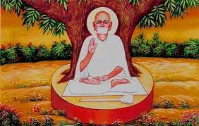
Figure-6

- 1.5.4. Benefits of mindfulness:
"While a wealth of evidence connects trait mindfulness and mindfulness training to a wide array of effects, the underlying active mechanisms remain relatively unexplored. Mindfulness is conventionally defined as (1) the continuous monitoring of present-moment experiences (2) coupled with an attitude of acceptance. Drawing upon conceptual, clinical, and empirical insights, we present a coherent and testable theoretical framework aimed at elucidating the impact of mindfulness on cognition, emotions, stress, and overall health. This framework, termed Monitor and Acceptance Theory (MAT), proposes that (1) heightened awareness of one's experiences enhances cognitive function, as attention monitoring skill fosters positive cognitive outcomes, yet this same skill can intensify emotional reactivity. Moreover (2), through altering one's relationship with monitored experiences, acceptance becomes instrumental in dampening emotional reactivity. Consequently, the combined proficiency in attention monitoring and acceptance elucidates how mindfulness ameliorates negative affect, stress, and stress-related health conditions. We explore MAT's contribution to the field of mindfulness science, suggest potential alternative explanations, and provide specific predictions for future research endeavors." (12)(Lindsay & Creswell, 2017)

- 1.6. Role in Life:
Numerous studies suggest that mindfulness training correlates with enhanced empathetic inclinations across various facets. (13)(De la Fuente-Anuncibay et al., 2019) Consequently, engaging in mindfulness practices brings about cognitive alterations within diverse aspects such as observation, description, and conscious action. This shift reverberates within the cognitive realm of the mindfulness construct. (14)(De la Fuente-Anuncibay et al., 2019) Research involving therapists has found that those who incorporate meditation exhibit higher empathy scores compared to non-practitioners.
- 1.7. Yogic techniques:
A mantra is a fusion of sacred syllables, composing a nucleus of spiritual potency. Unlike prayer, which involves chosen supplication words, a mantra constitutes a precise fusion of sounds and words, encapsulating a distinct form of consciousness or Sakti. The term's root, "man," in Sanskrit signifies "to think," while "tra" is derived from "trai," connoting "to safeguard or liberate from the confines of samsara or the material world." Thus, mantra signifies "the liberating and protective thought." However, manifold layers of meaning coexist within its essence. (15)(Mantras Words of Power by Swami Sivananda Radha, n.d.)(Roy et al., 2018)

- 1.8. benefits of mantra:
Chanting or reciting Mantras initiates and expedites the rise of the creative spiritual energy, fostering harmony across all aspects of the individual. The practitioner undergoes a gradual transformation into a dynamic hub of spiritual resonance, synchronized with a far more potent focal point of vibration. This energy can be harnessed and guided for the betterment of both the practitioner and others. (16) (Mantras Words of Power by Swami Sivananda Radha, n.d.)
- 1.9. Prana:
Prana, in its literal sense, means "to breathe forth." It arises from the prefix "pra," signifying "to bring forth," and the verb "an," denoting "to breathe" or simply "to live." Prana represents a subtle energy that permeates every nook and cranny of the universe. While we cannot directly see or touch it, especially as beginners in the realm of breath, we can indirectly engage with it through one of its most evident physical expressions and significant conduits: our breath. As Lama Govinda eloquently states in "Foundations of Tibetan Mysticism," "As long as there is breath, there is life. We can go without all conscious functions of the mind and the senses for a comparatively long time. Breathing stands foremost among the bodily functions of prana." (17) (Suparyanto dan Rosad (2015, 2020)

- 1.10. Need for the Study:
There are no related study found in anywhere that’s why this study is needed to find the Effect of Maha-Mrityunjay Mantra and Yogic Breathing on Mindfulness of University students.

Chapter-2:-Literature Review
2.1. Ancient Literature:
- 2.1.1. Mindfulness:
Awareness involves the capacity to direct attention towards one's internal processes and present experiences. Acceptance entails the skill of observing and embracing these streams of thoughts without judgment or avoidance. (18) (19)(Hatha Yoga Pradipika: Chapter II. On Prâṇâyâma, n.d.; Marga, n.d.; Sivananda, 1972; Swami, 1921; Vivekananda, 2021)
- 2.1.1.1. Bhagavad Gita:
The Bhagavad Gita discusses various philosophical concepts, including mindfulness. Mindfulness is referred to in the Bhagavad Gita as "sama" or "equanimity."
Chapter 2, verse 48: "Carry out your responsibilities with equanimity, Arjuna, letting go of all attachment to success or failure. This state of balanced composure is known as yoga."
Chapter 6, verse 18: "When through the practice of yoga, the yogi regulates their mental processes and attains a state of transcendence, free from all material cravings, they are said to have achieved true yoga."
Chapter 6, verse 26: "Whenever and wherever the mind wanders, driven by its restless and wavering nature, one must diligently reclaim it, drawing it back under the dominion of self-control."
Chapter 12, verse 13: "A devotee dear to Me is one who harbors no envy, extends kindness to all beings, renounces proprietorship and false pride, maintains equanimity amidst joy and sorrow, practices tolerance, remains content, exercises self-control, and unwaveringly dedicates themselves to devotional service with resolute determination. Such a devotee, with their mind and intellect focused on Me, holds a special place in My heart." (20)(Sivananda, 1972)

The Bhagavad Gita emphasizes the importance of cultivating a calm, focused, and equanimous mind through the practice of yoga and meditation. This state of mind allows one to perform one's duties without becoming attached to the outcome, and to see all living beings with kindness and compassion.
- 2.1.1.2. Gherand Samhita:
The Gheranda Samhita is a traditional Sanskrit text on Hatha Yoga that describes various practices and techniques for physical and spiritual purification. Mindfulness is referred to in the Gheranda Samhita as "samyama" or "samyama yoga."
Chapter 1, verse 2: "Yoga is the control of the mind-stuff. It is of two kinds, abhyasa (practice) and vairagya (non-attachment)."
Chapter 3, verse 3: "When the mind becomes free from attachment to external objects, it becomes fit for concentration."
Chapter 4, verse 4: "Sit in a comfortable posture with the spine straight, close the eyes and withdraw the mind from external objects. Fix it on any object or idea, and keep it there without any distraction."
Chapter 7, verse 31: "The yogi should practice samyama on the elements, the senses, the mind, the ego, and the intellect. By this practice, he attains the state of supreme consciousness."
(21)(Gheraṇḍa & Niranjanananda Saraswati, 2012)
The Gheranda Samhita emphasizes the importance of controlling the mind through the practice of yoga, and cultivating a state of mindfulness through the withdrawal of the senses from external objects. The practice of samyama, or concentrated meditation, is seen as a means of attaining higher states of consciousness and spiritual realization.
- 2.1.1.3. Patanjali Yoga Sutras:
The Patanjali Yoga Sutras is a classical text on yoga and meditation, composed by the sage Patanjali. Mindfulness is referred to in the Yoga Sutras as "smriti" or "awareness."
Sutra 1/2: "Yogas citta-vritti-nirodhah" - "Yoga is the restraint of the modifications of the mind-stuff."
Sutra 1/12: "Abhyasa vairagyabhyam tannirodhah" - "These mental modifications are restrained by practice and non-attachment."
Sutra 2/53: "Dharanasu ca yogyata manasah" - "By practice of concentration, the mind becomes fit for the attainment of steadiness."
Sutra 3/2: "Tada drastuh svarupe avasthanam" - "Then the seer (the true self) abides in its own nature." (22)(Vivekananda, 2021)
The Yoga Sutras emphasize the importance of controlling the mind through the practice of yoga and meditation, and cultivating a state of mindfulness through concentration and non-attachment. The attainment of a steady, focused mind is seen as a means of realizing the true self and attaining spiritual liberation.
- 2.1.2. Dharana:
||देशबन्धश्चित्तस्यधारणा|| (PYS 3/1)
Concentration is binding the mind to one place.
- 2.1.3. Dhyana:
||तत्रप्रत्ययैकतानताध्यानम्|| (PYS 3/2)
Uninterrupted stream of the content of consciousness is dhyana.

||शुचौदेशेप्रतिष्ठाप्यस्थिरमासनमात्मनःनात्युच्छ्रितंनातिनीचंचैलाजिनकुशोत्तरम्|| (B.G. 6/11)
Having firmly arranged a clean seat composed of sacred kusha grass, a deerskin, and a cloth – layered in sequence (kusha at the bottom, deerskin in the middle, and cloth on top) – at a moderate height, neither too high nor too low;
||तत्रैकाग्रंमनःकृत्वायतचित्तेन्द्रियक्रियःउपविश्यासनेयुञ्ज्याद्योगमात्मविसुद्धये||(B.G. 6/12)
Taking that position, focusing the mind, and mastering the activities of both mind and senses, the practitioner should engage in Yoga to achieve self-purification.
||समंकायसिरोग्रीवम्धारयन्नचालंस्थिरः| सम्प्रेक्ष्यनासिकाग्रंस्वंदिशश्चानवलोकयन्|| (B.G. 6/13)
Keeping the trunk, head, and neck aligned in a straight and steady posture, maintaining unwavering stability, and directing the gaze solely towards the tip of the nose, refraining from wandering in other directions.
||प्रशान्तात्माविगतभीर्ब्रह्मचारिव्रतेस्थितःमनःसंयम्यमच्चित्तोयुक्तआसीतमत्परः|| (B.G. 6/14)
Abiding unwaveringly in the vow of absolute chastity and free from fear, the Yogi should maintain perfect tranquility, with the mind under control and focused on Me. In this vigilant state, the Yogi should sit absorbed in my presence.
- 2.1.4. Samadhi:
||तदेवार्थमात्रनिर्भासंस्वरूपशून्यमिवसमाधिः|| (PYS 3/3)
That state becomes Samadhi when there is only the object appearing without the consciousness of one’s own self.
||सुषुम्नावाहिनिप्राणेसिद्ध्यत्येवमनोन्मनीअन्यथात्वितराभ्यासाःप्रयासायैवयोगिनाम्|| (HYP.4/20)
When prana flows within the sushumna, the state of manonmani (consciousness devoid of mind) becomes established. Consequently, other forced practices prove to be arduous for the yogi.
||पुरस्ताच्चैवपूर्येतनिशिचताखेचरीअभ्यस्ताखेचरीमुद्राप्युन्मनीसंप्रजायते|| (HYP.4/47)
The sushumna fully occupying the rear portion of the upper palate is also known as khechari. The practice of khechari mudra is followed by the state of unmani, which is consciousness devoid of the mind.

2.1.5. Samyama:

||त्रयमेकत्रसंयमः|| (HYP. 3/4)
The three (dharana, dhyana, and samadhi) together constitute samyama.

- 2.1.6.Concept of Prana:
||आदित्योहवैप्राणोरयिरेवचन्द्रमारयिर्वाएतत्सर्वंयन्मूर्तंचतस्मान्मूर्तिरेवरयिः|| (P.U. 1/5)
The sun is prana (life) and the moon is food (matter). All that which possesses form (like earth, water and fire) or lacks form (like air and ether) is food. Therefore, all form is rayi, food, indeed.
||अथादित्यउदयन्यत्प्राचींदिशंप्रविशतितेनप्राच्यान्प्रानान्रश्मिषुसंनिधत्ते; यद्दक्षिणांयत्प्रतीचींयदुदीचींयदधोयदूर्ध्वंयदन्तरादिशोयत्सर्वंप्रकाशयतितेनसर्वांप्राणांरश्मिषुसंनिधत्ते|| (P.U. 1/6)
When the su n rises in the east, he sends out life-giving rays to all creatures there. Similarly, in the northern, southern, western, upper and lower regions, he fills all creatures with his energy. Thus all creatures depend on him for life.

- 2.1.7. How Prana effects the Mind?
||चलेबातेचलंचित्तंनिशचलेनिशचलंभवेत्; योगीस्थाणुत्वमाप्नोतिततोवायुंनिरोधयेत्|| (H.Y.P.)
As prana flows, chitta (the mental force) flows. When prana is still, chitta is still. Through this (prana's steadiness), the yogi achieves stability, thus restraining the vayu (air).
- 2.1.8. MahaMrityunjay Mantra:
||ॐ त्र्यम्बकं यजामहे सुगन्धिं पुष्टिवर्धनम् उर्वारुकमिव बन्धनन्मृतोर्मुक्षिय मामृतात्|| (Rigveda. 7/59)
We revere the three-eyed One, fragrant and nurturing all. Just as a fruit separates from its stem's grasp, may we break free from mortality, from the clutches of death.

3.2. Modern Literature:
Mindfulness has been the subject of numerous studies and literature reviews in recent years. Here are some highlights from a selection of modern literature reviews on mindfulness:
  - Mindfulness-based interventions for physical conditions: A 2019 narrative review assessed 50 studies on mindfulness interventions for chronic pain, cardiovascular disease, and cancer. It concluded that such interventions effectively reduced symptoms and enhanced quality of life, with a moderate to high level of evidence supporting their use. (23)(Carlson, 2012)
  - Mindfulness-Based Stress Reduction and Mindfulness-Based Cognitive Therapy: A 2017 review evaluated Mindfulness-Based Stress Reduction (MBSR) and Mindfulness-Based Cognitive Therapy (MBCT) for mental health. Both were found effective in alleviating anxiety, depression, and stress, backed by strong evidence. (24) PMID: 25689576.
  - Mindfulness-based interventions for mental well-being among people with multiple sclerosis: A 2020 systematic review revealed mindfulness interventions' positive impact on mental well-being, depression, anxiety symptoms, and quality of life in individuals with multiple sclerosis. (25)(Simpson et al., 2019)
  - Mindfulness Meditation and the Experience of Positive Emotions: A 2018 review highlighted increased positive emotions resulting from mindfulness meditation, particularly with consistent practice over time. (26)(Williams, B, 2019)
  - Mindfulness-Based Interventions: A 2017 meta-analysis of 206 studies showcased their effectiveness in reducing depression and anxiety symptoms while improving physical health outcomes, such as blood pressure and pain. (27)(Marino et al., 2021)
  - The Potential of Mindfulness in Supporting Adolescents' Healthy Development: A 2019 review indicated potential benefits of mindfulness interventions for adolescents, including improved emotional regulation, self-esteem, and social relationships. (28)(Sibinga et al., 2016)
  - Mindfulness interventions for chronic pain: A 2017 systematic review of 38 studies found that mindfulness-based interventions might effectively reduce pain intensity and improve quality of life in those with chronic pain. (29) PMID: 21265650
  - Mindfulness-Based Stress Reduction for Military Veterans: A 2018 systematic review of 10 studies revealed potential efficacy in reducing symptoms of post-traumatic stress disorder (PTSD) and depression in military veterans. (30)(Marchand et al., 2021)
  - The construct validity of the Five Facet Mindfulness Questionnaire in meditating and non-meditating samples: A 2012 study verified the FFMQ's reliability in measuring distinct facets of mindfulness in both meditating and non-meditating groups. (31)(Baer et al., 2008)
  - Mindfulness-Based Interventions for Health: A 2016 systematic review encompassing 68 studies demonstrated the efficacy of mindfulness-based interventions, measured by the FFMQ, in reducing anxiety and depression symptoms, improving emotional regulation, and enhancing physical health outcomes, including blood pressure. (32)(Gotink et al., 2015)
  - Mindfulness and Cognitive Functioning: A Systematic Review - This 2014 systematic review of 30 studies found that mindfulness, as measured by the FFMQ, was positively associated with cognitive functioning, including attention, working memory, and executive function. (34)(Whitfield et al., 2022)
Overall, these reviews and many others suggest that mindfulness is a promising intervention for improving physical and mental health outcomes, reducing symptoms of stress, anxiety, and depression, and promoting overall well-being.

Chapter-3:- Aim and Objective
3.1. Aim and Objective:
- 3.1.1. Aim:
To investigate the Effect of Maha-mrityunjay Mantra and Yogic breathing on mindfulness of university students.
- 3.1.2. Objectives:
- To study the effect of Maha-mrityunjay Mantra on mindfulness of university students based on Five Facet Mindfuness Questionairre(FFMQ).
- To study the effect of Yogic breathing on mindfulness of university students based on Five Facet Mindfuness Questionairre(FFMQ).
3.2. Research Question and Hypotheses:
- 3.2.1. Research Question:
- Does Maha-Mrityunjay mantra improves mindfulness among university students?
- Does Yogic Breathing improves mindfulness among university students?
- 3.2.2 Hypothesis:
- 3.2.2.1. Althernate Hypothesis:
Maha-Mrityunjay mantra and Yogic Breathing improved mindfulness among the university students.
- 3.2.2.2. Null Hypothesis:
The null hypothesis is rejected and the results suggest that there is a real difference between the mean scores before and after practicing Maha-Mrityunjay mantra and Yogic Breathing among the university students.

Chapter-4:-Materials and Methods
4.1. Methodology:
4.1.1. Sample
- 4.1.1.1. Source of the subject: Bolpur
- 4.1.1.2. Sample size: 34
4.2. Sampleing technique: convenient Sampling technique
- 4.2.1. Study Design: convenient Sampling technique
4.3. Inclusion Criteria:
- Age ranged from 18-24 years.
- Both male and female.
- Experience with mindfulness: Depending on the purpose of the study, participants may be required to have prior experience with mindfulness techniques, such as meditation or yoga.
- Mental health status: The study may require participants to have a certain mental health status, such as being free of any psychiatric disorders or having a diagnosed mental health condition.
- Physical health status: Participants may be required to be in good physical health and not have any chronic illnesses or disabilities that could interfere with their ability to practice mindfulness.
4.4. Exclusion Criteria:
- History of severe mental illness: Participants with a history of severe mental illnesses such as schizophrenia, bipolar disorder, or borderline personality disorder may be excluded from the study.
- Substance abuse: Participants with a history of substance abuse or dependence may be excluded from the study.
- Trauma: Participants who have experienced recent traumatic events or who have a history of trauma may be excluded from the study.
- Medical conditions: Participants with medical conditions that could affect their ability to participate in the study or that could affect their ability to practice mindfulness may be excluded.
- Medications: Participants taking certain medications that could affect their ability to practice mindfulness may be excluded from the study.
4.5. Intervention: Mahamrityunjay Mantra and Yogic breathing.
4.6. Duration: 1 month.
4.7. Assessment tools: Five Facet Mindfulness Questionairre(FFMQ).
4.8. Informed Consent: Informed consent has been collected from the participants and their anonymity and confidentiality has been maintained. They were free to withdraw themselves at any time from the study.
4.9. Data Analysis: Data has been analyzed using JASP software and the p-value has been set to 0.05.
Chapter-5:- Result
Descriptive Statistics
 |  | Pre FFMQ |  | Post FFMQ
Valid |  | 34 |  | 34
Missing |  | 0 |  | 0
Mean |  | 2.888 |  | 3.106
Std. Deviation |  | 0.351 |  | 0.290
Shapiro-Wilk |  | 0.952 |  | 0.988
P-value of Shapiro-Wilk |  | 0.140 |  | 0.963
Minimum |  | 2.200 |  | 2.460
Maximum |  | 3.410 |  | 3.850

Table: 5.1
Looking at the means and standard deviations, we can see that the post-FFMQ mean score (3.106) is higher than the pre-FFMQ mean score (2.888), indicating a positive change in mindfulness scores. The standard deviation of the post-FFMQ scores (0.290) is smaller than the pre-FFMQ scores (0.351), indicating less variability in post-FFMQ scores compared to pre-FFMQ scores.
Paired Samples T-Test
Measure 1 |  |  |  | Measure 2 |  | t |  | df |  | P
Pre FFMQ |  | - |  | Post FFMQ |  | -4.032 |  | 33 |  | < .001
Note. Student's t-test.

Table: 5.2
The paired samples t-test in (Figure-4.2) shows a significant difference between the pre-FFMQ and post-FFMQ scores, with a t-value of (-4.032) and a p-value less than (0.001).

Chapter-6:- Discussion

Based on the table, we can see that there are 34 valid data points for both the pre-FFMQ and post-FFMQ measures, indicating that there are no missing data.
Looking at the means and standard deviations, we can see that the post-FFMQ mean score (3.106) is higher than the pre-FFMQ mean score (2.888), indicating a positive change in mindfulness scores. The standard deviation of the post-FFMQ scores (0.290) is smaller than the pre-FFMQ scores (0.351), indicating less variability in post-FFMQ scores compared to pre-FFMQ scores.
The Shapiro-Wilk test serves as a normality test, where its p-value reflects the likelihood of obtaining the observed outcome under the assumption of normal data distribution. In both the pre-FFMQ and post-FFMQ measurements, the Shapiro-Wilk test (Figure-4.1) yields p-values exceeding 0.05, indicating insufficient grounds to reject the null hypothesis of normality. It's crucial to recognize the relatively small sample size, potentially constraining the test's power.
In contrast, the paired samples t-test (Figure-4.2) demonstrates a noteworthy disparity between pre-FFMQ and post-FFMQ scores. The t-value of -4.032, coupled with a p-value below 0.001, suggests a statistically significant discrepancy. This signifies that the mean scores of pre-FFMQ and post-FFMQ are indeed different. The negative t-value indicates that post-FFMQ mean scores surpass those of pre-FFMQ, aligning with the descriptive statistics' findings.
Overall, these results suggest that there was a significant positive change in mindfulness scores from before to after the Maha-Mrityunjay Mantra and Yogic Breathing intervention on mindfulness, as measured by the FFMQ.

Chapter-7:- Conclussion

Based on the table of descriptive statistics and the paired samples t-test provided, we can conclude that there was a significant positive change in mindfulness scores from before to after. After Maha-Mrityunjay Mantra and Yogic Breathing intervention, as measured by the FFMQ. The mean score for post-FFMQ (3.106) was higher than the mean score for pre-FFMQ (2.888), indicating a positive change in mindfulness scores. The paired samples t-test unveiled a statistically significant distinction between the pre-FFMQ and post-FFMQ scores, evidenced by a t-value of -4.032 and a p-value below 0.001. Nevertheless, it's crucial to acknowledge that these outcomes stem from a relatively limited sample size, warranting cautious interpretation. To establish the reliability of these findings, additional research incorporating larger sample sizes would be imperative.

Chapter-8:- Appraisals

- 8.1. Strength and Limitation:

Strengths:
- The use of the FFMQ as a measure of mindfulness is a well-established and widely used instrument, which increases the reliability and validity of the results.
- The paired samples t-test used in the analysis is an appropriate statistical test to compare the means of two related groups.
- The Shapiro-Wilk test was used to assess normality of the data, which is an important assumption for the t-test.
- The results showed a statistically significant positive change in mindfulness scores, which suggests that the Maha-Mrityunjay Mantra and Yogic Breathing intervention was effective in improving mindfulness.

Limitations:
- The sample size was relatively small, which may limit the generalizability of the results to other populations.
- The study used a pre-post design without a control group, which limits the ability to draw causal conclusions about the effectiveness of the mindfulness intervention.
- The study relied on self-reported measures of mindfulness, which may be subject to bias and social desirability effects.
- The study did not account for potential confounding variables, such as prior experience with mindfulness practices or personality traits, which may have influenced the results.
- The study only measured short-term effects of Maha-Mrityunjay Mantra and Yogic Breathing intervention on mindfulness and did not assess the long-term sustainability of the improvements in mindfulness scores.

- 8.2. Future Direction:

Based on the strengths and limitations of the current study, there are several potential future directions for research:

- Larger Sample Size: Future studies could include a larger sample size to increase the generalizability of the results and to increase the power of the statistical analyses.

- Randomized Controlled Trials: Future studies could use randomized controlled trials with a control group to assess the effectiveness of Maha-Mrityunjay Mantra and Yogic Breathing intervention on mindfulness and to control for potential confounding variables.

- Long-Term Follow-Up: Future studies could assess the long-term effects of Maha-Mrityunjay Mantra and Yogic Breathing intervention by conducting follow-up assessments after several months or years.

- Objective Measures: Future studies could use objective measures of mindfulness, such as physiological measures or behavioral tasks, to supplement self-report measures and to reduce potential bias and social desirability effects.

- Subgroup Analysis: Future studies could conduct subgroup analysis to examine the effects of the Maha-Mrityunjay Mantra and Yogic Breathing intervention on mindfulness on different populations, such as individuals with specific mental health conditions or different demographic groups.

- Comparison of Maha-Mrityunjay Mantra and Yogic Breathing Interventions: Future studies could compare the effects of different types of interventions, such as mindfulness-based stress reduction (MBSR) or mindfulness-based cognitive therapy (MBCT), to determine which interventions are most effective for specific populations or outcomes.

Chapter-9
REFERENCES
- Baer, R. A., Smith, G. T., Lykins, E., Button, D., Krietemeyer, J., Sauer, S., Walsh, E., Duggan, D., & Williams, J. M. G. (2008). Construct validity of the five facet mindfulness questionnaire in meditating and nonmeditating samples. Assessment, 15(3), 329–342. https://doi.org/10.1177/1073191107313003
- Carlson, L. E. (2012). Mindfulness-Based Interventions for Physical Conditions: A Narrative Review Evaluating Levels of Evidence. ISRN Psychiatry, 2012, 1–21. https://doi.org/10.5402/2012/651583
- Creswell, J. D. (2017). Mindfulness Interventions. Annual Review of Psychology, 68, 491–516. https://doi.org/10.1146/ANNUREV-PSYCH-042716-051139
- De la Fuente-Anuncibay, R., González-Barbadillo, Á., González-Bernal, J., Cubo, E., & PizarroRuiz, J. P. (2019). Mediating effect of mindfulness cognition on the development of empathy in a university context. PLoS ONE, 14(4). https://doi.org/10.1371/JOURNAL.PONE.0215569
- G, S., & B. N., R. (2013). Effect of Deep Breathing on Respiratory Parameters in Healthy Young Individuals. Journal of Evolution of Medical and Dental Sciences, 2(19), 3305–3312. https://doi.org/10.14260/jemds/698
- Gheraṇḍa, & Niranjanananda Saraswati, S. (2012). Gheranda Samhita. 620.
- Gotink, R. A., Chu, P., Busschbach, J. J. V., Benson, H., Fricchione, G. L., & Hunink, M. G. M. (2015). Standardised mindfulness-based interventions in healthcare: An overview of systematic reviews and meta-analyses of RCTs. PLoS ONE, 10(4), 1–17. https://doi.org/10.1371/journal.pone.0124344
- Hart, W. (1987). The art of living : Vipassana meditation as taught by S.N. Goenka.
- Hatha Yoga Pradipika: Chapter II. On Prâṇâyâma. (n.d.). Retrieved August 22, 2021, from https://www.sacred-texts.com/hin/hyp/hyp04.htm
- Kabat-Zinn, J. (2013). Full Catastrophe Living - PDFDrive.com.
- Kwee, M. (1995). Wherever you go, there you are: Mindfulness meditation in everyday life. Behaviour Research and Therapy, 33(8), 996. https://doi.org/10.1016/0005-7967(95)90133-7
- Lindsay, E. K., & Creswell, J. D. (2017). Mechanisms of Mindfulness Training: Monitor and Acceptance Theory (MAT). Clinical Psychology Review, 51, 48. https://doi.org/10.1016/J.CPR.2016.10.011
- Loukas, M., Lanteri, A., Ferrauiola, J., Tubbs, R. S., Maharaja, G., Shoja, M. M., Yadav, A., & Rao, V. C. (2010). Anatomy in ancient India: A focus on the Susruta Samhita. Journal of Anatomy, 217(6), 646–650. https://doi.org/10.1111/j.1469-7580.2010.01294.x
- mantras words of power by Swami Sivananda Radha. (n.d.). https://www.ptonline.com/articles/how-to-get-better-mfi-results
- Marchand, W. R., Sandoval, K., Lackner, R., Parker, S. C., Herrmann, T., Yabko, B., Velasquez, T., Lewis, L., & Butler, J. (2021). Mindfulness-based interventions for military veterans: A systematic review and analysis of the literature. Complementary Therapies in Clinical Practice, 42(August 2020), 101274. https://doi.org/10.1016/j.ctcp.2020.101274
- Marga, P. (n.d.). English Translation with Original Text in Devanagari and Notes by Editor : The Astrological Magazine.
- Marino, F., Failla, C., Carrozza, C., Ciminata, M., Chilà, P., Minutoli, R., Genovese, S., Puglisi, A., Arnao, A. A., Tartarisco, G., Corpina, F., Gangemi, S., Ruta, L., Cerasa, A., Vagni, D., & Pioggia, G. (2021). Mindfulness-based interventions for physical and psychological wellbeing in cardiovascular diseases: A systematic review and meta-analysis. Brain Sciences, 11(6), 1–18. https://doi.org/10.3390/brainsci11060727
- meditation_and_jainism_032325_hr6.pdf. (n.d.).
- Roy, B., Chatterjee, S., & Mondal, S. (2018). Yoga and Vyayama: Traditional mind-body technique of ancient india. International Journal of Yoga, Physiotherapy and Physical Education, 3(2), 208–211.
- S-VYASA. (2000). Medical Applications of Yoga. Medical Applications of Yoga, 1–86. http://www.libraryofyoga.com/handle/123456789/903
- Sibinga, E., Copeland-Linder, N., Webb, L., Shields, A., & Perry-Parrish, C. (2016). Improving self-regulation in adolescents: current evidence for the role of mindfulness-based cognitive therapy. Adolescent Health, Medicine and Therapeutics, Volume 7, 101–108. https://doi.org/10.2147/ahmt.s65820
- Simpson, R., Simpson, S., Ramparsad, N., Lawrence, M., Booth, J., & Mercer, S. W. (2019). Mindfulness-based interventions for mental well-being among people with multiple sclerosis: A systematic review and meta-analysis of randomised controlled trials. Journal of Neurology, Neurosurgery and Psychiatry, 90(9), 1051–1058. https://doi.org/10.1136/jnnp-2018-320165
- Sivananda, S. R. I. S. (1972). Bhagavad gita. In World. https://doi.org/10.1093/obo/9780195399318-0010
- Suparyanto dan Rosad (2015. (2020). The Tibetan Yoga of Breath_ Breathing Practices for Healing the Body and Cultivating Wisdom. In Suparyanto dan Rosad (2015 (Vol. 5, Issue 3).
- Swami, S. (1921). Taittiriya Upanishad. 136.
- Vivekananda, S. (2021). Patanjali yoga sutras. Sristhi.
- Whitfield, T., Barnhofer, T., Acabchuk, R., Cohen, A., Lee, M., Schlosser, M., Arenaza-Urquijo, E. M., Böttcher, A., Britton, W., Coll-Padros, N., Collette, F., Chételat, G., Dautricourt, S., Demnitz-King, H., Dumais, T., Klimecki, O., Meiberth, D., Moulinet, I., Müller, T., … Marchant, N. L. (2022). The Effect of Mindfulness-based Programs on Cognitive Function in Adults: A Systematic Review and Meta-analysis. Neuropsychology Review, 32(3), 677–702. https://doi.org/10.1007/s11065-021-09519-y
- williams, B, J. (2019). How mindfulness training promotes positive emotions: Dismantling acceptance skills training in two randomized controlled trials. Physiology & Behavior, 176(3), 139–148. https://doi.org/10.1037/pspa0000134.How

Chapter-10:- Annexure
- 10.1. Consent Form:
Effect of Maha-Mrityunjay Mantra and Yogic Breathing on Mindfulness of University Students
I am doing a study on the Effect of Maha-Mrityunjay Mantra and Yogic Breathing on Mindfulness of University Students for that study I prepare an intervention. For that intervention, need subjects. For that I am giving the approach to you sir.
Exercising my free power of choice, hereby give my consent to be included as a subject in the study entitled “Effect of Maha-Mrityunjay Mantra and Yogic Breathing on Mindfulness of University Students” to help all teaching professionals to understand the current status of the mindfulness and to give the mindfulness related exercises Maha-mrityunjay Mantra and yogic breathing. I have been informed to my satisfaction by my attending researcher the purpose of my enrolment in the study.
I have read the information sheet provided to me and I have also been given full explanation by the researcher about the nature and purpose of the investigative procedures being undertaken.I have been given the freedom to question the attending researcher on all aspects of the study.
Hereby I give consent to the researcher of the study to release the information obtained as a result of my participation in this study to any scientific forum for the betterment of understanding about Body Composition and the associated metabolic profile of teaching professionals in Visva-Bharati University. However, privacy and confidentiality will be maintained. I will retain the right to abstain from further participation in the research at any time. I have been explained and have understood the necessity and the nature of all the investigative procedures.
Thus, having fully understood the procedure and implication of the above study, I agree to participate in the same.

Signature of the patient/Subject:……………………Date:……………………….

I confirm that I have explained the nature and purpose of the above study to

Signature of Investigator…………………………Date………………….
Witness:

- 10.2. FFMQ Questionairre:
