INTELLIGENT DEMAND RESPONSE FOR DOMESTIC LOADS IN SMART GRID

V.Umayal Muthu
Assistant Professor
Department of EEE
Velammal College of Engineering and Technology Madurai, India
uma@vcet.ac.in
Dr.A.Shunmugalatha
Dean (Academics)
Department of EEE
Velammal College of Engineering and Technology Madurai, India
asl@vcet.ac.in

M.Devaki
Assistant Professor
Department of EEE
Velammal College of Engineering and Technology Madurai, India
uma@vcet.ac.in

R.Saranya
Assistant Professor
Department of EEE
Velammal College of Engineering and Technology Madurai, India
asl@vcet.ac.in

ABSTRACT
There is Extreme increase within the demand of electrical energy that has not solely become challenge for its production however additionally it distribution. Thus this rising demand is growing the complexities of power grids by increasing requirement for larger responsibleness, efficiency, security and environmental and energy sustainability considerations. These feature in a very power grid towards smartness that eventually known as a today’s idea of “Smart Grid”. This is a abstract technique during which all good features area unit enforced so as to extend the distribution system of electricity Smart Grids” with its options and its completely different aspects on power distribution business has been presented. it's additionally explained that however these technologies modification and have a lot of potential to evolve and strength the distribution system.

Keywords— Power supply ,demand response for smart grid and peak

INTRODUCTION

Smart Grid has been characterized as associate integrated system which will increase the potency, dependableness and suppleness of the electricity network through a two-way flow of electricity and knowledge. the most purpose is to resolve the height downside by sanctionative period of time communications between the client and also the utility, and to extend power network resilience through the combination of renewable energy sources. Because, the customers favors to tailor their energy consumptions in responding to cost or environmental issues, the height load burden are reduced, and therefore sensible Grid will meet enlarged client demand while not adding dearly-won infrastructure

METHODOLOGY:
Here during this project, we have designed a system that indicates the patron concerning peak times and lean times and encourage him to shift the hundreds to non-peak hours. That successively cut backs the expense because of high capability installations and reduce the overloading issues. This project additionally has the supply of adding little power 21eneration units as and once it needs. Here in our project if the height hour consumption is high, the system itself can check it and cutoff the smallest amount priority hundreds.

BLOCK DIAGRAM:
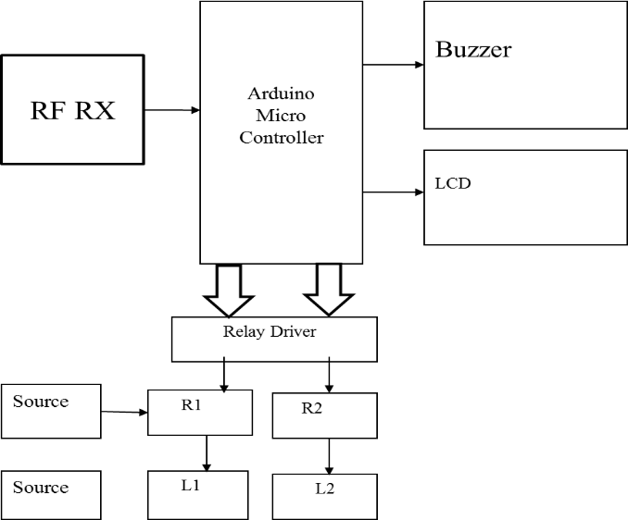
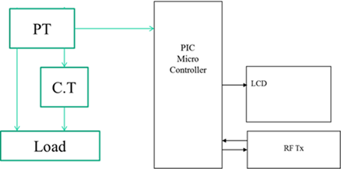

HARDWARE REQUIREMENTS:

- PIC16F877A
The PIC16F family of devices is CMOS (Complementary Metal compound Semiconductor). CMOS technology offers variety of benefits over different technologies. as an example, CMOS circuits consume little power, operate over quite an wide voltage vary and quite forgiving of dangerous layout and electrical noise. The name PIC ab initio observed "Peripheral Interface Controller".
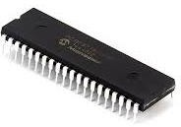

ARDUINO NANO:

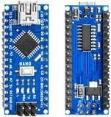
It is tiny low size board and conjointly versatile with a large kind of applications. And it is battery-powered via the Mini- B USB association, 6-20V unregulated external power provide (pin 30), or 5V regulated external power provide (pin 27). the facility supply is mechanically designated to the best voltage supply.

RF TRANSMITTER AND RF RECEIVER

The transmitter/receiver (Tx/Rx) combine operates at a frequency of 433MHz. Associate in Nursing RF transmitter receives serial knowledge and transmits it wirelessly through RF through its antenna connected at pin4. The transmission happens at the speed of 1Kbps -10Kbps. The transmitted knowledge is received by Associate in Nursing RF receiver in operation at a similar frequency as that of the transmitter.
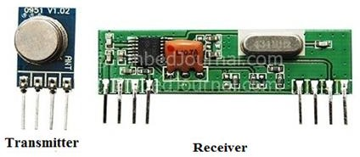

RELAY

A relay is associate degree control that opens and closes in restraint of another circuit. within the original kind, the switch is operated by associate degree magnet to open or shut one or several sets of contacts. it absolutely was fabricated by Henry in 1835. as a result of a relay is in a position to regulate associate degree output circuit of upper power than the input circuit, it are often thought of, in an exceedingly broad sense, to be a style of electrical electronic equipment. These contacts are often either ordinarily Open (NO), ordinarily Closed (NC), or change-over contacts. Normally-open contacts connect the circuit once the relay is activated; the circuit is disconnected once the relay is inactive. it's conjointly referred to as kind A contact or "make" contact.

BUZZER

A buzzer or pager is an audio device, which can be mechanical device, or electricity. Typical uses of buzzers and beepers embrace alarm devices, timers, and confirmation of user input like a click or keystroke. Early devices were supported Associate in Nursing mechanical device system a twin of an electrical bell while not the metal gong. Similarly, a relay is also connected to interrupt its own activating current, inflicting the contacts to buzz. these units were anchored to a wall or ceiling to use it as a sounding board. The word "buzzer" comes from the rasping noise that mechanical device buzzers created.
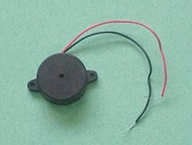

LCD DISPLAY

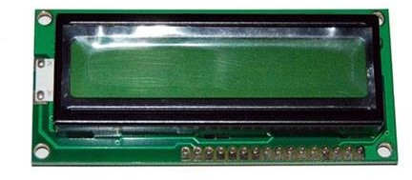
Displays of liquid cells (LCDs) square measure utilized in similar applications wherever LEDs square measure used. These applications show numerical and alphameric characters displayed in matrix and segmental displays.

POWER SUPPLY

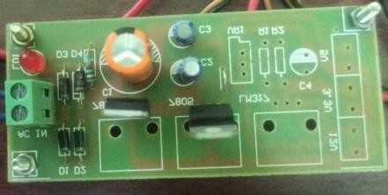
This supply produce selected voltage and cargo current ratings. subsequently may circuit diagram of an influence offer.since we want a relentless low voltage regulated power offer of +5V, providing input voltages to the microcontroller RS232, LM311 and liquid crystal display. LCD digital display alphanumeric display which needs five volts offer

STEP DOWN TRANSFOMER

A step-down transformer has less secondary winding than primary winding .In this project we have used 220 vac stepdown transformer used to convert the electrical output of a power source to match the voltage of our device,
. 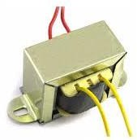

CURRENT TRANSFOMER

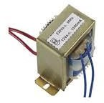
It is used to produce an alternating current in its secondary, which is proportional to the AC current in its primary. This is primarily used when a current or voltage is too high to measure directly.

POTENTIAL TRANSFORMER

It is a voltage transformer that reduces the voltage of a high voltage circuit to a lower level for the aim of measuring. These ar connected across or parallel to the road that is to be monitored
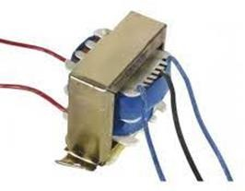

SOFTWARE REQUIRED:

1.SKETCH IDE – ARDUINO & NODE MCU MODULE PROGRAMMING SOFTWARE:
This name implies that Arduino uses for a program. The project's products are distributed as open source hardware and software, which are licensed under the GNU Lesser General Public License or the General Public License (GPL), permitting the manufacture of Arduino boards and software distribution by anyone. The microcontrollers are typically programmed using a dialect of features from the programming languages C and C++
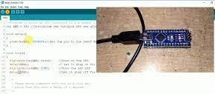

2 MPLAB ICD4

We used circuit debugger /programmer for fastest ,debugging and programming tool for pherpheral interface controller (pic)
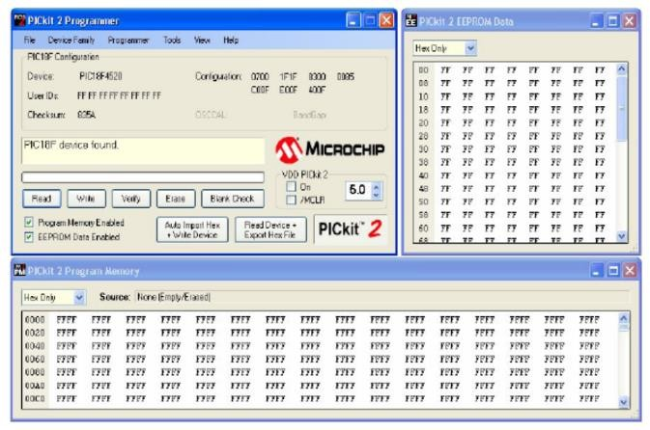

RESULT AND CONCLUSION:
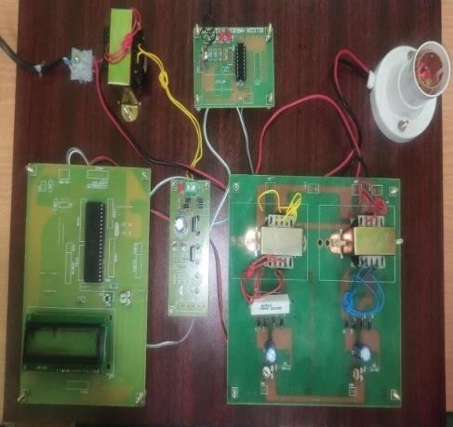
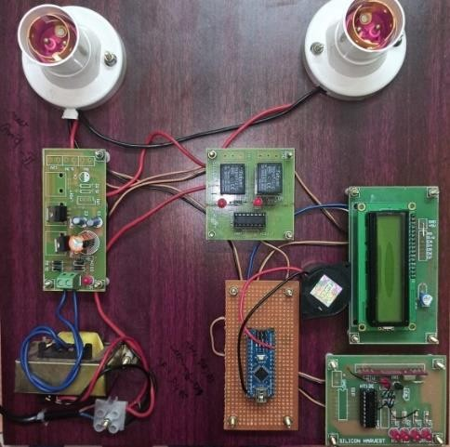
The project good grid based mostly domestic load management has been completed with success and therefore square measure verified. The results square measure in line with the expected output. The project has been checked with each software package and hardware testing tools. during this work current and voltage sensors, RF transmitter and receivers and relay interfaces square measure chosen square measure tried to be a lot of acceptable for the supposed application. The project has enough avenues for future improvement. The project may be a model that fulfills all the logical necessities. The project with smallest enhancements is directly applicable for real time applications. the project contributes a major revolution within the field of power grid automation and any paves a road path towards quicker development s within the same field. The project is any accommodative towards continuous performance and peripheral up gradations. This work is applied to form of industrial and industrial applications.

REFERENCES
[1] D. Gavrila, P. Marchal, and M.-M. Meinecke, "SAVE-U, Deliverable 1-A: Vulnerable Road User Scenario Analysis," technical report, Information Soc. Technology Programme of the EU, 2020.
[2]W. Jones, "Building Safer Cars," IEEE Spectrum, vol. 39, no. 1, pp. 82-85, Jan. 2019.
[3] United Nations—Economic Commission for Europe "Statistics of Road Traffic Accidents in Europe and North America," 2018.
[4] R. Bishop, Intelligent Vehicle Technologies and Trends. Artech House, Inc., 2019.
[5] L. Vlacic, M. Parent, and F. Harashima, Intelligent Vehicle Technologies. Butterworth-Heinemann, 2018.6. T. Heinrich, "Bewertung Von Technischen Maßnahmen zum Fußgängerschutz am Kraftfahrzeug," technical report, Technische Univ. Berlin, 2019.

