AI-Enhanced Drug Discovery and Pharmaceutical Development

Mr. P.J. Ghule*
Department of Pharmaceutics
Mula Rural Institute of Pharmacy, Sonai
Tal – Newasa, Dist – Ahmednagar
Mail ID: prashantpharma07@gmail.com

Mr. P.A. Kale
Department of Pharmaceutical Chemistry
Mula Rural Institute of Pharmacy, Sonai
Tal – Newasa, Dist – Ahmednagar

Ms. S.P. Kale
Department of Pharmaceutical Chemistry
MES, College of Pharmacy, Sonai
Tal – Newasa, Dist – Ahmednagar

Abstract:
Artificial intelligence (AI) has emerged as a powerful tool that leverages human-like information processing to facilitate solutions for complex challenges. Significant advancements in AI and machine intelligence represent a transformative breakthrough in drug discovery, development, and testing of pharmaceuticals and other consumable forms. By employing AI algorithms capable of analyzing vast biological data, including genomics and proteomics, researchers can identify disease-related targets and understand their interactions with potential drug candidates. This enables a more efficient and targeted approach to drug discovery, increasing the likelihood of successful drug approvals. Moreover, AI has the potential to reduce development costs by optimizing research and development processes.
Machine learning algorithms play a crucial role in predictive design, enabling the anticipation of the pharmacokinetics and toxicity of drug candidates. This capability allows for the prioritization and selection of lead compounds, reducing the need for extensive and potentially harmful animal testing. Personalized treatment approaches can also benefit from AI algorithms that analyze patient-specific data, leading to more effective treatment outcomes and improved patient adherence.
This review aims to explore and compare various applications of AI that facilitate automation and enhance productivity in drug development. Specifically, it focuses on novel drug target identification and design, drug repurposing, biomarker discovery, and patient stratification across different disease contexts. Additionally, it will highlight how these technologies are being implemented in clinical settings. This paradigm shift promises to drive further advancements in the integration of AI in automating processes within drug development, ultimately enabling more precise and personalized therapies.

Keywords:artificial intelligence, drug development, drug discovery,QbD,R&D.

The emerging pharmaceutical field:
The pharmaceutical sector has traditionally followed a conservative path, concentrating on the exploration and creation of small-molecule drugs, valued for their reliability, therapeutic effectiveness, and acceptable safety profiles for patients. A fundamental technique in pharmaceutical R&D has revolved around the methodical examination of molecular variations within combinatorial libraries. This method is designed to pinpoint fresh molecules exhibiting advantageous characteristics that can find applications in the realm of healthcare.
However, this traditional approach is facing challenges in meeting the ever-growing demands of the healthcare industry. Several reasons contribute to the limited success of this method in developing new medicines. First, extensive research and exploration of small-molecule drugs have led to the identification of most synthetic alternatives, leaving fewer unexplored candidates for future development. This results in a scarcity of new and promising molecules.
Furthermore, there are already highly stable and effective drugs available for many therapeutic areas, making it challenging for new molecules to surpass the efficacy of existing medications. As a result, the pharmaceutical industry faces an increasingly difficult path through clinical trials, as potential new drugs must demonstrate substantial improvements over well-established treatments to gain regulatory approval.
Another significant factor affecting the viability of this traditional approach is the aggressive competition from generic drug companies. As patents for existing drugs expire, generic manufacturers can produce and sell equivalent versions at lower costs, reducing the profitability of developing new molecules with limited product protection strategies.
As the pharmaceutical landscape continues to evolve, it is essential to explore alternative avenues for drug development. One of the most promising directions is the growing field of bio molecular drugs. Unlike small-molecule drugs, biomolecules are large entities composed of multiple molecular units, such as proteins and nucleic acids. Illustrations of prosperous biomolecular medications encompass insulin and adalimumab (commercialized as Humira), both of which have offered substantial contributions to the biopharmaceutical sector.
However, using biomolecules as pharmaceuticals presents its own challenges. Biomolecules tend to be more labile and often require infusion into the bloodstream for delivery. Additionally, modulating the pharmacokinetics of these drugs is complex due to the limited range of available routes of administration.To address these challenges, drug delivery has emerged as a multidisciplinary field, focusing on the development of innovative methods to deliver pharmaceuticals effectively and efficiently. Nanotechnology, with its ability to interact effectively with the human body and control drug distribution, has been a major focus of drug delivery research [1,2].

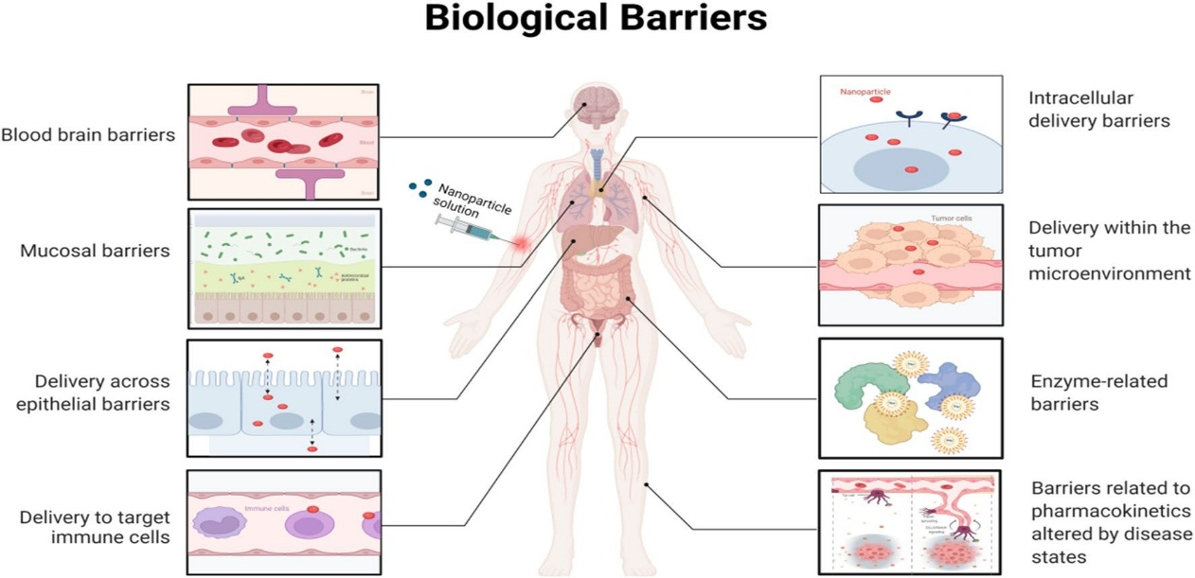

Fig.3Highlightingsomeofthesequentialbiologicalbarriersthatnanoparticles(NPs)mustovercometoachieveprecisiondrugdelivery.Asdiscussedinthisreview,smarterNPdesignsthatoptimizedeliverycansignificantlyimprovetheeffectivenessofprecisionmedicines,hence expeditingtheirclinicaltranslation
Figure 1: Introduction to drug delivery and biological barriers[3]
In this context, artificial intelligence (AI) has displayed significant potential. AI can assist in the design of drug delivery systems and enhance drug development processes. Nevertheless, the complete capability of AI within the pharmaceutical sector has not been fully realized. The incorporation of AI into drug development encounters constraints due to the necessity for ample, standardized datasets to train the algorithms effectively [4, 5].
In summary, the conventional method of creating small-molecule drugs via systematic chemical screening encounters difficulties in offering innovative solutions to the continually evolving healthcare sector.
. As a response, the pharmaceutical field is exploring new directions, such as biomolecular drugs and drug delivery systems, to meet the increasing demands of patients and healthcare providers. The integration of artificial intelligence into pharmaceutical research and development holds great potential to revolutionize drug discovery and improve patient care. [6,7,8]

Drug Delivery and Nanotechnology:
The biotechnology and pharmaceutical sectors have traditionally emphasized the fulfillment of technical prerequisites, including the proficient genetic modification of cells for the large-scale production of high-quality biomolecules. Nevertheless, the mere production of protein and nucleic acid-based medications doesn't guarantee their therapeutic effectiveness. These biomolecules are frequently delicate and susceptible to instability, impacting their biological stability and efficacy as drugs. As an instance, several humanized monoclonal antibody therapies are distributed as either liquid suspensions or lyophilized powders for injection, which restricts opportunities for pharmacokinetic regulation and product life cycle management [9,10].
To address these obstacles, there is an ongoing development of drug delivery systems with the aim of enhancing the stability and effectiveness of biomolecular medications. Drug delivery endeavors to enhance the therapeutic utility of drugs by devising formulations that mitigate natural degradation and enhance their ability to penetrate physical barriers. A key objective is to achieve drug accumulation precisely at the site of action, thereby amplifying the therapeutic impact while minimizing toxicity. Nanotechnology has arisen as a promising strategy for drug delivery systems because it facilitates interactions at both the cellular and subcellular scales, engages in molecular interactions with biomolecules, and evades triggering immune system responses [11,12].

Nano medicine refers to submicron-featured systems that actively benefit from nanofeatures to improve their pharmacokinetics compared to their native form. For example, drug delivery systems can use The utilization of nano-sized colloidal or dimensional characteristics serves as an active means to manipulate the pharmacokinetics of an active pharmaceutical compound (API). Systems such as liposomes employ nano- to micron-sized structures to transport API payloads to the target site or provide distinctive mechanisms of action for the active molecule.
To sum up, drug delivery systems and nanomedicine present opportunities for enhancing the stability, effectiveness, and therapeutic influence of biomolecular drugs. Through the deliberate integration of nanoscale characteristics into pharmaceutical product design, researchers and developers can augment the pharmacokinetics and overall efficacy of treatments, ultimately resulting in enhanced patient outcomes [13, 14].
Quality-by-design R&D
The shift from a trial-and-error method to a quality-driven rational engineering approach, termed Quality by Design (QbD), has played a pivotal role in the progress of drug delivery systems. At the heart of the QbD approach lies the establishment of the Quality Target Product Profile (QTPP), delineating the indispensable attributes necessary for the ultimate product to fulfill its intended function. Within drug delivery systems, the QTPP establishes a linkage between product quality attributes and its mode of action, with the objective of attaining distinct therapeutic outcomes, such as precise drug accumulation in specific tissues[15].

To attain the Quality Target Product Profile (QTPP), critical quality attributes (CQAs) are identified, representing the product characteristics directly associated with the intended therapeutic outcome. Critical process parameters (CPPs) and critical material attributes (CMAs) are described as process parameters and material qualities that exert an influence on the CQAs during the manufacturing process. These parameters and attributes are managed within manufacturing control plans to ensure consistent attainment of the desired product quality[16, 17, 18].

An instance of Quality by Design (QbD) in drug delivery involves enhancing the impact of an anticancer medication like doxorubicin by facilitating its specific buildup within solid tumors. In this context, the Quality Target Product Profile (QTPP) for the delivery system would be the localized drug accumulation at the tumor site, and the Critical Quality Attributes (CQAs) would encompass characteristics such as particle size, charge, and colloidal stability while considering these factors to achieve the desired outcome.
Artificial intelligence (AI) can assume a pivotal role in the Quality by Design (QbD) process. AI has the capacity to handle extensive datasets and offer well-informed predictions to discern the Critical Quality Attributes (CQAs) associated with the desired Quality Target Product Profile (QTPP). AI can collate data from diverse databases to predict precise Absorption, Distribution, Metabolism, and Excretion (ADME) as well as toxicity profiles, crucial elements for ensuring patient safety [19, 20].
Additionally, AI can provide assistance in process engineering and development by investigating the quality of materials and the ranges of production parameters to assess their individual influence on Critical Quality Attributes (CQAs). AI can also contribute to the scaling-up of the manufacturing process, as well as to the characterization and validation processes, enhancing the efficiency and reliability of drug development.
In conclusion, Quality by Design has been instrumental in the advancement of drug delivery systems, and artificial intelligence can further enhance this approach by providing informed predictions, managing large datasets, and supporting process engineering and development. The integration of AI in pharmaceutical development holds great promise for improving the efficiency and effectiveness of drug delivery systems, ultimately benefiting patient care [21, 22].

Artificial intelligence in drug delivery modeling
AI holds the capacity to substantially improve the design of nanosystems for drug delivery by offering advanced insights into the biological milieu and utilizing this understanding to craft efficient drug formulations. While the human body is a intricate system, it can be simplified into compartments separated by biological membranes for the purpose of drug delivery. These membranes function as barriers that drugs must traverse to reach their designated targets [23].
The process of passive diffusion through membranes operates according to physicochemical gradients and is dependent on the molecular characteristics of the drug. On the other hand, active diffusion involves energy-activated cellular systems and complex biological interactions. The design of drug delivery systems using the QbD approach is focused on identifying and leveraging specific transport mechanisms that impact drug pharmacokinetics.
AI can play a significant role in the QbD process by aiding in research, analysis, and modeling of multilayered data related to membrane interactions and drug distribution. It can help in parameterization and simulation, enabling a more systematic evaluation of models. System biology databases can support AI applications by providing solid information for AI training [24, 25].
AI can also aid in assessing the influence of drug delivery systems on drug pharmacokinetics, encompassing factors like deposition and toxicity. For example, AI tools have the capability to amalgamate data from various origins to forecast the efficacy of a drug delivery system tailored to specific APIs. Such predictions can be advantageous for drug repurposing or adjusting drug pharmacokinetics to align with the requirements of individual patients.
Nonetheless, a challenge in implementing AI lies in the accessibility of databases containing uniform information. The deployment of active AI, with the capacity to perceive and validate existing knowledge, has the potential to streamline the accumulation of necessary data for forthcoming AI applications. AI-guided experiments could generate cohesive and meticulously documented databases, thereby facilitating more accurate simulations and offering recommendations for drug delivery systems.
In conclusion, AI can contribute significantly to the rational design of Nano systems for drug delivery. By leveraging its capabilities in data analysis, modeling, and parameterization, AI can aid in the development of effective drug delivery systems that enhance drug pharmacokinetics and target-specific therapeutic effects [26, 27].

Artificial intelligence application in pharmaceutical product R&D:
The research and development (R&D) process in drug delivery can be distilled into two primary phases: the initial phase and the latter phase of R&D.
During the initial stage of R&D, the emphasis lies in translating the initial concept into a design and fabricating a prototype rooted in the theoretical mechanism of action established during the early research phase. The prototype undergoes iterative enhancement through testing, all while adhering to the intended mechanism of action. Modest lab-scale manufacturing procedures are employed to generate small quantities of the product for preliminary assessment. Principal challenges encountered in this stage encompass the intricate product design and ensuring the accurate realization of the prototype through a scalable process. Early substantiation of efficacy and safety holds paramount importance, particularly for novel pharmacological entities and consumer-oriented products [28].

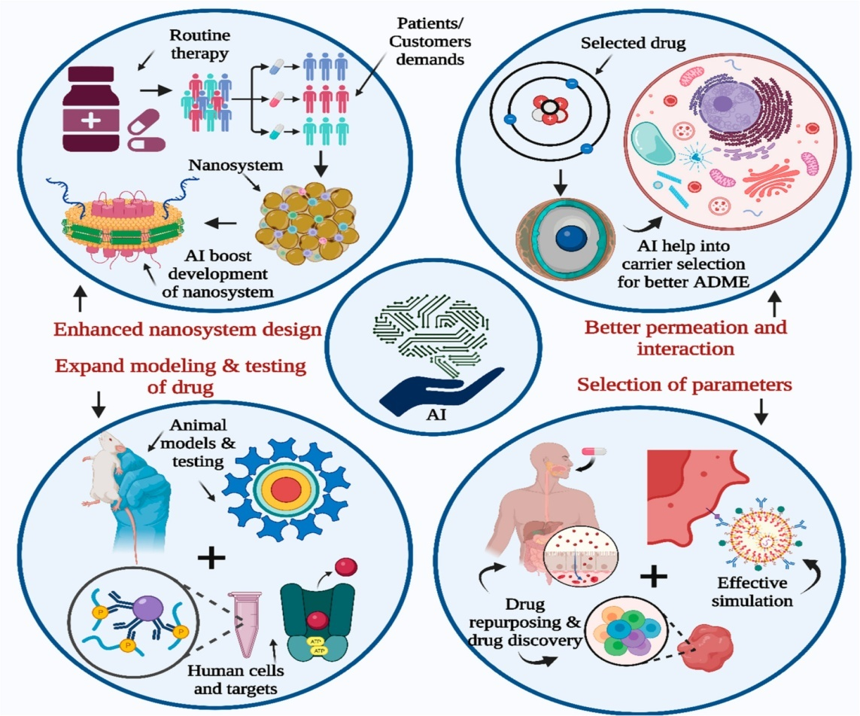
Figure 2: AI contribution to drug development and research. [29]
The late-stage development primarily centers on the reliability of the real manufacturing process and the advancement of scalability. It revolves around the capacity to manufacture growing quantities of the planned pharmaceutical products with specified quality standards. This scalability is critical for unlocking additional testing and developmental prospects. Late-stage development goes beyond the production stage and encompasses the entirety of product life cycle management.
Both phases of R&D are vital for the successful development of drug delivery systems. In the early phase, the emphasis is on designing and creating a prototype that aligns with the intended mechanism of action. It allows researchers to test and refine the product before advancing to larger-scale production. In the late phase, the focus shifts to ensuring the scalability and reliability of the manufacturing process, allowing for large-scale production and successful commercialization of the product. [30,31]
Throughout the entire R&D process, the application of AI can be valuable. AI can aid in data analysis, model development, parameterization, and simulation, enabling a more systematic evaluation of drug delivery systems. By leveraging AI, researchers can accelerate the development of drug delivery systems and improve their efficacy, safety, and scalability. [32]

Artificial intelligence application in prototyping and early development: an example scenario
In the early phase of drug delivery research and development, there are often limitations on the number of administration routes for a given molecular entity, which is determined by the molecule's chemical properties and intended application. In this stage, scientists investigate an extensive array of excipients, devices, and materials to craft the initial prototype of the drug product. Nevertheless, the selection of materials for screening is frequently influenced by the researcher's expertise and the R&D history of the company, potentially resulting in biased choices.

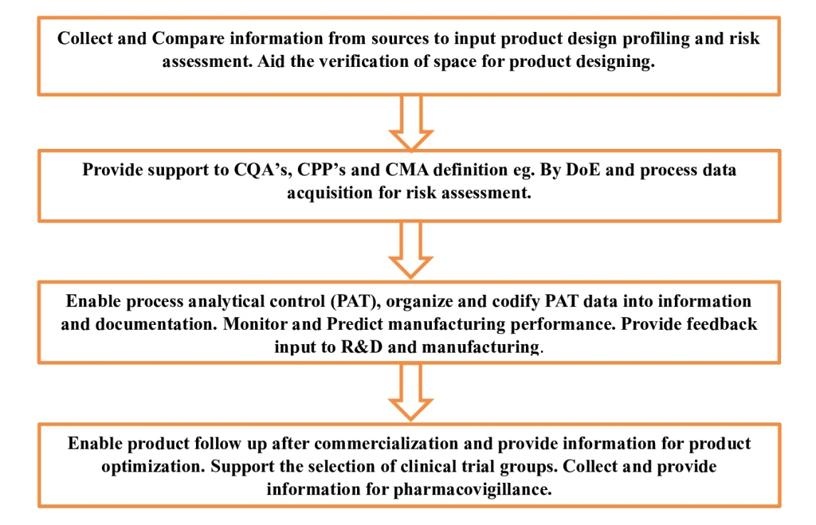
Figure3: Schematic of product development roadmap using quality-by-design approach.

The lack of comparable data and the difficulty in comparing different materials further complicate the decision-making process. Researchers typically rely on their existing knowledge and familiarity with certain excipients and materials, which might not always result in the most optimal formulations. Additionally, considerations for consumer-related preferences are often not fully taken into account at this stage.
In this context, AI can assume a pivotal role by aiding scientists in the selection of optimal excipients and combinations for screenings, as well as in enhancing the prototypes based on the outcomes. Passive AI can harness databases containing information on excipient interactions and molecular stability to furnish systematic recommendations for screenings. Conversely, active AI, exemplified by a robotic arm proficient in mixing and measuring parameters, can execute experimental arrays and assess the consequences of qualitative disparities among materials obtained from diverse suppliers. This not only elevates automation within the laboratory setting but also facilitates the acquisition of exceedingly consistent and comparable data across various projects and departments [33].
For advanced formulations, like Nano formulations or liposomes, AI can help overcome biases and accelerate unbiased technology testing. AI systems can provide evidence-based screening suggestions, explore innovative combinations, and identify knowledge gaps to spur innovation in the R&D pipeline [34].
Moreover, stability assessments are indispensable in the initial stages of development to guarantee the enduring manufacturability, distribution, and utility of the formulated compound. AI, specifically deep learning and neural networks, can be employed to forecast stability across different circumstances, even when extensive long-term stability investigations are constrained by time and resources.
In summary, AI can significantly enhance the early phase of drug delivery research and development by providing data-driven decisions, unbiased material selection, and efficient stability predictions. This enables researchers to make informed choices and accelerates the development of effective drug delivery systems [35].

Artificial intelligence in late-stage development: an example scenario
In the late-stage of pharmaceutical development, where Quality by Design (QbD) principles are applied, a primary objective is to guarantee the product's quality profile remains consistent from clinical testing to ongoing optimization and throughout the product's life cycle management. The nature of this developmental phase may differ depending on the particular product under development. It entails the amalgamation of information from multiple sources, encompassing R&D findings, manufacturing technology, process development, qualification, and quality control. Late-stage development assumes a pivotal role in furnishing the requisite groundwork for clinical trials, ensuring the safety of volunteers, and providing support for regulatory submissions.
Clinical trials are systematically conducted to gather data from substantial cohorts of participants, encompassing healthy individuals in the initial stages and diverse patient groups in later phases and pharmacovigilance. The amassed data undergo analysis and are reported to regulatory authorities to substantiate product submissions. In the early phases, fundamental statistical assessments like equivalence tests involving placebos and reference products are frequently employed to evaluate product efficacy. However, as the trials progress to later stages and incorporate pharmacovigilance, the emphasis shifts toward monitoring interactions and adverse effects.
Manufacturers devote substantial resources to generate pertinent documentation and consistently refine their processes. Regulatory correspondence and revisions represent resource-intensive endeavors for both firms and regulatory bodies. As novel products exhibit increasing heterogeneity, adhering to conventional evaluation norms becomes a challenge for agencies. Consequently, the availability of clear, comprehensive, and meticulously standardized documentation assumes pivotal significance to underpin product submissions. The integration of AI holds the potential to facilitate the collection and organization of information, leading to the creation of reports that align with submission prerequisites. Furthermore, AI stands to support agencies in the efficient processing and analysis of the furnished documentation, potentially reducing the duration of filing and trial procedures.

The incorporation of AI into regulatory procedures has the potential to simplify the organization, translation, and exchange of information between regulatory authorities and submitters. AI-assisted interpretation of scientific and industrial documentation before regulatory panel assessments could enhance the efficiency and cost-effectiveness of the regulatory approval process.
While the full implementation of AI in regulatory processes might require further development and consideration, the idea of using AI to improve information management, documentation, and communication in late-stage pharmaceutical development is promising. It has the potential to enhance regulatory efficiency, reduce barriers, and accelerate product approvals, ultimately benefiting both pharmaceutical companies and regulatory agencies [36].

Artificial intelligence in manufacturing development and control
In conventional manufacturing processes, the importance of standardization and consistency cannot be overstated when it comes to manufacturing batches of materials with clearly defined quality characteristics. The choices made regarding units, materials, and parameters frequently rely on historical experience and established knowledge, resulting in restricted alternatives. For instance, sterile production filtration units typically employ a small set of readily available filters with specified pore sizes and configurations. Likewise, the selection of solvents and plasticizers in granulation or extrusion units predominantly stems from commonly utilized combinations of excipients and reagents [37].
In pharmaceutical manufacturing, incorporating passive AI can offer customized solutions and assistance to technology units and commercial providers. Through the utilization of databases containing chemical and physical characteristics of materials, AI can assist in the identification of the most suitable materials and process units. This, in turn, can yield economic benefits and contribute to the establishment of more resilient manufacturing processes.
In the context of continuous manufacturing, where processes are time-resolved and units are operated simultaneously, AI can play a crucial role in system engineering, process control, and real-time analysis. AI can aid in predicting and optimizing process efficiency, detecting and responding to failures in real-time, and providing online process analytical control technologies. By integrating AI with process analytical technologies, such as UV, NIR, and FTIR, continuous manufacturing can achieve better process control and adaptability [38].

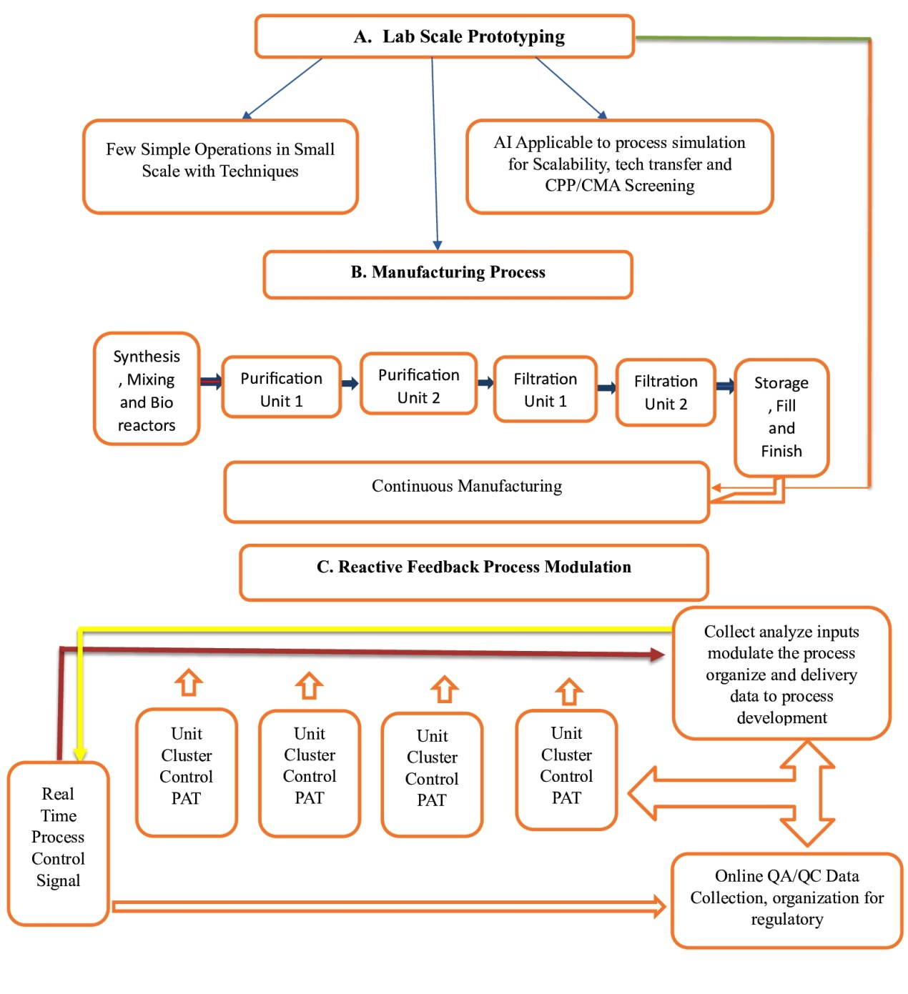
Figure 3: Manufacturing Stages and batch manufacturing

AI has the capacity to facilitate the shift from conventional batch manufacturing to continuous manufacturing by optimizing process parameters, reducing reaction durations, and ensuring the production of high-quality outcomes. An AI system that undergoes training during the process development and validation stages can be harnessed for parameter control within predetermined thresholds, resulting in the implementation of a flexible and adaptable process control approach.
Overall, the application of AI in pharmaceutical manufacturing can lead to more efficient and robust processes, better product quality, and streamlined regulatory submissions. By leveraging AI's capabilities, the pharmaceutical industry can embrace advancements in continuous manufacturing and achieve greater process efficiency and product innovation [39].

Landscape of AI implementation in the drug delivery industry
The integration of AI technology into drug delivery is in its nascent phase, offering substantial room for enhancement. Despite the existence of over 300 indexed products or nearly-commercial technologies in the realm of Nano-based drug delivery systems, the industry's perceived maturity is somewhat deceptive. Innovative drug delivery concepts have seen limited widespread adoption, and there is a noticeable absence of new inventions being disseminated across diverse applications [40].
In the drug delivery sector, numerous innovators are represented by small to medium enterprises, encountering escalating risks while advancing new technologies. The technological readiness levels (TRLs) associated with drug delivery encompass a spectrum ranging from early preclinical prototyping to commercial-scale, high-quality manufacturing. AI can assume a substantial role in risk mitigation during the initial phases of system design and development (TRL 3-6) and in the deployment of intelligent manufacturing processes to enhance process resilience, scalability, and transfer (TRL 4 and beyond) [41, 42].
One of the primary hurdles faced by AI developers in the drug delivery domain is the necessity for highly specialized AI systems designed for particular technological domains. This necessitates the rapid and simplified dissemination of AI platforms that can be employed by individuals with average IT/data proficiency. Customizing AI systems should also be a transparent process, granting control over inherent biases and upholding data security standards, especially for advanced technology enterprises.
Concerning data security, AI developers must confront issues related to the enduring implications of proprietary industrial data within AI systems. The approach of "forgetting" sensitive industrial data after its integration into an AI system must be meticulously administered to guarantee the privacy and security of the data.
To facilitate the adoption of AI in drug delivery, developers need to strike a balance between specialization and generic platforms that allow for customizable development. Creating open platforms with flexible options for customization could encourage wider adoption and collaboration across the drug delivery industry. With the right implementation and advancements, AI has the potential to revolutionize drug delivery and bring about more efficient and innovative solutions to improve patient outcomes [43].

Conclusion: the way forward
In summary, the potential and opportunities offered by the integration of AI in pharmaceutical technology and drug delivery are significant. However, there are reasonable delays in its incorporation within the pharmaceutical sector. The primary non-technical obstacles that impede the broad utilization of AI in this domain include the absence of standardized databases and a conservative regulatory stance toward conventional pharmaceutical manufacturing practices.
Efficiently training AI systems relies on the accumulation and standardization of data, but the pharmaceutical sciences have been less prompt in codifying and standardizing data compared to other scientific domains. Nevertheless, initiatives such as the Pistoia Alliance and efforts by private pharmaceutical entities are demonstrating potential in tackling this challenge.
The cautious regulatory stance, mandating AI systems to be fixed to particular codes post-training, restricts the sustained learning potential of AI in overseeing tasks such as manufacturing and clinical trials. Nevertheless, as Quality by Design (QbD) methodologies gain broader acceptance and with the emergence of the industry 4.0 paradigm, the pharmaceutical sector is experiencing significant changes, rendering it more open to the integration of AI applications [44].
The optimal approach to implementing AI for the pharmaceutical industry's maximum benefit remains uncertain. It may entail employing AI as a straightforward tool to augment robotic functions and enhance efficiency or employing it as a passive instrument for knowledge and data retrieval and organization. While deep learning technology already serves these functions to some extent, its utilization has been impeded by the uneven quality of data generated within the pharmaceutical domain.
An interactive AI system with the capability to explore and actively incorporate necessary knowledge for subsequent applications could offer significant benefits. This could be realized through a basic robotic system proficient in mixing and measuring, which can help fill knowledge gaps in incomplete databases and validate current findings. Embracing such interactive AI solutions has the potential to catalyze more efficient and innovative developments in pharmaceutical technology and drug delivery [45].Top of Form

References:
- Scannell JW, Blanckley A, Boldon H, Warrington B. “Diagnosing the decline in pharmaceutical R&D efficiency.” Nat Rev Drug Discov (2012),11, pp 191-200.
- Munos B. “Lessons from 60 years of pharmaceutical innovation.” Nat Rev Drug Discov 2009,8,pp 959-968.
- Saquib W, Zhibin L, Fangyingnan Z, Anna C, Ubaldo A, and Jun W. Engineering nano-drug biointerface to overcome biological barriers toward precision drug delivery. Journal of Nanobiotechnology (2022), 20, pp 395.
- Troiano G, Nolan J, Parsons D, Van Geen Hoven C, Zale S. “A Quality by Design approach to developing and manufacturing polymeric nanoparticle drug products.” AAPS J (2016), 18,pp 1354-1365.
- Trivedi B. “Quality by design (QbD) in pharmaceuticals.”Int J Pharm PharmSci(2012), 4, pp 17-29.
- Trivedi B. “Quality by design (QbD) in pharmaceuticals.”Int J Pharm PharmSci(2012), 4, pp 17-29.
- Roe R. “Designing the lab of the future: Robert Roe discusses the role of Pistoia Alliance in creating the lab of the future with Pistoia’s Nick Lynch.”SciComput World (2018),pp20-22.
- Lee CKH, Choy KL, Chan YN. “A knowledge-based ingredient formulation system for chemical product development in the personal care industry.”ComputChemEng(2014), 65, pp 40-53.
- Cui Y, Cui P, Chen B, Li S, Guan H. “Monoclonal antibodies: formulations of marketed products and recent advances in novel delivery system.” Drug Dev Ind Pharm (2017), 43, pp 519-530.
- Wong CY, Martinez J, Dass CR. “Oral delivery of insulin for treatment of diabetes: status quo, challenges and opportunities.” J Pharm Pharmacol(2016), 68,pp 1093-1098.
- TuncerDegim I, Celebi N. “Controlled delivery of peptides and proteins.”Curr Pharm Des (2007),13, pp 99-117.
- Rosen H, Abribat “T. The rise and rise of drug delivery.” Nat Rev Drug Discov(2005), 4,pp 381-385.
- Weissig V, Guzman-Villanueva D. “Nanopharmaceuticals (part 2): products in the pipeline.”Int J Nanomed(2015), 10,pp 1245.
- Etheridge ML, et al. “The big picture on nanomedicine: the state of investigational and approved nanomedicine products.”NanomedNanotechnolBiol Med (2013), 9, pp 1-14.
- Trivedi B. Quality by design (QbD) in pharmaceuticals. Int J Pharm PharmSci 2012;4:17-29.
- International Conference of Harmonization (ICH). Pharmaceutical quality system Q8-Q12, ,http://www.ich.org/products/guidelines/quality/article/quality-guidelines.html. [accessed January 2018].
- Troiano G, Nolan J, Parsons D, Van Geen Hoven C, Zale S. A Quality by Design approach to developing and manufacturing polymeric nanoparticle drug products. AAPS J 2016;18:1354-65.
- Rathore AS, Winkle H. Quality by design for biopharmaceuticals. Nat Biotechnol 2009;27:26-34.
- Yu LX. Pharmaceutical quality by design: product and process development, understanding, and control. Pharm Res 2008;25:781-91.
- Hrkach J, et al. Preclinical development and clinical translation of a PSMA-targeted docetaxel nanoparticle with a differentiated pharmacological profile. SciTransl Med 2012;4.
- Huang J, et al. Quality by design case study: an integrated multivariate approach to drug product and process development. Int J Pharm 2009;382:23-32.
- Cheng F, Zhao Z. Machine learning-based prediction of drugdrug interactions by integrating drug phenotypic, therapeutic, chemical, and genomic properties. J Am Med Inform Assoc 2014;21:e278-86.
- Hassanzadeh P, Atyabi F, Dinarvand R. The significance of artificial intelligence in drug delivery system design. Adv Drug Deliv Rev 2019;151152:169-90.
- Rafienia M, Amiri M, Janmaleki M, Sadeghian A. Application of artificial neural networks in controlled drug delivery systems. ApplArtifIntell 2010;24:807-20.
- Cui P, Wang S. Application of microfluidic chip technology in pharmaceutical analysis: a review. J Pharm Anal 2018;9.
- Esch EW, Bahinski A, Huh D. Organs-on-chips at the frontiers of drug discovery. Nat Rev Drug Discov 2015;14:248-60.
- Kim S, et al. Vasculature-on-a-chip for in vitro disease models. Bioengineering 2017;4:8.
- Aksu B, et al. A quality by design approach using artificial intelligence techniques to control the critical quality attributes of ramipril tablets manufactured by wet granulation. Pharm Dev Technol 2013;18:236-45.
- LalitkumarK.Vora et al. Artificial Intelligence in Pharmaceutical Technology and Drug Delivery Design. Pharmaceutics 2023, 15, 1916, 1-46.
- Rathore AS. Roadmap for implementation of quality by design (QbD) for biotechnology products. Trends Biotechnol 2009;27:546-53.
- Xu X, Khan MA, Burgess DJ. A quality by design (QbD) case study on liposomes containing hydrophilic API: I. Formulation, processing design and risk assessment. Int J Pharm 2011;419:52-9.
- Eaton MAW, Levy L, Fontaine OMA. Delivering nanomedicines to patients: a practical guide. NanomedNanotechnolBiol Med 2015;11:983-92.
- Gams M, Horvat M, Ozek M, Lu ˇ ˇstrek M, Gradiˇsek A. Integrating artificial and human intelligence into tablet production process. AAPS PharmSciTech 2014;15:1447-53.
- Rowe RC, Roberts RJ. Artificial intelligence in pharmaceutical product formulation: knowledge-based and expert systems. Pharm Sci Technol Today 1998;1:153-9.
- Khalid MH, Tuszynski PK, Szlek J, Jachowicz R, Mendyk A. From black-box to transparent computational intelligence models: a pharmaceutical case study. Proceedings—2015 13th International Conference on Frontiers of Information Technology (FIT 2015) 2016;114-18.
- Carlson M. The Robotic Reporter. Digit J 2015;3:416-31.
- Kleinebudde P, Khinast J, Rantanen J. Continuous manufacturing of pharmaceuticals. Wiley; 2017.
- Read EK, et al. Process analytical technology (PAT) for biopharmaceutical products: Part I. concepts and applications. BiotechnolBioeng 2010;105:276-84.
- Aksu B, et al. Strategic funding priorities in the pharmaceutical sciences allied to Quality by Design (QbD) and Process Analytical Technology (PAT). Eur J Pharm Sci 2012;47:402-5.
- Venditto VJ, Szoka FC. Cancer nanomedicines: so many papers and so few drugs!. Adv Drug Deliv Rev 2013;65:80-8.
- Eaton MAW, Levy L, Fontaine OMA. Delivering nanomedicines to patients: a practical guide. NanomedNanotechnolBiol Med 2015;11:983-92.
- Department of Defense. Technology Readiness Assessment Deskbook; 2005.
- Ragelle H, Danhier F, Préat V, Langer R, Anderson DG. Nanoparticle-based drug delivery systems: a commercial and regulatory outlook as the field matures. Expert Opin Drug Deliv 2016;1-14.
- Lamberti MJ, et al. A study on the application and use of artificial intelligence to support drug development. Clin Ther 2019;41:1414-26.
- Henstock PV. Artificial intelligence for pharma: time for internal investment. Trends PharmacolSci 2019;40:543-6.

