Title : "Exploring Tumor-Educated Platelets: A Paradigm Shift in Liquid Biopsy and Cancer Insight"
Authors :
Sudhakar.R, Associate Professor, Department of Pathology, NRI Medical College, Chinakakani
Poongodi.R, Assistant Professor, Department of Pathology, AIIMS Mangalagiri
Arundhathi.S, Associate Professor, Department of Pathology, AIIMS Mangalagiri
Prathiba.A, Associate Professor, Department of Pathology, Panimalar Medical College Hospital & Research Institute, Chennai

Introduction:
Tumor-educated platelets (TEPs) are a relatively recent discovery in the field of cancer research, shedding light on the intricate interactions between cancer cells and platelets. TEPs are platelets that have been exposed to tumor-derived signals and factors, resulting in distinct changes in their molecular and functional characteristics. These changes are believed to be a consequence of the crosstalk between cancer cells and platelets, leading to alterations in platelet behaviour, gene expression, and even their RNA profiles.
Liquid biopsies in cancer detection and monitoring:
Traditional tissue biopsies have long been the gold standard for cancer diagnosis and characterization. However, these procedures are highly invasive, can be associated with complications and may not always provide a representative sample of the entire tumor due to heterogeneity. Liquid biopsies offer a less invasive and more comprehensive alternative, enabling the detection of circulating tumor components shed into the bloodstream or other body fluids. Unlike tissue biopsies, which provide a static snapshot, liquid biopsies enable real-time monitoring of disease dynamics and treatment responses. And they have a wide array of applications from early cancer detection, to monitoring treatment response, minimal residual disease detection and therapeutic target identification.
Components of liquid biopsies:
- Circulating Tumor Cells (CTCs):
CTCs are cancer cells detached from primary tumors or metastatic lesions that travel through the bloodstream. They can be isolated as single cells or clusters using immunohistochemical markers (Epithelial cell adhesion for positive selection and common leucocyte antigen marker for negative selection). The half-life of these CTCs ranges between 1 hour to 2.4 hours. CTCs enumeration can predict prognosis and response to therapy. Phenotypic characterization and gene-expression profiling of CTCs offers insight into tumor heterogeneity and treatment markers.
- Exosomes:
Exosomes, small extracellular vesicles, play a role in intercellular molecular information exchange. They are detected in patients with various cancers and correlate with tumor progression, angiogenesis, and metastasis. Exosomes carry molecules, including proteins and nucleic acids, making them relevant biomarkers.
- Circulating Cell-Free DNA (ccfDNA):
Circulating cell-free DNA is derived from the tumor and has a short half-life in blood (114 min). ccfDNA levels correlate with tumor burden, making it valuable for cancer monitoring, detecting recurrence, and assessing treatment response.
- Tumor-Educated Platelets (TEPs):
TEPs are platelets altered by tumor cells, potentially carrying tumor-associated proteins or RNAs. TEPs interaction with tumor cells offers diagnostic and monitoring potential.

Role of platelets in cancer dynamics:
Platelets are anucleate cellular component in bloodstream produced by bone marrow megakaryocytes. They are recognized for their role in hemostasis and clot formation and currently have gained attention for their intricate involvement in various stages of cancer progression. Association of platelet count on progression of different tumor types (Eg:Non-small cell lung carcinoma, Colorectal cancers, Hepatocellular cancers) were extensively studied and was used as an isolated prognostic indicator. Of platelet indices, mean platelet volume (MPV) was extensively studied and was found to have significant correlation with tumour growth even before platelet count alteration. Emerging evidence suggests that platelets play a multifaceted role in tumor growth, angiogenesis, metastasis, and immune evasion

- Platelet Activation and Tumor Interaction:
Platelets are activated upon encountering tumor cells or components of the tumor microenvironment, leading to the release of growth factors (VEGF, PDGF), chemokines, and cytokines that foster tumor progression. Tumor cells can directly activate platelets through interactions with specific receptors, such as podoplanin, present on tumor cells and platelets. This activation promotes platelet aggregation, secretion, and the formation of platelet-tumor cell complexes.

- Tumor Angiogenesis:
Platelets contribute to tumor angiogenesis, a critical process for tumor growth and metastasis. Platelet-derived growth factors (PDGF) and vascular endothelial growth factor (VEGF) released upon platelet activation stimulate endothelial cell proliferation, vessel formation, and vascular permeability, facilitating the delivery of nutrients to the tumor.

- Metastasis Promotion:
Platelets aid in the metastatic cascade by supporting tumor cell intravasation, survival in circulation, and extravasation into target organs. Platelet-tumor cell interactions shield tumor cells from immune surveillance, as platelets cloak tumor cells, preventing recognition and elimination by immune cells. Moreover, platelets facilitate the adhesion of tumor cells to endothelial cells, promoting their arrest in the microvasculature of distant organs.

d) Immunomodulation and Immune Evasion:
Platelets contribute to immune evasion by fostering an immunosuppressive tumor microenvironment. They release factors that inhibit natural killer (NK) cells and cytotoxic T lymphocytes, impairing their antitumor activity. Platelet-derived transforming growth factor-beta (TGF-β) promotes regulatory T cell (Treg) differentiation, which further suppresses the immune response against tumors.

- Tumor-platelet crosstalk:
Being an anucleate cell, transcription process is completely absent in platelets however they are rich in RNA molecules and proteins. RNA molecules present within platelets are pre-messenger RNA, messenger RNA, ribosomal RNA, transfer RNA, microRNA, long non-coding RNA and circular RNA that are either inherited from megakaryocytes or absorbed from blood. Proteins present in platelets are of two categories: group of proteins that are produced by RNA machinery or acquired from megakaryocytes (Eg:Platelet factor 4) and proteins that are absorbed from blood (Eg:P-selectin). Platelets have the ability to directly interact with tumor cells, ingest circulating mRNA released by tumors, and even undergo specific splice events in response to signals from cancer cells and the tumor microenvironment. These changes sometimes happen in megakaryocytes in bone marrow which pass on to their platelet progeny. Platelets that directly absorb tumor proteins/RNA, undergo splicing following tumor protein/RNA uptake or produced from tumor educated megakaryocytes are all called “Tumor-educated platelets”. For unknown reasons, these changes do not hamper routine platelet functions. Similarly, no studies have ever documented sequestration of circulating tumor DNA by platelets.

Tumor-educated platelets in solid malignancies:
At the proteomic level, studies have shown significantly increased levels of VEGF and PDGF in TEPs compared to healthy controls in cases of colorectal cancers, head and neck cancers and pancreatic cancers. Tumor specific expression at molecular level is expressed in both coding and non-coding RNA sequences. Platelets are rich in RNAs inherited from megakaryocytes and sequestered from blood. Analysis of platelet RNA sequences using high-throughput methods have identified atleast one third of entire human gene transcripts in platelets. Platelets with such RNA rich repertoire would be a potential candidate for pancancer and individual cancer biomarker detection. Fig 1 illustrates the RNA transcripts in TEPs that are upregulated and downregulated in different cancer types.
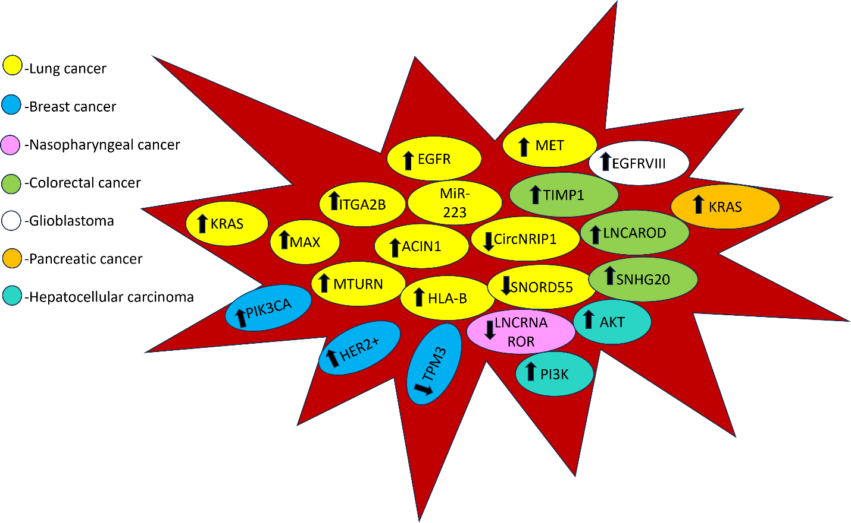

Fig:1 Illustration of RNA transcripts in TEPs upregulated or down regulated in different cancer types. EGFR-Epidermal growth factor receptor, KRAS-Kirsten rat sarcoma viral oncogene homolog, MAX-Myc associated factor X, PIK3CA-phospatidylinositol-4,5-bisphosphate 3-kinase catalytic subunit alpha, MTURN-Maturin, HER2-Human epidermal growth factor receptor 2, TPM3-Tropomyosin3, HLA-B- Human leucocyte antigen-B, MET-Mesenchymal epithelial transition, TIMP1-Tissue inhibitor of matrix metalloproteinases 1, LNCAROD-long coding RNA activating regulator of DKK1, SNHG20-Small nucleolar RNA host gene 20, ACIN1-Apoptotic chromatin condensation inducer 1, SNORD55-Small nucleolar RNA C/D box 55, CircNRIP1-circular RNA nuclear receptor interacting protein 1

In conclusion, tumor-educated platelets (TEPs) represent an exciting discovery that sheds light on the intricate interplay between cancer cells and platelets. These modified platelets offer insights into the molecular changes driven by tumors, and they hold potential as diagnostic and monitoring tools within liquid biopsies. Platelets, typically associated with blood clotting, play a multi-dimensional role in cancer dynamics. They contribute to angiogenesis, metastasis, immunomodulation, and immune evasion. Owing to their abundant presence in the bloodstream and the ease of separation, platelets have positioned themselves as superior candidates for liquid biopsy when compared to other sources. TEPs, being carriers of tumor-associated proteins and RNAs, could serve as valuable sources for identifying cancer biomarkers. TEPs have been found to exhibit unique protein and RNA profiles in various solid malignancies, showing potential for pan-cancer and individual cancer biomarker detection. As we delve deeper into their role and molecular characteristics, TEPs could revolutionize cancer diagnosis, monitoring, and the development of personalized treatment strategies.

Reference:
- Zhang Q, Song X, Song X. Contents in tumor-educated platelets as the novel biosource for cancer diagnostics. Front Oncol. 2023 Apr 17;13:1165600. doi: 10.3389/fonc.2023.1165600. PMID: 37139159; PMCID: PMC10151018.
- Poulet G, Massias J, Taly V. Liquid Biopsy: General Concepts. Acta Cytol. 2019;63(6):449-455. doi: 10.1159/000499337. Epub 2019 May 15. PMID: 31091522.
- Krishnan A, Thomas S. Toward platelet transcriptomics in cancer diagnosis, prognosis and therapy. Br J Cancer. 2022 Feb;126(3):316-322. doi: 10.1038/s41416-021-01627-z. Epub 2021 Nov 22. PMID: 34811507; PMCID: PMC8810955.
- Meng Y, Sun J, Zheng Y, Zhang G, Yu T, Piao H. Platelets: The Emerging Clinical Diagnostics and Therapy Selection of Cancer Liquid Biopsies. Onco Targets Ther. 2021 May 25;14:3417-3428. doi: 10.2147/OTT.S311907. PMID: 34079287; PMCID: PMC8164876.
- Varkey J, Nicolaides T. Tumor-Educated Platelets: A Review of Current and Potential Applications in Solid Tumors. Cureus. 2021 Nov 1;13(11):e19189. doi: 10.7759/cureus.19189. PMID: 34873529; PMCID: PMC8635758.
- Roweth HG, Battinelli EM. Lessons to learn from tumor-educated platelets. Blood. 2021 Jun 10;137(23):3174-3180. doi: 10.1182/blood.2019003976. PMID: 33940594; PMCID: PMC8351883.
- Ge X, Yuan L, Cheng B, Dai K. Identification of seven tumor-educated platelets RNAs for cancer diagnosis. J Clin Lab Anal. 2021 Jun;35(6):e23791. doi: 10.1002/jcla.23791. Epub 2021 May 6. PMID: 33955587; PMCID: PMC8183939.
- Ding S, Dong X, Song X. Tumor educated platelet: the novel BioSource for cancer detection. Cancer Cell Int. 2023 May 11;23(1):91. doi: 10.1186/s12935-023-02927-5. PMID: 37170255; PMCID: PMC10176761.
- Best MG, Wesseling P, Wurdinger T. Tumor-Educated Platelets as a Noninvasive Biomarker Source for Cancer Detection and Progression Monitoring. Cancer Res. 2018 Jul 1;78(13):3407-3412. doi: 10.1158/0008-5472.CAN-18-0887. Epub 2018 Jun 19. PMID: 29921699.

