Application of Biomarkers Alterations in Management of Diseases
Dr. Seema Kohli  HOD, Pharmacy,  Kalaniketan Polytechnic College,  Jabalpur, (M.P.), India. | Dr. Ankita Alice Singh  Faculty, Pharmacy,  Kalaniketan Polytechnic College,  Jabalpur, (M.P.), India.  Dr. Kaminee Sahu  Professor, Pharmacy,  Gyan Ganga Instt. Of Science and Technology  Jabalpur, (M.P.), India.  Dr. B.K. Jain  Faculty, Pharmacy,  Kalaniketan Polytechnic College,  Jabalpur, (M.P.), India.

Abstract
Biomarkers have a specific property that can be tested as an index of healthy natural processes, unhealthy processes, or reactions to exposure or interventions, including corrective ones. The failure to adhere to the same constraints that would apply for the use of variables that aren't natural causes many research utilising biomarkers to never reach their full potential. Any biomarker development should precede or follow the typical design of any epidemiological study or clinical trial. Because biomarkers can be used to explain observable symptoms of a condition and to identify the best treatments based on these phenotypes and genotypes, they have attracted a lot of attention. This chapter made endeavored to provide an outline of biomarker uses ,their category and the role played in the management of diseases.

Key Words: Biomarkers, Variability ,Validity, Disease.

I Introduction
Hulka and colleagues [1] outlined the definition of biological markers (biomarkers) as "cellular, biochemical or molecular alterations that are measurable in biological media such as human tissues, cells, or fluids." The concept has lately been expanded to encompass biological traits that can be scientifically examined and assessed as a sign of healthy biological processes, pathological processes, or pharmacological responses to a therapeutic intervention [2]. In actuality, biomarkers are instruments and technological advancements that help in comprehending the prognosis, aetiology, diagnosis, progression, remission, or result of medical intervention.
Generations of epidemiologists, doctors, and scientists have employed a variety of biomarkers to examine human disease. It is generally established that biomarkers can be used to diagnose and treat cancer, infections, genetic and immunological abnormalities, and cardiovascular disease [3]. Their usage in research has developed out of the necessity for a more accurate, recall-free measurement of exposures in the disease's causative pathway that also has the ability to reveal data on the exposures' assimilation and metabolism [4]. Biomarkers have also been considered by neuroscientists to aid in the diagnosis, treatment, and investigation of the causes of disorders of the neurological system. The neurological system has been studied using blood, brain, cerebrospinal fluid, muscle, vagrancy-whams, skin, and urine to learn more about it in both a healthy and pathological state. The operation of technically sophisticated biomarkers will soon become increasingly feasible because to the rapid evolution of molecular biology and laboratory technology. [5,6]. In the hands of clinical investigators, molecular biomarkers will provide a dynamic and significant method to comprehending the range of neurological complaints with obvious operations in logical epidemiology, clinical trials, and complaint prevention, opinion, and operation [7].
II Use of Biomarker
Since biomarkers can facilitate the development and approval of novel, cutting-edge medications and natural products, biomarkers are especially crucial during any epidemic situation, especially in the field of vaccinations. Clinical biomarkers are typically understood to be quantifiable natural indicators of the existence, rigidity, or kind of complaint in medical settings.(8)As of 2010, (Strimbu K, Tavel JA) Biomarkers have received a lot of interest since they can be used to explain the visible characteristics of a particular complaint and to find the best treatments based on these phenotypes and genotypes.(9)2019's Doubler CC In example, biomarkers for respiratory complaint that are comparable to those linked to acute respiratory distress pattern (ARDS) have been linked to higher mortality (IL-8, ICAM-1) and improved survival (nitric oxide).(Jain KK, 2017).
III Biomarker Pathways and Approach
With operations in experimental and logical epidemiology, randomised clinical trials, online and opinion research, and prognosis, biomarkers provide us with a dynamic and dominant way to assess the evolution of neurological complaint.
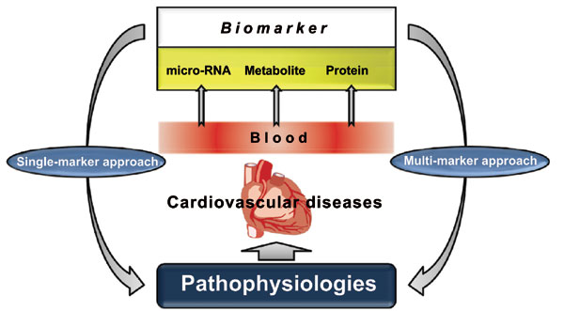
Figure 1: Biomarker Pathways

Biomarkers are defined as variations in the components of bodily fluids or apkins that provide the value for homogenous arrangement of a complaint and trouble factors and that can increase our knowledge of the pathogenesis of the complaint's underlying cause. Similar biomarkers can also represent the full spectrum of symptoms, from the first signs to the latter stages.
Regarding the stage of the complaint, a careful evaluation of the validity of the biomarkers is required. Causes of variation in biomarker dimension include both individual factors and laboratory processes.
IV Classification of Biomarker
Perera and Weinstein [3] categorise biomarkers according to the events that follow exposure to an illness (Fig. 2). Although biomarkers are ideal for epidemiological investigations, they can also be used to analyse a disease's progression and prognosis. According to Schulte, biomarkers have many functions. Biomarkers may be able to pinpoint the earliest occurrences in the course of nature, reducing the degree of misclassification of both exposure and disease, providing a window into potential disease pathogenesis mechanisms, accounting for some of the variability in risk prediction, and altering the outcomes. Biomarkers can also provide data on a disease's progression, prognosis, and therapeutic response. [11].
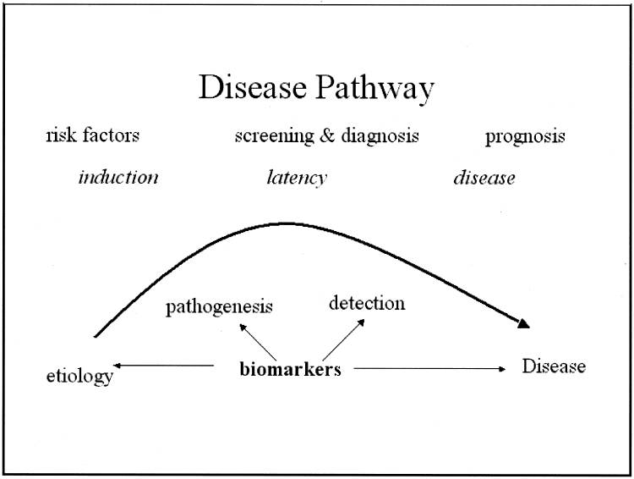
Figure 2: Disease pathway and potential impact of biomarkers.

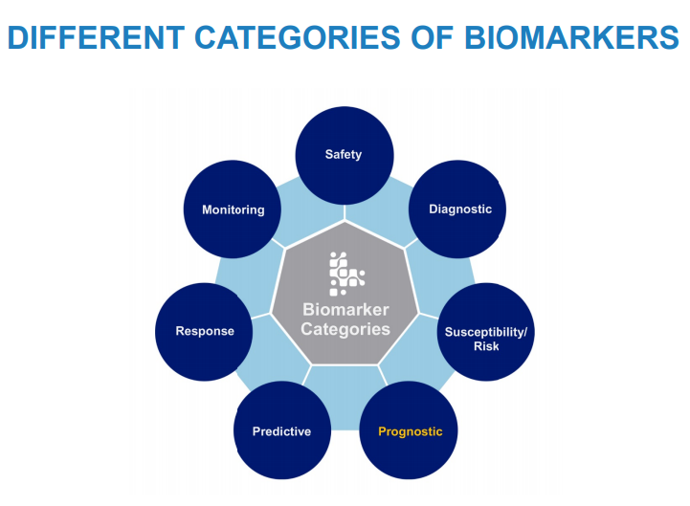
Figure 3: Different Category of Biomarkers

Prognostic Biomarker
Prognostic Biomarker can be used to select patients with greater likelihood of having a disease-related endpoint event or a substantial worsening in condition in clinical trials. A biomarker used to identify likelihood of a clinical event, disease recurrence or progression in patients who have the disease or medical condition of interest.
Example:
- Total kidney volume, to select patients with autosomal dominant polycystic kidney disease at high risk for progressive decline in renal function for inclusion in interventional clinical trials.
- C-reactive protein (CRP) level may be used as a prognostic biomarker to identify patients with unstable angina or a history of acute myocardial infarction with a greater likelihood of recurrent coronary artery disease events.
Diagnostic Biomarker
This is a biomarker that can be used to recognise individuals with a certain disease subtype or to identify or confirm the presence of a disease or condition of interest.
Examples include:
- Presence of chloride in sweat acts as a biomarker for diagnosis of cystic fibrosis.
• Haemoglobin A1c (HbA1c) or blood sugar acts as a biomarker for diagnosis of Type 2 diabetes mellitus (DM).
Accuracy in diagnosis is essential for medical practise. Diagnostic biomarkers are indispensable for treatment of a patient.
Predictive Biomarker:
A biomarker used to identify individuals who are more likely than similar individuals without the biomarker to experience a favourable or unfavourable effect from exposure to a medical product or an environmental agent.
Examples:
- Certain cystic fibrosis transmembrane conductance regulator (CFTR) mutations may be used as predictive biomarkers in clinical trials evaluating treatment for cystic fibrosis, to select patients more likely to respond to particular treatments.
- Human leukocyte antigen allele (HLA)–B*5701 genotype acts as a predictive biomarker to assess human immunodeficiency virus (HIV) patients before abacavir treatment and also to find patients at risk for severe skin reactions [11].

V Contributions of Valid Biomarkers to Clinical Research
Capabilities of Biomarkers
- Delineation of events between exposure and disease
- Establishment of dose-response
- Identification of early events in the natural history
- Identification of mechanisms by which exposure and disease are related
- Reduction in misclassification of exposures or risk factors and disease
- Establishment of variability and effect modification
- Enhanced individual and group risk assessments

VI Types of biomarkers:
There are types of biomarkers, like Molecular, histologic, radiographic, and physiologic characteristics are types of biomarkers. The basic examples of types of biomarkers are:
• Blood glucose (molecular)
• Tumour size (radiographic)
• Blood pressure (physiologic)

Because they are well-established and have clear advantages, biomarkers are utilised in the risk assessment, screening, and diagnostic processes. Histological classifications or established clinical criteria are used to categorise a range of neurological disorders. Additionally, the use of biomarkers may help us recognise neurological disease early and give a method for standardised disease classification. These benefits may help us better understand the underlying causes of diseases. All clinical exploratory procedures, including clinical trials and epidemiological observational research, can instantly take advantage of these advantages..

Intermediate biomarkers
Some biomarkers are directly linked to a disease because they are steps in the disease's causative chain. Others are indirectly connected to the cause in some way. There are many options to think about. A biomarker may require additional known or unidentified factors to contribute to disease. Although it is not the only factor, it is part of the causative chain and is still closely tied to the disease. The biomarker may either be connected to a known exposure or indicate a change brought on by the exposure that leads to the disease. [3].
VII Biomarker Bio-clinical Testing- Screening, diagnostic tests, and prognosis
Prodromal biomarkers allow for an earlier diagnosis or the ability to predict the desired outcome at a more incipient stage of the illness. Cerebrospinal fluid, blood, and urine offer the pertinent biological data for the diagnosis. In many illnesses, biomarkers are biological components that indicate a subclinical stage, dysfunction, or alternative expression of the disease. Biomarkers employed for screening or diagnosis frequently indicate the disease's surrogate symptoms. The goal of a clinical experiment includes: identifying those who are at risk of contracting the disease or who are still in its "preclinical" stages; reflecting the disease's natural history, which includes the stages of induction, latency, and detection; and reducing disease heterogeneity in clinical trials or epidemiologic studies. The increased validity and precision far surpass the challenge of obtaining such tissues from patients.
For individuals who test positive, treatment should be offered, and it should be respectable and accessible. The availability and respectability of treatments for those who test positive and are ill should be guaranteed. It's helpful to remember that primary (before the development of symptoms) or secondary (early or prodromal detection) prevention is the main advantage of netting. In clinical discussion and practise, specific diagnostics for neurological diseases are employed more frequently. Collection of data from many sources, some of which include the outcomes of specific tests, aids in achieving the goal of increasing the probability of a particular view in the case at hand. Although somewhat less frequently, clinical tests are also carried out for similar purposes such as the following: to assess the severity of the complaint, to forecast its circumstances, or to examine the effectiveness of a given treatment. Even more significantly, biomarkers for complaints quickly proceed to clinical studies. This kind of individual test also has the benefit of reducing the variety of complaints in clinical trials or experimental epidemiologic research, which improves knowledge of the phases of induction, quiescence, and discovery in the complaint's natural history. [3].

VIII Biomarker Variability and Validity
Certain facts of Bio Marker variability
Although there are many benefits to using biomarkers, variability is a significant issue. It makes little difference whether the biomarker is a proxy for a complaint, an indication of vulnerability, or an exposure or impact modifier.
• Inter-individual variation may be influenced by the degree of an outside exposure or by the way a purportedly poisonous substance is metabolised.
• Intra-individual variation is typically correlated with laboratory malpractice, other conditions, or exposures that are specific to the individual. Although group variability does occur, it frequently results from research.
Dimension error is a constant worry with biomarkers, but there may be other significant factors that contribute to individual or group variability. Some employees might always wear protective clothing, while others might not. The impact of the biomarker under evaluation as an exposure or as a measure of susceptibility can grow or decrease depending on how it interacts with other exposures, medications, or effect modifiers. Variability can also be ascribed to positive aspects like dietary habits or other unique traits. The amount of dietary fat can affect how hazardous compounds and lipid-soluble vitamins are measured biologically. The investigator must fully establish the major sources of variability in these investigations by taking these individual aspects into account.
Certain facts of Bio Marker validity
Although precise numbers are appealing, they are subject to the same issues as any variable. Just like any other variable, the reliability, validity, perceptivity, particularity, ascertainment bias, and interpretation of results employing biomarkers should be carefully examined. Whether the biomarker is being utilised as a variable in a clinical trial or an epidemiologic investigation, same issues still exist.
The key is repetition or trust. If the biomarker is unreliable, laboratory crimes may result in misclassification of exposures or complaints. The reliability of the biomarkers utilised in any disquisition may be impacted by changes in the laboratory labour force, laboratory practises, storage facilities, and transit methods. The evaluation of the validity of a biomarker is complex. Schulte and Perera [13] propose three features of measurement validity:
• Content validity is a measure of how closely a biomarker relates to the biological process being studied.
• Construct validity, measures additional relevant characters of the disease,
• Criteria validity indicates the degree to which a biomarker is associated with a certain disease and is based on sensitivity, specificity, and predictive power.

To evaluate the impact of disease misclassification more thoroughly, it is important to evaluate false positives and false negatives as well as positive and negative predictive power. The biomarker should always have a clear predictive value, however this isn't always the case. Receiver-operator characteristic curves can provide the necessary tools for selecting the best alternative in terms of sensitivity and false-positive rates, particularly when other tests are used. [14,15].
The use of the biomarker in the study must be made known by the investigator. When biomarker data are over interpreted, crimes are most frequently committed. The finding is interpreted by the investigator as a biomarker for the complaint or the observed overgrowth, on the other hand. No matter how high the likelihood or difficulty, a biomarker of this kind cannot be expected to function as a personal test unless it is a symptom of the complaint.. [16,3].

IX Advantages and Disadvantages of Biomarkers

The advantages and disadvantages of biomarkers are shown herein in tabulate form.
Advantages | Disadvantages
Objective assessment | Timing is critical
Precision of measurement | Expensive (costs for analyses)
Reliable; validity can be established | Storage (longevity of samples)
Less biased than questionnaires | Laboratory errors
Disease mechanisms often studied | Normal range difficult to establish
Homogeneity of risk or disease | Ethical responsibility

X Limitations of biomarkers alterations

Errors of Measurement

It makes sense that inaccurate biomarker testing would destroy the validity of the link to the disease. There are several varieties of measurement errors, in addition to those that occur in the lab.

The assessment of biomarkers may also be impacted by improper sample storage, changes in the storage environment, problems with the equipment used to collect samples, or delays in getting the samples to the lab.

• Since the bulk of specimens are handled by technicians, thorough training for new personnel is essential.

• Lastly, receiving and control problems can frequently result in mistakes, for example, when identifying numbers are manually inputted.

• A thorough procedure manual including the particulars of record-keeping, specimen monitoring, storage, and documentation.

Bias
Any study, even one using biomarkers, could be biased.
Non-Differential Bias: Unlike biases that take the study's results into consideration, non-Differential Bias promotes the null hypothesis of no link. However, it has less negative effects on the study. Problems can arise when the availability of the biomarker is differentially correlated with the exposure or the disease, when the techniques used to collect, store, measure, or assess specimens differ between people with and without the disease, when the outcome of interest is involved, or when any of these situations arise.
Differential bias boosts relationships in either direction, despite the fact that this may not accurately reflect the underlying relationship between the disease and the biomarker.

Confounding
The most major cause of confounding is the failure to notice situations that can influence how the biomarker is measured.
- They may be internal, such as the subject's weight, or external, such as the specific batch of laboratory supplies used.
- The unique qualities of a biomarker should be taken into consideration when choosing and interpreting it for any investigation.
- It's vital to consider the effects of any relevant confounders, such as age, gender, nutrition, and other metabolic factors, before starting the investigation.
- A biomarker's biological stability is important, especially if it will be stored for a long time.

These are frequently missed in analysis yet have a significant impact on the result. When planning a study, it is advisable to take into account potential confounders and gather pertinent internal and external data that may have an impact on the measurement. This data can be used to analyse the relationship between the biomarker and the desired outcome.

Cost

The scientific question and the financial resources should be used to determine the selection of the biomarker for investigation. But cost is also a constant worry. This might be significant in a modest clinical trial, but if an epidemiologic study involves thousands of participants, the cost might be enormous unless the laboratory method is automated and straightforward. In fact, for some tests, higher sample numbers can lower the per-subject cost. This often suggests that the biomarker is accessible and that including it in the study is feasible. Acceptability
Because they are derived from human tissues or body fluids, choosing biomarkers is not simple. The use of biomarkers may potentially come with some problem. The source of the biomarker is significant. Body fluids like blood and urine are usually well tolerated. Cerebrospinal fluid collection and biopsy (particularly of brain tissue) are more difficult and risky procedures.
XI Conclusion
Biomarkers are characterised as having a characteristic that can be tested as an indicator of healthy natural processes, unhealthy processes, or reactions to exposure or interventions, including corrective ones. Because the same guidelines that would apply to the use of artificial variables are not followed, numerous studies using biomarkers never reach their full potential. Any biomarker development should take place prior to or concurrently with the common design of any clinical trial or epidemiological study.
In any pandemic situation, the use of biomarkers is essential because they can expedite the development and approval of state-of-the-art medicines and biological products, notably in the area of vaccinations. Clinical biomarkers are typically defined as quantifiable biological indications of the presence, severity, or type of disease in clinical settings. The ability of biomarkers to describe a disease's observable symptoms and to choose the appropriate treatments based on both genetics and phenotypes has attracted a lot of interest. Acute respiratory distress syndrome (ARDS)-related biomarkers, such as IL-8 and ICAM-1, have been specifically associated to both increased mortality (IL-8, ICAM-1) and improved survival (nitric oxide). [17].

References
1. BS. Hulka. Overview of biological markers. In: Biological markers in epidemiology (Hulka BS, Griffith JD, Wilcosky TC, eds), pp 3–15. New York: Oxford University Press, 1990.
2. S. Naylor. Biomarkers: current perspectives and future prospects. Expert Rev Mol Diagn 3: 525–529, 2003.
3. FP. Perera, IB. Weinstein. Molecular epidemiology: recent advances and future directions. Carcinogenesis 21: 517–524, 2000.
4. Gordis L. Epidemiology and public policy. In: Epidemiology (Gordis L, ed), pp 247–256. Philadelphia: W.B. Saunders, 1996.
5. MM. Verbeek, D. De Jong, HP. Kremer. Brain-specific proteins in cerebrospinal fluid for the diagnosis of neurodegenerative diseases. Ann Clin Biochem 40: 25–40, 2003.
6 H. Reiber, JB. Peter. Cerebrospinal fluid analysis: disease-related data patterns and evaluation programs. J Neurol Sci 184: 101–122, 2001.
7. R. Mayeux. Biomarkers: potential uses and limitations. NeuroRx. 2004 Apr;1(2):182-8. doi: 10.1602/neurorx.1.2.182. PMID: 15717018; PMCID: PMC534923.
8 K. Strimbu, KA. Tavel. What are biomarkers? Curr Opin HIV AIDS. 2010; 5(6):463e466
9. CC. Dobler. Biomarkers in respiratory diseases. Breathe. 2019; 14(4):265e266
10. KK. Jain. The Handbook of Biomarkers. Springer Publishing Company; 2017.
11. Schulte PA. A conceptual and historical framework for molecular epidemiology. In: Molecular epidemiology: principles and practices (Schulte PA, Perera FP, eds), pp 3–44. San Diego: Academic Press, 1993.
12. AIDS Epidemic updat e 2007 WHO
13. PA. Schulte, FP. Perera. Validation. In: Molecular epidemiology: principles and practices (Schulte PA, Perera FP, eds), pp 79–107. San Diego: Academic Press, 1993.
14. MS. Pepe, ML. Thompson. Combining diagnostic test results to increase accuracy. Biostatistics 1: 123–140, 2000.
15. ML. Thompson, W. Zucchini. On the statistical analysis of ROC curves. Stat Med 8: 1277–1290, 1989.
16. R. Mayeux, AM. Saunders, S. Shea et al. Utility of the apolipoprotein E genotype in the diagnosis of Alzheimer’s disease. Alzheimer’s Disease Centers Consortium on apolipoprotein E and Alzheimer’s disease. N Engl J Med 338: 506–511, 1998.
17 L. Zhang, H. Guo. Biomarkers of COVID-19 and technologies to combat SARS-CoV-2. Adv Biomark Sci Technol. 2020;2:1-23. doi: 10.1016/j.abst.2020.08.001. Epub 2020 Aug 19. PMID: 33511330; PMCID: PMC7435336.

