Induced breeding in fishes: An overview
Sweety Gupta, Ajay Kumar, Vishal Bhojyawal, Karishma Agrahari, Prem Chand*
Department of Zoology,
T. D. P. G. College, V. B. S. Purvanchal University,
Jaunpur, Uttar Pradesh, India
* E-mail - premcpatel@gmail.com

Abstract:

Fish provides a very nutritious food for human beings. In Current scenario, the fish population is declining very sharply because water resources are highly polluted, over consumption and reducing the number of water bodies because of natural disasters and human interference. Due to high demand for fish as food, fish culture is a technique used to fulfil the requirements by increasing productivity. Induced breeding is a procedure in which an organism is stimulated by a specific hormone or some other synthetic hormone or by providing an environmental circumstance, initiated to breed in favorable conditions. The endocrine system performs as an executive relationship between the environmental incidents, maturation, and release of gametes in vertebrates. The pituitary hormones control some activities like impression of secondary sexual features, breeding behaviour during courtship and timing of reproduction throughout the breeding season. The gonadotropic hormones for instance follicle stimulating hormone (FSH) and luteinizing (LH) perform an important role in spawning, induced breeding .

Key Words: Induced breeding, Pituitary gland, Major Carps, Hypophysation, Gonadotropin Releasing hormones (GnRH), FSH, LH, Synthetic hormones.

Introduction:
From ancient times fish played a very important role in the life of human civilization, history tells us that some form of fish culture existed around 300 B.C (Hora, S.L., 1953). From the ancient period of time fish were considered as a source of highly nourishing food. It also provides vitamins, proteins, fats, fatty acids, omega-3, and amino acids, which are very important for health (Alp -Erbay and Yeşilsu, 2021, Allam, et al. 2020; Panda, S., 2016). India is second ranked globally in farmed fish production (Panigrahi, 2019). The current fish production in India has reached 8.3 million tons, which is expected to reach 12.5 million tons by 2025 (Dash et al. 2018). Major carps are the most important species from the perspective of their high food and nutritive values. The commonly cultured Indian major carps in inland waters like mrigal (Cirrhinus mrigala), rohu (Labeo rohita), calbasu (Labeo calbasu), catla (Catla catla), Chinese carps, black carp (Mylopharyngodon piceus), big head (Aristichthys nobilis), silver carp (Hypophthalmichthys molitrix), grass carp (Ctenopharyngodon idella), and mud carp (Cirrhina molitirella),generally they do not produce offsprings in circumscribed waters (Chaudhary et al. 1996). These culturable fishes are fully grown there but reproduce in the submerged shallow region apart from the direction of the rivers throughout monsoon season and that is their natural habitat (Alikunhi et al. 1965, Chakrabarti S. 2020). The Indian major carp was successfully induced in 1957 (Chaudhuri and Alikunhi, 1957) and in silver carp and grass carp introduced in India in 1959, and 1962 (Alikunhi et al., 1963). Indian major carps are known to spawn in specialized environments like bundhs, in that area’s rainwater accumulation takes place during the monsoon season. These man-made or natural conditions mimic their original spawning habitats and allow for successful reproduction. In the past, fish culturists had to rely on collecting fish seeds from the river system. However, such collections often included the desired species, but in addition unprofitable and unwanted species including predators and their separation sometimes became more difficult for farmers. The Asiatic carps are unable to breed in restricted static waters, due to deficiency of required ecological stimuli which affect the discharge of essential amount of pituitary hormones (Jha and Neupane 2019, Alikunhi et al. 1964, Panigrahi, L. 2019) and so extrinsic hormones such as pituitary extract or synthetic hormones are injected to spawning fish to induce them to breed in stagnant water and in this way confirm a reliable source of quality seed to enhance the production of fish and development of fishery (Panigrahi, L. 2019). Induced breeding in hatcheries has actually transformed the high-quality seed production of carp. By controlling the breeding process in a controlled environment, hatcheries can ensure better genetics and higher survival rates of the fish. This method reduces the reliance on natural seed collection, which can be unpredictable and unsustainable (Alikunhi et al., 1960).
Induced breeding, also known as hypophysation, is a method used to breed profitable fish species that do not typically breed in confined environments. By stimulating the fish's gonads with hormones like pituitary hormones or synthetic alternatives, the process encourages the release of eggs and sperm, allowing controlled breeding to occur under captive conditions (Hossain et al. 2021, Ervilha et al. 2022, Kumar et al. 2022, Siddique et al. 2022). This technique plays a crucial role in aquaculture and fisheries management. Induced spawning technique has spread out new opportunities in fish production throughout the world (Bhuiyan et al., 2013).
History of Induced Breeding:
The induced breeding technique was developed in Argentina by Houssay in 1930, which involved the use of pituitary extract to stimulate viviparous fish to give premature birth. This approach marked a significant advancement in understanding and manipulating fish reproductive processes for aquaculture purposes. Brazilians achieved success in induced breeding by pituitary extract in 1934. The method of induced breeding quickly gained traction beyond Argentina. It was adopted in America by researchers like Merlin and Hubs, as well as in Russia by Gerebilisky. In India, Khan firstly established induced breeding in fish Cirrhinus mrigala in the year 1937. Dr. Hiralal Choudhuri in 1955, also utilized this procedure in the minor carps like potasi (Pseudeotropius atherinoides) and Indian flying barb (Esomus danricus). Ramaswamy and Sunderaraj (1956) were first induced to breed magur (Clarias batrachus) and singhi (Heteropneustes fossilis). Dr. Hiralal Choudhuri's accomplishment in achieving the first successful induced breeding of major carps in 1957, involving Cirrhinus mrigala, C. reba, and Labeo rohita, marked a significant milestone in the advancement of aquaculture. The Indian major carp spawns are induced by injection of pituitary extract (gonadotropic hormones) or synthetic hormones (Alikunhi et al. 1960). Additionally, Parameswaran and Alikuni's success in breeding exotic Chinese carps,Ctenopharyngodon idella and Hypophthalmichthys molitrix, in 1963 further demonstrated the potential of induced breeding techniques in diversifying fish production.

Events of Natural Breeding:

Many cultured farm fishes, including Indian major carps, often do not produce offspring naturally in captive conditions. Indian major carps come under fishes which do not usually breed in restricted water or static water bodies such as lakes, ponds etc., but spawn normally in submerged territory of rivers and streams throughout monsoon season (Baruah, 2013). There are multiple reasons that played different role during breeding seasons as like environmental factors like photoperiods (day length), rainfall, temperature and water flow have an effect on the hormonal activity of pituitary gland and release of its gonadotropin, which regulate the maturation of gonads and spawning in male and female both (Alikunhi et al. 1965, Maulu, S. et al. 2021, Ibrahim et al. 1968, Siddique et al. 2022) The spawning site of Indian major carps benefits from fresh floods that eliminate terrestrial life and promote the growth of microflora and microfauna, providing a food source for the fry and fingerlings of these fish. This flood-driven cycle contributes to the survival and propagation of Indian major carps (Padhi and Mandal, 1994).
Disturbances arise in any of these environmental conditions may give rise to the inadequate secretion of hormones in captive conditions and therefore, the fish does not reproduce in confined regions. The induced breeding technique is established on the principles of artificially influenced hormonal or environmental factors (Kumar et al. 2021) for stimulation of reproduction in fishes (Figure 1, Harvey and Carolsfeld 1993).
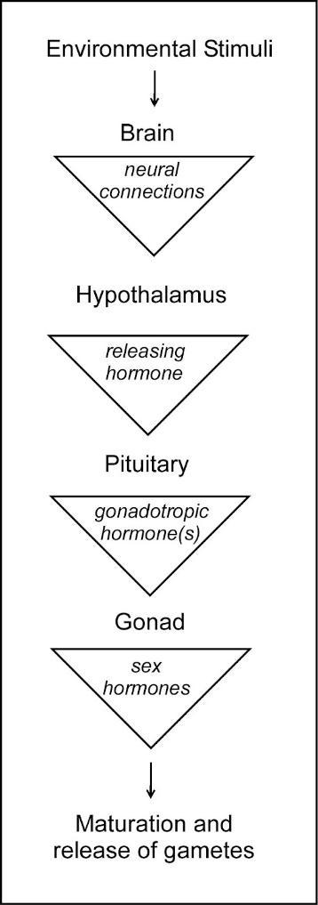
Figure 1: Flowchart displays environmental and hormonal events of natural breeding.

Need of induced breeding:

Due to the increase in demand of fish for consumption as food, amusement and decorative fishes used in aquariums, the natural fish populations are gradually declined during the past several decades, because of environmental degradation like photoperiod, rain, temperature, currents of water and overfishing, chemical composition of water and many more factors (Pankhurst and Mundey 2011, Jha and Neupane 2019, Sudha, C. 2012). This raised trouble in the development of ways for hatchery products of fish. Traditional aquaculture species such as trout, catfish, common carp, golden shiner and goldfish reach sexual maturity and spawn in hatcheries or ponds, when conditions are appropriate. Indeed, some valuable fish species have proven challenging to reproduce in captivity despite their economic importance for aquaculture. Many of these fish spawning takes place in natural environments that are nearly impossible to stimulate in hatchery, hormone induced spawning is the only reliable method to induce reproduction in these fishes (Panigrahi, L. 2019, De et al. 2020). The reproductive processes of fish in captivity are a crucial step towards domestication and the development of a sustainable aquaculture industry (Mylonas et al., 2010, Saraiva et al. 2018).

Fish pituitary gland:

The fish pituitary is a major endocrine gland which plays a decisive role in the neuroendocrine system including development, growth, and the functioning of other endocrine glands also. It is present in all vertebrates from agnathans (jawless fishes) to mammals and as in others it also consists of two main elements, the adeno-hypophysis derived from the Rathke's pouch and the neurohypophysis derived from the diencephalon (Harvey and Carolsfeld 1993, Shanthanagouda et al. 2018).
The pituitary gland of the fishes situated at the ventral region of the brain in concavity known as sella turcica is a very minute in size (pea-sized), remaining attached to the brain with the help of a stalk (Figure 2). Like higher vertebrates, the pituitary gland in fish plays a major role in synchronizing a variety of physiological activity, including reproduction. Follicle Stimulating Hormone (FSH) is one of the key hormones secreted by the fish pituitary gland, and it stimulates the development and maturation of sexual organs, ultimately leading to the induction of spawning in fishes.
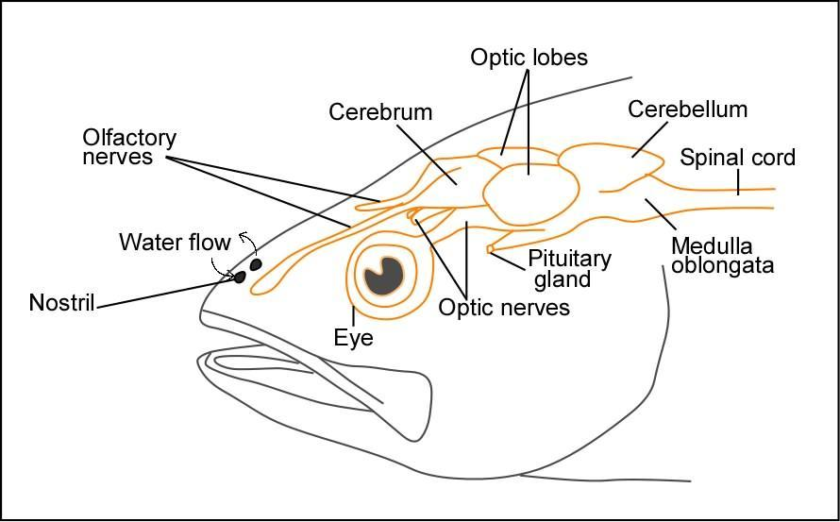
Figure 2. Schematic diagram of fish head showing location of pituitary gland ventral to the brain.

Procedure of induced breeding technique:

The most common method of induced breeding is hormone injection in which pituitary extract or other synthetic hormone is introduced in the body of ripe breeders which may be male or female. The mechanism of induced breeding is completed in several steps.
- Collection of Pituitary Gland from Fish:
Pituitary gland is harvested from a fully developed fish, which is called a donor fish. Most widely used donor fish is the common carp (Cyprinus carpio) as it breeds throughout the year and therefore mature individuals are available around the year (Islam, 2016).
The collection of pituitary gland from the fishes can be from the following two methods-
a) Collection of gland from the foramen magnum.
b) Collection of gland by dissecting the head.
a) Collection of glands from foramen magnum – The foramen magnum is first uncovered by take-off vertebral parts adhering to the skull. Fat is removed first by means of forceps and then cotton pieces. A couple of forceps then fitted into foramen magnum dorsally to the brain and anterior part of the brain now detached and remaining is precisely lifted out through the foramen magnum. The gland is then identified and removed.
b) Collection of glands by dissecting heads – The method of head removal is less time consuming and economical as the heads are used for human consumption later. At first the head is dissected using a sharp butcher’s knife, a portion of the scalp is chopped off in a clean cut with one stroke. Fat encompassing the brain is removed with the support of cotton. Olfactory and optic nerves are now severed, and then the brain is lifted up and removed. Then identify and locate the pituitary gland (Figure 3). After the dissection gland may come up along with the brain or may remain behind on the floor of the brain cavity often covered with membrane (Das and Khan, 1962). In any case the gland is carefully removed after separating it from the membrane or the brain proper. The gland must not be broken or tattered.

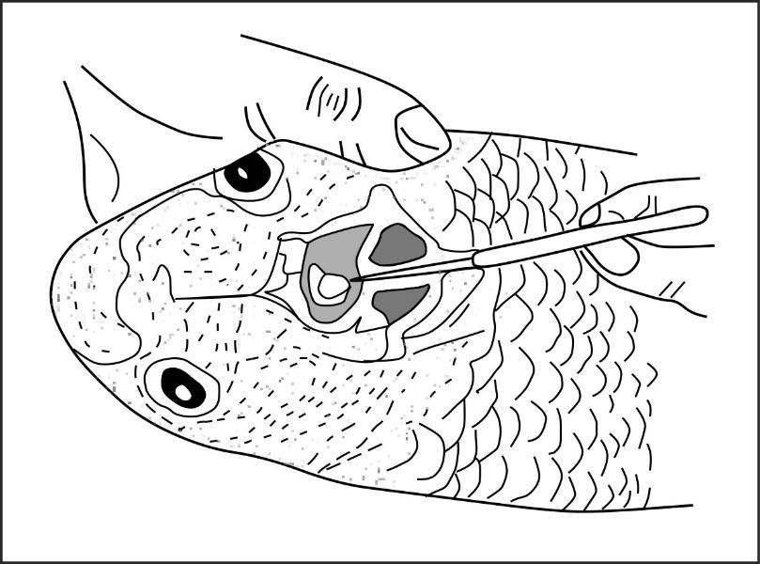
Figure 3. The pituitary gland is completely exposed following removal of cranial bone and brain from the carp head.
2. Preservation of Gland
The collected gland can be preserved for a duration of a week or more as per requirement. After collecting the pituitary glands are instantly stored in absolute alcohol in sterile vials and other bottles for preservation. The absolute alcohol method is widely followed in India while acetone dried method is widely used in the USSR and USA. Freezing method is also used for storage of glands.
- The pituitary glands can be preserved in absolute ethanol.
- Acetone is also used in some temperate countries for the preservation of glands.
- Pituitary glands can also be preserved in Glycerine.
3. Preparation of hormonal extract from pituitary gland:
The extract of pituitary glands collected from donor fishes are soaked to form an extract which is used to inject into the mature breeders and induce them to spawn.
- The known amount of pituitary gland is taken by measuring the total quantity of fish which are bred.
- The pituitary gland is then dried in air by utilizing blotting paper.
- After drying the gland is then transferred in a tissue homogenizer with a small amount of distilled water.
- The grade of dilution of homogenized gland should be 0.2 ml/kg of body weight of the fish.
- The pituitary extract is then centrifuged to separate the hormone and only the supernatant part of solution is utilized for injection in fishes.
4. Brooders Selection:
The selection of ripe brooders is a very important step in this technique because if brooders are not mature, healthy or fully ripe then this technique doesn't give appropriate results.
- The brooders are required to be mature enough and healthy.
- 2 – 4-year-old fishes are generally selected.
- The body weight of fishes is preferably 1 – 5 kg.

Characters for the identification of Male and Female mature Indian carps:
Salient features of male and female carps are described below in table 1, as well as in figure 4.

Table 1. Comparison of characteristics of male and female carp.

MALE FISH | FEMALE FISH
The inner surface of pectoral fin is rough | The inner side of pectoral fin is smooth
The abdomen is narrow | The abdomen is soft and bulging
The vent (genital region) is whitish in color and remains inwards | The vent is pinkish in color and remains protruded
When the abdomen is pressed gently milt oozes out | When the abdomen is pressed eggs are released

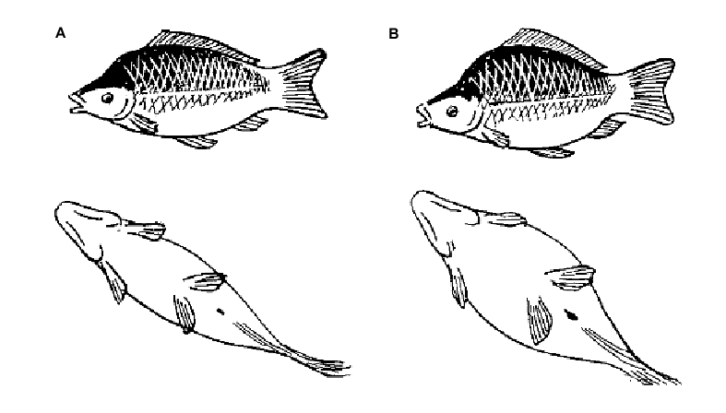
Figure 4. Schematic diagram of common carp; A. Male B. Mature female (Costa Pierce et al., 1989)

5. Injection to the Brooders:
Procedure of injection:
- Homoplastic injection: Homoplastic means closely related species. In this method extract from the pituitary of the one species injected into the another closely related fish species of the same group. For example, extract from the pituitary gland of the carp used to induce in another carp species.
- Heteroplastic injection: During heteroplastic injection, pituitary gland extract from the one species injected into the distantly related species for induced breeding. For example, pituitary gland extract from catfishes used to induce in carp fishes or vice versa.
Process of injection in fishes:
- It is very important to determine the correct dosage of pituitary gland extract which are given to breeders.
- The quantity of pituitary extract mainly depends on size and maturity of the breeders and it also depends upon the state of maturity of donor fishes.
- The extract from pituitary gland is injected to the brooders through hypodermic syringe. Pituitary extract injected into the brooders is either intramuscular or intraperitoneal.
- The female fish are usually given two doses of injection whereas the male given only a single dose of injection.
- Generally, females are given a preliminary dose of 2-3 mg/kg of body weight. The preliminary dose is not given to the male. After an interval of time about 6 hrs a second dose of 5–8 mg is given per kg of body weight of the female fish.
- The male was then given the first dose of injection with female @ 2-3 mg/kg of body weight. The doses of hormones depend upon the maturity of fish, age, sex and also the environmental conditions.
- For intramuscular injection, the fish is laid on its side while held in a hand net and the needle is inserted either in the caudal peduncle or in the shoulder (Figure 5, and 6). For intraperitoneal the injections are given in the bases of paired pectoral fins. But it is avoided because less expert hands can puncture the heart of the fish (Figure 5).

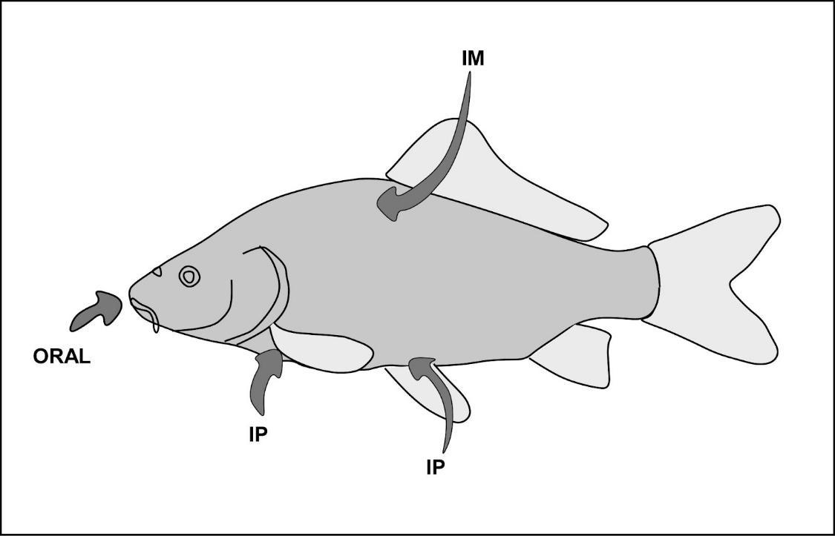
Figure 5. Three routes (Oral; Intramuscular, IM; and intraperitoneal, IP injection or slow-release implant) for administering spawning hormones to fish.

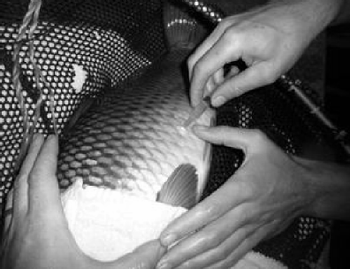
Figure 6. Photograph displays intramuscular injection in carp fish.

6. Spawning:
Once injecting hormones to the breeders (male and female) both male and female are instantly free into the breeding area or circular breeding hapa for spawning. Single set of brooders, consist of one female and two males. In breeding hapa, a "hapa" is a box-shaped area, in rectangular shape, made of fine net and is firmly fixed by four bamboo at each pole, in the pond (Figure 7a). Normally hapa is formed by fine meshed markin cloth or close fine meshed mosquito net. Thin markin cloths are used for hapa preparation because it does not restrict proper circulation of water and which save fish seedling to suffocation. Closed mesh mosquito netting is generally used for the hapa in breeding. The fine mesh allows for good water circulation while preventing fish eggs and milt from escaping through the openings. Due to the fine meshes, it allows an adequate flow of water and will also stop the laid eggs and milt float or wash away through the meshes. Average measurements of hapa range is 3M × 1.5M × 1M for breeders weighing 3 to 5 kgs. Keeping the hapa's height about 20 centimeters above the water level (Hossein et al.,2021). The hapa is closed on all sides but the roof can be open or closed as required (Figure 7a, b). Nowadays other than breeding hapa, Chinese hatcheries are in trend. These breeding tanks are circular in shape of about 2m in diameter and 1m deep (Figure 7c). Within 2-3 hours of the second injection of stimulus (hormones), the male and female start swimming actively, becoming highly excited and uneasy. Males start running towards the female, pressing her with the snout. The spawning takes place within 3-6 hours following the second dose. While injection of hormones can be given at any time in the day but cool, cloudy and injection in the evening give more appropriate results. Spawning occurs at midnight following the second injection which is given in the evening. After successful induced breeding produces the spawn of fertilized eggs. Then fertilized eggs are transferred into the hatching hapas for hatching. In Osteobarma belangeri, it is found the success rate of spawning is dependent on the rate of inducement and also type of inducing agent utilized (Das et al. 2016).
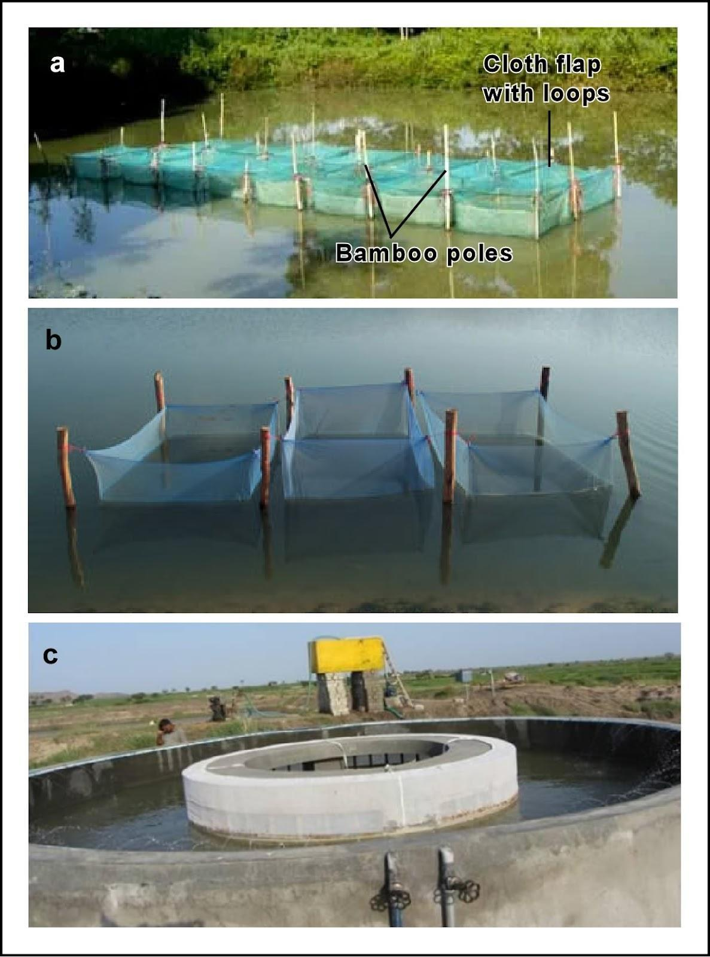
Figure 7: Different types of hapa (a) Breeding hapa (b) Hatching hapa (c) Operation of the Chinese hatchery
The fertilized eggs are crystalline, transparent and pearl like in appearance. They come to the upper side of the surface on slight movement of water, whereas unfertilized eggs are opaque or whitish in color as shown in figure 8 (Hossen et al. 2021).

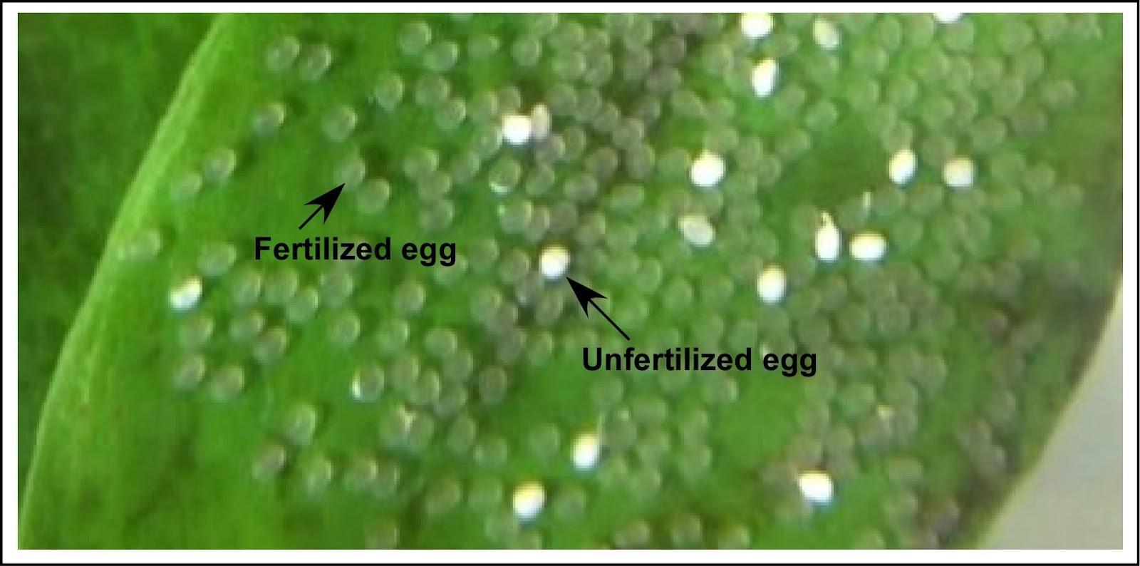
Figure 8. Photograph of fertilized and unfertilized eggs of Mystus gulio.

Role of other natural and synthetic hormones in induced breeding:

Hormones play a crucial role in inducing reproduction in fish. GnRH analogues (Gonadotropin-Releasing Hormone analogues) are frequently used in combination with dopamine antagonists to stimulate reproductive processes. Additionally, the injection of gonadotropins, such as HCG (Human Chorionic Gonadotropin), can also trigger spawning and oocyte maturation in fish (Park et al., 1992). These hormone-based techniques have been extensively employed to control and manipulate fish reproduction in aquaculture and research.
Extract of fish pituitary was primarily used for stimulation of breeding but due to preparatory difficulties in the injection and its proper preservation of pituitaries extract, recently synthetic hormones like LHRH-a, HCG, WOVA-FH,Ovatide, Synahorin, Ovaprime, are used for induced breeding (Figure 9).
- LHRH-a and Domperidone - LHRH-a (Luteinizing Hormone-Releasing Hormone agonist) and domperidone is used to induce oocyte maturation and ovulation in bighead carp, Aristichthys nobilis (Richardson) (Armandto C F, 1991).
- HCG - Human Chorionic Gonadotropin used to induce ovulation in fish. HCG offers three major advantages;
- HCG is more cost-effective.
- It has a longer shelf life due to better stability.
- It is available in a purified form.
After the injection of HCG in Labeo rohita with a dose of 460-2010 IU/kg body weight did not start spawning. However, in different studies it is shown that Labeo rohita spawn by injecting HCG with a dose of 600 IU/kg body weight. While in the case of silver carp, successful spawning could be obtained by injecting HCG alone with a dose of 630-660 IU and also with injection of HCG 240 IU + 12 mg carp pituitary per kg body weight.
WOFA-FH - WOVA-FH, a synthetic Gonadotropin Releasing Hormone analogue (SGnRH), has proven to be effective for induced breeding in Indian Major Carp, Exotic Carp and Catfish. SGnRHs are often used to manipulate reproductive processes in fish, and their success in inducing breeding are a valuable tool in aquaculture and fisheries management.

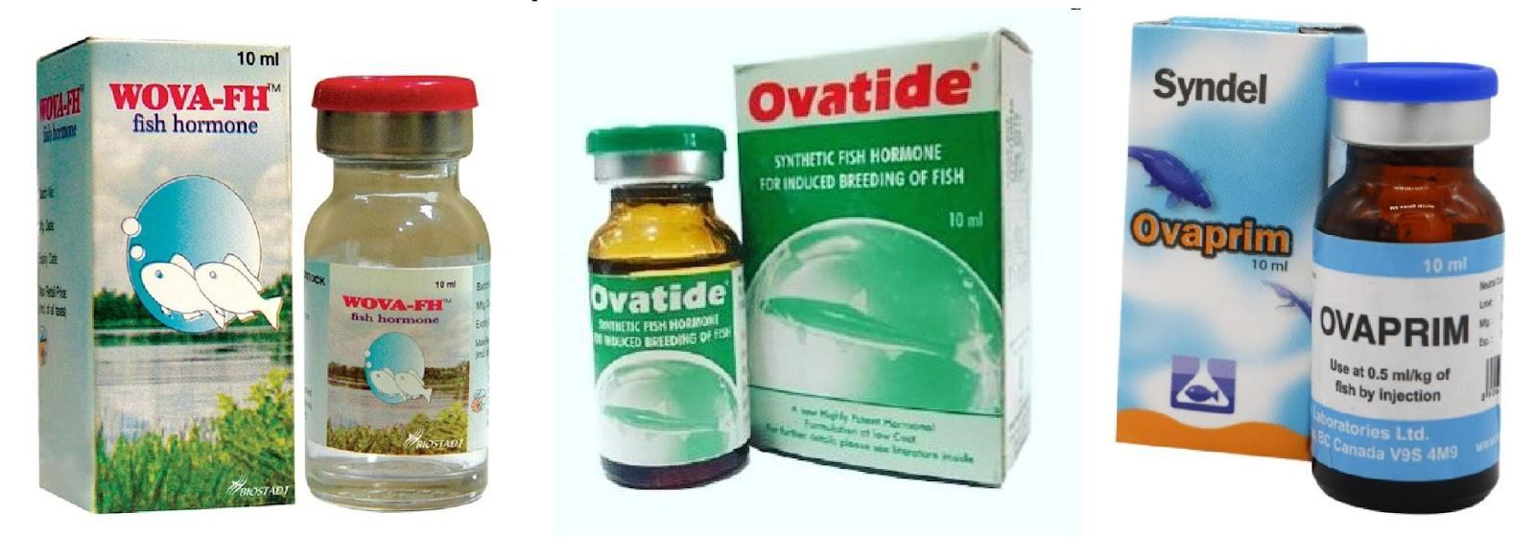
Figure 9: Few synthetic hormones, which are popularly used in induced breeding.

- Ovatide - Ovatide is an endemic, cheaper and used as hormone for induced breeding in fishes, and it is highly effective in induced breeding for major carps. The doses are varied for different species of carps as like, in case of Rohu and Mrigal are 0.20-0.40 ml/kg while in case of Catla 0.20-0.30 ml/kg, in silver carps and carp is 0.20-0.25 ml/kg. It gives high fertilization and hatching percentage about (85- 95%).

- Synahorin - Synahorin, which is a combination of CG (Chorionic Gonadotropin) and mammalian pituitary extract, was effective in inducing spawning when used in combination with pituitary extract in both rohu and silver carp. However, when Synahorin was administered alone to rohu, it did not successfully induce spawning.

- Ovaprim - Ovaprim is the new analogue of gonadotropin hormone for fish and a substitute of pituitary gland extract. Ovaprim is often considered better in comparison to carp pituitary extract in inducing spawning in various species of carp (Marte et al. 1987, Sharma and Singh 2012, Nandeesha et al. 1990). It is observed that the use of "ovaprim" has resulted in a higher production of eggs from "rohu" compared to the use of pituitary extract. The egg production increased from 1.15 lakh to 1.41 lakh when ovaprim was used. It is the new inducing hormone for fish and an absolute substitute of pituitary extract.
1. Fertilization and hatching rates are generally higher with Ovaprim treatment compared to pituitary.
2. Eggs treated with Ovaprim tend to be larger after water hardening, suggesting more complete egg development.
3. Spawning response time is similar for both Ovaprim and pituitary treatments.
4. Hatchlings obtained from Ovaprim treatment appear to be healthier, although further confirmation is needed.
5. On the basis of different studies, Ovaprim dosage required for the breeding of female brood fish of various species is as follows:
For Catla species 0.40 to 0.50 ml/kg dose of Ovaprim is sufficient. In case of Labeo rohita Ovaprim optimum dose is 0.30 to 0.40 ml/kg. while in Mrigal it is 0.25-0.30 ml/kg. in Silver carps and Grass carps it is 0.50-0.70 ml/kg dose is sufficient for induced breeding. In Big head and Fringe-lipped carp 0.50 ml/kg dose of Ovaprim is needed.
6. In the case of male, it is observed that most species 0f males have been responding to the range of 0.10 to 0.20 ml/kg.
7. It is observed that post-spawning, death rate of brooders treated with Ovaprim was negligible because of relatively less handling of fishes in comparison to pituitary gland extract treated fishes.
8. For the storage of Ovaprim refrigeration isn't required and it can be stored at room temperature.

Factors influencing induced breeding:
Environmental factors and doses of hormones also influence the induced breeding. Favourable climatic conditions are crucial for successful induced breeding. Failures can result from various factors including incorrect selection of adults (male and female) and improper injection of pituitary extracts and unfavourable weather. It's interesting to note that extreme hot or intense sunny days are not suitable for induced breeding. Multiple environmental conditions such as sunlight, temperature, water quality etc. influence the release of pituitary gonadotropins, which in turn control fish reproduction.
Climatic factors have a more pronounced impact on fish physiology compared to terrestrial animals, and aquatic ecosystems are generally more sensitive to environmental changes. As a result, the aquaculture industry is particularly vulnerable to the adverse effects of climate change (Pankhurst and Porter, 2003). The dynamic nature of aquatic environments makes them more susceptible to shifts in temperature, precipitation, and other climate-related factors, which in turn affects fish production and the overall sustainability of aquaculture operations.
Rainfall is a vital factor for the acceleration of sensational responses and hormonal functions of fish (Servili et al., 2020). In recent years, studies have shown that extreme temperature and rainfall events are adversely affecting the production of fish fry in hatcheries (Lebel et al., 2016, Siddique et al. 2022). Moreover, extreme climatic events are pushing production back by damaging hatchery infrastructure and brood stock.
- Light: Light plays a crucial role in regulating the reproduction of fish. Extended photoperiods can lead to early maturation and spawning of fish. In Indian climatic conditions, in Cirrhinus reba maturity obtained early.
- Temperature: Natural environmental temperature influences the maturation of individual male and female and breeding of fishes. The presence of optimum temperature ranges and critical limits, beyond which fish won't reproduce, is a consistent finding. Warm temperatures play a central role in stimulating gonadal maturation and accelerating spermiation in many fish species. This suggests that temperature directly impacts gonads and indirectly affects their responsiveness to pituitary gland stimulation, consequently influencing the gonadotropin synthesis and their release. For Indian major carps, it's noted that their breeding occurs in the temperature range of 24°C to 37°C, with the best temperature being around 27°C (Chaudhary 1968). Breeding success diminishes significantly beyond 30°C.
- Role of rain and water currents: The rheotactic effects to water current, where fish are influenced by the flow of water, is well-established. Rainfall becomes a prerequisite for the breeding of major carps, even the pituitary gland extraction is given. It's observed that a stronger monsoon with increased rain leads to greater water current, which in turn stimulates maturation and gonadal activity. Successful spawning in many fish species is induced during skies covered with clouds and rainy days, particularly during and after heavy showers. This is significant as the rainy, cool and cloudy weather seems to attract the fishes, contributing to the overall success of the spawning process.
- pH: The carps can breed within a wide pH range. However, alkaline pH levels are essential for successful breeding.
Advantages of Induced breeding:

There are many advantages of induced-breeding which are given as follows;

1. Specific Species Spawn: In induced breeding we obtain the spawn of desired fish species, and that helps in reducing the unwanted fish population in culture ponds.

2. On demand Availability: With the help of induced breeding we can provide specific and no delayed supply of fish spawn, that is not possible in wild conditions..

3. Flexible Supply: Induced breeding can provide fish seedling at varying demand and at different seasons and time, that makes it easily available at market demands, and it is not possible in nature.

4. Limit the Holding Period: It removes the need to continuously hold the potential male and female spawners in waiting for natural breeding, which helps in saving of resources and space.

5. Simplicity: The technique is relatively simple and can be learned by individuals without extensive technical knowledge, reducing the need for specialized training.

6. Cost-Effective: Induced breeding typically incurs lower costs compared to the collection of spawns from natural sources, making it economically advantageous.

These advantages collectively contribute to more efficient and reliable fish farming practices.
CONCLUSION:

Induced breeding technique, primarily of Indian major carps (IMC) obtained a great turning point in the fish farming in India and other countries and it also made the blue revolution possible. Carp-like fish which are usually cultured in ponds, do not breed in captive conditions due to environmental or hormonal factors. The environmental factors like temperature, rain current of water directly affect the hormonal activity of the pituitary gland gonads. In captivity, these conditions are not fulfilled so there are no sufficient hormones released and fishes do not breed in captivity. Success in inducing major Indian carps to breed in restricted water bodies by injection of gonadotropic hormones extracted from pituitary gland and other synthetic hormones is a major consequence in the epic of fish farming industries.
The successful induction of breeding in major Indian carps through the use of fish pituitary gland hormones marked a significant advancement in the field of fish culture in India. This breakthrough not only transformed traditional fish rearing methods but also opened up extensive opportunities for the growth of freshwater ponds fish culture, not just within India but also across other Asian countries with similar fish culture practices. This innovation has had a profound impact on aquaculture practices and fisheries management in the region.
Indeed, through continued refinement of breeding and hatching methods, along with the establishment of standardized hormone doses, there's potential to fulfil a substantial demand for high-quality fish seeds in India. The simplicity of the method means that private fish culturists can learn it with dedicated effort. To spread awareness of this technique, it's crucial to set up an ample number of demonstration centers across the country, involving fisheries experts in the process. This approach will play an important role in popularizing and disseminating the successful breeding technique.
Huge demand for artificial production of fish seed is anticipated to increase significantly in the coming years due to the potential decrease of fish seed in natural water resources. Fast growing industries in India have led to the establishment of numerous factories, resulting in the discharge of substantial amounts of waste into rivers nationwide. Unfortunately, these factory effluents have a detrimental impact on water quality, causing pollution and adversely affecting riverine fisheries in the process.
The important highlighted factors affecting riverine fisheries. The construction of dams has indeed hindered fish migration and altered natural spawning environments, leading to a decline in fish populations. Additionally, frequent floods during monsoon months and the construction of embankments have further impacted fish spawn collection and disrupted natural habitats. Given these challenges, there's a growing concern that riverine fisheries will continue to decline, making it increasingly difficult to obtain an adequate number of fish seed from these areas. This emphasizes the growing necessity for artificial fish breeding methods to fulfill the huge demand for fish seedlings in the face of these challenges.
This placing greater emphasis on the development and widespread adoption of induced breeding techniques for fish is a prudent step. Ensuring a consistent supply of high-quality fish seed is vital for successful increased levels of fish culture and the growth of fisheries. This method holds great potential for enabling economic estuarine fish varieties to breed successfully, thereby providing valuable seed for brackish water fish farming. By focusing on advancing this technique and promoting its usage, it's possible to address the challenges posed by changing riverine environments and industrialization, ensuring a sustainable future for fisheries.
The conducted experiments have yielded promising results and provided a solid foundation for ongoing research. There's a strong push to refine the techniques further, and the collective efforts being made are expected to contribute to increase the yield of fish seedings of preferred species on a commercial level. With dedicated endeavors and collaboration from all sectors, there's a belief that this progress will enable India to meet its demand for fish seed and further advance the field of fish culture.
References:
- Allam, B.W., Khalil, H.S., Mansour, A.T., Srour, T.M., Omar, E.A., Nour, A.A.M. (2020). Impact of substitution of fish meal by high protein distillers dried grains on growth performance, plasma protein and economic benefit of striped catfish (Pangasianodon hypophthalmus). Aquaculture 517:734792.
- Alikunhi, K.H., Sukumaran, K.K. and Parameswaran (1963) Induced spawning of the Chinese grass carp, Ctenopharyngodon idellus (C & V) and the silver carp, Hypophthalmichthys molitrix (C & V) in ponds at Cuttack, India. Proceedings Indo-Pacific Fisheries Council 10 (2): 181– 204.
- Alikunhi, K.H., Sukumaran, K.K., and Banerjee S.C. (1964) Preliminary observations on commercial breeding of Indian carp under controlled temperature in the laboratory. Bull. Cent. Inl. Fish. Res. Inst., Barrackpore 3: 20
- Alikunhi, K.H., Sukumaran, K.K., and Parameswaran, S. (1965). Observations on growth, maturity and breeding of induced bred, pond reared silver carp, Hypophthalmichthys molitrix and grass carp, Ctenopharyngodon idellus in India. Proc. Indian Academy of Science (B), 63(2): 80–95.
- Alikunhi, K. H., Vijayalakshmanan, M. A. and Ibrahim, K. H. (1960). Preliminary observations on the spawning of Indian carps induced by injection of pituitary hormone. Indian Journal of Fisheries, 7:1-19.
- Alp -Erbay, E., Yeşilsu, A.F., (2021). Fish Protein and Its Derivatives: Functionality, Biotechnology and Health Effects. Aquatic Food Studies, 1(1), AFS13.
- Armando C. F. (1991). LHRH-a and domperidone-induced oocyte maturation and ovulation in bighead carp, Aristichthys nobilis (Richardson). Aquaculture 93(1):87-94.
- Baruah, D. (2013). Indigenous techniques of breeding Indian major carps under confined conditions. Journal of Krishi Vigyan 2(1):33-35.
- Bhuiyan, A. S., Akhter, J., & Mushahida-Al-Noor, S. (2013). Efficacy of Two Inducing Agents, PG and DOM+SGNRH on the Induced Breeding of the Major Carp, Kalibaus (Labeo calbasu). Our Nature, 11(1), 17–24.
- Chakrabarti, S. (2020) A Concise Review Report on Induced Breeding of Indian Major Carps Through Pituitary Extract and Synthetic Hormone Analogues. International Journal of Recent Scientific Research. 11(11): 40011-40016.
- Chaudhuri H. (1955). Successful spawning of the carp minnow, Esomus danricus by pituitary gland injection. University of Calcutta, Calcutta. (PhD thesis).
- Chaudhuri, H. (1968). Breeding and selection of cultivated warm water fishes in Asia and Far Dast. FAO Fish Rep. 44 (4): 30–66.
- Chaudhari, H., and Alikunhi, K.H. (1957). Observations on the spawning in Indian carps by hormone injection. Current Science, 26 (12), 381–382.
- Chaudhary, H.,Singh, S.B., Sukumaran, K.K. (1996). Experiment on large scale production of seed of Chinese grass carp, Ctenopharyngodon idellus (C & V) and the silver carp, Hypophthalmichthys molitrix (C & V) by induced breeding in ponds India.Proc. Indian Acad. Sci. (B), 63(2): 80–95.
- Costa-Pierce, B.A., Rusydi, Safari, A., Atmadja, G.W., (1989). A small-scale hatchery for common carp, Monographs, The WorldFish Center, number 3999, April.
- Das, P., Behera, B. K., Meena, D. K., Singh, S. K., Mandal, S. C., Das, S. S., Yadav, A. K., Bhattacharjya, B. K. (2016). Comparative efficiency of different inducing agents on breeding performance of a near threatens Cyprinid Osteoberma belangeri in captivity. Aquaculture Reports 4(C):178-182.
- Das, S. and Khan, H. A. (1962). The pituitary and pisciculture in India with an account of the pituitary of some Indian fishes and review of techniques and literature on the subject. Ichthyologica 1(1): 43-58.
- Dash, L., Pradhan, D., and Gupta, S.D. (2018). Comparison of the efficiency of different synthetic hormone induction in the breeding of common carp; Cyprinus carpio (Linn.1758) in eco-carp hatchery, International Journal of Fisheries and Aquatic Studies, 6(2): 616-620.
- De, D., Shyne, A.P.S., Mukherjee, S., Kumar, P., Dayal, J.S., Raja, R.A., Bera, A., Suresh, V.R., Vijayan, K.K. (2020). Broodstock development and captive maturation of hilsa (Tenualosa ilisha) in a brackishwater pond-based system. Journal of Fish Biology 97(3):720-733.
- Ervilha, B.B., Diniz, M.A.S., Paschoalini, A.L., Dos Santos, J.C.E., Rizzo, E., Bazzoli, N. (2022). Morphological analysis of Prochilodus argenteus ovaries in successful and unsuccessful hypophysation-induced reproduction. Anatomia Histologia Embryologia 51(4):509-513.
- Harvey, B. J., Carolsfeld, J. (1993). Induced breeding in tropical fish culture.International Development Research Centre, Ottawa, Ontario, Canada, p 144
- Hora, S.L. (1953). Knowledge of the ancient Hindus concerning fish and fisheries of India 4. Fish in the Sutra and smrti literature. Journal of the Asiatic Society, Letters 19:63-77.
- Hossain, M.A., Hossain, M.A., Hasan, A.K. M.M., Das, B., Mian, S., Iqbal, M.M., 2021. Observation of embryonic and larval developmental stages in endangered Nona Tengra (Mystus gulio) induced with S-GnRHa. Punjab University Journal of Zoology, 36(1): 91-99.
- Houssay, B.A. (1930). Accion sexual de la hipofisis en los perces y reptiles. Rev. Soc.Agent. Biol. 6: 686-688.
- Islam, M. M., Asif A. A., Amin M. R. (2016). The Induced Breeding of Common Carps (Cyprinus carpio) in Bangladesh. Indian Journal of Science 23(84):619-632.
- Ibrahim KH, RM Bhowmik and GC Panicher (1968). Observation of the role of water temperature in induced breeding of Indian carp. J. Inland Fish. Soc. 2: 128-131.
- Jha, B.S., and Neupane S. (2019). Induced Breeding of Grass Carp, Ctenopharyngodon idella (Valenciennes) in Rupandehi, Nepal. ZOO-Journal 5:82-84
- Khan, H. (1938). Ovulation in fish (Effect of administration of anterior lobe of pituitary gland). Current Science 7: 233-234.
- Kumar, R., Gokulakrishnan, M., Debbarma J., Damle, D. K. (2022). Advances in captive breeding and seed rearing of striped murrel Channa striata, a high value food fish of Asia. Animal Reproduction Science 106957, 238
- Kumar, R., Mohanty, U.L., Pillai, B. R. (2021). Effect of hormonal stimulation on captive brood stock maturation, induced breeding and spawning performance of striped snakehead, Channa striata (Bloch ,1793). Animal Reproduction Science 106650, 224.
- Lebel, P., Sriyasak, P., Kallayanamitra, C., Duangsuwan, C., Lebel, L. (2016) Learning about climate-related risks: decisions of Northern Thailand fish farmers in a role-playing simulation game. Regional Environmental Change 16:1481–1494.
- Marte, C.L., Sherwood, N.M., Crim, L.W., and Harvey, B. (1987). Induced spawning of maturing milkfish (Chanos chanos forsskal) with gonadotropin-releasing hormone (GnRH) analogues administered in various ways. Aquaculture 60:303-310.
- Maulu, S., Hasimuna, O.J., Haambiya, L.H., Monde, C., Musuka, C.G., Makorwa, T.H., Munganga, B. P., Phiri, K. J., Nsekanabo, J. D. (2021) Climate change effects on aquaculture production: sustainability implications, mitigation, and adaptations. Frontiers in Sustainable Food Systems 5:609097
- Mylonas, C.C., Fostier, A., Zanuy, S. (2010) Broodstock management and hormonal manipulations of fish reproduction. General and Comparative Endocrinology 165 (3):516-534.
- Nandeesha, M.C., Rao, K.G., Jayanna, R., Parker, N.C., Varghese, T.J., Keshavanath, P. and Setty, H.P.C. (1990). Induced spawning of Indian major carps through single application of Ovaprim. In the second asian fisheries forum, (Eds: Hirano, R. and Hanyu, M.). Asian Fisheries Society, Manila, Philippines 581-585.
- Padhi, JK and Mandal, RK (1994) Improper fish breeding practices and their impact on aquaculture and fish biodiversity. Curr Sci. 1994; 66: 624-626.
- Panda, S. (2016). A review on induced breeding in fishes. International Journal of Bioassays 1-10.
- Panigrahi. L. (2019). Studies on induced breeding of some carps for seed production in fish seed hatchery of boudh. Journal of Emerging Technologies and Innovative Research 6(4):259-273
- Pankhurst, N.W. and Munday, P. L. (2011) Effects of climate change on fish reproduction and early life history stages. Marine and Freshwater Research 62:1015–1026
- Pankhurst, N.W., Porter, M.J.R., (2003). Cold and dark or warm and light: variations on the theme of environmental control of reproduction. Fish Physiology and Biochemistry. 28:385-389.
- Park IS, Kim HB, Choi HJ, Lee YD, Son JK (1992). Stimulation of spermiation by human chorionic gonadotropin (HCG) in mature flatfish, Paralichthys olivaceus. Bulletin of the Marine Research Institute of Cheju National University. 16:75–82.
- Ramaswamy, L. S., and Sundararaj, B.I. (1956). Inducing Spawning in the Indian catfish. Science 123 (3207):1080
- Saraiva, J. L., Castanheira, M. F.,López, A. P., Volstorf, J.,Studer, B. H. (2018) Domestication and Welfare in Farmed Fish. In book Animal Domestication 6:109-124.
- Shanthanagouda, A.H., and Khairnar, S. O., (2018). Breeding and spawning of fish: Role of endocrine gland. International Journal of Fishery and Aquatic Studies 6(4):472-478.
- Sharma, A.P., and Singh V.K., (2002). Induced breeding responses of Indian major carps viz. Labeo rohita, Catla catla and Cirrhina mrigala using ovaprim and carp pituitary extract. Indian Journal of Animal Science. 72(4):351-354.
- Siddique, M.A.B., Ahammad A.K.S., Bashar, A., Hasan, N.A., Mahalder, B., Alam M.M., Biswas, J.C., Haque, M.M., (2022). Impacts of climate change on fish hatchery productivity in Bangladesh: A critical review. Heliyon 8(12): e11951.
- Servili, A., Canario, A.V.M., Mouchel, O., and Muñoz-Cueto, J.A. (2020) Climate change impacts on fish reproduction are mediated at multiple levels of the brain-pituitary-gonad axis. General and Comparative Endocrinology. 291:113439.
- Sudha, C. (2012). Study of induced breeding in ornamental fish, poecilia sphenops.Pelagia Research Library, European Journal of Experimental Biology, 2 (4):1250-1255.

