**Breaking the outer layer of the “virus (Covid-19)” with the help of electrical stimulation and protect the Human body against virus (Covid-19) infection.**

**Dr. Mamataben Soni, Dr. Bhavinkumar Soni**

**GRAPHICAL ABSTRACT**

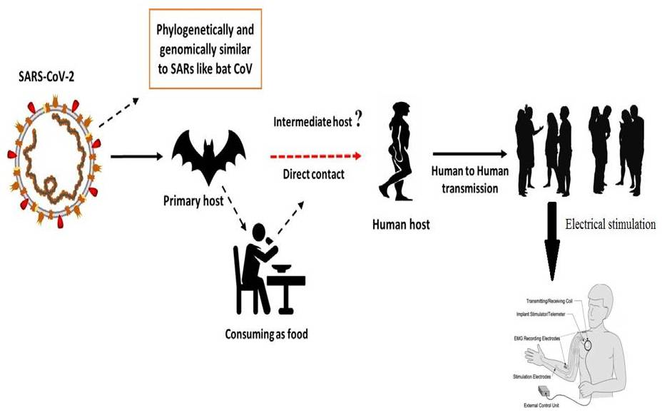

**KEY WORDS**

Electrical stimulation, Covid-19, Current, Voltage, SARS-CoV, MERS-CoV,

**INTRODUCTION**

Corona viruses are members of the Corona viridian family of the Nidovirales order. Corona refers to the crown-like spikes on the virus's outer surface; hence it was given the name corona virus. Corona viruses are small (65-125 nm in diameter) and contain a single-stranded RNA nucleic material ranging in size from 26 to 32kbs (Fig. 1). Corona viruses are classified into four subgroups: alpha (a), beta (b), gamma (c), and delta (d). Acute Lung Injury (ALI) and Acute Respiratory Distress Syndrome (ARDS) are caused by SARS-CoV, H5N1 influenza A, H1N1 2009, and Middle East respiratory syndrome corona virus (MERS-CoV), which can lead to pulmonary failure and death. Until 2002, when the world witnessed a Severe Acute Respiratory Syndrome (SARS) outbreak in Guangdong, China, caused by SARS-CoV, these viruses were thought to primarily affect animals [Zhong et al., 2003]. Only a decade later, another severe corona virus, the Middle East Respiratory Syndrome corona virus (MERS-CoV), caused an endemic in the Middle East [Wang et al., 2013].

Within the first fifty days of the outbreak, a new corona virus killed over eighteen hundred individuals and infected over seventy thousand more in Wuhan, China's booming commercial metropolis. This virus was found as belonging to the corona virus b family. The novel virus was named Wuhan corona virus or 2019 novel corona virus (2019-nCov) by Chinese researchers. The International Committee on Virus Taxonomy (ICTV) classified the virus as SARS-CoV-2 and the illness as COVID-19[Cui et al, 2019; Lai et al., 2019;WHO 2020]. As of this writing, SRAS-CoV infected 8098 people with a 9% fatality rate across 26 countries, whereas new corona virus (2019) infected 120,000 people with a 2.9% death rate across 109 countries. It shows that SARS-CoV-2 has a higher transmission rate than SRAS-CoV, which could be attributed to a genetic recombination event at the S protein in SARS-CoV-2's RBD region, which may have increased its transmission capacity.



**Figure:1.** The structure of the respiratory illness caused by the human corona virus History of the electrical stimulation therapy use in various diseases

One of the issues in this case is the use of electrical equipment for blood electrification (Black Boxes, Magnetic Pulse Generators), with the assertion that such devices can be used to treat infections such as viruses, bacteria, and yeast, as well as diseases such as cancer. These assertions have a historical basis in scientific literature. In 1990, Lyman and colleagues reported that delivering 50 to 100 microamperes of direct current through Aids-infected blood inactivated the Aids virus and halted viral proliferation (Lyman et al., 1990). This study was presented on March 14, 1991, at the First International Symposium on Combination Therapies (an AIDS conference) in Washington, DC.

The development of more effective antibiotics against bacterial infections has revolutionized medical treatment over the last few decades, resulting in a drastic reduction in mortality caused by microbial diseases; however, the widespread use of antibiotics has unfortunately led bacteria to develop defenses against antibacterial agents, resulting in increased resistance, imposing serious limitations on the options for treating bacterial infections, which is a major threat (Castro et al., 2002; Silveira et al.,2006). Bacteria belonging to the genera In the global picture of bacterial resistance, *Enterobacter* and *Staphylococcus* stand out, and the medications used to control them are often ineffective, making treatment challenging (Martins et al.,2012).*Enterobacter* is a genus of gram-negative facultative anaerobic bacilli of the *Enterobacteriaceae* family. *Enterobacter* *aerogenes* and *Enterobacter cloacae* are opportunistic bacteria that have emerged as critical care unit infections capable of building β -lactam resistance mechanisms (Regli et al., 2015).

The stronger the Amp-C gene expression by *Enterobacter*, the greater the mechanism of resistance to certain antibiotics such as cephalosporin, and cases of carbapenemase-producing bacteria has been reported (Tuon et al., 2015). *Staphylococcus aureus*, on the other hand, is gram-positive *cocci* bacteria found in healthy people's skin and nasal passages; it is the predominant etiological agent of skin infections due to its capacity to compromise the skin barrier's integrity. *S. aureus* infections can be fatal, causing pneumonia, meningitis, endocarditis, septicemia, and even systemic infections. Furthermore, infections caused by this agent have a high morbidity and mortality rate in both hospital and home-based cases (Martins et al.,2012).

Because of this bacterium's high potential for antibiotic resistance, it has emerged as a major source of hospital infections, driving it to become a worldwide concern (Almeida et al., 2007; Zavadinack et al., 2001). Since the discovery of treatment-resistant *S. aureus* in the 1950s, several outbreaks of hospital and community infections have been related to resistant bacteria, viruses, and parasites (Barradas et al., 1997). In actuality, a high prevalence of *S. aureus*-caused purulent skin infections is common in general practise and the emergency department (Sukumaran et al.,2016). Furthermore, antimicrobial drug resistance is one of the most critical factors impacting disease epidemiology, resulting in an increase in the prevalence and lethality of previously thought-to-be-under-control diseases (Barradas et al., 1997). Because of the vital importance of microbial resistance evolution and the need to prevent hospital and non-hospital infections, novel bacteriostatic and bactericidal drugs that improve the therapy of sick patients are needed. One feasible solution is High Frequency Equipment (HFE). HFE produces alternating currents (high voltage, low intensity), and its vacuum or gas glass electrodes conduct current and ionize air molecules, producing fluorescence. The physiological effects seen are due to the synthesis of ozone (O3) by the current-generated spark when it crosses the electrode, as well as the heating action of the equipment produced by the formation of an electric field. For example, local peripheral vasodilation enhances blood flow and oxygenation (Martins et al.,2012;Korelo et al., 2013). Physiotherapists and aestheticians use the device to treat skin disorders, as an analgesic, anti-inflammatory, and primarily to speed cicatricial processes(Martins et al.,2012;Korelo et al., 2013; Sa HP et al., 2010).

When O3 comes into contact with the skin, it is converted into molecular oxygen (O2) and atomic oxygen (O) due to its oxidative capacity. The effectiveness of O3 action on bacteria is ensured by the fact that it acts on the bacterial membrane by interfering with enzyme activity, reducing cell permeability, and triggering oxidation of amino acids and nucleic acids, which ends in bacterium death (Martins et al.,2012;Korelo et al., 2013; Oliveira et al., 2011). In this regard, this study assessed the bactericidal activity of HFE in typical *S. aureus* and *E. aerogenes* strains many times and at varying intensities, as well as the sensitivity of this electrotherapeutic resource on these bacteria.

Figure 2 a depicts *E. aerogenes* bacterial growth after 30, 60, 90, 120, and 180 seconds of irradiation with 6, 8, or 10 mA HFE. When compared to the control group, the spark at 6 mA had no bactericidal effect; however, a significant bacterial growth reduction occurred at 8 mA at 120 and 180 seconds, and at 10 mA, reduction could already be verified at 30 seconds; however, total bacterial growth inhibition occurred only at 10 mA at 180 seconds.

At all intensities evaluated, *S. aureus* growth was severely reduced; however, no bacterial growth was seen after 120 and 180 seconds at 6 mA. When the flashing intensity was increased to 8 and 10 mA, microbe growth was reduced after just 30 seconds of irradiation, implying that the higher the intensity, the shorter the time necessary for the equipment to provide a bactericidal effect (Figure 2 b.).

|  |  |
| --- | --- |
|  |  |
| **Figure: 2a.** At varying times (seconds), the antibacterial effect of high frequency equipment on the growth of a typical culture of *Enterobacter* aerogenes.  **Notes:** The results are given as mean± standard error of the mean. The data were analysed using one-way ANOVA, followed by Tukey post hoc. *p<0.01 when compared to the control group. | **Figure: 2b.** The antimicrobial effect of high frequency equipment on the growth of a standard culture of *Staphylococcus aureus* at different times (seconds).  **Notes:** The results are given as mean standard ± error of the mean. The data were analysed using one-way ANOVA, followed by Tukey post hoc. *p0.01 when compared to the control group. #p<0.05 when compared to 6 mA in 30 seconds. |

**DISCUSSION**

Electrical stimulation devices, in our opinion, have a solid basis for usage in the treatment of numerous disorders. Like cancer, AIDS, Herpes and many more. So here, we discuss that current Global epidemic covid-19 were spread on the earth. For this epidemic covid-19 we also use this method and break the outer surface of the corona virus and burst its cell. Use of this method to stop the replication of cell. In some case electrical stimulation can suppress the activity of cell.

**ACKNOWLEDGEMENT**

We will gratitude **Evellyn Claudia Wietzikoski Lovato and his team** who published research article on **“High frequency equipment promotes antibacterial effects dependent on intensity and exposure time”** its published in journal **Clinical, Cosmetic and Investigational Dermatology** in **2018**. This article helps the analysis of result in my review article.

**REFERENCES**

* Almeida MC, Simoes MJS, Raddi MSG. [Ocorrencia de infeccao urinaria em pacientes de um hospital universitario]. *Revista de Ciências Farmacêuticas Básica e Aplicada*. 2007;28(2):215–217. Portuguese.
* Barradas RC. [O desafio das doencas emergentes e a revalorizacao da epidemiologia descritiva]. *Revista Saúde Pública*. 1997;31(5):531–537. Portuguese.
* Castro MS, Pilger D, Ferreira MBC, Kopittke L. [Tendencias na utilizacao de antimicrobianos em um hospital universitario, 1990–1996.] *Revista Saúde Pública*. 2002;36(5):553–558. Portuguese.
* Cui J, Li F, Shi Z-L. Origin and evolution of pathogenic corona viruses. Nat Rev Microbiol 2019;17(3):181–92.
* Korelo RIG, Oliveira JJJ, Souza RSA, Hullek RF, Fernandes LC. Gerador de alta frequencia como recurso para tratamento de ulceras por pressao: estudo piloto. *Fisioter Mov*. 2013;26(4):715–724.
* Lai C-C, Shih T-P, Ko W-C, Tang H-J, Hsueh P-R. Severe acute respiratory syndrome coronavirus 2 (SARS-CoV-2) and corona virus disease-2019 (COVID- 19): the epidemic and the challenges. Int J Antimicrob Agents 2020;105924.
* Lyman WD, et al. Lab Test Results of HIV inactivation by electric current: Reporting Inactivation of AIDS Virus by Electric Current. First International Symposium on Combination Therapies in Washington DC on March 14th, 1991.
* Martins A, Silva JT, Graciola L, et al. [Efeito bactericida do gerador de alta frequencia na cultura de *Staphylococcus aureus*]. *Fisioterapia e Pesquisa*. 2012;19(2):153–157. Portuguese.
* Oliveira LMN. [Utilizacao do ozonio atraves do aparelho de alta frequencia no tratamento da ulcera por pressao]. *Revista Brasileira de Ciências da Saúde.* 2011;9(30):41–46. Portuguese.
* Organization WH. Laboratory testing for coronavirus disease 2019 (COVID-19) in suspected human cases: interim guidance, 2 March 2020. World Health Organization, 2020.
* Regli AD, Pages JM. *Enterobacter aerogenes* and *Enterobacter cloacae*: versatile bacterial pathogens confronting antibiotic treatment. *Front Microbiol*. 2015;6:392.

1. Sa HP, Nunes HM, Santo LAE, et al. [Estudo comparativo da acao do laser GaAIInP e do gerador de alta frequencia no tratamento de feridas cutaneas em ratos: estudo experimental]. *ConScientiae Saúde*. 2010;9(3):360–366. Latin.
2. Silveira GP, Nome F, Gesser JC, et al. [Estrategias utilizadas no combate a resistencia bacteriana]. *Revista Química Nova*. 2006;29(4):844–855. Portuguese.
3. Sukumaran V. Bacterial skin and soft tissue infections. *Aust Prescr*. 2016;39(5):159–163.
4. Tuon FF, Scharf C, Rocha JL, Cieslinsk J, Becker GN, Arend LN. KPC-producing *Enterobacter aerogenes* infection. *Braz J Infect Dis*. 2015;19(3):324–327.
5. Wang N, Shi X, Jiang L, Zhang S, Wang D, Tong P, et al. Structure of MERS-CoV spike receptor-binding domain complexed with human receptor DPP4. Cell Res 2013;23(8):986.
6. Zavadinack MN, Herreiro F, Bandeira COP, et al. *Staphylococcus aureus*: incidencia e resistencia antimicrobiana em abcessos cutaneos de origem comunitaria. *Acta Scientiarum*. 2001;23(3):709–712.
7. Zhong N, Zheng B, Li Y, Poon L, Xie Z, Chan K, et al. Epidemiology and cause of severe acute respiratory syndrome (SARS) in Guangdong, People’s Republic of China, in February, 2003. The Lancet 2003;362(9393):1353–8.