SAMPLING IN NURSING RESEARCH

Sampling in nursing is the most crucial part of the nursing research. To acquire this, there is a need to apprehend various types of sampling methods. Knowledge of sampling designs is fundamental for growing a research plan.
Sampling
Sampling is defined as a process in which we select a sample or a component from large group or groups of population to fulfil our research objectives. This selected sample can be any events, individuals, actions, measures required to perform research. Thus a Sample is representative of the larger population from which it is derived.
Process of selecting a sample from population is known as sampling plan.
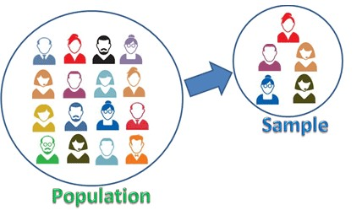
Source: https://sixsigmastudyguide.com/wp-c content/uploads/2020/12/ds1.png

Advantages
- Since it is small in size it requires less area to be covered.
- It is a time saving and cost effective process and yields faster results.
- We can estimate sampling errors by means of sample.
- Accuracy is more as sampling is done by skilled investigators.
Limitations
- Probability of bias.
- In some cases we cannot yield significant finding from sample
Two types of sampling are:
- Probability Sampling
- Non Probability Sampling
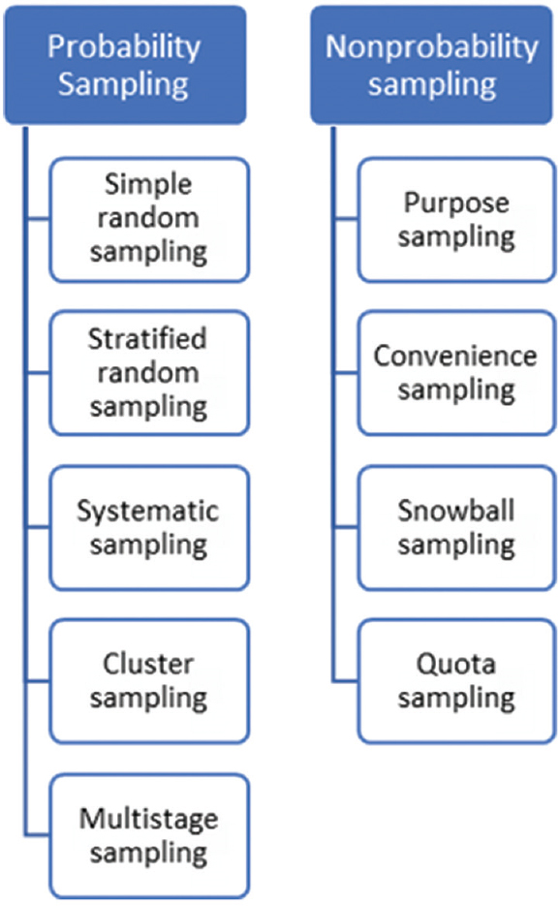
Source: Kandola D, Banner D, O’Keefe-McCarthy S, Jassal D. Sampling Methods in Cardiovascular Nursing Research: An Overview. Canadian Journal of Cardiovascular Nursing. 2014 Aug 1;24(3).

Probability Sampling:
- This type of sampling also known as random sampling is a method of sample selection by chance. In this method sampling unit in the population has a probability to be selected as sample. It is considered as “gold standard approach” of sampling. In case of homogenous population probability of selection of each member in the sample is very high.
For example: Think of a pot of cooked rice, if we want to check if the rice is cooked or not, we will pick some rice in the spoon and check whether it is cooked or not, this spoon of rice will symbolize the whole population of rice in the pot and each and every rice grain has the same chance of selection. Subtypes of Probability Sampling are:
- Simple random sampling
- Stratified random sampling
- Systematic sampling
- Cluster sampling
- Multistage sampling

- Simple Random Sampling
In simple random sampling there is similar opportunity for each and every unit of the population to be selected. Sample selection is simple and random only. This is the first-class method of sampling for the homogenous population.

Example- Let us say there are 200 students in a classroom and we have to select 60 students by using simple random sampling. The list of all students (n=200) is the sampling frame. Sample (n=50) can be selected by using random number table or lottery method for simple random sampling;
- Random number table method
- Lottery method
Advantages
- easy method
- an unbiased and fair way of selecting the sample
- each and every part of the population has similar chance of selection
- sample is representative of the population
Disadvantages
- In case of large population it is not possible to have full list of all the members

- Stratified Random Sampling
In this sampling, the population is split into homogenous groups called as strata. Sample is then selected by means of simple random sampling from these homogenous strata.
Example- In studying the prevalence of diabetes in an elder population, we can stratify the population on the basis of gender and obtain sex-wise prevalence of diabetes. We can further stratify by means of residential area such as city, village, town and can obtain area-wise prevalence of diabetes having equal representation from each group of patients.
Advantages:
- outcomes with more accuracy than other sampling methods
- good results can be obtained from small sample using strata
- representative sample
- ease of generalizations of findings from the sample to population
- less biased method
Disadvantages
- not relevant in the population which can’t be divided into subgroups.
Indications:
- in case of focus on a specific strata
- in case when difficult to get in touch with sample population
- to create association between two strata

- Systematic Sampling:
This sampling involves the selection of participants in a predetermined and orderly sequence. Here the participants are selected after a regular time interval.
Steps:
- start sampling with a well-defined structural population
- define the idyllic sample size
- do sequencing of samples
- select sample interval
E.g. First sample is randomly selected the, every 10th student sitting in classroom is included in the study.
Advantages:
- easy to generate, perform and evaluate the sample
- minimal risks
- preferred in case of diverse participants
Disadvantages
- hidden periodicity within the population resulting in sample no longer random and representative

- Cluster Sampling:
In this type of sampling, population segments are taken as the clusters and participants are selected from each cluster in a random manner. This is distinct from other probability sampling where population is further divided based on the age, gender, career etc. But here sample is selected in a random way from natural cluster e.g. villages within a district, schools within a town.
Example; list of individuals suffering from gout, if we search area wise, the regions acts as clusters and participants can be selected from clusters.
Advantages of
- inexpensive as prices of travelling and list are significantly reduced through this method
- very feasible method of sample selection
Disadvantages
- Sampling bias: Population will have biased opinion if the group selected has biased opinion
- Sampling errors: It has high chances of error as compared to the other methods of probability sampling

- Multi Stage Sampling:
In multi stage sampling is performed in many stages.
Example: In a national survey, random number of cities is chosen in all the states followed by random number of colonies and streets. In the third stage, houses will be selected.
Advantages
- suitable in primary data collection for geographically dispersed area
- flexible data collection as per need of investigator
- different sampling methods can be used at different stages
- minimal cost and time for collection of data
- accuracy more than cluster sampling in spite of using with the same sample
Disadvantages
- introduces considerable degree of subjectivity
- non-representative sample
- sample highly prone to bias
Non Probability Sampling:
In this type of sampling each and every unit of the population does not have equal chance of being chosen as the sample. It is opposite to probability sampling and is used in both qualitative and quantitative researches. This type of sampling is less expensive but chances of selection bias are more as compared to probability sampling. Sample selected don’t represent the entire population. Its types are:
- Convenience Sampling
- Purposive sampling
- Quota sampling
- Snow ball sampling

- Convenience Sampling
In convenience sampling members of a sample are selected on the basis of their convenience and easy approachability for a researcher. This method is most commonly used in pilot study.Example- People in the neighbourhood or street.

Advantages
- sample selection by this method is very easy and inexpensive.
- suitable for pilot research and generation of hypothesis
- quick method of sample selection
Disadvantages of convenience sampling:
- higher chance of sampling error

- Purposive Sampling
Purposive sampling is also known as subjective/selective/judgmental sampling. Here purpose of study defines the selection of sample units. This method can be used in case of less number of participants and is based on the researcher’s knowledge and experience. This method is also used to filter the samples selected by other techniques.
Advantages
- gives opportunity to researchers to justify their sample selection
- provides several non- probability sampling techniques for a researcher to draw on
Disadvantages
- prone to researcher’s bias
- representativeness of the sample is not maintained

- Quota Sampling
This method is based on the selection criteria defined by the researcher on the basis of definite characteristics which serve as a quota for sample selection. This method is similar to stratified random sampling but is a non random method sampling.
Example: In a sample of 200, the researcher wants 30% women & 70% men in the sample and would continue selecting the sample until his quota for men is complete i.e. 70%
Advantages
- useful in case when there is need of representative sample but probability sample can’t be obtained
- quicker and easier to carry out as there is no need of sampling frame
- avoids over presentation of data and improves strata representations within the population
- provides easy comparison of groups.

Disadvantages
- sampling error can’t be determined as sample has not been chosen by random selection.
- can cause sample bias
- cannot make generalization of findings
- results in overall increase in sample size which would increase costs of the research and time duration.

- Snow Ball Sampling
This method of sampling is also known as sequential or chain sampling. Here existing study subjects helps in recruitment of other subjects from their links. Thus, the sample size increases in number like a rolling snow ball.
Example: In case of drug addicts or in case of sex workers or HIV patients
Advantages
- quick and easy method of sampling
- cost-effective
Disadvantages
- chances of sample bias and sample error can be high
- It is difficult method of sample collection if the target population is uncooperative

Important Points:
- Selection of a sample depends on the population of interest.
- To yield good results sampling should be planning carefully.
- Gold standard in sampling methodology - Probability sampling
- Generalisation of the findings – Probability sampling
- No generalisation of findings - Non-probability sampling

REFERENCES
- Sharma G. Pros and cons of different sampling techniques. International journal of applied research. 2017 Nov 26;3(7):749-52.
- Bhardwaj P. Types of sampling in research. Journal of the Practice of Cardiovascular Sciences. 2019 Sep 1;5(3):157.
- Kandola D, Banner D, O’Keefe-McCarthy S, Jassal D. Sampling Methods in Cardiovascular Nursing Research: An Overview. Canadian Journal of Cardiovascular Nursing. 2014 Aug 1;24(3).
- Curtis AC, Keeler C. Sampling design in nursing research. AJN The American Journal of Nursing. 2021 Mar 1;121(3):53-7.
- Gray JR, et al. Sampling. In: Burns and Grove’s the practice of nursing research: appraisal, synthesis, and generation of evi - dence. 8th ed. St. Louis: Elsevier; 2017. p. 329-62.
- Elfil M, Negida A. Sampling methods in clinical research; an educational review. Emergency. 2017;5(1).
- Acharya AS, Prakash A, Saxena P, Nigam A. Sampling: Why and how of it. Indian Journal of Medical Specialties. 2013 Jul 7;4(2):330-3.
- https://sixsigmastudyguide.com/wp-c content/uploads/2020/12/ds1.png

