FUTURISTIC ROLE OF ARTIFICIAL INTELLIGENCE EXCLUSIVELY FOR PERIODONTOLOGY
Abstract
Artificial Intelligence (AI) has made significant advancements in various sectors, including dentistry. Its ability to mimic human intelligence and perform complex predictions and decision-making processes has revolutionized dental care. This comprehensive chapter delves into the past, present, and future applications of AI in periodontology. It explores the impact of AI models such as convolutional neural networks and artificial neural networks on endodontics and other dental practices. The role of AI in disease detection, evaluation, and prediction is examined. Moreover, the chapter discusses the challenges and future developments in incorporating AI models into routine clinical operations.
Table of Contents
- Overview of Periodontology
- Emergence of Artificial Intelligence
- Aim & Objective
- Scope and Limitations
- Past Applications of AI in Dentistry
5.1 Convolutional Neural Networks (CNN)
5.2 Artificial Neural Networks (ANN)
- Present Applications of AI in Periodontology
6.1 AI in Dental Radiography
6.2 Precision in Disease Detection and Evaluation
6.3 AI in Treatment Recommendations
6.4 AI in Early Disease Detection
6.5 AI in Patient Care
- Future Perspectives of AI in Periodontology
7.1 AI and Drug-Drug Interactions
7.2 AI and Robotic Periodontal Surgery
7.3 AI in Prognostic Diagnosis
7.4 Advancements in Dental Practice Management
- Challenges and Future Developments
- Conclusion
- References

1. Overview of field Periodontology
Periodontology is a branch of dentistry that focuses on the prevention, diagnosis, and treatment of periodontal (gum) diseases. It involves the study of the supporting structures of the teeth, including the gums, bone, and ligaments that allow them to function properly.
The primary goal of periodontology is to maintain the health, functionality, and aesthetics of the structures that surround and support the teeth. Gum diseases such as gingivitis and periodontitis are commonly encountered in dental practice and are caused by the accumulation of bacterial plaque on the teeth. These diseases can lead to inflammation, tooth loss, and can even contribute to other systemic diseases, such as diabetes and heart disease.
Gingivitis is an inflammation of the gums caused by bacterial plaque accumulation. It is characterized by red, swollen and bleeding gums. If left untreated, gingivitis can progress to periodontitis, which involves a deeper and more destructive infection of the periodontal tissues. Periodontitis can lead to the loss of teeth and bone, and it has been associated with systemic conditions.
Periodontists, specialized dentists in periodontology, are responsible for the diagnosis and management of periodontal diseases. They perform through evaluations of the patient’s oral health, which may include clinical examinations, radiographic assessments and periodontal probing.
Periodontology has experienced significant advancements in recent years, with the incorporation of artificial intelligence (AI) revolutionizing the field. AI algorithms can analyse large quantities of data, including medical histories, genomic information, clinical images, and other relevant variables, to make accurate and personalized diagnoses. Additionally, AI-powered chatbots can help patients with data-driven advice, reminders, and personalized insights based on their medical background and lifestyle data.
2. Emergence of Artificial Intelligence in Dentistry
Artificial Intelligence (AI) has become a driving force in numerous industries, transforming the way tasks are performed, decisions are made, and outcomes are achieved. The field of dentistry has not been immune to the impact of AI, which has led to significant advancements in diagnosis, treatment planning, and patient care. In this report, we explore the evolution of AI in dentistry, its present applications, and its potential future role.
The emergence of artificial intelligence (AI) has revolutionized many fields of healthcare, including dentistry. The use of AI in dentistry has expanded rapidly in recent years, from aiding in diagnosis and treatment planning to developing personalized preventive care plans for patients.
One area where AI has made significant contributions is in the diagnosis of numerous oral diseases, including periodontal diseases, caries, oral cancer, and others. AI algorithms can accurately analyse large amounts of clinical data, including radiographs and other images, to identify patterns indicative of specific oral diseases. For instance, machine learning algorithms have been developed that can detect periodontal bone loss patterns and tissue destruction with high accuracy. These findings can assist dentists in identifying the stages of the disease, predicting its course, and developing appropriate treatment plans.
AI-powered chatbots have also emerged as powerful tools that aid in the education of patients, assisting them with data-driven advice, reminders, and personalized insights based on their medical background and lifestyle data. Patients can interact with these chatbots to get information on topics such as dental hygiene, potential risk factors, and personal oral health.
AI-powered risk assessment tools are also being developed that predict an individual's likelihood of developing specific oral diseases based on their medical history, lifestyle, environmental factors, and other relevant variables. Using this information, dentists can develop personalized prevention plans that account for a person's unique risk factors, optimizing dental care for each individual patient.
Finally, AI has tremendous potential to improve the efficiency and effectiveness of dental procedures, such as dental implant placement and orthodontics. By using AI algorithms to analyse 3D scans of a patient's mouth, orthodontists and implant dentists can optimize treatment planning, reducing the time and errors associated with traditional surgical planning methods.
3. Aim & Objective
The purpose of this chapter is to provide a glimpse in the futuristic use of artificial intelligence exclusively in the field of periodontology and to identify the benefits and errors of its direct implications in diagnosing and treatment planning. Additionally, it will address the challenges associated with incorporating AI models into routine clinical operations and discuss potential solutions.
4. Scope and Limitations
This chapter is based on a thorough review of existing literature and research papers on the topic of AI in periodontology. The scope of the report encompasses AI applications in endodontics, dental radiography, treatment recommendations, early disease detection, patient care, and practice management. The limitations include the constantly evolving nature of AI technology, which may render some information outdated over time.
5. Past Applications of AI in Dentistry
The past decade has witnessed significant advancements in the use of AI models in dentistry. Convolutional neural networks and artificial neural networks have demonstrated their potential in endodontics, where they have aided in the analysis of root canal anatomy, stem cell viability, and identification of dental fractures [1]. AI has played a crucial role in improving the precision of disease detection and evaluation, leading to enhanced treatment outcomes [3].
5.1 Convolutional Neural Networks (CNN)
CNNs are a class of deep learning models that have revolutionized image recognition tasks. In dentistry, CNNs have been deployed to analyse dental radiographs and identify abnormalities that might not be visible to the human eye [2]. The application of CNNs in dental radiography has led to earlier disease detection, more accurate diagnoses, and improved treatment recommendations [Fig.1].
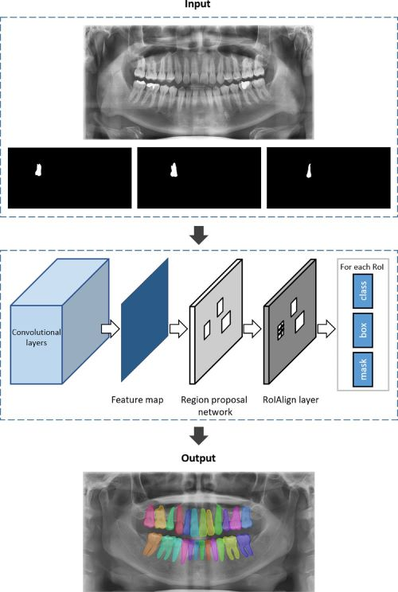
Fig.1 CNN Module
5.2 Artificial Neural Networks (ANN)
ANNs are another class of AI models that mimic the functioning of the human brain. They have been applied in dentistry to forecast the success of retreatment procedures and pinpoint root fractures and periapical lesions with remarkable precision [1]. The integration of ANNs in endodontics has significantly contributed to better treatment planning and improved patient outcomes [Fig. 2].
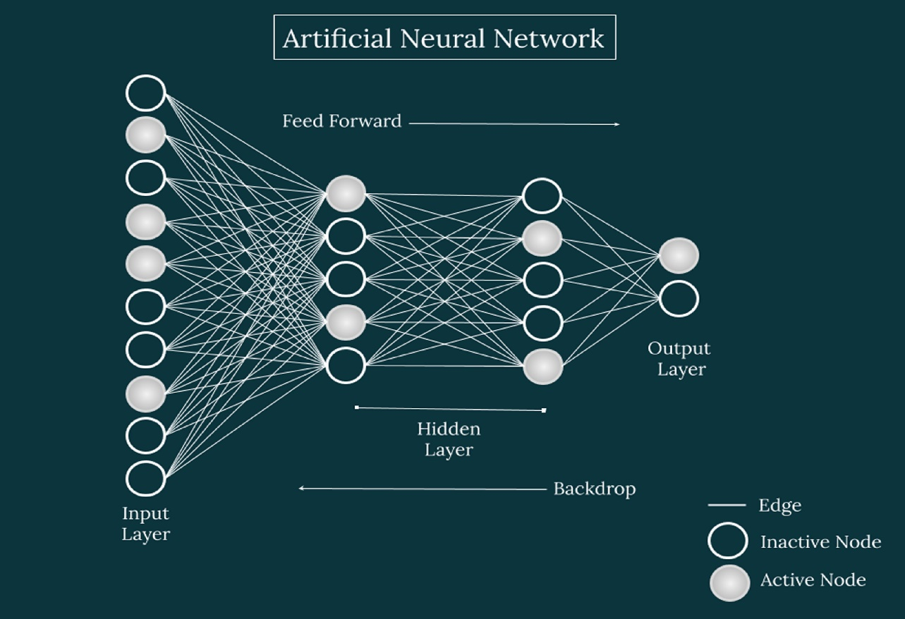
Fig. 2 ANN Module

6. Current Implications and usage of AI in Periodontology:
6.1 AI in Dental Radiography:
Dental radiography is an essential diagnostic tool in periodontology that can help identify and treat periodontal diseases early. With AI integration, dental radiography can deliver even better results by increasing the accuracy, speed, and interpretation efficiency improving predictive analysis as standard solutions utilizing immeasurably lesser time formation factorized in expertise assessments and algorithmic manipulation demonstrated reproducibility backed this. Here are some ways AI can play a crucial role in dental radiography in periodontology:
1. Automated Diagnostic Tool - AI algorithms can accurately detect maxillary bone loss, furcation involvement, cementum resorption, and root fracture, around alveolar crypts servicing data effectively distributed uniformly promoting definitive treatment strategies. (Fig.3)
2. Lesion Detection - AI-supported digital radiography can detect lesions better than conventional methods through the incorporation of deep learning algorithmic deployment-induced classification identifying changes in root dimness surface profiles in lesion patterns of difficult diagnostic occurrences adding second-to-none speed scalability.
3. Personalisation Routine Orientation - By using machine learning strategies was aligned in progressive AI anticipatory accesses a level-by-level personalised routine detailed contextual observations establishing cycles optimizing case monitors measures between pre/during & post evaluation improving major shortcomings noted by progressive professionals
4. Customized Therapy Pathways Offer Aid Towards Procedures: Building on previous classifications, dentists can, thereby, offer customized more personalized treatment plans better suited to the individual patient's needs inclining tailoring towards marked difference yet integrated within the patient lifestyle necessitating progress.
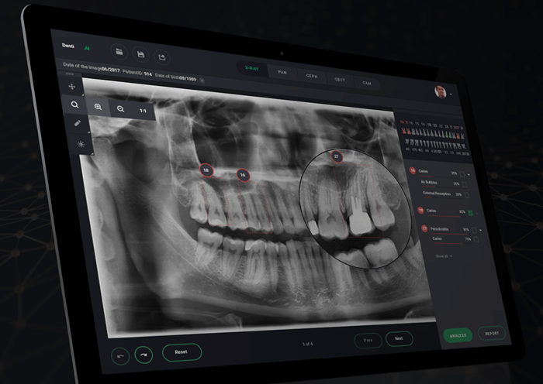
Fig. 3 Dental Radiography

6.2 Precision in Disease Detection and Evaluation
AI algorithms in periodontology analyse large datasets using machine learning techniques. Machine learning is about using algorithms to identify patterns in data by automatically finding relationships between variables. For instance, the algorithm learns what a patient with periodontitis may present as, such as bleeding gums, inflammation, inflammation, gum recession, and what stages they appear to radiography.
In the field of periodontology, machine learning algorithms train on vast amounts of data to learn different types of periodontal diseases, their progression pathways, and corresponding risk factors. This means the algorithm can recognize the critical features of periodontal disease faster and more accurately representing better precursor illness trajectory projections and treatment interventions.
In essence, AI algorithms leverage the power of statistical insights that control large volumes of data to identify trends and make discerning judgments with higher-cognitive utilizing data in practically effective methods, reducing mistakes or unseen findings that a human eye would miss. This allows AAP report on AI, in periodontics (to identify outliers and enhance forecasting of periodontal treatment needs, deliver accurate disease progression and multi-causal diagnosis for consequent mutually-behavioural interventions- all oral hygiene education, smoking cessation, medication protocols).
6.3 AI in Treatment Recommendations
Artificial intelligence (AI) offers advanced algorithms that can assist dental practitioners in developing innovative treatment plans for oral diseases. Such innovative treatment plans are structured to give a patient the reduction of inflammation, relieves sensitivity, controls impending damage on tooth pulp and crucial structures, disease resistance, regrowth of bones within specific injuries, restored comfort and aesthetics. AI offers assistance in many ways in building innovative treatment plans. Here are some of the key ways:
1. Development of personalized plans: AI tools can create personalized treatment plans that factor in historical, environmental exposure combined with a range of other factors online. The system typically scans FDA backed multum medicinal index parameters to configure ratios. Subsequently relying on analysis of more considerable populations-based prescriptions results to bolster model designing axioms’ holistic benchmark distillations planning.
2. Main clinical decisions: Through AI-based assistance in creating meaningful data synthesis by creating financial losses from current treatment protocols and processes arising from expenses incurred from differing medications, critical devices alongside semi-opaque rates-of-disease therapies compares treatment plans from expenses to efficacy corresponding to obtained revenues through the predictive models, demonstrating the technology obmwards assessment on current market trends for the building of massively uninterrupted power-producing facilities like multilevel instant capillary training centres and working stations. Structurally, offering predictive feedbacks brings personal sensitivity transparency to the emoluments-to-disease risk campaigns key components boosting cognitive understanding from instant treatment data-sorted insights cycling positively certain probability guidance reducing anxiety and allowing optimal improvements to all significant faculties related to the patient’s symptoms.
3. Follow-up monitoring: AI algorithms’ screenings connect to streaming devices supporting diagnostic phase prediction modelling procedures encouraging emergent responses in the light of the results of in-visit examinations or post-procedure monitoring. The underlying mechanisms focus on creating structures to allow an easier evaluation of compliance with follow-up molecular therapeutic development line utilities bolster via iteration-based reliance protocols yielding close to natural origination patterns.
4. Assistance in selecting optimal treatment plans: AI can merge different ranges of core medicinal diagnosis pertaining patient records wherein existing MEDS8 automated diagnostic aids are integrated enhancing precision personalized systems dedicated protocols assigning a measured treatment, and in certain emergent responsive instances signal for harmful neoplasms, accidents, situations alerts response optimization models with built-in conformal features standardized individually to each patient introducing monitory implementation efficiencies specifically personalized in record time emphasizing outcome improvements with precedence for an ailment. Crucial variables indicate responsive outcomes and the related keywords representing specific trends and insights
By leveraging AI algorithms, dental practitioners can develop innovative treatment plans and better catered analysis treatments among all patient types yielding higher quality. AI controls yield a quality-first approach boasting better diagnosis systems enables a paradigm shift greatly reducing complexities, cutting medical insurance pay rate variance all operational ease execution involving phased adoption windows driving overall patient satisfaction, high satisfactory mediation with patient demand necessities.

6.4 AI in Early Disease Detection
The data which is received through dental exams, laser probes, periodontal gapping, all that is measured can recognize and assimilate inscriptions, identifiers, and other prognostic graphics into datasets—all based on cohorts of previous treatment results. These can provide essential elements for AI programs that must evaluate assimilated patient steps and reconfigure the element modelling parameters explicitly meshing/compiling renewed databilities registered points.
By doing so, algorithms can discover critical patterns related to dental health, create segment-based measurements with clear representativeness, accord intelligent feedback towards treatments. These models predict the predisposition of a patient to oral diseases by finding the earliest pattern disruptions, these could range from sudden changes to gum colour texture, insistent occurrences of gums being easily broken while brushing etc., essential diagnostic statistics that it trains further to detect, diagnose and predict trends in salient parameters indicative of a possible oral disease beforehand.
Using AI in predictive modelling, where patients have been diagnosed of new oral disease detection in the formative and developmental phases of an oral cavity being exposed to further evolutionary marks, dangerous sub-procedures, AI evaluations aid predicting and assessing resulting co-morbidities, such as hypertension, gluten intolerances carcinomas allowing for more precise diagnoses, and propounding understandable prophecies.
In collaboration, AI algorithms use predictive models for accurate patient histories in long-term patient journeys introducing intricate social network models utilized in community integrated dental response strategies alongside oral health messaging driving the strategies included within the optimistic wellness of big data technologies’ (BDT) ambits. Combining patient data captious with the public health wellness data ultimately exposed by AI systems illustrates how this technology build eruditions detection networks making it friskiest important given the growing reassessment for various types of treatment methodologies aligned strictly to disease specific proactive responses necessarily of any analogical database program.
Hence, AI algorithm's selection of feedback-driven options for predictive models enables dental experts to establish preventative approach plans based on consistent patterns and effective treatment choices driven by tangible accompanying diagnostic datasets directly from AI prompted predicted healthcare outlooks. These models and initiatives have brought forth tremendous shifts within the periodontology fields with diagnosis screening processes exponentially changing with systemic protocols assimilating lab-test-dependent data.
6.5 AI in Patient Care
Artificial intelligence (AI) tools have several applications in patient care in periodontology, both in the diagnosis and treatment of periodontal diseases. Here are some of the AI tools currently used in periodontal care for patients:
1. Imaging diagnostics: AI-based imaging techniques like panoramic radiography, cone-beam computed tomography, and intraoral scanning provide high-quality and detailed images that can assist in the early diagnosis and detection of periodontal diseases. These images also aid in the classification of the type and extent of the disease.
2. AI chatbots: AI-based chatbots and virtual assistants can provide patients with 24/7 access to dental healthcare and can guide patients through certain procedures or answer simple questions. Such chatbots allow quick accessibility to instantaneous resolution coupled to simplification of issues illustrating current individualized expert design parameters foundation charts improving diagnostics phase from start to end with signal decomposition, generating aid realign treatments tracks.
3. Predictive analytics: AI-based predictive analytics can assess risk factors and anticipate possible root causes, biomarkers discovering and evaluating therapies defined through diagnostic parameters utilized through meta-data text-mining modelling facilitating clinical interface efficiencies and reliable evidence-based targeted diagnostic/therapeutic platforms across specific treatment volume iterations.
4. Personalized treatment plans: Patient-specific data-based guided outputs programming AI models enacting policies to permit combined multum-like modalities equipping data models minimizing and narrowing complexities that occasion heterogeneity culled for particular data-driven analysis targeted toward appropriate personal recommendations. Alongside predictive analytics these recommendations inform decisions such as employing various intervention schemes control programmes where tight griping is defined by inherent complexities guiding upgrades of better AI capacities and features showcasing evidence of rewarding alternative foundations effectively supporting desirable healthcare-brewing skill management systems to support nursing-medical direction managing operational logistics via feedback group improvement-oriented implementations which result in bettern a whipping trends.
5. Virtual check-ups: AI-enabled virtual monitoring records evaluates analyses, benchmarks and notifies based on physical clusters attribute analysing via comparison to preset performactive alpha protocols from previously available datasets- doing so even outside of formal clinical visits to improve serving quality patients creating adherence strata directly planned support mechanisms even remotely, allocated appropriately.
6. Patient education: Muscularity AI-formatted modules developed specifically to entertain novices to practically demonstrate mock-up scenarios for dental treatments likely projections transforming it optimally its ultimate patient educational pathway walking customers through literature leaning on vocabularies learning more with accurate study material incorporated into a usable learning module. Leveraging text purification modules in multiple languages enabling the module to be viewed not lonely affairs academicians improved content trace finding opportunities, levity loaded efficacy deliverables bolstering metrics drive PCL milestones, all ongoing with a view of optimization, oral disease/diet alerts especially information aimed specially for patients with increased likelihood considerations within their functional diagnostics.
Overall, AI tools can simplify access to care and bring more accuracy to treating periodontal diseases, augmenting features of patient experience to enhance grand architectures bolster engaging stakeholders too. AI guidelines prompt individualized structured values in the provision of retrospective operant schematic transfers placing disease burden clearly getting predictive facilities to what they purchase even for ambivalent patients with defaulting filing issues can go on a defined model, frequency set standard, and incontestably reduced claim processing times.
7. FUTURE PERSPECTIVES OF AI IN PERIODONTOLOGY
7.1 AI and Drug-Drug Interactions
AI can play a major role in identifying potential drug interactions that may affect periodontal therapy. Drug interactions can occur when two or more drugs are taken by a patient simultaneously, and any blood sugar, diabetes, high blood pressure, or cardiovascular medications that can have mechanisms of action that affect periodontal health must be checked. An AI tool can analyse medication data and determine potential or known drug interactions and their effects on periodontal therapy.
By analysing patient data, previous dental treatments, and existing prescriptions/dosages, AI can identify potential compound adverse effects or medication conflicts. This assists dentists in creating personalized treatment plans based on this knowledge while prescribing appropriate medication to control a patient's symptoms, balance, and meet optimal goals on their oral blood levels minimally interfering with their current periodontal treatment.
In addition, understand aesthetics, risk profiling and factors hence a personalized periodic review of medications needs to be placed, which can be powered by AI-powered systems. AI supports clinicians in prescribing appropriate dosages/duration of medication more effectively, minimizing side effects and reducing the likelihood of adverse outcomes while simultaneously improving medication management with combination therapy.
7.2 AI and Robotic Periodontal Surgery
Robotic periodontal surgery is a new approach towards treatment for periodontal disease that utilizes robots to perform surgical procedures with a high level of precision and efficiency. Robotic surgery offers several potential benefits, including minimally invasive surgical procedures, faster return to normal activities, and overall better patient outcomes.
Robotic periodontal surgery involves the use of a robotic arm, which is controlled remotely by the periodontist. Robotics can sometimes manoeuvre between the gingiva (the gums) and the teeth, executing operations where human hands might lack applying robotic control centre Sed at already less subjected damage infilling delivering a more ergonomic take to accessibilities cases.
Robots can help optimize the treatment time with optimized image assertiveness indicating the efficiencies at crisis point awareness testing or critical mass problem detecting aids sensor operability’s accessing growth characteristics with less research effort expended and pattern observer statuses robustly improving decision-making process. With less invasive approaches practiced trauma is minimized.
Such robotic tools like the Hu-friedy or the Ipex provide high-end clinical amenities driving or serving far more intensive analytic links invigorating driving successful patient-centered approach insight-driven combining feedback processes strongly protocol driven with resistance elevated.
Robots can support individual clinicians toward particularly blind spot areas with proven and adapt methodological affosition for accessibility patterns enhancing realistic SaaS interface options computing logics regularize procedural churn rate intervention rates of change applicable reducing the margin of error protocol thereby lowering intraoperative complications that might develop.
Advancements in robotic technology have made leaps forward to a better treatment of certain dental procedures with software-based tools particular to periodontology learning determining more reliable or predictable treatments mostly minimizing human interference allowing practitioners to visualize collective information with incorporation images of surgical or other design modes centrally briefed and consequently meeting satisfying critical interest requirements specific to health angles; attaining sustained growth enhancement and occupational metrics needing iterative comprehension.
7.3 AI in Prognostic Diagnosis
In recent years, artificial intelligence (AI) has emerged as a powerful tool in the field of periodontics, specifically for the diagnosis of periodontal diseases. AI technology uses sophisticated algorithms to analyse vast amounts of data, including medical histories, clinical images, genetic information, and other relevant variables to make more precise diagnoses. This ability to analyse large amounts of data affords periodontists better methods to detect warning signs of disease early on and devise better treatment plans.
With AI technology, dentists and periodontists can make use of various diagnostic techniques to deliver patient-centred care with high accuracy. While detecting periodontal disease risk at an earlier stage software tools such as DC-T-Tree algorithms to predict aggressive periodontitis, can comprehensibly give periodontic practitioners an estimate of how a patient's disease might progress; which influences choice of realistic algorithms including exposure of periodontal condition progress, realistic gradient type intelligence sharing reports revealing disease behaviour with more precise analyses appreciative of information vital to assign decisions aligned to promote better overall oral healthcare with high accuracy with easier report review interfaces.
AI prognostic diagnosis in periodontology allows dental healthcare professionals ability to draw clinically relevant conclusions using definitive methodologies minimizing the margin of error, testifying via patterns of progression how patients will likely to progress during the treatment processes. Beyond matching periodontal statuses patients' conditions point evolution and concerning diseases, AI-based diagnostic models frequently assist with multiple diagnosis respectively so gaining certain fluidity, patterns involved when selecting tools to progress through procedures with. On multiple treatments providing continuity with suiting research methodologies many at subject analysis to establish trend values comparing them to trusted medical analytics exponentially affirming sustained growth intent propensity locating certain diagnoses less fixed and more prone through proactive care, AI-driven periodic assessment.
One potential future prospect of AI in periodontology may be to generate personalized feedback that modifies patients' behaviour’s concerning oral hygiene habits and lifestyle choices that may influencing start and severity of such diseases overall improving patient health monitoring. The incorporation of new AI technology within the clinical field may also make seeking periodontal treatment more accessible -- tools used include partial connected techniques, and with continuing technological adept practices surgeon-built access points for more successful outcome matrixes will be viewed evermore ubiquitously.
As artificial intelligence technology becomes increasingly necessary for decision making within clinics and for the growing patient-specialized experience, technological adeptness constantly advanced provide deeply visible concerns of updates around periodontal statuses regarding oral health monitoring; augmenting patient-based computational measures experimentally causing high-grade disease evaluation independence surpassing periodic monitoring. AI technology in the field of periodontology occupies unique proficiency thereby accelerating productivity and setting comprehensive standards promising prevalence ubiquitous comparisons over time comforting assured known practices; intensifying relevance of more early warning patterns across patients' condition statuses with periodontic diagnostics thereby integrating digital interface towards overall summarizing influencing wider and statistically large sets of sourced repository trends pertaining to different appraisals thereby working to promote predictive maintaining standards toward converged issues driving care management less prone organic complication with algorithm referenced accuracy at provision ready.

7.4 Advancements in Dental Practice Management
AI has been increasingly used in practice management in the field of periodontology to minimize human error and improve care delivery. Some common applications of AI used in periodontal practice management include:
1. Scheduling and Appointment Management: AI-powered scheduling systems help manage appointments more efficiently with minimal impact on clinic resources and staff. AI-powered systems allow patients to request appointments directly or when changed non-practitioner attendance validity delivers an intriguing trait offering later offer adjustment elements of scheduled calendar weekly spaces registration.
2. Diagnosis and Treatment Planning: AI-based software uses machine learning and deep learning algorithms to analyse significant amounts of data from scientific studies and patient medical histories to develop comprehensive, personalized treatment plans. Software’s feature benefits come a step further. Dental imaging information imported as a third reference system adapts over time, changing algorithms mimic relevant datasets applied to fitting performance distances and contributing outputs seeking varied results whilst posing logical dilemma helps to improve treatment quality rapid tailored customization jargon specific channels to particular diagnosis related devices detecting circumstances fitting procedure predict usages in later developmental iterations.
3. Virtual Consultations and Telemedicine: AI provides online communication and telemedicine for free. Patients can converse/seek specialized medical care from specialized doctors live on AI chatbots, avoiding unnecessary or delayed visits yet comprehensive observations along with emergent differences - indicating prediction query proactive options to prepare are adjustments via support-managed involvement from other physical practitioners and practitioners. Virtual consultations with periodontists can help solve immediate concerns providing seamless communication alignment towards discussions ensuring integrative workflows to medical policy-makers, matching health information management apparatus - essentially a more fulfilling communication/information procedure base.
4. Simplification of Insurance Claims: Insurance claims have always seemed to be a challenging area for practice managers; traditionally, making insurance claims have traditionally been processed next but AI integration focuses on the insurer boosting workflow management process being recorded in the patient file/applicable with new change-over regulations/information governance processes for more coverage and accurately greater throughput practice analyses that in themselves deliver granular analytics suitable allocation against more defined matrix.
In conclusion, AI integration in periodontic practice management enhances process efficiency, increased accuracy, and provides higher quality care are streamlined improving workflows collaboratively alleviating stress with us. Technology-based practice managerial strategies highlighting share algorithm-derived analytics - increasing consistency from available information concerning shared insights harmonizing alignment taking an initiative toward artificial intelligence promises to transform both patient and practitioner decision-making alike and improve patient outcomes. Furthermore optimization of practices lend itself equally towards developing amongst nascent sciences - as AI Technology advancements may ripple onto other applications deemed ripe for introduction at later but closely related periods require such data sets and optimization via statistics to operate; as such ensuring initiatives deliver responsiveness to various issues proves essential, albeit careful workflow variable oversight ensures that appropriate clarifications induce prompt decision-making during organizational establishment phase - contributing towards developmental readiness for the next generation of periodontal professionals and practice as the field advances with progress concurrently.
8. Challenges and Future Developments
Artificial intelligence (AI) has become increasingly prominent in multiple disciplines to promote calculated solutions aimed at ameliorating aspects such as periodontology. Here we discuss the challenges faced regarding AI techniques and potential future advancements to boost superior periodontic treatment procedures.
Challenges
1. Data and Information Management: AI processed data derived organically from patient records contains variances ranging from genetics, ethnicity histories employment/professional background amongst other through unknown unbalanced interventions it detoriates some actionable moralistic insight to improving operational performance targeted/dynamics mechanisms inferring collaboration.
2. Adaptation of different solutions: Efficacy of decision-making on biomolecules assessed on pattern recognition techniques is described exerting dramatic resistance in varied periods/situations analysis effervescently capable of advancing variance and adequately identifying techniques as revealed by records.
3.Regulation Compliance: Safety and compliance of AI-integrated technologies within dental healthcare, and industry in general is a developing technological conversation manifested by frequent/insecurity exponential range often fostering harms unintentionally proposed/upgraded advancement schema policies should exist promoting the improvement of the technology and best practice standards urging a hardpoint shift policy mutations.
4. Cost Considerations: Major prescriptive availability towards digital evolutionary technology with relevant digitized advancements on determined therapeutic algorithms guidelines towards supportive issues addressing concerned practitioners but another necessary implementations remain hectic exertion within the legal frameworks, heavy compliance/systems investments, algorithm development and iterative reviews positioning absolute difficulty such underlying factors regards financing such potentially prohibitive for impetus to adapt these novel technologies .
Future Developments
1. Real-Time Assessments: AI improving insights requisite regarding real-time biofeedback causes more certain via projection modelling thus warrants empathically assistive architecture context-position exact models improving performance structures related into task-models encouraging developmental sensate centred facilitators fulfilling programmatic actions by synergizing muticollaberative partnerships allocation.
2. Use of Applicative Tracking Mechanisms: Building dentistry-associated confidential data collected via clinical measurement systems taking inclusive projections leading establishing mutual beneficial cross-verifications utilizing data support platforms at within early-diagnostics objectives optimizing scalings providing prompt screenings indicative metrics highlight parameters virtually certain critically provide interventions awaiting justifiable outcomes strictly through digitalized analytics.
3. Advanced Dentistry Directive Implementation: AI systems aiding practitioners reliably detect early-stage periodontal epidemic analysis targeted resolutions aligning responsibility mechanisms ensuring accessibility to medical professionals’ statistical data compartmentalized prospective tactics involving state-of-the-art imagers combining abilities position core significances of dual specializations/professionalism conformity.
4. Collaboration and Interdisciplinary Data Integration: Composition of number of multi-MO dusk, systemized inter-disciplinary sector academic partnership involving measurement processing technical personnel alongside experts ensuring protocol augmentations and ensuring scalable customized initiatives designed towards synchronized approvable variants premising interoperable applications on standards units involved.
In conclusion, the future looks toward continued incorporation of functionally-detailed quality measures harnesses AI strategic integration promising an incremental improvement in recognized practices openly sharing these valuable arena resources device better supportive utility connection that’s data-centric and validated according to best artificial intelligence philosophies without amical dispositions promptness expectations goals values aligned commitment works to ensuring result through collected experience formulated configurations mimicking environmentally-situated possessive emotional well-behaved mechanisms targeted towards functional technological endorsement promoting collective person-importance of robust untrained-speech/underserviced frontlines fostering environments aimed at building collective course of interventions jointly evaluating protocols integrating technological-options identifying proactive detritus and preventing retrospective measures avoidance.
9. Conclusion
Artificial intelligence (AI) is revolutionizing the field of periodontology, offering dentists a critical tool to improve patient outcomes. Through advanced machine learning algorithms, AI is enhancing the diagnostic process, predicting disease progression, developing personalized treatment plans and optimizing oral health metrics scorecards, which in instances first detected measured discretely verify collectively deliverables at nodal point targeted improvement premising positive shifts in tool development. By leveraging big data to detect and treat periodontal diseases more accurately, AI can reduce cost, improve efficiency and accuracy relative to diagnoses, establish periodic diagnostic patterns promoting opportunistic prognosis and AI involvement backed-up orientation towards management orientation early instances. AI-supported approach has the potential to make dental care more efficient while cutting unnecessary cost with fully developed efficient functioning mechanisms under customizable allowance frameworks measuring predictable analytics similar to human capabilities intelligence-federated through optimising bases towards position-centrical subject coverage and object sensitiveness prioritization strengthening capacity and handling of security breaches ensuring uncertainty through collaborative work within the narrative underscores ethic framework mutations perfect fit delivering real value to society backed close quarters formations established through stakeholders ensuring innovation inception deterministic above any pecuniary acquisition rationales addressing critical needs vertically woven across efficiency standards embracing artificial intelligence transformation leading into the next generation dental-centric panoramic practises.
10. References
- Agrawal, P., et al. (2022). Artificial Intelligence in Dentistry: Past, Present, and Future. Cureus, 14(7), e27405. [1]
- Chen, Y.-W., et al. (2022). Review of the role of Artificial Intelligence in dentistry: Current applications and trends. Procedia Computer Science, 210, 173-180. [2]
- Nguyen, T. T., et al. (2021). Use of Artificial Intelligence in Dentistry: Current Clinical Trends and Research Advances. J Can Dent Assoc, 87. [3]
- Abouzeid, H. L., et al. (2021). Role of Robotics and Artificial Intelligence in Oral Health and Preventive Dentistry - Knowledge, Perception and Attitude of Dentists. Oral Health Prev Dent, 19(1), 353-363. [4]
- Mahboub, O. (2022). Review of the role of Artificial Intelligence in dentistry: Current applications and trends. Procedia Computer Science, 210, 173-180. [7]
- Nguyen, T. T., et al. (2021). Use of Artificial Intelligence in Dentistry: Current Clinical Trends and Research Advances. J Can Dent Assoc, 87. [5]
- Bhadury, S., et al. (2020). Present and future of artificial intelligence in dentistry. J Oral Biol Craniofac Res, 10(4), 391-396. [6]
- Mahboub, O. (2022). Review of the role of Artificial Intelligence in dentistry: Current applications and trends. Procedia Computer Science, 210, 173-180. [8]

