VIABILITY OF BIOFUELS IN INDIA
Pracheth Dasika Arya Ashar

- ABSTRACT
The viability of biofuel as an energy source has gained a significant amount of attention in India due to various reasons such as rural development and a green environment. The feasibility of biofuel is calculated by testing and examining the availability of biomass resources and their conversion technologies and their efficiency in the generation of energy. This study gives us a comprehensive viability analysis of biomass utilization for energy production in the context of the Indian market. The research uses a multidimensional approach that adds up several factors such as technical and economic factors, and environmental and social factors to give the feasibility and sustainability of biofuel and its energy systems. The results show insights into the favorable utilization of biofuel resources and technology pathways that should maximize the energy efficiency of the Indian biofuel market.
- INTRODUCTION
Climate Change is one of the biggest hurdles that mankind needs to solve. At a time, which is marked by an upsurge in energy demands with the constantly depleting fossil fuel reserves, and the imperative to transition towards more sustainable energy sources, the spotlight has increasingly turned towards biofuels as a solution for rural areas and secondary energy requirements. As societies strive to reduce their carbon footprint and secure a reliable energy future, the viability of biofuels stands at the forefront of scientific, economic, and environmental discourse. Biofuels, which are derived from organic materials, have gained significant attention due to their potential to alleviate greenhouse gas emissions, enhance security, and revitalize rural economies. However, as with any transformative attempt, a comprehensive viability analysis is crucial to assess the true potential and resolve the complexities they present.

- Literature Review
Ashwini Kumar Choubey is the Hon'ble Minister of State for Environment, Forests, and Climate Change in the Government of India. 'Biofuel can help India switch to renewable energy and achieve net zero goals. The transportation sector has been working to reduce pollution, and biofuel and ethanol blending will help.'

According to a director at India's biggest refiner, Indian Oil Corp, the country's state-run fuel retailers are increasing their ethanol storage capacity by 51% as the country aims to double the biofuel's blending with petrol to 20% by 2025. India is the world's third-most populous oil importer, with foreign suppliers covering over eighty per cent of its requirements. Prime Minister Modi has committed to attaining zero emissions of carbon by 2070 and is urging the industry to reduce their carbon footprint by switching to cleaner solutions such as biofuels. India is on track to meet its aim of 10% ethanol-blended petrol in its financial year concluding March 31, according to SSV Ramkumar, who spoke at an energy conference. Last year, India announced a five-year goal of selling 20% ethanol blended fuel across the country by 2025, with sales beginning in selected regions of the country in April 2023.
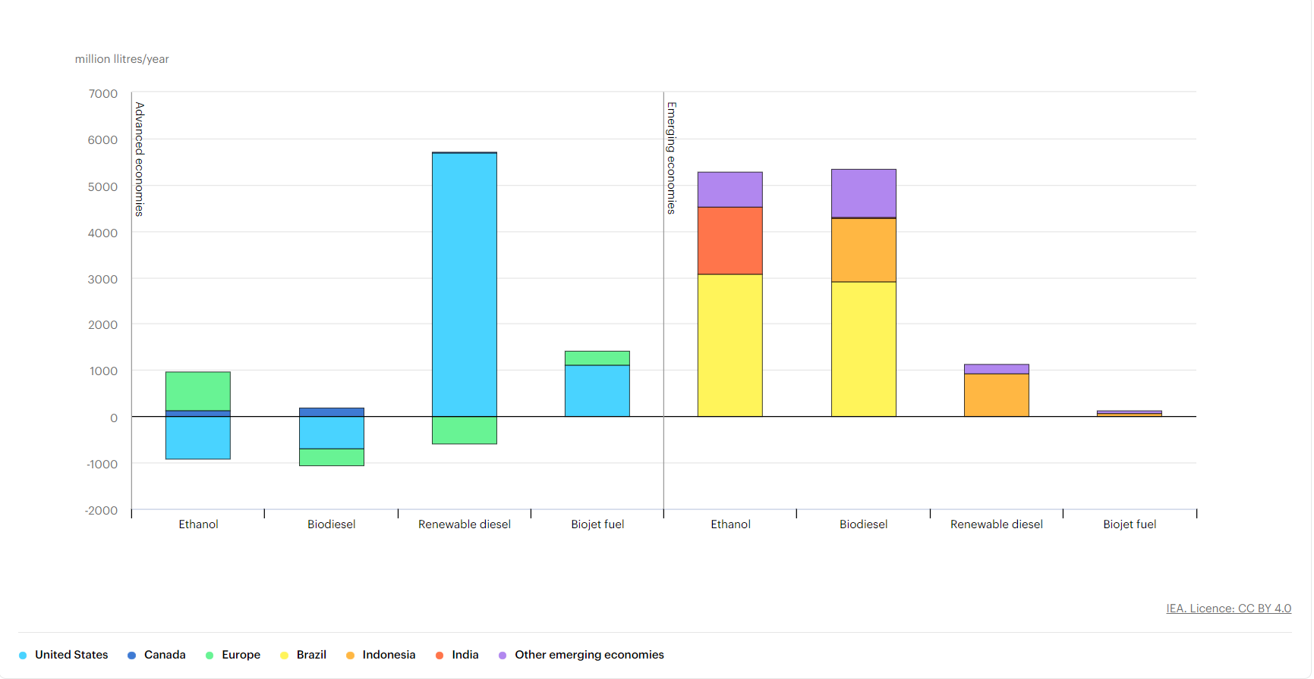
Biofuel demand growth by fuel and region, 2022-2024 (IEA)

The Indian central finance ministry has suggested a 2-rupee levy on unblended petrol beginning in October. Indian Oil Corp, Hindustan Petroleum Corp, and Bharat Petroleum Corp own storage capacity for 178 million litres of ethanol. "With the current capacity, approximately 4.30 billion Litres of ethanol can be managed annually, assuming a 15-day operation period." With a tankage capacity of 446.4 million litres by 2025, approximately 10.6 billion Litres of ethanol may be handled yearly, according to Ramakumar.

Field investigations carried out by ICRISAT in Andhra Pradesh in 2008 under the National Agricultural Innovation Project (NAIP) found the cost of inputs (fertiliser and imputed cost of irrigation) in sugarcane production was Rs. 6691 ha-1 compared to Rs. 1948 ha-1 in sweet sorghum cultivation. Sugarcane growing necessitates greater use of scarce resources such as irrigation water and heavily subsidised fertilisers. While sweet sorghum is grown in rainfed circumstances, it requires approximately 160-180 ha cm of irrigation water

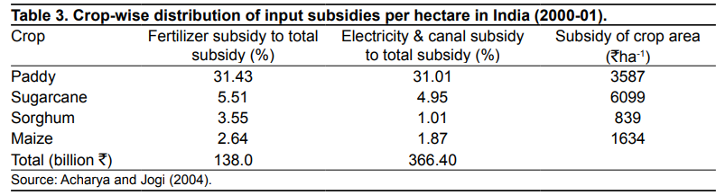

Furthermore, crop-specific estimates of input incentives per hectare for 2000-01 show that sugarcane received the largest input subsidy of Rs.6099 ha-1, while sorghum received the lowest at 839 ha-1. The disparity in irrigation subsidies supplied to sugarcane and sorghum was Rs.1444 ha-1.

Strategies for biofuel production

Biofuels Bioeconomy and policy recommendations:
A low-carbon economy requires a bioeconomy. The transition to a bioeconomy will be based on the technological progress of several activities, and hence on the availability of sustainable feedstocks.
Biofuel processing risk mitigation strategies:
The usage of fossil fuels contributes significantly to greenhouse gas emissions. Greenhouse gases generated by biofuel combustion are much lower compared to those produced by traditional fuels.
Advances, prospects, problems, and possibilities in biofuel thermal applications:
Biodiesel and bioethanol are the only biofuels utilized in engines. Partially bioethanol was utilized as a blending component in gasoline-powered motors. It is suitable for Otto cycle engines. It combines with petrol up to 10% and higher in current engines with the same engine efficiency as petrol.

Parameter Values
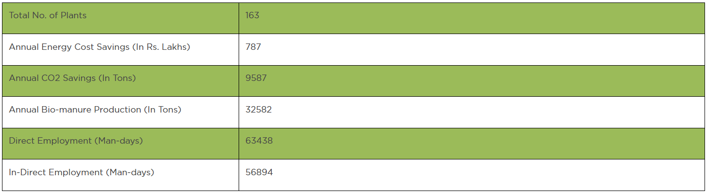
Source: mnre.gov.in

4. ANALYSIS
In today's world, where there is a high reliance on conventional energy sources, the globe is exploring for alternative energy sources to meet consumption needs. Biofuel is one of the non-conventional sources of energy that can fulfil the excess energy needs of India. As the farmers are harvesting one or more than one (usually two or three) crop in an individual year, the biofuel production differs from state to state and farmer to farmer as well as crop to crop. According to data on the Ministry of New and Renewable Energy's website, the present availability of biofuel in India is expected to be over 750 MMT per year, with surplus biofuel availability anticipated to be around 230 MMT per year. Approximately 32% of total primary energy use in the country is still sourced from biofuel, and more than 70% of the country's population is reliant on it for energy. As of October 31, 2022, a total capacity of 10205.61 MW was installed in the Biofuel Power and Cogeneration Sector. Biofuel IPP installed capacity is 1871.11MW, bagasse cogeneration installed capacity is 7562.45MW, and non-bagasse cogeneration installed capacity is 772.05MW.
Among the several states in India, the top five states with the highest average biofuel production are Punjab with 98.06 tonnes followed by Kerala with 93.65 tonnes and Karnataka with 54.70 tonnes. Rounding off the list of top 5 states with the highest average biofuel production are Haryana with 32.58 tonnes and Gujarat with 27.96 tonnes. This study amounts to the average biofuel production in India, which totals 20.13 MT.
The average surplus biofuel produced in India is around 6.47MT. The top 5 states with the highest average surplus biofuel produced are Karnataka, Punjab, Andhra Pradesh, Gujarat, and Meghalaya. Karnataka has the highest average surplus biofuel with 48.42 tonnes followed by Punjab with 34.84 tonnes and Andhra Pradesh with 12.30 tonnes. The final two states Gujarat with 11.17 tonnes and Meghalaya with 9.74 tonnes come in 4th and 5th place in the surplus production of biofuel.
The average production of biofuel in India is 20.13MT and the average surplus biofuel production is 6.47MT whereas the average biofuel utilization is only 13.66MT which is close to 51% of the average production and surplus combined. The top 5 states with the highest biofuel utilization are Kerala, Punjab, Haryana, Tamil Nadu, and Gujarat. Kerala utilizes its biofuel the most with 88.99 tonnes utilized of the 93.65 tonnes produced. The next two states are Punjab with 63.22 tonnes utilized of the 98.06 tonnes produced and Haryana with 28.42 tonnes utilized of the 32.58 produced. Rounding off the list is Tamil Nadu with 23.72 tonnes utilized of the 26.17 tonnes produced and Gujarat with 16.78 tonnes utilized of the 27.96 tonnes produced.
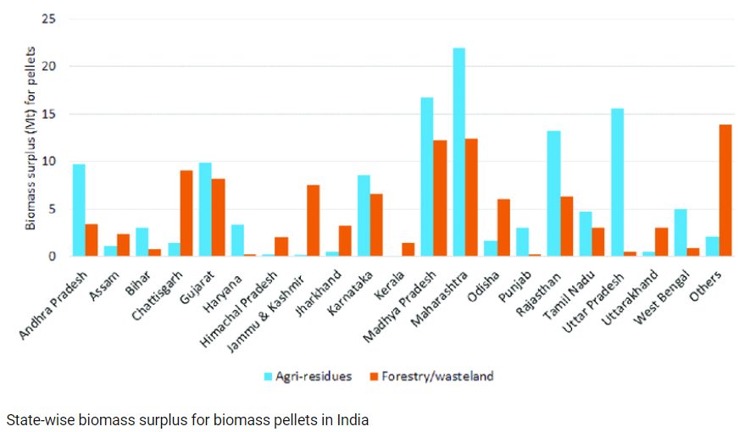
Source: Research gate

5. Result
As seen from the above analysis we can conclude that Biofuel has the potential to become one of the dependable sources of energy in future which can be used as an alternate energy source with solar and wind energy systems to create a green and eco-friendly environment. The states with the highest percentage share of utilization of biofuel are the states of Goa and Tripura with 100% utilization of the 6.16 tonnes and 4.00 tonnes respectively produced and utilized. The next highest percentage share of utilization is the state of Arunachal Pradesh with the percentage of 93.07% utilized of the 6.97 tonnes produced. This shows that the smaller states utilize the most biofuel produced. Hence the same can be done for the larger states with the help of a proper system. The Indian government and the Ministry of New and Renewable Energy are also taking initiatives and putting policies in place, such as the Biogas-based Power Generation and Thermal Energy Programme (BPGTP).

The BPGTP's Program Implementing Agencies (PIAs) will work with Panchayati Raj/ Local Bodies (LBs) as overarching institutions to enable need-based interventions beneath the community development program in the countryside as well as regions to cover Northeastern Areas, Forest Fringe Villages, and areas with a high population concentration of SC/ ST communities, including tribal areas.
Future Scope
1. Feedstock Development: Efforts should be made to identify and develop more efficient and sustainable feedstock sources for biofuel production. This includes non-food crops, algae, waste biomass, and lignocellulosic materials.
2. Improved Conversion Technologies: Such as enzymatic hydrolysis and thermochemical processes, can lead to higher biofuel yields and more efficient production processes.
3. Aviation and Marine Biofuels: Research is being done in the aviation and maritime industries to incorporate Biofuels so that they can reduce the carbon footprint.
4. Biofuel Blending: Advanced biofuels can be blended with traditional fossil fuels to create cleaner-burning blends. For example, ethanol and petrol can be blended, and biodiesel and diesel can be blended.
5. Policy Support and Incentives: Government support through policies, incentives, research and development, and adoption can encourage biofuels as a part of a broader strategy to reduce greenhouse gas emissions and achieve energy security.
In conclusion, Biofuels ought to grow in the following years provided there is continued research, innovation, and collaboration across multiple disciplines. As the world strives for a sustainable and carbon-neutral energy landscape, biofuels are poised to play an important role in achieving these goals.

References
- https://oar.icrisat.org/6520/1/WPS_34.pdf
- https://www.sciencedirect.com/science/article/abs/pii/S0016236123013030
- https://www.carandbike.com/news/india-increasing-ethanol-storage-targets-20-blended-gasoline-by-2025-2805641
- https://energy.economictimes.indiatimes.com/news/renewable/world-biofuel-day-2023-siam-international-meet-highlights-role-of-biofuels-in-sustainable-mobility/102604740
- https://mnre.gov.in/bio-energy/current-status

