A New Approach to Shaping the Spectrum of Emission Mask for OFDM

|  |  |  |  |
| --- | --- | --- | --- |
| Amit Kumar [Research scholar](https://scholar.google.co.in/scholar?q=research+scholar&hl=en&as_sdt=0&as_vis=1&oi=scholart) SVCET Rajuri, pune(India)  amit150894@gmail.com | Ghuge Avishka S.[Research scholar](https://scholar.google.co.in/scholar?q=research+scholar&hl=en&as_sdt=0&as_vis=1&oi=scholart) SVCET Rajuri, pune(India)  avishkaghuge@gmail.com | Aher Shreedhar S.[Research scholar](https://scholar.google.co.in/scholar?q=research+scholar&hl=en&as_sdt=0&as_vis=1&oi=scholart) SVCET Rajuri, pune(India)  shridharahr0@gmail.com | Manoj kumar  Assistant professor, Electronics and Telecommunication Engineering Dept.  SVCET Rajuri, Pune(India)  manoj1985.111@gmail.com |

ABSTRACT

Spectral efficiency at the transmitter is used to describe orthogonal frequency division multiplexing (OFDM). Here, spectral efficiency must be improved through the use of quadrature amplitude modulation (QAM). To decrease spectral leakage, an effective pulse form has been modelled. When received through the channel, these pulses are intended to have zero inter-symbol-interference (ISI) and a finite duration. In order to combat spectral leakage and, ultimately, adjacent channel interference (ACI), a spectral emission mask system has been put into place with suggested pulses. A series of lines used to modify the levels of radio signals is known as a spectral mask. In essence, spectral masks were designed to lower ACI by removing extraneous radiation at frequencies outside of the required bandwidth.

**Keywords** - Spectral Mask; OFDM, HPA, EVM, Quadrature Amplitude Modulation (QAM).

# 1. INTRODUCTION

A multi carrier system like OFDM is essentially utilised for Long-Term Evolution (LTE) 5G connectivity, among other things. It actually uses a multi-carrier signal with a modest data rate, making it extremely resistant to interference, fading, and selective multipath effects while still offering a good spectral efficiency. Today's systems using OFDM have processing requirements for the signal format that are quite high, however with technological modernization comes some processing challenges [1]-[2]. The use of multicarrier modulation and OFDM has gained attention in recent years because it provides the ideal framework needed for wireless data transmissions.

In the 1960s and 1970s, OFDM technology was first tested and analysed. Since then, research has been conducted to eliminate noise and interference between channels that are loosely separated. In addition to other requirements, selectively variable propagation conditions and noise or interference must not be present for error-free data transmission to be achieved. Earlier, it was not practical for general use to use OFDM for large levels of processing. Digital audio transmission was one of the earliest systems to use OFDM (DAB). In it, OFDM was able to offer a very dependable method of data transport throughout a wide range of signal route circumstances. One such instance was the beginning of DAB digital radio in Europe and other nations [3]-[5]. Also used for digital television was OFDM. After a few years, as a result of rising incremental integration levels, OFDM was introduced for use in 5G wireless network communications systems, which began to be deployed around 2009. OFDM was also used in Wi-implementation. Fi's OFDM was utilised not just for Wi-Fi but for other wireless services as well. Despite the fact that OFDM is so successful, it is prone to spectral leakage. Inter-channel interference results from this spectral leakage (ISI). It is suggested to use a spectrum emission mask to prevent spectral leakage and ultimately ICI [6].

**2. SYSTEM MODEL**

An OFDM signal can be represented as.

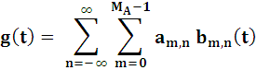 (1)

The m-th subcarrier of the nth symbol is  symbol information is conveyed. The term  "number of active subcarriers" and the  transmit pulse shape p is a time-shifted variant (t).

 (2)

Additionally, subcarrier spacing is F and symbol

period is T. Correlating the received signal r (t) with the receive filter γm,n (t) at the receiver side yields the demodulated symbol ām,n.

 (3)

Where (.)* is a complex conjugate operation, and (t) the receive pulse γ (t) 2 is a time frequency shifted version of it.

 (4)

In an OFDM-based system with pulse shaping, the transmitted signal is first synthesised using equation (1), sent through propagation channels, and then analysed by equation at the receiver (3). Figure 1 shows the rectangular QAM lattice with the subcarrier spacing set to F = 1/MTs and the symbol period set to T-NTs, where Ts is the sampling period M, N. represents the size of the Fast Fourier Transform (FFT) and the number of samples that make up one symbol period, respectively [7]-[10].



**Figure**1 Shows the QAM system's rectangular lattice.

**3. PROBLEM FORMULATIONS**

Our goal is to use 256 QAM to boost the frequency from 20MHz to 80MHz. For specific configurations, the transmitter modulation accuracy, necessary spectrum mask, and necessary spectral flatness are described. This illustration demonstrates how various measurements can be made on a waveform. The WLAN Toolbox is used to create the waveform.

**4. OPTIMAL SOLUTION**

The generation of an 80MHz VHT (Very High Throughput) waveform with gaps of 10 microseconds. Each packet employed 256 QAM modulation and random data to lessen out-of-band emission and satisfy spectral mask requirements. First-up sampling and spectral filtering are performed on the baseband waveform. Here, we employ the high-power amplifier (HPA) model, which introduces distortion and spectrum regrowth. Once more, following the modelling of a high-power amplifier, measurements of the spectral emission mask are made by upsampling and filtering the waveform, modulation accuracy is assessed by downsampling to the baseband waveform, and spectral flatness is assessed following baseband waveform downsampling[11] [12] [13] [14] . In addition, the spectrum is measured. Figure (2) and Figure demonstrate this procedure (3)

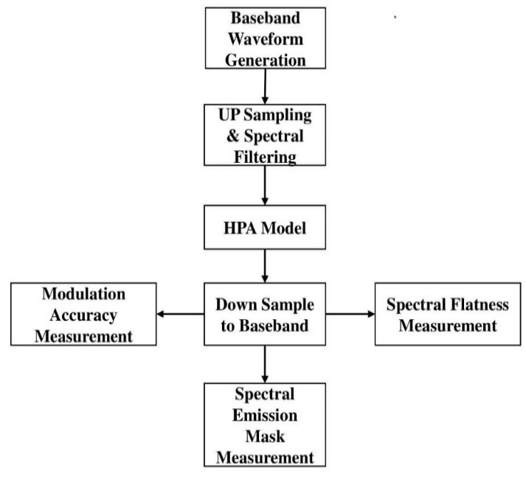

**Figure** 2. Transmitted Model

**4.1. IEEE 802.11ac VHT Packet Configuration**

This example generates an IEEE 802.11ac waveform made up of several packets in the VHT format. Utilizing a VHT format configuration object, VHT waveform is described. The wlan VHT Configuration function allows for the creation of objects. The configuration is contained in the object's properties. The item in this illustration is set up for an 80 MHz bandwidth. In order to quantify the modulation accuracy per spatial stream, just one spatial stream signal is propagated per antenna; consequently, space time block coding is not applied [15]-[21].

**4.2. Baseband Waveform Generation**

One or more packets can be generated by the waveform generator wlan Waveform Generator, and each packet can have an idle period added. In this example, 20 packets with idle times of 10 ms will be generated. The VHT packet configuration object cfgVHT and random bits for all packets and data are produced and supplied as arguments to the wlan Wave form Generator [22].

**4.3. Oversampling and Filtering**

Out-of-band spectrum emissions induced by implicit rectangular pulse shaping in the OFDM modulation and spectral regrowth brought on by the high-power amplifier are eliminated using spectral filtering; however, the waveform must be oversampled in order to see the out-of-band spectral emissions. An interpolation filter is needed while oversampling in order to eliminate spectral images brought on by up sampling. An interpolation filter that simultaneously serves as a spectral filter is used to oversample the waveform in this case. As a result, the waveform can satisfy the demands of the spectral mask. In this case, waveform oversampling and filtering are accomplished using a FIR (finite impulse response) interpolator with a DSP (digital signal processor) [23]-[24].

**4.4. High Power Amplifier Modelling**

The high-power amplifier causes spectrum regrowth and in-band distortion, which are examples of nonlinear behaviour. For 802.11ac, the RAPP model is utilised to mimic power amplifiers. RAPP model results in AM. distortion and uses communication memory-less nonlinearity in its modelling. To lessen distortion, the high-power amplifier is back-off to operate below the saturation point. The variable hpaBackoff regulates the back-off. With a 6db noise figure, thermal noise is introduced to the waveform [25]-[28].

**4.5. Error vector magnitude (EVM) and Spectral Flatness Measurements**

In order to analyse the physical layers, run the EVM, and test the spectral flatness, the oversampled waveform was resampled to baseband. Before downsampling for resampling, a low pass anti-aliasing filter is performed. The spectral flatness measurement will show the low pass filter's influence. FIR Decimator using the same oversampling coefficients. The rx Waveform contains every packet, which is identified, synced, and extracted. For every packet, measurements of the EVM and spectral flatness are taken [29]-[32]

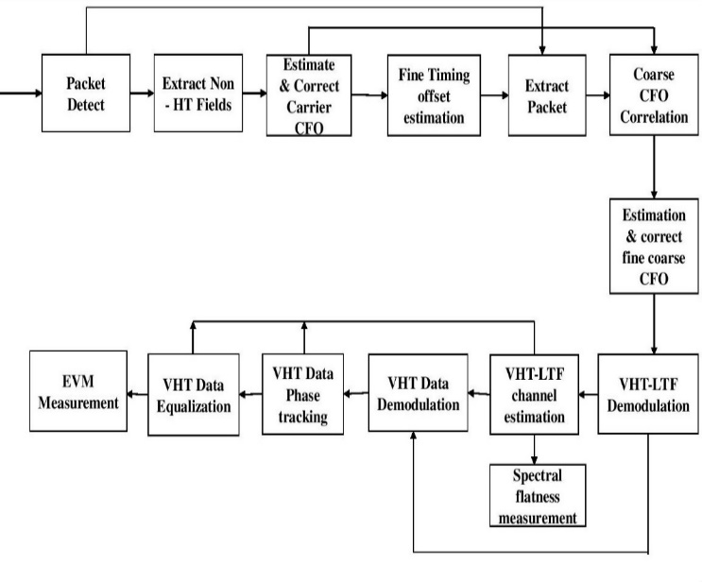

**Figure** 3 Processing Chain Spectral Emission

**4.6. Mask Steps for chain spectral mask**

1. The packet's beginning is discovered..
2. The coarse carrier frequency offset (CFO) calculation and correlation are carried out after the extraction of the non-HT fields.
3. The estimation of precise symbol timing is done using the frequency corrected non- HT fields.
4. Using the tiny symbol timing offset, the packet is retrieved from the waveform.
5. The coarse CFO estimates are used to adjust the extracted packet.
6. The fine CFO is estimated using the L-LTF, which is extracted. The entire packet has the offset adjusted.
7. For every transmit stream, the VHT-LTF is retrieved, and channel estimate is done.
8. The spectral flatness is calculated using the channel estimation.
9. Demodulating OFDM after extracting the VHT data field.
10. The field pilot subcarriers of the demodulated data are used to estimate noise.
11. The channel and noise estimates are used to phase correct and equalise the VHT data field.
12. The closest constellation point is located for each spatial stream's data-carrying subcarrier, and the EVM is then calculated.

**5. RESULT ANALYSIS**

**5.1. Transmitter**

20 extremely high throughput packets are transmitted with 256 symbols utilising the Keiser filter at the transmitter for bit transfer. All the Kaiser Filter-related factors are convolutioned using an interpolation filter. To plot the magnitude phase response, all the parameters are applied to the transmitted signal. For the purpose of calculating the precision of modulation and spectral mask shaping, Error Vector Magnitude (EVM) is used. For 20 packets, the rms EVM is calculated.



**Figure** 4 Magnitude & Phase Response

**5.2. Receiver**

All the 20 packets transfer at a time then receiver receive theses by estimating noise power by using demodulation.



**Figure** 5 Spectral Flatness

Constellation means to locate each symbol according to magnitude & phase in single diagram. Constellation indices to calculate for location of symbols.

 

**Figure** 6 Constellation Diagram **Figure** 7 Error Vector Magnitude (RMS EVM)

In spectral emission mask shaping mask is put on the 256 symbols or 20 packets for no noise is enter in that packet,

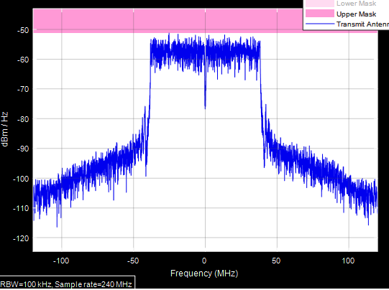

**Figure** 8 Spectral Emission Mask

Figure 8. Shows proposed system will play important role to make OFDM more effective.

**6. CONCLUSION**

The spectral mask plot, noisy constellation, and out-of-band emission in the high-power amplifier model's results all show severe band distortion and spectral expansion. Filtering is used in the spectrum filtering and down sampling steps. The spectral flatness measurement is impacted by these reactions. The suggested system has been successfully put into use. The effectiveness of spectral emission mask shaping is confirmed.

**7. ACKNOWLEDGEMENTS**

I would want to express my deep gratitude to my wife and my advisor for all of their assistance and support throughout the paper work and outcome, including their priceless monitoring and encouragement.

**References**

1. Sukhpal singh and Harmanjot Singh “Review Paper on OFDM- Ccocept and Application”. *IJEDR*, vol. 3, pp. 1-4, 2015.
2. Amit Saini, Vijaya Bhandari, “OFDM Transmission and reception review” *International Research Journal of Engineering and Technology*

*(IRJET),* vol.2, pp. 1029-1033, 2015.

1. Tangina Sultana and Shamim Ara Shawkat “Employment of Pulse Shaping Techniqwes for Efficient PAPR Reduction in OFDM System,” *Institute of information and Communication Technology (IICT)*, pp. 482-487, 2014.
2. K. Mallikanti, *“*Analysis of OFDM System by Using Pulse Shaping Filters for DSP Applications”. *International Journal of Electronics and communication Engineering,* pp. 235-240, 2017.
3. T. H. Pham, S. A. Fahmy and I. V. McLoughlim, “Spectrally Efficient Emission Mask Shaping for OFDM Cognitive Radios” *Digital Signal Processing,* vol.50, pp. 150-161, 2016.
4. Zhao Zhao, Malte Schellmann, Xitao Gong , Qi Wang, Ronald Böhnke and Yan Guo, “Pulse Shaping design for OFDM systems”. *EURASIP Journal on Wireless Communication and Networking*, Vol. 74, pp. 1-25, 2017.
5. Manoj Kumar, Ashutosh Pande, Manish K. Patidar and Narendra Singh,“A survey paper on ISI & PAPR reduction techniques in OFDM”. *An international conference on recent innovations in engineering, science & management*, Jaipur India. 2019
6. Manoj Kumar, Manish K. Patidar and Narendra Singh, “BER sensitivity of OFDM system to carrier frequency offset”. *3rd International Conference on Mathematical Modelling, Applied Analysis and Computation*, Jaipur India. 2020
7. K. N. Le, Insights on ICI and its effects on performance of OFDM systems, *Digital Signal Processing*, vol. 18 (6), pp. 876–884, 2008.
8. Y. M. Chen, I. Y. Kuo, “Design of low pass filter for digital down converter in OFDM receiver” *International Confrence on wirless Networks, Communication and Mobile Computing,* vol. 2, pp. 1094-1099, 2005
9. T. H. Pham, I. V. McLoughlin, S. A. Fahmy, “Shaping spectral leakage for IEEE 802.11p vehicular communications”, *IEEE Vehicular Technology Conference (VTC)*, pp. 1–5, 2014. Systems Journal, vol. 12, no. 4, pp. 3920–3931, Dec. 2018.
10. N. Fatema, G. Hua, Y. Xiang, D. Peng, and I. Natgunanathan, “Massive MIMO linear precoding: A survey,” IEEE
11. K. N. Le, “Insights on ICI and its effects on performance of OFDM system” *Digital Signal Processing* vol. 18, no. 6, pp. 876–884, 2008.
12. R. Saxena, H. D. Joshi, “Performance improvement in an OFDM system with MBH combinational pulse shape”, *Digital Signal Processing, vol.* 23, no. 1, pp. 314–321, 2013.
13. J. D. Rhodes, “Output universality in maximum efficiency linear power amplifiers,” *Int. J. Circuit Theory Appl.,* vol. 31, no. 4, p. 385405, Jul. 2003.
14. V. Carrubba, A. Clarke, M. Akmal, J. Lees, J. Benedikt, P. Tasker, and S. Cripps, “The continuous class-F mode power amplifier*,” in Proc. Eur. Microw. Conf.,* Sep. 2010, pp. 1674–1677.
15. M. Berroth and R. Bosch, “High-frequency equivalent circuit of GaAs FETs for large-signal applications,” *IEEE Trans. Microw. Theory Tech.*, vol. 39, no. 2, pp. 224–229, Feb. 1991.
16. M. T. Hunter, A. G. Kourtellis, C. D. Ziomek, and W. B. Mikhael, “Fundamentals of Modern Spectral Analysis,” *IEEE Instrumentation & Measurement Magazine,* August 2011.
17. M. Helfenstein, E. Baykal, K. Muller, and A. Lampe. “Error Vector Magnitude (EVM) Measurements for GSM/EDGE Applications Revised under Production Conditions,” *IEEE International Symposium on Circuits and Systems*, May 2005.
18. Z. Wei, W. Yuan, S. Li, J. Yuan, G. Bharatula, R.Hadani, and L. Hanzo, “Orthogonal time-frequency space modulation: A promising next-generation waveform,” IEEE Wireless Commun., vol. 28, no. 4,pp. 136–144, 2021.
19. Y. Xiao and J. Rosdahl, “Throughput and delay limits of IEEE 802.11,” IEEE Communications Letters, 6(8):355–357, August 2002.
20. A. I. Perez-Neira, M. Caus, R. Zakaria, D. Le Ruyet, E. Kofidis, M. Haardt, X. Mestre, and Y. Cheng, “MIMO signal processing in offset-QAM based filter bank multicarrier systems,” IEEE Trans. Signal Process., vol. 64, no. 21, pp. 5733–5762, 2016.
21. P. Choi, J. GAO, N. Ramanathan, M. Mao, S. Xu, C.C. Boon, S. A. Fahmy, L.-S. Peh, “A case forleveraging 802.11p for direct phone-to-phone communications,” Proceedings of the International Symposium on Low Power Electronics and Design,pp. 207–212, 2014.
22. IEEE 802 Standard; Part 11; Amendment 6: Wireless Access in Vehicular Environments, Jul. 2010.
23. K. N. Le, “Insights on ICI and its effects on performance of OFDM system” Digital Signal Processing vol. 18, no. 6, pp. 876–884, 2008.
24. R.Saxena, H. D. Joshi, “Performance improvement in an OFDM system with MBH combinational pulse shape”, Digital Signal Processing, vol. 23, no. 1, pp.314–321, 2013.
25. J. D. Rhodes, “Output universality in maximum efficiency linear power amplifiers,” Int. J. Circuit Theory Appl., vol. 31, no. 4, p. 385405, Jul. 2003.
26. V. Carrubba, A. Clarke, M. Akmal, J. Lees, J.Benedikt, P. Tasker, and S. Cripps, “The continuous class-F mode power amplifier,” in Proc. Eur. Microw. Conf., Sep. 2010, pp. 1674–1677.
27. M. Berroth and R. Bosch, “High-frequency equivalent circuit of GaAs FETs for large-signal applications,” IEEE Trans. Microw. Theory Tech., vol. 39, no. 2, pp. 224–229, Feb. 1991.
28. M. T. Hunter, A. G. Kourtellis, C. D. Ziomek, and W.B. Mikhael, “Fundamentals of Modern Spectral Analysis,” IEEE Instrumentation &amp; Measurement Magazine, August 2011.
29. M. Helfenstein, E. Baykal, K. Muller, and A. Lampe.“Error Vector Magnitude (EVM) Measurements for GSM/EDGE Applications Revised under Production Conditions,” IEEE International Symposium on Circuits and Systems, May 2005.
30. P.-U. Su, Y.-H. Chen, and T.-Y. Yang, &quot;A 0.35-um SiGe WCDMA direct conversion transmitter with DC offset compensation for carrier leakage reduction,&quot; IEEE VLSI-TSA, 27-29 Apr. 2005, pp. 149-152, 2005.

.