Smart Sign Language Glove for Diversified Users

Kumarkaushik K S
Computer Network Engineering,
BMS College of Engineering
Bengaluru, India

Dr. R Ashok Kumar
Department of Information Science,
BMS College of Engineering,
Bengaluru, India

ABSTRACT
In today's world, communication skills are critical for improving interpersonal interactions and managing human resources. In your everyday life, efficient communication skills can help you comprehend and be understood by others, making it easier to navigate relationships. Dialogue is essential in human existence.
This gap between specially abled and vocal communicators can be bridged in one of two ways either by learning sign language or by using interpretation. This Research proposes a digital aid, that is in the form of Smart glove, which is focusing on making the smart IoT device usable by everyone. As each human hand is physically different, also bend the fingers create are unique, this is the problem that was addressed in this study by gathering more comprehensive and diverse samples with the help of flex sensor embedded glove, which were then fed into the training model created using the Random Forest algorithm. The model was successful in classifying new data without being overfit or memorised, as indicated by its prediction rate of 0.90 and F-1 Score of 0.82. By increasing its validation accuracy relative to its training accuracy, the model was able to predict new gesture successfully.

Keywords – Sign language glove, Random Forest Algorithm, smart IoT device, Machine Learning in Sign Language, Flex sensors, Sensor-Based Gesture Recognition.

INTRODUCTION

Sign language is a visual-gestural language used by deaf and hard of hearing individuals as their primary means of communication. It is a fully-fledged language with its own grammar, syntax, and vocabulary. Sign language plays a crucial role in fostering communication, expression, and social interaction within the deaf community [13]. The origins of sign language can be traced back to various deaf communities around the world, each with its own unique sign language. In the 18th century, prominent educators such as Abbé de l'Épée and Thomas Gallaudet made significant contributions to the recognition and development of sign language. [13] Sign languages are distinct from spoken languages and vary across different regions. Signs are composed of hand shapes, facial expressions, body movements, and spatial relationships. Sign languages possess complex grammatical structures and allow for nuanced communication [14]. A smart sign language glove can enable real-time translation of sign language into spoken language or text, enhancing communication between sign language users and non-signing individuals. [14] The development of a smart glove can improve accessibility to information and services for sign language users in various domains, including education, healthcare, employment, and public spaces. [14] significance of a smart sign language glove lies in its ability to cater to the diverse needs and preferences of sign language users, accommodating variations in Finger bends and individual type of human hand size. Sign language plays a crucial role in enabling effective communication for individuals who are deaf or hard of hearing. It allows deaf individuals to express their thoughts, emotions, and ideas, and facilitates their inclusion in social, educational, and professional settings. Sign language is not only a means of communication but also a vital aspect of cultural identity and community bonding for deaf individuals. Sign language users often face challenges in accessing information and services due to a lack of sign language interpreters or communication barriers in various environments such as hospitals, educational institutions, and public spaces. Non-sign language users, including family members, friends, and professionals, may have limited or no knowledge of sign language, making effective communication challenging. The need to rely on a third-party interpreter can cause delays and disruptions in real-time conversations, impeding spontaneity and fluidity of communication. Developing technological solutions, such as the Smart Sign Language Glove, is essential to address the communication gap between sign language users and non-sign language users. [15] These solutions offer several benefits, Smart gloves equipped with sensors and algorithms can recognize and translate sign language gestures into written or spoken language in real-time, allowing for immediate communication. By providing a portable and user-friendly device, individuals can independently express themselves and overcome communication barriers without relying on interpreters or others. Technological advancements can extend the reach of sign language communication by making it accessible in various settings, including remote or online interactions. Technological solutions facilitate communication between sign language users and non-sign language users by automatically converting sign language gestures into a form of communication that the non-sign language user can understand. By enhancing communication accessibility, smart sign language gloves contribute to the inclusivity and equal participation of individuals with hearing impairments in social, educational, and professional contexts.

Contributions of this work

The development of a smart sign language glove, catering to a diverse range of users with various hand sizes and shapes, marks a significant step forward in accessibility and inclusivity. By gathering data from a wide array of individuals, this innovative project has ensured that the glove's functionality is not limited to a specific group, but rather, it can be seamlessly adapted to accommodate the unique needs of each user. Leveraging the power of the random forest model, the glove's recognition capabilities have been refined to accurately interpret sign language gestures across a diverse user base, enhancing the overall user experience. The integration of the mobile interface, SingL Companion, further elevates the glove's usability, providing an intuitive and user-friendly platform for communication. This work represents a remarkable contribution to the advancement of assistive technologies, empowering individuals with speech and hearing impairments to engage with the world more effortlessly and confidently. It embodies a true commitment to embracing diversity and building a more inclusive society, where technology serves as a bridge to connect people from all walks of life.

Literature Review

Overview of existing technologies and devices for sign language interpretation and communication is important step in understanding where contributions are needed. Video Relay Services (VRS) enables sign language users to communicate with non-signing individuals through video calls with the assistance of a sign language interpreter [1]. It relies on video conferencing technology and requires a stable internet connection and specialized software or applications [15,1]. There is also, the Portable Electronic Translators. These handheld devices use video or image recognition technology to translate sign language into spoken or written language. They often have a limited vocabulary and may not accurately interpret complex sign language expressions [15]. Another method to deal with language barrier is Motion capture systems, they utilize sensors or cameras to track and record the movements of a sign language user's body and hands. The captured data is then processed and translated into text or speech [15]. In the realm of computer vision and machine learning, the integration of classification and learning algorithms with popular libraries such as OpenCV and OpenPose has revolutionized the field of gesture recognition, particularly in the context of sign language interpretation. By leveraging the capabilities of these libraries, it becomes possible to capture frames from video or image sources, extract key points representing the hand, and subsequently employ classifiers to predict the specific gestures being made by individuals [16,17]. The utilization of OpenCV and OpenPose libraries provides a powerful foundation for developing robust gesture recognition systems. OpenCV, an open-source computer vision library, offers a wide range of functionalities for image and video processing, including frame acquisition, manipulation, and analysis. This library provides developers with a comprehensive set of tools to extract useful features from images and videos, which are vital for recognizing and interpreting gestures accurately. Additionally, the integration of OpenPose library further enhances the capabilities of gesture recognition systems. OpenPose is a popular real-time multi-person keypoint detection library that can accurately identify key points, or keypoints, in a given frame. By analyzing the spatial relationships and movements of these keypoints, the library enables the extraction of critical information about human poses, including hand gestures. By combining the power of OpenCV and OpenPose, it becomes possible to not only capture frames but also accurately detect and track hand keypoints within those frames. The process of gesture recognition begins with the acquisition of frames from video or image sources. These frames serve as the raw input data for subsequent analysis. OpenCV's capabilities allow for efficient frame acquisition from a wide array of sources, including webcams, video files, or even live video streams. Once the frames are acquired, they can be processed and manipulated to enhance their quality and extract relevant features. OpenCV provides a comprehensive suite of tools for image preprocessing, noise reduction, and enhancement, ensuring that the frames are optimized for subsequent analysis. After preprocessing, the OpenPose library comes into play, performing keypoint detection on the frames. By analyzing the spatial relationships of keypoints, OpenPose can accurately identify and track the hand's key points, even in the presence of occlusions or complex poses. The keypoint detection algorithm identifies the positions of the fingertips, palm, and other relevant hand landmarks, enabling a detailed representation of the hand's pose within the frame [15]. Once the key points are identified, classification and learning algorithms are deployed to predict the specific gestures being made by individuals. These algorithms utilize a combination of machine learning techniques, such as deep neural networks or traditional statistical classifiers, to analyze the extracted features and make accurate predictions. The classifiers are trained using labeled datasets, where each gesture is associated with a specific label. Through the learning process, the classifiers are able to generalize and recognize previously unseen gestures based on the learned patterns and relationships in the training data [18]. The classification and learning algorithms play a critical role in the accuracy and robustness of the gesture recognition system. They enable the system to differentiate between different sign language gestures, even when there are subtle variations or hand movements. The performance of these algorithms depends on various factors, such as the quality of the training data, the complexity of the gestures, and the chosen machine learning approach. Continuous improvements and advancements in machine learning techniques contribute to the evolution of gesture recognition systems, allowing for more precise and reliable interpretations of sign language gestures [15,17]. The integration of classification and learning algorithms with libraries like OpenCV and OpenPose has significantly advanced the field of gesture recognition, particularly in the domain of sign language interpretation. By combining the powerful features of these libraries, it becomes possible to capture frames, identify key points representing the hand, and employ classifiers to accurately predict the gestures being made. The utilization of OpenCV and OpenPose provides developers with a comprehensive toolkit to build robust and efficient gesture recognition systems, paving the way for enhanced communication and accessibility for individuals who rely on sign language [15,18]. While image processing techniques can be powerful tools for sign language prediction, they are not without their limitations and drawbacks. Here are some of the main drawbacks associated with relying solely on image processing for sign language predictions. Image processing techniques primarily focus on capturing and analyzing visual information from images or video frames. However, sign language encompasses not only hand gestures but also facial expressions, body movements, and contextual cues. By solely relying on image processing, important non-manual components of sign language may be overlooked, leading to incomplete or inaccurate predictions. Image processing techniques are sensitive to variations in lighting conditions and backgrounds. Changes in lighting, such as shadows or different lighting sources, can impact the quality of captured images and affect the accuracy of hand gesture recognition. Similarly, complex or cluttered backgrounds can introduce noise and interfere with the detection and tracking of hand keypoints. In real-world scenarios, hand gestures may be partially occluded by objects, clothing, or other body parts. Image processing techniques struggle to accurately detect and track hand keypoints when occlusions occur, leading to incomplete or ambiguous representations of hand gestures. Additionally, when multiple hands or interactions between hands occur, the complexity of analyzing and predicting gestures increases significantly. Image processing techniques heavily rely on the viewpoints and camera angles from which images or video frames are captured. Different viewpoints and angles can result in variations in hand appearance and orientation, making it challenging to generalize hand gestures across different camera setups. Consequently, sign language predictions may be influenced by the specific camera placement and limited to a particular perspective. The performance of image processing algorithms for sign language prediction heavily depends on the quality and diversity of the training data. If the training dataset predominantly consists of specific individuals or limited variations of sign language gestures, the algorithm may struggle to generalize and accurately predict gestures from unseen signers or different dialects. Dataset bias can lead to a lack of robustness and limited applicability in real-world scenarios. [23] In certain applications, such as real-time sign language interpretation, the processing speed and latency of image processing techniques become crucial. High-resolution image processing and complex algorithms can be computationally intensive, leading to delays in gesture recognition and potentially hampering the real-time nature of the interaction. To address these drawbacks, researchers often combine image processing techniques with other modalities, such as depth sensors, wearable devices, or additional sensors that capture non-visual information. This multi-modal approach aims to overcome the limitations of image processing alone and provide a more comprehensive and accurate representation of sign language gestures. By leveraging complementary data sources, the system can capture facial expressions, body movements, and other non-manual cues, leading to improved sign language prediction capabilities. Wearable Devices are also a potential solution, some wearable devices, such as wristbands or armbands, incorporate sensors to capture hand and finger movements during sign language communication [8,11,12]. These devices may rely on machine learning algorithms for sign language recognition and interpretation [15]. In recent years, the development of wearable devices equipped with sensors has opened up new avenues for predicting sign language. These devices, such as wristbands or armbands, offer the ability to capture hand and finger movements during sign language communication, enabling more accurate and intuitive prediction of sign language gestures. Several methods have been employed to leverage wearable devices and their sensors in sign language prediction. This paragraph will illustrate some of the different methods used in this domain [15]. One common approach is to utilize inertial measurement units (IMUs) embedded within wearable devices. IMUs consist of accelerometers, gyroscopes, and magnetometers, which collectively capture motion-related data. By attaching IMU-based wearable devices to the wrist or arm, hand and finger movements can be tracked and recorded in real-time. The data from the IMUs is then processed using algorithms to extract meaningful features that represent the sign language gestures. Machine learning techniques, such as hidden Markov models (HMMs) or deep learning architectures, are commonly employed to learn the mapping between the extracted features and specific sign language gestures. This method provides a non-intrusive and portable solution for sign language prediction, as the wearable devices can be comfortably worn without impeding the natural movement of the user's hands [3,6]. Another method involves using electromyography (EMG) sensors embedded within wearable devices. EMG sensors measure the electrical activity of muscles and can capture the muscle contractions associated with hand and finger movements during sign language communication. [4] By placing the wearable device on the forearm or upper arm, the EMG sensors detect and record the electrical signals produced by the relevant muscles. Signal processing techniques, such as feature extraction and pattern recognition algorithms, are then applied to the recorded EMG signals to identify specific hand and finger movements. Machine learning algorithms, including support vector machines (SVMs) or artificial neural networks, can be trained on labelled datasets to predict sign language gestures based on the extracted EMG features. This method allows for a more direct and precise measurement of muscle activity, enabling accurate sign language prediction [15]. Wearable devices can also incorporate flex sensors or bend sensors to capture hand and finger movements. These sensors are typically placed on finger joints or glove-like attachments to measure the degree of flexion or bending. As the user performs sign language gestures, the flex sensors detect the changes in finger joint angles and provide continuous feedback on hand movements. The sensor data is then processed using algorithms that map the sensor readings to specific sign language gestures. Similar to other methods, machine learning algorithms can be employed to train models on the sensor data and predict sign language gestures accurately. This method offers a lightweight and unobtrusive solution, allowing users to maintain natural hand movements while still capturing the necessary information for sign language prediction [2]. Another innovative approach is the use of depth sensors, such as time-of-flight cameras or structured light sensors, integrated into wearable devices. These sensors provide depth information by capturing the distance between the sensor and objects in the environment. By wearing a depth sensor-equipped device on the wrist or arm, the 3D position and movement of the hand and fingers can be tracked in real-time. Depth data is processed using computer vision techniques, such as hand segmentation, tracking, and pose estimation algorithms, to extract the relevant features for sign language prediction. Machine learning models are then trained on these features to recognize and predict sign language gestures accurately. This method offers a comprehensive representation of hand movements in three-dimensional space, allowing for enhanced accuracy and robustness in sign language prediction [5]. In addition to individual sensors, wearable devices can also incorporate multiple sensors to capture a broader range of information. For example, combining IMUs with EMG sensors allows for capturing both motion-related data and muscle activity simultaneously. By fusing the data from multiple sensors, more comprehensive and accurate representations of hand and finger movements can be obtained, leading to improved sign language prediction performance. Sensor fusion techniques, such as Kalman filters or particle filters, can be employed to integrate the data from different sensors and provide a unified estimation of hand gestures [15]. Wearable devices equipped with sensors offer a promising avenue for predicting sign language gestures. Methods such as using IMUs, EMG sensors, flex sensors, or depth sensors incorporated into these devices enable the capture of hand and finger movements during sign language communication. By processing the sensor data and employing machine learning algorithms, accurate sign language predictions can be achieved. Each method has its own strengths and considerations, depending on factors such as accuracy, portability, user comfort, and computational requirements. The ongoing advancements in wearable technology and sensor miniaturization continue to push the boundaries of sign language prediction, enhancing communication and accessibility for individuals who rely on sign language. Many existing technologies for sign language interpretation and communication are costly, making them inaccessible for individuals with limited financial resources. Availability of these technologies may be limited in certain regions or communities. Current solutions may have limitations in accurately recognizing and interpreting sign language gestures, especially for complex or non-standard signs. Ambient noise, lighting conditions, and variations in signing styles can affect the performance of these systems. Some existing devices may be bulky, uncomfortable to wear, or require extensive calibration, which can impede the natural flow of sign language communication. The learning curve for operating and adapting to new technologies can be steep for both sign language users and non-signing individuals. These drawback creates a need for a smart and affordable IoT device that can be used by diverse group of people.

Methodology, Design and Development

A. Description of the proposed smart sign language glove design and functionality:
1. Glove Design: The smart sign language glove is designed to be lightweight, flexible, and comfortable for prolonged use. It is adjustable to fit different hand sizes and accommodate individual preferences. The glove is made of breathable materials to ensure user comfort.
2. Sensor Placement: The glove is equipped with sensors strategically placed on key areas of the hand, such as the fingertips and knuckles. These sensors capture the movements and positions of the hand, enabling accurate recognition of sign language gestures.
3. Wireless Connectivity: The glove is designed to have wireless connectivity capabilities, such as Bluetooth or Wi-Fi, allowing it to connect with external devices, such as smartphones or computers.

B. Explanation of the hardware and software components involved:
1. Hardware Components: Sensors: The glove incorporates flex sensors. These sensors detect and measure hand movements and Resistance. Microcontroller: A microcontroller unit (MCU) or a small computing device is integrated into the glove to process the sensor data and execute the necessary algorithms. Power Source: The glove is powered by an external power source, ensuring continuous operation. Communication Module: A communication module enables wireless/wired connectivity for transmitting data between the glove and external devices.
2. Software Components: The software includes a sign language recognition algorithm that processes the sensor data to recognize and interpret sign language gestures. Machine learning technique Random forest algorithm is employed for accurate recognition. Gesture Mapping: The software maps the recognized sign language gestures to corresponding spoken language or text output. It converts the captured hand movements into meaningful communication outputs. User Interface: The software has a user interface, through a smartphone application/a dedicated interface on an external device, to provide visual and audio feedback for users called SingL Companion. The integration of hardware and software components enables the smart sign language glove to capture hand movements, process the data, recognize sign language gestures, and provide real-time translation or interpretation. The proposed methodology ensures that the glove is capable of accurately interpreting a wide range of sign language gestures and facilitating effective communication for diversified users.

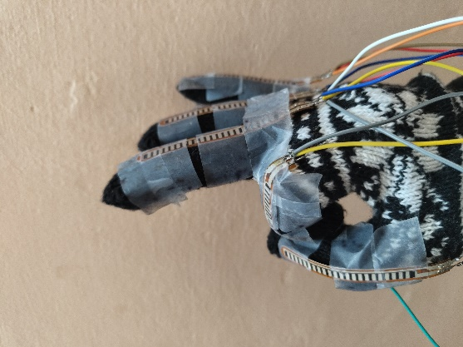

Figure 1: Glove performing a sign

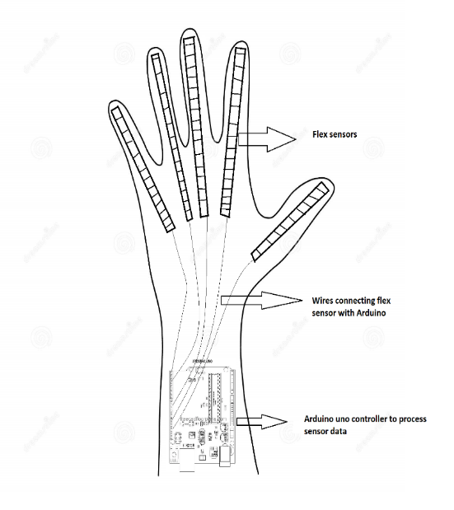
Figure 2: Smart Glove design

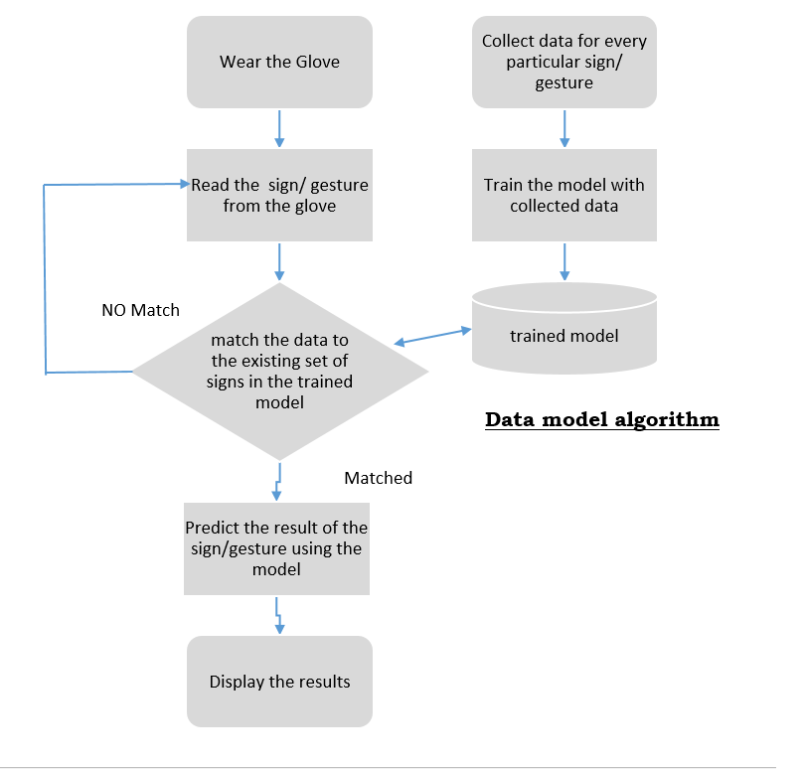
Figure 3: System design

Algorithm 3.1
Nomenclature –
Senor Data = 𝑥1, 𝑥2, 𝑥3, … . , 𝑥𝑖 where, 𝑖 = 1,2,3, … , 𝑁 and 𝑥𝑖 is individual dataset of 5 fingers having 𝑦𝑗 Datapoints at time for each gesture X

Step1: Load 𝑥𝑖 from Senor Data
Step1a: For 𝑥𝑖 in range Senor Data
Step1b: identify the unique labels in 𝑥𝑖 and create a decision tree node

Step 2: calculate entropy for node in the decision tree to identify importance node Ni_{j}
Ni_{j} = W_{j}C_{j} W_{left(j)}C_{left(j)} -W_{right (j)} C_{right(j)}

W= weight of the node
left(j) = child node in the left branch
right(j) = child node in the right branch
C_{j} = impurity value of node

Step 3: calculate importance for each feature/ label
F_{i} = ∑ Ni_{j} split by feature X / ∑ all nodes Ni_{k}

Step 4: these F_{i} are normalized to get values between 0 and 1

Step 5: calculate feature importance to generate random forest model
RF=∑ normalized F_{i} / T
T= total number of trees in the model

Step 6: stop

Algorithm 3.2
Nomenclature –
Senor Data = 𝑥1, 𝑥2, 𝑥3, … . , 𝑥𝑖 where, 𝑖 = 1,2,3, … , 𝑁 and 𝑥𝑖 is individual dataset of 5 fingers having 𝑦𝑗 Datapoints at time for each gesture X

Step 1: read 𝑥𝑖 using COM4 in a loop every 5 sec

Step 2: feed 𝑥𝑖 to predict ()
Predict () = RF.predict ()
(RF=∑ normalized F_{i} / T from data model algorithm)

Step 3: if prediction exists continue
Else return to Step 1
Step4: forward the data to SingL companion using sockets.

Step 5: stop

C. Overview of the data collection process and training of the machine learning model:
1. Data Collection: The data collection process involves gathering a diverse and representative dataset of sign language gestures from different people of different hand sizes, the Arduino program collects data from analogue pins and prints resistance values on Serial COM4 port, this data collected using a python program automated to read in a loop which are stored into a CSV file that can be further cleaned and processed.
2. Data Pre-processing: The collected data undergoes pre-processing to ensure its quality and suitability for training the machine learning model by removing the unwanted features in the reading, such as fluctuations in the readings and only retaining the 5 resistances values from 5 fingers and its corresponding labels.
3. Training the Machine Learning Model: The extracted features are used to train a machine learning model for sign language recognition and interpretation. The training process involves feeding the extracted features and corresponding sign labels to the model, adjusting the model's internal parameters to minimize the prediction errors. Techniques such as cross-validation and data augmentation are employed to improve the model's performance and generalization ability.

D. Discussion on the evaluation metrics and testing procedures:
The data set in CSV format is feed to the Random forest algorithm and an 80-20 split is made to first analyse evaluation metrics such as accuracy, precision, recall, and F1-score. This is to create a base evaluation for the model. Further the full data set is fed as the training data and the new incoming serial output from the glove used to check the prediction accuracy.

Figure 4: SingL companion

Results and Evaluation

1. Collected Data: The data was gathered using five different gestures and 450 rounds of data collection from individuals with various and distinctive hand, palm, and finger sizes, which provided us with a distributed and varied dataset that would aid in our goal of developing an algorithm that would cover the objective of serving a broad range of users. One of the biggest challenges in gathering the data was getting people to perform the gestures naturally rather than stressing out about how they were doing it, as they would often make very rigid movements and then perform the same gesture very differently when not under pressure. The generated heatmap in fig. 6 provides a visual representation of the correlation between different finger positions in the provided dataset. Each cell in the heatmap corresponds to a pair of finger positions, and the color of the cell indicates the strength and direction of the correlation between those positions. By examining the heatmap, we can gain insights into the relationships and dependencies between finger positions. A strong positive correlation is represented by a dark shade of red, indicating that as one finger position increases, the other finger position tends to increase as well. On the other hand, a strong negative correlation is shown by a dark shade of blue, indicating that as one finger position increases, the other finger position tends to decrease. In this particular heatmap, we can observe that the Thumb and Middle finger positions exhibit a strong positive correlation, as indicated by the dark red color. This suggests that when the Thumb is positioned at a higher value, the Middle finger tends to be positioned higher as well. Similarly, the Thumb and Pinky finger positions also show a positive correlation, albeit weaker than the Thumb-Middle correlation. Conversely, the Thumb and Index finger positions display a relatively weaker negative correlation, shown by a light shade of blue. This implies that when the Thumb is positioned at a higher value, the Index finger tends to be positioned lower. The Thumb-Ring and Thumb-Pinky correlations appear to be neutral or weak, indicating no significant relationship between these finger positions.
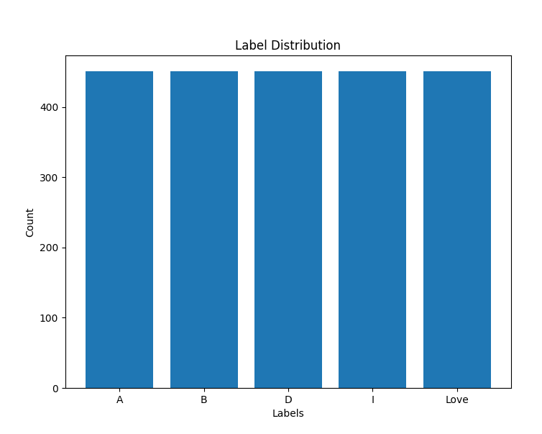
Figure 5: Data distribution for 450 rounds

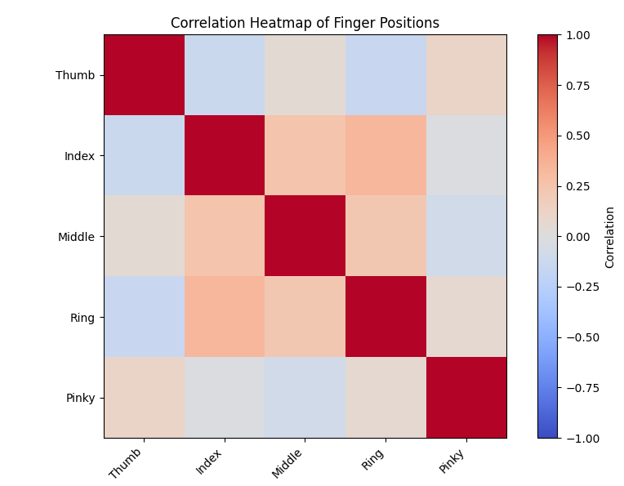
Figure 6: Heat map indicating the correlation between finger positions

Overall, the heatmap provides a clear and concise visual representation of the correlations between different finger positions. It allows us to identify which finger positions tend to move together or in opposite directions, aiding in the understanding of the interplay between different fingers during sign language gestures.
The generated box plots in fig. 7 provide a visual representation of the distribution of finger positions for each label in the provided dataset. Each box plot represents a specific finger position (Thumb, Index, Middle, Ring, Pinky) and displays the median, quartiles, and potential outliers within each label group. By examining the box plots, we can gain insights into the variability and central tendency of the finger positions for each label. The box in the plot represents the interquartile range (IQR), which spans the middle 50% of the data. The line inside the box represents the median, indicating the central value of the data distribution. The whiskers of the box plot extend to the minimum and maximum values within a certain range. Any data points lying beyond the whiskers are considered potential outliers and are represented as individual points. Comparing the box plots across different finger positions and labels, we can identify differences in the distribution of finger positions. For example, if the height of the box varies significantly between two labels for a specific finger position, it suggests that there might be a notable difference in the measurement values for that finger between those labels. Furthermore, the presence of outliers can indicate the existence of extreme values or potential anomalies within the finger positions for specific labels. Outliers that lie far outside the whiskers may warrant further investigation to understand the reason behind their divergence from the majority of the data.
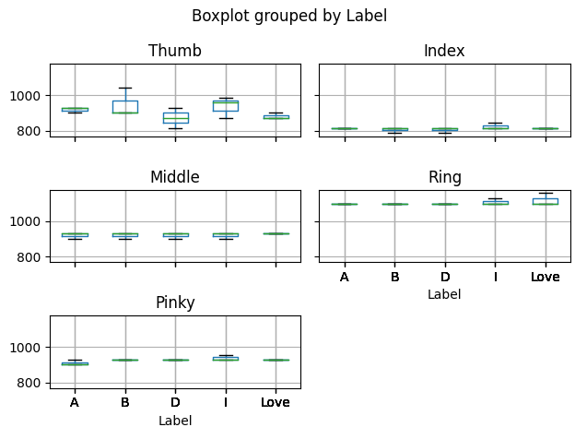
Figure 7: Box plot grouped by labels

Overall, the box plots allow for a clear and concise comparison of the finger positions' distributions within each label. They provide insights into the central tendency, spread, and potential outliers, allowing you to identify any patterns, differences, or similarities in the finger positions across the different labels in the dataset.

2. Performance Evaluation Metrics: Various metrics are used to evaluate the performance of the smart sign language glove, such as accuracy, precision, recall, F1-score. These metrics provide insights into the model's ability to correctly recognize and interpret sign language gestures. Performance was evaluated on a separate test dataset that was not used during the training phase. The model, which is depicted in Table 1 below, enjoys accuracy ratings of 80%, precision ratings of 90%, recall ratings of 80%, and most importantly, an F1-score of 82% that lies between 80 and 90%, which is a good sweet spot to be in to avoid overfitting.

Table1: Results
Accuracy | 0.8093126385809313
Precision | 0.902489417456158
Recall | 0.8093126385809313
F1-Score | 0.821105347664597
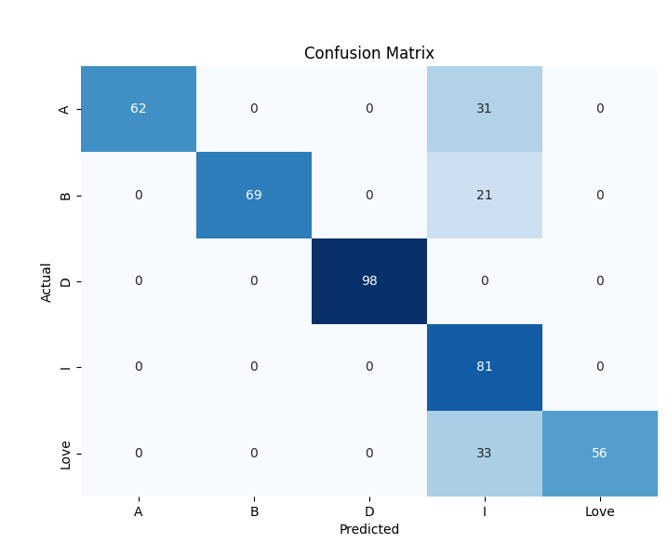
Figure 8: confusion matrix
As seen the fig.8 the confusion matrix indicates that the model is able to predict most symbols successfully without an error prediction, but suffered some loss in accuracy on “I” as its required participation of most fingers as seen fig.7, as a result of users performed this symbol in different variation under different conditions, which explains the variations in confusion matrix.

A. Analysis of the accuracy, speed, and usability of the smart sign language glove:
1. Accuracy: The smart sign language glove's accuracy is measured by how effectively it can discern and understand sign language motions. As previously noted, the model properly predicted the majority of gestures from persons with various hand sizes, with an F1-score of 82%. The model found it challenging to forecast when the gesture was extremely similar to or close to the resting hand reading, like "B" when the thumb is bent in slightly by few degrees. There were instances where the predictions failed when the user performed the gesture with different variations. As shown in Table 2, the difference between the validation scores and training scores can be seen to have just marginal difference which indicates that the model is near best fit conditions. Therefore, the model achieving intended results.
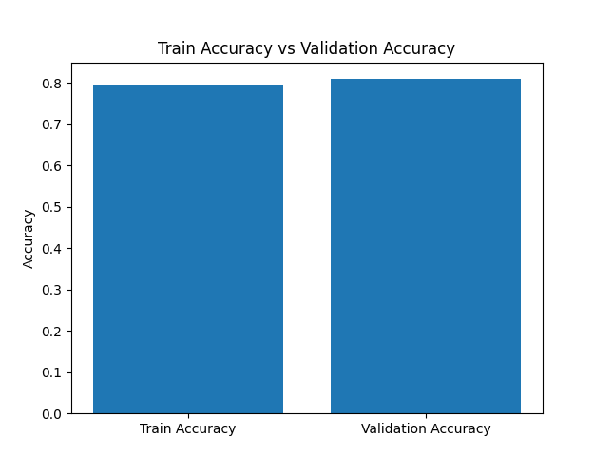
Figure 9: Comparison of train accuracy vs validation accuracy

Table 2: Accuracy and loss scores compared with validation scores to demonstrate best fit
Train Accuracy | 0.7971175166297118
Validation Accuracy | 0.8093126385809313
Train Loss | 0.38088574796161145
Validation Loss | 0.3317905612290872

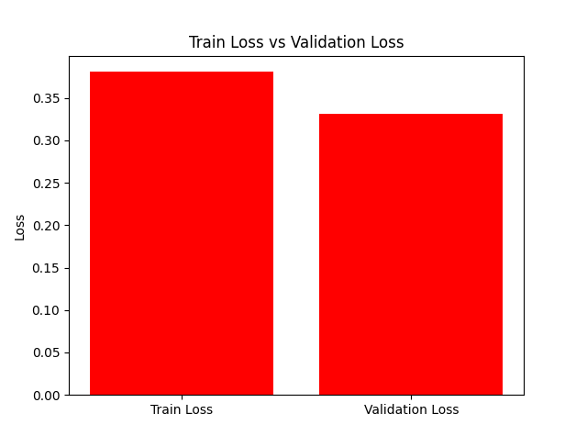
Figure 10: Comparison of train loss vs validation loss

The results of your random forest model for sign language classification using Smart Glove are quite promising. The model achieved a train accuracy of 0.7971, indicating that it correctly predicted the sign language gestures for approximately 79.71% of the training samples. This suggests that the model has learned important patterns and features from the training data, enabling it to make reasonably accurate predictions. The validation accuracy of 0.8093 is slightly higher than the train accuracy, indicating that the model's performance extends beyond just memorizing the training data. It implies that the model has a good generalization capability, successfully applying the learned patterns to unseen data. This is a positive outcome, as it indicates that the model is not overfitting to the training set and can perform well on new sign language samples. The train loss of 0.3809 and validation loss of 0.3318 further reinforce the effectiveness of the model. The low values of both losses indicate that the model is able to minimize errors and make accurate predictions. A lower loss signifies that the predicted probabilities of sign language gestures are closer to the true labels, indicating a better fit between the model's predictions and the actual data.
2. Speed: Speed is the time taken by the smart sign language glove to process and interpret the hand movements into spoken language or text output. The device processes and anticipates the gesture in less than a second, and the SingL companion is programmed to use sockets to establish a two-way connection with the device as shown in fig 13. This should result in one cycle of prediction finishing in under 1.5 seconds, which is acceptable speed for a prototype. Reducing the lag to under a second will reduce the lag to acceptable real-time standards.
3. Usability: We observed the User feedback on factors such as comfort, fit, ease of putting on and taking off, and intuitive interaction and what we found out was that although the glove gave a snug and comfortable fit for usage, wearing the glove with electronics attached and removing it was considered as problem as the parts are delicate and need a careful procedure to remove it.

B. Comparison of the proposed glove with existing technologies and solutions:
There are majorly 3 different types of technologies that exist as discussed previously they are camera-based systems, motion capture systems and Hybrid approach where both are used to get best results. As the smart sign language is designed towards affordable for all smart IOT device market our comparison and competition becomes the wearable devices based on motion capture, the unique contribution or improvement that we have worked on is to build a model that can predict the hand movements of diversified users without a need for calibration and unique cloud profiles need to run, such services make the device expensive avoid which creates mass market appeal.
Table 3: Signs performed and their results
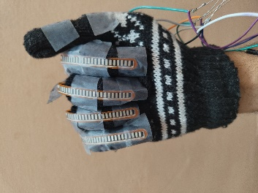
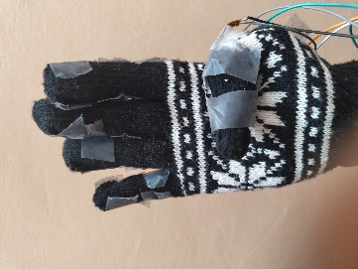
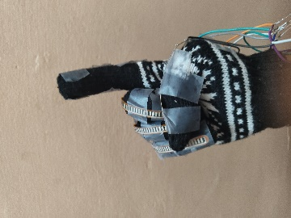
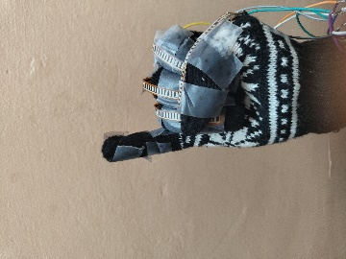
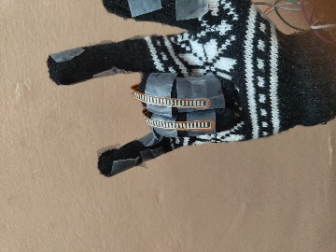

Discussion and Conclusion

The results obtained from the evaluation and analysis of the smart sign language glove show that creating a cost effective and user friendly for the mass market is possibility, with a prototype performing with a 90% precession and a speed of under 1.5 seconds makes it a feasible to user in real-time conversations. This increase in usability can be a major factor in the disable community warming up to the idea of using an interpreter device which they have not been keen on before. The major strength of the model was achieved from the fact, that people with different sizes of hands produced slightly different bends that resulted in less than 10-15° which in turn gave the model stability that it produced. Assuming that there will ways be extreme cases that this logic could be broken and finding a way to incorporated a logic to cover this scenario to the existing model can be seen as a future work. The results of your random forest model for sign language classification demonstrate its effectiveness in accurately predicting sign language gestures. The model's high accuracy and low loss values on the training and validation sets indicate its ability to learn meaningful patterns and generalize well to unseen data. However, further analysis and evaluation are recommended to assess its performance across different sign language classes, identify potential sources of error, and ensure its robustness in real-world scenarios. Exploring alternative feature representations and considering more complex model architectures could also contribute to enhancing the model's performance.
Based on the research, it has been concluded that adding more sensors to the glove, such as between the fingers and on the palm, would increase the rate of detection when a user makes a series of motions that the gadget can instantly understand. The goal is to avoid making the glove too big or uncomfortable to wear in everyday situations. As per the user feedback making the glove more easily wearable by reducing the wired connection and introducing printed circuits with no external wiring can be considered as a future improvement. The potential for expanding the capabilities of the smart sign language glove to support multiple sign languages or variations within a specific sign language is a huge field that can be explored. Conducting real-world deployments and validation studies of the smart sign language glove in various settings, such as educational institutions, community centres, or workplace environments. This can provide insights into the glove's effectiveness, usability, and user acceptance in practical scenarios.

REFERENCES

[1] M. Chattopadhyay, M. Parulekar, V. Bhat, B. Raisinghani and S. Arya, "Sign Language Translation using a Chrome extension for Google Meet," 2022 IEEE Region 10 Symposium (TENSYMP), Mumbai, India, 2022, pp. 1-5, doi: 10.1109/TENSYMP54529.2022.9864398.
[2] A. B. Jani, N. A. Kotak and A. K. Roy, "Sensor Based Hand Gesture Recognition System for English Alphabets Used in Sign Language of Deaf-Mute People," 2018 IEEE SENSORS, New Delhi, India, 2018, pp. 1-4, doi: 10.1109/ICSENS.2018.8589574.
[3] Suharjito, N. Thiracitta, H. Gunawan and G. Witjaksono, "The Comparison of Some Hidden Markov Models for Sign Language Recognition," 2018 Indonesian Association for Pattern Recognition International Conference (INAPR), Jakarta, Indonesia, 2018, pp. 6-10, doi: 10.1109/INAPR.2018.8627031.
[4] L. C. Galea and A. F. Smeaton, "Recognising Irish Sign Language Using Electromyography," 2019 International Conference on Content-Based Multimedia Indexing (CBMI), Dublin, Ireland, 2019, pp. 1-4, doi: 10.1109/CBMI.2019.8877421.
[5] T. Kapuscinski, M. Oszust and M. Wysocki, "Recognition of signed dynamic expressions observed by ToF camera," 2013 Signal Processing: Algorithms, Architectures, Arrangements, and Applications (SPA), Poznan, Poland, 2013, pp. 291-296.
[6] A. K. Talukdar and M. K. Bhuyan, "Vision-Based Continuous Sign Language Spotting Using Gaussian Hidden Markov Model," in IEEE Sensors Letters, vol. 6, no. 7, pp. 1-4, July 2022, Art no. 6002304, doi: 10.1109/LSENS.2022.3185181.
[7] Punsara, K.K.T & Premachandra, H.H.R.C & Chanaka, A.W.A.D & Wijayawickrama, Raveen & Abhayasinghe, Nimsiri & de Silva, Rajitha. (2020). IoT Based Sign Language Recognition System. 162-167. 10.1109/ICAC51239.2020.9357267.
[8] Jeyasheeli P, G., & Miss, A.K. (2019). IoT Based Sign Language Interpretation System. Journal of Physics: Conference Series, 1362.
[9] A. Suri, S. K. Singh, R. Sharma, P. Sharma, N. Garg and R. Upadhyaya, "Development of Sign Language using Flex Sensors," 2020 International Conference on Smart Electronics and Communication (ICOSEC), Trichy, India, 2020, pp. 102-106, doi: 10.1109/ICOSEC49089.2020.9215392.
[10] Triyono, Liliek & Pratisto, Eko & Bawono, S & Aji, Fendi & Yudhanto, Yudho & Raharjo, Bangun. (2018). Sign Language Translator Application Using OpenCV. IOP Conference Series: Materials Science and Engineering. 333. 012109. 10.1088/1757-899X/333/1/012109.
[11] Ambar, Radzi & Fai, Chan & Abd Wahab, Mohd Helmy & Abdul Jamil, Muhammad Mahadi & Ma’radzi, Ahmad. (2018). Development of a Wearable Device for Sign Language Recognition. Journal of Physics: Conference Series. 1019. 012017. 10.1088/1742-6596/1019/1/012017.
[12] Abougarair, Ahmed & Arebi, Walaa. (2022). Smart glove for sign language translation. International Journal of Robotics and Automation. 8. 109-117. 10.15406/iratj.2022.08.00253.
[13] Woll, Bencie, ' The History of Sign Language Linguistics', in Keith Allan (ed.), The Oxford Handbook of the History of Linguistics (2013; online edn, Oxford Academic, 1 July 2013), doi: 10.1093/oxfordhb/9780199585847.013.0005.
[14] Ramadani Rasimi, Teuta & Memedi, Buniamin & Agai, Arita. (2020). Language Form in Terms of Sign Language. International Journal of Humanities and Social Science. 10. 10.30845/ijhss.v10n9p6.
[15] Ahmed MA, Zaidan BB, Zaidan AA, Salih MM, Lakulu MMB. A Review on Systems-Based Sensory Gloves for Sign Language Recognition State of the Art between 2007 and 2017. Sensors (Basel). 2018 Jul 9;18(7):2208. doi: 10.3390/s18072208. PMID: 29987266; PMCID: PMC6069389.
[16] N. K. Bhagat, Y. Vishnusai and G. N. Rathna, "Indian Sign Language Gesture Recognition using Image Processing and Deep Learning," 2019 Digital Image Computing: Techniques and Applications (DICTA), Perth, WA, Australia, 2019, pp. 1-8, doi: 10.1109/DICTA47822.2019.8945850.
[17] Arora, Sandhya & Roy, Ananya. (2018). Recognition of sign language using image processing. International Journal of Business Intelligence and Data Mining. 13. 163. 10.1504/IJBIDM.2018.088428.
[18] P. R. Futane and R. V. Dharaskar, "Video gestures identification and recognition using Fourier descriptor and general fuzzy minmax neural network for subset of Indian sign language," 2012 12th International Conference on Hybrid Intelligent Systems (HIS), Pune, India, 2012, pp. 525-530, doi: 10.1109/HIS.2012.6421389.
[19] A. Sanil, H. S. Lal, R. Krishnan, S. M, S. R and A. A, "Smart American Sign Language Recognition For Deaf," 2022 International Conference on Innovations in Science and Technology for Sustainable Development (ICISTSD), Kollam, India, 2022, pp. 209-214, doi: 10.1109/ICISTSD55159.2022.10010566.
[20] S. Sa, M. R. Chowdary, M. Satvika, K. Kalidindi, S. Bj and P. Kokila, "Gesture Recognition Glove For American Sign Language Using Accelerometers," 2023 International Conference on Advancement in Computation & Computer Technologies (InCACCT), Gharuan, India, 2023, pp. 784-789, doi: 10.1109/InCACCT57535.2023.10141835.
[21] N. T. Muralidharan, R. R. S., R. M. R., S. N. M. and H. M. E., "Modelling of Sign Language Smart Glove Based on Bit Equivalent Implementation Using Flex Sensor," 2022 International Conference on Wireless Communications Signal Processing and Networking (WiSPNET), Chennai, India, 2022, pp. 99-104, doi: 10.1109/WiSPNET54241.2022.9767137.
[22] L. Ji, J. Liu and S. Shimamoto, "Recognition of Japanese Sign Language by Sensor-Based Data Glove Employing Machine Learning," 2022 IEEE 4th Global Conference on Life Sciences and Technologies (LifeTech), Osaka, Japan, 2022, pp. 256-258, doi: 10.1109/LifeTech53646.2022.9754851.
[23] De Sisto, Mirella & Vandeghinste, Vincent & Egea-Gómez, Santiago & Coster, Mathieu & Shterionov, Dimitar & Saggion, Horacio. (2022). Challenges with Sign Language Datasets for Sign Language Recognition and Translation.

