GEOPHYSICAL INVESTIGATION OF GROUNDWATER EXPLORATION USING SELF-POTENTIAL AND RESISTIVITY METHOD IN VEPPILAIPATTI VILLAGE, SALEM DISTRICT, TAMIL NADU, INDIA

Gopal V¹, Chandravijay M¹, Ranjith Kumar R¹, Anshu R², Krishnamurthy R. R¹ Prabhu Dass Batvari, B³
¹ Centre for Earth and Atmospheric Sciences, Sathyabama Institute of Science and Technology (Deemed to be University), Jeppiaar Nagar, Rajiv Gandhi Salai, Chennai - 600 119. Tamil Nadu, INDIA.
²Department of Geology, University of Madras, Guindy Campus, Chennai-600 025.
³Department of Defence and Strategic Studies, SRM Institute of Science and Technology, Chennai, 603 203

*Corresponding Author
Dr. Anshu R
r.anshuraju@gmail.com

INTRODUCTION
Geophysics is a substance of study concerned with the physiological processes and physiological properties of the Object and its surrounding set surroundings, and the use of vicenarian methods for their analysis. The period geology sometimes refers exclusive to the geological applications. Material's contour, its gravitational and magnetic comic construction and arrangement, its mechanics and their opencast look in bag geomorphology, the its internal procreation of magmas, volcanism and careen formation. Over the bygone individual decades, geophysical surveying has prettified increasingly potent and helpful for module the submersed groundwater conditions (Murthy et al; 1968 and Raman et al: 2000).
Geophysical exploration is the technological analysis of material properties of the connective encrustation for enquiry of mineralized deposits or geologic artifact. With the uncovering of oil by geophysical methods in 1926, efficient method for locating oil and pigment deposits aroused the use and betterment of many geophysical methods and equipment. Geophysical methods notice differences or anomalies of somatic properties within the earth's freshness. Spacing, attraction, elasticity, and electrical resistivity are properties most commonly rhythmic. In the covering of geophysical methods for groundwater exploration, it is often misunderstood by more than they are misused to flat notice groundwater. The important exploratory techniques normally adopted are Geological methods, Geomorphological methods, Remote sensing methods, and Geophysical methods. Geophysical methods depend on confident physical properties of earth materials. The properties are plumbed and variations in their values in lateral or straight directions are made use of for assemblage underground content. The significant properties of rock that are made use are Gravity prospecting, Magnetic prospecting, Seismic prospecting, Electrical prospecting and Radiometric prospecting.
Electrical Methods
Electrical resistivity method depends on the activity of earth to course of electric ongoing. The resistivity of an earth organization depends on its mineral composition and is influenced to a very sizable alter by the interstitial liquid accumulation tell their in. Electrical resistivity method involves the measurement of open cut possibility caused by the passageway of an exciting current. In real set measurements, a show of electrode arrangement is victimized.
Electrical Resistivity Method
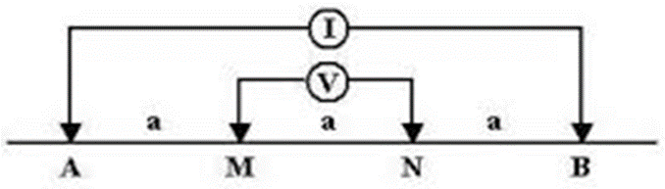
Fig.1 shows the Wenner electrode Setup
Electrical resistivity technique based on the measurement of surface potential caused by the flowing of an electric current on the ground from an artificial source depends on the validity of Ohm's law for linear conductors R-Av/1, where the resistance is R in Ohms, offered to current flow I and Av is the potential difference(volts), across two faces of the passing material. The resistance of layer m is proportional to its L, length and inversely proportional to its cross-sectional area, R α L/A. The electrical resistivity or the specific resistance, P of the conducting layer, then is Ρ= (A/L) R = (∆v / I) A/L
The above figure shows the arrangement and the current and potential lines in a homogeneous and isotropic medium. The potential difference between the two potential electrodes, M and N due to the current introduced by the two current electrodes, A and B.
Electrode Setup
The real-time measurements involve a various kinds of electrode setup are made, setups may differ in the electrode distance and geometry. Familiarly used configurations are Wenner, Schlumberger and dipole-dipole. In Wenner electrode setup, 4 electrodes, equi-distant one with respect other, are kept in a linear line, the outer two is the current electrodes.
Schlumberger setup is also similar to Wenner configurations, but in this condition the potential electrodes are kept close to one another and away from the current electrodes, with the distance between the potential electrodes (MN) being generally kept less than 0.2 AB.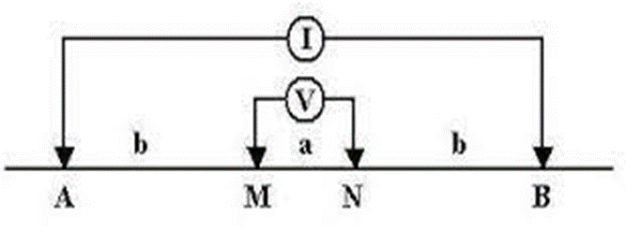
Fig.2 shows the Schlumberger electrode configuration
Horizontal Profiling and Vertical Electrical Sounding
These methods are supported in greeting of the object to travel of galvanic prevailing. The resistivity of a shake object depends on its asphaltic schoolwork and is influenced to a really broad change by the interstitial food collection recognize there in. Electrical resistivity method involves the activity of layer possibility caused by the delivery of an electric underway. In factual earth measurements, a variety of electrode arrangements are utilized.
Self-Potential
The self-potential (SP) strategy could be a detached electrical geophysical strategy based upon measuring of spontaneous or common electrical potential created within the soil due to: electrochemical intuitive between minerals and subsurface liquids, electro dynamic forms coming about from the flow of ionic liquids or thermoelectric components from temperature angles within the subsurface.
Study Area
The study area is from Veppilaipatti village, Salem district, Tamil Nadu. This area lies between north latitude and longitude 11⁰35’03″ and 78⁰21’35″,11⁰35’03’’ and 78⁰21’39’’ and south latitude and longitude 11⁰34’51’’ and 78⁰21’33’’, 11⁰34’56’’ and 78⁰21’38’’. Salem district is bounded north Tamil Nadu. It is located between on 11.669437°N Latitude, 78.140865°E Longitude at an average elevation of 278 m (912 ft) above the mean sea level except Yercaud hills. It has an area of about 7905.38 kms with 38, 96,388 inhabitants. Salem surrounded by hills: the north is surrounded by Nagaramalai hills, Jarugumalai on the south, Kanjamalai on the west, Godumalai on the east and the Shevaroy Hills on the northeast. Entire district comprises of a hard rock terrain of Archaean age and it has the principal rock type of granite and a semi-arid weather.
Geology and Geomorphology of Study Area
Salem district is rich in mineral deposits like Magnesite, Bauxite, Granite, Limestone, Quartz and Iron ore. Geologically, the entire Salem district can be classified into hard rock formation. More than 90 percent of the district is underlain by hard rock of Archaean age. Quartz, Feldspar, and limestone those are resistant to weathering and also seen as patches in Charnockite and gneissic varieties and the above rock types found Sedimentary Formation. The granulite terrain of Salem area has witnessed two major periods of granitic activity – one during Late-Archaean to Early Palaeo-Proterozoic and the other during Neo-Proterozoic times. The granites of older event are restricted to the southern part of Salem district i.e. North of Moyar – Bhavani – Attur Lineament (MBAL), while the younger Pan-African event is spread in the terrain south of MBAL. The rocks of the Khondalite and Charnockite groups have been subjected to regional magmatisation and retrogression with influx of quartzo-feldspathic material resulting in the formation of different types of gneiss such as biotite gneiss, hornblende gneiss, Augen gneiss, garnetiferous biotite gneiss, garnetiferous quartzo-felspathic gneiss depending upon the parent rock. The entire area of Salem district is a pediplain. The Shevaroy Hills on the northeast and Jarugumalai on the south side of the district constitutes the remnants of the much-denuded Eastern Ghats and rise to heights of over 1031 m above mean sea level. There are numerous small residual hills like Nagaramalai, Kanjamalai and Kodhumalai hills. The elevation of the area is ranging between 120 m and 200m above Mean Sea Level (MSL). The prominent geomorphic units identified in the district through interpretation of Satellite imagery are Structural hill, Pediments, Shallow Pediments, Buried Pediments and Alluvial plain.
The soils can be broadly classified into 6 major soils types including Red insitu, Red Colluvial Soil, Black Soil, Brown Soil, Alluvial and Mixed Soil. Majority of the district is covered by Red insitu and Red Colluvial soils. Block soils are mostly seen in Salem, Attur, Omalur and sankari taluks. Brown Soil is majorly found in Yercaud and Omalur and the Alluvial Soil is found in the river courses of Omalur and Sankari. Mixed soil is found only in Attur taluk.
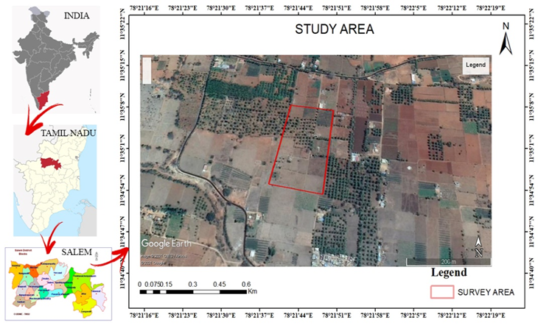
Fig.3 shows the Study area map
Rainfall and Climate
Salem district gets rain beneath the impact of both southwest and northeast rain storm. The northeast rainstorm primarily contributes the precipitation within the area. Precipitation information from six stations over the period 1901-2003 were utilized and an examination of the analysis appears that the ordinary yearly precipitation over the area shifts from approximately 800 mm to 1600 mm. It is the least around Sankari (800 mm) within the southwestern portion of the district. It continuously increments towards north, northeast and east and attains a greatest around Yercaud (1594.3 mm) within the northern portion.
The Salem district enjoys a tropical climate. The climate is charming amid the period from November to January. Mornings in common are muggier than the evenings, with the stickiness surpassing 75% on a normal. Within the period June to November the evening mugginess surpasses 60% on a normal. Within the rest of the year the evenings are drier, the summer evenings being the driest. The hot climate starts early in March, the most elevated temperature being come to in April and May. Climate cools down continuously from almost the center of June and by December, the cruel day by day most extreme temperature drops to 30.2°C, whereas the cruel day by day least drops to 19.2°C and 19.6°C in January in Salem and Mettur Dam.
Hydrogeology of the Study Area
Salem district is underlain completely by Archaean Crystalline arrangements with later alluvial deposits happening along the waterway and streams courses like Cauvery, Thirumanimutharu, Sarapangandhi are the vital waterways within the locale. But Cauvery, other streams stream as it were amid blustery seasons. Weathered, fissured and broken crystalline rocks and the later alluvial stores constitute the important aquifer frameworks within the area. The permeable arrangements within the area are represented by waterway alluvium. These alluvial deposits are kept to the Major Stream and stream courses as it were. Ground water happens beneath phreatic conditions. The greatest immersed thickness of these aquifers is up to 10 m depending upon the topographic conditions. The difficult solidified crystalline rocks of Archaean age represent weathered, fissured and broken arrangements of gneisses, stones, Charnockite and other related rocks.
Objectives of the Study
The major objective of present study is to explore the ground water.
- To portray the outcrop geology of the ponder area.
- To investigate sub surface breaks, weathered zone and water filled pores spaces at a chosen depth (Using 2D profiling)
- To choose appropriate area to vertical electrical sounding utilizing profile information 3D plot created from surfer.
- To investigate ground water potential of the chosen point and to choose a point to penetrate for high yielding bore well. (Using Vertical electrical sounding, Schlumberger electrode configuration).
MATERIALS AND METHODOLOGY
There are a few variations in electrical method. In reality, biggest assortment of strategies is conceivable in electrical method of prospecting and it'll be no shock in case unused strategies are created in upcoming years. In electrical strategies, the characteristic electrical field in a region was examined or the ground is charged by an artificial electrical field and dispersion of the electric field at the surface of the soil was explored.
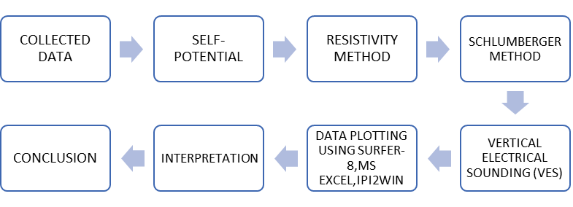

METHODOLOGY FLOW CHART
Electrical Resistivity Method
Electrical method procedures depend on the reaction of the earth in passing the stream of electricity. Among the geophysical methods, electrical resistivity strategies appreciate the most noteworthy popularity and are broadly utilized for both territorial and point by point groundwater overviews since of its way better settling control, less costs as well as run of appropriateness. Electrical resistivity strategies have utilized in this case to Portray potential zones of subsurface water and to discover thickness of immersed layers, profundity to the subsurface topography.
Apparent Resistivity
The capacity to carry current is a critical property of rock shaping minerals, this property utilizes of in electrical method of prospecting. Electrical resistivity looking over depends on measuring of the resistivity 'p' of subsurface by passing a known electric current into the ground and measuring the potential difference between two points. This technique depends on usage of Ohm's law in linear conduction, represented as,
$$R=\frac{∆V}{I}$$
Electrode Configuration
In real estimation, an assortment of electrodes course of arrangements is utilized, contrast within the inter-electrode distance and geometry. The foremost commonly utilized arrangement is the Wenner and Schlumberger arrangements.
Schlumberger Arrangements
The Schlumberger terminal setups are additionally a cluster like Wenner, but contrasts in putting the two current terminals with a much bigger gap than that between the potential (inward) electrodes. As it were one set of cathodes either potential or current are moved to extended interims at a time whereas conducting profundity soundings not at all like in Wenner cluster where there are four electrodes are moved at the same time. The current anodes are signified by A and B, whereas the potential anodes are signified by M and N. The gap between M and N is signified by 'b' whereas the gap AB is signified by a'. The apparent resistivity is given by,
$ρ$a = KR,
$K=π\frac{AM. AN}{MN}$ ,
Interpretation of Resistivity Data
Elucidation of resistivity information in words of the subsurface geology and hydrology shapes 2 imperative stage within investigation of subsurface water. Point of translation of resistivity, to decide the thickness of layer and resistivity of diverse horizons present. Interpretation of V.E.S information is both quantitative and subjective. The sort of V.E.S bend gotten demonstrates the nature of subsurface that will be anticipated in a zone. For case, a H sort bend with difficult shake territory be deciphered as comprising of (1) a dry top soil layer taken after by (2) moist weathered rock/regolith, underlain by (3) the bed rock. There are numerous ways to decipher the resistivity information beginning from observational strategy using Modern strategies utilizing quick systems.
Self-Potential
The self-potential (SP) strategy may be an inactive electrical geophysical strategy based upon the estimation of spontaneous or natural electrical potential created within the soil due to: electrochemical interactions between minerals and subsurface liquids, electro kinetic forms coming about from the flow of ionic liquids or thermoelectric mechanisms from temperature angles within the subsurface. A few physical forms caused sources of SP are still hazy. Groundwater is thought to be common calculate capable for SP. Potentials are produced by the stream of water, by water responding as an electrolyte and as a dissolvable of distinctive minerals. Electrical conductivity to create possibilities of permeable rocks depends on porosity and on versatility of water to pass through the pore spaces depend on ionic mobilities, solution concentrations, viscosity, temperature & pressure.
RESULTS AND DISCUSSION
VES are done in field utilizing shlumberger arrangement additionally self-potential itself. In all 3 soundings were done and analysed. The least and most extreme value of AB/2 (current electrode division) chosen for the studies is 2m to 60m, the clear resistivity information of Vertical Electrical Sounding areas has plotted on graph (log-log) and coordinated with master curve for getting the layers. The depth sounding curves are classified based on layer resistivity combinations.
Geo-Survey Equipment
The geo-physical instrument was utilized for field work is DDR-2, which is the innate IGIS make from Hyderabad. The 3 Vertical Electrical Depth Soundings (VES) were taken for basic examination of the subjective and quantitative elucidations. The readings are arranged underneath. The 3 numbers of sounding were at first coordinated manually with the master curves arranged for vertical electrical sounding by the Ernesto Orellana and Harold. Mooney, Intercien Costanilla De Los Angeles, Madrid 1966. At that point the deciphered information has been confirmed utilizing the computer program and subtle elements are as takes after:

Table 1. The values of VES reading 1
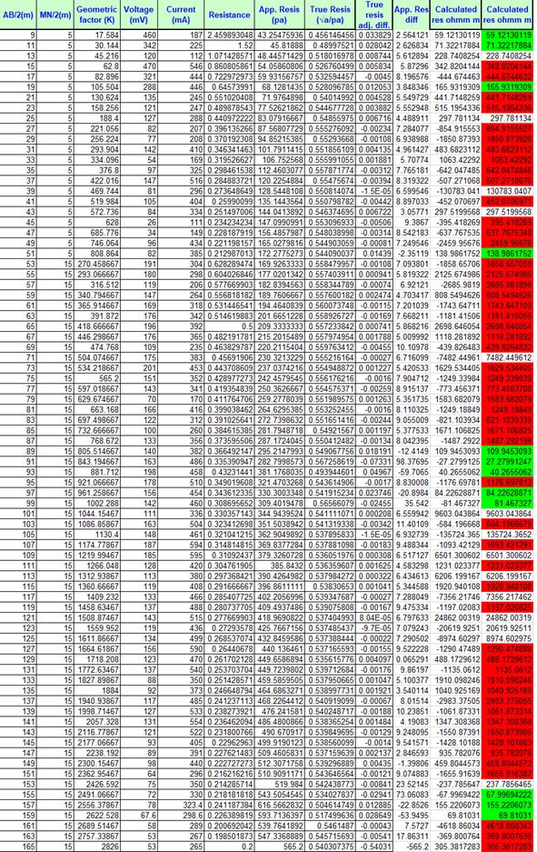

Table 2. The values of VES reading 2

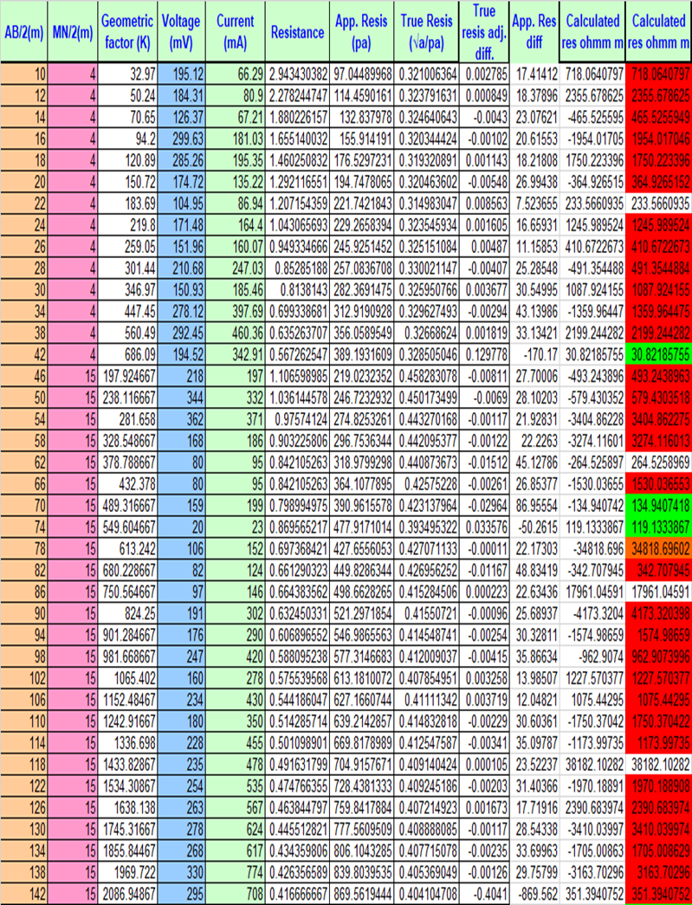

Table 3. The values of VES reading 3
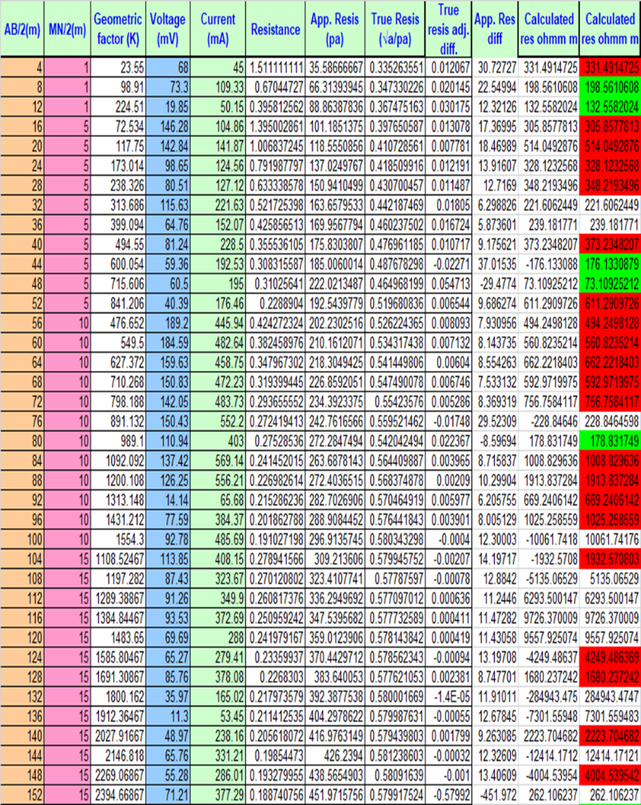
Table 4. The values of Self-Potential data
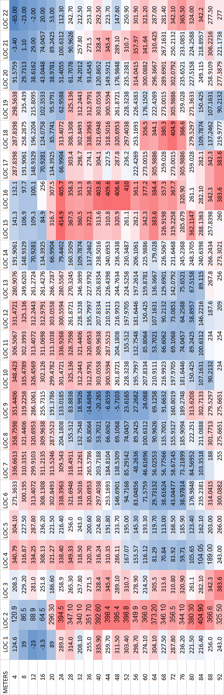

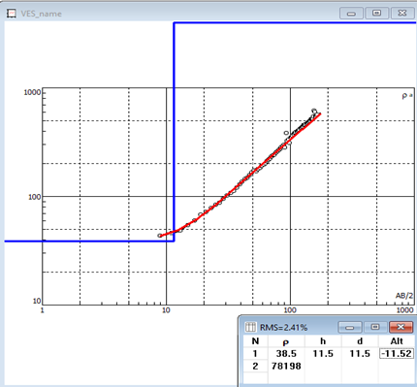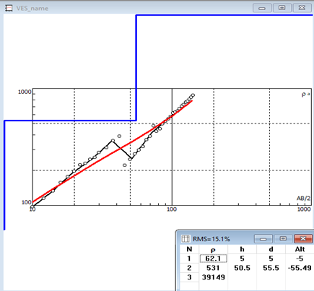
Fig 4 shows the VES Curve at Location 1 Fig 5 shows the VES Curve at Location 2
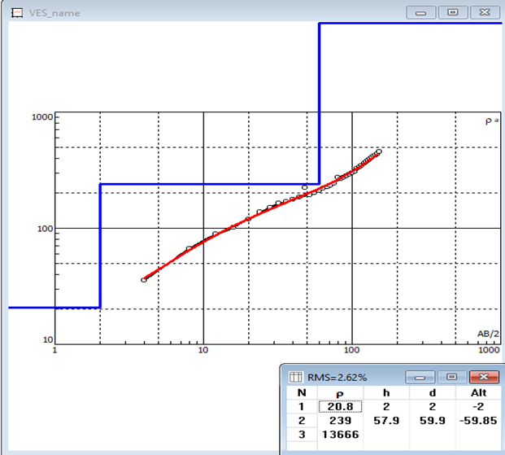
Fig 6 shows the VES Curve at Location 3

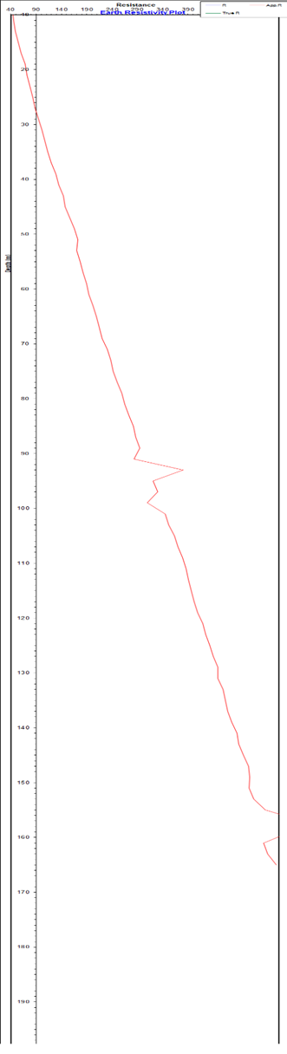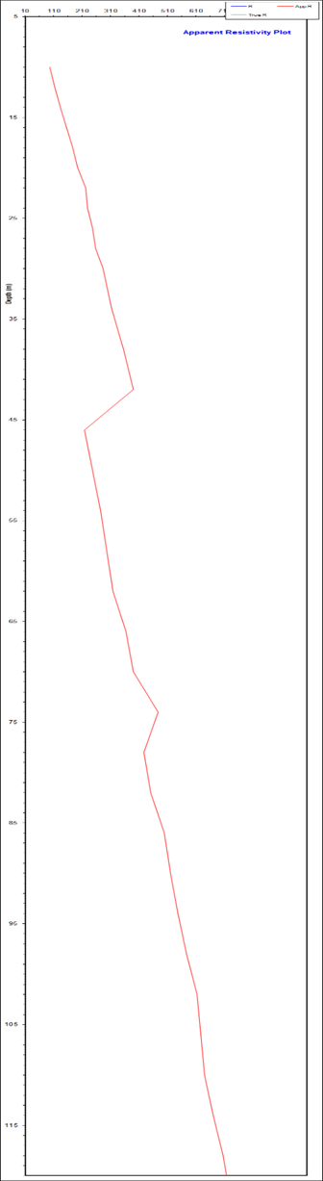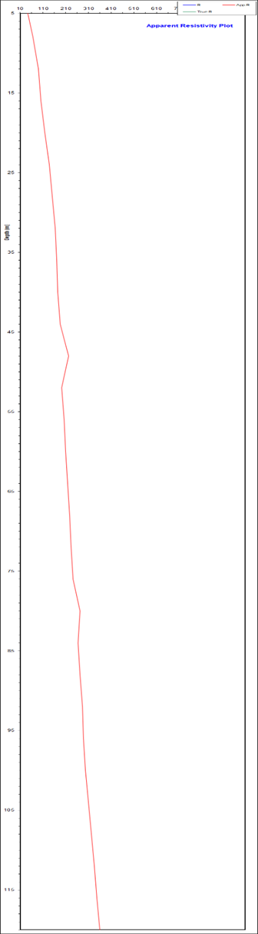
Fig 7,8,9 shows the Apparent Res Plot Vs Depth

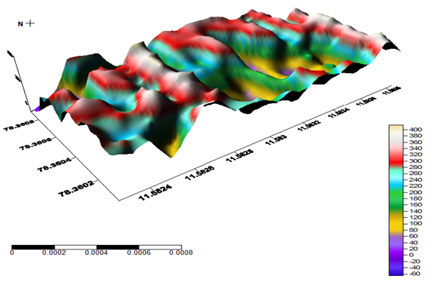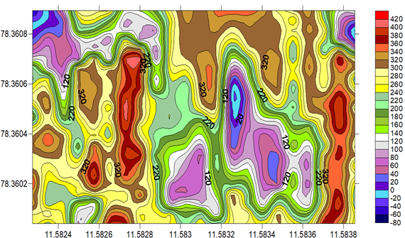
Fig 10. Shows the 3D view of the Apparent Resistivity Plot Fig 11. Shows the 3D view of the Apparent Resistivity Plot APPARENT RESISTIVITY CONTOUR MAP
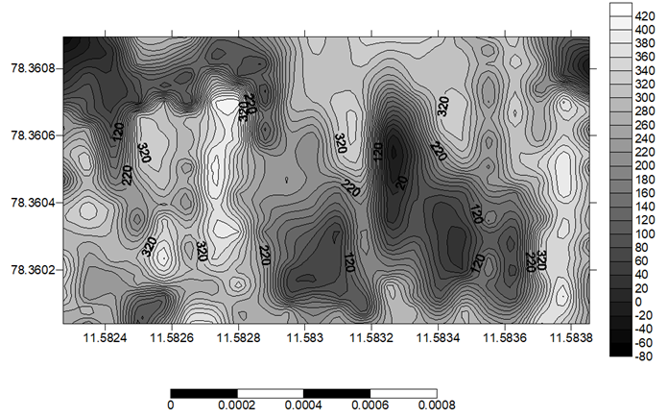
Fig 12. Shows the apparent resistivity contour map and their depth
CONCLUSION
Ground water exploration has been done in part of the Veppilaipatti Village, Vazhappady Taluk, Salem District in Tamil Nadu using 2D profiling and VES using Schlumberger electrode configuration and self-potential method. Vertical electrical sounding strategy of the electrical resistivity strategy and self-potential strategy has demonstrated to be effective and exceedingly successful within the recognizable proof and outline of subsurface structures that are great for groundwater amassing in a crystalline basement complex range. The foremost portion of the consider region is overwhelmed by the A and H type curve which uncovers the number of subsurface layers, their thickness and their water bearing capacity inside the study. Based on self-potential information it shows the three negative values point within the zone considered as the streaming potential point within the area (the weathered water saturated point). At the same point took the VES based on Schlumberger strategy, distinguished three water bearing zone 67m, 30m and 73m depth. The explored VES (VES POINT 2, Depth at 73m) recommended as high yielding well bore point among the studied region. In final it is that the electrical resistivity study has helped in understanding the ground hydrology and the event of salt and brackish water within middle portion of the study region and the surfer diagram uncovers that 3D subsurface of the study area.
SELECTED REFERENCES
Adeotil, L., Alile. O. M., Uchegbulam, O, and Adegbola, R. B. Geoelectrical Investigation of the Groundwater Potential in Mowe, Ogun State, Nigeria, British Journal of Applied Science & Technology 2(1): pp. 58-71.
Adepelumi, A. A., Akinmade, O. B., Fayemi, O (2013). Evaluation of Ground Water Potential of Baikin Ondo State Nigeria Using Resistivity and Magnetic Techniques: A Case Study. Universal Journal of Geoscience, Vol 1(2), pp. 37-45.
Emmanuel C. Okolie (2010). Geophysical investigation of effects of topographic complexities on groundwater potential in Ibusa, Delta State Nigeria, Archives of Physics Research, 1 (3): pp. 62-71. Jeyavel, T., Raja Kumar., Balasubramanian, A., Kumar, R.S., Dushiyanthan, C., Karthikeyan,
K., Thiruneelakandan, B., Davidraju, D., and Manoharan, K (2011). Delineation and evaluation of groundwater potential zones using electrical resistivity survey and aquifer performance test in Uppodai of Chittar - Uppodai water shed, Tambaraparani River Basin, Tirunelveli-Thoothukudi Districts, Tamilnadu, J. Ind. Geophys. Union Vol.15, No.2, pp.85-94.
Joseph Olakunle Coker, (2012). Vertical electrical sounding (VES) methods to delineate potential groundwater aquifers in Akobo area, Ibadan, South-western, Nigeria. Journal of Geology and Mining Research Vol. 4(2), pp. 35-42.
Kavidha, R., and Elangovan, K (2013). Delineation of Groundwater Prospective Zones by Electrical Resistivity Method in Erode District, Tamilnadu, India, Journal of Environment. Vol. 02, Issue 01, pp. 14-18.
Lateef, T.A. (2012). Geophysical Investigation For Groundwater Using Electrical Resistivity Method - A Case Study Of Annunciation Grammar School, Ikere Lga. Ekiti State, South Western Nigeria. IOSR Journal of Applied Physics (IOSRJAP) ISSN - 2278-4861 Volume 2, PP 01-06.
Murthy, B. V. S., Varaprasada Rao, S. M and Bhimasankara, M. V. L. S (1982). Structure and geology of the Munneru valley as inferred from gravity and magnetic surveys, J. Indian Acad.
Narasimha Prasad, N.B (2011). Geophysical investigation for groundwater exploration in Lakshadweep Islands - A case study, J. Ind. Geophys. Union Vol.15, No.4, pp.221-227.
Oseji. Julius Otutu and Ajnabi, O (2009). Hydrogeophysical investigation of groundwater potential in Emu kingdom, Ndokwa land of Delta State, Nigeria. International Journal of Physical Sciences Vol. 4 (5), pp. 275-284. Owen, R., Gvavav O.,and Gwaze, P(2005). Multi-electrode Resistivity Survey for Groundwater Exploration in the Harare Greenstone Belt, Zimbabwe. Hyrdogeology Joumal. Vol14, pp.244-252.

