Impact of MWCNT on Metal – Organic Contact of Rose Bengal and Safranin –T Dye Based Organic Device

Sudipta Sen*, N. B. Manik
Condensed Matter Physics Research Centre, Department of Physics
Jadavpur University, Kolkata-700032, India
*Corresponding Author’s Email: sagnike000@gmail.com

Abstract:
Carbon-based nanomaterials have gained significant attention in various research disciplines due to their exceptional characteristics, including an excellent aspect ratio, substantial surface area, and superior thermal and electrical conductivity. In this study, Multi walled carbon nanotubes (MWCNT) have been selected from an array of carbon-based nanomaterials. This study focuses on exploring the use of multi-walled carbon nanotubes (MWCNT) within the realm of organic electronics. Organic dye-based devices possess distinct advantages in comparison to their inorganic counterparts, a fact well acknowledged in the field. However, there exist certain drawbacks associated with the utilization of organic dyes in the context of being positioned between two metallic electrodes, hence establishing metal-organic interface. The charge injection process during formation of metal-organic junction is influenced by the presence of a high concentration of traps and a high injection barrier at the contact region. The improvement in charge flow at the junction and the enhancement of conductivity, as well as the reduction in threshold voltage, can be achieved by decreasing these values. From this standpoint, the inclusion of multi-walled carbon nanotubes (MWCNT) has been implemented within the device. In the process of fabricating organic dye-based devices, two distinct organic dyes, namely Rose Bengal (RB) dye and Safranin - T dye, have been selected. Four devices were developed, with two devices being made without the inclusion of multi-walled carbon nanotubes (MWCNT), while the other two devices incorporate MWCNT. This study aims to examine the impact of trap energy and injection barrier on the movement of charge carriers at the interface between metal and organic materials. Additionally, it seeks to investigate any alterations in these parameters when multi-walled carbon nanotubes (MWCNT) are present.

Keywords: Injection Barrier; MWCNT; Rose Bengal Dye; Safranin – T Dye; Threshold Voltage;
Trap Energy

1. Introduction

In the past few decades, the study on the physics and chemistry of nanostructures is getting significant attention after the discovery of fullerenes, carbon nanotubes and graphenes. The atypical properties of carbon nanostructures are due to the size effects, which can be seen in zero-dimensional carbon quantum dots, one-dimensional carbon nanotubes, and two-dimensional grapheme layers [1-2]. These nanoscale materials have certain properties such as higher strength, lighter weight, increased control of light spectrum, and greater chemical reactivity than their larger-scale counterparts [3]. For carbon nanotubes, the classification can be done on the basis of chirality and also on the basis of number of graphene sheets. In terms of graphene sheets, the carbon nanotubes can be distinguished as single walled carbon nanotubes (SWCNT), double walled carbon nanotubes (DWCNT) and multi walled carbon nanotubes (MWCNT) [4].

In this present work, we have chosen MWCNT from the family of carbon based nanomaterials (CBN). MWCNT has good electrical conductivity, a large aspect ratio, low mass density and excellent thermal properties [5]. Our main objective of this work is to study one of the applications of MWCNT in the field of organic electronics in terms of device physics.

Organic dye based devices have certain excellent attributes such as cost effectiveness, light weight, flexibility and large area device fabrication [6-7]. Despite these attributes, when these organic dyes are sandwiched between two metallic electrodes, the charge flow at the metal – organic contact gets hindered. Poor charge injection process at the metal – organic contact can be caused by several factors. Organic devices are predisposed to traps [8]. High trap energy is a significant factor which hampers the flow of charges at the junction area. Injection barrier at the metal – organic contact contributes to the lowering of active charge carrier flow in the device. To improve the device performance in terms of lowering of the threshold voltage and enhanced conductivity, reduction of both of these parameters is very much necessary. In this perspective, we have incorporated MWCNT in the organic device, to observe and study its effect on both trap energy and injection barrier. We have selected two organic dyes namely Rose Bengal (RB) dye and Safranin – T dye. As electrodes, we have chosen Indium Tin Oxide (ITO) coated glass substrate and Aluminium (Al). A total of four devices have been prepared with and without MWCNT. Current flow in the prepared devices has been characterized by using the steady- state current voltage (I –V) plot and it has been analyzed by using Richardson – Schottky (R-S) thermionic emission process [9]. Charge trapping process has also been studied by using G (V) – V characteristics of the device. Image charge carriers are also considered in calculating the injection barrier and subsequently the effect of MWCNT on the injection barrier considering the image charge effect. The Norde method has also been used in this work to check the congruity of the estimated value of injection barrier from I- V characteristics of these devices.

2. Experimental Details

2.1 Materials

RB dye is an anionic dye of xanthenes organic compound [10]. Chemical Abstracts Service (CAS) number and molecular weight of this dye are 632-69-9 and 1017.64 g/mol respectively [11-12]. Safranin - T dye is a cationic azine dye [13]. CAS number and molecular weight of this dye are 477-73-6 and 350.84 g/mol respectively [14]. Empirical formula of this dye is C₂₀H₁₉ClN₄ [15]. Fig.1 (a) and Fig.1 (b) illustrate structures of both RB dye and Safranin - T dye. Both these dyes have been bought from Sigma- Aldrich.

The Multi-walled Carbon Nanotube (MWCNT) is classified as a carbon-based substance that exhibits exceptional physiochemical, thermo-mechanical, and electrochemical characteristics [16]. MWCNT is of 10 µm length and 12 nm of outer diameter. The surface area of MWCNT is 220 m² /g. The carbon content of MWCNT is more than 98%. CAS number of MWCNT is 308068-56-6 [17]. Fig.1 (c) shows the structure of MWCNT. It has been also bought from Sigma- Aldrich.

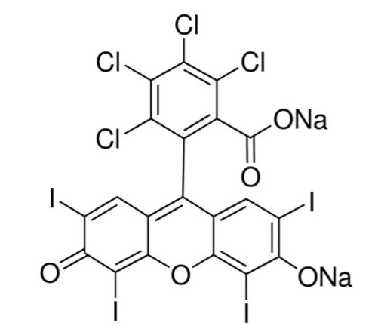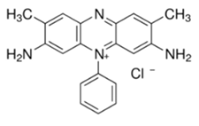
(a) (b)

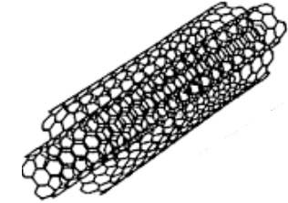
(c)

Fig. 1 Schematic Structures of (a) Rose Bengal (RB) Dye, (b) Safranin –T dye and (c) Multi – Walled Carbon Nanotube (MWCNT)

2.2 Sample Preparation

Preparation of PVA solution is mentioned in one of our previously published works [18]. PVA acts as an inert binder. RB dye solution is formed by adding 2 mg of RB dye with the prepared PVA solution. After that this RB dye solution is kept in two beakers. In one beaker, there is only RB dye solution and in another, 2 mg of MWCNT is prepended to form the solution with MWCNT and this solution is stirred for one hour. After that, RB dye solution without MWCNT is spin coated at 2000 rpm speed and dried at 3500 rpm speed on a pre cleaned ITO coated glass substrate. Similarly, the same solution is deposited on Al. Then, both ITO coated glass and Al are sandwiched together in the semi – dry state to form the RB device without MWCNT. Similarly, the RB solution with MWCNT is also spin coated to prepare the RB device consisting of MWCNT. The prepared devices are kept in vacuum desiccators for 48 hours to dry before electrical characterization. Organic Device forming comprising of Safranin –T dye with and without MWCNT has been done by using the similar processes, which are being done while making the RB dye based device in presence and in absence of MWCNT. The Safranin –T dye based device with and without MWCNT are also kept in vacuum desiccators for 48 hours to dry before electrical characterization. Fig. 2 expresses schematic diagram of the prepared organic device.

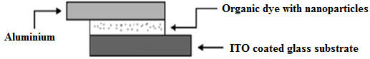
Fig. 2 Schematic Diagram of the prepared organic device

3. Measurements

Measurement techniques are already mentioned in one of our previous published works [19]. The temperature is maintained at 27⁰C during the experiment.

4. Results and Discussions

The interfacial current (I) due to Richardson-Schottky (R-S) thermionic emission can be expressed as
$I=I_{0}$ (exp ($\frac{qV}{nkT})$ -1) (1)
$I_{0}=$ $AA^{*}T^{2}$ exp ($-\frac{qϕ_{b}}{kT}$) (2)
The above used symbols carry their usual meaning [20-22]. The interfacial barrier height obtained from the extrapolation of I₀ in the semi log forward bias I-V characteristics.

$ϕ_{b}=\frac{kT}{q}ln⁡(\frac{AA^{*}T^{2}}{I_{0}})$ (3)

Fig. 3 (a) and Fig. 3 (b) show the dark I – V characteristics of both RB dye and Safranin – T dye based organic devices with and without MWCNT. With MWCNT, the current flow at the metal – organic contact of RB dye and Safranin – T has been increased about 4 times and 3.5 times respectively. Aspect ratio of MWCNT will have paramount effect on both electrical and mechanical properties when it is incorporated in these organic devices. MWCNT acts as conductive fillers of traps resulting in better flow of charge carriers in both of these organic devices.

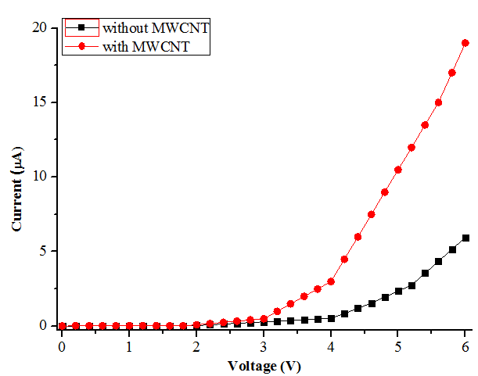
(a)

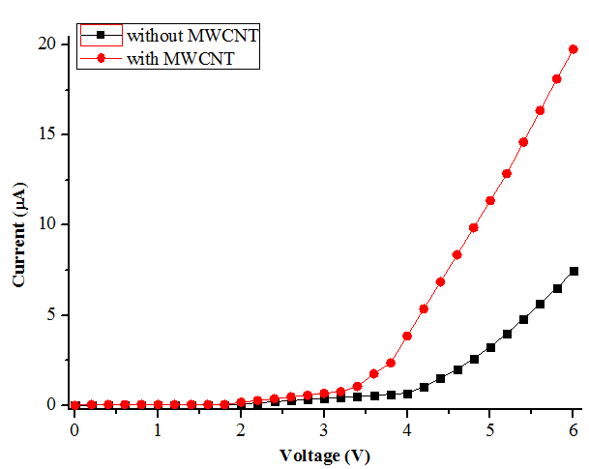
(b)
Fig. 3 Dark Current – Voltage Characteristics of Devices Comprising of (a) RB dye and (b) Safranin –T dye with and without MWCNT

For estimating injection barrier of these organic devices, semi logarithmic I – V characteristics have been plotted in Fig. 4. Fig. 4 (a) and Fig. 4 (b) show the semi logarithmic I – V plots of RB dye and Safranin- T dye with and without MWCNT respectively. The value of saturation current ($I_{0})$ can be estimated from the semi logarithmic I – V plots and by putting the value of $I_{0}$, in equation (3), the injection barriers of both RB and Safranin – T dye based devices in absence and in presence of MWCNT can be estimated. From equation (3), it can be observed that, injection barrier is inversely proportional to $I_{0}$. With presence of MWCNT, $I_{0}$ increases significantly, which results in decrease in injection barrier at the metal – organic junction.

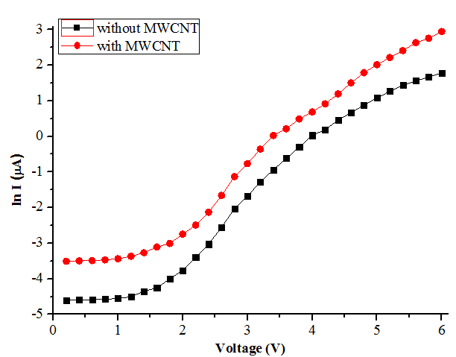
(a)

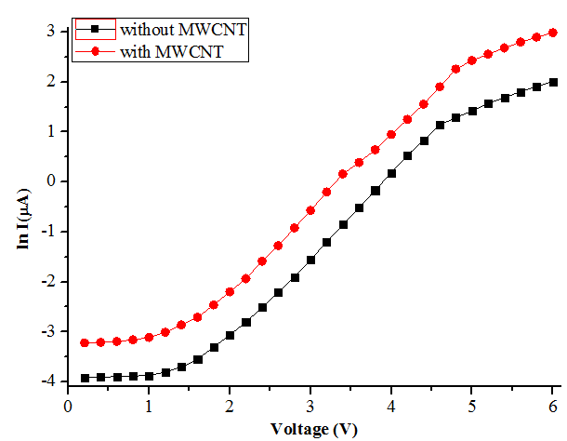
(b)
Fig. 4 Semi logarithmic Current – Voltage Characteristics of Devices Comprising of (a) RB dye and (b) Safranin –T dye with and without MWCNT

The trap energy can be written as expressed in the following equation (4)

$E_{t}$=$mkT$ (4)
Symbols used here have their usual meaning [23] and m is calculated from both the double logarithmic plot of I -V characteristics of the RB dye based devices and Safranin – T dye based devices with and without MWCNT, which have been shown in Fig. 5.

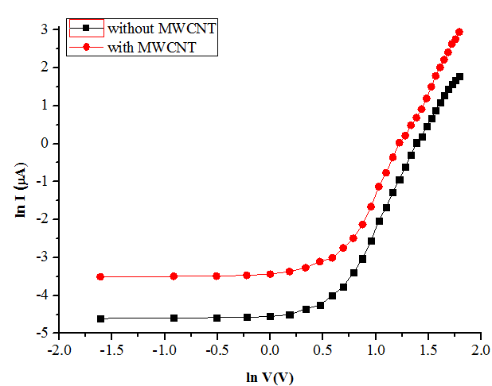
(a)
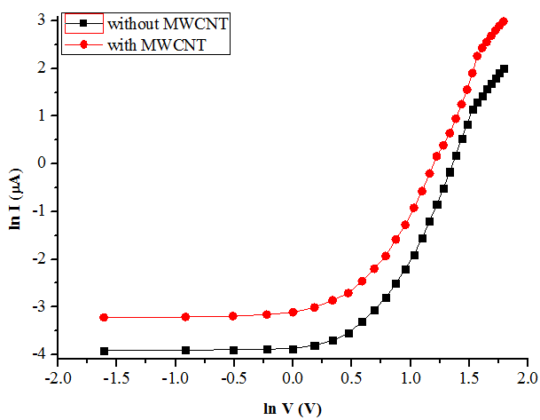
(b)
Fig. 5 Double logarithmic Current – Voltage (ln I- ln V) Characteristics of Devices Comprising of (a) RB dye and (b) Safranin –T dye with and without MWCNT

Estimation of injection barrier has been done by using Norde function. For both the devices, injection barrier has been calculated by using the following equation (5) [24-26]. V₀ is estimated from the plot which is shown in Fig. 6 (a) and Fig. 6 (b) respectively for both RB dye and Safranin – T dye based devices respectively without and with MWCNT.

$ϕ_{b}$= F (V_{min}) + $\frac{V_{0}}{X}$-$\frac{1}{β}$ (5)

Symbols carry their usual meaning [27].

The value of V₀ decreases with the incorporation of MWCNT. As shown in equation (5), the injection barrier is directly proportional to V₀. It can be inferred that due to the lowering of V₀ in presence of MWCNT, the injection barrier is lowered at the metal – organic junction for both devices.

The charge trapping effect has also been analyzed by using a method which is proposed by Rizvi et al. , which is shown in the following equation (6) [28].

G (V) = $\frac{d\log{ (I)}}{d\log{ (V)}}$ (6)

G (V) would show a peak due to trap filling. Large amount of traps result in significant change in I-V characteristics.

Fig. 7 (a) and Fig. 7 (b) show G (V) –V plot for both the devices comprising of RB dye and Safranin – T dye respectively under the influence of MWCNT. With MWCNT, more sharp peaks exist in the plot which indicates that the traps are filled and it will lower the injection barrier resulting in charge injection improvement at the metal – organic contact.

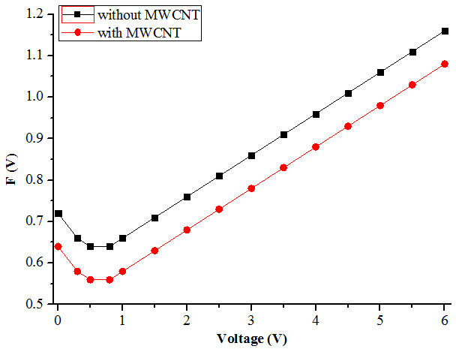
(a)

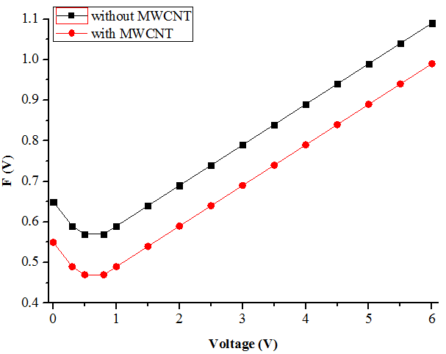
(b)
Fig. 6 Norde’s function F (V) –V plot of the Organic Devices Comprising of (a) RB dye and (b) Safranin –T dye with and without MWCNT

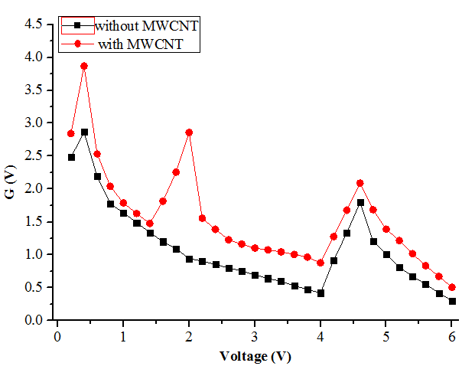
(a)

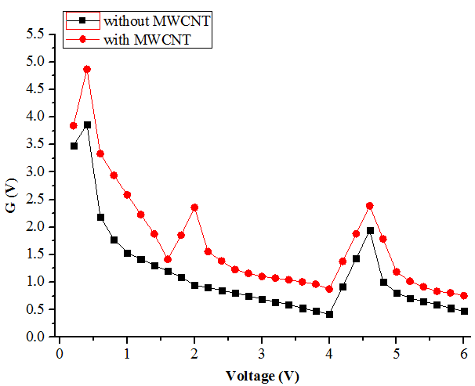
(b)
Fig. 7 G (V) –V plot of the Organic Devices Comprising of (a) RB dye and (b) Safranin –T dye with and without MWCNT

Charge – carrier injection from metal to organic layer is known to be restricted by a superposition of an external electric field and the Coulomb field, binding the carrier with its image twin on the electrode is given by the following expression in the equation (7) [29-30]

U(x) = $ϕ_{b}$ – $\frac{q^{2}}{16πε_{0}εx}$ – eFx (7)
x = distance away from the metal insulator interface, located at x = 0, $ϕ_{b}$ = injection barrier in the absence of both the external field and the image charge effect, F = external field, q = charge of an electron, ε = dielectric constant and $ε_{0}$ = dielectric permittivity.

We have calculated the injection barrier of both the devices in absence and in presence of MWCNT. The applied field is 10⁵ V/cm and the value of the dielectric constant is 3 and the potential distribution is located at 2 nm away from the interface.

The estimation of threshold voltage, trap energy and injection barrier of both the devices comprising of RB dye and Safranin –T dye respectively in absence and in presence of MWCNT are shown in the Table 1.

Table 1: Estimation of Threshold Voltage, Trap Energy, Injection Barrier for RB dye and Safranin –T Dye Based Device without and with MWCNT

Organic Device | Threshold Voltage (V) | Trap Energy (eV) | Injection Barrier from Steady State  I –V characteristics  (eV) | Injection Barrier from Norde Function  (eV) | Injection Barrier considering Image – Charge Effect  (eV)
RB Dye | 4.00 | 0.087 | 0.920 | 0.893 | 0.754
RB Dye + MWCNT | 3.00 | 0.075 | 0.860 | 0.842 | 0.685
Safranin –T Dye | 4.00 | 0.059 | 0.810 | 0.780 | 0.790
Safranin –T Dye + MWCNT | 3.50 | 0.047 | 0.790 | 0. 755 | 0.760

Table 1 shows that, for RB dye, threshold voltage, trap energy and injection barrier estimated from
steady – state I – V characteristics have been reduced to 25%, 13.79% and 6.52 % respectively in presence of MWCNT. For Safranin – T dye also, threshold voltage, trap energy and injection barrier estimated from steady – state I – V characteristics have been reduced to 12.5%, 20.33% and 2.47% respectively with MWCNT. Congruity of the values of injection barrier which are obtained from I – V characteristics and by using Norde function is shown in the Table 1. Injection barrier considering image charge effect has been lowered considerably in presence of MWCNT for both the organic devices. High aspect ratio of MWCNT allows lowering of percolation threshold of electrical conductivity resulting in improving of the device performance by reducing both trap energy and injection barrier at metal – organic contact.

5. Conclusions

In this present work, influence of MWCNT on the charge injection process at the metal – organic contact has been studied. We have used two dyes, RB dye and Safranin – T dye respectively. We have observed the parameters which affect the charge injection process mainly i.e. trap energy and injection barrier, have been decreased significantly with MWCNT. Lowering of both of these parameters will improve the charge flow at the junction area resulting in better conductivity and the devices will be turned on at lower voltages. For both RB dye and Safranin – T dye, incorporation of MWCNT provides more conductive pathways by reducing the trap concentration and injection barrier at metal – organic contact. Reduction of trap energy in presence of MWCNT for both the devices can be observed from G (V) – V characteristics. We have also used Norde function to estimate the injection barrier of these devices and it has been found out that the value of injection barrier from I – V plot and by using Norde method remain congruous to each other. Effects of image charges on the injection barrier of the organic devices have also been studied and subsequently effects of MWCNT on the injection barrier considering image charges have also been estimated in this work. This present work will be informative to observe and study one of the applications of MWCNT regarding the improvement of certain parameters that influence the charge flow at metal – organic contact.

References

[1] T. C. Dinadayalane and J. Leszczynski, “Remarkable diversity of carbon–carbon bonds: structures and properties of fullerenes, carbon nanotubes, and graphene”, Structural Chemistry, 2010, 21, 1155-1169

[2] D. Maiti, X. Tong, X. Mou and K. Yang, “Carbon – Based Nanomaterials for Biomedical Applications: A Recent Study”, Frontiers in Pharmacology, 2019, 9, 1-16
[3] G. S. Dhakad, R. Aich, M. S. Kushwah and J. S. Yadav, “Nanotechnology: Trends and Future Prospective”, Global Journal of Bio - Science and BioTechnology, 2017, 6, 548-553

[4] M. Youssry, M. Al-Ruwaidhi, M. Zakeri and M. Zakeri, “Physical functionalization of multi-walled carbon nanotubes for enhanced dispersibility in aqueous medium”, Emergent Materials, 2020, 3, 25-32

[5] V. S. Aigbodion, P. A. Ozor and N. I. Sukdeo, “New Insights in Decoration of Carbon Nanotube for Improved Electrical Conductivity and Thermomechanical Properties of Polymer Nanocomposites”, Proceedings of the International Conference on Industrial Engineering and Operations Management Nsukka, Nigeria, 5 - 7 April, 2022, 1251-1257

[6] Q. Zhang, W. Hu, H. Sirringhaus and K. Müllen, “Recent Progress in Emerging Organic Semiconductors”, Advanced Materials, 2022, 34, 1-4

[7] S. R. Forrest, “The path to ubiquitous and low-cost organic electronic appliances on plastic”, Nature, 2004, 428, 911-918
[8] H. F. Haneef, A. M. Zeidell and O. D. Jurchescu, “Charge carrier traps in organic semiconductors: a review on the underlying physics and impact on electronic devices”, Journal of Materials Chemistry C, 2020, 8, 759-787
[9] S. M. Sze and K. K. Ng, “Physics of Semiconductor Devices”, 2007, [3rd ed.], John Wiley & Sóns, New York, 159-181

[10] P. Argüeso , A. Tisdale, S. S. -Michaud, M. Sumiyoshi and I. K. Gipson, “Mucin characteristics of human corneal-limbal epithelial cells that exclude the rose bengal anionic dye”, Investigative Opthalmology & Visual Science, 2006, 47, 113-119

[11] Y. B. Tambe, R. Ameta and S. Kothari, “Use of N-Doped Zinc Oxide for Photocatalytic Degradation of Rose Bengal”, Journal of Applicable Chemistry, 2016, 5, 1199-1207

[12] M. A. Rauf, J. P. Graham, S. B. Bukallah, M. A. S. Al-Saedi, “Solvatochromic behavior on the absorption and fluorescence spectra of Rose Bengal dye in various solvents”, Spectrochimica Acta Part A: Molecular and Biomolecular Spectroscopy, 2009, 72, 133-137

[13] V. K. Gupta, A. Mittal, R. Jain, M. Mathur and S. Sikarwar, “Adsorption of Safranin-T from wastewater using waste materials — activated carbon and activated rice husks”, Journal of Colloid and Interface Science, 2006, 303, 80 - 86

[14] Y. Shi, X. Wang, X. Wang, K. Carlson and Z. Li, “Removal of Toluidine Blue and Safranin O from Single and Binary Solutions Using Zeolite”, Crystals, 2021, 11, 1181-1-1181-15

[15] S. Sen, P. K. Das and N. B. Manik, “Study on Effect of Single Walled Carbon Nanotubes on Junction Properties of Safranin – T Dye Based Organic Device”, Journal of Physics Communications, 2021, 5, 045004-1- 045004-9

[16] N. Baig, I. Kammakakam and W. Falath, “Nanomaterials: a review of synthesis methods, properties, recent progress, and challenges”, Materials Advances, 2021, 2, 1821-1871

[17] M. Zgrzebnicki, N. Krauze, A. G. -Puchalska, J. K. - Kozar, E. Piróg and A. Jwdrzejewska et al., “Impact on CO₂ Uptake of MWCNT after Acid Treatment Study”, Journal of Nanomaterials, 2017, 2017, 1-11

[18] S. Sen and N. B. Manik, “Modification of Barrier Height and Depletion Layer Width of Methyl Red (MR) Dye - Based Organic Device in Presence of Single - Walled Carbon Nanotubes (SWCNT)”, Indian Journal of Physics, 2022, 96, 385-390

[19] S. Saha and N. B. Manik, “Effect of different concentration of TiO₂ nanoparticles in phenosafranin dye-based organic photovoltaic device”, Indian Journal of Physics, 2015, 89, 907-913

[20] M. Yildirim, “Determination of Contact Parameters of Au/n-Ge Schottky Barrier Diode with Rubrene Interlayer”, Journal of Polytechnic, 2017, 20, 165-173

[21] F. Muhammad, M. Tahir, M. Zeb, M. N. Kalasad, S. M. Said and M. R. Sarker et al., “Synergistic enhancement in the microelectronic properties of poly- (dioctylfuorene) based Schottky devices by CdSe quantum dots”, Scientific Reports, 2020, 10, 1-13

[22] N. A. Roslan, A. Supangat and S. Sagadevan, “Investigation of Charge Transport Properties in VTP: PC71BM Organic Schottky Diode”, Electronics, 2022, 11, 1-10

[23] A. Haldar, S. Maity and N. B. Manik, “Effect of back electrode on photovoltaic properties of crystal-violet-dye-doped solid-state thin film”, Ionics, 2008, 14, 427-432

[24] H. Norde, “A modified forward I -V plot for Schottky diodes with high series resistance”, Journal of Applied Physics, 1979, 50, 5052-5053

[25] Y. S. Ocak, R. G. Guven, A. Tombak, T. Kilicoglu, K. Guven and M. Dogru, “Barrier height enhancement of metal/ semiconductor contact by an enzyme biofilm interlayer”, Philosophical Magazine, 2013, 93, 2172-2181

[26] A. Turut, “Determination of barrier height temperature coefficient by Norde’s method in ideal Co/n-GaAs Schottky contacts”, Turkish Journal of Physics, 2012, 36, 235-244

[27] P. -T. Lin, J. -W. Chang, S. -R. Chang, Z. -K. Li, W. -Z. Chen and J. -H. Huang et al., “A Stable and Efficient Pt/n-Type Ge Schottky Contact That Uses Low-Cost Carbon Paste Interlayers”, Crystals, 2021, 11, 259-1-259-9

[28] S. M. H. Rizvi, P. Mantri and B. Mazhari, “Traps signature in steady state current-voltage characteristics of organic diode”, Journal of Applied Physics, 2014, 115, 244502-1-244502-9

[29] V. I. Arkhipov, H. von Seggern and E. V. Emelianova, “Charge injection versus space-charge-limited current in organic light-emitting diodes”, Applied Physics Letters, 2003, 83, 5074-5076

[30] H. Bässler, “Charge transport in disordered organic photoconductors: a Monte carlo simulation

study”, Physica Status Solidi. B. Basic research, 1993, 175, 15-56

