Biotechnological Interventions for Mineral Accumulation in Rice
Prachi Sakariya QC microbiologist
Gujarat Life Sciences Pvt. Ltd.
Gorwa BIDC, Vadodara Gujarat, India

ABSTRACT
The world population was continuously increasing, suffer from a lack of food, so that fighting hunger continues to be a challenge for humanity. Globally, especially in the growing country, millions of people are suffering from micronutrient deficiency (Zn and Fe), also called “hidden hunger”. Mineral accumulation in food grains is effectual strategy to tackle this issue as well as providing cost-effective and sustainable technique of delivering micronutrients to a population through a diverse diet. The popularity and consumption of white/polished rice has increased, resulting in a loss of nutritional value. Therefore, to promote health benefits to the public at large, the nutrigenomic capability of white rice can be improved by integrating the phytochemicals related to the rice bran layer of brown rice by biofortification processes like agronomical practices, conventional breeding, over expression of gene, CRISPR technology, and RNAi techniques. Hence, this chapter focuses on enhancing the dietary qualities of white/polished rice by mineral accumulation with help of biotechnological and molecular techniques.

Keywords- Biofortification, Rice, Anti-nutrient, Malnutrition, CRISPR technology, RNAi

INTRODUCTION

In India, approximately 14.5 million men, 28.2 million pregnant women and 85.7 million children suffer from anaemia every year due to a diet low in iron and zinc, also called “hidden hunger”. especially staple foods [1]. Biofortification is a process of increasing micronutrients in food crops. Biofortification is an upcoming, promising, cost-effective, and sustainable technique of delivering micronutrients to a population through a diverse diet. Rice is the most important food source for humans and will feed more people for longer than any other crop [2]. Rice is the main source of calories for more than 3.5 billion people worldwide. In the future, rice will continue to be an important staple food for billions of people and will become one of the world's most important agricultural products, close to the country's food security, employment and economic development. Globally rice crop is estimated to cover 164.7 million acres [3]. Rice is a popular staple in regions where human Fe deficiency is common. But polished/ white rice does not provide enough Fe and Zn to match human nutritional requirements. The target Fe concentration for biofortification in polished rice is 15 mg kg–1, which requires a 7.5-fold increase from the average grain Fe concentration found in commonly cultivated rice cultivars. Meanwhile, in rice germplasm, there is only a limited amount of variation in polished grain Fe concentrations, which range roughly between 1 and 11 mg kg–1 [5].
we need to produce more staple grains should be of the highest nutritional value in sustainable ways.
Biofortification of essential micronutrients into crop plants can be achieved through three main approaches (Fig 1): Agronomical practices, Conventional breeding and new breeding technologies (Molecular and biotechnological approach)
- Agronomic techniques: In this method we are applying fertilizer, foliar spray, nutrient primers and microbes’
base culture on plants for increasing their nutrients value. Also known as ferti-fortification.
- Conventional breeding: cross between two parents in which one is high yielding variety and one is mineral rich variety
- New breeding technologies: It includes Molecular Breeding & Transgenic Approach in which transfer genetic materials in plants.
There are many limitations of agronomic and breeding approaches. When we are applying fertilizer, small fraction of the applied fertilizer is absorbed by plants, and a large portion is lost, causing serious environmental pollution. Other disadvantages like, breeding approaches is depending on existing gene pool, takes a long time, in crosses no guarantee of particular gene combination, undesirable genes can be transferred (Linkage drag), effects of environment and genotype interaction, relies only on phenotypic selection and improvement of many traits is not possible [4]. Through these new molecular techniques, we are able to directly improve crops by insertion or deletion of a certain segment of a gene and in the end we get the desired plant without interference for other good characters, to be more productive and save time. These NBTs can be distinguished from other GMO plants due to their stable and definite mutation [2].

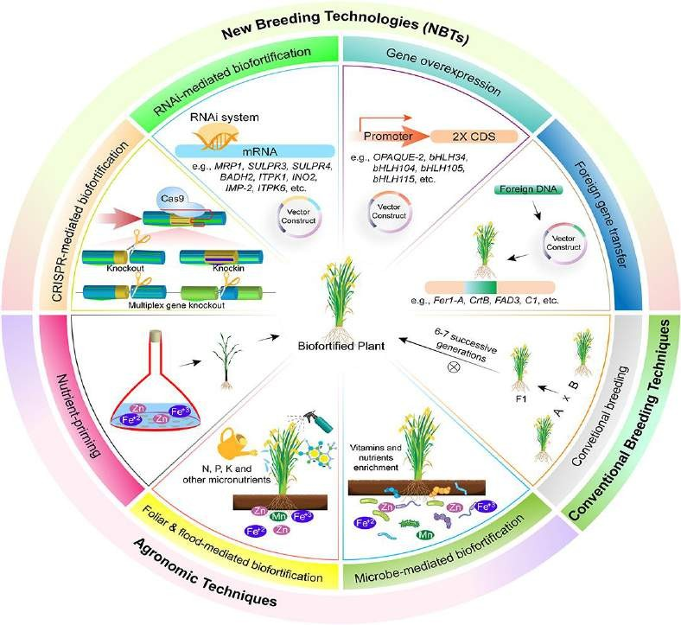

Image source: [15]

- WHY RICE?
- Rice is a staple food of half of the world population
- India is the world's 2nd largest producer of rice, and the 1st largest exporter of rice in the world
- Rice is maximum cultivated crop in India. So, rice is major source of employment for our Indian farmers
- Rice is good option to overcome malnutrition
- Rice play an important role in food security
- Time has come to play role in nutritional security

LIMITATION FOR MINERAL ACCUMULATION IN RICE
Brown rice contains on average 90% endosperm, 6-7% bran and 2-3% embryo by weight [7]. Bran, unlike endosperm, is a large storehouse of lipids, proteins, vitamins, minerals and dietary fiber[8], [9]. Recent X-ray micro fluorescence studies have shown that Zn, Fe, and potassium (K) concentrations decrease in the following order: bran > hull > whole grain > brown and polished rice [10], [11]. Zn and Fe is distributed throughout the endosperm (polished rice; Takahashi et al., 2009; Johnson, 2013) but concentration in the bran is approximately 3 times higher than that in the rice husk and endosperm [12] [10], the husking and polishing of the rice removes the bran from the rice, thereby enabling the rice to be polished. It consumes elements that are not found in the food of many consumers. Therefore, it is important to increase the Zn and Fe concentration in the rice endosperm [6]. Phytic acid present in grains are other limitation due to their chelator nature. Most cereals, approximately 80% of the total phytic acid gets accumulated in the aleurone layer. Phytic acid accumulates as mixed salts called phytate. Phytate has six negatively charged ions, making it a potent chelator of divalent cations such as Fe2+, Zn2+, Ca2+ and Mg2+ and reduces bioavailability of such important divalent minerals [13]. Monogastric animals cannot digest the phytate minerals due to lack of the phytase enzyme in their gut [14]. To achieve effective availability of minerals from rice, it is essential to reduce phytic acid. NBTs to increase the mineral content in grains, by overexpressing metal-storage proteins like lactoferrin, ferritin and downexpressing phytic acid pathways [14].

- MOLECULAR AND BIOTECHNOLOGICAL APPROACHES
Along with ferti-fortification, biotechnological approaches can be used for the simultaneous incorporation of genes involved in the enhancement of micronutrient concentration, their bioavailability, and reduction in the concentration of antinutrients. In this chapter focus on three techniques: Over expression of gene, RNA interference and CRISPR-Cas9.

Over expression of gene
Gene over-expression is the process which leads to the abundant target protein expression by adding constitutive/strong promoter regulatory elements before the target gene so that genes can be transcribed and translated efficiently
There are three ways of getting the target gene:
  - Obtaining from the gene library
  - Amplifying the target gene by PCR technique
  - Designing and synthesizing target gene construct

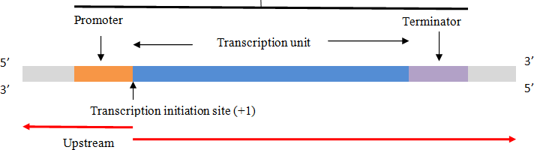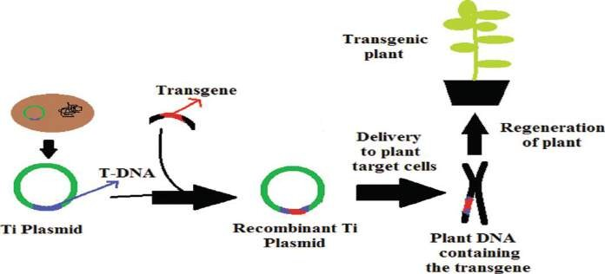
downstream

Figure 1: Schematic representation of transgenic plant development
Promoters add in upstream region of gene and this transgene insert into plasmid by restriction enzyme and ligase enzyme. This recombinant of artificial vector transfer into plant by many gene transformation techniques like agrobacterium mediated transfer, electroporation, particle bombardment method, microinjection etc and make transgenic plant with desired traits.

RNA Interference
Tissue specific RNAi-mediated silencing of phytic acid gene significantly reduced the phytate levels in seeds without disturbing the germination potential of seeds and plant growth. Binding of the short RNA molecule to the target mRNA functionally inactivates the target mRNA and sometimes leads to degradation of the target mRNA. The three catalytic core components, Dicer, Argonaute (AGO), and RNA-dependent RNA polymerase (RdRP), and their associated small interfering RNA molecules (siRNAs). RNA-induced silencing complex (RISC), which contains multiple proteins, including a ribonuclease enzyme. The siRNA nucleotide sequence directs the protein complex to bind to a complementary sequence of mRNA and lead to post-transcriptional gene silencing [16].

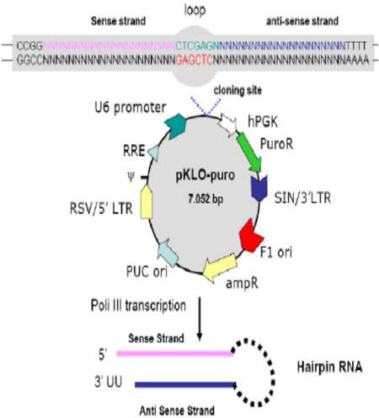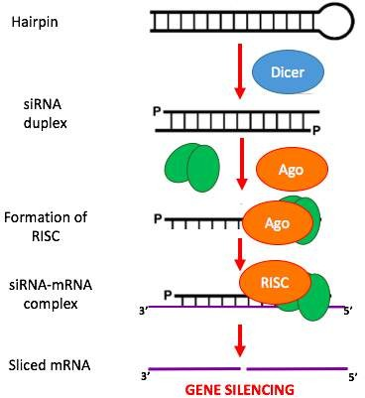

Figure 2: Mechanism of RNA interference through SiRNA biosynthesis
Ds RNA with sense strand and anti- sense strand insert into vector and make artificial constructed vector. This vector transform into plant cell and once this construct rich into plant cell cytoplasm, dicer enzyme cut this ds RNA strand (hairpin structure) and make duplex structure. Next RISC complex bind and this whole complex structure bind with targated m-RNA and silenced their function.

CRISPR-Cas9 Technique
This technique adapted from defense mechanism against virus of bacteria. In this system, Cas9 is an enzyme using guide RNA leading to cut target DNA sequence (Fig.3). Desired genetic sequence could add in repairing system to make customize DNA.
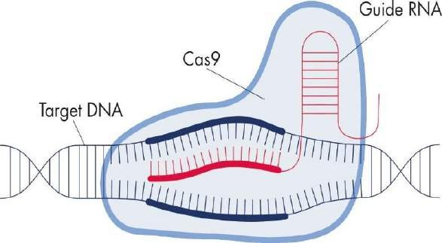

Figure 3: CRISPR-Cas9 gene editing

- CASE STUDIES OF MINERAL ACCUMULATION BY BIOTECHNOLOGY

- Molecular breeding of Osfer2 gene to increase iron nutrition in rice grain [17]

Objective: Overexpression of endogenous Ferritin gene Osfer2 for development of cisgenic rice plants
  - Methodology
    - The gene Osfer2 from Swarna rice variety was ovrexpressed in Pusa Sugandhi II.
    - Total RNA was isolated from swarna seeds and clone the Osfer2 gene
    - Genetic transformation via biolistic method in Pusa Sugandhi II
    - Total RNA were extracted from the mature dehusked seeds of cisgenic plants for semi qRT-PCR
    - Analysis of iron and zinc concentration in grains histochemical localization of iron in grain tissues
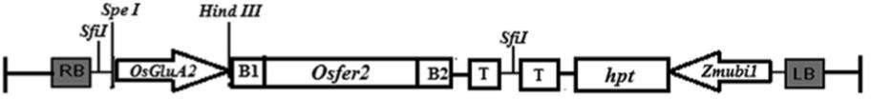

Figure 4: Schemetic representation of gene cassette introduced into rice

Partial map of overexpression vector construct (pOsGluA2-Osfer2-001) used for biolistic transformation of indica rice cultivar. Recombinant vector contains 767 bp of Osfer2 gene under 1.76 kb GluA2 promoter. hpt gene as a plant selectable marker.

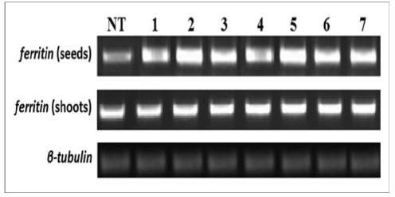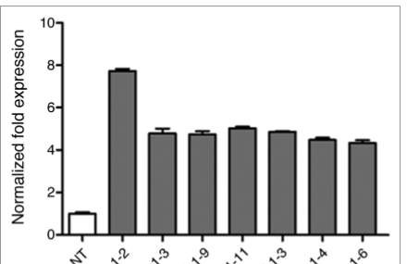

Figure 5: PCR and qRT-PCR analysis
semi-quantitative RT-pCR of ferritin gene of T3 transgenic seeds and shoots showing the overexpression of ferritin gene in seeds of 1–7 different progenies and Quantitative RT-pCR of ferritin gene of T3 transgenic seeds reflecting the maximum level of Osfer2 gene expression in 276–1-2. All progenies showed higher level of expression as compared with NT control.

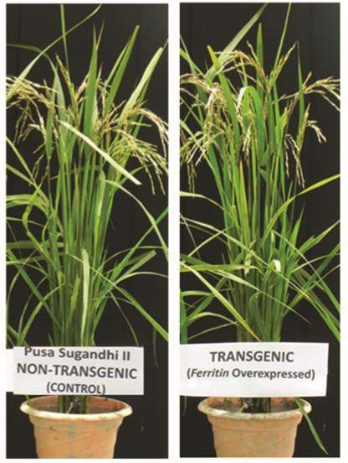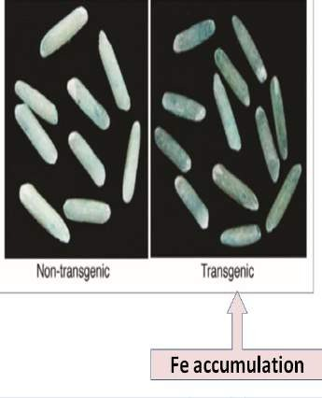

Figure 6: Morphology of T2 pusa sugandhi II and prussian blue staining
Morphology of transgenic rice ferritin overexpressor T2 plant and non-transgenic pusa sugandhi II and Localization of iron by prussian blue staining of milled rice seeds.

Iron biofortification of myanmar rice [18]
Objective:1. Study of Fe ﬂow to the endosperm through transporter gene OsYSL2
2. Study of Fe accumulation in seed by the Fe storage protein gene SoyferH2
  - Methodology
    - Transformation of the paw san yin rice variety by Fer-NAS-YSL2 vector & A.tumefaciens (strain C58)
    - Leaves of T0 transgenic and non-transgenic lines were used for DNA isolation for Detection of the gene insertion in transgenic lines by genomic PCR
    - Greenhouse cultivation of T0 and T1 plants
    - Total RNA was extracted from T2 seeds quantitative RT-PCR analysis Metal concentration analysis of seeds by Spectroscopy
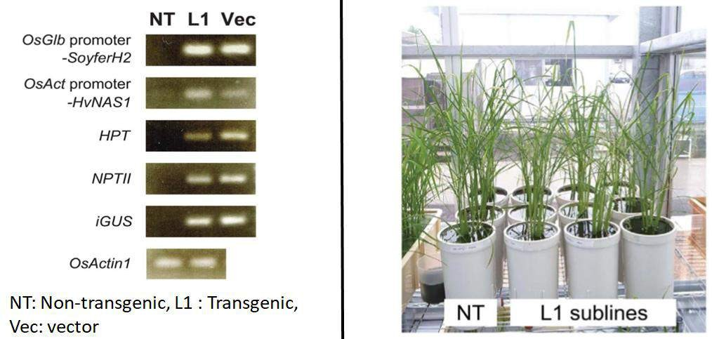

Figure 7: Conformation of transgene by gene specific PCR in T1 plants
NT, non-transgenic Paw SanYin line; L1, Paw San Yin-Fer-NAS-YSL2 line and Photograph was taken during tillering stage at 30days after transplanting. NT, non-transgenic Paw San Yin. L1 sublines, Paw SanYin-Fer-NAS-YSL2 transgenic line 1 sublines.

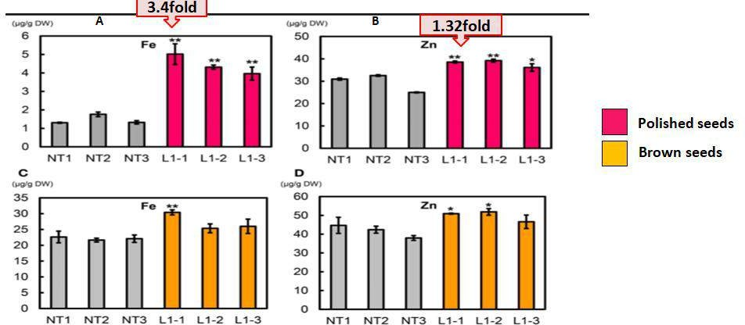

Figure 8: Metal concentrations in T2 polished and brown seeds of Paw SanYin-Fer-NAS-YSL2

- A Node-Expressed Transporter OsCCX2 Is Involved in Grain Cadmium Accumulation of Rice [19]
Objective: Knockout mutants of OsCCX2 genes (Cadmium) are generate by CRISPR/cas9 editing method
  - Methodology
    - RNA guided genome editing technology (CRISPRCas9) to target the OsCCX2 gene in Nipponbare
    - Genetic transformation of Agrobacterium cells EHA105 with CRISPR-Cas9CCX2 gene
    - Rice seed grow in a hydroponic solution and the plants were harvested for Cd determination in WT, ccx2- 1 and ccx2-2
    - Total RNA sample isolated for Semi qRT-PCR
    - Analysis of Cd Concentration in grains was quantified by Spectroscopy
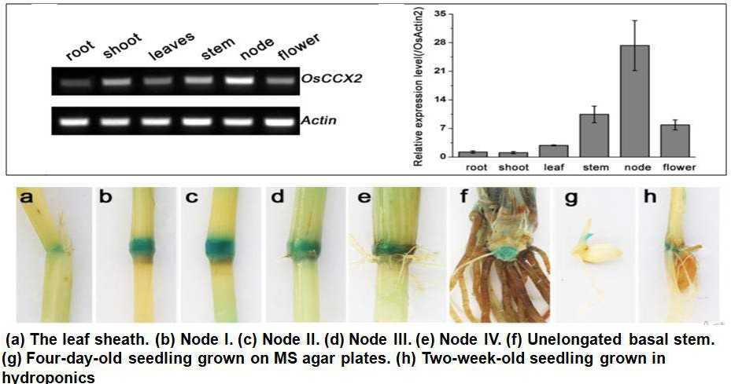

Figure 9: The semi-quantitative-RT-PCR analysis of OsCCX2 transcript levels & Histochemical GUS staining of OsCCX2

Conﬁrm the preferential expression of OsCCX2 in node tissues and Strong GUS signal was detected only in
node tissues.

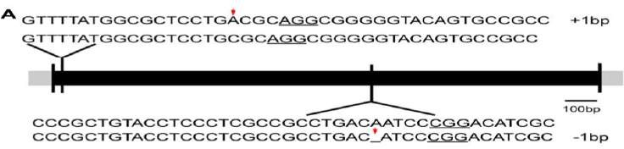

Figure 10: Targeted mutagenesis of OsCCX2 gene by CRISPR-Cas9

Two independent gene edition sites were designed (NGG motifs underlined). Sequences of the mutant alleles are aligned to the genome sequence of wild type, and two homozygous mutant lines (ccx2-1 and ccx2-2) were obtained with 1 bp insertion and 1 bp deletion separately (shown by red arrows).
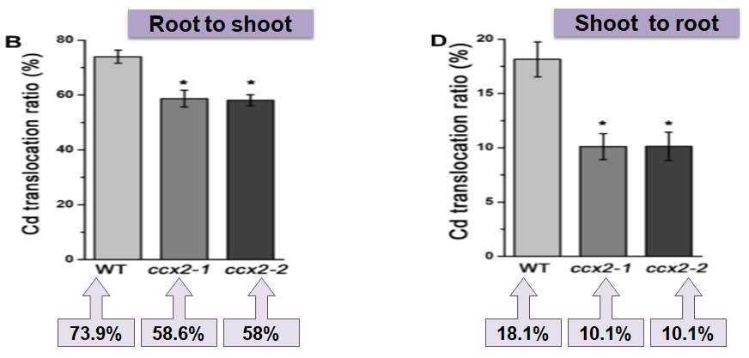

Figure 11: Translocation ratio of Cd
The calculated root-to-shoot and shoot-to-root translocation ratio of ccx2 mutants (average, 5.0%) is
signiﬁcantly lower than that of the wild type.

Genetically engineered rice with appA gene enhanced phosphorus and minerals [20]
Objective: Generate low phytate rice by over expressing appA gene
- Methodology
  - Isolation and cloning of appA gene from E. coli
  - Vector construction with pUC- zein-appA-nos gene
  - Rice tissue culture and Agrobacterium mediated genetic transformation
  - DNA isolated from leaves of T0 & T1 plants for PCR
  - Total RNA isolated from T3 seeds for cDNA synthesis and gene expression
  - Determination of total phosphorus, inorganic phosphorus and phytic acid by Spectroscopy
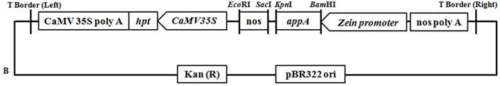

Figure 12: Schemetic representation of Vector for genetic transformation (appA – Acidphosphatase)

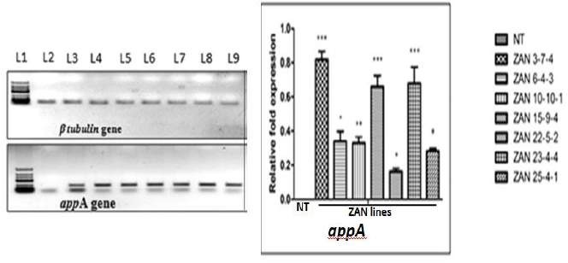
Figure 13: Semi qPCR analysis of T3 transgenic seeds
The non-transgenic seeds did not show any ampliﬁcation for the transgene. Both transgenic and non-transgenic plants
showed ampliﬁcation for b-tubulin, the housekeeping gene

Table 1: Phosphorus, phytic acid content and phytase activity in seeds

Cultivars/line | Total P mg/g | Pi mg/g | Phytic acid mg/g | Phytase activity U/mg total protein
NT | 3.60 ± 0.012 | 0.08 ± 0.002 | 12.61 ± 0.45 | 0.58 ± 0.099
ZAN 3-7-4 | 3.23 ± 0.015ns | 0.33 ± 0.001*** | 6.16 ± 0.13*** | 6.39 ± 0.152***
ZAN 6-4-3 | 3.69 ± 0.023ns | 0.31 ± 0.004*** | 6.75 ± 0.05*** | 2.42 ± 0.198***
ZAN 10-10-1 | 3.68 ± 0.088ns | 0.31 ± 0.009*** | 6.64 ± 0.19*** | 2.74 ± 0.099***
ZAN 15-9-4 | 3.93 ± 0.233ns | 0.34 ± 0.011*** | 5.64 ± 0.09*** | 7.07 ± 0.042***
ZAN 22-5-2 | 3.49 ± 0.055ns | 0.58 ± 0.019*** | 6.43 ± 0.05*** | 3.44 ± 0.095***
ZAN 23-4-4 | 3.71 ± 0.036ns | 0.45 ± 0.003*** | 6.80 ± .0.08*** | 5.65 ± 0.528***
ZAN 25-4-1 | 3.52 ± 0.020ns | 0.46 ± 0.004*** | 8.19 ± 1.09** | 2.47 ± 0.123***

Analysis indicated lower phytate levels in the seeds of transgenic plants compared to the non-transgenic control.
The mean phytic acid values showed almost 45% reductions in phytic acid level in ZAN-15-9-4.
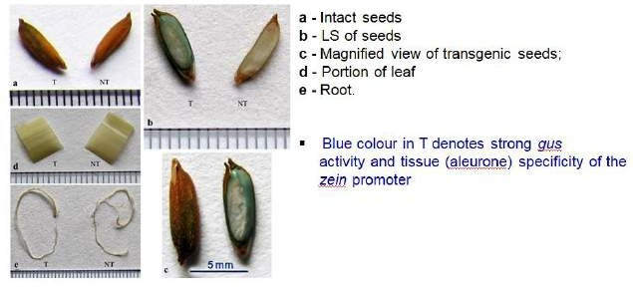

Figure 14: Histochemical gus analysis of transgenic rice lines

Table 2: Seed mineral content of non-transgenic control (NT) and T3 transgenic lines

Cultivars/line | Iron µg/g | Zinc | Calcium | Manganese | Magnesium mg/g
NT | 19.62 ± 0.94 | 10.02 ± 0.63 | 6.42 ± 0.20 | 5.07 ± 0.36 | 0.45 ± 0.001
ZAN 3-7-4 | 34.20 ± 0.31*** | 26.90 ± 0.41*** | 38.39 ± 0.87*** | 5.62 ± 0.20ns | 0.71 ± 0.001***
ZAN 6-4-3 | 33.41 ± 0.81*** | 26.68 ± 1.26*** | 17.94 ± 0.17*** | 7.31 ± 0.06*** | 0.82 ± 0.002***
ZAN 10-10-1 | 38.92 ± 0.39*** | 16.00 ± 0.95*** | 33.25 ± 1.01*** | 6.40 ± 0.14*** | 0.65 ± 0.063***
ZAN 15-9-4 | 29.95 ± 0.81*** | 29.60 ± 1.72* ** | 36.45 ± 0.29*** | 9.98 ± 0.21*** | 0.72 ± 0.023***
ZAN 22-5-2 | 34.57 ± 0.49*** | 24.30 ± 0.40*** | 25.98 ± 0.25*** | 9.08 ± 0.11*** | 0.91 ± 0.002***
ZAN 23-4-4 | 24.53 ± 0.60*** | 12.10 ± 0.99** | 10.40 ± 0.17*** | 9.48 ± 0.18*** | 0.97 ± 0.005***
ZAN 25-4-1 | 26.48 ± 0.41*** | 24.50 ± 0.69*** | 27.55 ± 0.21*** | 10.73 ± 0.13*** | 0.90 ± 0.001***

The highest Fe²⁺, Zn ²⁺, Ca ²⁺, Mn ²⁺ and Mg ²⁺ content was obtained in the following respective transgenic lines: ZAN-10-10-1 (38.92 ± 0.39 lg/g), ZAN-15-9-4 (29.60 ± 1.72 lg/g), ZAN-3-7-4 (38.39 ± 0.87 lg/g), ZAN-25-4-1
(10.73 ± 0.13 lg/g) and ZAN-23-4-4 (0.97 ± 0.005 mg/g.

RNAi-Mediated Silencing of ITPK Gene Reduces Phytic Acid Content, Alters Transcripts of Phytic Acid Biosynthetic Genes, and Modulates Mineral Distribution in Rice Seeds [21]
Objective: RNAi-mediated silencing of OsITP5/6K-1 gene
- Methodology
  - Cloning of rice ITP5/6K-1 gene and RNAi vector construction
  - Tissue culture of rice plants and Agrobacterium mediated genetic transformation
  - DNA was extracted from leaves (T0) for PCR-based screening of transgenic plants
  - Total RNA isolated from T2 seeds for qRT-PCR expression analysis
  - Determination of total phosphorus (TP) and inorganic phosphorus
  - Analysis of (Fe²⁺), (Mg²⁺), (Mn²⁺) and (Zn²⁺) content in milled seeds of non-transgenic (NT) and transgenic (T2) seeds by Atomic Absorption Spectroscopy

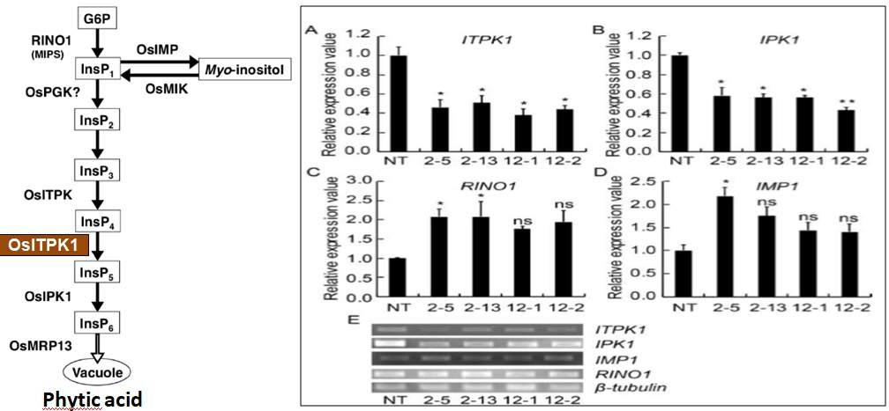

Figure 15: Expression analysis of different genes of phytic acid
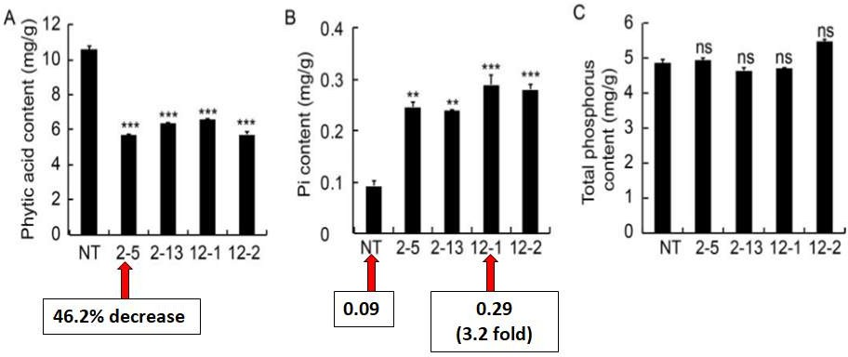
Determine the down-regulation of OsITP5/6K-1 gene in transgenic plants at the transcript level, qRT-PCR analysis was performed using gene-specific primers and they checked the transcript levels of three other genes of phytic acid biosynthesis pathway, namely IPK1, RINO1 and IMP1. The down-regulation of the ITP5/6K-1 gene resulted in enhanced transcript levels of RINO1 and IMP1 genes with respect to NT.

Figure 16: Analysis of phytic acid (A), inorganic phosphorus (Pi) (B) and total phosphorus (TP)m
content (C)
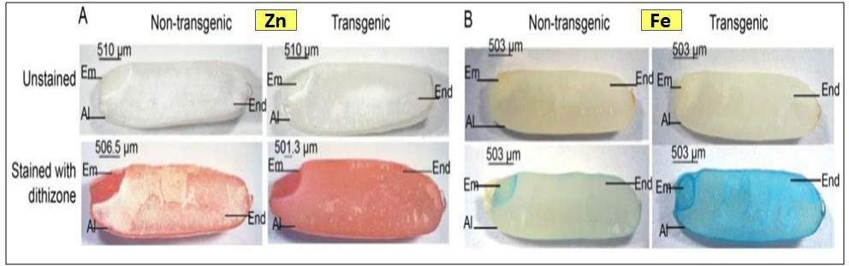
Figure 17: Histochemical localization of Zn and Fe
μ-XRF imaging analysis, which transgenic rice grains revealed higher color intensity, indicating a greater accumulation of Zn and Fe in the endosperm region.

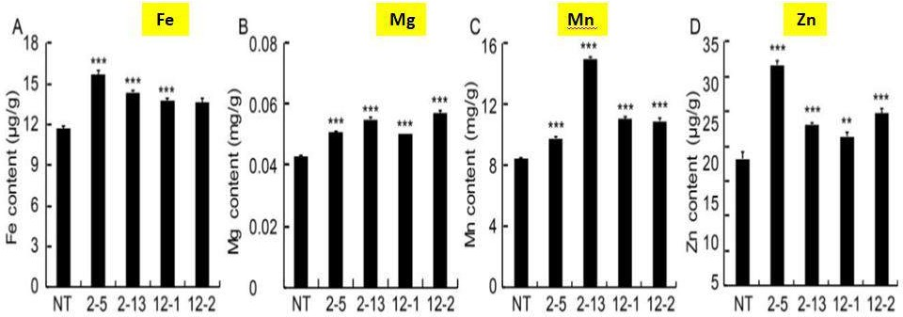

Figure 18: Analysis of (Fe²⁺), (Mg²⁺), (Mn²⁺) and (Zn²⁺) content in milled seeds by Atomic Absorption
Spectroscopy
Fe content showed 1.3-fold increase compared to NT, and Mg, Mn and Zn exhibited a concomitant increase of 1.4-fold, 1.7-fold and 1.6-fold, respectively.

CONCLUSION
More than a billion people suffer from Fe and Zn deficiencies globally. Rice (Oryza sativa) is a popular staple in regions where human Fe deficiency is common [5]. But polished/ white rice does not provide enough Fe and Zn to match human nutritional requirements. In rice germplasm, there is only a limited amount of minerals due to polishing. The development of Fe and Zn in rice is considered the best way to solve these problems. However, biological enrichment of Fe and Zn by Fertilizer and breeding methods in rice is very difficult due to insufficient genetic modification. At the same time, biotechnological intervention has led to an increase in the amount of Fe and Zn in rice. The development of effective genetic biological amplification techniques relies on knowledge of the functions of different genes involved in the uptake, translocation and storage of Fe and Zn. It has become evident with different case studies that a molecular and biotechnological approaches do increase micronutrients and decrease antinutrients.

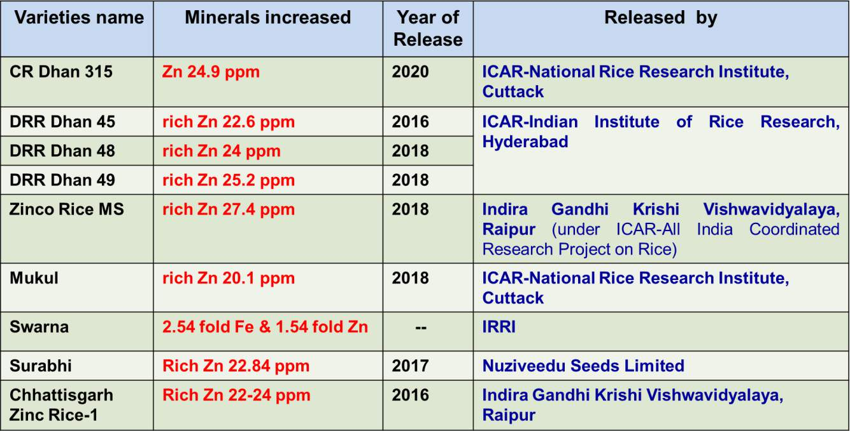
(Normal rice contain 12 ppm Zn)

REFERENCES
- Datta, S., & Bouis, H. E. (2000). Application of biotechnology to improving the nutritional quality of rice. Food and nutrition bulletin, 21(4), 451-456.
- Shahzad, R., Jamil, S., Ahmad, S., Nisar, A., Khan, S., Amina, Z., ... & Zhou, W. (2021). Biofortification of cereals and pulses using new breeding techniques: current and future perspectives. Frontiers in Nutrition, 665.
- Calicioglu, O., Flammini, A., Bracco, S., Bellù, L., & Sims, R. (2019). The future challenges of food and agriculture: An integrated analysis of trends and solutions. Sustainability, 11(1), 222.
- Cominelli, E., Pilu, R., & Sparvoli, F. (2020). Phytic acid and mineral biofortification strategies: from plant science to breeding and biotechnological approaches. Plants, 9(5), 553.
- Smith, M. R., Golden, C. D., & Myers, S. S. (2017). Potential rise in iron deficiency due to future anthropogenic carbon dioxide emissions. GeoHealth, 1(6), 248-257.
- Nakandalage, N., Nicolas, M., Norton, R. M., Hirotsu, N., Milham, P. J., & Seneweera, S. (2016). Improving rice zinc biofortification success rates through genetic and crop management approaches in a changing environment. Frontiers in plant science, 7, 764.
- Chen, H., Siebenmorgen, T. J., & Griffin, K. (1998). Quality characteristics of long‐grain rice milled in two commercial systems. Cereal chemistry, 75(4), 560-565.
- Shahzad, Z., Rouached, H., & Rakha, A. (2014). Combating mineral malnutrition through iron and zinc biofortification of cereals. Comprehensive Reviews in Food Science and Food Safety, 13(3), 329-346.
- Sun, G. X., Liu, X., Williams, P. N., & Zhu, Y. G. (2010). Distribution and translocation of selenium from soil to grain and its speciation in paddy rice (Oryza sativa L.). Environmental science & technology, 44(17), 6706-6711.
- Lu, L., Tian, S., Liao, H., Zhang, J., Yang, X., Labavitch, J. M., & Chen, W. (2013). Analysis of metal element distributions in rice (Oryza sativa L.) seeds and relocation during germination based on X-ray fluorescence imaging of Zn, Fe, K, Ca, and Mn. PLoS One, 8(2), e57360.
- Johnson, A. A. (2012). Enhancing the chelation capacity of rice to maximise iron and zinc concentrations under elevated atmospheric carbon dioxide. Functional Plant Biology, 40(2), 101-108.
- Trumbo, P., Yates, A. A., Schlicker, S., & Poos, M. (2001). Dietary reference intakes. Journal of the American Dietetic Association, 101(3), 294-294.
- Sparvoli, F., & Cominelli, E. (2015). Seed biofortification and phytic acid reduction: a conflict of interest for the plant?. Plants, 4(4), 728- 755.
- Gupta, P. K., Balyan, H. S., Sharma, S., & Kumar, R. (2021). Biofortification and bioavailability of Zn, Fe and Se in wheat: present status and future prospects. Theoretical and Applied Genetics, 134, 1-35.
- Shahzad, R., Jamil, S., Ahmad, S., Nisar, A., Khan, S., Amina, Z., ... & Zhou, W. (2021). Biofortification of cereals and pulses using new breeding techniques: current and future perspectives. Frontiers in Nutrition, 665.
- Maqbool, M. A., Aslam, M., Beshir, A., & Khan, M. S. (2018). Breeding for provitamin A biofortification of maize (Zea mays L.). Plant breeding, 137(4), 451-469.
- Paul, S., Ali, N., Gayen, D., Datta, S. K., & Datta, K. (2012). Molecular breeding of Osfer2 gene to increase iron nutrition in rice grain. GM crops & food, 3(4), 310-316.
- Aung, M. S., Masuda, H., Kobayashi, T., Nakanishi, H., Yamakawa, T., & Nishizawa, N. K. (2013). Iron biofortification of Myanmar rice. Frontiers in Plant Science, 4, 158.
- Hao, X., Zeng, M., Wang, J., Zeng, Z., Dai, J., Xie, Z., ... & Li, D. (2018). A node-expressed transporter OsCCX2 is involved in grain cadmium accumulation of rice. Frontiers in Plant Science, 9, 476.
- Bhattacharya, S., Sengupta, S., Karmakar, A., Sarkar, S. N., Gangopadhyay, G., Datta, K., & Datta, S. K. (2019). Genetically engineered rice with appA gene enhanced phosphorus and minerals. Journal of Plant Biochemistry and Biotechnology, 28, 470-482.
- Karmakar, A., Bhattacharya, S., Sengupta, S., Ali, N., Sarkar, S. N., Datta, K., & Datta, S. K. (2020). RNAi-mediated silencing of ITPK gene reduces phytic acid content, alters transcripts of phytic acid biosynthetic genes, and modulates mineral distribution in rice seeds. Rice Science, 27(4), 315-328.

