Noonan syndrome-A rare case report

Abstract
Noonan syndrome is a developmental disorder characterized by facial dysmorphia, short stature, cardiac defects and skeletal malformations. It may be sporadic or inherited as an autosomal dominant or recessive trait and occurs, one in 1,000-2,500 children. Genetic mutations responsible for Noonan syndrome, PTPN11 was identified on chromosome number 12 resulting in a gain of function of the nonreceptor protein tyrosine phosphatase SHP-2 protein. We hereby report a case of 18 years old male presenting with the features like short stature, pectus excavatum, frontal bossing, hypertelorism, mid facial hypoplasia and clinodactyly of digitis. Two dimensional imaging was performed for conformation of the diagnosis. Multidisciplinary treatment is the key to success in managing patients with Noonan syndrome.

Key Words: Noonan syndrome, pectus excavatum, PTPN11, hypertelorisim, clinodactyly

Introduction

Noonan syndrome (NS) is an autosomal dominant genetic condition with a distinctive phenotypic triad: craniofacial abnormalities that lead to congenital heart disease, unique facial phenotypes, and short stature ^{[1]}. Its first description was proposed by Kobylinski in 1883 ^{[2]}. However, Jaqueline Noonan and Ehmke first studied NS in 1963. ^{[2,} ^{3,} ^{4]} NS is also called webbed neck syndrome, or Turner syndrome. ^{[5]} Live births with an incidence rate of one in 1,000 to one in 2,500 severe cases. Phenotype, but mild cases may be as common as one in 100 live births. ^{[6]} The ratio of men to women in NS is the same. ^{[7,} ^{8]} Familial cases account for about 20 % of cases. ^{[9]}
Since 2001, the gene encoding the protein involved in the intracellular signaling pathway RASMAPK (mitogen activator protein) has been mutated. Kinases) cause NS and other genetic diseases with similar phenotypes, such as cardiofacial skin syndrome, Costello syndrome, neurofibromatosis type 1 or Noonan syndrome with polychromatic spots (NSML, formerly known as LEOPARD syndrome). Because of the phenotypic characteristics and underlying molecular mechanisms of these diseases, they are classified based on the label of "RAS opathies" or "neurocardial facial skin syndrome". ^{[10]}

Case report

An 18-year-old male patient presented to the department with the complaint of a congenital deformity in his face. The patient also reported aesthetic and functional discomfort along with sensitivity to hot and cold food items. Medical history revealed that patient had bronchial asthma since 1 year of age and is under medication that is Salbutamol inhaler dosage (100 mcg twice daily since 1 years), Oral Montelukast (10 mg) + Fexofenadine (120 mg) once daily. Patient also reported of hernia repair at the age of 5 years and cranioplasty done 10 years back. There was no relevant history of drug allergy, dental or family history. Personal History revealed that the patient cleans his teeth once daily with toothbrush and paste, consumes mixed diet. Patient has normal psychological status, normal bowel and bladder habits, normal sleep habits and no history of substance abuse. The general examination revealed conscious, co-operative, well oriented to time, place and person. Physical examination revealed patient is short stature and moderately nourished, Pectus Excavatum is noted (figure 1), Clinodactyly of digits noted (figure 2a, 2b). There was a no signs of pallor, icterus, cyanosis, clubbing, Edema. No generalized lymphadenopathy and splenic or liver enlargement is seen.

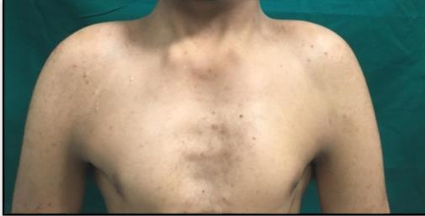
Fig 1: Chest examination showing Pectus excavatum, webbed neck

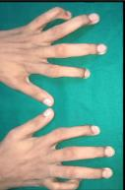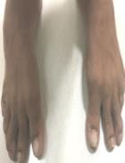

Fig 2a: Clinodactyly of toes
Fig. 2b: Clinodactyly of 5th finger

The extra oral examination shows that the patient has dolicocephalic skull, asymmetrical facial features, Prominent supraorbital ridges, hooded eyes with Hypertelorism, Mid facial hypoplasia, Micrognathia, Surgical scars noted on the right and left temple region. (Figure 3a, 3b)
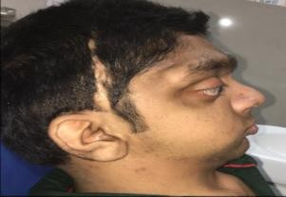

Fig 3a: Lateral view showing midfacial hypoplasia, micrognathia and epicanthal folds

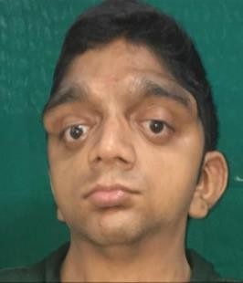

Fig 3b: Front view showing Hooding eyes drooping eyelids, hypertelorism, Proptosis of eyes

Intra orally there was no soft tissues abnormality detected on labial mucosa, buccal mucosa, Floor of mouth. Macroglossia is noted wiith high arched palate and generalized inflammation. (Figure 4a)buccal mucosa, Floor of mouth. Macroglossia is noted wiith high arched palate and generalized inflammation. (Figure 4a)
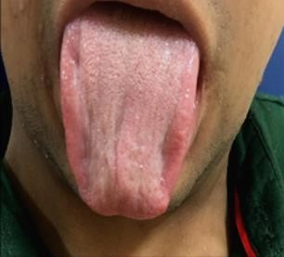

Fig 4a: Macroglossia

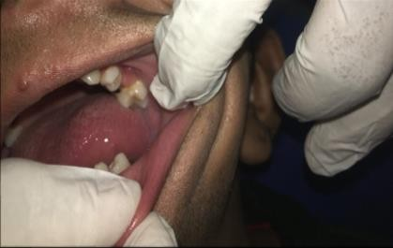

Fig 4b: Intra oral Picture showing Missing teeth and rotated left maxillary 1st premolar

Hard tissue examination revealed missing teeth, root stumps (Green), partially erupted teeth, Rotations and generalised spacing in teeth. Calculus and stains are also present.

Radiographic Investigation were carried out. Panoramic radiograph (figure 5a) taken reveals altered morphology of condyle, coronoid and articular eminence. Right and left condyle appears to be long and slender. Root stumps w.r.t 65, 75, 85 were noted. Retained deciduous teeth w.r.t 51, 52, 54, 63, 71, 72, 73,
81, 82 and 83 were noted. Impacted teeth w.r.t 13, 23 and 43 were seen. The root of 43 is in a close approximation to the inferior border of mandible. 36 and 46 are embedded in the alveolar bone and the roots of 36 and 46 are in close approximation to the inferior border of mandible. Bony irregularities seen on the inferior border of mandible. The angle of mandible and the ramus region appears to be shorter on both right and left side. There was no evidence of other permanent tooth buds.
Lateral cephalogram shows prominent supra orbital ridge. The occipitial condyle was less dense as compared other parts of skull and retrognathic mandible was noted. (Figure 5b)
In Posterior anterior cephalogram: There was Facial asymmetry, under developed lower facial skeleton and mid face hypoplasia was noted. (Figure 5c)

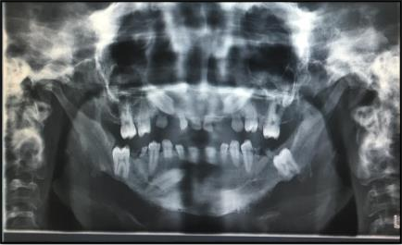
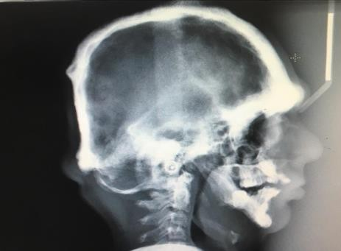

Fig 5a: Panoramic Radiograph Fig 5b; Lateral Cephalogram

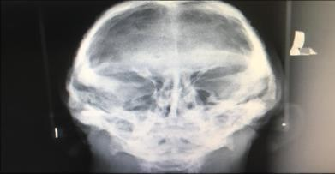

Fig 5c : Posterior Anterior Cephalogram

Discussion

It is an autosomal dominant condition. The aetiology of NS is unknown, although a gene called NS-1 which is in the 12q 22- region. The most common abnormalities in NS are webbing of the neck, short stature, pectus excavatum or pectus carinatum, hypertelorism, cubitus valgus, ptosis, downward slanted palpebral fissures, ear abnormalities and micrognathia. ^{[11]}
In the present case we came across an 18-year-old male patient who presented with the features like pectus excavatum, and clinodactyly of the digits in hands and toes Extraoral findings like dolichocephalic skull, prominent supra orbital ridge, hypertelorism, mid facial hypoplasia was noted. There was no mental retardation and sensorineural deafness noted in our case. Intraoral examination revealed malocclusion, high arched palate and macroglossia. Radiological examination revealed that the patient had facial asymmetry under-developed maxilla and Mandible with poorly developed dentition.
Various syndromes and anomalies have similar features as of NS. Differential diagnosis of NS includes Cardiofaciocutaneous (CFC) syndrome, Costello syndrome and Turner syndrome.

Conclusion
Individuals with NS require detailed and regular follow-up for ongoing audiologic, cardiac, developmental, ophthalmologic, neurologic, and other associated problems. The high incidence of abnormalities associated with the NS emphasizes the importance of early diagnosis. Early detection of this condition would result in better use of diagnostic and therapeutic approaches.

References
- Tajan M, Paccoud R, Branka S, Edouard T, Yart A. The RASopathyfamily: consequences of germline activation of the RAS/MAPKPathway. Endocr Rev,2018:39:676-700.
- Ierardo G, Luzzi V, Panetta F, Sfasciotti GL, Polimeni A. Noonan Syndrome: A case report. Europian journal of Paediatric Dentistry,2010:11(2):97-100.
- Emral ME, Akcam MO. Noonan syndrome: a case report. Journal of Oral Science,2009:51(2):301-306.
- Digilio MC, Marino B. Clinical-manifestations of Noonan syndrome. Images Paediatr Cardiol,2001:3(2):19-30.
- Asokan S, Muthu M, Rathna PV. Noonan syndrome: A case report. J Indian Soc Pedod Prevent Dent, 2007, 144-147.
- Bhambhani V, Muenke M. Noonan Syndrome. Am Fam Physician,2014:89(1):37-43.
- Jongmans M, Sistermans EA, Rikken A, Nillesen WM, Tamminga R, Patton M et al. Genotypic and phenotypic
characterization of Noonan syndrome: new data and review of the literature. Am J Med Ge net A,2005:134:165-170.
- Shaw AC, Kalidas K, Crosby AH, Jeffery S, Patton MA. The natural history of Noonan syndrome: a long-term follow-up study. Arch Dis Child,2007:92:128-132.
- Binder G, Neuer K, Ranke MB, Wittekindt NE. PTPN11 mutations are associated with mild growth hormone resistance in individuals with Noonan syndrome. J Clin Endocrinol Metab,2005:90:5377-5381.
- Carcavilla A. Noonan syndrome: genetic and clinical update and treatment options. an Pediatr (Barc),2020:93(1):61.e1- 61.e14.
- Allanson JE, Roberts AE. Noonan Syndrome. In: Adam MP, Ardinger HH, Pagon RA, Wallace SE, Bean LJH, Mirzaa G, Amemiya A, editors. Gene Reviews® [Internet]. Seattle (WA): University of Washington, Seattle, 2001, 1993-2021.
- Asokan S, Muthu MS, Rathna Prabhu V. Noonan syndrome: A case report. J Indian Soc Pedod Prev Dent,2007:25:144-7.
- Shrinuvasan S, Chidambaram R. and Ramesh V. NOONAN Syndrome – A RARE CASE REPORT. Indian. J.Med.Case Rep,2014:3(1):12-16.
- Kumar M, Chandar VV, Koduri S, Sankireddy S. Noonan Syndrome with cleft palate: A rare case report. J Indian Acad Oral Med Radiol,2016:28:207-10.

