A highly selective chromogenic probe
for Hg²⁺

Hossein Tavallali
Department of Chemistry
Payame Noor University, PNU
19395-4697 Tehran, Iran
tavallali@yahoo.com

Shiva Rajaei Dastghaib
Department of Chemistry
Payame Noor University, PNU
19395-4697 Tehran, Iran
shivarajaei@yahoo.com

Abstract
In this paper, indigo carmine (IC) was proposed as a highly accurate and sensitive colorimetric chemosensor for the determination and detection of mercury (II) (Hg²⁺), which is a very toxic and dangerous pollutant. The chromogenic probe (IC) in the aqueous medium shows a color change from indigo to light blue upon interaction with Hg²⁺. The range of linear and the limit of detection of Hg²⁺ were 0.15-20.2 μM and 0.06 μM, respectively. Also, the relative standard deviation (RSD) based on ten replicates calculated for two different concentrations of 7.4 μM and 15.8 μM of Hg²⁺ was 2.1% and 1.4%, respectively. The proposed method has advantages such as: simplicity, low cost, high accuracy, wide linear concentration range, low limit of detection, high sensitivity and selectivity, no separation and preconcentration steps, and can be used in neutral water media. The concentration of Hg²⁺ in tap water, mineral water and plasma samples can be easily detected and determined using this method. It should be noted that this ideal colorimetric chemosensor for Hg²⁺ has not been reported before.
Keywords: chromogenic probe, colorimetric chemosensor, mercury (II) detection, indigo carmine (IC).

- Introduction
The development of selective and sensitive chemosensors is an important assignment for detecting transition metal ions, which play important roles in chemical, biological, medicinal, and environmental processes [1, 2]. Among them, the most toxic and ubiquitous heavy-metal ions of pollutants, Mercury ion (Hg²⁺) arising from a variety of natural and anthropogenic sources, has attracted a particular attention [3, 4]. Water-soluble divalent mercuric ion (Hg²⁺) can cause several serious diseases such as the brain damage, gastrointestinal system diseases, nephropathy and neurological diseases even at very low concentrations since they can easily enter the body through the skin or the esophagus [5, 6]. The United States Environmental Protection Agency (EPA) has set a maximum Hg²⁺ contaminant level in food and drinking water at 0.002 ppm (0.01 µM) [7].
Common methods for detecting Hg²⁺ include atomic absorption spectrometry (AAS) [8], inductively coupled plasma optical emission spectrometry (ICP-AES) [9], inductively coupled plasma mass spectrometry (ICP-MS) [10] and High-Performance Liquid chromatography (HPLC) [11] have been explored. These practices do not offer a cost-effective, rapid and real time-monitoring system for Mercury ions [12]. In this regard the colorimetric chemosensors are a powerful tool for the sensing of Mercury ions [13]. Therefore, development of simple colorimetric chemosensor that can selectively sense Hg²⁺ in aqueous media is significant.
Indigo carmine (3,3'-dioxo-2,2'-bis-indolyden-5,5'-disulfonic acid, IC) (scheme 1) is an available commercial dye with promising features that make it suitable for use as a chemosensor. Previously we have reported some spectroscopic applications of Indigo Carmine in the determination of some cations [14-16]. IC as a fluorescent and colorimetric chemosensor was used for the detection of Cu²⁺ and HPO₄²⁻ in H₂O/DMSO media [17].

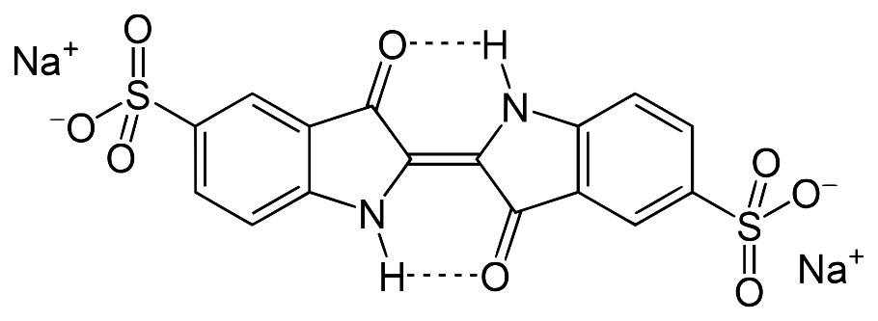
Scheme 1. Structure of IC.

- Experimental
- Chemical substances and reagents
All chemicals with analytical grade were purchased from Merck and used as soon as received. Indigo Carmine dye, di sodium salt, was used for preparing the solutions. The solution of Hg²⁺ and all cations, including Na⁺, K⁺, Mg²⁺, Ca²⁺, Sr²⁺, Ba²⁺, Fe²⁺, Fe³⁺, Co²⁺, Ni²⁺, Cu²⁺, Zn²⁺, Ag⁺, Cd²⁺, Pb²⁺ was prepared with its nitrate salt in deionized water.

- Apparatus
Shimadzu 1601 PC UV-Vis spectrophotometer with 10.0 mm diameter quartz cuvettes was used to record and measure all absorption spectra. Deionized water was used in the reference cell. A Jenway 3510 digital pH meter calibrated with two standard buffer solutions was used to measure pHs. Using a 50 μL Hamilton syringe, the desired amount of analyte solution was introduced into the cuvette.

- Measurement methods
Stock solutions of IC and Hg(NO₃)₂ were prepared with concentrations of 1.0 × 10⁻³ M and 1.0 × 10⁻² M in deionized water, respectively. Then, 3-540.0 µL of Hg(NO₃)₂ solution with a concentration of 0.1 mM was added to 2.0 mL of IC with a concentration of 25.0 µM. They were mixed and then the UV-vis spectra were taken at room temperature.

- Results and discussion

Different metal ions were added to the solution of IC, and the UV-Vis absorption spectrum was investigated. Among various metal species such as Na⁺, K⁺, Mg²⁺, Ca²⁺, Sr²⁺, Ba²⁺, Al³⁺, Cd²⁺, Sn²⁺, Pb²⁺, Bi³⁺, Ti²⁺, Cr³⁺, Mn²⁺, Fe²⁺, Fe³⁺, Co²⁺, Ni²⁺, Cu²⁺, Zn²⁺, Ag⁺, and Ce³⁺, only Hg²⁺ showed a color change from indigo to light blue accompanied by a distinct spectral shift at 610.0 nm. Other species did not show changes in the spectrum and color of IC solution (Fig. 1).
(a)
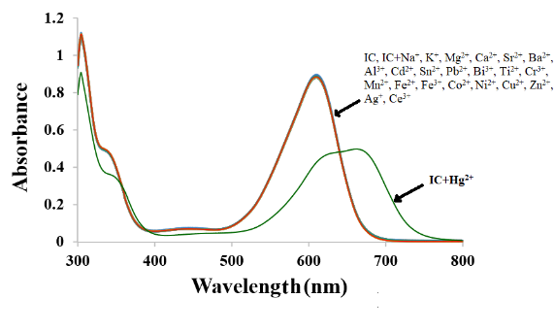
(b)
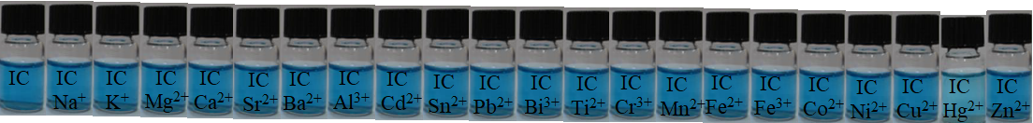
Fig. 1. (a) Absorption spectrum, (b) The color changes of IC (25.0 µM) with the different metal ions (1.0 equiv.).

The interaction of IC with Hg²⁺ was investigated by UV–vis titration (Fig. 2). When Hg²⁺ was added to IC, the absorption band at 610.0 nm gradually decreased and a new absorption band appeared at 666.5 nm. In such a curve, an obvious isosbestic point at 640.5 nm was observed, indicating the interaction between IC and Hg²⁺. The molar extinction coefficient of the peak at 610.0 nm is 3.58 × 10⁴ M⁻¹cm⁻¹ and the new peak at 666.5 nm is 4.36 × 10³ M⁻¹cm⁻¹, indicating a mercury-based d-d transition and can be considered as the metal-to-ligand charge transfer mechanism. (MLCT) mechanism.

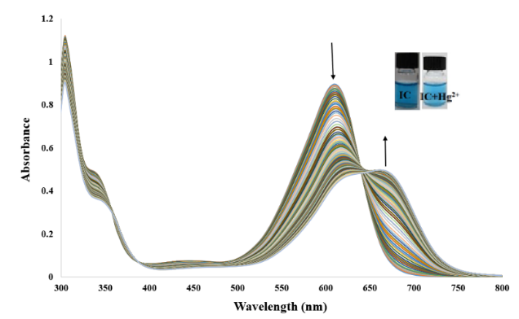

Fig. 2. UV–vis IC spectrum (25.0 μM) with stepwise addition of Hg²⁺ (0.15–21.26 μM) and
the color change of IC.

Benesi-Hildebrand analysis [18] was used to determine the stoichiometry of IC binding to Hg²⁺. Absorption titration data (Fig. 3) show that the complex formed between IC and Hg²⁺ has a stoichiometric ratio of 1:1 (Eq. 1) and the binding constant of Hg²⁺ is 2.77×10³ M⁻¹.

Eq. 1 $\frac{1}{(A{-A}_{0})}=\frac{1}{{(A_{max}-A}_{0})}\left[\frac{1}{K_{ass}{\left[{Hg}^{2+}\right]}^{n}}+1\right]$

Fig. 3. Benesi-Hildebrand plot of IC (1/(A₀-A) change at 610.0 nm versus 1/[Hg²⁺] function) based on 1:1 binding stoichiometry with Hg²⁺.

In order to apply to the environmental systems, the pH dependence of IC in the absence and presence of Hg²⁺ was performed at different pH (2.5-12.6) (Fig. 4). In the pH range (2.5-7.0), IC showed no change without the presence of the Hg²⁺ ions. The increase of in absorption caused by the addition of Hg²⁺ ion was observed at pH 7.0. This result guarantees its use in environmental conditions (pH 5.2-9.0) without any change in Hg²⁺ detection. Therefore, pH 7.0 was chosen for all colorimetric measurements.
To investigate the application of the proposed method in environmental systems, the effect of pH was studied. It was performed in the absence and presence of Hg²⁺ at different pH (2.5-12.6) (Fig. 4). The IC did not change in the pH range (2.5-7.0) without the presence of Hg²⁺ ions, but in its presence an increase in the absorbance was observed at pH 7.0. Therefore, pH 7.0 was selected for the proposed method.

Fig. 4. The effect pH on the proposal method.

The interaction time of the IC sensor with Hg²⁺ was investigated (Figure 5). The results showed that the reaction occurs in the first few seconds and remains constant for the next 40 minutes at the absorption wavelength of 610.0 nm.

Fig. 5. The effect of time on the proposal method.

To verify the linear range of the proposed method, a calibration curve was plotted (Fig. 6). The linear range was 0.15-17.36 μM, and the regression equation for the data was A_{610.0} = 0.8766–0.025C_{Hg} (μM) with R² = 0.9901. The limit of detection and limit of quantification for the measurement of Hg²⁺ were calculated to be 0.06 and 0.22 μM, respectively. The relative standard deviation for two concentrations of Hg²⁺, 7.4 and 15.8 μM and 10 replicate measurements, was 2.1% and 1.4%, respectively.

Fig. 6. Calibration curve.

Different metal cations were used to determine the selectivity for Hg²⁺ (Fig. 7). The results showed that the proposed method has good selectivity and the IC can be used as a potential chemosensor for the detection of Hg²⁺.
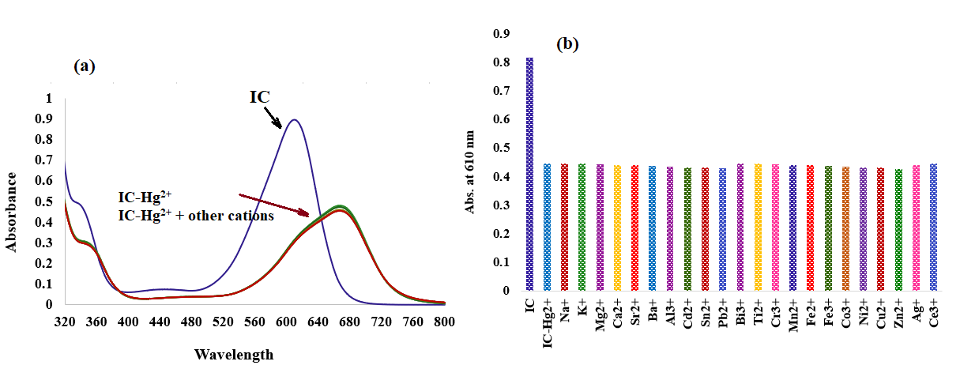
Fig. 7. Effect of coexisting substances on (a) Absorption spectrum,
(b) absorbance of IC in the presence of Hg²⁺.

To determine Hg²⁺, the proposed method was used in real samples, but Hg²⁺ could not be detected in the samples. Therefore, the spiking method was carried out. The measurement of Hg²⁺ in the samples was repeated three times, and the recovery values between 96.00 and 103.90% showed good accuracy of the proposed method (Table 1). The results show that this method can be used to measure Hg²⁺ in real samples.

Table. 1. Determination of Hg²⁺ in real samples by spiking method.
Sample  (n = 3) | Hg²⁺ (μM) |  | Average recovery (%) | Relative error (%)
 | Amount added | Amount found
Tap water | 0.00 | - | - | -
 | 4.00 | 3.98 ± 0.02 | 99.50 | -0.50
 | 8.00 | 8.31 ± 0.05 | 103.90 | 3.00
 | 10.00 | 10.15 ± 0.03 | 101.50 | 3.88
Mineral water | 0.00 | - | - | -
 | 4.00 | 3.95 ± 0.03 | 98.75 | -1.25
 | 8.00 | 8.08 ± 0.02 | 101.00 | 1.00
 | 10.00 | 9.76 ± 0.04 | 96.00 | -2.40
plasma | 0.00 | - | - | -
 | 4.00 | 4.01 ± 0.04 | 100.25 | 0.25
 | 8.00 | 8.06 ± 0.05 | 100.75 | 0.75
 | 10.00 | 10.10 ± 0.06 | 101.00 | 0.06

- Conclusion

A method for the determination of the toxic substance Hg²⁺ was proposed, which has advantages over other methods, such as simple, fast, no separation and preconcentration, low cost, high accuracy, wide linear concentration range, low detection limit, high sensitivity, compatibility, and the selectivity is excellent. Therefore, these results show that IC as a chemosensor can be used to detect Hg²⁺ by a colorimetric method in an aqueous solution at room temperature.
References

- B. Kaur, N. Kaur, S. Kumar, “Colorimetric metal ion sensors – A comprehensive review of the years 2011–2016,” Coord. Chem. Rev., vol. 358, pp. 13-69, 2018.
- G. Guzzi, A. Ronchi, P. Pigatto, “Toxic effects of mercury in humans and mammals,” Chemosphere, vol. 263, pp. 127990, 2021.
- H.F. Cheng, Y.A. Hu, “Mercury in municipal solid waste in China and its control: a review,” Environ. Sci. Technol., vol. 46, pp. 4695-4696, 2012.
- D. Naftz, C. Angeroth, T. Kenney, B. Waddell, N. Darnall, S. Silva, C. Perschon, J. Whitehead, “Anthropogenic influences on the input and bio-geo-chemical-cycling of nutrients and mercury in Great Salt Lake, Utah USA,” Appl. Geochem., vol. 23, pp. 1731-1744, 2008.
- T. Takeuchi, N. Morikawa, H. Matsumoto, Y. Shiraishi, “A pathological study of Minamata disease in Japan,” Acta Neuropathol., vol. 2, pp. 40-57, 1962.
- V. Bhardwaj, V.M. Nurchi, S.K. Sahoo, “Mercury toxicity and detection using chromo-fluorogenic chemosensors,” Pharmaceuticals, vol. 14, pp. 123, 2021.
- Mercury Update: Impact on Fish Advisories, EPA Fact Sheet EPA-823-S2-01-011, EPA, Office of Water, Washington, DC, 2001.
- C. Yu, “Interference from soluble iron on mercury determination in water by cold vapor atomic absorption spectrometry (CV-AAS) with sodium borohydride as reductant,” Anal. Sci., vol. 37, pp. 1181-1184, 2021.
- M. Faraji, Y. Yamini, M. Rezaee, “Extraction of trace amounts of mercury with sodium dodecyle sulphate-coated magnetite nanoparticles and its determination by flow injection inductively coupled plasma-optical emission spectrometry,” Talanta, vol. 81, pp. 831-836, 2010.
- G. Chen, H.W. Chen, X.Z. Jin, H.T. Chen, “Determination of ultra-trace amount methyl-, phenyl- and inorganic mercury in environmental and biological samples by liquid chromatography with inductively coupled plasma mass spectrometry after cloud point extraction preconcentration,” Talanta, vol. 77, pp. 1381-1387, 2009.
- Z.B. Gao, X.G. Ma, “Speciation analysis of mercury in water samples using dispersive liquid-liquid microextraction combined with high-performance liquid chromatography,” Anal. Chim. Acta, vol. 702, pp. 50-55, 2011.
- L.N. Suvarapu, S.O. Baek, “Recent studies on the speciation and determination of mercury in different environmental matrices using various analytical techniques,” Int. J. Anal. Chem., Vol. 2017, pp. 1-28, 2017.
- A. Loredo, L. Wang, S. Wang, H. Xiao, “Single atom switching as a general approach to designing colorimetric and fluorogenic probes for mercury ions,” Dyes Pigm., vol. 186, pp. 109014, 2021.
- H. Tavallali, E. Shaabanpur, P. Vahdati, “A highly selective optode for determination of Hg (II) by a modified immobilization of indigo carmine on a triacetylcellulose membrane,” Spectrochim. Acta A Mol. Biomol. Spectrosc., vol. 89, pp. 216-221, 2012.
- A. Massoumi, H. Tavallali, “Kinetic Spectrophotometric Determination of Vanadium by Catalytic Effect on the Indigo Carmine-Bromate Reaction,” Anal. Lett., vol. 31, pp. 193-206, 1998.
- H. Tavallali, A. Massoumi, “Simultaneous kinetic spectrophotometric determination of vanadium(V) and iron(III),” Talanta, vol. 47, pp. 479-485, 1998.
- H. Tavallali, G.Deilamy-Rad, A. Moaddeli, K. Asghari, “Indigo Carmine-Cu complex probe exhibiting dual colorimetric/ fluorimetric sensing for selective determination of mono hydrogen phosphate ion and its logic behavior,” Spectrochim. Acta A Mol. Biomol. Spectrosc., vol. 183, pp. 319-331, 2017.
- H. A. Benesi, J. H. Hildebrand, “A spectrophotometric investigation of the interaction of iodine with aromatic hydrocarbons,” J. Amer. Chem. Soc., vol. 71, pp. 2703-2707, 1949.

