AI: The Next Frontier of Technology
I. Introduction to Artificial Intelligence
- What is Artificial Intelligence?
  - Artificial Intelligence (AI) refers to a category of computer software capable of autonomously learning and making informed choices. These AI systems are exposed to extensive datasets, through which they acquire the ability to execute tasks. For instance, an AI application trained on an array of images can develop the capability to identify diverse objects within those images.
- Definition and Scope of AI:
  - AI constitutes a diverse realm encompassing a spectrum of technological innovations. Among the prevalent AI technologies are:
    - Machine Learning: Machine learning, an AI facet, empowers computers to learn from data sans explicit programming. These algorithms find application across domains like image classification, fraud detection, and natural language processing.
    - Natural Language Processing (NLP): NLP, nestled within AI, navigates the interplay between computers and human language. This domain fuels applications like speech recognition, text summarization, and machine translation.
    - Computer Vision: A sector of AI, computer vision focuses on extracting insights from images and videos. Its algorithms underpin advancements in realms such as autonomous vehicles, medical image analysis, and facial recognition.
- What is AI not?
  - AI comprises a spectrum of technologies, diverging from a solitary entity into an assembly that empowers computers to undertake tasks previously deemed the sole province of humans. These AI innovations lack sentience or consciousness, and they remain bereft of self-contemplation.

- Why is AI important?
  - AI holds significant importance due to its capacity to profoundly transform multiple sectors and enhance our daily experiences across diverse dimensions. To elucidate, AI possesses the capability to be employed in:
    - Enhancing the field of healthcare through the creation of innovative diagnostic methods and treatments.
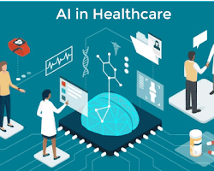
AI finds application in the creation of novel diagnostic instruments and therapeutic approaches. One instance is the utilization of AI in crafting systems capable of detecting cancer cells in images with greater precision compared to human medical practitioners.
    - Enhancing transportation efficiency by pioneering self-driving automobiles and advancing public transportation networks.
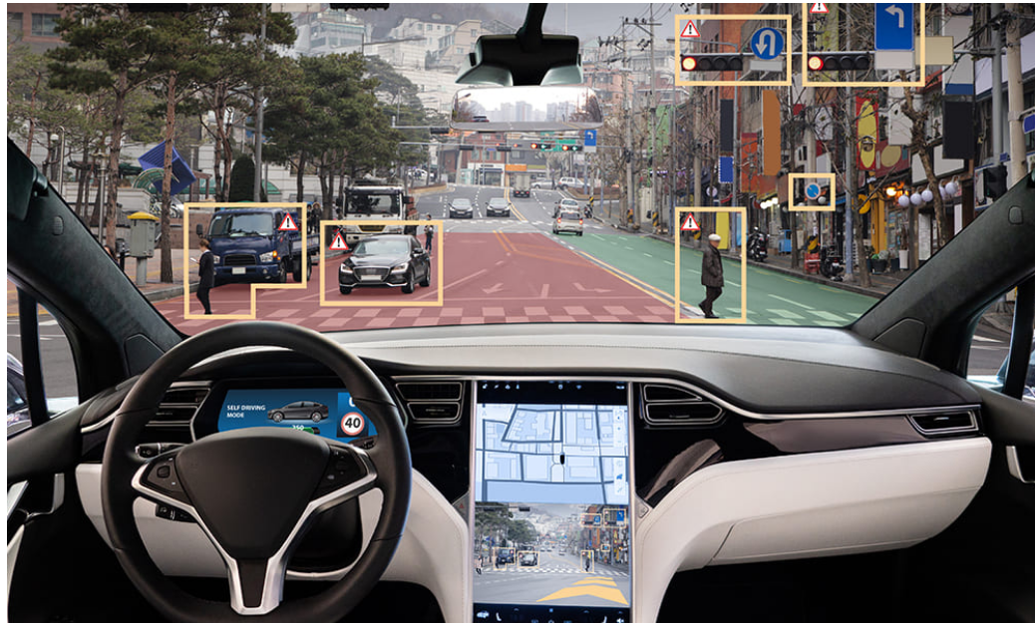
Presently, self-driving vehicles stand as a prominent manifestation of AI in action. These automobiles employ an array of sensors and AI-driven algorithms to maneuver through roads autonomously, devoid of human intervention.
    - Individualizing education through the provision of customized learning resources to students.
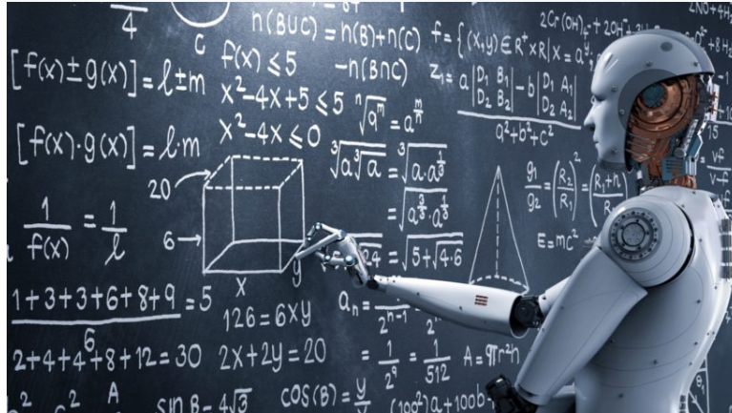
AI holds the potential to offer students personalized learning materials. To illustrate, AI is currently employed in the creation of systems capable of monitoring students' advancements and suggesting customized learning tasks based on their individual progress.

- What are some current AI trends?
  - Presently, there are several pivotal AI trends that warrant attention:
    - The rise of deep learning: Deep learning constitutes a subset of machine learning that employs artificial neural networks to glean insights from data. This approach has demonstrated its prowess in achieving cutting-edge outcomes across diverse domains, including image recognition and the realm of natural language processing.
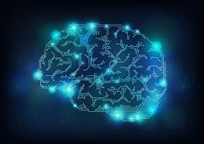
    - The development of quantum computing: Quantum computing represents a novel computing paradigm harnessing the principles of quantum mechanics for computational tasks. Its transformative potential extends to the realm of AI, offering the capability to address challenges currently beyond the grasp of classical computers while enhancing computational efficiency.
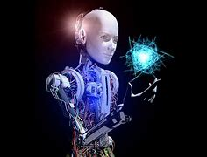

    - The increasing use of AI in the real world: AI innovations are progressively finding practical application in reality. Instances include the integration of AI in self-driving automobiles, virtual assistants, advanced language models like ChatGPT, and sophisticated medical diagnostic systems, among other domains.
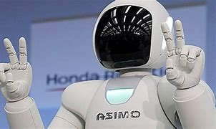
- How can we use AI responsibly?
  - While advancing and implementing AI technologies, it remains crucial to exercise responsibility and uphold ethical considerations. A judicious examination of AI's conceivable hazards, encompassing issues like job displacement and the potential malevolent exploitation of AI, is imperative. Moreover, ensuring the equitable and impartial utilization of AI constitutes an essential aspect of its ethical deployment.

II. Evolution of AI: From the Past to the Present
- The trajectory of Artificial Intelligence (AI) showcases a remarkable evolution spanning various phases throughout its history. Embark on a chronological exploration to fathom the developmental trajectory of AI, tracing its evolution from its nascent origins to the contemporary frontiers of progress.
- Early AI Developments and Their Limitations:
  - The annals of AI boast a history steeped in longevity and richness, tracing its roots back to the 1950s. In its early inception, AI pioneers drew inspiration from the human brain's intricacies, striving to engineer machines capable of human-like thinking and reasoning. However, the nascent endeavors faced constraints imposed by the paucity of computational power and data accessibility.
  - One of the initial forays into AI materialized in the form of ELIZA, crafted in 1966. ELIZA stood as a pioneering natural language processing program, simulating the role of a Rogerian therapist. Despite its ability to engage in dialogues with humans, ELIZA's capacity to comprehend and respond to intricate queries remained limited.
  - Further along the timeline, MYCIN emerged in 1972 as another notable AI project. Designed as a medical diagnosis program, MYCIN served to aid physicians in identifying infectious diseases. By scrutinizing patient data, MYCIN could furnish treatment recommendations. However, its adaptability and learning capabilities with respect to new data remained circumscribed.
- Emergence of Machine Learning and Deep Learning:
  - During the 1980s, a groundbreaking paradigm in AI emerged under the banner of machine learning. This innovative approach endowed AI algorithms with the capacity to glean insights from data sans explicit programming. This transformative shift facilitated AI systems in yielding vastly superior outcomes compared to their predecessors.
  - Among the most triumphant incarnations of machine learning resides deep learning, a lineage of algorithms mirroring the intricacies of the human brain's structure. These algorithms possess the acumen to unravel intricate patterns ingrained within data. Notably, deep learning has emerged as a torchbearer, achieving cutting-edge achievements across diverse domains, including image recognition, natural language processing, and speech analysis.
  - In recent times, deep learning has cast a resounding impact upon the AI landscape. Harnessing insights from the neural architecture of the human brain, deep neural networks equipped with multiple strata empower AI systems to ingest colossal datasets and distill intricate features. The ramifications have been momentous, with AI models fueled by deep learning orchestrating feats of exceptional magnitude in realms such as natural language comprehension, strategic gaming, and autonomous vehicular navigation.
- Impact of Big Data and Improved Hardware on AI Progress:
  - The dynamic interplay of expansive datasets and enhanced hardware has wielded a profound impact on the trajectory of AI advancement. The reservoir of big data furnishes AI programs with the indispensable fodder for learning and refinement. Simultaneously, the augmentation of hardware capabilities empowers AI systems to expedite and optimize data processing.
  - The amalgamation of machine learning, deep learning, big data, and refined hardware has galvanized a meteoric surge in the cadence of AI's evolution. Across a multifaceted spectrum of domains, AI's widespread applications testify to its transformative potential across industries.
  - The augmentation of AI systems with abundant data fosters a more profound and precise learning curve, resulting in heightened accuracy across diverse tasks. This catalyzes progress, permeating realms ranging from personalized recommendations in virtual realms to advancements in medical diagnosis and the unearthing of new pharmaceutical solutions.
  - Furthermore, strides in specialized hardware have propelled AI processing to new heights. Graphics Processing Units (GPUs) and Tensor Processing Units (TPUs) are emblematic of hardware tailored for adeptly managing AI computations. This hardware leap has enabled AI algorithms to process data at unprecedented speeds, ushering in the feasibility of real-time AI applications.

III. Current State of Artificial Intelligence
- The domain of artificial intelligence (AI) is burgeoning rapidly, encompassing an expansive array of applications. AI's transformative touch is evident in the inception of self-driving cars, virtual aides, and medical diagnostic systems. A surge in the tempo of AI advancement has been conspicuous in recent times, propelled by the advent of novel machine learning and deep learning algorithms.
- Machine Learning and Deep Learning:
  - Machine learning stands as an AI variant, enabling computers to glean insights from data without the need for explicit programming. These algorithms undergo training on extensive datasets, leveraging the data to adeptly execute tasks. Deep learning, a subset of machine learning, employs artificial neural networks to absorb insights from data. These advanced algorithms have notably garnered remarkable outcomes in diverse domains, ranging from image recognition and natural language processing to speech recognition.
- The Impact of AI:
  - The influence of AI on our lives is already pronounced, and its trajectory promises even more substantial implications. Its current role in enhancing business operations, elevating healthcare standards, and streamlining our daily routines is just the tip of the iceberg. The latent potential of AI extends to addressing global challenges like climate change and poverty, holding the promise of transformative solutions for these intricate problems.
- The Future of AI:
  - The horizon of AI's future is radiant with potential. It holds the power to reshape industries and enhance the quality of our lives across a spectrum of domains. Yet, it is imperative to wield AI with responsibility and ethical mindfulness. Deliberating on the potential hazards like workforce displacement and the unethical utilization of AI becomes vital. Ensuring AI's deployment is equitable and free from biases also stands as a paramount concern in this transformative journey.

- Widely used AI applications across industries:
  - Self-Driving Cars: The application of AI in self-driving vehicles involves enabling them to autonomously traverse roads while steering clear of obstacles.
  - Virtual Assistants: The application of AI in self-driving vehicles involves enabling them to autonomously traverse roads while steering clear of obstacles.
  - Medical Diagnosis: AI is harnessed in the realm of medical diagnosis to create systems capable of outperforming human doctors in accurately diagnosing diseases.
  - Financial Trading: AI is used in financial trading to develop systems that can trade stocks and other financial instruments more effectively than human traders.
  - Fraud Detection: AI is used in fraud detection to develop systems that can detect fraudulent activity.
  - Customer Service: AI is used in customer service to provide 24/7 support and answer customer questions.
  - Manufacturing: AI is used in manufacturing to automate tasks, improve efficiency, and reduce costs.
  - Agriculture: In the field of agriculture, AI plays a pivotal role in enhancing crop yields, mitigating pest issues, and elevating the standards of food safety.
  - Education: Within the realm of education, AI is harnessed to individualize learning experiences, offer constructive feedback, and evaluate the advancement of students.
- Ethical concerns and challenges in AI implementation:
  - Potential Bias: AI systems may inherit bias if they are trained on biased datasets, which could result in unjust treatment towards specific groups.
  - Privacy Concerns: AI systems have the capacity to amass substantial personal data, raising the potential for privacy infringements or surveillance.
  - Employment Disruption: AI systems have the capability to automate tasks currently managed by humans, potentially causing displacement in the job market.
  - Weaponization Dilemma: AI systems could be utilized to create autonomous weaponry, introducing ethical complexities surrounding automated lethal actions.

- The integration of AI with other technologies:
  - The convergence of AI with complementary technologies like robotics, extensive data analysis, and the Internet of Things (IoT) is fostering the emergence of groundbreaking applications.
  - To illustrate, AI-driven robotic systems are revolutionizing manufacturing processes by automating various tasks. Furthermore, AI is harnessed to scrutinize voluminous datasets for insights into patterns and trends. In addition, AI facilitates interconnecting IoT devices, forming intelligent environments.
  - The amalgamation of AI and allied technologies presents novel prospects and complexities. Addressing the ethical considerations arising from AI utilization is crucial, ensuring its responsible and beneficial deployment.
IV. Futuristic Trends in Artificial Intelligence
- Here are some futuristic trends in artificial intelligence (AI):
  - AI-Augmented Creativity and Artistic Expression:
    - Unique concept: AI as a collaborator for artists and creatives. AI can be used to help artists and creatives in a variety of ways, such as generating new ideas, providing feedback, and helping to create finished products.
    - Algorithm: Harnessing Generative Adversarial Networks (GANs) for innovative artistic AI. GANs stand as a distinctive class of machine learning algorithms, capable of crafting lifelike and imaginative visuals, written content, and melodies.
  - Swarm AI and Collective Intelligence:
    - Unique concept: AI systems working collectively as a swarm. Swarm AI is a type of AI that involves multiple AI agents working together to achieve a common goal. Swarm AI systems can be very efficient and robust, and they have been used in a variety of applications, such as traffic management and robotics.
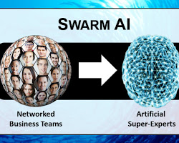
    - Algorithm: Particle Swarm Optimization (PSO) for collective AI. PSO is a type of algorithm that can be used to solve optimization problems. PSO works by simulating the behavior of a flock of birds or a school of fish.
  - Quantum AI and Quantum Machine Learning:
    - Unique concept: Leveraging quantum computing for AI applications. Quantum computing, a novel computing paradigm, leverages the principles of quantum mechanics to execute calculations. Quantum computers possess the capability to tackle challenges that currently pose difficulties for classical computers. This has the potential to usher in significant strides in AI, including the creation of advanced AI algorithms that surpass the capabilities of existing ones.
    - Algorithm: Utilizing the Quantum Boltzmann Machine for quantum-powered AI. Quantum Boltzmann Machines represent a category of machine learning algorithms specifically designed to facilitate the training of quantum computers. These innovative algorithms have demonstrated their efficacy across various domains, including tasks like image classification and natural language processing, showcasing their potential to enhance quantum-based AI applications.
  - AI for Space Exploration and Communication:
    - Unique concept: AI's role in interstellar communication and navigation. AI can be used to help with a variety of tasks related to space exploration and communication, such as developing new navigation algorithms, communicating with extraterrestrial life, and analyzing data from space probes.
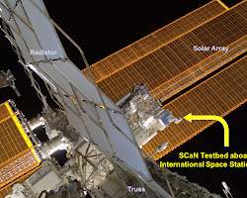
    - Algorithm: Reinforcement Learning for autonomous space missions. Reinforcement Learning is a type of machine learning algorithm that can be used to train AI agents to perform tasks in an environment. Reinforcement Learning has been used to train AI agents to fly drones and to navigate robots in dangerous environments.
  - Conscious AI and AI Ethics:
    - Unique concept: The ethical implications of creating sentient AI. As AI technology continues to develop, there is a growing concern about the ethical implications of creating sentient AI. Some people believe that creating sentient AI could have a number of negative consequences, such as the potential for AI to become hostile or to enslave humanity.
    - Algorithm: Ethics-aware AI agents with explainable decision-making. Ethics-aware AI agents are AI agents that are programmed to take ethical considerations into account when making decisions. Ethics-aware AI agents have been proposed as a way to address the ethical concerns raised by sentient AI.
- These represent merely a selection of the forward-looking trends within the realm of AI. The current era presents an exhilarating opportunity for engagement in AI research, as the discipline is undergoing rapid transformation, offering manifold potential advantages. Nonetheless, it remains crucial to remain cognizant of the ethical considerations intrinsic to AI and to uphold the principle of utilizing AI for beneficial purposes.
V. Algorithms for Future AI
- Here are some examples:
  - Neural Networks:
    - Neural networks, a category of machine learning algorithms, draw inspiration from the intricate workings of the human brain. Comprising interconnected nodes akin to neurons, neural networks undergo training on data to discern patterns within. This technology finds application in a spectrum of AI tasks, encompassing image recognition, natural language processing, and speech recognition.
    - The operational sequence of a neural network unfolds as follows:
      - Initialization of the neural network, entailing the establishment of weights and biases.
      - Feeding data into the neural network to facilitate training.
      - Determination of the network's output, which takes the form of a prediction.
      - Calculation of the network's error, reflective of the divergence between the anticipated and actual outputs.
      - Modification of network weights and biases to curtail the error.
      - Iterative repetition of steps 2 through 5 until error minimization is achieved.
    - The analysis of neural networks is a multifaceted endeavor. Among the pivotal aspects subjected to scrutiny are the network's precision, intricacy, and the temporal aspect of its training process.
  - Genetic Algorithms:
    - Genetic algorithms are a type of optimization algorithm that is inspired by the process of natural selection. Genetic algorithms work by simulating the process of evolution. In genetic algorithms, a population of solutions is created, and then the solutions are iteratively improved. The best solutions are selected to reproduce, and the offspring of the best solutions are then added to the population. This process is repeated until a solution that is good enough is found. Genetic algorithms are used to solve a variety of optimization problems, including finding the shortest path between two points and scheduling tasks.
    - The algorithm for genetic algorithms is as follows:
      - Initialize the population. This includes creating a population of solutions.
      - Evaluate the population. This involves evaluating the fitness of each solution.
      - Select the parents. The parents are selected based on their fitness.
      - Reproduce the parents. The parents are reproduced to create offspring.
      - Mutate the offspring. The offspring are mutated to introduce new variations.
      - Evaluate the offspring. This involves evaluating the fitness of each offspring.
      - Repeat steps 2-6 until a solution that is good enough is found.
    - The analysis of genetic algorithms is a complex topic. However, some of the key factors that are analyzed include the fitness of the solutions, the diversity of the population, and the time it takes to find a solution.
  - Bayesian Networks:
    - Bayesian networks are a type of probabilistic graphical model that is used to represent uncertainty. Bayesian networks are made up of nodes, which represent variables, and edges, which represent the relationships between the variables. Bayesian networks are used in a variety of AI applications, including medical diagnosis and fraud detection.
    - The algorithm for Bayesian networks is as follows:
      - Initialize the Bayesian network. This includes initializing the probabilities of the nodes.
      - Observe the data. This data is used to update the probabilities of the nodes.
      - Make a prediction. The prediction is made by calculating the probability of each possible outcome.
    - The analysis of Bayesian networks is a complex topic. However, some of the key factors that are analyzed include the accuracy of the predictions, the complexity of the network, and the time it takes to make a prediction.
- These are just a few of the futuristic trends in AI. It is an exciting time to be involved in AI research, as the field is rapidly evolving and there are many potential benefits to be gained from AI. Nonetheless, vigilance regarding the ethical implications posed by AI remains crucial, with a parallel need to guarantee the constructive utilization of AI technology.
- Here are some additional futuristic trends in AI:
  - Quantum AI Advancements: The realm of Quantum AI emerges as an innovative domain, harnessing quantum computing to address problems currently beyond classical computers' reach. This sphere holds transformative potential within the AI landscape and represents a captivating avenue of research.
  - AI's Societal Contributions: AI's current strides in tackling global challenges, like climate change and poverty, hint at its future role in addressing an even broader array of issues. Envisioned applications span from pioneering medical breakthroughs and enhancing education to fostering sustainable urban environments.
  - AI Governance: As AI's capabilities grow, a pivotal responsibility emerges to ensure its judicious use. Confronting ethical dilemmas, including bias and prejudice, underscores the need for comprehensive regulations from both governmental and corporate entities, promoting the ethical deployment of AI solutions.
VI. Potential Risks of AI
- With the increasing integration of Artificial Intelligence (AI) into various aspects of our daily lives, a multitude of advantages and prospects emerge. Nonetheless, acknowledging and tackling the potential hazards linked with its extensive adoption remains crucial. Let's delve into some notable apprehensions concerning AI, elucidated in straightforward terms.
  - Job Displacement:
    - One of the primary worries about AI is the possibility of job displacement. As AI systems and automation technologies advance, certain jobs could be taken over by machines. Tasks that are repetitive, rule-based, or require minimal human decision-making might be automated, leading to job losses in certain industries. While AI can create new job opportunities, the transition can be challenging for those whose jobs are replaced.
  - Misuse of AI for Malicious Purposes:
    - An additional focal point of unease is the potential misemployment of AI for detrimental intents. While AI displays remarkable prowess in applications like facial recognition, natural language processing, and autonomous systems, there exists a risk that malevolent actors could exploit its capabilities. These adversarial uses encompass activities like orchestrating intricate cyber assaults, propagating misinformation, or generating deepfake content to deceive and manipulate individuals.
  - Bias in AI Systems:
    - AI systems learn from vast amounts of data, and if the data itself contains biases, these biases can be reflected in the AI's decisions. This creates the risk of perpetuating societal biases, discrimination, or unfair treatment. For instance, biased AI algorithms could lead to unfair hiring practices, discriminatory loan decisions, or even exacerbate existing inequalities in society.
  - Lack of Transparency in AI Systems:
    - The intricate nature of AI models often renders it difficult to discern the rationale behind particular conclusions or suggestions. This opacity in the decision-making process gives rise to apprehensions regarding liability and credibility. Users might exhibit hesitancy in placing trust in AI systems when the mechanisms behind decision-making remain inscrutable. This concern becomes particularly pronounced in vital sectors like healthcare and finance, where comprehensibility is crucial.
- To address these potential risks, researchers, policymakers, and developers are working on several fronts. Some strategies include:
  - Ensuring that AI technologies are developed responsibly and ethically, with thorough testing and validation.
  - Encouraging collaboration between AI experts, ethicists, and policymakers to establish guidelines and regulations for AI development and usage.
  - Promoting AI transparency and explainability, so users can understand how AI systems arrive at their conclusions.
  - Striving to eliminate biases in AI models by carefully curating data and regularly auditing AI systems for fairness.
VII. Ethical Considerations in AI
- Here are some ethical considerations in AI, including the importance of ensuring that AI is used in a way that is fair and unbiased, respects human rights, and is transparent and accountable:
  - Fairness and Unbias:
    - Ensuring the equitable and impartial utilization of AI stands as a paramount concern. This implies that AI systems must refrain from exhibiting discrimination towards any particular demographic and should not inadvertently reinforce existing disparities. For instance, an AI system employed for recruitment purposes must not exhibit bias against women or individuals from marginalized communities.
  - Human Rights:
    - AI should be used in a way that respects human rights. This means that AI systems should not be used to violate people's privacy or to harm people physically or emotionally. For example, an AI system that is used to monitor people's movements should not be used to track people without their consent.
  - Transparency and Accountability:
    - Ensuring the transparency and responsibility of AI deployment is of utmost significance. This implies that individuals should have the capacity to comprehend the functioning of AI systems, and they should possess the means to hold AI developers liable for their decisions. For instance, in cases where an AI system's decision leads to harm, individuals should be able to comprehend the rationale behind the decision and identify the parties responsible for its outcome.
- These are just some of the ethical considerations that need to be taken into account when developing and using AI systems. It is important to have open and honest conversations about these issues so that we can ensure that AI is used for good and not for harm.
- Here are some examples of how AI can be used in a fair and unbiased way:
  - AI can be used to develop personalized learning tools that are tailored to the individual needs of each student.
  - AI can be used to screen job applicants for potential biases in their resumes.
  - AI can be used to develop algorithms that detect and prevent fraud.
- Here are some examples of how AI can be used in a way that respects human rights:
  - AI can be used to develop medical devices that are safe and effective for all people, regardless of their age, race, or gender.
  - AI can be used to develop products that are accessible to people with disabilities.
  - AI can be used to promote social justice by fighting against discrimination and inequality.
- Here are some examples of how AI can be used in a transparent and accountable way:
  - AI systems should be designed in a way that allows people to understand how they work.
  - AI systems should be subject to rigorous testing and evaluation.
  - AI systems should be accompanied by clear documentation that explains how they work and how they make decisions.
VIII. AI Governance and Policy
- As Artificial Intelligence (AI) continues to advance, it's crucial to establish governance and policy frameworks to ensure its responsible development and deployment. Let's explore two essential aspects of AI governance in simple language, along with unique concepts and algorithms.
  - AI Safety and Preemptive Control Mechanisms:
    - Unique Concept: Safety Mechanisms for Avoiding Unintended AI Behavior
    - AI safety involves implementing measures to prevent AI systems from unintentionally causing harm. While AI has tremendous potential, there is a risk that it may make errors or display unexpected behavior. To address this, researchers are developing safety mechanisms that act as safeguards against unintended consequences.
    - Example: AI-controlled self-driving cars use safety mechanisms to avoid accidents. They constantly analyze the environment and anticipate potential hazards, such as pedestrians or other vehicles, to make safe decisions while navigating roads.

    - Algorithm: Monte Carlo Tree Search for Safe AI Decision-Making
    - Monte Carlo Tree Search (MCTS) is an algorithm used in AI to make informed decisions while considering various possibilities and their potential outcomes. It helps AI systems identify the best course of action by simulating numerous scenarios and selecting the one with the least risk.
    - Example: MCTS is utilized in strategic games like chess and Go. AI agents use this algorithm to explore different move sequences and anticipate their opponents' responses, ultimately making more informed and safer moves during gameplay.

  - Global Collaboration on AI Regulations:
    - Unique Concept: International Efforts for Unified AI Regulations
    - AI is a global technology that transcends geographical boundaries. To address its challenges effectively, countries and organizations are coming together to establish harmonized regulations and guidelines. Collaborative efforts aim to promote ethical AI development and ensure its responsible use on a global scale.
    - Example: Various international organizations, such as the United Nations and the World Economic Forum, are facilitating dialogues and agreements on AI governance. They encourage countries to work together, share best practices, and create cohesive policies to navigate the complexities of AI technologies.

    - Algorithm: Federated Learning for Privacy-Preserving Global AI Models
    - Federated Learning is an innovative approach that enables AI models to be trained across multiple devices or servers without sharing raw data. This decentralized process ensures data privacy while allowing AI systems to learn from diverse sources and create better, more inclusive models.
    - Example: Companies with operations in multiple countries can use federated learning to build AI models using data from different regions while adhering to local data privacy regulations. This way, the models can benefit from a broader range of data without compromising individual users' privacy.
IX. Conclusion
- The horizon of artificial intelligence (AI) is filled with boundless possibilities. AI holds the capability to reshape various industries and enhance our lives through multifaceted avenues. For instance, AI's prowess can contribute to the creation of novel medical treatments, the establishment of sustainable urban landscapes, and the enhancement of educational systems.
- Yet, in the realm of AI, there exist potential pitfalls as well, including the displacement of jobs and the potential misuse of AI for nefarious purposes. As we embark on the journey of AI advancement, it becomes imperative to meticulously assess these risks.
- Outlined below are some of the potential merits of AI:
  - Enhanced healthcare: AI's potential extends to the creation of innovative medical treatments, precise disease diagnosis, and tailored patient care.
  - Sustainability in urban spaces: AI has the capacity to optimize traffic flow, curtail energy consumption, and elevate waste management practices in cities.
  - Elevated education: AI stands poised to personalize educational experiences, provide targeted feedback, and gauge student progress.
- Conversely, the spectrum of potential AI risks includes:
  - Displacement of jobs: The advent of AI could automate tasks traditionally carried out by humans, potentially leading to job displacement for certain individuals.
  - Malicious exploitation: There's a possibility of AI's misuse for malicious objectives, such as crafting autonomous weaponry or generating deceptive deepfake content.
  - Bias: AI systems might inherit bias from biased training data, resulting in unjust or discriminatory decisions.
- Tackling these risks is pivotal as AI advances. The responsible and ethical use of AI demands our attention. Ensuring equitable access and benefits for all, rather than a privileged few, is a crucial aspect.
- The path AI charts is enigmatic, yet its transformative potential is undeniable. In navigating this path, it's paramount to exercise prudence in AI's development and application, harnessing its capabilities for positive impact while averting harm.

