5-(4-fluorophenyl)-2-hydroxypyridine: An exceptional fluorosensor for transition metal ions
Anuva Samanta*
Department of Chemistry, Victoria Institution (College)
78-B, A. P. C. Road, Kolkata 700009, India

Corresponding Authors: anuva.samanta25@gmail.com

ABSTRACT
Using steady state absorption and fluorescence methods, the photophysical reactions of 5-(4-fluorophenyl)-2-hydroxypyridine (FP2HP) towards different transition metal salts have been investigated. In its excited state, this molecule exhibits keto-enol tautomerization. However, because it has electron-rich nitrogen atoms and electron-deficient fluorine atoms, it fluoresces very weakly. This could cause the molecule to undergo light-induced electron transfer. When d-block metal ions such as Hg²⁺, Fe²⁺, Zn²⁺, Cd²⁺, Cu²⁺, and so on are present, the target molecule displays significant changes in its absorption and fluorescence characteristics. Based on the chelation enhanced fluorescence (CHEF) mechanism, all experimental phenomena point to the excellent potential of this structurally simple molecule (FP2HP) as a chemosensor for transition metal ions.

Keywords: 5-(4-fluorophenyl)-2-hydroxypyridine, chelation enhanced fluorescence, Transition metal, electron transfer

I. INTRODUCTION
The term "transition metal ion sensing" describes the technique of finding and quantifying transition metal ions in a variety of settings, including industrial processes, environmental samples, and biological systems [1-3]. Understanding these metal ions' functions in many systems and resolving possible health and environmental issues depend on the detection and monitoring of these metal ions. Applications for transition metal ion sensing are numerous and include medical diagnostics, environmental monitoring, and research in materials science and biology. The selection of a sensing method is contingent upon various parameters, including but not limited to sensitivity, selectivity, and application-specific needs [1-6]. Because air and water pollution are constantly rising, research in this field has recently concentrated on monitoring polluting species such As³⁺, Pb²⁺, Cd²⁺, and CO [7-8]. In fluorescence spectroscopy, chelation-enhanced fluorescence is a method used to increase a fluorophore's fluorescence signal when it forms a stable complex (chelate) with a metal ion. The photophysical characteristics of the fluorophore are changed by the interaction between the metal ion and the fluorophore, leading to an increase in fluorescence intensity. Applications in analytical chemistry, environmental science, and biology that need the selective detection of metal ions will find great benefit from this method. Fluorescence can be quenched through a process called photoinduced electron transfer (PET). The transfer of an electron from a donor fluorophore to an acceptor causes a non-radiative decay process, which lowers the fluorescence intensity. When it comes to fluorophores with nitrogen functional groups, this phenomena is highly prevalent [9–10]. This metal-induced quenching phenomena is mostly redox in nature, and the d-block elements are excellent quenchers [11–12]. If the metal-receptor interaction is larger than the metal-fluorophore interaction, the intrinsic quenching qualities [13] will be reduced. Lactim-lactam tautomerization in the excited state was determined by spectroscopic investigation of the photophysics of 5-(4-fluorophenyl)-2-hydroxypyridine (FP2HP) [14]. The structure of this molecule, 5-(4-fluorophenyl)-2-hydroxypyridine (FP2HP), is highly intriguing for the PET process since it consists of an electron-withdrawing fluorine atom and an electron-donating nitrogen centre. This article discusses the use of FP2HP as a new fluorosensor for transition metal elements.

II. MATERIALS AND METHODS
- Materials. A detailed report on the synthesis of FP2HP has already been published [14]. Triple-distilled water is used to create the FP2HP aqueous solutions. Spectroscopic grade organic solvents were used in this investigation. After being purified, the metal salts, which included Cu(H₂O)₆(ClO₄)₂, Co(H₂O)₆(ClO₄)₂, Hg(H₂O)₆(ClO₄)₂, Fe(H₂O)₆(ClO₄)₂, Zn(H₂O)₆(ClO₄)₂, and Cd(ClO₄)₂.H₂O, were utilized. These were collected locally.

- Absorption and emission. The measurement of absorption and fluorescence spectra is done using a Perkin Elmer (Model LS-55) fluorimeter and a Hitachi UV-Vis spectrophotometer (Model U-3501), respectively. Utilizing -naphthol (f = 0.23 in methylcyclohexane) as a reference molecule, the fluorescence quantum yield of the designated molecule in various conditions was ascertained [14].

III. RESULT AND DISCUSSIONS
A. Spectral behavior in solvents
In liquids with different polarity, FP2HP shows two absorption bands at about 260 nm and ~310 nm, as shown in Fig. 1a. Since in this N-containing molecule, hydrogen binding interaction is possible, both the absorption bands in protic liquids have a minor wavelength shift. These bands are assigned to arise from ππ* transitions because of their high value of molar extinction coefficient (ε). The lactim and lactam forms of FP2HP are identified as the lower wavelength and higher wavelength absorption band, respectively, based on the documented literature study of the parent chemical 2-hydroxy-pyridine [15–16] [14].
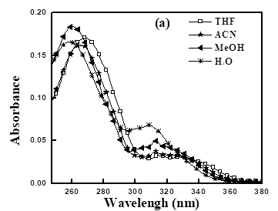
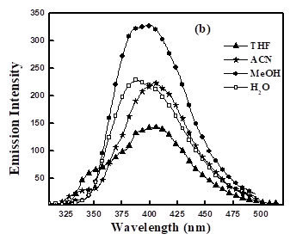
As seen in Fig. 1b, the excited state performance of FP2HP in various solvents is fairly complicated. It displays a dual fluorescence band in ACN, THF, DMSO, and other solvents at about 340 and 410 nm upon excitation at 260 nm. We can infer that these two bands came from the enol and keto forms of FP2HP as hydrogen bonding cannot develop in such polar aprotic solvents. Single emission spectra of the keto form originate at around 395 nm because the transition from the enol form to its tautomeric keto form in polar protic liquids is barrier-free. Table 1 contains all of the title compound's steady state spectrum data. The investigated molecule displays the lactim-lactam tautomarization reaction, or proton transfer reaction (ESIPT), upon excitation. It is noteworthy that, as indicated in Table 1, the lactam form exhibits a higher quantum yield (⁆f) compared to the lactim form. One possible explanation for the FP2HP's fairly low fluorescence quantum yields is the process of photoinduced electron transfer, or PET. One can presume that electron transfer takes place from the nitrogen atom with a lone pair to the fluorine atom with an electron deficiency by comparing this system to the molecular system previously reported eligible for PET process [17–18].

Fig.1 (a) Absorption in the steady state and (b) fluorescence spectra of FP2HP at room temperature in different solvents.

Table 1: At 298 K, the ground state absorption (λa), excited state fluorescence (λ_{f}) maxima, and quantum yields (Φ_{f}) of FP2HP.
Solvents | λ_{a}  (nm) | λ_{f}  (nm) | Φ_{f} (E-form) (x10²) | Φ_{f} (K-form) (x10²)
MeOH | 260, 318 | 396 | - | 4.44
CAN | 266, 325 | 338, 407 | 0.24 | 2.47
H₂O | 259, 310 | 392 | - | 9.25
THF | 269, 325 | 352, 403 | 0.05 | 2.22

B. Spectral features of FP2HP towards metal ion sensitivity
When metal ions are added, FP2HP exhibits some really interesting spectrum behaviours. This characteristic instructs the molecule to be thought of as a fluorosensor for various metal ions. The absorption and fluorescence spectra of FP2HP alter during complexation with 3d block metal ions like Cu(II), Zn(II), Fe(II), or Hg(II); however, no such typical result was observed for alkali metal ions like Na(I), K(I), Ca(II), etc. The absorption spectra of FP2HP as a result of the transition metal salts added to its acetonitrile solution are shown in Fig. 2. When metal ion concentrations (Cu²⁺, Zn²⁺, Fe²⁺, and Hg²⁺) in spectroscopic titrimetric study of FP2HP increase, the optical density of the higher energy band decreases and the higher wavelength band experiences a hypsochromic shift. Other metal ions such as Mn²⁺, Co²⁺, Ni²⁺, and Cd²⁺ do not cause any discernible alterations. Here is an explanation of the lower frequency band's blue shifting. The nitrogen loan pair participates in the ππ* transition, which impedes the nπ* transition and raises the energy difference between the molecule's S₀ and S₁ states. It is clear from Fig. 1a that the absorption spectra of enol are solvent independent, but the spectra of keto form are solvent dependent. While FP2HP is blue shifted by about 15 nm in water, it has an absorption maximum of about 325 nm in ACN. Since the water of crystallisation found in the inorganic salts utilised in the sensing properties causes the surrounding environment around the fluorosensor to behave similarly to an aqueous medium, it may also exhibit the blue shift.
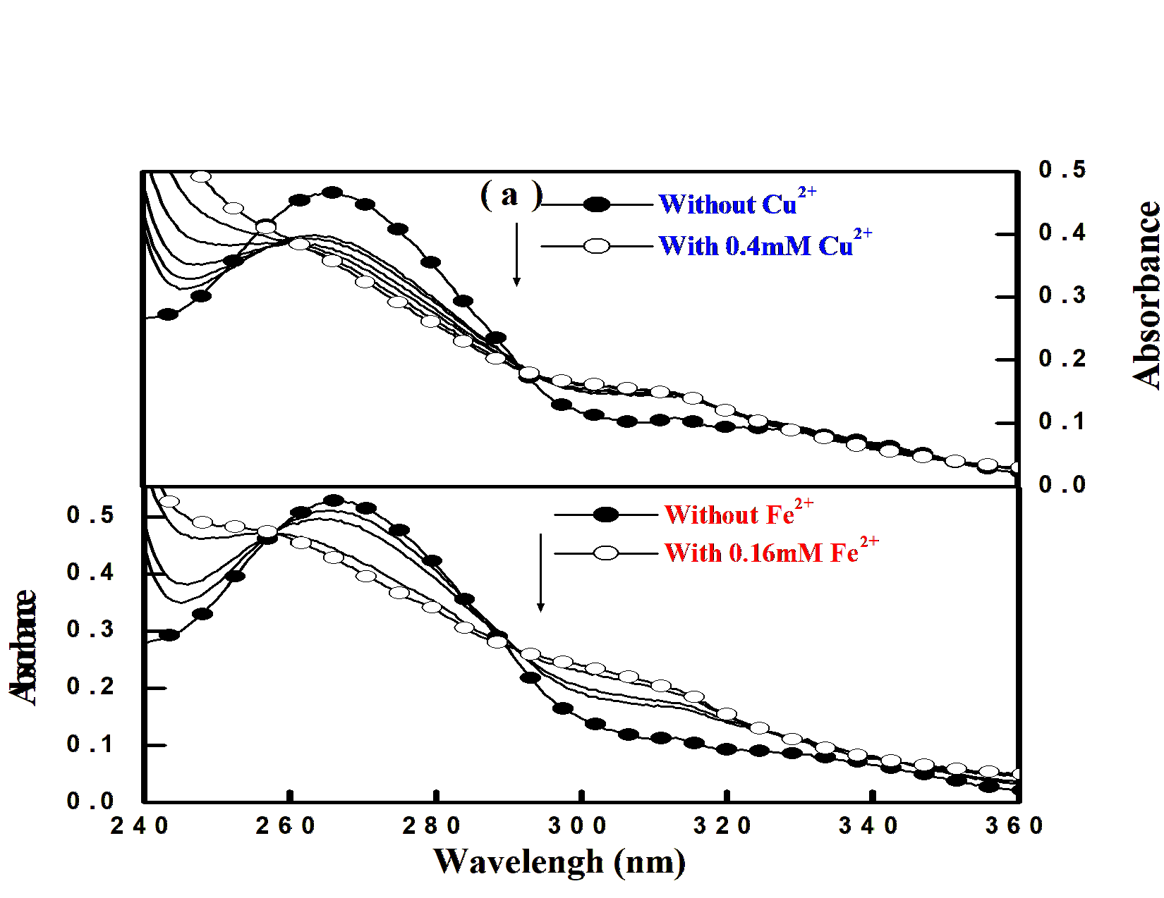
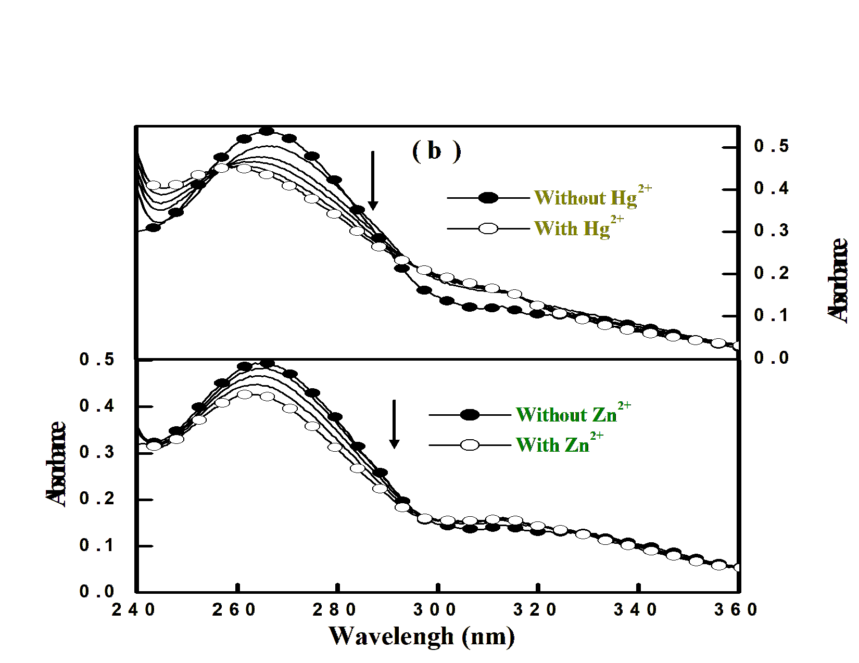

Fig. 2: FP2HP's absorption spectra in relation to (a) Cu(II) and Fe(II) in ACN. (b) In ACN, Hg(II) and Zn(II).

The same exact conditions are applied in the case of fluorimetric titrations of FP2HP with the addition of a different d block metal element in acetronitrile solution, as demonstrated in the steady state UV-Visible spectral investigations. As shown in Fig. 3, the target molecule exhibits excellent fluorescence amplification with the gradual addition of metal ions. This makes sense in light of the well-known PET process' inhibition. The PET process is stopped as the lone pair on the nitrogen centre engages with the additional metal ions. This kind of metal-probe complex creation also inhibits the typical excited state PT response. Table 2 lists the spectrum characteristics of the receptor FP2HP in the presence of various metal ions. When metal ions are added incrementally, the system's emission intensity increases with slight red shifting. As the metal solution builds up to a certain concentration, the system reaches its maximum fluorescence intensity, and beyond this concentration, quenching of the fluorescence may be seen. It is apparent that in the case of fluorescence (~8 nm), the spectrum shift is less notable than that which was reported for its ground state behaviour (absorption) in the presence of any metal ion. On the emission maxima of FP2HP, a modest bathochromic shift (~6-8nm) is seen upon the addition of different metal ions. This can be explained by the fact that as the charge density over the nitrogen atom decreases upon electronic excitation, the binding strength between metal ions and fluorophore weakens.
Table 2 and Fig. 4 clearly show that the considerable chelation enhanced fluorescence enhancement (CHEF) is limited to a few specific metal ions, such as Cu²⁺, Fe²⁺, Hg²⁺, and Zn²⁺, with fluorescence intensities increasing only marginally for other metal ions, such as Mn²⁺, Cd²⁺, etc. Notably, Fe²⁺ — which is well-known for its effectiveness in quenching—shows remarkable fluorescence amplification when it interacts with the fluorophore. Therefore, it is simple to determine that the metal ion binding-induced augmentation of fluorescence in the presence of transition metal ions is greater than the emission intensity reduction resulting from quenching. In a similar vein, the quenching metals Cu²⁺ and Hg²⁺ show the same outcomes as the Fe²⁺ ion. The addition of d block metal ions to FP2HP results in an overall fluorescence enrichment, indicating that this ESIPT-undergoing molecule can also be employed as a metal sensor.

Fig. 3: Emission spectra of FP2HP in steady state in acetonitrile solution at increasing concentration of (a) Cu(II) ([Cu²⁺]=0 to 150μM) and Fe(II) ([Fe²⁺]=0 to 460μM) (b) Hg(II) ([Hg²⁺]=0 to 260μM) and Zn(II) ([Zn²⁺]=0 to 280μM)

Fig. 4: The FP2HP metal enhanced fluorescence diagram is shown when d block metal ions are present.

Table 2: Fluorescence characteristics of FP2HP with varying metal ion input
Ionic Input | Fluorescence Enhancement (FE) | Φ_{f} (x10²)
Nil | 1.0 | 2.47
Ni²⁺ | 1.5 | 1.07
Mn²⁺ | 6.7 | 6.20
Fe²⁺ | 25.3 | 18.57
Zn²⁺ | 17.8 | 13.60
Cd²⁺ | 8.8 | 6.46
Cu²⁺ | 25.4 | 54.77
Cr²⁺ | 10.3 | 3.37
Hg²⁺ | 27.7 | 17.17
Co²⁺ | 11.9 | 4.42

CONCLUSIONS
The title chemical 5-(4-fluorophenyl)-2-hydroxypyridine (FP2HP) has been demonstrated in this paper to be a fluorosensor for a variety of transition metal ions, including Hg²⁺, Fe²⁺, Cu²⁺, and others. As it travels through keto-enol tautomerism, the title molecule shows a fluorescence signature on proton transfer reaction in the S1 state. But because there may be a light-induced electron transfer reaction present, the quantum yield in fluorescence is rather low. Both the proton transfer (PT) and electron transfer (ET) reactions are suppressed in the excited state by the transition metal-induced enhancement of fluorescence intensity. Consequently, the approved molecule can be used to great effect as a new type of sensitive CHEF-based sensor that fluoresces for various D block metal elements.

REFERENCES
[1] K. Rurack (2001) Flipping the light switch ‘ON’ – the design of sensor molecules that show cation-induced fluorescence enhancement with heavy and transition metal ions. Spectrochim. Acta. Part A. 57, 2161.
[2] A. P. deSilva, H. Q. N. Gunaratne, T. Gunnlaugsson, A. J. M. Huxley, C. P. McCoy, J. T. Rademacher and T. E. Rice (1997) Signaling recognition events with fluorescent sensors and switches. Chem. Rev. 97, 1515-1566.
[3] A. P. deSilva and P. Tecilla (2005) Special issue on fluorescent sensors. J. Mater. Chem. 15, 2617-2976.
[4] E. Kimura and T. Koike (1998) Recent development of zinc-fluorophores. Chem. Soc. Rev. 27, 179-184.
[5] A. W. Czarnik (1992) Fluorescent Chemosensors for Ion and Molecule Recognition, ACS, Washington.
[6] B. Valeur and I. Leray (2000) Design principles of fluorescent molecular sensors for cation recognition. Coord. Chem. Rev. 205, 3-40.
[7] C. A. Burtis and E. R. Ashwood (1999) Tietz Textbook of Clinical Chemistry. W. B. Saunders, Philadelphia.
[8] D. J. Anderson, B. G. Yan Xu, L. M. Ng, L. Z. Kricka, K. J. Skogerboe, D. A. Hage, L. Schoeff, J. Wang, L. J. Sokol, D. W. Chan, K. M. Ward and K. A. Davis (1997) Clinical chemistry. Anal. Chem. 69, 165R-229R.
[9] A. P. deSilva, H. Q. N. Gunaratne, J-L Habib-Jiwan, C. P. McCoy, T. E. Rice and J-P Soumillion (1995) New fluorescent model compounds for the study of photoinduced electron transfer: The influence of a molecular electric field in the excited state. Angew. Chem. Int. Ed. Engl. 34, 1728-1731.
[10] A. J. Bryan, P. deSilva, S. A. deSilva, R. A. D. D. Rupasinghe and K. R. A. S. Sandanayake (1989) Photo-induced electron transfer as a general design logic for fluorescent molecular sensors for cations. Biosensors. 4, 169-179.
[11] J. A. Kemlo and T. M. Shepherd (1977) Quenching of excited singlet states by metal ions. Chem. Phys. Lett. 47, 158-162.
[12] A. W. Varnes, R. B. Dodson and E. L. Wehry (1972) Interactions of transition-metal ions with photoexcited states of flavines. Fluorescence quenching studies. J. Am. Chem. Soc. 94, 946-950.
[13] R. A. Bissel, A. P. deSilva, H. Q. N. Gunaratne, P. L. M. Lynch, G. E. M. Maguire, C. P. McCoy and K. R. A. S. Sandanayake (1993) Fluorescent PET (photoinduced electron transfer) sensors. Top. Curr. Chem. 168, 223-264.
[14] A. Samanta, B. K. Paul, S. Kar and N. Guchhait (2010) Excited state keto-enol tautomerization reaction in 5-(4-fluorophenyl)-2-hydroxypyridine: Spectroscopic study and quantum chemical calculation (rev. submitted J. Fluores.).
[15] Y. Matsuda, T. Ebata and N. Mikami (1999) Vibrational spectroscopy of 2-pyridone and its clusters in supersonic jets: Structures of the clusters as revealed by characteristic shifts of the NH and CO bands. J. Chem. Phys. 110, 8397-8407.
[16] A. Held and D. W. Pratt (1993) Ammonia as a hydrogen bond donor and acceptor in the gas phase. Structures of 2-pyridone-NH3 and 2-pyridone-(NH3)2 in their S₀ and S₁ electronic states. J. Am. Chem. Soc. 115, 9718-9723.
[17] T. Asami, M. Baba and S. Yoshida (1993) Inhibition of photosynthetic electron transport (PET) by halogenated 4-hydroxy-pyridine derivatives. Biosci. Biotech. Biochem. 57, 350-351.
[18] A. Tamayo, C. Lodeiro, L. Escriche, J. Casabo, B. Covelo and P. Gonza´lez (2005) New fluorescence PET systems based on N₂S₂ pyridine-anthracene-containing macrocyclic ligands. Spectrophotometric, spectrofluorimetric, and metal ion binding studies. Inorg. Chem. 44, 8105-8115.

