Occurrence of Fungal Diversity and its Isolation from Garbage Dump Sites Soil in Coimbatore, Tamil Nadu, India.

Gopika Nair. M
Research Scholar
Department of Botany
PSG College of Arts & Science -14
Coimbatore, India
Email: gopikanrm@gmail.com

V. Priya
Assistant Professor
Department of Botany
PSG College of Arts & Science -14
Coimbatore, India
Email: priyasrikumar17@gmail.com
ABSTRACT
This study aimed to investigate the presence and diversity of fungi in garbage waste soils of Coimbatore, India. Five soil samples were collected from the dumping sites in Coimbatore district. The soil samples were serially diluted and cultured on mycological media, followed by identification based on colonial and microscopic features. A total of 65 colonies of different fungi were isolated, representing 6 species of which Aspergillus dominated with 42 colonies. Aspergillus flavus (26.15%), Aspergillus niger (20%), Aspergillus fumigatus (9.23%), Aspergillus melleus (9.23%). Penicillium genus showed 23 colonies while Penicillium chrysogenum (22%) and Penicillium aurantiogriseum (14%). Our findings highlight the presence of fungi in these environments, emphasizing the importance of wastelands and their future use for beneficial industrial purposes.
Keywords: Fungi; Wasteland soil; Garbage dumping site; Industrial uses
- INTRODUCTION
In the biosphere, microbes are everywhere, and their existence always has an impact on the conditions under which they can flourish [1]. Microorganisms can be found everywhere in air, water, and soil. Several ecosystem services are provided by soil microbial communities, which can also enhance soil fertility, increase plant tolerance to biotic and abiotic stresses, boost crop productivity, and engage in nutrient cycling[2]. In addition to these significant roles in soil biochemical processes, they also play a vital role in pharmaceutical, agricultural, and industrial applications. They have been used to obtain several products like beverages, organic acids, enzymes, antibiotics, and vitamins for decades. Soil contains varieties of microorganisms which can be classified as bacteria, actinomycetes, fungi, algae, and protozoa, and can be established in any natural environment. In nearly all soil microbial communities, fungi and bacteria are the two dominant groups. Both soil fungi and soil bacteria are subjects of extensive research as they both have distinct advantages in many industrial processes. Studies have been focused on fungi recently due to their unique biological properties and the valuable products they can produce. Their versatility and ability to produce valuable products like enzymes, and bioactive compounds, role in industries like pharmaceuticals, food and beverages, and textiles make them essential components of many industrial processes. The present study was conducted to identify the fungal isolates in wasteland soil in Coimbatore district, Tamil Nadu. Wasteland soil is considered to be unstable and unusable. The identification of beneficial fungi from the same may open doors for wasteland management and other beneficial purposes.
- MATERIALS AND METHODS

- Collection of Soil sample
Soil samples were collected from five different locations at a depth of 5cm from the Sewage dumping area in Coimbatore city. The soil samples were transported to the laboratory in polyethylene bags. The soil samples were serially diluted and plated.

- Serial Dilution Technique
A set of six sterilized test tubes with 10ml of distilled water in the first test tube and 9ml of distilled water in the remaining test tubes were prepared respectively. One gram of soil samples was added to the first test tube containing 10ml distilled water and mixed it well. Further, 1 ml of suspension was removed with a sterile pipette and transferred to the second test tube containing 9 ml of distilled water. This process was repeated; each time 1 ml of the previous suspension was taken and transferred to the next test tube. Labelling of these tubes was done sequentially starting from 10⁻¹ to 10⁻⁵ [5].
- Pour plate technique for Isolation
For the growth of fungal colonies, 1 mL of the soil sample from the tube labelled as 10⁻⁵ was added to a tube with about 15 mL of molten Potato Dextrose Agar (PDA) media inside the laminar airflow chamber. The soil sample was properly mixed in the media and then poured into a sterile Petri plate and closed with a lid. The media was allowed to completely solidify [6].
- Subculturing of the isolates
Inside the laminar airflow, the plate cultures containing fungus were taken and it was opened very less as the spores may come out. A loopful of fungal culture was taken by the tip of a sterilized inoculating loop and streaked in the new sterile PDA plate. The plate was closed and incubated for 48-72 hours. The process was repeated for three to four weeks until pure isolates were obtained [7].
- Staining of Fungi
For the microscopic identification of the pure fungal isolates obtained, the Lactophenol cotton blue (LCB) staining method was used [8]. It is the most widely used method of staining and observing fungi. A drop of 70% alcohol was placed on the microscopic slide followed by the fungal suspension. One or two drops of LCB stain were added to it and covered with a coverslip for the examination.
- Identification of fungi
The colonies were examined for slow or rapid growth, topography (flat, heaped, regularly or irregularly folded), texture (yeast like, powdery, granular, velvety or cottony), surface pigmentation and reverse pigmentation), and other unique fungal structures (Hyphae, macro conidia, micro conidia, chlamydospores). The isolated fungi were then identified to the genus level and to the species when it's possible. A microbiological expert confirmed the presence of the identified fungi.
- RESULTS AND DISCUSSION
The study was conducted to identify the fungal species present in the garbage dumping area, Coimbatore in Tamil Nadu. The study area was differentiated into five zones during the study period. A total of 65 fungal isolates were obtained from the study area of which six genus were identified. Most of the species belonged to Aspergillus genus. Aspergillus dominated with 42 colonies. Aspergillus flavus (26.15%), Aspergillus niger (20%), Aspergillus fumigatus (9.23%), Aspergillus melleus (9.23%). Penicillium genus showed 23 colonies while Penicillium chrysogenum (22%) and Penicillium aurantiogriseum (14%). The identified soil fungi along with their identification features are listed out in Table 1.
Table 1: Micro and Macromorphological characteristics of the Fungal isolates
Sl no | Name of fungi | Colour of conidium | Reverse plate colour | Texture | Arrangement of spore | Phialide shape
1 | Aspergillus flavus | Dark green to grey | White | Smooth velvety | Globose to sub globose | Flask shaped
2 | Aspergillus niger | Homogenous black | White | Wrinkled and powdery | Spherical sporangia | Flask shaped
3 | Aspergillus fumigatus | Yellow to green | Goldish brown | Powdery | Large spherical sporangia | Flask shaped
4 | Aspergillus melleus | Yellowish orange | Dark yellow | Wrinkled and powdery | Sub globose smooth conidia | Flask shaped
5 | Penicillium chrysogenum | Blue- green | White | Velvety and powdery | Subglobose | Flask shaped  (brush like)
6 | Penicillium aurantiogriseum | Grey | Yellowish | Powdery | Subglobose | Flask shaped

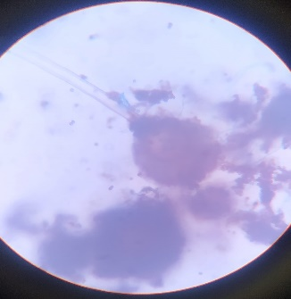
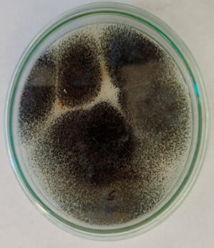
The macro morphological and micromorphological views of the fungal isolates are represented in the figures given below.
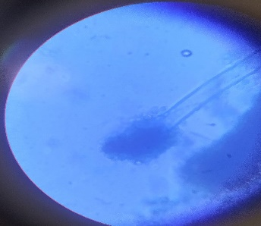
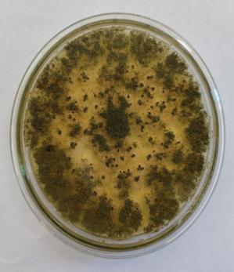
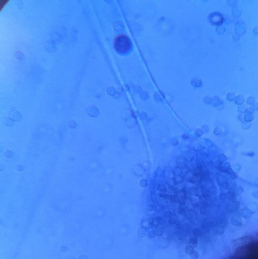
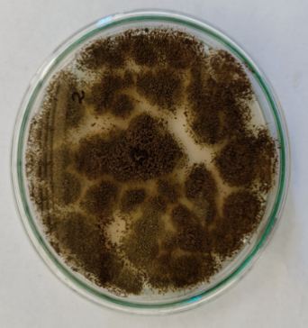
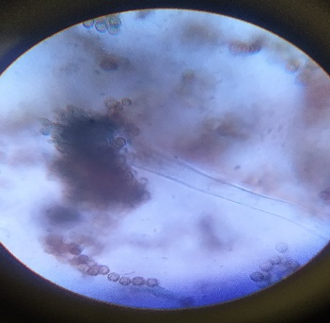

Fig 1. Aspergillus niger Fig 2. Aspergillus fumigatus
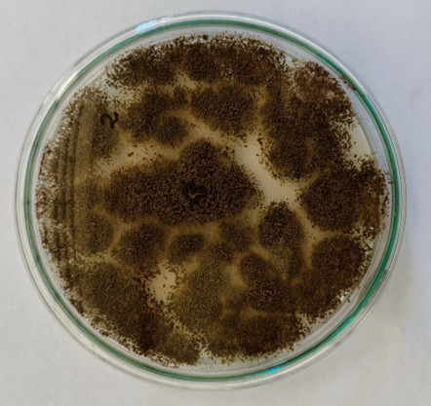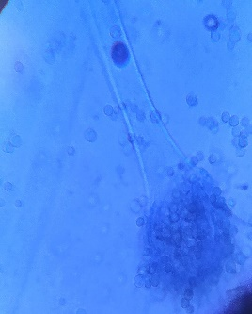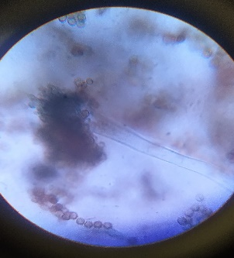
Fig 3. Aspergillus flavus Fig 4. Aspergillus melleus
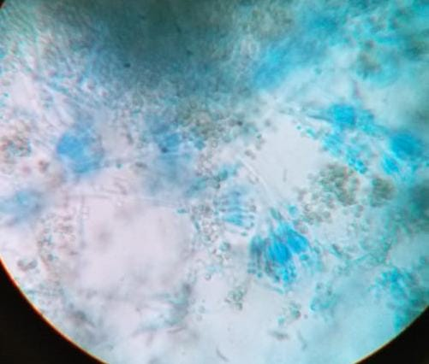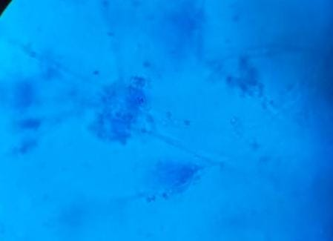
Fig 5. Penicillium chrysogenum Fig 6. Penicillium aurantiogreseum

- CONCLUSION
The present research findings report the presence of fungal species in waste dumping site soils of Coimbatore, Tamil Nadu. The Aspergillus was found to be dominant among the obtained 65 isolates. Many of the identified isolates have proven to be beneficial in various industrial purposes and further studies can be conducted on the future usage of these isolates for necessary purposes.
- REFERENCES
- Gupta, A., Gupta, R., & Singh, R. L. (2017). Microbes and environment. Principles and applications of environmental biotechnology for a sustainable future, 43-84.
- Gayan, A., Borah, P., Nath, D., & Kataki, R. (2023). Soil microbial diversity, soil health and agricultural sustainability. In Sustainable Agriculture and the Environment (pp. 107-126). Academic Press.
2.
3. Ndabankulu, K., Egbewale, S.O., Tsvuura, Z. et al. Soil microbes and associated extracellular enzymes largely impact nutrient bioavailability in acidic and nutrient poor grassland ecosystem soils. Sci Rep 12, 12601 (2022). https://doi.org/10.1038/s41598-022-16949-y
4. Contesini, F. J., de Lima, E. A., Mandelli, F., Borin, G., Alves, R. F., & Terrasan, C. R. F. (2018). Carbohydrate active enzymes applied in the production of functional oligosaccharides. In Encyclopedia of food chemistry (pp. 30-34). Elsevier.
5. Cappuccino, J. G. S. (1999). Microbiology: a laboratory manual/James G., Cappuccino and Natalie Sherman (No. 576 C3.).
6. Yamagata, M. (1992). Microbiological procedure: Fungi (mould and yeast) plate count. In Laboratory Manual on Analytical Methods and Procedures for Fish and Fish Products (pp. E-10). Marine Fisheries Research Department, Southeast Asian Fisheries Development Center.
7. Jain, A., Jain, R., Jain, S., Jain, A., Jain, R., & Jain, S. (2020). Sub-culturing of Bacteria, Fungi and Actinomycetes. Basic Techniques in Biochemistry, Microbiology and Molecular Biology: Principles and Techniques, 101-103.
8. Astrid, L. (1999). Preparation of lactophenol cotton blue slide mounts. Community eye health, Vol. 12 (30), Pg No. 24.

