DESIGN AND IMPLEMENTATION OF CLINICCARE APP FOR EFFICIENT HEALTHCARE SERVICES
Dr.R.JAYAVADIVEL
Associate Professor,
Department of Computer Science and Engineering,
Alliance College of Engineering and Design,
Alliance University, Bangalore.
ABSTRACT
CLINICARE App is a mobile application designed to connect patients and medical professionals, providing a convenient platform for efficient healthcare services. The app offers various features aimed at enhancing doctor-patient interactions and improving healthcare accessibility. Doctors can utilize CLINICARE App to manage appointments, monitor their schedules, and securely share vital patient data with their colleagues. This includes information such as diagnoses, prescriptions, and other relevant specifications, facilitating effective collaboration among healthcare professionals.
For patients, the app provides access to their medical records, allowing them to track their health progress over time. By having this information readily available, patients can actively participate in their healthcare journey and make informed decisions about their well-being. One of the key advantages of CLINICARE App is the ability to consult with doctors remotely through video or phone chats. This feature proves especially beneficial for individuals residing in rural areas or those who face challenges in visiting a doctor's office. By offering remote consultations, the app enables individuals to receive timely medical advice and treatment from the comfort of their own homes.
It provides doctors with the ability to schedule appointments, monitor their schedules, and share vital patient data with their colleagues. Patients can access their medical records through the app, allowing them to track their health progress over time. The app also enables remote consultations with doctors via video or phone chats, making it easier for patients to receive medical treatment from the comfort of their own homes. This feature is particularly beneficial for those who live in rural areas or have difficulty travelling to a doctor's office. The app provides doctors with comprehensive patient information, including current diseases and follow-up information in conclusion, CLINICARE App bridges the gap between patients and medical professionals, facilitating efficient healthcare services and improving accessibility. By providing a platform for seamless communication, secure data sharing, and remote consultations, the app empowers both doctors and patients to enhance healthcare delivery and achieve better health outcomes.
Keywords: CLINICARE App, Online appointment, medical professionals, Follow-up information, Monitoring schedules
1. INTRODUCTION

A mobile application called CLINICARE App promises to link patients and medical professionals. The app should enable doctors to set up appointments, monitor their schedules, and communicate vital patient data to their colleagues, such as a patient's diagnosis, prescription, and other pertinent specifications. Patients can access their medical records using the app, enabling them to follow the development of their health over time. People can consult with doctors remotely, utilising video or phone chats, making it easier to get medical treatment from the comfort of their own homes. Those who reside in rural places or find it difficult to travel to a doctor's office would particularly benefit from this feature. This software lets doctors learn every detail about patients, as well as the current diseases and follow-up information. CLINICARE App is a mobile application designed to revolutionize the way patients and medical professionals interact and provide healthcare services. With its comprehensive set of features, the app aims to enhance convenience, efficiency, and accessibility in the healthcare industry. For doctors, CLINICARE App offers a user-friendly interface that allows them to easily set up appointments and manage their schedules. This eliminates the need for manual appointment booking and scheduling processes, saving valuable time for both doctors and patients. Additionally, the app enables doctors to securely communicate vital patient data to their colleagues, ensuring seamless collaboration and continuity of care.
By sharing information such as diagnoses, prescriptions, and pertinent specifications, medical professionals can make well-informed decisions and provide optimal treatment to their patients. on the other hand, can benefit from CLINICARE App's functionality. By using the app, patients gain access to their medical records, empowering them to actively participate in managing their health. They can view their health data, track progress over time, and stay informed about any ongoing treatments or medications. This feature promotes patient engagement and enables individuals to make informed decisions regarding their well-being. One of the standout features of CLINICARE App is its remote consultation capability. Through video or phone chats, patients can consult with doctors without the need for in-person visits.
This proves especially advantageous for individuals living in rural areas or facing travel challenges, as they can receive timely medical advice and treatment from the comfort and convenience of their own homes.
The app ensures that distance is no longer a barrier to accessing quality healthcare. Patients can access their medical records using the app, enabling them to follow the development of their health over time. This feature is particularly useful for patients with chronic conditions who need to monitor their health regularly. The app also enables remote consultations with doctors via video or phone chats, making it easier for patients to receive medical treatment from the comfort of their own homes. This feature is particularly beneficial for those who live in rural areas or have difficulty travelling to a doctor's office.
The CLINICARE App provides doctors with comprehensive patient information, including current diseases and follow-up information. This information is critical for doctors to provide accurate and effective treatment to their patients. The app also allows doctors to access patient data from anywhere, ensuring that they can provide timely and efficient care to their patients. The doctor and patient need to communicate more effectively. According to Life Care Hospital, it significantly affects the effectiveness and efficiency of a hospital's patient appointment scheduling system. However, at certain hospitals, to register, the patient or companion must make an appointment at the registration desk. Paper and pens are the basis of the entire system.
Due to the limitations of this sort of appointment scheduling system, patients must spend a lot of time in queues since they must fill out appointment paperwork when they arrive at the hospital or clinic and there is no chance to register anywhere, at any time.
A significant technological development has led to the creation of a system for scheduling doctor's appointments. Before visiting the hospital, clients can make an appointment from their home or another location utilizing an appointment scheduling app. This suggested mobile application for the patient’s appointment would assist Life Care Hospital in providing better healthcare by efficiently facilitating the delivery of healthcare services. The patient has an appointment and must stand in line. The patient cannot be informed if the doctor needs to cancel an appointment due to an emergency. In summary, CLINICARE App is a groundbreaking mobile application that connects patients and medical professionals, facilitating efficient communication, seamless data sharing, and remote consultations.
Objectives
- To improve the efficiency of the patient appointment scheduling system by allowing patients to book appointments remotely from their homes or other locations, reducing the need for physical queues and paperwork.
- To facilitate effective communication between doctors and patients, allowing patients to consult with doctors remotely through video or phone calls, and providing doctors with access to critical patient information such as medical records, diagnoses, and prescriptions.
- To enhance the quality of healthcare services provided by Life Care Hospital by streamlining the delivery of healthcare services and improving the accuracy and completeness of patient information.
- To increase the accessibility of healthcare services, particularly for patients who live in remote areas or find it difficult to commute to a doctor's office.
- To improve patient satisfaction and reduce waiting times by providing real-time information about appointment cancellations or rescheduling due to emergencies.
- To reduce administrative burdens on doctors and hospital staff by automating appointment scheduling, tracking patient information, and facilitating secure communication among healthcare professionals.

2. LITERATURE SURVEY
Table 2.1 Literature Survey
Sl. No. | Paper Title | Method | Advantages | Limitations
1 | Online Health Care Online Doctor Appointment Booking System | Health care via internet | Users receive therapy within a reasonable amount of time | It is a costly investment
2 | Mobile Devices and Apps for Health Care Professionals | patient’s EHR & HCP management of EHRs and PACSs | Facilitate engagement through effective patient-focused care | Data Privacy
3 | Electronic Health Records (EHRs) | Digital records of patients' health information | Improved accuracy and accessibility of patient information, easier communication between healthcare providers, potential for data analysis and research | Costly implementation and maintenance, potential for errors in data entry, privacy, and security concerns
4 | Clinical Decision Support Systems (CDSS) | Computer-based tools that provide clinicians with diagnostic or treatment suggestions | Can improve diagnostic accuracy and reduce errors, can help standardize care, potential for increased efficiency and cost savings | Dependence on quality and completeness of input data, potential for information overload or incorrect suggestions, resistance to implementation by some doctors
5 | Medical Imaging | Use of technology to visualize internal structures of the body | Can assist in diagnosis and treatment planning, non-invasive alternative to some procedures, potential for real-time imaging during procedures | Costly equipment and training, potential for misinterpretation or false positives/negatives, exposure to radiation
6 | Social, ethical, and legal barriers to e-health. | Literature analysis and survey data from primary care physicians on adoption of information technology are reviewed. | To investigate the present status of information technology in health care, the perceived benefits and barriers by primary care physicians which was difficult in previous times. | Barriers include lack of access to capital by health care providers, complex systems and lack of data standards that permit exchange of clinical data, privacy concerns and legal barriers.
7 | Bates, B.R., Romina, S., Ahmed, R. and Hopson, D. | Independent sample t-tests were conducted to compare each attributed message to its counterpart attributed to a generic web page on measures of trustworthiness, truthfulness, readability, and completeness | This study examines consumer evaluations of web pages attributed to a credible source as compared to generic web pages on measures of message quality | Results demonstrated that differences in attribution to a source did not have a significant effect on consumers' evaluations of the quality of the information
8 | Bodkin, C. and Miaoulis, G. (2007), “eHealth  information quality and ethics issues: exploratory  study of consumer perceptions,” International Journal  of Pharmaceutical and Healthcare Marketing | Using a national random sample of 1,227 respondents, this study identifies online health care information seekers and explores the type of information they seek, their perceptions of eHealth web site quality and ethics. | The results indicate that while WebMD currently dominates the eHealth care market, the future for niche eHealth care web sites appears promising as consumers' perceptions of eHealth care web site quality and ethical behaviors improve. | The development of ethical codes for eHealth web sites is having an effect on consumers' perceptions.

3. EXISTING SYSTEM

Existing systems in the healthcare industry that aim to improve communication and enhance healthcare services include:
1.Electronic Health Records (EHR) Systems: EHR systems digitize and centralize patient health records, enabling healthcare providers to access and update patient information securely. These systems improve communication and information sharing among healthcare professionals, leading to better coordination of care.
2.Telemedicine Platforms: Telemedicine platforms facilitate remote consultations between doctors and patients through video or phone calls. These systems allow patients to receive medical advice, prescriptions, and follow-up care without the need for in-person visits. Telemedicine platforms have gained significant popularity, especially in providing healthcare access to individuals in remote areas.
3.Appointment Scheduling Systems: Appointment scheduling systems streamline the process of booking and managing patient appointments. They often offer features such as online appointment booking, automated reminders, and calendar integration. These systems reduce wait times, optimize healthcare provider schedules, and improve patient satisfaction.
4.Health Information Exchange (HIE) Systems: HIE systems enable the secure exchange of patient health information between different healthcare organizations and providers. They facilitate the sharing of medical records, test results, and other relevant data, ensuring continuity of care and avoiding duplication of tests or procedures.
5.Remote Monitoring Systems: Remote monitoring systems utilize wearable devices, sensors, and mobile apps to track patients' vital signs, activity levels, and other health parameters. These systems enable healthcare providers to remotely monitor patients' health conditions and intervene promptly when necessary, improving disease management and reducing hospital readmissions.
6.Medication Management Systems: Medication management systems help patients and healthcare providers track and manage medication adherence.
They provide reminders for medication intake, refill notifications, and medication interaction checks, ensuring patients follow prescribed treatment plans and avoid medication errors.
7.Health Portals and Patient Portals: Health portals and patient portals are online platforms that allow patients to access their health records, communicate with healthcare providers, schedule appointments, request prescription refills, and access educational resources. These portals enhance patient engagement and empowerment in managing their healthcare.
8.Setmore: An easy-to-use appointment scheduling app for doctors. It allows doctors to create their practice's booking page, book appointments from their website, and set up automatic appointment reminders.
9.SimplyBook.me: A scheduling software and app for medical services, clinics, and hospitals. It provides a booking page, mobile apps, Facebook bookings, reminders, and more.
10.HealthPlix SPOT: A doctor appointment app that allows patients to book appointments with doctors online
11.ZocDoc: An on-demand doctor app that uses AI (Artificial Intelligence) to match healthcare professionals to patients based on their needs
12. MyChart: An online software created by Epic Systems that connects patients with healthcare providers
These existing systems, along with the CLINICARE App, contribute to the digital transformation of healthcare by improving communication, efficiency, and accessibility in healthcare delivery. Each system addresses specific aspects of healthcare management, promoting better patient outcomes and healthcare provider collaboration.

4. SYSTEM DESIGN
Here we have used MySQL where the respective users are stored in the database so that they can use the credentials to login and use their services. Registered users can make their login at any time to app, and it is ensured that app provides the best security for authentication.
A medical app may have a wide range of features and capabilities, but at its core, it needs a dependable and secure system architecture that can cope with the app's demands. When creating a system architecture for a doctor app, you may want to consider the following crucial factors:
Clients, communication components, APIs (Application Programming Interfaces) and business logic, and storage and infrastructure services should be included in the system architecture of a medical app.
Client-Side: The user interface of the app, which includes the mobile or online application, is known as the client-side. Features including patient registration, appointment scheduling, health information, messaging, and payment processing are included in this component. Depending on the app's needs, various frameworks and programming languages can be used to build the client-side.
Server-Side: The server-side component manages the app's back-end functions, such as user authentication, API (Application Programming Interfaces) integration, and database management. The logic for processing appointments, prescriptions, and other patient data is likewise handled on the server-side. Node.js, Ruby on Rails, or PHP are just a few of the technologies that can be used to create this component.
Cloud Services: To store and manage patient data, including Electronic Health Records (EHRs), medical photographs, and lab results, a doctor app may need cloud services. Secure and scalable storage solutions can be offered by cloud services like Amazon Web Services (AWS), Google Cloud Platform (GCP), or Microsoft Azure.
APIs: Application Programming Interfaces (APIs) let the doctor app interact with services provided by other companies, including lab systems, pharmacy databases, and payment gateways.
Security: Due to the sensitive patient data it contains, security is an essential element of a medical app. Encryption, access limits, and audit logging are a few examples of security measures that should be incorporated into the system design to protect patient data from hacking or unauthorized access.

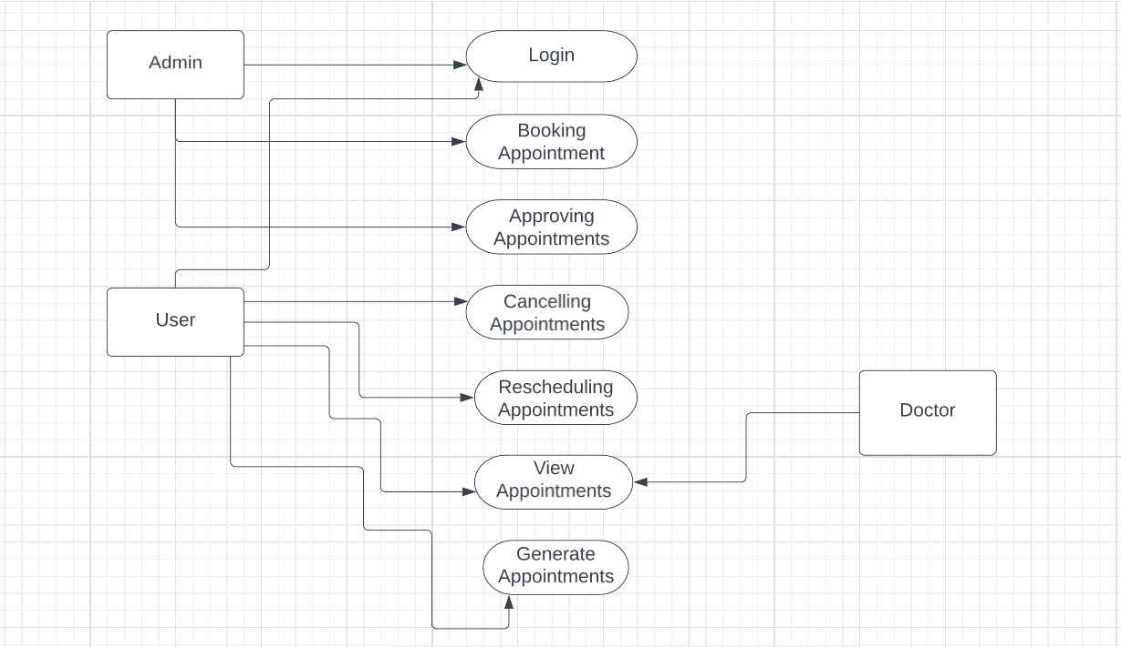
Fig 4.1 System Architecture

5. IMPLEMENTATION & SCREENSHOTS
The purpose of this methodology report is to outline the steps involved in creating a Hospital Management System App using the Flutter framework. This report will cover the entire process from requirement gathering to deployment of the app on multiple platforms.
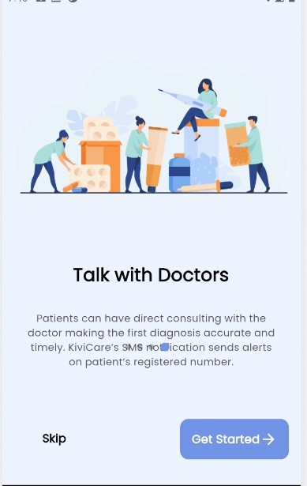
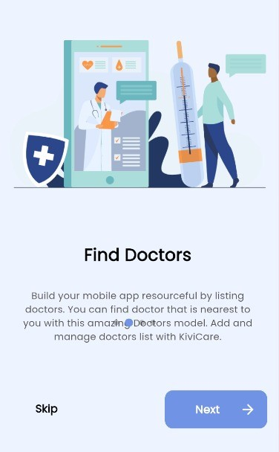
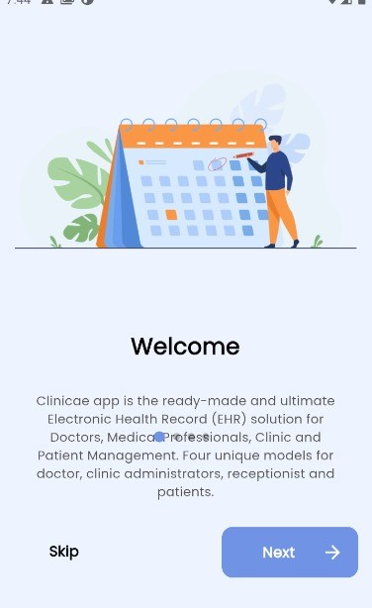
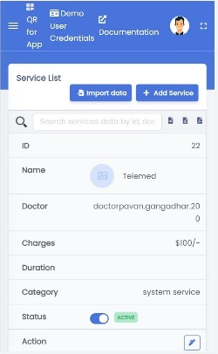
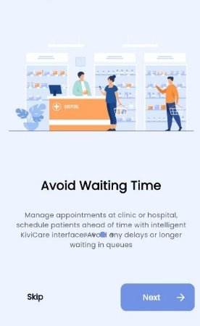
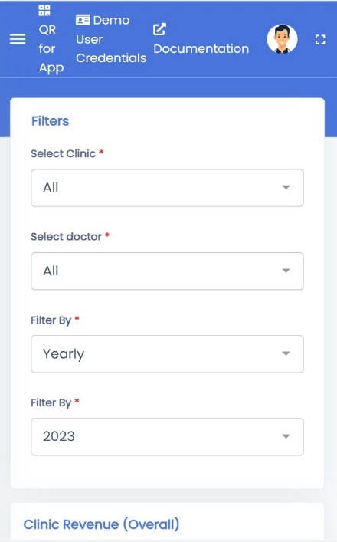

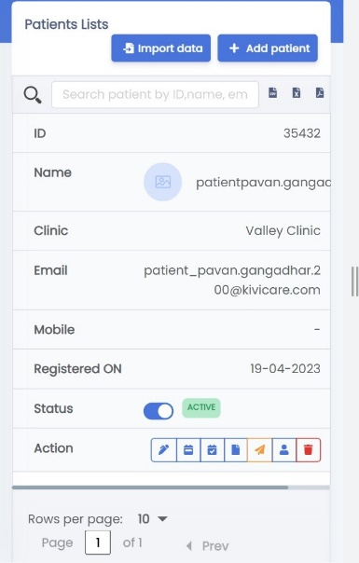
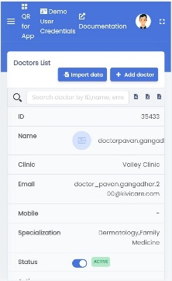

6.CONCLUSION
The Hospital Management System App is a vital solution for modern hospitals to streamline their operations and improve patient care. By following the methodology outlined in this report and leveraging the appropriate tools and technologies, we can create a high-quality app that meets the needs of hospital staff, patients, and other stakeholders.
The CLINICARE App is a transformative mobile application that revolutionizes the way patients and medical professionals interact and provide healthcare services. With its comprehensive set of features, the app enhances convenience, efficiency, and accessibility in the healthcare industry.
For doctors, the app offers a user-friendly interface that simplifies appointment scheduling and schedule management, eliminating the need for manual processes and saving valuable time for both doctors and patients. The app also enables secure communication of vital patient data to colleagues, ensuring seamless collaboration and continuity of care. This empowers medical professionals to make well-informed decisions and provide optimal treatment to their patients.
Patients benefit from the functionality of the CLINICARE App. They can access their medical records, enabling them to actively participate in managing their health and track progress over time. The app promotes patient engagement and informed decision-making regarding their well-being.
The standout feature of remote consultations via video or phone chats eliminates barriers to accessing quality healthcare, particularly for individuals in rural areas or facing travel challenges.
The CLINICARE App addresses the need for effective communication and streamlines the appointment scheduling process, as highlighted by the challenges faced in traditional systems. By allowing patients to make appointments from their homes or any location, the app improves efficiency and reduces waiting times. Patients are also notified promptly if a doctor needs to cancel an appointment due to an emergency, avoiding unnecessary visits and inconvenience.
Overall, the CLINICARE App facilitates efficient communication, seamless data sharing, and remote consultations between patients and medical professionals. It empowers individuals to actively manage their health and provides doctors with comprehensive patient information, ensuring accurate and effective treatment. By leveraging technology, the app enhances the delivery of healthcare services, making it more accessible, convenient, and patient-centred.

REFERENCES
  - Online Health Care Online Doctor Appointment Booking System Rakesh Patil Dept. Of Information Technology, Alamari Ratnamala Institute Of Engineering And Technology, Yash Goyal Dept. Of Information Technology, Alamari Ratnamala Institute Of Engineering And Technology Shahbaz Shaikh Dept. Of Information Technology, Alamari Ratnamala Institute Of Engineering And Technology, Mr. Shital Agrawal Dept.of Computer Engineering, Alamuri Ratnamala Institute Of Engineering And Technology,. Yash Shejwal Dept.of Information Technology, Alamuri Ratnamala Institute Of Engineering And Technology, published on 25 April -2022.
  - Clinical Decision Support Systems: From Theory to Practice Author(s): Robert A. Greenes, Dean F. Sittig Publication: JAMIA Year: 2017 DOI: 10.1093/jamia/ocw104
  - Electronic Health Records: Benefits, Barriers, and Best Practices Author(s): Jerome H. Carter, Mark E. Frisse Publication: The American Journal of the Medical Sciences Year: 2016 DOI: 10.1016/j.amjms.2016.01.008
  - Medical Imaging: Current Technologies and Future Directions Author(s): Elliot K. Fishman, Alexander R. Margulis Publication: The American Journal of the Medical Sciences Year: 2011 DOI: 10.1016/j.amjms.2010.08.018
  - Eric Jamoom, Ph.D., M.P.H., M.S.; Paul Beatty, Ph.D.; Anita Bercovitz, Ph.D., M.P.H.; David Woodwell, M.P.H.; Kathleen Palso, M.A.; and Elizabeth Rechtsteiner, M.S. Physician Adoption of Electronic Health Record Systems: United States, 2011
  - Gerald Gianutsos, PhD, JD Identifying Factors That Cause Pharmacy Errors. Release Date: December 1, 2008. University of Connecticut School of Pharmacy.
  - E-healthcare: An analysis of key themes in research Avinandan Mukherjee, John McGinnis – International Journal of Pharmaceutical and Healthcare Marketing 2007.
  - . Anderson, J.G. (2007), “Social, ethical and legal barriers to e-health”, International Journal of Medical Informatics, Vol. 76, pp. 480-3
  - Bates, B.R., Romina, S., Ahmed, R. and Hopson, D. 431 No. 1, pp. 45-52.
  - Bodkin, C. and Miaoulis, G. (2007), “eHealth information quality and ethics issues: an exploratory study of consumer perceptions”, International Journal of Pharmaceutical and Healthcare Marketing, Vol. 1 No. 1, pp. 27-42.
  - Dolan, G., Iredale, R., Williams, R. and Ameen, J. (2004), “Consumer use of the internet for health information: a survey of primary care patients”, International Journal of Consumer Studies, Vol. 28 No. 2, pp. 147-53.
  - Campbell, R.J. (2001), “Consumer health, patient education, and the internet”, The Internet Journal of EHealthcare: Medical Practice Management System (IJSRD/Vol. 9/Issue 06/2021/022) All rights reserved by www.ijsrd.com 110 Health, Vol. 2 No. 2, available at: www.ispub.com/ostia/index.
  - A Distributed e-Healthcare System Based on the Service Oriented Architecture Kart, F. Gengxin Miao Moser, L.E. Melliar-Smith, P.M. Dept. of Electr. & Computer. Eng., Univ. of California, Santa Barbara, CA.
  - A Service Oriented Architecture for a Health Research Data Network Rohan Baxter and Ross Sparks and Uma Srinivasan and Mark Cameron and Laurent Lefort.
  - 16. Zhang X, Yu P, Yan J. Patients' adoption of the e-appointment scheduling service: a case study in primary healthcare. Stud Health Techno Inform. 2014;204:176–181. [PubMed] [Google Scholar]
  - Jones R, Menon-Johansson A, Waters AM, Sullivan AK. eTriage - a novel, web-based triage and booking service: enabling timely access to sexual health clinics. Int J STD AIDS. 2010;21(1):30–33. doi: 10.1258/ijsa.2008.008466.ijsa.2008.008466 [PubMed] [CrossRef] [Google Scholar]
  - Online scheduling applications may improve customer satisfaction, but setup is not always easy. Internet Healthc Strategy. 2004;6(5):1–5. [PubMed] [Google Scholar]
  - Wang W, Gupta D. Adaptive appointment systems with patient preferences. Manuf Serv Oper Manag. 2011;13(3):373–389. doi: 10.1287/msom.1110.0332. [CrossRef] [Google Scholar]
  - Tang PC, Black W, Buchanan J, Young CY, Hooper D, Lane SR, Love B, Mitchell C, Smith N, Turnbull JR. PAMFOnline: integrating Health with an electronic medical record system. AMIA Annu Symp Proc; AMIA Annual Symposium; November 8, 2003; Washington, DC. 2003. pp. 644–648. http://europepmc.org/abstract/MED/14728253 . [PMC free article] [PubMed] [Google Scholar]
  - Denizard-Thompson NM, Feiereisel KB, Stevens SF, Miller DP, Wofford JL. The digital divide at an urban community health centre: implications for quality improvement and health care access. J Community Health. 2011;36(3):456–460. doi: 10.1007/s10900-010-9327-5. [PubMed] [CrossRef] [Google Scholar]
  - Zhang X, Yu P, Yan J, Hu H, Goureia N. Patients' perceptions of web self-service applications in primary healthcare. Stud Health Technol Inform. 2012;178:242–249. [PubMed] [Google Scholar]
  - Siddiqui Z, Rashid R. Cancellations, and patient access to physicians: Zocco and the evolution of e-medicine. Dermatol Online J. 2013;19(4):14. [PubMed] [Google Scholar]
  - Clingan SA. Going online: the role of web-based initiatives in health information technology. J Med Pract Manage. 2011;26(4):225–227. [PubMed] [Google Scholar]
  - Healthit. [2016-09-26]. What is a patient portal? https://www.healthit.gov/providers-professionals/faqs/what-patient-portal .
  - Healthit. [2016-10-03]. Meaningful use defination and objectives https://www.healthit.gov/providers-professionals/meaningful-use-definition-objectives
  - HIMSS. [2016-10-03]. Using patient portals to achieve Meaningful Use Stage 2 http://www.himss.org/using-patient-portals-achieve-meaningful-use-ep-edition?ItemNumber=35966 .
  - Real-time scheduling faces operational challenges. Internet Healthc Strategy. 2005;7(1):1–6. [PubMed] [Google Scholar]
  - Abbott KC, Boocks CE, Sun Z, Boal TR, Poropat ich RK. Walter Reed Army Medical Center's internet-based electronic health portal. Mil Med. 2003;168(12):986–991. [PubMed] [Google Scholar]
  - Cayirli T, Veral E. Outpatient scheduling in health care: a review of literature. Prod Oper Manag. 2003;12(4):519–549. doi: 10.1111/j.1937-5956.2003.tb00218. x. [CrossRef] [Google Scholar]
  - Gupta D, Denton B. Appointment scheduling in health care: challenges and opportunities. IIE Transactions. 2008;40(9):800–819. doi: 10.1080/07408170802165880. [CrossRef] [Google Scholar]
  - Moher D, Liberati A, Tetzlaff J, Altman DG. Preferred reporting items for systematic reviews and meta-analyses: the PRISMA statement. Ploss Med. 2009;6(7): e1000097. doi: 10.1371/journal.pmed.1000097. http://dx.plos.org/10.1371/journal.pmed.1000097 . [PMC free article] [PubMed] [CrossRef] [Google Scholar]
  - Romano M. Not just a Web site. In response to consumers as well as competitors, hospitals are getting more sophisticated with their Internet presence. Mod Health. 2003;33(21):22–26. [PubMed] [Google Scholar]
  - Knight A, Lembke T. Appointment zen - shaping demand and matching capacity. Austa Fam Physician. 2014;43(4):234–238. http://www.racgp.org.au/afp/2014/ april/appointment-zen/ [PubMed] [Google Scholar]
  - Lowes R. Let patients book their own appointments? Med Econ. 2006;83(11):27–28. [PubMed] [Google Scholar]
  - Friedman JP. Internet patient scheduling in real-life practice. J Med Pract Manage. 2004;20(1):13–15.[PubMed][GoogleScholar]
  - Federowicz M. Improving access to improve quality: evaluation of an organizational innovation. Find Brief. 2008;11(5):1–4. [PubMed] [Google Scholar]
  - Farr C. Dentistry takes the CyberCare: scheduling, consultations, records move to the net. Dent Today. 2000;19(5):106–113. [PubMed] [Google Scholar]
  - Illman J. 'Expedia' system for appointments. Health Serv J. 2013;123(6351):9. [PubMed] [GoogleScholar]
  - Walters BA, Danis K. Patient Online at Dartmouth-Hitchcock - interactive patient care web site. AMIA Annu Symp Proc; AMIA Annual Symposium; December 8, 2003; Washington, DC. 2003. p. 1044. http://europepmc.org/abstract/MED/14728547 . [PMC free article] [PubMed] [Google Scholar]
  - Lowes R. Phones driving you crazy? Try clinical messaging. Med Econ. 2004;81(6):65, 69–72, 76. [PubMed] [Google Scholar]
  - Appointments. Patient choice is the only option. Health Serv J. 2009;119(6183):27. [PubMed] [Google Scholar]
  - Baldwin FD. Book 'me. Enterprise-wide scheduling presents challenges, but CIOs will find it worth the time and effort. Healthc Inform. 2001;18(9):37–42. [PubMed] [Google Scholar]
  - Judd J. The benefits of a practice-managed Web site. MGMA Connex. 2002;2(4):25–26. [PubMed] [Google Scholar]
  - Zhang X, Yu P, Yan J, Ton A M Spil I. Using diffusion of innovation theory to understand the factors impacting patient acceptance and use of consumer e-health innovations: a case study in a primary care clinic. BMC Health Serv Res. 2015; 15:71. doi: 10.1186/s12913-015-0726-2. https://bmchealthservres.biomedcentral.com/articles/10.1186/s12913-015-0726-2 .10.1186/s12913-015-0726-2 [PMC free article] [PubMed] [CrossRef] [Google Scholar]
  - Cao W, Wan Y, Tu H, Shang F, Liu D, Tan Z, Sun C, Ye Q, Xu Y. A web-based appointment system to reduce waiting for outpatients: a retrospective study. BMC Health Serv Res. 2011; 11:318. doi: 10.1186/1472-6963-11-318. https://bmchealthservres.biomedcentral.com/articles/10.1186/1472-6963-11-318 .1472-6963-11-318 [PMC free article] [PubMed] [CrossRef] [Google Scholar]

