**Energy Audit of a Higher Education Institute – The First Step towards Greening a College Campus**

*Nandini Gupta*

*Department of Environmental Science*

*Bir Bikram Memorial College, Agartala, Tripura, 799004*

**Abstract**

A systematic investigation to develop an energy efficiency program in any establishment is known as an energy audit. It consists of tasks that look for potential for energy conservation as a preliminary step to the creation of an energy-saving program. Energy use at colleges and universities has a significant effect on both financial and environmental interests. This article is simply the first step in the direction of our goal of an energy-efficient, environmentally friendly campus.The methodology used for this analysis comprises a thorough inspection of the facilities and the gathering of information on the lighting, fan, computer, printer, pump, and air conditioning loads, among other data. The examination of the data gathered and the identification of areas with a high potential for energy conservation are the next steps in the energy audit process.This study also seeks to pinpoint energy-saving techniques for reducing energy waste on the campus of Bir Bikram Memorial College. Educating the college community about the importance of energy conservation and how they may help to reduce greenhouse gas emissions are the main objectives of this study.

**Keywords:** Institutional energy audit, Energy conservation, Energy management

1. **Introduction**

All of the energy demands of an institution or establishment may be satisfactorily addressed via energy conservation. Utilizing less of an energy service is referred to as energy conservation. An effective service called an energy audit looks into ways to save energy without compromising performance in a building or system. Energy audits are described as "the verification, monitoring, and analysis of use of energy, including submission of technical report containing recommendations for improving energy efficiency with cost benefit analysis and an action plan to reduce energy consumption" in the Energy Conservation Act of 2001. The adoption of the suggested actions can assist consumers in significantly reducing their energy consumption levels. Energy conservation is the first step in a good energy management program; it will result in proper equipment rating, the use of high efficiency equipment, and a change in practices that result in significant energy waste. Energy management and conservation both depend on energy audits.

Bir Bikram Memorial College was chosen for the energy audit because many people are involved in educational facilities and the potential for energy conservation is also very high in such establishments. The objective of this study is to examine how much energy is used on the college campus and find ways to use less energy while maintaining the same level of productivity. Due to the unplanned and erratic use of light, fans in classrooms, practical rooms, auditoriums, as well as rooms with computer facilities and UPS, institutional buildings are taken into consideration in this article.

1. **Objective of Energy Audit Exercise**

The goal of the energy audit is to encourage energy conservation in the Bir Bikram Memorial College campus and turn it into a campus that cares about the environment. The energy audit's objective is to find, quantify, describe, and rank, cost-saving measures related to energy use in various College buildings and blocks.

The purpose of the energy audit study was to:

• Determining where energy is being wasted and estimating where it could be saved in the college campus

• Outlining practical, affordable ways to increase energy consumption efficiency.

• Estimating the costs and payback times associated with implementation of each suggested action.

• Documenting the outcomes and important data produced by these efforts.

1. **Energy Audit Methodology**

**Energy Audit**

Energy audit is an efficient process which looks into ways to save energy without compromising the performance in a building or system. Following are energy auditing activities in general order:

* **Identification of all energy systems**
* **Evaluation of conditions of the systems**
* **Analysis of impact of improvement to those systems.**
* **Preparation of energy audit report**

The three-step methodology used for this investigation included the following steps:

1. Data gathering - During the initial data collection phase, thorough data collection was carried out utilizing several approaches, including observation, key person interviews, and measurements.
2. Data Analysis: Using Microsoft Excel 2007, a thorough analysis of the gathered data was performed. The graphical representations were created using the database that Microsoft Excel created.
3. Recommendation - Based on the findings of the data analysis and observations, various measures for lowering power usage without compromising comfort and satisfaction, as well as an analysis of their costs, were suggested.
4. **Data Collection-** Toknow the power consumption pattern in detail, the exhaustive data collection exercise was performed at all the departments.

* Information about the general electrical appliances was collected by observation and interviewing.
* The details of usage of the appliances were collected by interviewing key persons
* Light intensity was measured using Lux meter (Lux Meter LX-101A) at all the places
* Approximations and generalizations were done at places with lack of information

**2. Data Analysis** – In data analysis, the information is analyzed to uncover patterns, find gaps, and determine the areas that need attention. The power consumption patterns and the locations where electrical energy is squandered were determined by analysis of the power consumption measurements.

**3. Recommendation:** Based on the capital cost recovery time, suggestions were given after performing an energy and cost analysis of various appliances. The following steps made up this process:

• A capital cost estimate was made for replacing a process or equipment.

• The amount of energy saved by the replacement was determined using the annual cost of energy.

• The capital cost recovery time, which is defined as the entire amount of time it takes for the savings in energy expenses to offset the capital expenditures involved, was calculated by comparing these two prices.

**D. Results and Discussion**

**1. Bir Bikram Memorial College’s present energy scenario**

In Tripura, Bir Bikram Memorial College is a renowned public institution of higher learning. The site of Bir Bikram Memorial College is roughly 6 acres in size, and it has a combined student body of 4000 across the arts, commerce and science fields. The College has 33 non-teaching staff employees and 51 faculty members. This college has access to electricity around-the-clock. This college is organized into three sections: the academic section, the science section, and the administrative section. The academic block is the largest one. The structure has six stories and two basement levels. Admistrative block is a sizable three-story building, while Science block is a lengthy two-story structure.

* Specific Energy Consumption (SEC)

The amount of energy used for each unit of output from a product is known as the Specific Energy Consumption (SEC). The power bills that made up the College's SEC were used to compute the precise energy consumption by students, faculty, and staff. For the 2014–2015 fiscal year, the SEC was determined as 24.57 kWh/person/year and Rs. 173.22/person/year.

**1.2. Academic building**

Academic building structural foundation was planned for Basement I+ Basement II+ Ground floor + 3 floors. The total covered area of all the floors is **4545.99** square mt. The layout drawing (Plate.3) shows the dimensions of each individual room. To give it a respectable and official appearance, the structure is painted a cream colour. The academic building's total connected load is 99682 Watt.

**Room analysis on the basis of energy consumption**

**Basement I** consists of 1) Canteen kitchen 2) Canteen room 3) Toilet (Gents) and corridor. Total covered area for Basement I is: **224.34 square mt.** So basement –I is having total 3 rooms. Total energy consumption per month in the basement I is **620.1 kWh.** (Table 1 in Annexure)

**Basement II** consists of 1) Professors’ room 2) Examination committee’s room 3) Staff toilet (Ladies and Gents) 4) Xerox room and locker room 5) Locker room and Corridor. Total covered area for Basement II is: **411.85square mt .** So in basement –II is having a total of 5 rooms. Total energy consumption per month in the basement II is**1336.01 kWh (**Table 2 in Annexure)

**Ground floor** covered an area of **1414.54 square mt** with **10** nos of theory classrooms, one seminar room and 2 toilets (Ladies and gents). Energy consumption per month in the ground floor is **2246.26 kWh** (Table 3 in Annexure)

Six theory classrooms, two restrooms, and a hallway were located on the first floor, which had a floor space of 659.22 square meters. The first floor's monthly energy consumption is 1110.52 kWh (Table 4 in the Annexure).

**Second floor** covered an area of **964.42 square mt** with 5 nos of theory classrooms, one smart class, Library, music room, 2 toilets and corridor. Total energy consumption per month in the second floor is **1945.44 kWh**(Table 5 in Annexure)

**Third floor** covered an area of **871.59 square mt** with 5 nos of theory classrooms, 2 toilets, Computer room, conference hall and corridor. Total energy consumption per month in the second floor **1634.25 kWh** (Table 6 in Annexure)

**1.3. Administrative block**

Administrative block is a large three- storied building having a total of 13 rooms. Principal’s office, DDO room and UGC room are situated in this building. Ground floor, 1st floor and 2nd floors of the building covered an area of **601.08 sq mt, 631.47** sq mt and **569.29** sq.mt respectively. Energy consumption units per month of ground floor, 1st and 2nd floors are **899.34** kWh, **2359.5** kWh and **1161.784** kWh respectively. Total connected load of the administrative building is **35827 Watt** (Table7, 8,9 in Annexure).

**1.4. Science Block**

Science block consists of a long two- storied building having a total of 9 rooms. Physics and Chemistry labs, boys and girls’ common rooms are situated here. Ground floor of the building covers an area **of 564,54 Square mt and the total energy consumption 1305.24 kWh**. (Table 10 in Annexure). 1st floor covered an area **of 470.63 Square mt. Total** energy consumption of 1st floor is **158.73kWh and** Total connected load of Science block is **19191Watt.** (Table 10& 11 in Annexure)

|  |  |  |  |  |
| --- | --- | --- | --- | --- |
| **Table 12. TOTAL CONNECTED LOAD FOR DIFFERENT USAGE( IN WATT)** | | | | |
|  | **Lighting** | **Fan load** | **Other electronic appliances** | **Total** |
| Academic Block | 42035 | 26445 | 31202 | **99682** |
| Science Block | 5900 | 3025 | 10266 | **19191** |
| Administrative Block | 14228 | 5920 | 15679 | **35827** |
| **Total** | **62163** | **35390** | **57147** |  |
| **TOTAL CONNECTED LOAD OF THE COLLEGE**  **1,54,700 Watt** | | | | |

(Number of lights, fans and other electrical appliances and their respective wattage details are given in Annexure Table No.1-11)

**Fig.3.Load Distribution in the College**

**2. Analysis of lighting system efficiency in the College**

Calculating the amount of energy used per square meter is the first step in calculating the fluorescent lighting system's efficiency. This is done by dividing the total wattage of the lighting system by the size of the classroom.

**Table 13. Energy used per sq meter**

|  |  |  |  |
| --- | --- | --- | --- |
| **Name of Blocks** | **Area (Sq.mt)** | **Total wattage of light(Watt)** | **Energy used per sq meter**  **(Watt/ sq.mt)** |
| **Academic block** | 4545.99 | 42035 | **9.25** |
| **Science block** | 1035.17 | 5900 | **5.70** |
| **Administrative block** | 1801.85 | 14228 | **7.90** |
|  | 7383.01 | 62163 | **8.42** |

Measuring the illumination lux levels is the next stage. A lumen is a unit of measurement for light, and a lux is the lumens per square meter. The recommended illuminance are listed in Table 14 below and are in accordance with the Energy Conservation Building Code (ECBC) - 2006, which was released by the Bureau of Energy Efficiency (BEE), Government of India.

**Table 14 ECBC Standard**

|  |  |
| --- | --- |
| **Type of Interior Or Activity** | **Minimum Illuminance required(In Lux)** |
| General | 200 |
| Reading Room | 200 |
| Reading tables | 200 |
| Bathrooms | 50 |
| Computer Workspace | 300 |
| Parking Area | 20 |
| Music Rooms | 200 |
| Interior Sports halls | 200 |
| Corridors, passageways &Stairs | 50 |
| Cafeterias ,Dining Rooms and Mess Rooms | 150 |
| Canteens , Food Preparation and Cooking | 300 |

**Table 15. Lux meter Reading of Academic Block**

|  |  |  |
| --- | --- | --- |
| **Floors** | **Rooms and other Places of the College** | **Illuminance (Lux)** |
| Basement I | Corridor | 30 |
| Toilet | 60 |
| Canteen | 230 |
| Basement II | Corridor | 47 |
| Toilet | 44 |
| Professor’s room, exam committee room, locker room | 40 |
| Ground floor | Class rooms | 470 |
| Corridor | 180 |
| 1st floor | Class rooms | 580 |
| Corridor | 230 |
| 2nd floor | Class rooms | 790 |
|  | Library | 260 |
|  | Corridor | 260 |
| 3rd floor | Class rooms | 940 |
|  | Corridor | 260 |

**Table 16.Lux meter Reading of Science Block**

|  |  |  |
| --- | --- | --- |
| **Floors** | **Rooms and other Places of the College** | **Illuminance (Lux)** |
| Ground floor | Physics lab | 22 |
| Corridor | 220 |
| Girls common room | 26 |
| Boys common room | 50 |
| Student’s Council room | 230 |
| Chem. Lab | 110 |
| 1st floor | Class rooms | 50 |
| Corridor | 150 |

**Table 17** **Lux meter Reading of Administrative Block**

|  |  |  |
| --- | --- | --- |
| **Floors** | **Rooms and other Places of the College** | **Illuminance (Lux)** |
| Ground floor | Academic sec. | 390 |
| Corridor | 266.69 |
| 1st floor | Principal’s office | 450 |
| Meeting ROOM | 260 |
| Establishment section | 380 |
| Corridor | 260.75 |
| 2nd floor | Toilet | 30 |
| E.V.S lab | 170 |
| Conference hall | 4270 |
| Corridor | 450 |

According to the ECBC standards it is found that the current lighting intensities are high in most of the class rooms and office rooms in academic building and Administrative building. Very low light intensities were observed in all the laboratories. Toilets also show lower lux level than the standard. In the Academic block, lux readings of all the rooms in the basement II area are below the ECBC standard.

**2 .Benchmarking**

Benchmarking is the practice of contrasting a given process' performance with that of the best possible process in an effort to raise the standard of the process and raise the quality of the resulting system, product, and services, among other things. It enables businesses to create strategies for implementing best practices, typically with the goal of enhancing certain performance facets. Benchmarking may be a one-time occurrence, but it's frequently seen as an ongoing process in which businesses always look to improve. Energy consumed per person, including faculty, staff, and students, serves as the standard for comparing Bir Bikram Memorial College's energy usage. Here are the benchmarking criteria: Block-wise energy performance is measured in terms of kWh per person and kWh per m2.

**3. Energy saving potential in the Bir Bikram Memorial College**

3.1. **Elimination of Energy Wastages**

It has been observed that in all the toilets, exhaust fans are on for 6 hours a day though it is not required and much of the total load consumed can be saved without any effect on their performance. This wastage of energy can be saved if the usage hours are reduced to 3 hours per day.

**a) Energy and Cost Saving Calculation for reducing Exhaust fan’s operating hours**

Total 37 Exhaust fans ( each 40 Watt) are there in our College.

Total energy consumption 40x 37=1480 Watt

Currently exhaust fans are on for 6 hrs /day

Power consumption /day= 1480x6=8880 Watt-hr

(1 kWh=1 unit) =8.88 kWh

Energy cost/day= 8.88x7.05=Rs.62.60/-

Energy cost per month for 26 days working days=62.60x26=Rs. 1627.60/-

Annual energy Cost=Rs.1627.60x12=19531.20/-

Now we calculate assuming the operating hours -3 hrs /day

Total energy consumption 40x 37=1480 Watt

Power consumption /day= 1480x3=4440 Watt-hr

(1 kWh=1 unit) = 4.44 kWh

Energy cost/day= 4.44 x7.05=Rs.31.30 /-

Energy cost per month for 26 days working days=31.30x26=Rs. 813.8/-

Annual energy Cost=Rs.813.8x12=9765.6 /-

**Annual energy cost saving =Rs (19,531.20-9,765.6)/-= Rs. 9765.6/-**

**b)Conserving energy by using the photocopier only when necessary or avoiding using it in sleep mode, consumes energy as follows:**

Energy Consumption of Xerox Machine in Sleep Mode = 1x 100Watt

Power Saving for Approximate Non operating Mode Hours For 1 hours In A Day =100W x 1hr/day = 100Wh/Day

Energy in kWh = 100/1000 = 0.1kWh/day

Energy for a Month = 0.1kWh x 26days =2.6 kWh =2.6 Units Monthly Energy Cost =2.6 x 7.05 =Rs18.33/-

**Annual Energy Cost Saving = Rs18.33x12 =Rs 219.96/-**

* **Saving energy cost by using energy efficient appliances**
* **Potential of Saving Energy by Replacing all fluorescent lamps (FL) with compact fluorescent lights (CFL)**

**a) Fluorescent lamps Energy Savings Cost Estimation**

Total number of Fluorescent lamps or tubes = 1072

Actual wattage of Fluorescent lamps inclusive of choke =50W

Energy consumed by Fluorescent lamps for 5 hour per day =1072 x50x5

=268000 watt-hours

Energy consumed by Fluorescent lamps for 5 hour per month = 268000x26 working days=6968000 watt-hr/month =6968kWh

Therefore, Monthly Energy consumed cost by Fluorescent lamps = 6968x7.05= Rs.49124.40/-

So, Annual Energy Consumed cost by Fluorescent lamps =49124.40x12= Rs. 589492.80/-

**b) Energy savings by switching to CFL that are equivalent to fluorescent lamps**

A 23 watt CFL can produce 1600 lumens of illumination

A 50 watt FL lamp can produce 2400 lumens of illumination.

Consequently, 1.5 numbers of 23 watts CFL are needed to produce 2400 lumens of illumination.

Hence, the total wattage of Fluorescent lamps = 1072 x 50watts =53600 watts

So, the number of CFL required to replace all Fluorescent lamps @ 23 watts x1.5,

34.5 watts CFL=50watts FL. =53600 /34.5watts = 1554

1554 number of CFLs are needed to replace all Fluorescent lamps

Energy saving by CFL replacement = 1554 x15.5 watts =24087 watts

Energy consumption from CFL on average 5 hours /day = 24087watts x5 hours = 120435 watt-hr =120.435 kWh

Daily cost of energy consumption by CFL =120.435x7.05 kWh=Rs.849.06/-

Saving Cost of energy /day = Rs.849.06/-

Monthly Energy cost saving due to CFL=849.06x26working day=Rs.22,075.73/-

**Annual Energy cost saving=22075.73x12=Rs. 2,64,908.82/-**

Calculation of Payback Period for switching to CFL :-

Expenditure t on 1 CFL of 23 watts = Rs230/-

Total cost of replacement =1554 x 230 = Rs. 3,57,420 /-

**Payback Period = 3,57,420 /2,64,908.82= 1 year 4 months**

**c) Using motion sensors in restrooms and hallways:**

By using automation techniques, there is a lot of opportunity to save energy in hallways and bathrooms. There, motion sensors can be utilized to automatically turn on the light whenever there is movement and turn it off when there is none. This can significantly lower the overall energy load in the hallways and restrooms.

Approximate number of tube lights in college corridor = 4

Average power of the tube lights = 50W

Approximate number of motion sensors need to be installed= 3

Average daily consumption decrease due to motion sensors = 4h

Total annual energy saved in corridor = (4x50x4x26x12)/1000 = 249.6 kWh

Annual Saving in Rs. = 249.6 x7.05 = Rs. 1760/-

Installation price for each motion sensor = Rs. 250

Installing motion sensors throughout a corridor will cost in total = 3x250 = Rs. 750/-

Time for Capital Cost Recovery = (750/1760) = 0.42 yr=5 months

Therefore, it takes 0.42 years to recoup the capital cost of installing motion sensors in hallways. Similar capital cost recovery times are also applicable for toilets. Therefore, taking this action is strongly advised to significantly lower energy usage in hallways and bathrooms.

**Table 18. Summary of energy saving potential in the Bir Bikram Memorial College**

|  |  |  |  |  |
| --- | --- | --- | --- | --- |
| **Energy-saving techniques** | **Cost Of Savings Amount in Rupees (Rs)** | **Investment (Rs)** | **Payback Period** | **Feasibility** |
| Replacing Fluorescent Tubes by CFL | **2,64,908.82/-** | 3,57,420/- | 1year 4 months | Technically & Economically feasible |
| Operating the photocopier machine in active mode | **219.96/-** | Nil | Nil | Technically feasible |
| Reducing Exhaust fan’s operating hours | **9765.60/-** | Nil | Nil | Technically feasible |
| Use of Motion Sensors in a typical  Corridor | **1760/-** | 750/- | 5 months | Technically feasible |

**E. Suggestions for Increasing Energy Efficiency**

On the basis of the study of the power usage data, some actions have been suggested for enhancing the campus's energy efficiency. Where appropriate, a thorough cost analysis of implementing the suggested remedies has been conducted. A variety of general energy efficiency measures have also been listed.

* Replacing of all T-12 Fluorescent Tubes by CFL is recommended.
* Enameled paint, which would reflect light, should be used to paint all interior walls.
* When not in use, turn off the photocopier at the main outlet; in other words, avoid leaving the machine in standby or sleep mode, which consumes energy.
* Use of Motion Sensors in Corridors and Toilets.
* Verify the star ratings of each new electrical installation.
* Energy efficient design should be encouraged for any new constructions and renovations of buildings
* Raise awareness with regular awareness campaigns
* Posters and hoardings should be used as reminders
* Install tubelights in the proper place and orientation. These tube lights must be equipped with a reflector, electronic ballast, and other necessary components.
* Rather of repairing fans, replace them.

**F. Future Plan**

* Energy audit is an ongoing continuous process. After implementation of the recommendations, regular monitoring is very important
* It is necessary to establish a committee at the college level, under the direction of the Principal, to examine the application of energy-saving methods. A biannual compliance report from each department and section head should be submitted for evaluation and action.
* Performance of energy efficiency should be tracked and an annual review of the adoption of energy-saving measures should be conducted. The Principal of the college should get a report on the situation. The Institute budget should make electrical energy consumption a top priority with separate heads for departments.
* The college must keep looking for new ways to lead in terms of cost reduction, energy security, and environmental protection.

**G. Conclusion**

The adage "Energy saved is energy generated" is well-known. This demonstrates that energy audit needs to be conducted in order to save electricity at a significantly cheaper cost than adding generation capacity of energy at higher cost. The power utility is under pressure to increase capacity in order to fulfil the demand due to the steadily increasing demand for electricity. With very little adjustments to the current system, all sectors can save energy through energy audits, which will lower our nation's demand for electricity.

Energy use at colleges and universities has a significant effect on both financial and environmental interests. For example, less CO2 is emitted if less electricity is used. Reductions in CO2 emissions can be paired with financial benefits as well as it will help in mitigating global warming, climate change and natural resource conservation. Good environmental performance positively influences the reputation of a College. Furthermore, a lower CO2 emission and energy efficient practices can result in a better image of the College for students, employees vis-a-vis other educational institutions. Bir Bikram Memorial College can create a climate responsible energy efficient green campus through implementation of some simple recommendations as formulated in this energy audit study.The entire college community must be determined and committed to make the campus green and climate-responsible over the long run. However, these efforts can have a big payoff in the form of increased quality of life on campus, environmental and economic sustainability, and reputation as a leader by example, and financial gains.

Bir Bikram Memorial College and other educational institutions can have a significant impact on how the next generation thinks about energy and the environment. With the results of this energy audit, the college is in a strong position to assume a leading position in the fight against energy waste and climate change. The college must also keep looking for new opportunities to lead in terms of cost reductions, energy security, and environmental protection.

**Acknowledgements**

We are deeply indebted to the Principal, Bir Bikram Memorial College for extending logistic support and rendering all possible facilities in compilation of the Energy Audit Report.

**References**

* Free guide to achieving financial success as an energy auditor by Energy audit Institute-USA.
* Working manual on energy auditing by the Asian productivity organization(apo) and National productivity council (npc) in New Delhi, India, conducted in 2007.
* Energy Conservation Building Code (ECBC) – 2006, published by the Bureau of Energy Efficiency (BEE), Govt. of India
* Official website of the Bureau of Energy Efficiency, Govt. of India, [www.beeindia.nic.in](http://www.beeindia.nic.in/)
* <http://www.energymanagertraining.com/new_course.php>
* US Government’s Energy Star page for fluorescent bulbs, <http://www.energystar.gov/index.cfm>
* George Mel & Jose Victor: Energy audit of IIT Bombay campus:2008
* [www.en.wikipedia.org/wiki/Energy_audit](http://www.en.wikipedia.org/wiki/Energy_audit)
* The Energy Conservation Act, 2001, <http://powermin.nic.in/acts_notification/energy_conservation_act/index.htm>

**ANNEXURE**

|  |  |  |  |  |  |  |
| --- | --- | --- | --- | --- | --- | --- |
| TABLE1. **Basement-I** | | | | | | |
| **Palces** | **Name of the equipments** | **Rating of equipment(watt)** | **Number of equipments** | **Connected load (Watt)** | **Total running hrs/day** | **Energy consumed /month(kwH)** |
|  | Tube light | 50 | 20 | 1000 | 5 | 130 |
| Canteen  Kitchen | Fan | 55 | 15 | 825 | 5 | 107.25 |
|  | Exhaust fan | 40 | 1 | 40 | 5 | 5.2 |
|  | Bulb light | 15 | 1 | 15 | 5 | 1.95 |
|  | Tube light | 50 | 28 | 1400 | 5 | 182 |
| Canteen | Fan | 55 | 15 | 825 | 5 | 107.25 |
| (Toilet) | Tube light | 50 | 1 | 50 | 5 | 6.5 |
|  | Exhaust fan | 40 | 4 | 160 | 5 | 20.8 |
|  | Bulb light | 15 | 3 | 45 | 5 | 5.85 |
| Corridor | Tube light | 50 | 5 | 250 | 5 | 32.5 |
|  | Alarm bulb | 100 | 1 | 100 | 5 | 13 |
|  | Wall light (CFL) | 15 | 4 | 60 | 5 | 7.8 |
| **Total energy consumption per month =620.1 kWh** | | | | | | |

|  |  |  |  |  |  |  |
| --- | --- | --- | --- | --- | --- | --- |
| TABLE. 2.**Basement-II** | | | | | | |
| **Places** | **Name of the equipments** | **Rating of equipment(watt)** | **Number of equipments** | **Connected load (watt)** | **Total running hrs/day** | **Energy consumed**  **/month(kwH)** |
| **Professor’s room)** | Tube light | 50 | 32 | 1600 | 5 | 208 |
|  | Fan | 55 | 21 | 1155 | 5 | 150.15 |
| **Xerox and Locker Room** | Tube light | 50 | 25 | 1250 | 5 | 162.5 |
|  | Fan | 55 | 15 | 825 | 5 | 107.25 |
| **Locker room** | Tube light | 50 | 21 | 1050 | 5 | 136.5 |
|  | Fan | 55 | 12 | 660 | 5 | 85.8 |
|  | Room ac |  | 1 | 0 | 5 | 0 |
|  | Xerox machine | 1300 | 1 | 1300 | 5 | 169 |
|  | Table fan | 80 | 1 | 80 | 5 | 10.4 |
|  | Inverter | 50 | 1 | 50 | 24 | 31.2 |
| **Exam committee room** | Tube light | 50 | 8 | 400 | 5 | 52 |
|  | Fan | 55 | 6 | 330 | 5 | 42.9 |
|  | Computer | 120 | 2 | 240 | 5 | 31.2 |
|  | Printer | 120 | 2 | 240 | 5 | 31.2 |
| **Ladies toilet** | Exhaust fan | 40 | 1 | 40 | 5 | 5.2 |
|  | Bulb | 100 | 1 | 100 | 5 | 13 |
| **Gents toilet** | Tube light | 50 | 2 | 100 | 5 | 13 |
|  | Exhaust fan | 40 | 3 | 120 | 5 | 15.6 |
|  | Bulb light | 100 | 3 | 300 | 5 | 39 |
| **Corridor** | Tube light | 50 | 4 | 200 | 5 | 26 |
|  | CFL light | 15 | 3 | 45 | 5 | 5.85 |
|  | Alarm bell | 2 | 1 | 2 | 5 | 0.26 |
| **Total energy consumption per month =1336.01 kWh** | | | | | | |

|  |  |  |  |  |  |  |
| --- | --- | --- | --- | --- | --- | --- |
| **TABLE3.Ground floor** | | | | | | |
| **Places** | **Name of the equipments** | **Rating of equipment** | **Number of equipments** | **Connected load (Watt)** | **Total running hrs/DAY** | **Energy consumed /month(KWH)** |
| **(watt)** |
| Room No - 101 | Tube light | 50 | 22 | 1100 | 4.5 | **128.7** |
|  | Fan | 55 | 12 | 660 | 4.5 | **77.22** |
| Room No - 102 | Tube light | 50 | 27 | 1350 | 4.5 | **157.95** |
|  | Fan | 55 | 15 | 825 | 4.5 | **96.525** |
| Room No - 103 | Tube light | 50 | 29 | 1450 | 4.5 | **169.65** |
|  | Fan | 55 | 15 | 825 | 4.5 | **96.525** |
| Room No - 104 | Tube light | 50 | 8 | 400 | 4.5 | **46.8** |
|  | Fan | 55 | 6 | 330 | 4.5 | **38.61** |
| Room No.105 | Tube lights | 50 | 14 | 700 | 1 | **18.2** |
|  | Ceiling fans | 55 | 16 | 880 | 1 | **22.88** |
|  | CFL Bulbs | 15 | 7 | 105 | 1 | **2.73** |
|  | Sound box | 150 | 2 | 300 | 1 | **7.8** |
|  | Projector | 297 | 1 | 297 | 1 | **7.722** |
|  | Tube light | 50 | 1 | 50 | 1 | **1.3** |
| Toilet | Exhaust fan | 40 | 1 | 40 | 1 | **1.04** |
| (F) |
|  | Tube light | 50 | 1 | 50 | 1 | **1.3** |
| Toilet | Exhaust fan | 40 | 1 | 40 | 1 | **1.04** |
| (M) |
| Room No - 107 | Tube light | 50 | 16 | 800 | 4.5 | **93.6** |
|  | Fan | 55 | 12 | 660 | 4.5 | **77.22** |
| Room No.108 | Tube light | 50 | 10 | 500 | 4.5 | **58.5** |
|  | Ceiling fans | 55 | 6 | 330 | 4.5 | **38.61** |
| Room No - 109 | Tube light | 50 | 26 | 1300 | 4.5 | **152.1** |
|  | Fan | 55 | 15 | 825 | 4.5 | **96.525** |
| Room No.110 | Tube lights | 50 | 25 | 1250 | 4.5 | **146.25** |
|  | Ceiling fans | 55 | 15 | 825 | 4.5 | **96.525** |
| Room No.113 | Tube lights | 50 | 21 | 1050 | 4.5 | **122.85** |
|  | Ceiling fans | 55 | 12 | 660 | 4.5 | **77.22** |
| Corridor | Tube lights | 50 | 8 | 400 | 4.5 | **46.8** |
| CFL bulbs | 15 | 12 | 180 | 4.5 | **21.06** |
| Motor pump | 6000 | 2 | 12000 | 1 | **312** |
| Toilet(F) | Tube lights | 50 | 1 | 50 | 4.5 | **5.85** |
|  | C.F.L | 15 | 1 | 15 | 4.5 | **1.755** |
|  | Exhaust fan | 40 | 5 | 200 | 4.5 | **23.4** |
| **Total energy consumption per month =2246.26 kWh** | | | | | | |

|  |  |  |  |  |  |  |
| --- | --- | --- | --- | --- | --- | --- |
| **TABLE4. 1st floor** | | | | | | |
| **Places** | **Name of the equipments** | **Rating of equipment(watt)** | **Number of equipments** | **Connected load(Watt)** | **Total running hrs/day** | **Energy consumed /month(kwH)** |
| Room No.201 | Tube Lights | 50 | 22 | 1100 | 4.5 | **128.7** |
| Ceiling Fans | 55 | 12 | 660 | 4.5 | **77.22** |
| Room No.202 | Tube lights | 50 | 26 | 1300 | 4.5 | **152.1** |
| Ceiling Fans | 55 | 15 | 825 | 4.5 | **96.525** |
| Room No.203 | Tube lights | 50 | 29 | 1450 | 4.5 | **169.65** |
| Ceiling Fans | 55 | 15 | 825 | 4.5 | **96.525** |
| Room No.204 | Tube lights | 50 | 12 | 600 | 4.5 | **70.2** |
| Ceiling Fans | 55 | 6 | 330 | 4.5 | **38.61** |
| Defence studies   room | Tube lights | 50 | 16 | 800 | 1.5 | **31.2** |
| Ceiling Fans | 55 | 16 | 880 | 1.5 | **34.32** |
| CFL bulbs | 15 | 7 | 105 | 1.5 | **4.095** |
| over head projector | 750 | 1 | 750 | 1 | **19.5** |
| Toilet | Tube lights | 50 | 1 | 50 | 1.5 | **1.95** |
| exhaust fan | 40 | 1 | 40 | 1.5 | **1.56** |
| Room No.207 | Tube lights | 50 | 12 | 600 | 4.5 | **70.2** |
| Ceiling Fans | 55 | 6 | 330 | 4.5 | **38.61** |
| corridor | Tube lights | 50 | 8 | 400 | 4.5 | **46.8** |
| CFL bulbs | 15 | 12 | 180 | 4.5 | **21.06** |
| diode bulb | 100 | 1 | 100 | 4.5 | **11.7** |
| **Total energy consumption per month =1110.525 kWh** | | | | | | |

|  |  |  |  |  |  |  |
| --- | --- | --- | --- | --- | --- | --- |
| **TABLE.5.2nd floor** | | | | | | |
| **Places** | **Name of the equipments** | **Rating of equipment**  **(watt)** | **Number of equipments** | **Connected load (Watt)** | **Total running hrs/day** | **Energy consumed/month(kwh)** |
| Room No - 301 | Tube lights | 50 | 22 | 1100 | 4.5 | **128.7** |
|  | ceiling fan | 55 | 12 | 660 | 4.5 | **77.22** |
| Room No 302 | Tube lights | 50 | 30 | 1500 | 4.5 | **175.5** |
|  | ceiling fan | 55 | 15 | 825 | 4.5 | **96.525** |
| Room No - 303 | Tube lights | 50 | 30 | 1500 | 4.5 | **175.5** |
|  | ceiling fans | 55 | 15 | 825 | 4.5 | **96.525** |
| Library | Tube lights | 50 | 80 | 4000 | 4.5 | **468** |
|  | ceiling fans | 55 | 38 | 2090 | 4.5 | **244.53** |
|  | CFL light | 15 | 15 | 225 | 4.5 | **26.325** |
|  | Vacuum cleaner | 400 | 1 | 400 | 1 | **10.4** |
|  | Table fans | 80 | 1 | 80 | 4.5 | **9.36** |
|  | Computer | 120 | 2 | 240 | 4.5 | **28.08** |
|  | Printer | 120 | 1 | 120 | 4.5 | **14.04** |
| Smart class | Tube lights | 50 | 14 | 700 | 2.25 | **40.95** |
|  | ceiling fan | 55 | 16 | 880 | 2.25 | **51.48** |
|  | CFL light | 15 | 8 | 120 | 2.25 | **7.02** |
|  | Sound box | 150 | 4 | 600 | 2.25 | **35.1** |
|  | LCD projector | 297 | 1 | 297 | 2.25 | **17.3745** |
|  | Computer | 120 | 1 | 120 | 2.25 | **7.02** |
|  | Amplifier | 160 | 1 | 160 | 2.25 | **9.36** |
| Toilet  (M) | Tube lights | 50 | 1 | 50 | 2.25 | **2.925** |
|  | Exhaust fans | 40 | 1 | 40 | 2.25 | **2.34** |
|  | CFL Bulb | 15 | 1 | 15 | 2.25 | **0.877** |
| Toilet (F) | Tube lights | 50 | 1 | 50 | 2.25 | **2.925** |
|  | Exhaust fans | 40 | 1 | 40 | 2.25 | **2.34** |
|  | Bulb | 15 | 1 | 15 | 2.25 | **0.877** |
| Music dept. | Tube lights | 50 | 30 | 1500 | 1.5 | **58.5** |
|  | ceiling fan | 55 | 15 | 825 | 1.5 | **32.175** |
|  | sound box | 150 | 1 | 150 | 1.5 | **5.85** |
|  | Amplifier | 160 | 1 | 160 | 1.5 | **6.24** |
|  | wall speaker | 150 | 6 | 900 | 1.5 | **35.1** |
| Corridor | Tube lights | 50 | 8 | 400 | 4.5 | **46.8** |
|  | CFL light | 15 | 10 | 150 | 4.5 | **17.55** |
|  | Alarm light | 100 | 1 | 100 | 4.5 | **11.7** |
|  | bell | 2 | 1 | 2 | 4.5 | **0.234** |
| **Total energy consumption per month =1945.443kWh** | | | | | | |

|  |  |  |  |  |  |  |
| --- | --- | --- | --- | --- | --- | --- |
| **TABLE.6.3rd floor** | | | | | | |
| **Places** | **Name of the equipments** | **Rating of equipment**  **(watt)** | **Number of equipments** | **Connected load (Watt)** | **Total running hrs/day** | **Energy consumed /month(kwh)** |
| Room No -401 | Tube | 50 | 22 | 1100 | 4.5 | 128.7 |
|  | Fan | 55 | 12 | 660 | 4.5 | 77.22 |
| Room No - 402 | Tube | 50 | 30 | 1500 | 4.5 | 175.5 |
|  | Fan | 55 | 15 | 825 | 4.5 | 96.525 |
| Conference hall | Tube | 50 | 52 | 2600 | 1 | 67.6 |
|  | Fan | 55 | 38 | 2090 | 1 | 54.34 |
|  | LCD projector | 297 | 1 | 297 | 1 | 7.722 |
|  | Sound box | 300 | 4 | 1200 | 1 | 31.2 |
|  | Amplifier | 160 | 1 | 160 | 1 | 4.16 |
|  | CFL light | 15 | 13 | 195 | 1 | 5.07 |
|  | Mixer | 1000 | 1 | 1000 | 1 | 26 |
| IT department | Tube | 50 | 10 | 500 | 1.5 | 19.5 |
|  | Fan | 55 | 16 | 880 | 1.5 | 34.32 |
|  | Computer | 120 | 20 | 2400 | 1.5 | 93.6 |
|  | CFL light | 15 | 8 | 120 | 1.5 | 4.68 |
|  | Printer | 120 | 1 | 120 | 1.5 | 4.68 |
|  | Internet server | 6000 | 1 | 6000 | 4.5 | 702 |
| Corridor | Tube | 50 | 12 | 600 | 4.5 | 70.2 |
|  | CFL light | 15 | 11 | 165 | 4.5 | 19.305 |
|  | Alarm light | 100 | 1 | 100 | 4.5 | 11.7 |
|  | Bell | 2 | 1 | 2 | 4.5 | 0.234 |
| **Total energy consumption per month =1634.256 kWh** | | | | | | |

**Administrative block**

|  |  |  |  |  |  |  |
| --- | --- | --- | --- | --- | --- | --- |
| **TABLE.7.Ground floor** | | | | | | |
| **Places** | **Name of the equipments** | **Rating of equipment(watt)** | **Number of equipments** | **Connected load (Watt)** | **Total running hrs/day** | **Energy consumed/month(kwH)** |
| Store room | Stand fan | 100 | 1 | 100 | 6 | 15.6 |
|  | Tube Lights | 50 | 2 | 100 | 6 | 15.6 |
|  | Ceiling Fans | 55 | 1 | 55 | 6 | 8.58 |
| Academic  sec. | Tube Lights | 50 | 15 | 750 | 6 | 117 |
|  | Ceiling Fans | 55 | 8 | 440 | 6 | 68.64 |
|  | computer | 120 | 1 | 120 | 6 | 18.72 |
|  | printer | 120 | 1 | 120 | 6 | 18.72 |
| Stipend section | Stand fan | 80 | 1 | 80 | 6 | 12.48 |
|  | Ceiling Fans | 55 | 6 | 330 | 6 | 51.48 |
|  | Tube Lights | 50 | 12 | 600 | 6 | 93.6 |
| Corridor | Tube light | 50 | 5 | 250 | 6 | 39 |
|  | Fan | 55 | 6 | 330 | 6 | 51.48 |
|  | CFL bulb | 15 | 12 | 180 | 6 | 28.08 |
|  | CFL bulb | 15 | 9 | 135 | 6 | 21.06 |
|  | Aqua guard | 20 | 1 | 20 | 6 | 3.12 |
| Gents toilet | Bulb | 15 | 1 | 15 | 6 | 2.34 |
|  | Exhaust fan | 40 | 4 | 160 | 6 | 24.96 |
|  | Tube light | 50 | 4 | 200 | 6 | 31.2 |
| Ladies toilet | Tube light | 50 | 2 | 100 | 6 | 15.6 |
|  | Exhaust fan | 40 | 3 | 120 | 6 | 18.72 |
|  | Bulb light | 15 | 1 | 15 | 6 | 2.34 |
| Store room | CFL light | 15 | 4 | 60 | 6 | 9.36 |
|  | Tube light | 50 | 10 | 500 | 6 | 78 |
|  | Fan | 55 | 5 | 275 | 6 | 42.9 |
|  | Exhaust fan | 40 | 1 | 40 | 6 | 6.24 |
|  | CFL bulb | 15 | 1 | 15 | 6 | 2.34 |
| Reception room | Tube light | 50 | 1 | 50 | 6 | 7.8 |
|  | Fan | 55 | 1 | 55 | 6 | 8.58 |
|  | CFL bulb | 15 | 1 | 15 | 6 | 2.34 |
| Store room | Tube light | 50 | 1 | 50 | 6 | 7.8 |
|  | Fan | 55 | 1 | 55 | 6 | 8.58 |
|  | CFL bulb | 15 | 2 | 30 | 6 | 4.68 |
|  | Motor pump | 2400 | 1 | 2400 | 1 | 62.4 |
| **Total energy consumption per month =899.34 kWh** | | | | | | |

|  |  |  |  |  |  |  |
| --- | --- | --- | --- | --- | --- | --- |
| **TABLE.8.1st floor** | | | | | | |
| **Palces** | **Name of the equipments** | **Rating of equipment**  **(watt)** | **Number of equipments** | **Connected load (Watt)** | **Total running hrs/day** | **Energy consumed/month**  **(kWh)** |
| Establishment | Tube Lights | 50 | 12 | 600 | 6 | 93.6 |
|  | Ceiling Fans | 55 | 6 | 330 | 6 | 51.48 |
|  | Bulbs | 15 | 6 | 90 | 6 | 14.04 |
|  | Printer | 150 | 1 | 150 | 6 | 23.4 |
|  | Computer | 120 | 1 | 120 | 6 | 18.72 |
|  | Heater | 2000 | 1 | 2000 | 6 | 312 |
| Cash Room | Tube Lights | 50 | 10 | 500 | 6 | 78 |
|  | Ceiling Fans | 55 | 4 | 220 | 6 | 34.32 |
|  | Bulbs | 15 | 2 | 30 | 6 | 4.68 |
|  | Computer | 120 | 1 | 120 | 6 | 18.72 |
|  | Printer | 150 | 1 | 150 | 6 | 23.4 |
| D.D.O Room | Tube Lights | 50 | 6 | 300 | 6 | 46.8 |
|  | Ceiling Fans | 55 | 3 | 165 | 6 | 25.74 |
|  | Computer | 120 | 1 | 120 | 6 | 18.72 |
|  | Printer | 150 | 1 | 150 | 6 | 23.4 |
|  | Heater | 2000 | 1 | 2000 | 6 | 312 |
|  | Calling bell | 2 | 1 | 2 | 6 | 0.312 |
|  | Stand Fan | 80 | 1 | 80 | 6 | 12.48 |
| Room  For meeting | Tube light | 50 | 14 | 700 | 6 | 109.2 |
|  | Fan | 55 | 4 | 220 | 6 | 34.32 |
|  | CFL light | 15 | 6 | 90 | 6 | 14.04 |
| Xerox room | Tube light | 50 | 1 | 50 | 6 | 7.8 |
|  | Fan | 55 | 1 | 55 | 6 | 8.58 |
|  | CFL light | 15 | 1 | 15 | 6 | 2.34 |
|  | Xerox machine | 1300 | 3 | 3900 | 6 | 608.4 |
| Room of PS to the principal | Tube light | 50 | 2 | 100 | 6 | 15.6 |
|  | Fan | 55 | 2 | 110 | 6 | 17.16 |
|  | CFLlight | 15 | 1 | 15 | 6 | 2.34 |
|  | Alarm | 2 | 1 | 2 | 6 | 0.312 |
|  | Computer | 120 | 1 | 120 | 6 | 18.72 |
|  | Table fan | 50 | 1 | 50 | 6 | 7.8 |
| Principal's room | Tube light(with reflector) | 50 | 12 | 480 | 6 | 74.88 |
|  | CFL light | 15 | 4 | 60 | 6 | 9.36 |
|  | Fan | 55 | 5 | 275 | 6 | 42.9 |
|  | Computer | 120 | 2 | 240 | 6 | 37.44 |
|  | Table fan | 50 | 1 | 50 | 6 | 7.8 |
|  | Printer | 120 | 1 | 120 | 6 | 18.72 |
|  | Inverter | 50 | 1 | 50 | 24 | 31.2 |
|  | Scanner | 36 | 1 | 36 | 6 | 5.616 |
|  | Fax | 30 | 1 | 30 | 6 | 4.68 |
| Toilet | Tube light | 50 | 1 | 50 | 6 | 7.8 |
|  | Exhaust fan | 40 | 2 | 80 | 6 | 12.48 |
|  | CFL light | 15 | 1 | 15 | 6 | 2.34 |
| Toilet(f) | CFL bulb | 15 | 2 | 30 | 6 | 4.68 |
|  | Exhaust fan | 40 | 3 | 120 | 6 | 18.72 |
|  | Tube light | 50 | 1 | 50 | 6 | 7.8 |
| Gents toilet | Tube light | 50 | 4 | 200 | 6 | 31.2 |
|  | Exhaust fan | 40 | 4 | 160 | 6 | 24.96 |
|  | CFL bulb | 15 | 1 | 15 | 6 | 2.34 |
| Corridor | Tube light | 50 | 1 | 50 | 6 | 7.8 |
|  | CFL Bulb | 15 | 4 | 60 | 6 | 9.36 |
|  | Tube | 50 | 5 | 250 | 6 | 39 |
| **Total energy consumption per month =2359.5 kWh** | | | | | | |

|  |  |  |  |  |  |  |
| --- | --- | --- | --- | --- | --- | --- |
| **TABLE.9.2nd floor** | | | | | | |
| **Places** | **Name of the equipments** | **Rating of equipment**  **(watt)** | **Number of equipments** | **Connected load (Watt)** | **Total running hrs/day** | **Energy consumed/month**  **(kwH)** |
| Corridor | Tube lights | 50 | 5 | 250 | 6 | 39 |
|  | Bulbs | 15 | 4 | 60 | 6 | 9.36 |
|  | Calling bell | 2 | 1 | 2 | 6 | 0.312 |
|  | C.F.L tube | 15 | 1 | 15 | 6 | 2.34 |
| Gents toilet | Tube lights | 50 | 1 | 50 | 6 | 7.8 |
|  | Exhaust fan | 55 | 4 | 220 | 6 | 34.32 |
|  | Bulbs CFL | 15 | 4 | 60 | 6 | 9.36 |
| Conference hall | Tube Lights | 50 | 36 | 1800 | 6 | 280.8 |
|  | Bulbs CFL | 15 | 9 | 135 | 6 | 21.06 |
|  | Ceiling Fans | 55 | 22 | 1210 | 6 | 188.76 |
| U.G.C room | Tube light | 50 | 12 | 600 | 2 | 31.2 |
|  | CFL bulb | 15 | 6 | 90 | 2 | 4.68 |
|  | Computer | 120 | 2 | 240 | 2 | 12.48 |
|  | Xerox machine | 1300 | 1 | 1300 | 2 | 67.6 |
|  | Fan | 50 | 6 | 300 | 6 | 46.8 |
|  | Scanner | 36 | 1 | 36 | 6 | 5.616 |
|  | Printer1 | 120 | 2 | 240 | 6 | 37.44 |
|  | Printer2 | 120 | 1 | 120 | 6 | 18.72 |
| E.V.S lab | Refrigerator | 299 | 1 | 299 | 24 | 186.576 |
|  | Hot plate | 1000 | 1 | 1000 | 1 | 26 |
|  | Autoclave | 1000 | 1 | 1000 | 1 | 26 |
|  | Hot air oven | 2000 | 1 | 2000 | 1 | 52 |
|  | Incubator | 1000 | 1 | 1000 | 1 | 26 |
|  | Weighing machine | 20 | 1 | 20 | 1 | 0.52 |
|  | pH. meter | 20 | 1 | 20 | 1 | 0.52 |
|  | Spectro-photometer | 200 | 1 | 200 | 1 | 5.2 |
|  | Tube light | 50 | 4 | 200 | 1 | 5.2 |
|  | CFL bulb | 15 | 4 | 60 | 1 | 1.56 |
|  | Fan | 55 | 4 | 220 | 1 | 5.72 |
| Record room | Tube light | 50 | 4 | 200 | 1 | 5.2 |
|  | CFL bulb | 15 | 2 | 30 | 1 | 0.78 |
|  | Fan | 55 | 2 | 110 | 1 | 2.86 |
| **Total energy consumption per month =1161.784 kWh** | | | | | | |

**Science Block**

|  |  |  |  |  |  |  |
| --- | --- | --- | --- | --- | --- | --- |
| **TABLE.10.Ground floor** | | | | | | |
| **Places** | **Name of the equipments** | **Rating of equipment**  **(watt)** | **Number of equipments** | **Connected load (Watt)** | **Total running hrs/day** | **Energy consumed**  **/month**  **(KwH)** |
|  | Diode bulb | 100 | 1 | 100 | 5 | 13 |
|  | Tube light | 50 | 3 | 150 | 5 | 19.5 |
|  | Aqua guard | 20 | 2 | 40 | 5 | 5.2 |
| Corridor | Motor pump | 1800 | 1 | 1800 | 1 | 1.8 |
|  | water cooler | 200 | 2 | 400 | 5 | 52 |
| Physics lab | Tube light | 50 | 25 | 1250 | 2.5 | 81.25 |
|  | Diode bulb(large) | 200 | 8 | 1600 | 2.5 | 104 |
|  | Ceiling fan | 55 | 15 | 825 | 2.5 | 53.625 |
|  | Refrigerator | 150 | 1 | 150 | 1 | 3.9 |
|  | D.C Power supply | 2 | 3 | 6 | 2.5 | 0.39 |
|  | Computer | 120 | 1 | 120 | 2.5 | 7.8 |
|  | Printer | 150 | 1 | 150 | 2.5 | 9.75 |
| common room(girls) | Diode bulb | 100 | 6 | 600 | 5 | 78 |
|  |
|  |
|  | fan | 55 | 10 | 550 | 5 | 71.5 |
| common room(boys) | Tube Light | 50 | 14 | 700 | 5 | 91 |
|  |
| Student's council | Tube light | 50 | 4 | 200 | 6 | 31.2 |
|  | Fans | 55 | 4 | 220 | 6 | 34.32 |
| Chemistry lab | Tube light | 50 | 20 | 1000 | 3 | 78 |
|  | Fans | 55 | 9 | 495 | 3 | 38.61 |
|  | Bulbs | 100 | 3 | 300 | 3 | 23.4 |
|  | Hot plate | 1200 | 2 | 2400 | 3 | 187.2 |
|  | Melting point apparatus | 200 | 2 | 400 | 3 | 31.2 |
|  | Regulator water bath | 1000 | 1 | 1000 | 3 | 78 |
|  | Refrigerator | 200 | 1 | 200 | 3 | 15.6 |
|  | Distillation pump | 2500 | 1 | 2500 | 3 | 195 |
| **Total energy consumption per month =1305.245kWh** | | | | | | |

|  |  |  |  |  |  |  |
| --- | --- | --- | --- | --- | --- | --- |
| **TABLE.11.1st floor** | | | | | | |
| **Places** | **Name of the equipments** | **Rating of equipment**  **(watt)** | **Number of equipments** | **Connected load (Watt)** | **Total running hrs/day** | **Energy consumed /month (kWh)** |
| Room No.11 | Tube Lights | 50 | 2 | 100 | 3 | 7.8 |
|  | Diode Bulbs | 100 | 1 | 100 | 3 | 7.8 |
|  | Ceiling Fans | 55 | 4 | 220 | 3 | 17.16 |
| Room No.10 | Tube Lights | 50 | 2 | 100 | 3 | 7.8 |
|  | Diode Bulbs | 100 | 3 | 300 | 3 | 23.4 |
|  | Ceiling Fans | 55 | 5 | 275 | 3 | 21.45 |
| Room No.9 | Tube Lights | 50 | 3 | 150 | 3 | 11.7 |
|  | Diode Bulbs | 100 | 2 | 200 | 3 | 15.6 |
|  | Ceiling Fans | 55 | 4 | 220 | 3 | 17.16 |
| Room No.8 | Tube Lights | 50 | 3 | 150 | 3 | 11.7 |
|  | Ceiling Fans | 55 | 4 | 220 | 3 | 17.16 |
| **Total energy consumption per month =158.73kWh** | | | | | | |

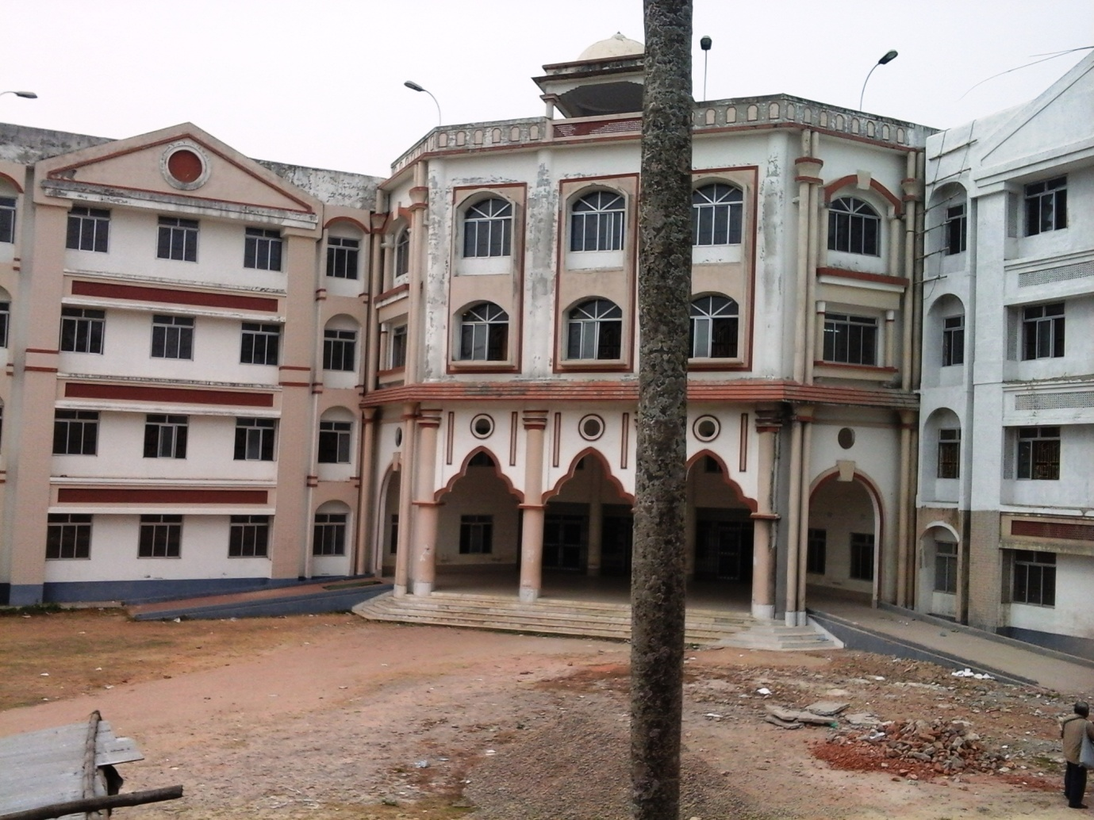

**Plate 1. Academic building of Bir Bikram Memorial College**

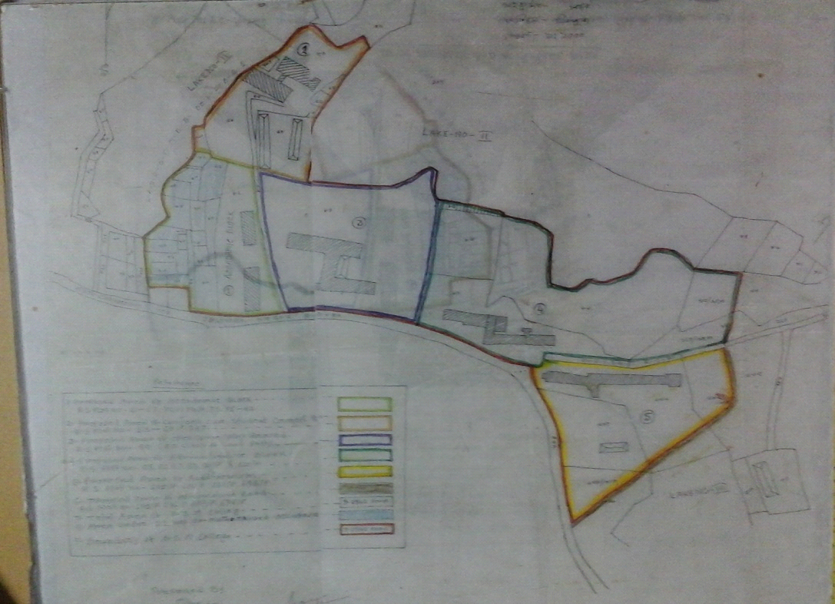

**Plate 2. Map of Bir Bikram Memorial College campus**

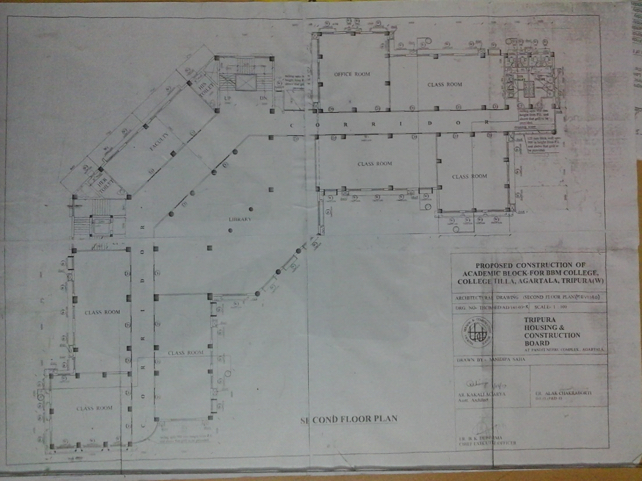

**Plate 3. Blue print of Academic building of Bir Bikram Memorial College with area**

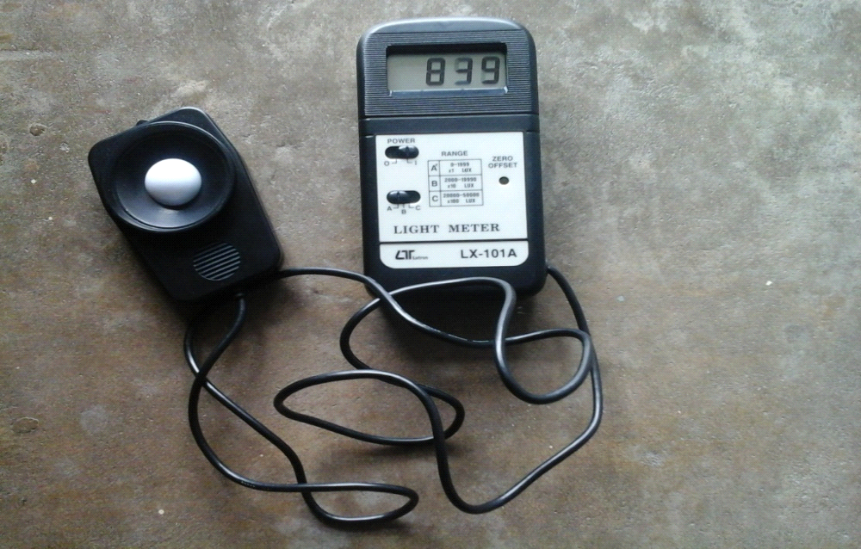

**Plate 4 . Lux meter (Lux Meter LX-101A)used for light intensity study of Bir Bikram Memorial College buildings**