SOIL EVALUATION AND CONSERVATION IN IoT
I.Lakshmi
Department of Computer Science Engineering, Hindustan Institute of Technology & Science (Hits) ilakshmi@hindustanuniv.ac.in Mobile:9677051822
Abstract
The present IoT (Internet of Things) initiative aims to streamline agricultural processes for farmers by implementing an efficient monitoring system for their fields. This system provides relevant information pertaining to the specific crop and corresponding traits that are most appropriate for growth and productivity. The present manuscript provides guidance to the user regarding the selection of plants for cultivation, contingent upon the characteristics of the soil. The existing framework for assessing soil for agricultural purposes is fraught with several noteworthy inadequacies. The utilization of cover crops for soil moisture management has been noted to have a significant impact on the proliferation of pests, insects, and diseases. Farmers who possess a limited level of expertise may be challenged to effectively navigate the intricacies of agricultural practices, potentially leading to the emergence of allelopathic impacts. The extant limitations in the proposed endeavor are being confronted through the ensuing strategies:
- The implementation of sheds for the regulation of soil moisture as a substitute for cover crops, with the capability to open and close in accordance with the requirements, is proposed.
- Presenting sensor data and results in an easily comprehensible format that is user-friendly.
- Problem Definition
  - Proposed System
The economic growth of a country is significantly reliant on the agricultural sector. The majority of individuals within a country such as India depend upon agricultural activities to sustain their economic well-being. The objective of this endeavor is to develop a Smart Agricultural System that empowers farmers to enhance their agricultural methodologies through the utilization of advanced technologies such as Internet of Things (IoT), Wireless Sensor Networks (WSNs), and Cloud computing. The potential advantages of the introduction of a shed and efficient horticultural measures in managing moisture levels during periods of absence extend to both agricultural producers and consumers.
  - Existing System
Sensors that quantify variables such as temperature, humidity, and moisture content. The utilization of data collection tools serves as a means of acquiring information regarding agricultural operations, enabling farmers to make critically informed decisions based on the insights and recommendations derived from the gathered data. Sensors perceive all physical stimuli and subsequently convert analog signals to digital data. The measurement of the temperature and relative humidity values within the field is facilitated through the deployment of specialized sensors that detect temperature and humidity levels, accordingly.
  - Motivation
The distinguishing factors between gardening and farming, with regards to their objectives of food production, pertain to their scales of operation and underlying aims. The agricultural sector employs large-scale farming practices, wherein the development of scalable commodities represents a crucial impetus. Gardening, at a smaller scale, primarily serves the purpose of providing individual recreation and sustenance to the gardener's own household or local community. There exists a significant degree of commonality between the aforementioned expressions, particularly with regards to certain agricultural endeavors of intermediate scale that are commonly referred to as market gardening. The concept of assessing and preserving soil quality with the aid of Internet of Things (IoT) technology is an achievable endeavor that can furnish individuals with timely alerts and reminders concerning watering their garden plants. The Internet of Things (IoT) has the capacity to facilitate the development of a personalized system that aligns with our specific requirements.
- Introduction
  - Internet Of Things
The ecosystem of the Internet of Things (IoT) comprises smart devices that are enabled for web usage by means of embedded systems, including processors, sensors, and communication equipment. These devices are capable of collecting, transmitting, and responding to data from their immediate environment. The acquisition and transmission of sensor data harnessed by IoT devices is facilitated by connecting to an IoT gateway or other such edge device. Subsequently, the gathered sensor data is either processed locally or relayed to the cloud for further analysis. These technological devices engage in occasional communication and utilize the exchanged data in carrying out their respective functions in conjunction with similar gadgets. While human operators may be involved in the initial setup, instruction-giving, or data retrieval related to devices, a significant portion of the task is accomplished autonomously by the gadgets themselves. The implementation of Internet of Things (IoT) technology within the agricultural sector has the potential to facilitate various farming practices and alleviate the workload of farmers. Sensors have the capability to acquire and collate pertinent data pertaining to the properties and characteristics of the soil, including moisture content, temperature, quantity of precipitation, and various other variables. Such information can potentially facilitate the automation of farming procedures.
  - Home Gardening
Selecting the optimal location, determining the appropriate garden dimensions, and selecting the suitable types and cultivars of vegetables constitute potential key elements in a robust domestic horticulture strategy. The art of fostering and tending to vegetation is commonly referred to as gardening, a specialized sector within the broader field of horticulture. Valuable botanical specimens, notably root crops, leafy greens, fruits, and herbs, are cultivated with the primary objective of providing nourishment, serving as pigment sources, or serving medicinal or aesthetic functions. On the contrary, ornamental plants are often cultivated for their aesthetic characteristics such as striking flowers, foliage, or overall visual appeal in horticultural settings. This initiative will provide significant advantages to gardeners as they will have the capacity to employ sensors to ascertain crucial factors such as temperature, humidity, and moisture levels. The method proposed by the present research endeavors to apprise agriculturalists or horticulturists regarding the optimal time to irrigate their crops.
- Hardware Requirements
The Things that are used in our Project are:
  - Arduino Uno R3
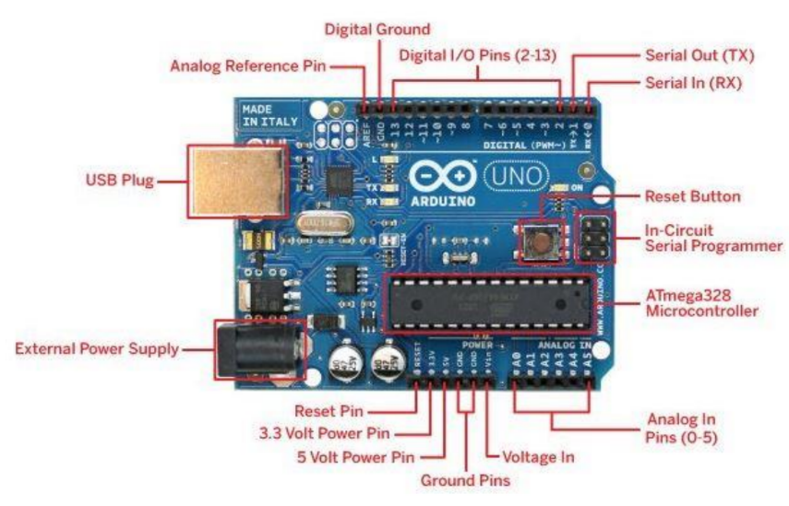
FIGURE 1: BLOCK DIAGRAM OF UNO R3
1. USB Power
The Arduino board may be powered by your computer's USB cord. Simply attaching the USB cable to the USB connection is all that is required.
2. Power (Barrel Jack)
By connecting an Arduino board to the Barrel Jack, you may power it straight from the AC mains power source.
3. Voltage Regulator
The voltage regulator's job is to steady the DC voltages utilized by the CPU and other components while regulating the voltage supplied to the Arduino board.
4. Crystal Oscillator
The crystal oscillator assists Arduino in resolving time-related problems. 16.000H9H is the number etched on the crystal of the Arduino board. It informs us that the frequency is 16 MHz, or 16,000,000 Hertz.
5.17. Arduino Reset
You may restart your application from scratch by resetting your Arduino board. There are two methods to restart the UNO board. the reset button (17) on the board, first. The second option is to attach an external reset button to the RESET Arduino pin (5).
6.7.8.9. Pins (3.3, 5, GND, Vin)
- 3.3V: Provide 3.3 output volts.
- Supply 5 output volts at (7) volts.
- The majority of the Arduino board's components operate without issue at 3.3 and 5 volts.
- GND (8) (Ground) – The Arduino has a number of GND pins that may be utilized to ground your circuit.
- Vin (9) — The Arduino board may also be powered from an external power source, such as an AC mains power supply, via this pin. ten analog pins.
10. Analog pins
A0 through A5 are the six analog input pins of the Arduino UNO board. These pins can read the signal from an analog sensor, such as a temperature or humidity sensor, and turn it into a digital value that the computer can read.
11. Main microcontroller
Every Arduino board features a separate microcontroller. It is probably the thought process behind your board. Each Arduino board has a slightly different main IC (integrated circuit). The ATMEL Company typically manufactures microcontrollers. Before loading up a new program from the Arduino IDE, you must be aware of what IC your board has. The top of the IC has access to this information. Consult the datasheet for further information regarding the IC's design and operations.
12. ICSP pin
ICSP (12) primarily consists of an AVR programming header for the Arduino that includes MOSI, MISO, SCK, RESET, VCC, and GND. SPI (Serial Peripheral Interface) is a term that is frequently used to describe what may be thought of as an "extension" of the output. Actually, what you are doing is slaving the output device to the SPI bus's master.
13. Power LED indicator
When you link your Arduino into a power source, this LED should light up to show that your board is powered up properly. There is a problem with the connection if this light does not illuminate.
14. TX and RX LEDs
You have two labels on your board: TX (transmit) and RX (receive). On the Arduino UNO board, they may be found in two locations. First, identify the pins used for serial connection at the digital pins 0 and 1. Two, the TX and RX took the lead (13). As the serial data is sent, the TX led flashes at various rates. The baud rate that the board is using determines how quickly things flash. During the receiving process, RX flashes.
15. Digital I/O
There are 15 total digital I/O pins on the Arduino UNO board, of which 6 are used to produce PWM (Pulse Width Modulation). These pins may be set up to function as digital output pins to control various modules like LEDs, relays, etc. or as digital input pins to read logic values (0 or 1). PWM may be produced by using the "" pins.
16. AREF
Analog Reference is the abbreviation for 16. It is occasionally used to establish an external reference voltage as the maximum value for the analog input pins, which is typically between 0 and 5 volts.
  - Soil Moisture Sensor
The quantification of water within the soil is accomplished through employment of soil moisture sensors for assessment of the volumetric water content. Soil moisture sensors gauge the volumetric water content indirectly through the utilization of additional characteristics of the soil, such as electrical resistance, dielectric constant, or interaction with neutrons, as a surrogate for establishing the moisture content. The direct gravimetric assessment of the unconstrained earth's moisture necessitates extracting a specimen, desiccating it, and gauging its weight.
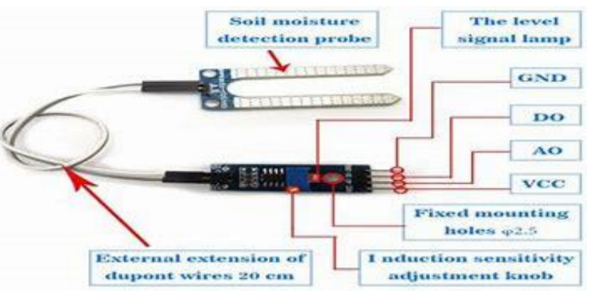
FIGURE 2: Soil Moisture Sensor
  - DHT22 - Temperature And Humidity Sensor
Various designs for soil temperature sensors incorporating thermistors, thermocouple wires, and averaging thermocouples are readily accessible. Various units of measurement, such as degrees Celsius (°C), degrees Fahrenheit (°F), and degrees Kelvin (°K), can be converted from electrical signals dispatched from the sensors to our data recording devices. Humidity sensors operate by measuring the degree of relative humidity in the immediate vicinity of their placement. The measurement of both the moisture content and temperature in the air is determined as a ratio of the quantity of moisture present in the air relative to the maximum quantity that can be retained at the current temperature. This percentage serves as a means of assessing the extent of moisture present within the atmosphere.
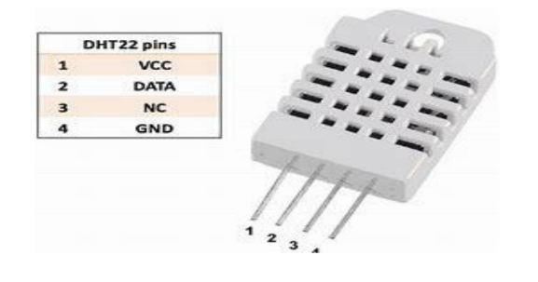
FIGURE 3: Temperature and Humidity Sensor

  - Bread Board
A breadboard serves as a fundamental platform for constructing electronic prototypes. The solderless breadboard, which is reusable in nature, does not require any soldering for its effective operation. The aforementioned characteristic confers simplicity in the deployment of the component for the purpose of generating provisional prototypes, as well as facilitating the conduction of experimental assessments pertaining to circuitry design. The endeavor to repurpose a stripboard, such as Veroboard, or any other form of a prototyping printed circuit board intended for the creation of singular or partially permanent soldered models, presents complexities. The utilization of breadboards extends to the prototyping of a diverse array of electronic systems, ranging from minute analog and digital circuits to encompassing central processing units (CPUs).
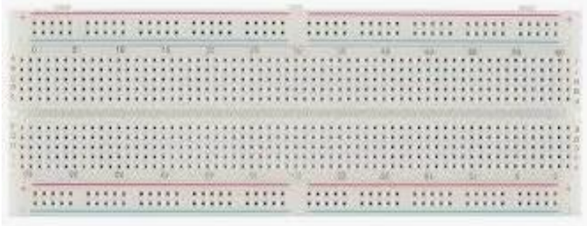
FIGURE 4: Breadboard

  - Servo Motor
The manipulation of angular or linear position, velocity, and acceleration can be accurately managed through the utilization of a servomotor. This component functions as either a rotary actuator or a linear actuator. This assemblage entails a suitable motor that is integrated with a position feedback sensor. Furthermore, it is imperative to note that the operation of servomotors requires a notably intricate controller, commonly a dedicated module specifically designed for this purpose. A servo motor is a feedback-controlled servomechanism that governs its movement and ultimate positioning through position feedback. The input to the control of the output shaft is indicated by a signal, which may take the form of either analog or digital, reflecting the command position. In order to provide position and velocity feedback, the motor is connected to a particular type of encoder. In the context of the most elementary scenario, the measurement pertains solely to the geographical coordinates of a given location. In the present study, the ascertained output position is assessed in relation to the designated command position, which corresponds to the controller's external input. An error signal is generated in cases where there is a discrepancy between the desired and actual output position, following which the motor will rotate in the required direction to enable the output shaft to achieve the intended location. "The reduction in the error signal towards zero as the locations converge results in the automatic termination of the motor's operation."
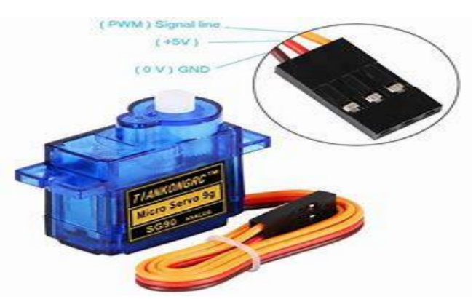
FIGURE 5: Serve Motor

  - Connecting Wires
The Universal Serial Bus (USB) is a prevailing industry standard that prescribes specific norms for cables, connectors, and power supply protocols, primarily intended for compatibility and use with computers, peripheral devices, and other computing systems. An assemblage of electrical wires, potentially consolidated within a cable, that feature a connector or pin located at either extremity is conventionally known as a jump wire. Other aliases for this electrical construct include jumper wire, jumper, or jumper. Its primary function entails the interconnection of components within a breadboard or other testing apparatus, either internally or with external apparatus/elements, without the need for soldering. Various tools and apparatus including a breadboard, header connector of a circuit board, and a piece of test equipment can all serve as means to fabricate apertures or grooves for accommodating the "end connectors" utilized for retaining individual jump wires.
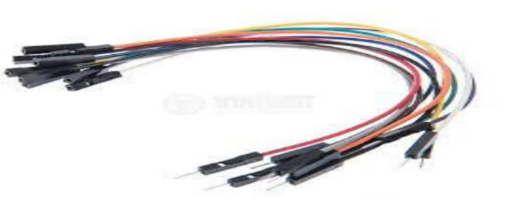
FIGURE 6: Connecting lines

  - USB Cable
USB Cable is used to connect an Arduino microcontroller to a PC or Mac.
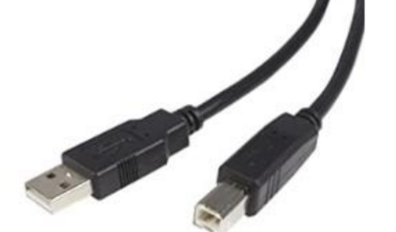
FIGURE 7: USB Cables

  - ARDUINO IDE
The Arduino, an open-source electronics platform, consists of a straightforward integration of both hardware and software components. The reception and conversion of various inputs, such as the activation of a sensor light, the pressing of a button, or the submission of a tweet, represent a range of examples that an Arduino board could accommodate with the subsequent generation of relevant outputs, such as motor activation, LED illumination, or online content posting. Transmitting a prescribed sequence of directives to the microcontroller affixed to the board shall provide guidance to the board, outlining the course of action to be undertaken. The prescribed mode to accomplish this feat involves operating the Arduino Software (IDE), which is constructed on Processing, and the Wiring-based Arduino Programming Language.
FIGURE 8: Arduino IDE
  - VISUAL STUDIO IDE
The Arduino platform, which is an open-source entity, is constructed using uncomplicated hardware and software. The receipt of various inputs, such as the illumination of a sensor, activation of a button through tactile feedback, or the dissemination of a tweet, may be processed by an Arduino board, resulting in a consequent output, such as the initiation of a motor, the illumination of an LED, or the transmission of data online. Transmission of a predefined set of instructions to the microcontroller within the board shall prompt the latter to execute a designated course of action. The attainment of this objective can be accomplished through the utilization of the Arduino Software (IDE), founded on Processing, and the Wiring-based Arduino Programming language.
FIGURE 9: Visual studio IDE

- PROGRAM FLOW
  - Algorithms
    - Algorithm – For Gardening
Step 1: Start
Step 2: Reads the Current Moisture, temperature, And Humidity Through Sensors
Step 3: Send Data from Arduino to Visual Studio Ide
Step 4: Display the Received Data in Visual Studio Ide
Step 5: Displays the Crop Suitable Depending on Current Parameters
Step 6: End
    - Algorithm – For Farming
Step 1: Start
Step 2: Select Crop to Be Grown
Step 3: Reads the Current Moisture, temperature, And Humidity Through Sensors
Step 4: Send Data from Arduino to Visual Studio Ide
Step 5: Display the Received Data in Visual Studio Ide
Step 6: Compare the Current Values with Ideal Values
Step 7: Display Low, High, Or Perfect
Step 8: Delay To 4 Seconds
Step 9: Repeat Step 3,4,5,6 & 7 Until It Says Perfect
Step 10: End
  - Flowcharts
    - Flowchart – For Gardening
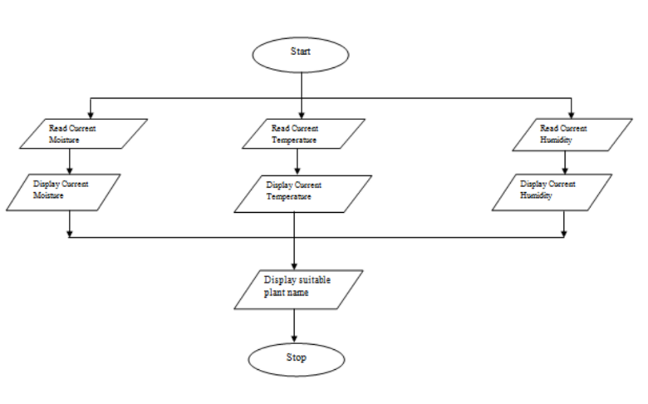
FIGURE 9: Flowchart for gardening
    - Flowchart – For Farming
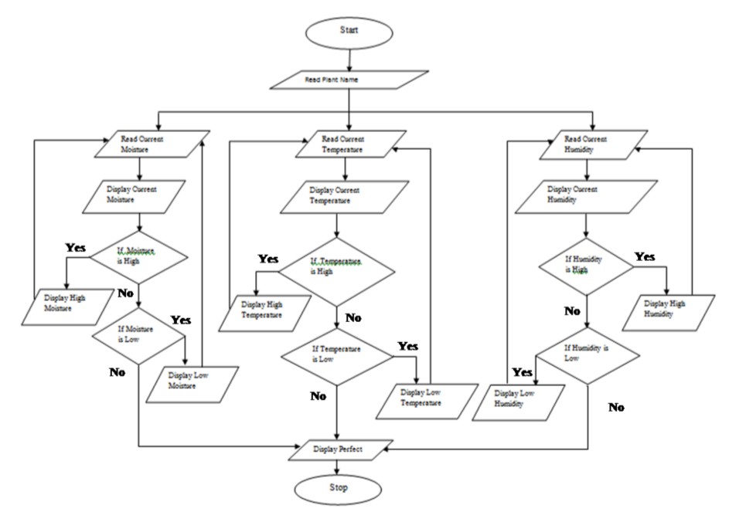
FIGURE 10: Flowchart for farming
  - Circuit Diagrams
    - Circuit Diagram – For Gardening
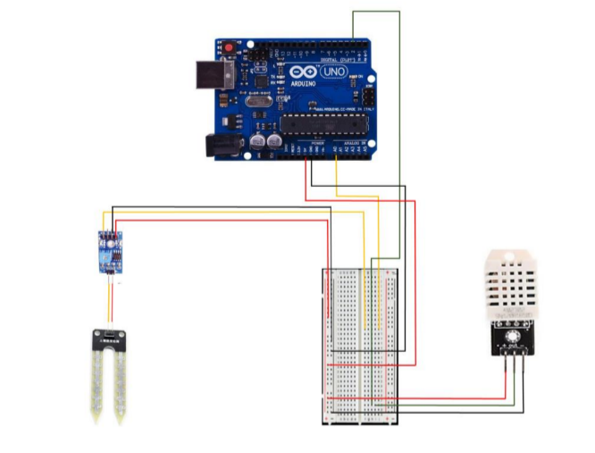
FIGURE 11: Circuit Of Gardening
    - CIRCUIT DIAGRAM – FOR FARMING
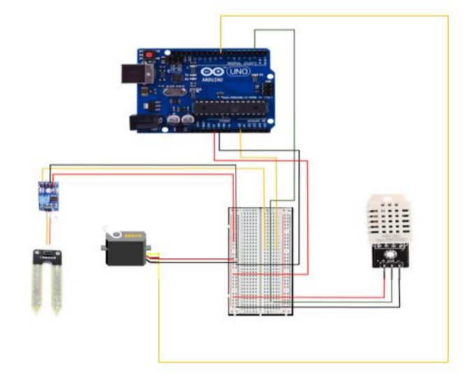
FIGURE 12 Circuit Of Farming
- Output
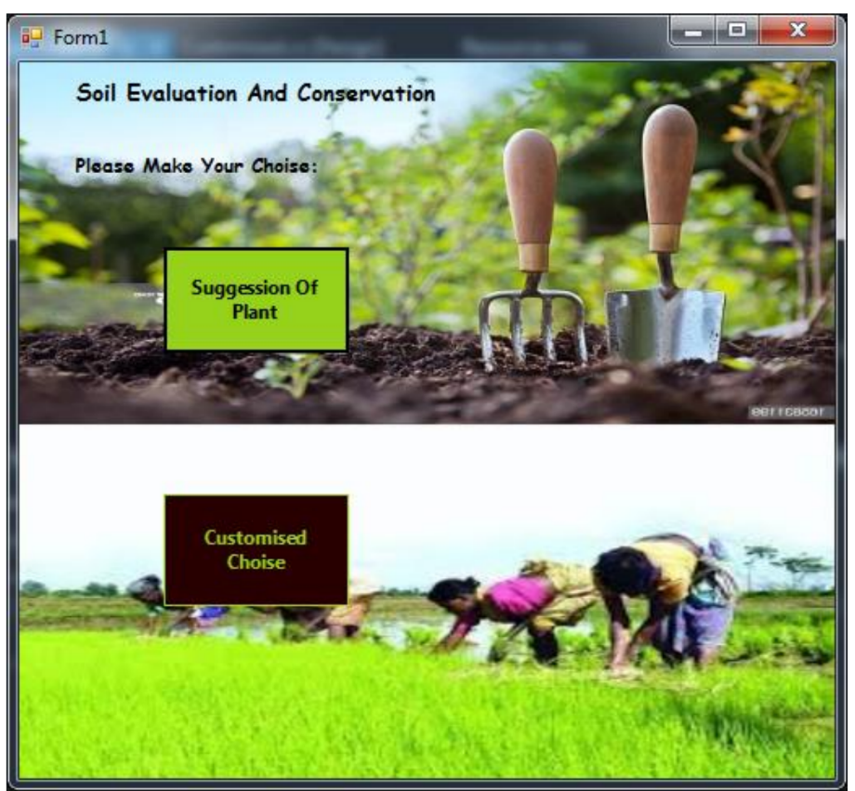
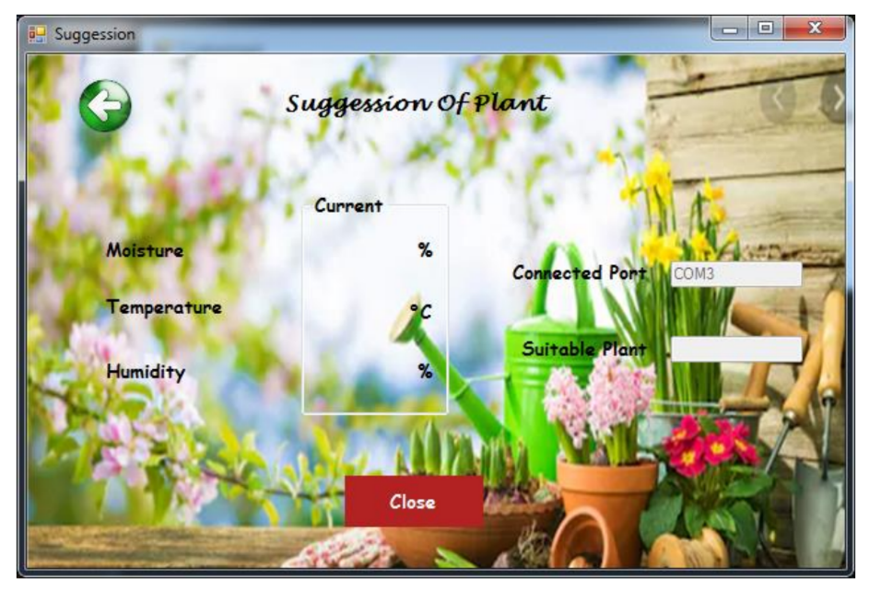
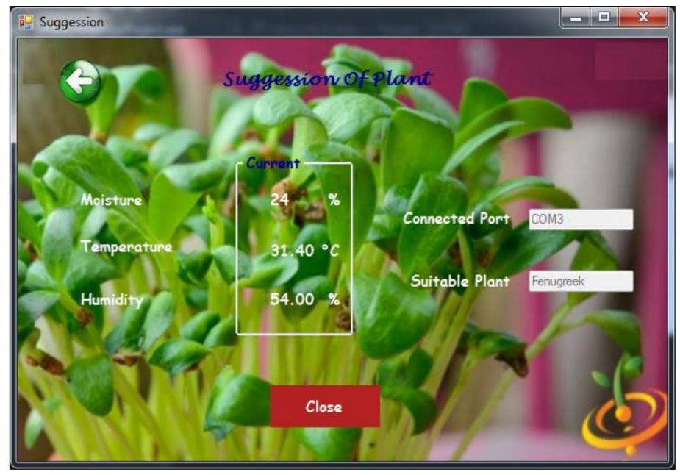
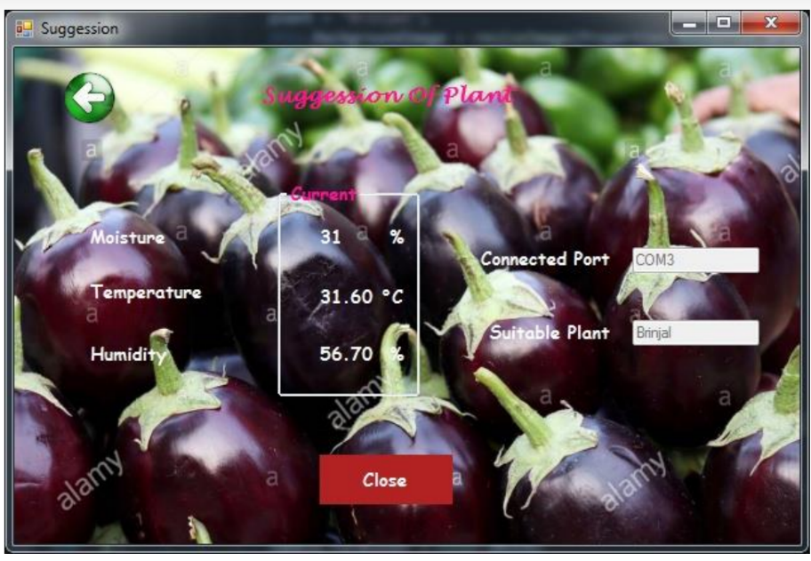
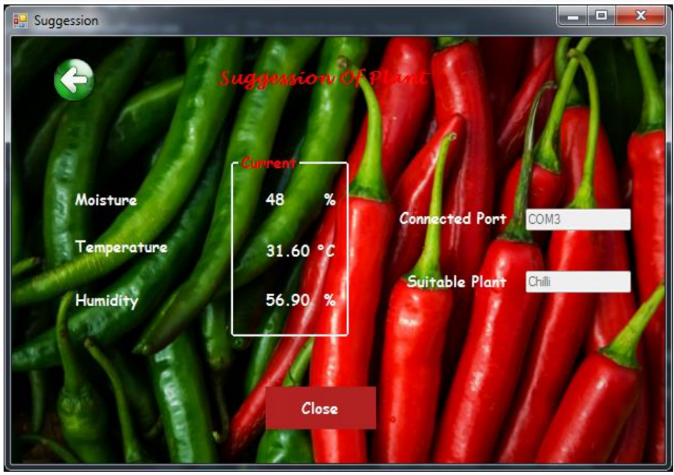
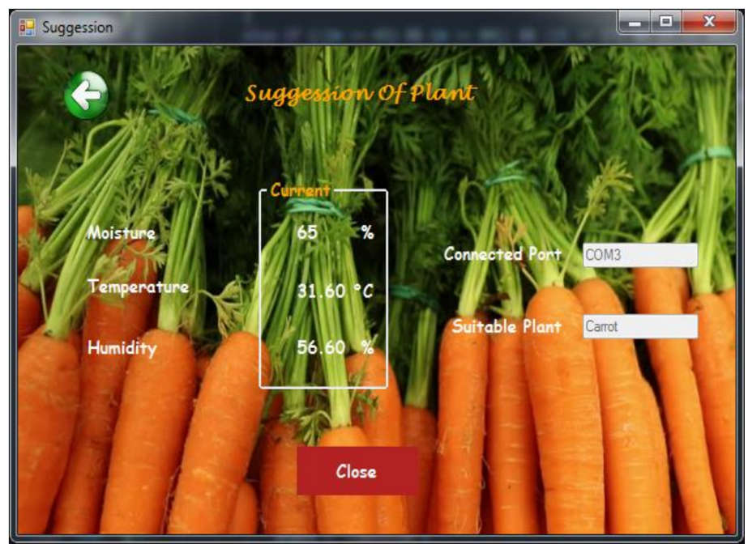
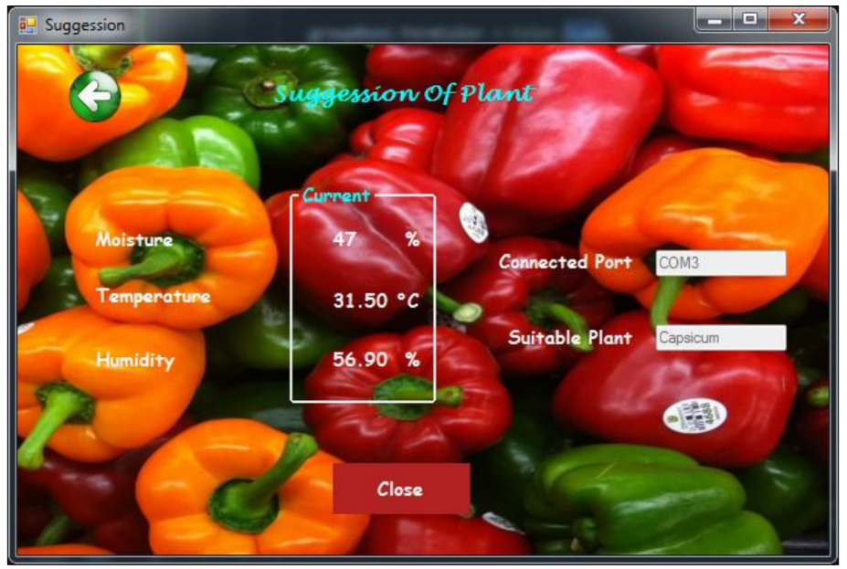
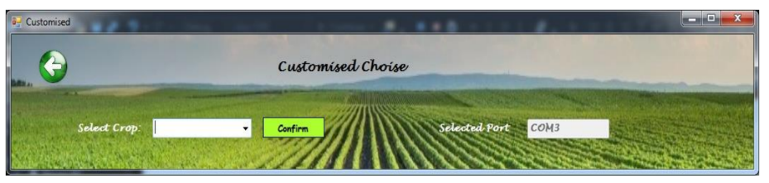
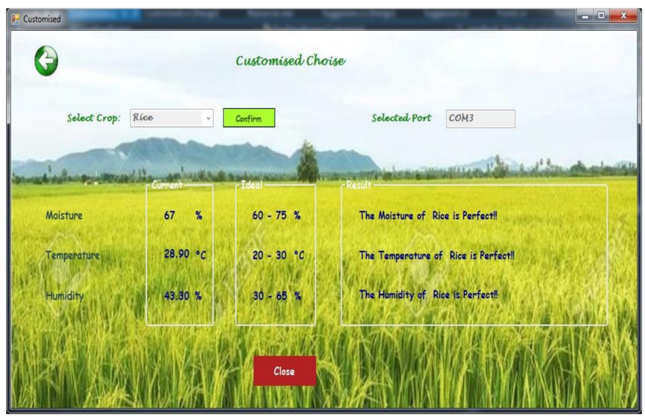
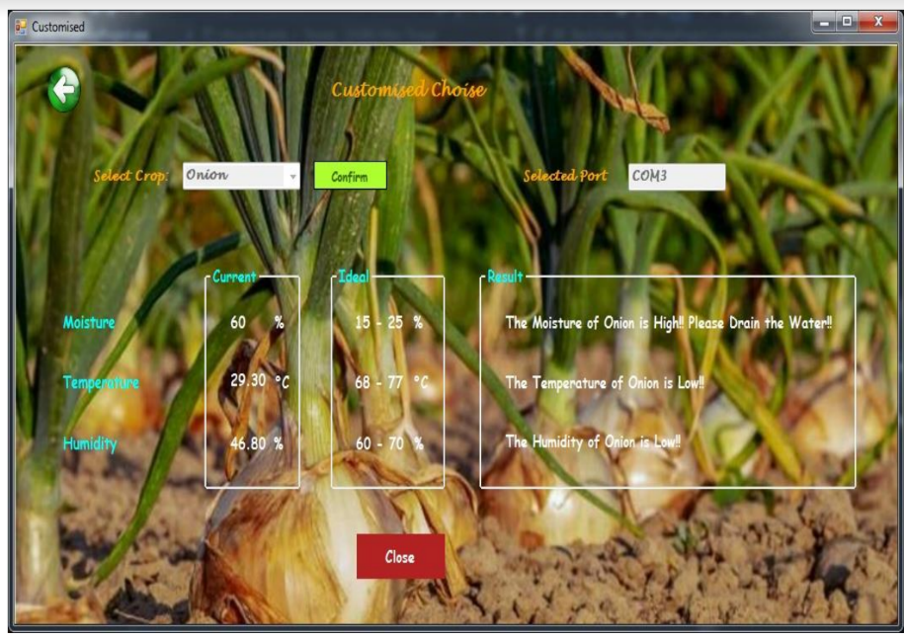
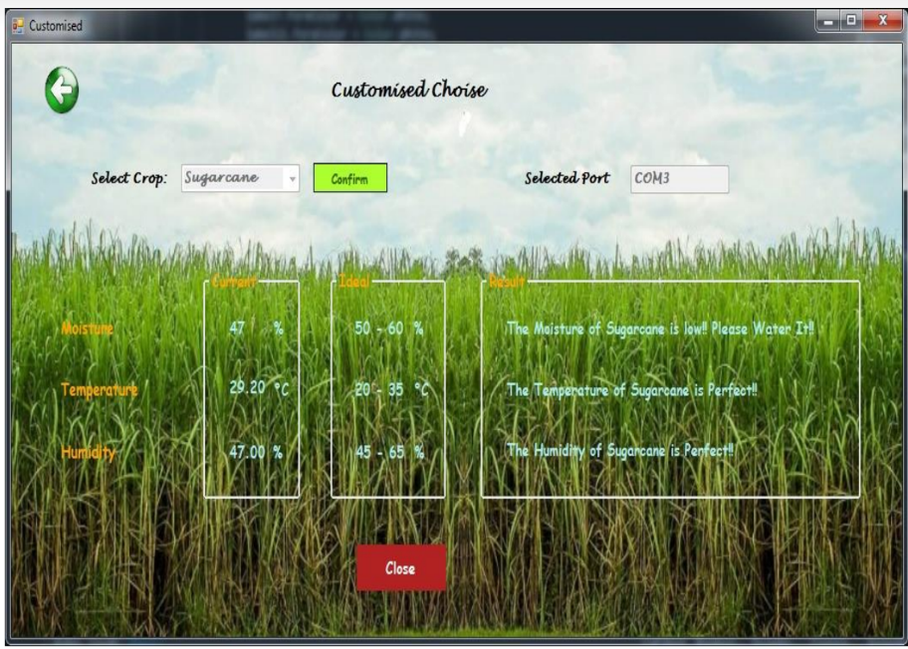
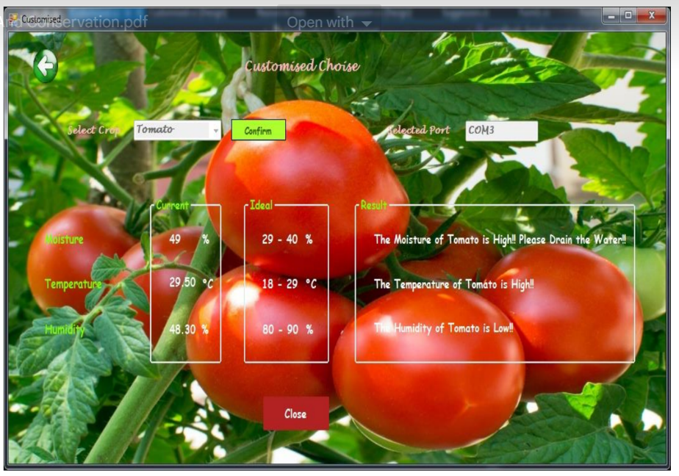
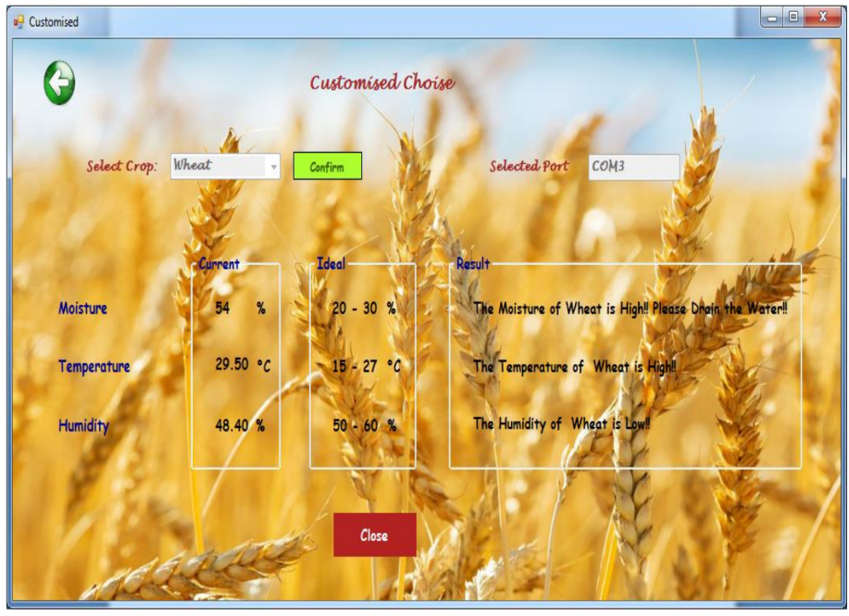
- Working And Implementation
This study revolves around the Internet of Things (IoT) framework, wherein the principal components employed encompass the Arduino UNO R3 development board, Moisture sensor, DHT 22 sensor, and servo motor. The Arduino board comprises microcontroller units and input/output pins that facilitate interconnections with other components within the operational system. The code embedded within the Arduino board's system dictates the operational control of the system's processes.
The present study aimed to investigate the objectives and outcomes of the project.
The analog output pin of the moisture sensor is interfaced with the A0 pin on the Arduino microcontroller board.
The DHT22 sensor's output pin is linked to a pair of connections on the Arduino microcontroller board.
The output pin of the servo motor is linked to eight pins on the Arduino microcontroller.
All constituent parts are interconnected to both the ground and respective 5-volt power sources. When the values detected by the moisture sensor and DHT22 sensor reach a certain threshold, the servo motor is triggered to initiate the movement of the shed in either an opening or closing direction. The shed is operated based on the moisture level of the surrounding soil. In instances where the moisture level is low, the shed is opened. Conversely, when the moisture level is found to be optimal, the shed is closed. Lastly, if the moisture level is high, the shed is closed to prohibit water from entering the soil. This allows the farmer to effectively drain excess water from their land. The aforementioned structure is designed in such a way that its constituting material enables the penetration of sunlight and provides the essential light requirements for the well-being of the cultivated crops. The utilization of a breadboard is deemed essential for circuit extension, while the integration of connecting wires serves the purpose of linking the respective components.
- Conclusion And Future Enhancement
The present work constitutes a straightforward and practical undertaking developed through the implementation of the Arduino platform. This project, referred to as The Shed, aims to facilitate the preservation of moisture, thereby promoting water conservation. The aforementioned action will serve as a prompt for the farmer to irrigate the crops, and in cases where an overabundance of water is detected, it will additionally notify the farmer to effect drainage measures. The proposed undertaking is a modest undertaking that has the potential to be scaled up significantly through the integration of a multitude of sensors in the field, an automated water pumping system facilitated by relay modules and a GSM (Global System for Mobile communication) module for wireless communication, and the utilization of Cloud Computing for database processing. By adopting this approach, it would serve as a catalyst to inspire the younger generation to engage in agricultural activities, even in the absence of any previous farming experience.
Reference
Harshada Navale, Prof. B.V.Pawar, Arm Based Gas Monitoring System. International Journal of Scientific & Technology Research Volume 3, Issue 6, June 2014.
Kumar Mandula, Ramu Parupalli, CH.A.S.Murty, E.Magesh, Rutul Lunagariya, Mobile-based home automation using Internet of Things(IoT). 2015 International Conference on Control, instrumentation, Communication and Computational Technologies (lCCICCT).
I. Lakshmi, A Survey of Smart Cities with future Internet of Things Published in IJFRCSCE Journal, Volume 4, Issue 2, February 2018.
I. Lakshmi, IoT Device for Smart Locker using GSM Based Technique published in the International Journal of Pure and Applied Mathematics in March 2018.
I. Lakshmi, M. Lokeshwari, S. Sarjanaa, Contingency Assertion and Tracking System for Night Drivers Utilizing IoT Predicated System International Conference on Computational Science & its Applications -ICCSA-2018 in March 2018.
Luay Fraiwan, Khaldon Lweesy, Aya Bani-Salma, Nour Mani, A Wireless Home Safety Gas Leakage Detection System. Biomedical Engineering (MECBME), 2011 1st Middle East Conference on 21-24 Feb. 2011.

