ADVANCED BIOPROCESSING METHODS: ENHANCING PRODUCTION, PROCESSING, AND ISOLATION OF MICROBIAL PRODUCTS

Kiran Bala
Department of Zoology
Deshbandhu College,
University of Delhi-110019, India.
Email : kbala@db.du.ac.in

Sakshi Verma
Central University of Haryana,
SH 17, Jaat, Haryana 123031, India.
Email : sakshiverma94310@gmail.com

Arushi Dogra
Faculty of Life Sciences and Biotechnology
South Asian University, Delhi-110068, India.
Email : dograarushi2001@gmail.com

Raj Kumar
S.N. Sinha College Tekari,
Gaya Magadh University, Bihar-824236, India.
Email : raj12140in@gmail.com

Anjana Singh
Department of Botany, Deshbandhu College,
University of Delhi, Delhi-110019, India.
Email : asingh12@db.du.ac.in

Pushp Lata
Department of Zoology,
University of Delhi, Delhi -110 007, India.
Email : plata@zoology.du.ac.in

ABSTRACT

The bioprocess technique involves creating useful products using whole microorganisms, living cells, or components of living organisms through a series of processes such as upstream, fermentation, and downstream processing. This technique improves the connection between biological systems and scientific and industrial fields.
Bioprocessing techniques play a significant role in modern biotechnology, revolutionizing industries such as pharmaceuticals, food production, and biofuels. This chapter explores the fundamentals of bioprocessing, delving into microbial fermentation, cell culture techniques, downstream processing, recent advancements, and real-world case studies. Readers will gain insights into the multifaceted world of bioprocessing.

I. INTRODUCTION

Bioprocessing techniques have become the cornerstone of numerous industries, offering innovative solutions to produce valuable products and materials. This technology involves the utilization of microorganisms, cultured cells, or еnzymеs to create a wide range of products.
The entire process of bioprocessing is divided into three stages [1]:
- Upstream Processing
- Fermenter bioprocessing
- Downstream Processing

A. Upstream Processing:
  - Inoculation: Introduction of the selected biological sources (such as cells or microorganisms) into a culture medium or bioreactor to start production. [2]
  - Cultivation: Optimization of growth situations, inclusive of temperature, pH, oxygen stages, and nutrient supply, to create a controlled atmosphere for the growth and development of organic producers.

B. Fermenter Operations:
  - Fermentation: In the process of fermentation, biological organisms take part in certain metabolic activities that transform raw materials into the desired product, which may be proteins, enzymes, prescription medications, biofuels, or other valuable molecules. [3]
  - Harvesting: After fermentation, the product is recovered by collecting the culture broth or mobile suspension. This step frequently uses separation techniques including centrifugation, filtration, and sedimentation. [30]

C. Downstream Processing:
  - Purification: cleaning up the acquired product to get rid of pollutants and impurities. To refine the product, processes including chromatography, ultrafiltration, and infiltration are used.
  - Concentration: The concentration of the cleansed product increases its potency and reduces volume, improving its suitability for the intended technique and application. [4]
  - Formulation: In some cases, the essential excipients and appropriate stability are incorporated before the purified product is made into its final dosage form, which may include pills, vaccinations, or injectable solutions.
  - Quality Control: the use of precise, pleasant manipulation techniques to demonstrate and confirm the quality of the product, health and welfare, and integrity throughout the manufacturing process.
  - Scale-Up: scaling up production from laboratory to utility study while preserving the quality and performance of the product. [5]
  - Waste Management: Constant focus on sustainability and proper waste management to lessen the impact of bioprocessing on the environment.

Bioprocess technique is a roadmap towards the sustainable efficient and environmentally friendly methods for the production of a large range of useful biproducts, contributing to the modernization and advancement of various industries and also minimize the devastation in environment.
This chapter aims to convey the fundamental principles involved in the bioprocess technique the practical application of this technique in industries kind of fermenter involved in this technique. This chapter explores that how the type of microorganism is harvested to get a useful product sustainably. This chapter revolves around the main processes, challenges and advantages of bioprocessing, it also highlights about the role of bioprocessing in pharmaceuticals, and environmental management.

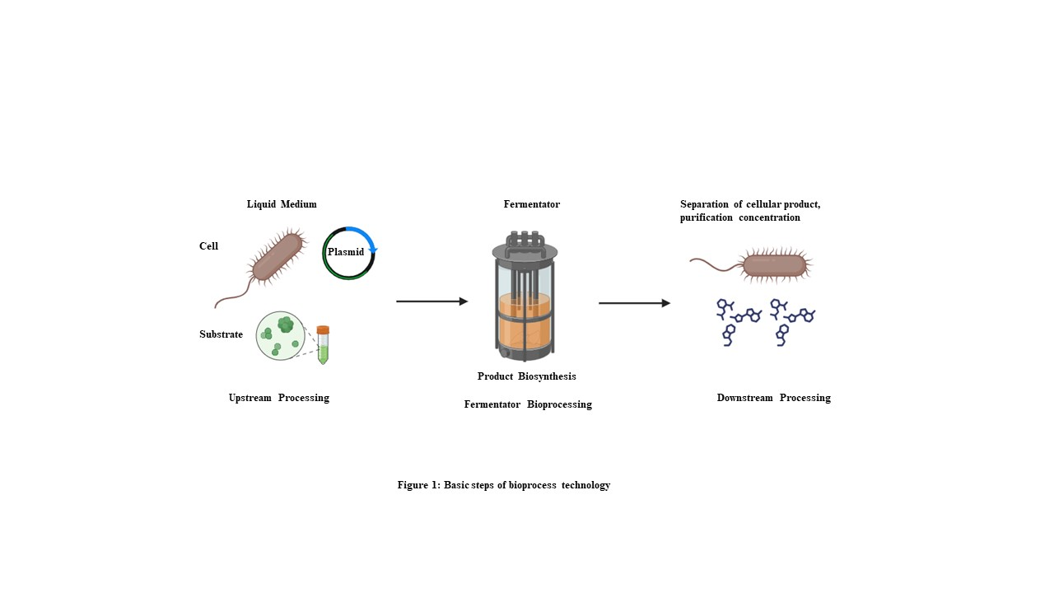

- HISTORY, PURPOSES AND OBJECTIVES OF BIOPROCESS

A. Historical Concept and Milestones in the development of bioprocessing techniques.
These processes have been used by humans since ancient times for activities like bread making, chееsе production, and fermenting alcoholic beverages. [6] The history of bioprocessing is a story of happy incidents and scientific innovation. As we move into more recent periods, we start to realize that the history of bioprocessing is shaped by the contributions of a small number of gifted and diligent scientists who achieved significant advancements in our knowledge of the medical uses for this bioprocess. [7] Alcoholic beverages are the earliest example of a bioprocess technology it was a combination of yeast cells with nutrients (cereal grains) to create a fermentation system. [8] During this process, the organisms consumed the nutrients for their growth and produced by products (alcohol and carbon dioxide gas) that assisted in the creation of the beverage. The 19th century can be seen as the beginning of modern biotechnology. [9] With the advancements in recombinant DNA technology, we now can produce a vast array of protein-based therapeutics, significantly improving the quality of life for seriously ill patients. Furthermore, bioprocessing plays an effective role in various emerging industries and technologies, including the production of sustainable biofuels like ethanol and biodiesel, therapeutic applications involving stem cells, gene therapy vectors, and novel vaccine development.

The given table compiles most of the breaking points in the bioprocessing technique:

Table 1: Major breaking point in bioprocess technique in Chronological order

S No. | Chronological order of product development | Developed product (Major contribution)
1. | 6000BC | Used in brewing mostly in Sumerian and Babylonia
2. | 2400BC | Barley’s malting and Beer’s fermentation was used in Egypt
3. | 1680 | Anton von Leeuwenhoek discovered yeast under the microscope
4. | 1835 | Alcoholic fermentation associated with yeast
5. | 1857 | Louis Pasteur proved yeast is a living cell that ferments sugar into alcohol
6. | 1877 | Pasteur showed that some bacteria can kill anthrax bacilli
7. | 1923 | Production of Citric acid in industries, Banting and Best proved that insulin from animals could be used to treat people suffering from diabetes
8. | 1928 | Alexander Fleming discovered Penicillium notatum which inhibits Staphylococcus bacteria
9. | 1930 | Production of amino acids in industries
10. | 1939s | Production of Antibiotics (P. notatum) in industries suggested by Florey and Chain
11. | 1979 | Production of monoclonal antibodies from hybridoma cells.
12. | 1982 | Industrialization of Human insulin production in E. coli by Eli Lily company
13. | 1984 | first, therapeutic Mab (Anti CD3) manufactured for the market.
14. | 1994 | Production of Hepatitis B vaccine for the market
15. | 1996 | Yeast genome project completed (Cerevisiae)
16. | 2002 | On an industrial scale, disposable bioreactors are used
17. | 2007 | The bioprocess product market jumped off

B. Purposes of Bioprocess Techniques
- For the manufacturing of proteins and antibiotics, there is no effective alternative. Additionally, it is thought that bioconversion can produce a high yield or high production and that microorganisms are capable of carrying out a variety of sequential processes.

C. Objectives of Bioprocess Techniques
- Be familiar with the foundational concepts of microbial kinetics, metabolism tests, and energetics.
- Gain a comprehensive understanding of the design and operation of fermentation processes while learning the principles of bioreactor engineering.
- Gain knowledge of integrated biochemical processes to synthesize and purify biological products.

III. STEPS AND PREREQUISITE FOR BIOPROCESSING

A. Upstream Bioprocessing
The step upstream bioprocessing is the first step towards the bioprocess technique. Success requires a solid awareness of the fundamental process ideas and the underlying biological events. This step involves the genetically altered microorganisms (such as bacteria or yeast) or maybe mammalian cells in a bioreactor to obtain desired results or products such as medicinal proteins, enzymes, or vaccines. Developing a high-yield upstream step is quite complex and challenging and involves several steps each with specific requirements and considerations. The most challenging characteristic of the upstream bioprocess step is that it involves the use of living microorganisms which at times do not behave as predicted or as we want, [10] In the past few decades, a lot of progress and improvement has been made in the field of upstream bioprocessing which is possible because of the increase in understanding about cell culture which ultimately leads to the better preparation of cell culture media. Now let’s get through into the details about the steps of upstream bioprocessing:

1. Microorganism selection: The selection of microorganisms for upstream bioprocessing is a critical step as it determines the fulfilment of the bioprocess technique. Here, the choice of the organism depends upon the type of product we want to supply, specific requirements of bioprocess, and microorganism characteristics. [11] Here are some important facts when selecting microorganisms for upstream bioprocessing:

a) Microorganism Types:
- Bacteria: Bacterial cells are commonly used in the production of small molecules, enzymes, and a few biopharmaceuticals. They seem to be easy for genetic manipulation and can grow quickly.
- Yeast: Saccharomyces cerevisiae yeast cells are used in the production of proteins, vaccines, and biofuels. They are eukaryotic microorganisms that can undergo post-translational modifications.
- Mammalian Cells: Chinese hamster ovary (CHO) cells, are commonly used in the production of complex biopharmaceuticals such as monoclonal antibodies. They can perform complex post-translational modifications on proteins and integrate them into human-like systems. [12]
b) Compatibility of the product: The product's characteristics specify the microorganism used. For example, if we are creating a healing protein that requires glycosylation, mammalian cells are likely to be chosen due to their ability to perform this modification. [12]
c) Potential for Genetic Engineering: Genetic alteration is strongly required to enhance microorganisms for specific bioproduction processes. Some microorganisms, such as E. Coli, have well-defined genetic profiles and are simple to engineer.
d) Growth characteristics: Growth rate, biomass yield, and substrate consumption rates are all important factors to consider. For large-scale production, fast-growing microorganisms may be preferred.
e) Regulatory Approval: Regulatory agencies (for example, FDA and the EMA) have specific guidelines for the use of microorganisms in bio production. So, the chosen microorganism must meet regulatory requirements. [13]
f) Safety: Safety is one of the most prominent questions. Microorganisms must not endanger workers or the environment. Some microorganisms may also necessarily require containment measures.
g) Extensibility: The microorganism must be capable of scaling up the manufacturing process. This decision is influenced by factors such as the availability of large-scale fermentation equipment and price issues.
h) Stability and productivity: The reliability of the microorganism's genetic modifications and its productivity over long fermentation runs are essential factors.
i) Impact on the environment: When it comes to sustainable bioprocessing, it's important to consider waste generation, energy consumption, and resource utilization.

2. Media formulation: Media formulation in the context of upstream bioprocessing refers to the preparation of a growth medium that provides all the essential nutrients required for the cultivation of microorganisms (such as bacteria, yeast, or mammalian cells) in a bioreactor. [12] The right composition of the growth medium is essential for the successful growth and production of the desired product.

a) Components of Growth Media:
- Carbon Source: In some cases, when the product is obtained from the direct dissimilation of it the most often choice is the carbon source. The production of primary or secondary metabolites or the formation of biomass is recognized by the metabolization rate of the carbon source. [13] The most common carbon source for fermentation is carbohydrates and the widely available carbohydrate is starch which is obtained from maize and some other cereals. Malt is also used as the main substrate for beer brewing and in many countries, it is extracted from malted grains like barley. Sucrose obtained from sugar cane or beet is also used in fermentation media in a very impure form that is beet or cane molasses which is further used in the production of ethanol some microbial gums, and amino acids and may be used for high-value products that are antibiotics, vaccine, special enzyme and fine chemicals. [15] [14]
- Nitrogen Source: Nitrogen is important for protein synthesis and cellular growth. Most industries use this as their source. Ammonium salts, nitrates, or amino acids like ammonium sulphate or yeast extract can function as nitrogen resources. Some other proteinaceous sources of N₂ compound can serve as a source of amino acid i.e., soya meal, peanut meal, cotton-seed meal, and yeast extract. [15] [16]
- Salts: Inorganic salts carry valuable ions such as potassium, sodium, magnesium, and phosphate, which are required for cellular processes and maintaining osmotic balance. [16]
- Trace Elements: Trace elements like iron, copper, zinc, and manganese are required in small quantities as cofactors for enzymes and different cell functions.
- Vitamins: Some microorganisms require vitamins as additional nutrients. Biotin, riboflavin, and thiamine are common examples.
- Buffering Agents: pH manipulation is essential for cellular growth. To keep the pH stable during the fermentation process, buffers such as phosphate or bicarbonate are combined. [17]
- Antifoam Agents: It is added into the fermenter to prevent excessive foaming, which can disrupt the process and affect the oxygen switch.
- Inducers or Induction Agents: In some cases, specific inducers can be delivered to enhance the expression of genes required for the preferred product's yield.
b) Considerations in Media Formulation:
- Microorganism Specific requirements: Different microorganisms have different nutritional requirements. The media must be developed as it meets the needs of the chosen microorganism.
- Optimization: To achieve maximum cell growth and product yield, media are frequently optimized using the design of experiments (DoE). This may also include fixing nutrient levels, ratios, and other factors.
- Sterilization: To avoid contamination, all additives in the growing medium, as well as the bioreactor and associated system, should be sterilized. Sterilization may affect carbohydrate stability so it is advised to sterilize sugar separately. In recent advanced bioprocess technique to avoid subsequent contamination all the materials that are entering into the system is sterilized. The apparatus is designed and operated in a manner so that the risk of contamination is very low or even not at all. [15]
- Cost-Efficiency: Media components acknowledge the cost of substances as well as the economic viability of the bioprocess. [19]
- Regulatory Compliance: If the bioprocess is designed for the production of pharmaceuticals or other regulated products, the media formulation must strongly adhere to regulatory guidelines.
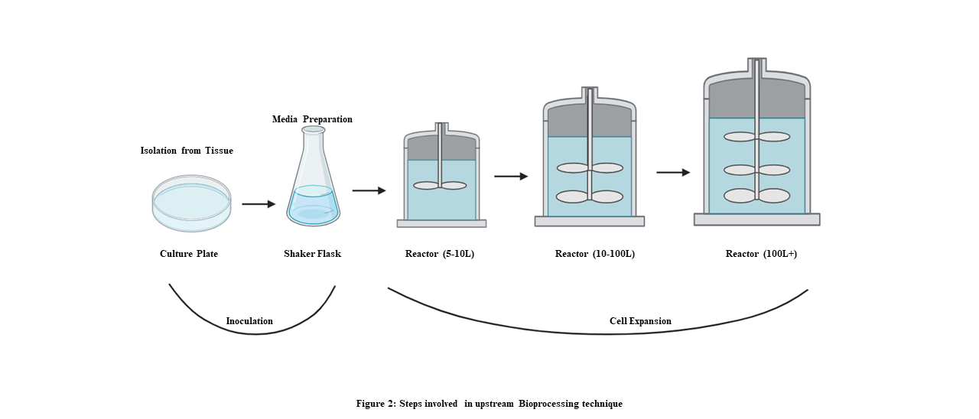

Figure 2: Steps involved in upstream Bioprocessing techniques

c) Calculation in media formulation:
- Mass balance: Mass balance is an important concept. It is a scientific technique that ensures the total mass of all components in a growth medium is calculated and balanced accurately. This procedure begins with identifying all of the components required in the growth medium, including carbon sources, nitrogen sources, salts, nutrients, trace elements, and other required additives. The desired concentration in the final medium is unique for each element, typically in grams per litres (g/L) or other applicable units. [20] Using these assigned concentrations and the total volume of the growth medium, the mass of each component required to acquire the desired concentrations is calculated. The overall mass of all additives is then verified to ensure that it matches the expected value.
In media formulation, a mass balance works as follows:
- Component Identification: The first step is to make a list of all the components that will be included in the growth medium. Carbon sources, nitrogen sources, salts, vitamins, trace elements, and any other additives required for the specific microorganism being cultured are typically included.
- Assigning Concentrations: For every component, you identify the desired concentration in the final growth medium. This concentration is typically expressed in grams per litre (g/L) or other appropriate units depending on the component. [21]
- Calculating Masses: Using the specified concentrations and the volume of the growth medium, we can calculate the mass of each component to achieve the desired concentrations. This is obtained by multiplying the concentration by the total volume. [20]
For example, if you want 10g/L of a certain salt in a 1-litre medium, you'd need 10 g of that salt.
- Verifying Total Mass: After calculating the mass of each component, we must ensure that the total mass of all components adds up correctly. This confirms that the medium was properly proposed.
- Adjustments if necessary: If the total mass does not meet the expected value, adjustments to the concentrations or quantities of individual components may be made until the mass balance is satisfied.

The key formula used for mass balance is
Mass In = Mass Out + Accumulation [22]
Mass in = Defines as the total mass of all those components which enter the system, in the form of raw material or ingredient.
Mass out = Defines as the total mass of all those components that leave the system, in the form of product waste or any losses.
Accumulation = The change in mass of components within the system like concentration due to chemical reactions or another process,
Here is an example of Mass balance in a chemical Reactor
Let’s suppose that we have a chemical reactor Where a specific compound named compound “S” is being produced. Now we need to calculate the accumulation of compound “S” in the reactor over a certain period.

Given:
The initial mass of compound “S” in the reactor = 100 gm.
Compound “S” is now continuously fed into the reactor at a rate of 10gm/m.
Compound “S” is being consumed in the reaction at a rate of 5gm/m.
The reactor operates for 20 minutes

Calculations:
Mass in = Rate of Inflow × Time [22]
(10g/min) × (20 min) = 200 grams
Mass out = Rate of Outflow × Time [22]
(5g/min) × (20min) = 100 grams
Accumulation = Mass out + Accumulation [22]
200 grams = 100 grams + Accumulation
Now, the accumulation of compound “S” in the reactor
Accumulation = Mass in – Mass Out
Accumulation = 200 grams – 100 grams = 100 grams
So, here over the 20 minutes, there was an accumulation of 100 g. of compound “S” in the reactor
- Molar Concentration: To convert mass-based concentration to molar concentration for precise nutrient control.
- Molar concentration, also known as molarity, is a measure of the concentration of a solute (substance being dissolved) in a solution. It is one of the most commonly used topics in chemistry, and it is especially important in bioprocessing media systems. Molar concentration is frequently used in the media method for bioprocessing to specify the concentration of specific additives within the growth medium, such as vitamins (e.g., glucose) or salts. For example, if you need to prepare a growth medium with a molar concentration of 0.1 M for glucose, you would dissolve 0.1 moles of glucose in each litre of medium.

The key formula used in the calculation of the molar concentration is
Molarity = Moles of Solute/litres of Solution [23]
Were,
Molarity (M): For molar concentration it is used as a unit of measurement. Expressed as mol/L (moles per Liter)
Moles of solute: It is used to represent the quantity of the solute, and measured in mol. A mole is a unit of measurement that is equal to 6.022 x 10^23 and this is also known as Avogadro number.
Liters of Solution: The volume of solution in which the solute is dissolved, measured in L(litres).

Here is an example of Calculating the Molarity of Glucose (C6H12O6) in a growth media.
Given is,
Mass of glucose used = 18g.
The molar mass of C6H12O6 (glucose) is = 180.16g/mol
The volume of growth medium = 1L.

Calculations:
- Calculate the number of moles of glucose:
Moles of glucose = Mass (g) / Mol. Weight (g/mol.) [23]
Moles of glucose = 18g/180.16g/mol ≈ 0.1 moles

- Calculate the molar concentration (molarity):
Molarity = Moles of solute / Liters of solution [23]
Molarity of glucose = 0.1moles/1L = 0.1 M
So, here in the given example, a growth medium with a molar concentration of 0.1M for glucose is prepared. This suggests that there are 0.1 moles of glucose dissolved in every litre of the medium.

- Dilution Calculation: Calculate the volumes and concentrations required for dilution if stock solutions are used to achieve the final medium composition. Dilution calculations in media formulation include calculating the amount of a stock solution required to prepare a desired volume and concentration of a final solution. This method is used when we have a concentrated solution or stock solution that needs to be diluted to a specific concentration for a specific application, such as preparing a growth medium in bioprocessing.

The key formula for dilution calculation is:
C1V1 = C2V2 [23] [24]
Where:
C1 = Initial concentration of the stock solution
V1 = volume of stock solution to be used
C2 = final concentration (desired)
V2 = desired final volume of the diluted solution

Here are two common applications of dilution calculations in media formulation:
- Preparing a Growth Medium by Diluting a Stock Solution: Assume you have a known concentration (C1) of a concentrated glucose solution (inventory solution) and you need to prepare a 1-liter growth medium with a lower glucose Concentration (C2). [23] The dilution calculation formula can be used to calculate the volume of stock solution (V1) required to achieve the desired concentration.
- Serial Dilutions: In some cases, you might need to create a series of diluted solutions with decreasing concentrations from a single stock solution. The dilution method can be used at each step to calculate the volume of the stock solution required for each dilution in a serial dilution.

Given here is an example of Diluting a glucose stock solution for a growth media
Given,
Glucose stock solution concentration (C1) = 1.0 M (1mole/Liter)
Desired glucose concentration in growth media (C2) = 0.1 M
The desired final volume of the growth medium (V2) = 1L.

Calculations:
We need to use the dilution formula i.e., C1V1=C2V2
Put the known values,
C1= 1.0 M
C2 = 0.1 M
V2 = 1L
Solve for V1
V1 = (C2 x V2) / C1
V1 = (0.1M x 1L) / (1.0M)
Calculation:
V1= (0.1) / (1.0) x 1L
V1 = 0.1 L
So, by this calculation, we conclude that we have to mix 0.1 litres (100 millilitres) of the 1.0M glucose stock solution with diluent so that we can achieve a final volume of 1L in the growth medium with a glucose concentration of 0.1M.
- Inoculation: Inoculation is an important step in upstream bioprocessing in which a carefully selected microorganism is introduced into a sterile bioreactor to start the manufacturing process. This step prepares the groundwork for the cultivation of microorganisms to produce a variety of bio products such as pharmaceuticals and biofuels. Inoculum preparation usually involves growing the microorganism in a smaller culture vessel under sterile conditions, constantly checking its growth, and ensuring that the biomass concentration is appropriate. The inoculum is then transferred to the production bioreactor, where variables such as aeration, mixing, temperature, and pH control are carefully managed to promote optimal growth and product formation. Inoculation is important for achieving steady and high-yield bioprocessing results while limiting contamination risk. [19] [8]

Here are important concerns and information about inoculation in upstream bioprocessing:
- Selection of microorganisms: Microorganism preference is an important factor that depends upon the desired product and the specific bioprocessing goals. [10] Factors to consider include the strain's productiveness, growth characteristics, genetic balance, and product yield.
- Preparation of inoculum: The term inoculum defines the culture of microorganisms prepared to be put into the bioreactor. Generally, it is grown in a smaller vessel called a seed fermenter or a shaker flask. [10] Important factors involved in inoculum preparation are: [25] [26]
Sterility: Sterility refers to maintaining aseptic conditions to prevent contamination.
Growth Medium: A medium that provides the nutrients required for optimal growth.
Scaling: Make sure that the size of the inoculum is according to the size of the production bioreactor.
Monitoring: Analysing cellular density or other relevant parameters to determine inoculum operational capability.
- Volume of inoculum and density: The volume of inoculum introduced into the bioreactor must be carefully calculated to achieve the desired preliminary cellular density or biomass concentration. The fermentation method can be hampered by inoculum size if that is too short or too long. [26]
- Mixing and proper aeration: Proper aeration and proper mixing both are important to distribute the inoculum evenly and ensure uniform growth into the bioreactor. Sparging provides oxygen regularly to meet the microorganism's metabolic needs. [26]
- Temperature and pH Regulation: Maintaining the proper temperature and pH level is essential for the microorganism's productivity. To maintain those conditions, automated and advanced control systems are frequently used. [26]
- Monitoring and sampling: Continuous tracking and periodic sampling of culture are required to assess cell growth, product formation, and other related features. This information guides process control decisions.
- Fed-batch Inoculation: In some cases, a fed-batch strategy for inoculation is used, in which nutrients are delivered to the bioreactor regularly to manipulate improvement and product formation rates. [8]
- Batch vs. Continuous Inoculation: Depending on the bioprocess requirements, inoculation can be done as a batch (a single addition of inoculum at the start) or continuously (with a non-stop inflow of fresh inoculum during fermentation). [8]
- Contamination Prevention: Strict aseptic techniques and cleanroom conditions are used to keep unwanted microorganisms out of the bioprocess. [25]

B. Bioreactor operation/Fermenter bioprocessing:
Bioreactor operation is a core component of bioprocess techniques used in the production of a wide range of bio products such as pharmaceuticals, enzymes, biofuels, and biopolymers. [26] Bioreactors are vessels or systems that are designed to promote the growth and metabolic activity of microorganisms or cells in a controlled environment. [27] Here is a careful assessment of bioreactor operation in bioprocess techniques: [28] [29] [30]
- Sterility and Aseptic Technique: Bioreactors must strictly follow sterility to avoid infection by unwanted microorganisms. Aseptic techniques, such as autoclaving, media sterilization, and maintaining aseptic conditions within the bioreactor, are critical. [28]
- Inoculation: The system begins with the inoculation of the bioreactor; in which we introduce a carefully prepared culture of microorganisms or cells. The primary parameters are the inoculum size and initial cell density. [8]
- Growth and Monitoring: Bioreactors can provide controlled conditions for microorganisms or cell growth, such as temperature, pH, dissolved oxygen, and agitation. [28] Monitoring those parameters is more important to ensure that the process continues without interruption and that growth is controlled.
- Substrate Addition: Substrates like carbon and nitrogen are required to be added to the bioreactor to support microbial growth and product formation. Feeding strategies such as batch, fed-batch, and continuous feeding can all be used.
- Oxygen Supply: Aerobic microorganisms require an adequate supply of oxygen. Sparging (bubbling) air or oxygen-enriched gases into the culture medium can introduce oxygen. [30]
- Mixing and Agitation: Uniform distribution of nutrients, oxygen, and microorganisms throughout the culture is ensured by proper mixing and agitation. [28] Impellers, stirrers, and spargers are frequently used for this purpose.
- PH Control: pH level maintenance is essential because it can impact microbial growth and the formation of products. [28] Acids and bases could be uploaded as needed by automated pH management systems.
- Sampling and Analysis: Culture samples are sampled and analysed regularly to assess cell growth, product formation, and nutrient concentrations. This data informs process changes.
- Downstream Processing Integration: The operation of a bioreactor is usually followed by downstream processing steps such as filtration, purification, and product recovery. [30] The integration of these steps is important for effective product recovery.
- Process Control and Automation: The operation of a bioreactor can be controlled and monitored using advanced control frameworks that significantly regulate temperature, pH, agitation, and feeding based on real-time data. [28]
- Scale-Up and Scale-Down: Bioprocesses may also begin at a laboratory scale and want to be scaled up for industrial manufacturing. Scale-up includes replicating the conditions and parameters from small-scale bioreactors to larger vessels. [8]
- Cleaning and Maintenance: Proper cleansing and maintenance of bioreactors are essential to save us from contamination, it also ensures equipment integrity and maintains process consistency.
Bioreactors are available in a variety of sizes and forms, each applied to specific applications and bioprocess requirements. Here are some examples of common bioreactors used in bioprocessing:

a) Stirred-Tank Bioreactors:
The most common type of bioreactor is the stirred-tank bioreactor. They are made up of a cylindrical vessel equipped with impellers or agitators to provide proper blending and aeration. Stirred-tank bioreactors are suitable for a wide range of microbial cultures. [31,32]

- Applications:
General Microbial culture
Bacterial fermentations
Cell suspension cultures
- Advantages:
Versatile and widely used
Aeration and mixing that is effective
Scalable for varying volumes
- Disadvantages:
Shear-touchy cultures are vulnerable to disruption.
Restricted for high-density culture

i) Continuous Stirred Tank Bioreactors:
To maintain a constant level of product yield, fresh nutrients are added, and culture broth is continuously removed. Continuous operation allows for steady-state conditions and is used in large-scale industrial approaches. [27]

- Application
Industrial manufacturing on a large scale
Production of alpha interferon and Methods for maintaining a steady state
Microorganisms' continuous way of life
Wastewater treatment
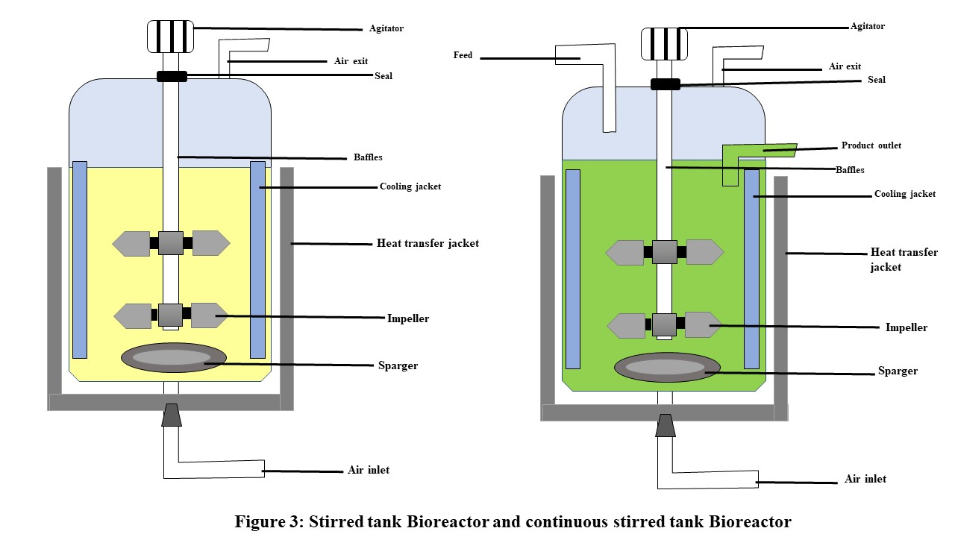

- Advantages:
Productivity is high.
Consistent conditions
Efficient resource utilization
- Disadvantages:
Control and operation are complicated.
Over time, there is a risk of contamination.

b) Air-Lift Bioreactors: Aeration is used in air-lift bioreactors to mix the culture and provide oxygen to microorganisms. They lack mechanical agitators and are less shear-sensitive, making them ideal for sensitive mobile cultures and applications requiring gentle blending. [31]

- Applications: [33]
Sensitive Cell cultures
Fermentation in anaerobic conditions
Microorganisms that are sensitive to shear
Single-cell protein
- Advantages: [33]
Gently mixing
Shear stress has been reduced.
Large-scale applications are possible.
- Disadvantages: [ 33]
Reduced oxygen transfer rates
Complex operation and design

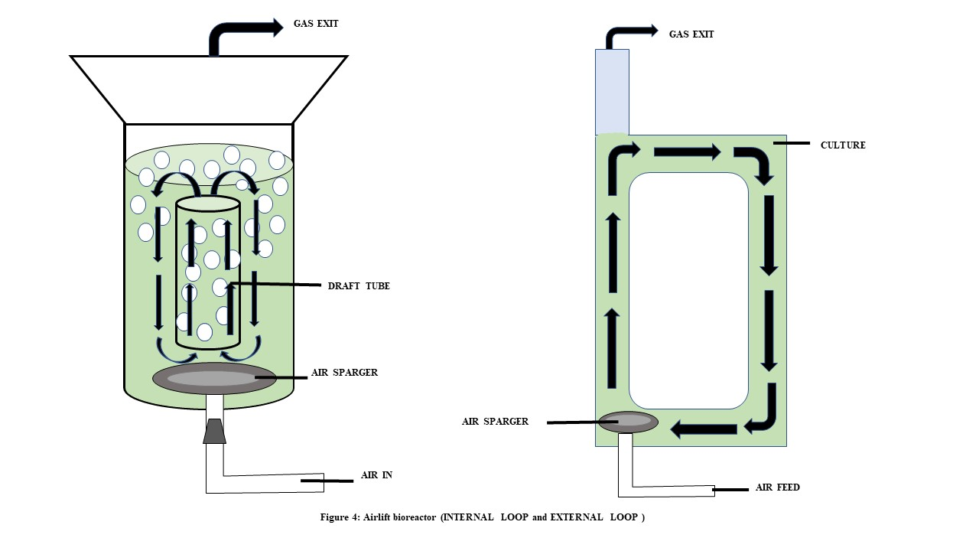

c) Bubble Column Bioreactor: A bubble column bioreactor is a type of bioreactor recognized by its vertical column layout, in which gas (typically air or oxygen) is introduced at the bottom to create bubbles that mix and oxygenate the culture medium. Within the liquid segment, microorganisms are suspended. [27] [31]

- Applications:
Aerobic microbial culture
The fermentation process for biofuel
Wastewater treatment
Research and development in biology
- Advantages:
Both the design and operation are simple.
Mass transfer is efficient due to the formation of a bubble.
Aerobic culture suitable
Scalable for various volumes
Microorganisms under low-shear stress
- Disadvantages:
Control over bubble length and distribution is limited.
Blending performance is lowered for viscous or non-Newtonian fluids.
In high-density cultures, the oxygen transfer rate may be limited.
Channelling and dead zones are possible.

d) Packed-Bed Bioreactors: Packed-Bed bioreactors are made up of a column filled with solid support material, such as beads or Fibers. Microorganisms attach to the support material, and nutrients pass through the bed. In immobilized cell bioprocesses, packed-bed reactors are frequently used. [34]

- Applications: [35]
Used in enzyme production
Immobilized cell culture
Continuous process

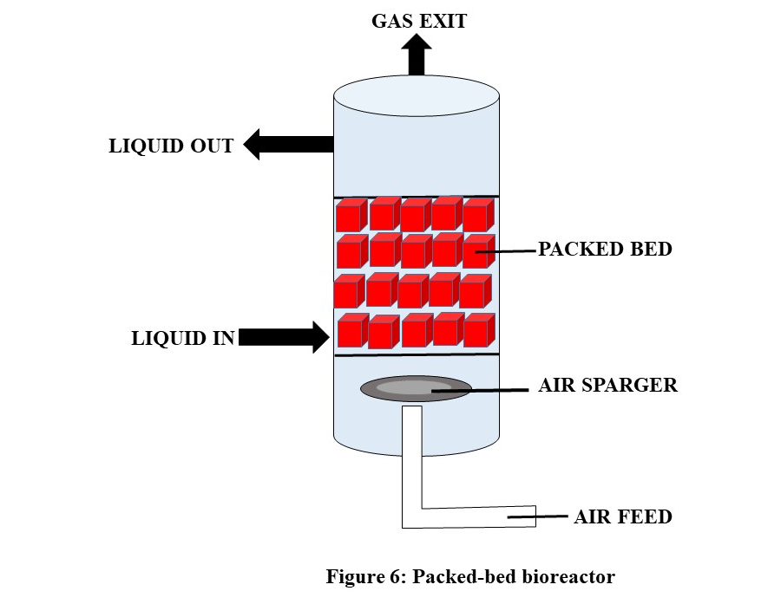

- Advantages: [35]
Continuous operation
Efficient transfer of mass
High cell density
- Disadvantages: [27]
Limited to those cultures that have been immobilized
Maintenance and cleaning are difficult.

e) Fluidized-Bed Bioreactors: Fluidized-bed bioreactors have a column in which microorganisms and additives
are suspended and agitated by an upward flow of liquid or gas. They are used in applications were high surface area and mass transfer are needed. [34] [35]

- Applications:
High-cell-density cultures
Bioconversion by microorganisms
Solid-substrate fermentation
- Advantages:
High rates of mass transfer
Continuous operation
efficient use of space
- Disadvantages:
Complex operation and design
Risks of clogging and biomass washout seem to be risks.

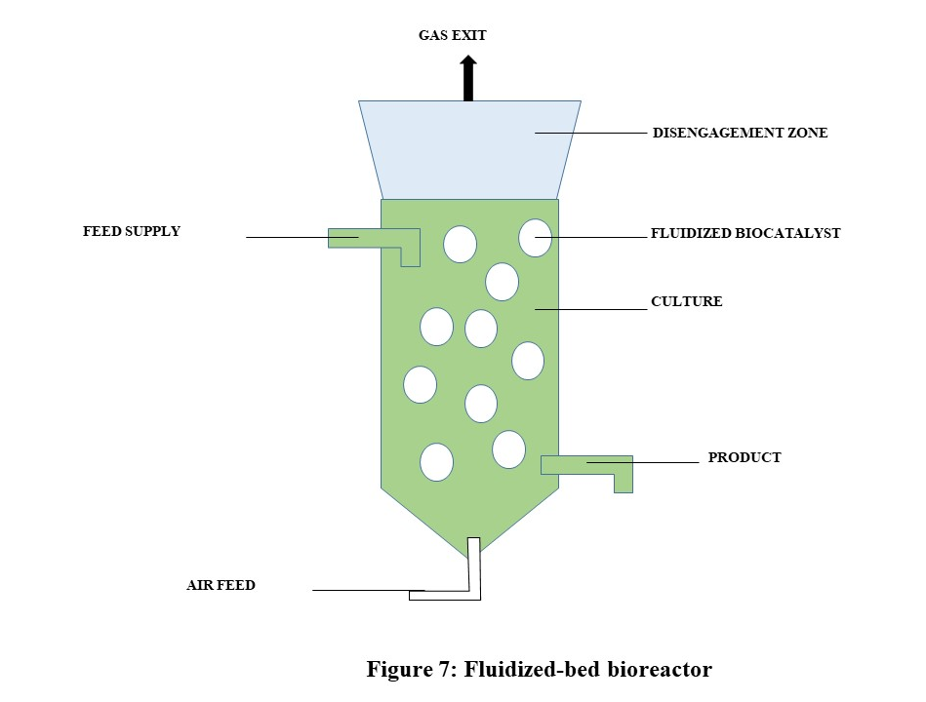

f) Photo bioreactor: Photo bioreactors are bioreactors designed specifically for photosynthetic microorganisms such as algae and cyanobacteria. They provide controlled lighting conditions to optimize photosynthesis and biomass production. [36]

- Applications:
Cultures of algae and cyanobacteria
Manufacturing of photosynthetic biomass
Manufacturing of biofuels and bioplastics
- Advantages:
Light conditions can be precisely controlled.
Exceptional biomass and product yields
Applications in the environment
- Disadvantages:
Only photosynthetic organisms can exist.
Light management systems that are complex

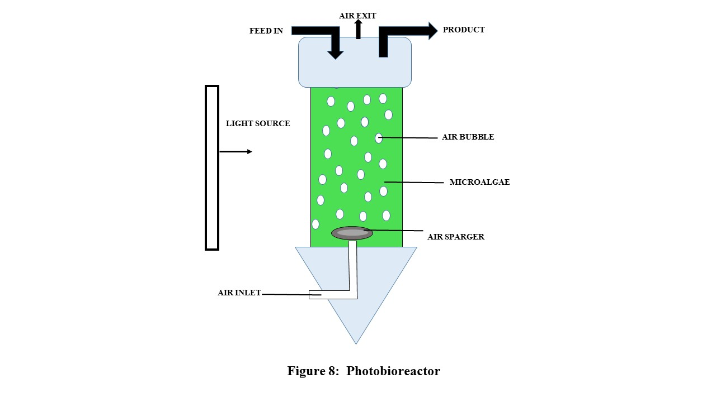

g) Membrane Bioreactor: Membrane bioreactors have membranes in the bioreactor vessel for separation and filtration. They are used in programs that require high product purity or to maintain continuous cultures. [37]

- Applications:
Production of biopharmaceuticals
The ongoing fermentation
Processes of separation and filtration
- Advantages:
High product purity
Effective downstream processing
The contamination risk has now been reduced.
- Disadvantages:
Membrane cleaning and maintenance
Initial set-up expenses

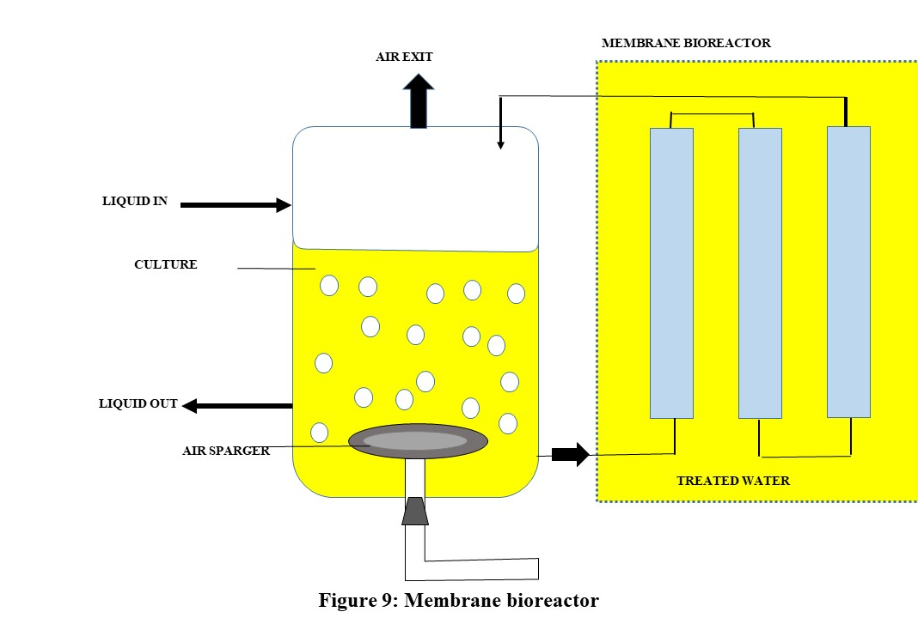

C. Downstream Processing:
Downstream processing in bioprocessing refers to the stage of the manufacturing process that occurs after the cultivation and harvesting of microorganisms or cells and mainly focuses on the purification, separation, and recovery of the desired bio products. [4] It is an important step in the production of biopharmaceuticals, enzymes, biofuels, and a variety of other bio products. Downstream bioprocessing typically consists of a series of unit operations designed to isolate and purify the target product from the complex mixture generated during the upstream bioprocessing process. [5] The important downstream processing factors:

- Harvesting: The first step is to collect the culture broth, which contains the microorganisms, cells, and desired products. Harvesting methods vary depending on the product and can include filtration, centrifugation, or sedimentation. The first step is to collect the culture broth, which contains the microorganisms, cells, and desired products. Harvesting methods vary depending on the product and can include filtration, centrifugation, or sedimentation. [30]
- Disruption of Cells: Cell disruption techniques are used to release the product into the liquid segment when the product is intracellular. Mechanical disruption, enzymatic treatment, and sonication are other options. [5]
- Clarification: Because of cell debris and impurities, the harvested broth is generally cloudy. Clarification techniques, such as filtration and centrifugation, are used to remove large particles and yield a clean solution. [27]
- Filtration and Separation: Filtration is used to separate particles of different sizes along with cells, debris, and proteins. Techniques such as depth filtration and membrane filtration are common. Separation methods such as chromatography and adsorption may also be used. [30]
- Concentration: The product is often present within the clarified solution at a low concentration. Concentration steps are used to increase the concentration of the product, making it easier to deal with. Ultrafiltration and diafiltration are two techniques.
- Purification: Purification is the process of removing contaminants and impurities from a product in order to achieve high purity. This is achieved through the use of chromatography, precipitation, and crystallization. [30]
- Sterilization: To ensure that the purified product is free of microorganisms, it is usually sterilized. It is possible to use sterile filtration, heat treatment, or irradiation. [15]
- Preparation of the final product and formulation: Following purification and sterilization, the product may go through scheme steps such as buffer exchange, pH adjustment, or stabilizer addition to prepare it for the final product shape (e.g., liquid, powder, or lyophilized). [28]
- Analysis and quality assurance: Analytical techniques are used to monitor product quality throughout downstream processing to ensure that it meets specified purity and potency criteria.
- Storage and distribution: The finished product is stored in proper conditions and distributed for its intended use, whether it is for pharmaceuticals, industrial applications, or other purposes. [27]

IV. APPLICATIONS OF BIOPROCESSING TECHNIQUES

Bioprocess strategies are used in a wide range of industries, including pharmaceuticals, agriculture, environmental control, food manufacturing, and others. Let’s discuss some important applications of the bioprocessing technique:

- Biopharmaceuticals: An important role of bioprocessing is seen in biopharmaceutical industries as it involves the production of therapeutic proteins, vaccines, antibodies, and some other complex biological methods which use living cells and microorganisms. Bioprocessing enables the safe and efficient production of these drugs and maintains high purity and high quality for patients around the globe. This technique is essential in biopharmaceuticals as it meets the needs of advanced medical treatment. [10]
- Enzyme Production: Bioprocessing plays an important role in enzyme production as this technique allows the efficient and large-scale production of enzymes using microorganisms or cells that are genetically engineered. The resulting enzymes have applications in various industries which include food, textile, detergent, and biofuels. The bioprocessing process maintains high yield and purity as well as functionality making it suitable for growth in enzyme production. [10]
- Biofuels: This technique is also used in the production of bioethanol, biodiesel, and biogas which all are biofuels. [11]
- Agriculture: By producing products like bio fertilizer bio pesticides and GMO (Genetically Modified Crops) bioprocess techniques contribute to the fields of agriculture.
- Food and Beverage Industries: These industries also benefit from the bioprocess technique as it is useful for the production of cheese, yogurt, beer, and bread. [22]
- Waste management: Organic waste can be converted into useful biogas through the process of anaerobic digestion. The bioprocess technique helps towards the sustainable approach to the disposal of waste. [34]
- Biomedical applications: The bioprocessing technique supports tissue engineering, and regenerative medicine and it also enables the growth manipulation, and production of cells for the purpose of biomedical therapeutics which makes it important in the field of biomedical applications. [22]
- Bioinformatics: By helping in data analysis and modelling bioinformatics helps in understanding and improving the productivity and efficiency of biotechnological processes.

All the applications given here are only a few examples the scope of the bioprocessing technique is much more than this and also it is like to grow and expand into new and innovative areas. [8]

V. CONCLUSION

The bioprocess approach has a wide range of applications in the biotechnology and bioengineering fields, and its future growth prospects are encouraging. In order to improve the production of valuable substances and to solve numerous problems brought on by human activity, scientists are constantly manipulating organisms. This adaptable method can help with wastewater treatment, turn organic waste into biofuel, and reduce global warming. In particular, bioprocessing can use microalgae to trap carbon dioxide gas and release it back into the environment through power stations and industrial facilities using specialized fermenters like photobioreactors.
Despite their many benefits, bioprocess approaches pose difficulties for researchers. Contamination risk, production costs, complicated pressure control systems, and sensitivity to environmental conditions are some of these difficulties. However, due to the growing use of bioprocess technology, continual attempts are being made to better and get around these challenges.
In general, bioprocess engineering has a bright future. However, there are worries and queries in some sectors of bioprocessing, particularly with reference to Genetically Modified Organisms (GMOs) [38]. Raising public knowledge of these technologies is therefore essential.
Bioprocessing techniques are a cutting-edge technology that converts lab operations into operational guidelines. This method uses living things to protect the environment, laying the groundwork for a bio-based future. In order to address current requirements while safeguarding the safety of our planet, coordination between science and industry is essential in this endeavour.

REFERENCES

- https://bioprocessing.weebly.com/bioprocess-technology.html
- Sood, S., Singhal, R., Bhat, S., & Kumar, A. (2011) Inoculum Preparation. Comprehensive Biotechnology, 151–164. doi:10.1016/b978-0-08-088504-9.00090-8
- John E. Smith (2009) Biotechnology, pp. 49 – 72 Publisher: Cambridge University Press Print publication https://doi.org/10.1017/CBO9780511802751.005.
- Baumann, P., & Hubbuch, J. (2016). Downstream process development strategies for effective bioprocesses: Trends, progress, and combinatorial approaches. Engineering in life sciences, 17(11), 1142–1158. https://doi.org/10.1002/elsc.201600033
- Gaugler, L., Mast, Y., Fitschen, J., Hofmann, S., Schlüter, M., & Takors, R. (2022). Scaling down biopharmaceutical production processes via a single multi-compartment bioreactor (SMCB). Engineering in life sciences, 23(1), e2100161 https://doi.org/10.1002/elsc.202100161
- "Bioprocessing". www.kgi.edu. Archived from the original on 2015-03-23. Retrieved 2017-11-17.
- Allen, P. (2022, February 23). The history of Bioprocessing: Part 1. ALLpaQ Packaging Group. https://allpaq.com/the-history-of-bioprocessing-part-1/#:~:text=The%20earliest%20form%20of%20bioprocessing,of%20history%20%E2%80%93%20in%207%2C000%20BCE.
- Shuler, M. L. and kargi F. (1991) Bioprocess Engineering: Basic concepts. Prentice Hall, Englewood Cliffs, N.J., p. 448
- Putting biotechnology to work: Bioprocess engineering. (1992). National Academies Press.
- Lindskog, E. K. (2018). Upstream Bioprocessing: Basic Concepts. Biopharmaceutical Processing, 97–110. doi:10.1016/b978-0-08-100623-8.00005-0
- A.A. Refaat, (2012) Biofuels from Waste Materials, 217-261, ISBN 9780080878737, https://doi.org/10.1016/B978-0-08-087872-0.00518-7.
- Meleady, P., Doolan, P., Henry, M., Barron, N., Keenan, J., O'Sullivan, F. & Clynes, M. (2011). Sustained productivity in recombinant Chinese hamster ovary (CHO) cell lines: proteome analysis of the molecular basis for a process-related phenotype. BMC Biotechnology, 11(1), 1-11.
- Laulund, S., Wind, A., Derkx, P. M. F., & Zuliani, V. (2017). Regulatory and Safety Requirements for Food Cultures. Microorganisms, 5(2), 28. https://doi.org/10.3390/microorganisms5020028
- Franceschetti, D. R., & Markov, S. A. (2012). Bioprocess engineering. In Applied science (pp. 240–245). essay, Salem Press.
- Gupta, Sanjay. (2012). Kumar A, Ray DK & Gupta SM (2012) “Bioprocess Technology”: Biotechnology in medicine and agriculture: principles and practices. (eds. Kumar A, Pareek A & Gupta SM) I. K. International publishing house Pvt. Ltd., New Delhi, India, pp. 827-857.
- Catherine A. Ingraham, John L. Ingraham (2000). Introduction to Microbiology.
- "Front Matter." National Research Council (1992) Putting Biotechnology to Work: Bioprocess Engineering. Washington, DC: The National Academies Press. https://doi.org/10.17226/2052.
- National Academies of Sciences, Engineering, and Medicine. 1992. Putting Biotechnology to Work: Bioprocess Engineering. Washington, DC: The National Academies Press. https://doi.org/10.17226/2052.
- Stanbury, P. F., Whitaker, A., & Hall, S. J. (2013, October 22). Principles of Fermentation Technology. Elsevier.
- Bioprocessing explained, A. (2019) Bioprocessing Explained. Bioprocessing Explained. https://bioprocessingexplained.home.blog
- Casida, L. E. (1964). Industrial Microbiology.
- Doran, P. M. (1995). Bioprocess engineering principles. Elsevier.
- Comprehensive Biotechnology. (2019) Elsevier.
- Link, H., & Weuster-Botz, D. (2011) Medium Formulation and Development. Comprehensive Biotechnology, 119–134. https://doi.org/10.1016/b978-0-08-088504-9.00092-1
- Link, H., & Weuster-Botz, D. (2011) Medium Formulation and Development. Comprehensive Biotechnology, 119–134. https://doi.org/10.1016/b978-0-08-088504-9.00092-1
- Erickson, L. E. (2009) Bioreactors.
- Antolli, P. G., & Liu, Z. (2012) Bioreactors: design, properties, and applications.
- Jagani, N., Jagani, H., Hebbar, K., Gang, S. S., Vasanth Raj, P., Chandrashekhar, R. H., & Rao, Jv. (2010) An Overview of Fermenter and the Design Considerations to Enhance Its Productivity. Pharmacologyonline, 1, 261–301
- Gogate, P. R., Beenackers, A. A. C. M., & Pandit, A. B. (2000). Multiple-impeller systems with a special emphasis on bioreactors: A critical review. Biochemical Engineering Journal, 6(2), 109–144.
- Wang, S. J., & Zhong, J. J. (2007). Bioreactor Engineering. Bioprocessing for Value-Added Products from Renewable Resources, 131–161.
- Schirmer, C., Maschke, R.W., Pörtner, R (2021) An overview of drive systems and sealing types in stirred bioreactors used in biotechnological processes. Appl Microbiol Biotechnol 105, 2225–2242. https://doi.org/10.1007/s00253-021-11180-7
- Glick, B. R., Pasternak, J. J., Patten, C. L. (2010). Molecular Biotechnology: Principles and Applications of Recombinant DNA.
- Wang, S. J., & Zhong, J. J. (2007). Bioreactor Engineering. Bioprocessing for Value-Added Products from Renewable Resources, 131–161.
- Singh, J., Kaushik, N., & Biswas, S. (2014). Bioreactors –Technology & Design Analysis Jagriti Singh, Nirmala Kaushik* & Soumitra Biswas. The Scitech Journal, I, 28–36.
- Sen, P., Nath, A., & Bhattacharjee, C. (2017). Packed-Bed Bioreactor and Its Application in Dairy, Food, and Beverage Industry. In Current Developments in Biotechnology and Bioengineering: Bioprocesses, Bioreactors and Controls.
- Suh, I. S., & Lee, C. G. (2003). Photobioreactor engineering: Design and performance. Biotechnology and Bioprocess Engineering, 8(6), 313–321.
- Asif, M. B., Hai, F. I., Jegatheesan, V., Price, W. E., Nghiem, L. D., & Yamamoto, K. (2018). Applications of membrane bioreactors in biotechnology processes. In Current Trends and Future Developments on (Bio-) Membranes: Membrane Processes in the Pharmaceutical and Biotechnological Field.
- Markov, S. A. (2012). Bioprocess Engineering (pp. 240-245). EBSCO. https://www.researchgate.net/publication/281750990

