"Emerging Frontiers: Marine Drugs in the Management of Future Cardiovascular Diseases"
Sandhanam K¹, T. Tamilanban^{1*}, Swetha S¹, Nisma Rahman¹, Yuvashree S¹
¹Department of Pharmacology, SRM College of Pharmacy, SRM Institute of Science and Technology, Kattankulathur, Chengalpattu, Tamil Nadu - 603203, India;

*Corresponding Author:
Dr. T. Tamilanban,
Associate Prof,
Dept. of Pharmacology,
SRM College of Pharmacy,
SRM Institute of Science and Technology,
Kattankulathur, Chengalpattu,
India.
tamilant@srmist.edu.in

Abstract:
Cardiovascular disease (CVD) remains a significant global health burden, necessitating continuous efforts to identify innovative therapeutic strategies. In recent years, marine organisms have garnered increasing attention as promising sources of bioactive compounds with potential therapeutic applications in CVD. This abstract explores the emerging trends and future prospects of marine-derived drugs in the management and treatment of cardiovascular conditions. Marine organisms are rich sources of diverse secondary metabolites with various pharmacological activities relevant to cardiovascular disease (CVD). These bioactive compounds display anti-inflammatory, antioxidant, antithrombotic, anti-hypertensive, and lipid-lowering properties. Notably, essential fatty acids, particularly omega-3 PUFAs like EPA and DHA, have shown significant benefits in reducing CVD risk factors such as triglycerides, improving endothelial function, and reducing inflammation. Additionally, marine-derived peptides and proteins are being explored as potential therapeutic agents for CVD. Among these, ACE-inhibitory peptides from fish, shellfish, and seaweeds have shown antihypertensive effects and potential cardioprotective benefits. Additionally, novel marine proteins with antithrombotic and anti-inflammatory properties are being explored as future treatment options for atherosclerosis and related conditions. Advancements in marine biotechnology and bioprospecting techniques have facilitated the discovery of previously unknown bioactive compounds from marine organisms. In the future, advanced analytical methods like metabolomics and proteomics will enhance our comprehension of marine drug interactions and mechanisms of action. While translating marine drugs into clinical practice poses challenges of scalability, sustainability, and regulatory issues, the integration of cutting-edge technologies offers substantial potential to overcome these obstacles and revolutionize cardiovascular medicine. Marine drugs present a thrilling frontier in the search for innovative therapies for cardiovascular disease. The rich reservoir of bioactive compounds found in marine organisms offers unique opportunities to develop targeted interventions that can complement existing treatment modalities and potentially transform the management of CVD. Through continued research and collaboration between marine scientists, pharmacologists, and clinicians, the promise of marine-derived drugs as effective cardiovascular therapeutics can be fully realized in the not-so-distant future.

Keywords: Marine drugs, Hypertension, Shellfish, Polysaccharides and novel marine proteins

Graphical Abstract:
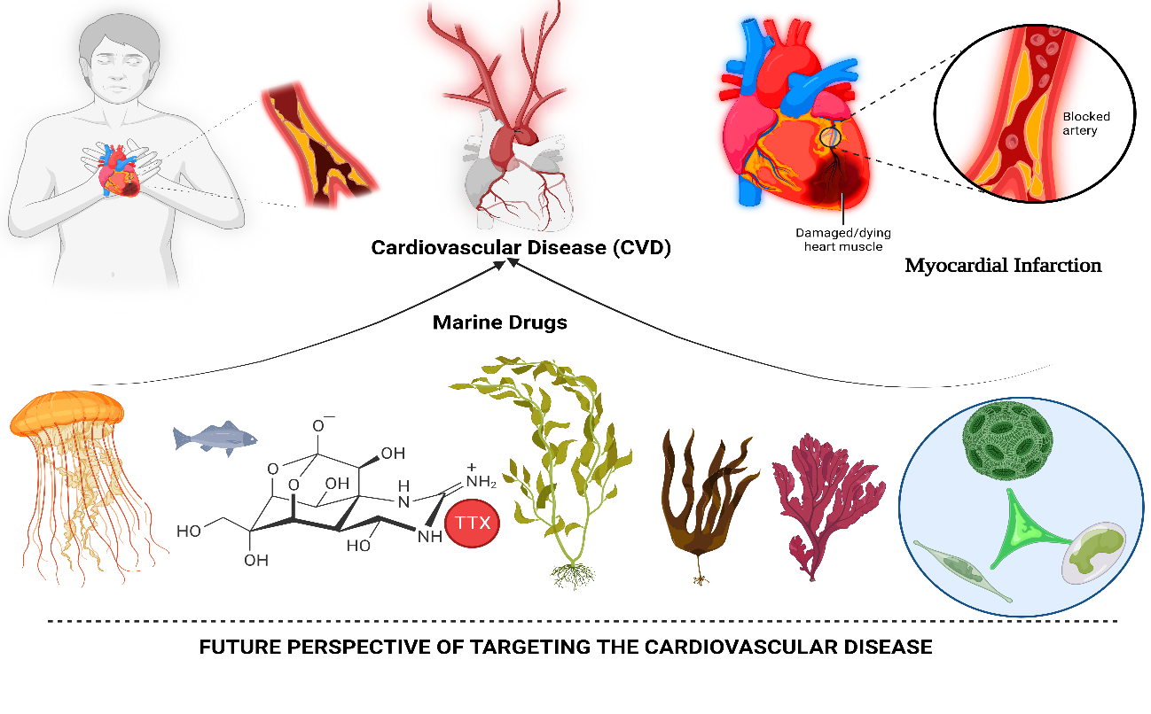
- INTRODUCTION:
Drugs obtained from marine sources are called "marine drugs." 70% of the earth is covered with oceans. Captivatingly, a vast amount of marine drugs obtained from various species of bacteria, fungi, and sponges have been widely used across the world. The marine sources are rich sources of bioactive products and are described as exhibiting or possessing exceeding potency in their pharmacological action. Exploration of diverse drugs from marine sources led to the realisation that they have potential in the management of a wide array of diseases.(1)
Marine drugs have been used in China and Japan since ancient times and are famous for their use of resources. The scope of use of marine drugs in cardiovascular diseases would be inevitable. Any drug affecting cardiovascular function is called a cardiovascular drug. Cardiovascular disease is reported to cause a high mortality rate. About 20% of the adult population is considered to be suffering from a major independent risk factor for CVS disease, which is hypertension. The antihypertensive action of drugs by inhibiting angiotensin-converting enzyme is expected to be a useful therapeutic approach. Coronary artery disease, which occurs due to narrowing and clot formation in arteries, is expected to be the primary hazard. In order to achieve a balance between ischemia and hemorrhage, antiplatelet and anticoagulation drugs are suggested. However, the major drawback of the synthetic drug approach is that they are incomprehensible and cause major adverse effects; hence, the approach has been developed as an economic and safer drug innovation from a natural source.(2)

- MARINE DRUG BIODIVERSITY
Marine natural products (MNPs) have gained significant recognition in drug discovery for their abundant bioactive compounds. Marine species, surpassing terrestrial plants and nonmarine microbes, are the primary source of MNPs. These compounds have been extensively studied and found to exhibit actions against cardiovascular disease and cancer. The marine environment supports a diverse range of species, with the majority of animal phyla and a vast number of plant and animal species residing in the oceans. Marine organisms, including sponges, fish, corals, mollusks, and microorganisms, are valuable sources of bioactive compounds with medicinal potential. The unique chemical and physical conditions of the marine environment have led to the evolution of diverse bioactive chemicals in marine species to withstand environmental stressors. Throughout history, various cultures have utilised marine animals for therapeutic purposes, and ancient literature records their use. Efforts to harness the medicinal properties of marine invertebrates have been ongoing, and traditional Chinese medicine has contributed valuable insights. Despite centuries of research, our comprehensive understanding of marine creatures remains incomplete. Marine-derived drugs have been developed since the 19th century, with notable applications in treating cancer, heart disease, diabetes, and neurodegenerative diseases. Marine-based plants and microbes have shown particular promise in cancer treatment, with numerous marine-derived compounds identified and isolated. Marine microorganism-derived compounds have the unique ability to selectively target harmful bacteria while preserving beneficial bacteria, promoting a healthy and balanced microbial environment. These marine compounds also exhibit prebiotic effects, supporting the maintenance of a healthy and diverse microbial flora. In the context of skin health, marine compounds have been found to enhance the synthesis and organization of skin proteins, leading to improved wound healing and repair. Additionally, they offer valuable antioxidant and photoprotective properties, contributing to overall skin well-being.(3)

III. MARINE DRUGS IN CARDIOVASCULAR DISEASES
A. Hypertension:
Hypertension, commonly known as high blood pressure, occurs when the force of blood against the walls of your blood vessels is too high, measuring at 140/90 mmHg or higher. Though it is prevalent, if left untreated, it can have serious health implications. Notably, individuals with high blood pressure may not experience any noticeable symptoms. Consequently, the only way to determine its presence is by undergoing regular blood pressure checks. (4)
Several factors contribute to an increased risk of developing high blood pressure, including advancing age, genetic predisposition, being overweight or obese, leading a sedentary lifestyle, consuming a high-salt diet, and excessive alcohol consumption. To reduce blood pressure levels, implementing lifestyle changes is vital. Embracing a healthier diet, quitting tobacco use, and adopting a more active lifestyle can be beneficial. Nevertheless, some individuals may still require medication to manage their blood pressure effectively. Blood pressure is denoted by two numbers: the first (systolic), representing the pressure in blood vessels during heart contractions, and the second (diastolic), representing the pressure while the heart is at rest between beats. For a diagnosis of hypertension, it is essential that, during two separate measurements on different days, the systolic blood pressure readings are consistently 140 mmHg and/or the diastolic blood pressure readings are consistently 90 mmHg.(5)
The angiotensin-I-converting enzyme (ACE) plays a crucial role in blood pressure regulation by converting angiotensin I to angiotensin II, a potent vasoconstrictor (as shown in Fig 1). As a result, inhibiting ACE activity becomes a key focus in the battle against hypertension. To minimize potential side effects, there has been a growing interest in discovering natural ACE inhibitors as alternatives to synthetic drugs. Marine organisms have emerged as abundant sources of diverse bioactive compounds, attracting considerable attention in the quest for ACE inhibitors with various health benefits.
Recent research has highlighted the potential of marine-derived compounds such as bioactive peptides, chitooligosaccharide derivatives (COS), and phlorotannins as potent ACE inhibitors. These compounds show promising results and may be developed into nutraceuticals and pharmaceuticals to effectively combat hypertension. This review aims to explore the possibilities of marine-derived ACE inhibitors and their potential as novel therapeutic drug candidates for hypertension treatment (7).
The marine environment provides a rich source of bioactive compounds with various structures. As a result, isolating ACE inhibitors from marine resources has become an exciting field of study, considering the numerous health benefits these compounds offer. Studies have highlighted the strong ACE inhibitory activity found in marine-derived bioactive peptides, chitooligosaccharide derivatives (COS), and phlorotannins. Among them, marine-derived phlorotannins stand out as particularly valuable bioactive compounds, holding great promise for the development of novel pharmaceuticals and functional foods. By considering these marine-derived compounds, we may find a promising approach to treating and preventing hypertension.
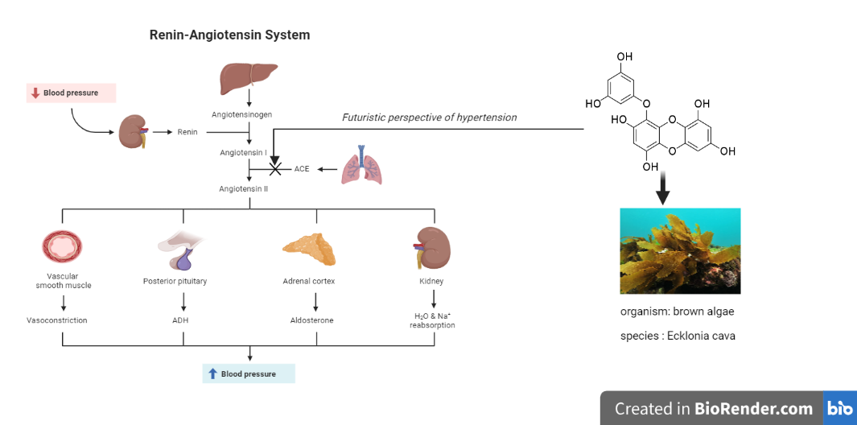
Fig. 1: Marine drugs targeting the Renin-Angiotensin System
B. Coronary Artery Disease:
Presently, coronary artery disease (CAD), a condition associated with inflammation and atherosclerosis, remains the primary cause of global mortality. The therapeutic strategies for CAD encompass the use of anti-ischemic drugs, antiplatelet drugs, anticoagulant drugs, and lipid-lowering drugs. Advancements in medical treatment have resulted in significant updates in CAD medication, notably the promising outcomes of angiotensin receptor-neprilysin inhibitors and sodium-glucose cotransporter 2 inhibitors. However, despite these advancements, CAD continues to present substantial residual risks, urging the exploration of novel drugs.
Recent studies have shed light on the potential of marine natural products in treating CAD. These marine drugs offer a range of beneficial effects, including resistance against platelet aggregation, coagulation, lipid levels, inflammation, and oxidation, all while minimizing adverse effects. Although this field has received limited attention in the past, it deserves significant emphasis. Experimental investigations have identified several marine natural products with remarkable effectiveness in CAD treatment. The intricate nature of CAD underscores the importance of exploring active substances derived from marine natural products, as they have demonstrated links to CAD by lowering lipids, preventing blood clot formation, and inhibiting inflammation.(5)
Numerous in vivo and in vitro experiments have provided compelling evidence for the efficacy of various drugs in treating coronary artery disease (CAD). The molecular mechanisms of drugs like fucoxanthin, saponins, astaxanthin, xyloketal B, DSW, terpenes, benzoic acid derivatives, sponge extract, asperlin, fucoidan, alginate, ulvan, chitosan, heteromorph prolifera polysaccharides, chondroitin sulfate, proteins, bioactive peptides, and lipids have been thoroughly elucidated. However, for some drugs, their functions in CAD treatment have only been confirmed through biochemical indicators, and further investigation is needed to understand their underlying mechanisms due to the lack of high-quality clinical evidence (as reported in reference 8). There is a need for future research on the signaling pathways associated with carrageenan, PPs, and ACE inhibitory peptides. Additionally, while existing studies have focused mainly on active substances, there has been relatively less attention on the development of marine drugs for CAD treatment, limiting their direct clinical application. Further exploration in this field is crucial and can contribute significantly.
Despite the availability of several antithrombotic drugs, ongoing efforts are being made to identify novel potential drugs due to the limitations and side effects associated with current therapies. The major side effect of antithrombotic medications is bleeding, ranging from mild to severe and potentially leading to fatal consequences. Regular monitoring during treatment is necessary to address these complications. However, vulnerable populations, such as older individuals or those with renal dysfunction, may still experience undesirable side effects despite proper clinical management. This may require the use of an antidote, constant patient monitoring, or administering drugs in low systemic doses, all of which can lead to unfavorable treatment outcomes. Heparin, the most commonly used anticoagulant, poses challenges due to its high risk of bleeding, low bioavailability, and need for parenteral administration. Heparin-induced thrombocytopenia further restricts its use in certain cases. To maximize benefits while avoiding complications, combined therapies of antiplatelets and anticoagulants with dose adjustments are employed. However, all existing antithrombotic medications have side effects and necessitate regular monitoring. Given the limitations of current antithrombotics, the development of potent and safe antithrombotic drugs in thrombotic research is still necessary. Researchers worldwide are focusing on designing, synthesizing, and identifying such molecules from various natural sources. Marine sources have gained significant attention due to their unique properties and importance, leading to frequent reviews of marine antithrombotics. This review aims to cover recent investigations conducted over the past five years on novel marine antithrombotic molecules, discussing their structures and associated anticoagulant activities, including alkaloids, polyphenols, terpenes, peptides, sulfated glycans, and sulfated rhamnans.(9)

C. Atherosclerosis:
Atherosclerosis is a persistent medical condition characterized by the accumulation of lipids and chronic inflammation in the arterial wall. This condition serves as the underlying cause of diseases such as coronary heart disease, cerebrovascular disease, and thromboembolic disease. However, the scarcity of affordable therapeutic agents that effectively slow down the progression of atherosclerosis remains a significant challenge. Thus, there is an urgent need to develop new drugs to address this issue. In recent years, the scientific community has increasingly focused on the research and development of drugs derived from marine sources. Marine organisms provide a diverse and abundant resource for the development of drugs targeting atherosclerosis. This study aims to explore the latest advancements in understanding the structures and mechanisms of action of marine-derived substances with anti-atherosclerotic properties. It also seeks to discuss the challenges associated with the application of these substances, including marine polysaccharides, proteins and peptides, polyunsaturated fatty acids, and small-molecule compounds. By doing so, this research aims to provide a theoretical basis for utilizing marine biological resources in the treatment of atherosclerosis.(10)
Atherosclerosis (AS) is a complex condition with significant implications for cardiovascular diseases (CVDs), influenced by multiple factors. Identified risk factors include hyperlipidemia, high levels of low-density lipoprotein cholesterol (LDL-C), hypertension, smoking, diabetes, and obesity. However, the current management strategies primarily focusing on blood lipid adjustment and anti-inflammatory treatments have limited efficacy. Additionally, some lipid-lowering drugs, like statins, come with undesirable side effects, necessitating alternative or complementary therapies that effectively treat AS without adverse consequences. (11)
Marine organisms, thriving in unique growth environments, produce natural active substances with distinctive structures and functions. Recent research on marine-derived active substances, such as polysaccharides, proteins and peptides, polyunsaturated fatty acids, and small-molecule compounds, has shown promising therapeutic potential in treating AS. This study will discuss the structures of each active substance and explore their therapeutic effects on atherosclerotic plaques, along with the underlying mechanisms through which these substances exert their anti-atherosclerotic effects. By offering a theoretical foundation, it aims to encourage further investigations into marine-derived active substances as promising candidates for AS treatment. The use of marine-derived active substances, encompassing polysaccharides, proteins, peptides, polyunsaturated fatty acids, and small-molecule compounds, holds great promise as therapeutic agents for atherosclerosis. In-depth research into these substances from marine sources could lead to novel and effective treatments for AS, ultimately improving patient outcomes and enhancing the overall quality of life.(12)

IV. CONCLUSION
The marine-derived compounds have shown promise as ACE inhibitors for hypertension prevention and as therapeutic agents for coronary artery disease (CAD) and atherosclerosis. Natural ACE inhibitors derived from marine organisms have demonstrated potent ACE inhibitory activity. These compounds can be developed into nutraceuticals and pharmaceuticals for hypertension prevention and treatment. CAD treatment has seen promising advancements with the use of marine natural products, which offer beneficial effects like platelet resistance, coagulant resistance, lipid-lowering effects, inflammation resistance, and oxidation resistance, all with minimal adverse effects. However, to fully comprehend the underlying mechanisms and harness the potential of marine-derived drugs for CAD treatment, further research is essential. Notably, marine-derived substances such as polysaccharides, proteins, peptides, polyunsaturated fatty acids, and small-molecule compounds have demonstrated anti-atherosclerotic properties, showing great promise as potential therapeutic agents in combating CAD. Exploring marine resources and their bioactive compounds can contribute to the development of new drugs with enhanced efficacy and fewer side effects, offering new options for the prevention and treatment of these cardiovascular conditions.
References:
1. Wei X, Rao C, Xiao X, Chen L, Goh M. Risk assessment of cardiovascular disease based on SOLSSA-CatBoost model. Expert Syst Appl (2023) 219:119648. doi: 10.1016/j.eswa.2023.119648
2. Sweeney M, Cook SA, Gil J. Therapeutic opportunities for senolysis in cardiovascular disease. FEBS J (2023) 290:1235–1255. doi: 10.1111/febs.16351
3. Kocere A, Lalonde RL, Mosimann C, Burger A. Lateral thinking in syndromic congenital cardiovascular disease. Dis Model Mech (2023) 16: doi: 10.1242/dmm.049735
4. Vesa CM, Bungau SG. Novel Molecules in Diabetes Mellitus, Dyslipidemia and Cardiovascular Disease. Int J Mol Sci (2023) 24:4029. doi: 10.3390/ijms24044029
5. Wagner N, Wagner K-D. Pharmacological Utility of PPAR Modulation for Angiogenesis in Cardiovascular Disease. Int J Mol Sci (2023) 24:2345. doi: 10.3390/ijms24032345
6. Peña LF, González-Andrés P, Parte LG, Escribano R, Guerra J, Barbero A, López E. Continuous Flow Chemistry: A Novel Technology for the Synthesis of Marine Drugs. Mar Drugs (2023) 21:402. doi: 10.3390/md21070402
7. Wald NJ. A strategy to reduce cardiovascular disease by more than 80%. BMJ (2003) 326:1419–0. doi: 10.1136/bmj.326.7404.1419
8. Verhaar MC, Stroes E, Rabelink TJ. Folates and Cardiovascular Disease. Arterioscler Thromb Vasc Biol (2002) 22:6–13. doi: 10.1161/hq0102.102190
9. Sessa F, Salerno M, Esposito M, Cocimano G, Pomara C. miRNA Dysregulation in Cardiovascular Diseases: Current Opinion and Future Perspectives. Int J Mol Sci (2023) 24:5192. doi: 10.3390/ijms24065192
10. Bansal M. Cardiovascular disease and COVID-19. Diabetes & Metabolic Syndrome: Clinical Research & Reviews (2020) 14:247–250. doi: 10.1016/j.dsx.2020.03.013
11. Sethi Y, Patel N, Kaka N, Kaiwan O, Kar J, Moinuddin A, Goel A, Chopra H, Cavalu S. Precision Medicine and the future of Cardiovascular Diseases: A Clinically Oriented Comprehensive Review. J Clin Med (2023) 12:1799. doi: 10.3390/jcm12051799
12. Anderson KM, Odell PM, Wilson PWF, Kannel WB. Cardiovascular disease risk profiles. Am Heart J (1991) 121:293–298. doi: 10.1016/0002-8703(91)90861-B

