BIOLOGICAL EFFECTS OF IONIZING RADIATION
G Thangam¹, S Iyyappan^{2*} and S Mathu Kumar³
¹Department of Science & Humanities, Rohini College of Engineering & Technology, Palkulam, Tamilnadu, India.
^{2,3}Department of Mechanical Engineering, Ponjesly College of Engineering, Nagercoil, Tamilnadu, India.
Abstract:
Ionizing radiation emerges as a form of energy discharged by atoms through electromagnetic waves or particles. This particular radiation finds utility across diverse domains like medicine, industry, agriculture, and research. Despite its intrinsic harm and potential toxicity to organisms, regulated amounts find application in medical imaging and radiotherapy. Prolonged exposure to low levels of ionizing radiation amplifies the risk of enduring effects, notably cancer. Moreover, extremely elevated radiation doses can induce pronounced consequences such as radiation burns and swift fatality due to acute radiation syndrome. Within this chapter, an outline is presented detailing the potential biological repercussions at the cellular level stemming from radiation exposure.
Keywords: Radiation, DNA, Chromosome.
- Introduction
  - Exposure of radiation to people:
Individuals might encounter ionizing radiation while at home or in public spaces, as well as during their time at work or within medical facilities. Exposure to radiation can occur through external means or internal processes. Internal exposure can occur by the inhalation or absorption of radionuclides into the bloodstream. On the other hand, external exposure can result from the deposition of radioactive substances on the skin or clothing.
The radionuclide can be eliminated from the body through washing. The occurrence of ionizing radiation exposure might originate from external factors, such as medical radiation exposure from x-rays. This exposure can be halted by shielding the radiation source. The radiation harms the cells and tissues of the human body, and the impact of this radiation on the body is referred to as the biological effects of radiation.
  - The Cellular Structure
The cell, regarded as the foundational component of living organisms, is composed of two primary elements: the nucleus and the cytoplasm, as depicted in Figure 1. The cytoplasm, under the direction of the nucleus, plays a central role in carrying out various metabolic processes.

The nucleus consists of two arms linked by a centromere. These chromosomes contain genes, which serve as the essential carriers of hereditary information in all living organisms. Genes, in turn, are made up of DNA molecules.
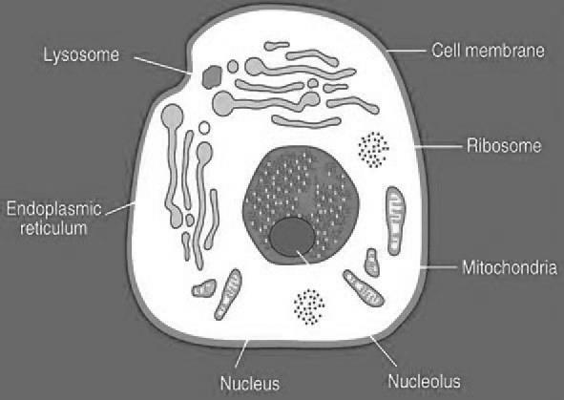
Figure 1. Structure of Human Cell
The distinctive nature of a chromosome is defined by its gene sequence. Within the cell's cytoplasm, four crucial organelles—ribosomes, endoplasmic reticula, mitochondria, and lysosomes-undertake essential metabolic functions. Comprising protein and ribonucleic acid (RNA), ribosomes play a pivotal role in orchestrating the synthesis of proteins in living organisms.
- Classifications of Biological effects
The biological effects of radiation can be classified into two types. They are
- Direct damage:
If the ionizing radiation directly leads to molecular disruption then it is direct damage,
- Indirect damage:
Indirect damage takes place when free radicals are generated, subsequently assaulting other components within the cell.
2.1. Direct damage:
2.1.1. DNA molecule:
The DNA molecule showcases a double-helix structure, comprising two strands constructed from sugar molecules connected by phosphate bonds.
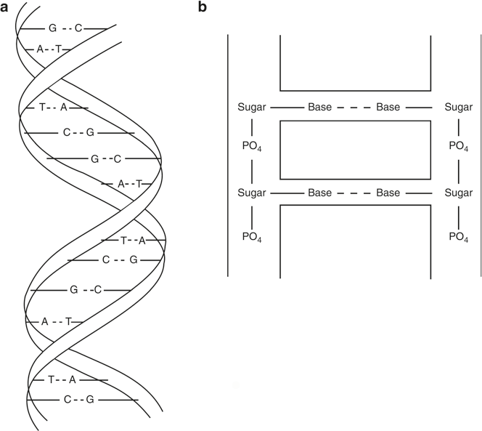
These strands resemble the rungs of a ladder and are made up of four bases: thymine (T), adenine (A), guanine (G), and cytosine (C). These bases establish connections with the sugar molecules on both sides of the strands and are bonded together by hydrogen bonds, as depicted in Figure 2.
Figure 2. Structure of DNA
2.1.2. Effect of radiation on DNA
Figure 3a illustrates the standard DNA molecule. Radiation can induce damage to this molecule through the subsequent mechanisms:
- Cleavage of hydrogen bond (in figure 3b)
- Missing of base (in figure 3c)
- Breakage of single strand (in figure 3d)
- Breakage of double strand (in figure 3e)
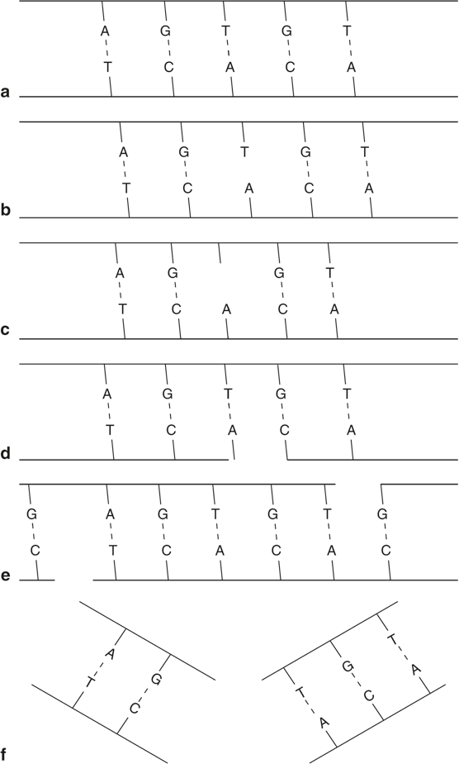

Figure 3. a) Normal DNA, b) Cleavage of hydrogen bond, c) Missing of base, d) Single strand Breakage and e)Double strand Breakage
2.1.3. Chromosome
Mutations in DNA molecules can impact chromosomes, leading to structural alterations known as aberrations. These aberrations are categorized into two main types.
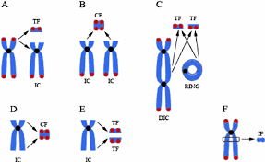
Figure 4. Aberrations of chromosomes
- Chromatid aberrations
Only one chromatid within this context experiences the effect, and the broken sections of chromatids will undergo rejoining.
- Chromosome aberration
In this scenario, the broken chromatid undergoes duplication, resulting in daughter cells containing impaired chromosomes. Subsequently, four distinct processes come into play as in Table 1.
Table 1. Process of chromosomes aberrations
Name of the Process | Explanations
Deletion | Fragment of chromosome is broken and it is deleted
Inversion | The fractured segment reattaches in the opposite sequence.
Translocation | A broken fragment from one chromosome attaches to a fragment from a different chromosome.
Reciprocal translocation | Two broken fragments from different chromosomes reattach to each other incorrectly.
2.2. Indirect damage
In this process, radiation impacts water molecules, which are significant components of cells, resulting in the production of free radicals. These free radicals then interact with DNA molecules, leading to molecular damage.
- Conclusion
In conclusion, the biological effects of radiation on cells are complex and multifaceted, reflecting the intricate interplay between radiation and cellular components. Ionizing radiation, with its ability to directly or indirectly interact with cellular molecules, can induce DNA damage, leading to mutations and potential cancer development. The cellular response to radiation, including DNA repair mechanisms and apoptosis, showcases the cell's remarkable ability to mitigate damage. Understanding these effects is vital for both medical and technological advancements. It guides the safe use of radiation-based therapies in medicine while promoting the responsible implementation of radiation-emitting technologies in various applications.
References
- Wang, H., Jiang, H., Van De Gucht, M., & De Ridder, M. (2019). Hypoxic Radioresistance: Can ROS Be the Key to Overcome It? Cancers, 11(1), 112. doi:10.3390/cancers11010112.
- B.H. Brown, R.H. Smallwood, D.C. Barber, P.V. Lawford, D.R. Hose, “Medical Physics and Biomedical Engineering”, Institute of physics publishing, Bristol and Philadelphia, 1999.
- Gopal B. Saha. “Physics and Radiobiology of Nuclear Medicine” Fourth Edition, Springer, 2006.
- Steve Webb, The Physics of Medical Imaging, Taylor & Francis, Newyork, Second Edition, 2012.

