Cardiac bioengineering: From tissue engineering to 4D bioprinting

Susmita Saikia¹, Asghar Ali¹, Md. Salik Noorani^{1,}*
¹ School of Life and Chemical Sciences, Jamia Hamdard University, New Delhi-110062, India.
* Corresponding Author: Dr Md. Salik Noorani: saliknoorani@jamiahamdard.ac.in

Susmita Saikia
School of Life and Chemical Sciences
Jamia Hamdard University
New Delhi 110062, India.
Email Id: susmitakaki@gmail.com

Dr Asghar Ali
School of Life and Chemical Sciences
Jamia Hamdard University
New Delhi 110062, India.
Email Id: asgharali@jamiahamdard.ac.in
*
Corresponding Author

Dr Md. Salik Noorani
School of Life and Chemical Sciences
Jamia Hamdard University
New Delhi 110062, India.
Email Id: saliknoorani@jamiahamdard.ac.in

ABSTRACT
The emerging field of cardiac bioengineering aims to combine the principles of biology and engineering to understand, repair, and regenerate the heart. This chapter explores the latest advancements in cardiac bioengineering, including tissue engineering, biomaterials, and 3D bioprinting. Additionally, it excavates the challenges and opportunities in describing these advancements into clinical applications for treating cardiovascular diseases. The chapter aimed to explore various aspects of cardiac tissue engineering and different 3D and 4D bioprinting techniques. This chapter also emphasizes the important developments in cardiac bioengineering that are bringing about a revolution in the way that heart diseases are treated.

Keywords—Cardiovascular diseases, cardiac tissue engineering,3d bioprinting, 4D bioprinting.

INTRODUCTION

The heart, a marvel of biological engineering, is an intricate organ that pumps oxygen-rich blood throughout the body. Despite its incredible resilience, the heart is susceptible to various diseases, leading to heart failure, arrhythmias, and other life-threatening conditions. Cardiovascular diseases (CVD) have continued to be the primary cause of death worldwide [1] . The prevalence of these diseases is expected to rise even further in the upcoming decades due to an aging population[2] . Some of the different types of heart diseases are 1) coronary artery disease (CAD): It is the condition of the artery when the blood vessels that supply the heart muscle with oxygen and nutrients become narrowed or blocked. 2) heart attack (myocardial infarction, MI): It is the condition, which is characterized by prolonged myocardial ischemia, which lasts for approximately 20 minutes. The blockage of coronary blood flow causes the ischemia due to the rupture of a mature atherosclerotic plaque and the subsequent formation of a thrombus. 3) arrhythmias: It is a condition of abnormal heartbeats. It may be too fast (tachycardia), too slow (bradycardia), and irregular heartbeats. Sometimes, it may be harmless, but in some cases, it requires treatment. 4) heart failure: It is the condition of the heart in which it is unable to pump blood effectively to fulfil the body’s needs. It may result because of the weakening or the increase in the stiffness of the heart muscle. 5) valvular heart disease: It is the condition where the heart valves are damaged or don’t function properly. 6) congenital heart disease: These are the abnormalities that are present by birth. These can be simple issues with the heart’s structure or complex defects that require surgical intervention. 7) cardiomyopathies: These are diseases which involve the heart enlargement, thickening or stiffening of the heart, which effects the ability of the heart to pump blood properly. 8) pericardial diseases: It involve inflammation or abnormalities of the pericardium. 9) hypertensive heart disease: This is the condition of high blood pressure, which can lead to the damage to the blood vessels.
Among the above-mentioned diseases, myocardial infarction (MI) is the major cause of death worldwide[3]. The risk of experiencing an acute myocardial infarction (heart attack) was significantly linked to various factors, including dyslipidemia, smoking, psychosocial stress, diabetes mellitus, hypertension, obesity, alcohol consumption, physical inactivity, and a diet lacking in fruits and vegetables. Some of the measures that can be adopted for the reduction of heart diseases are stopping the use of tobacco, consumption of less salt in the diet, and more intake of fruits and vegetables. Various heart diseases, along with their symptoms and treatments, were given in Table 1.

Table 1. Various heart diseases with their symptoms and treatments

S no. | Type of Disease | Symptoms | Treatment
1. | Coronary Artery Disease (CAD)[4] | - Chest pain or discomfort (angina).  - Pain or discomfort in the arms, shoulder, or chest area.  - Fatigue or weakness.  - Nausea or vomiting. | - Medicines to control blood pressure and cholesterol levels and reduce the risk of blood clots.  - Angioplasty and stent placement.  - Coronary Artery Bypass Grafting (CABG).
2. | Heart attack (Myocardial infarction) | - Sudden severe chest pain or pressure that may radiate to the arms.  - Cold sweat.  - Nausea or vomiting.  - Pain or discomfort in the other upper body areas. | - Emergency medications like aspirin and thrombolytics to prevent blood clotting.  - Cardiac rehabilitation- After stabilization patients, proper exercise, education and support were required.
3. | Arrhythmias [5] | - Palpitations (sensation of skipped or irregular heartbeats).  - Rapid heartbeat (tachycardia) or slow heartbeat (bradycardia).  - Chest pain or discomfort. | - Cardioversion: Electric shocks.  - Implantable devices: Pacemakers.
 | Heart failure[6] | - Shortness of breath.  - Swelling (edema) in the legs, ankles, feet, or abdomen.  - Persistent cough or wheezing. | - Implantable devices: Devices like cardiac resynchronization therapy (CRT) or left ventricular assist devices (LVADs) may be used.
 | Valvular heart disease | - Fatigue or weakness.  - Shortness of breath, especially during physical activity or when lying down.  - Chest pain or discomfort. | - Valve repair or replacement: Surgical procedures or transcatheter techniques can be used to repair or replace the faulty valves.
6. | Congenital Heart Disease | - Cyanosis (bluish tint to the skin, lips, and fingernails).  - Poor growth and weight gain in infants.  - Fatigue or weakness.  - Shortness of breath, especially during physical activity. | - Treatment includes medications, catheter-based interventions, or surgical corrections.
7. | Cardiomyopathy [7] [8] | - Shortness of breath, especially during physical activity.  - Fatigue or weakness.  - Swelling in the legs, ankles, and feet.  - Dizziness or lightheadedness.  Irregular heartbeat. | - Medications.  - In advanced cases, devices like pacemakers, ICDs, or LVADs may be used.  - Heart transplant: For severe cases.
8. | Pericardial Diseases [9] | - Chest pain is often sharp and relieved by sitting up or leaning forward (pericarditis).  - Swelling in the abdomen (pericardial effusion). | - Anti-inflammatory drugs.  - Pericardiocentesis: In pericardial effusion, excess fluid may be drained using a needle.
9. | Hypertensive Heart Disease [10] | - High blood pressure (often asymptomatic).  - Shortness of breath.  - Chest pain or discomfort (angina).  - Fatigue or weakness. | - Medications: Drugs to control blood pressure.  - Lifestyle changes.

Traditional treatments for heart diseases have often relied on medication, surgical interventions, and heart transplants. However, these approaches have limitations, such as donor shortages and immune rejection. An alternate method of 3D printing offers the remarkable capacity to build complex 3D structures by layer-by-layer deposition of materials such as plastic, metal, powders, ceramics, liquids, and hydrogels[11]. With the new advancements in the field of 3D printing it can also be feasible to create biological materials such as cells, and tissues. By the precisely deposition of the bioinks, 3D functional living structures with customised designs and layouts could be made. The bioinks can originate from diverse cell reservoirs obtained from the patient, such as pluripotent stem cell (iPSC)-derived cells, hydrogel biomaterials, and supportive substances like growth factors and signaling molecules [12]. The process of the cardiac 3D printing is shown in Fig.1.
Cardiac bioengineering presents an innovative path to address these challenges by combining engineering principles with biological knowledge to develop novel solutions for cardiac ailments. However, despite of the several advancements in the field of cardiac bioengineering the field is still in the stage of infancy and requires extensive research and innovations. Therefore, in order to comprehend the various breakthroughs in the field of cardiac bioprinting, it is imperative to give a comprehensive review. This chapter reports the advancements in the fields of cardiac tissue engineering, 3D printing and the future perspective of 4D printing.
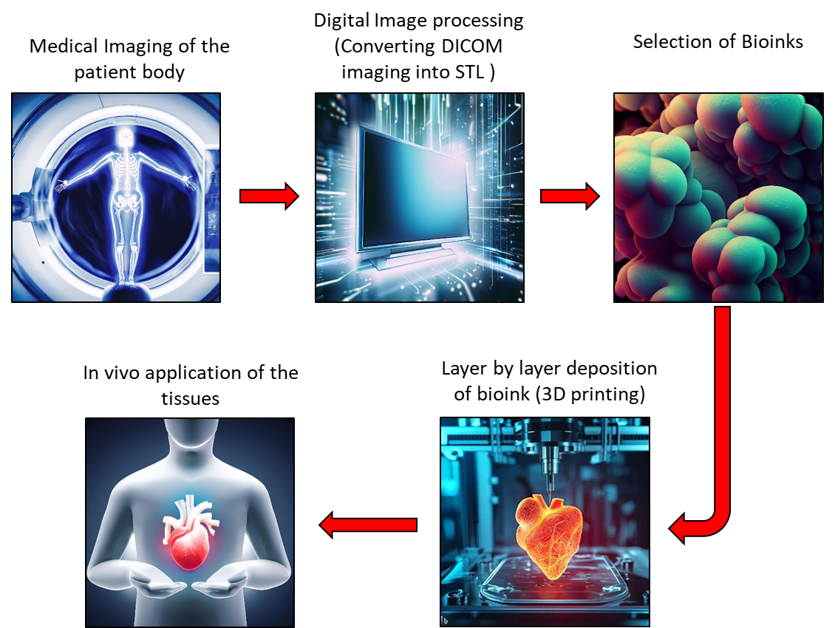

Figure 1. Illustration of the 3D printing process use for the cardiac tissue constructs.

TISSUE ENGINEERING AND BIOMATERIALS FOR CARDIAC REPAIR

Cardiac Tissue Engineering
Tissue engineering offers the potential to replace damaged or scarred cardiac tissue with functional, lab-grown constructs. The focus of cardiac tissue engineering is to create and repair the damaged actual cardiac tissues with artificially created tissues. Currently, the researchers are focused on two approaches. One approach is to develop functionally engineered cardiac tissues (ECTs). The ECTs are developed at microscales at a thickness usually of less than 500 µm. Microscale ECTs are helpful in predicting the response of the drugs and, therefore, useful for drug screening applications [13]. Another approach is creating macroscale engineered cardiac pumps (ECPs), which encompass engineered human ventricles and complete heart models, mimicking the intricate structure of the natural heart. Researchers have made significant progress in developing cardiac patches, scaffolds, and engineered heart tissues (EHTs) using a combination of cells, biomaterials, and growth factors. This section explores the state-of-the-art techniques in tissue engineering for cardiac repair.

Biomaterials in Cardiac Bioengineering
Biomaterials play a crucial role in providing mechanical support and promoting cell adhesion, proliferation, and differentiation in cardiac tissue engineering. Polymers are the most widely used materials in cardiac bioengineering. The diverse characteristics found in various human tissues require the utilization of a diverse range of polymers in the field of tissue engineering[14]. Polymers used for the biomaterials are either natural polymers or synthetic polymers. Both polymers have advantages and challenges in cardiac tissue engineering. Synthetic polymers offer more controllable properties, while natural polymers have biological relevance[15]. Researchers aim to strike a balance between these properties to create effective and functional cardiac tissue constructs for therapeutic applications[16]. Various natural and synthetic materials, such as hydrogels, decellularized matrices, and nanomaterials, are being investigated for their potential in regenerating cardiac tissue.

3D BIOPRINTING OF CARDIAC CONSTRUCTS

Charles Hull developed the first stereolithographic technique in 1984. The first 3D printers for the industrial purpose were debuted in the market four years later and was referred to as a “Stereolithography Apparatus”. The schematic of the progress of bioprinting is explained in the Fig 2.

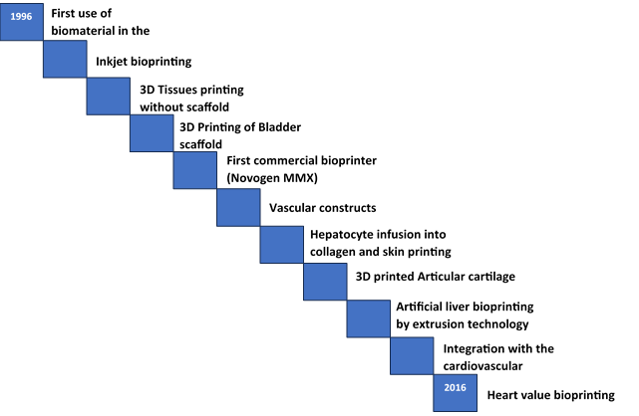
Figure 2. History of Bioprinting [17]

Principles and Techniques of Cardiac Bioprinting
The revolutionary technique of 3D bioprinting was based on the method of additive manufacturing. It creates the 3D components by depositing the materials layer by layer. However, cardiac bioprinting involves the creation of more complex structures to mimic the actual heart tissues. Various 3D bioprinting was classified according to the method of the material deposition [18] which involves 1) thermal inkjet based bioprinting, 2) Digital light processing bioprinting 3) Extrusion Printing and 4) Freedom reversible embedding bioprinting.
- Thermal inkjet based bioprinting: Injet printing are of 2 types. Thermal and Piezoelectric printers. While piezoelectric-based printers emit acoustic waves, thermal-based printers produce pressure pulses and eject droplets by localized heating. The working principle of thermal inkjet based bioprinter is similar to the inkjet printers. The printing is done by the contactless deposition of precise tiny droplets of the “bioink” on the surface of a hydrogen substrate. It utilises an electric current pulse which subsequently creates bubbles that create a pressure pulse that forces the ink droplet onto the substrate.
- Digital light processing Printing: The primary benefit of this printing is it has a simple and quick process of manufacturing The pressure was generated by creating the transient pulse by the piezoelectric transducer.
- Extrusion Printing: Extrusion printing, in contrast to other methods, allows for quicker, easier and less expensive bioprinting by continuously extruding bioink onto a substrate using pneumatic or mechanically driven fluid dispensing system.
- Freedom reversible embedding printing: In 3D environment, hydrogels are good option to assist cell proliferation. However, the majority of hydrogels have weak mechanical qualities, which could cause hollow constructions printed with them to collapse under the force of gravity

The 3D bioprinting process constitutes the following steps:
- CT-imaging: The CT-scan or computed tomography is the medical imaging tool used to generate the internal imaging of the body parts. It utilizes the X-ray to create cross-sectional images of the internal body parts. These images are then stacked one over another to create 3D body parts.
- Segmentation of the region of interest: The CT-scan images are obtained in the DICOM (Digital imaging and communications in medicine) format, which was segmented based on the HU (Hounsfield units) values. Computerised software like materialise Mimics research is used for the segmentation based on the HU values. The Hounsfield scale is the linear scale that assigns the 0 HU value to the water and -1000 to the air. The relative HU values of the tissues were then calculated based on the relative radiodensity using the formula given below. The standard HU values for the different tissues are given in Table 2.

$$HU= 1000*\left(\frac{μ_{tissue}-μ_{water}}{μ_{water}}\right)$$

Table 2. Hounsfield units (HU) values for human tissues

S. No. | Tissues | HU values
1. | Fat | -50 to -100 HU
2. | Muscle | +40 to +60 HU
3. | Blood | +30 to +70 HU

- Generating the 3D components from the DICOM images: The segmented parts are then rendered into 3D components using the Materialise 3-Matic software. The finished 3D geometry was then exported into the STL (Standard triangle language) format.
- Selection of the biomaterials and the appropriate 3D printers: The appropriate bioprinters were chosen based on the types of tissues or structures and the resolution of the product we wanted to print. Before selecting the appropriate material for the biomaterials, the compatibility of the biomaterial with the bioprinters is to be ensured.
- Post-processing: Post-processing is required to enhance the surface properties of the finished products. The final inspection testing of the component was also performed before using it for the desired application.

4D bioprinting: A future perspective of 3D Printing
Use The term “4D printing” was introduced by Skylar Tibbits in 2014 [19]. 4D printing is an advancement in the field of 3D printing. The components made by the 3D bioprinting have a limitation in that they are inherently rigid and maintain the shape in which it is initially printed, and thus it, is able to serve only a singular function [20]. 4D-bioprinting utilizes smart materials which are responsive to certain stimuli. These materials have the distinctive characteristic of having pre-programmed responses, which makes them well-suited for intelligent applications [21]. The different types of additive manufacturing processes used are selective laser melting (SLM), Selective laser sintering (SLS), stereolithography (SLA), electron beam melting (EBM), fused deposition modelling (FDM), etc. The materials used for the printing should be able to transform themselves against external stimuli. Some physical external stimuli are light, moisture, temperature[22], electric energy, magnetic energy, and ultraviolet light [23]. The smart materials are also responsive to the chemical stimulus such as pH level and biological stimuli like glucose level and enzymes. A programmable material has the capability to undergo the appropriate transformation when an external stimulus is applied. Some of the characteristics of the smart materials are illustrated in Fig 3. Despite several advancements in this field, numerous challenges still persist. Some of the limitations are the higher cost of the printable materials, large printing time, and lack of the specialized software.
Figure 3. Characteristics of the smart materials used for 4D printing.
Smart materials used for 4D printing
Transiency
(response to external stimuli)
Immediacy
(fast response)
Self-actuation
(Change their appearance and shape)
Selectivity
(response is divided and expected)

Conclusion
In recent years, the field of cardiac bioengineering has witnessed tremendous progress aiming to reduce the patient suffering from heart diseases. Cardiac tissue engineering, biomaterials, 3D and 4D bioprinting are redefining the landscape of cardiac medicine. However, there are several challenges, such as long-term safety, scalability, and cost-effectiveness. To overcome these hurdles and accelerate the translation of these groundbreaking advancements into practical treatments, collaborations between scientists, engineers, medical practitioners, and regulatory agencies are essential. Cardiac bioengineering has the potential to transform cardiovascular engineering and enhance patient outcomes on a worldwide scale with continuous work in this dynamic subject.

REFERENCES

[1] A. E. Guttmacher, F. S. Collins, and E. G. Nabel, “genomic medicine Cardiovascular Disease,” 2003. [Online]. Available: www.nejm.org
[2] E. G. Lakatta, “Age-associated cardiovascular changes in health: Impact on cardiovascular disease in older persons,” Heart Failure Reviews, vol. 7, no. 1. 2002. doi: 10.1023/A:1013797722156.
[3] V. L. Roger, “Epidemiology of Myocardial Infarction,” Medical Clinics of North America, vol. 91, no. 4. 2007. doi: 10.1016/j.mcna.2007.03.007.
[4] P. A. McCullough, “Coronary artery disease,” Clin. J. Am. Soc. Nephrol., vol. 2, no. 3, pp. 611–616, May 2007, doi: 10.2215/CJN.03871106.
[5] D. guan Fu, “Cardiac Arrhythmias: Diagnosis, Symptoms, and Treatments,” Cell Biochem. Biophys., vol. 73, no. 2, 2015, doi: 10.1007/s12013-015-0626-4.
[6] A. Groenewegen, F. H. Rutten, A. Mosterd, and A. W. Hoes, “Epidemiology of heart failure,” European Journal of Heart Failure, vol. 22, no. 8. 2020. doi: 10.1002/ejhf.1858.
[7] J. Brieler, M. A. Breeden, and J. Tucker, “Cardiomyopathy: An Overview,” American family physician, vol. 96, no. 10. 2017.
[8] T. Ciarambino, G. Menna, G. Sansone, and M. Giordano, “Cardiomyopathies: An overview,” International Journal of Molecular Sciences, vol. 22, no. 14. 2021. doi: 10.3390/ijms22147722.
[9] R. G. Pai, “Pericardial Diseases,” in Cardiology Board Review, Second Edition, 2023. doi: 10.1002/9781119814979.ch18.
[10] S. K. Masenga and A. Kirabo, “Hypertensive heart disease: risk factors, complications and mechanisms,” Frontiers in Cardiovascular Medicine, vol. 10. 2023. doi: 10.3389/fcvm.2023.1205475.
[11] B. C. Gross, J. L. Erkal, S. Y. Lockwood, C. Chen, and D. M. Spence, “Evaluation of 3D printing and its potential impact on biotechnology and the chemical sciences,” Anal. Chem., vol. 86, no. 7, 2014, doi: 10.1021/ac403397r.
[12] R. Levato, J. Visser, J. A. Planell, E. Engel, J. Malda, and M. A. Mateos-Timoneda, “Biofabrication of tissue constructs by 3D bioprinting of cell-laden microcarriers,” Biofabrication, vol. 6, no. 3, 2014, doi: 10.1088/1758-5082/6/3/035020.
[13] Y. Liu, T. Xia, J. Wei, Q. Liu, and X. Li, “Micropatterned co-culture of cardiac myocytes on fibrous scaffolds for predictive screening of drug cardiotoxicities,” Nanoscale, vol. 9, no. 15, 2017, doi: 10.1039/c7nr00001d.
[14] B. D. Ulery, L. S. Nair, and C. T. Laurencin, “Biomedical applications of biodegradable polymers,” Journal of Polymer Science, Part B: Polymer Physics, vol. 49, no. 12. 2011. doi: 10.1002/polb.22259.
[15] L. D. Huyer et al., “Biomaterial based cardiac tissue engineering and its applications,” Biomedical Materials (Bristol), vol. 10, no. 3. 2015. doi: 10.1088/1748-6041/10/3/034004.
[16] S. Franz, S. Rammelt, D. Scharnweber, and J. C. Simon, “Immune responses to implants - A review of the implications for the design of immunomodulatory biomaterials,” Biomaterials, vol. 32, no. 28. 2011. doi: 10.1016/j.biomaterials.2011.05.078.
[17] K. Karzyński et al., “Use of 3D bioprinting in biomedical engineering for clinical application,” Med. Stud., vol. 34, no. 1, 2018, doi: 10.5114/ms.2018.74827.
[18] T. G. Papaioannou, D. Manolesou, E. Dimakakos, G. Tsoucalas, M. Vavuranakis, and D. Tousoulis, “3D bioprinting methods and techniques: Applications on artificial blood vessel fabrication,” Acta Cardiol. Sin., vol. 35, no. 3, 2019, doi: 10.6515/ACS.201905_35(3).20181115A.
[19] S. Tibbits, “4D printing: Multi-material shape change,” Archit. Des., vol. 84, no. 1, 2014, doi: 10.1002/ad.1710.
[20] K. Wadher, R. Trivedi, N. Wankhede, M. Kale, and M. Umekar, “3D printing in pharmaceuticals: An emerging technology full of challenges,” Annales Pharmaceutiques Francaises, vol. 79, no. 2. 2021. doi: 10.1016/j.pharma.2020.08.007.
[21] D. Tan, A. Nokhodchi, and M. Maniruzzaman, “3D and 4D Printing Technologies: Innovative Process Engineering and Smart Additive Manufacturing,” in 3D and 4D Printing in Biomedical Applications, 2018. doi: 10.1002/9783527813704.ch2.
[22] V. K. Yadav et al., “A novel synthesis and characterization of polyhedral shaped amorphous iron oxide nanoparticles from incense sticks ash waste,” Environ. Technol. Innov., vol. 20, 2020, doi: 10.1016/j.eti.2020.101089.
[23] S. Modi, V. K. Yadav, A. Amari, H. Osman, C. A. Igwegbe, and M. H. Fulekar, “Nanobioremediation: a bacterial consortium-zinc oxide nanoparticle-based approach for the removal of methylene blue dye from wastewater,” Environ. Sci. Pollut. Res., vol. 30, no. 28, 2023, doi: 10.1007/s11356-023-27507-y.

