Cutaneous Tuberculosis: Clinicopathological spectrum and diagnostic challenges

Authors: Dr. Abhishek Yadav, Dr. C.P. Baveja, Dr. Tanisha Bharara, Dr. Vasim Ahmad
INTRODUCTION
In 2021, eight countries captured more than two thirds of global tuberculosis case share namely India (28%) Indonesia (9.2%), China (7.4%), Philippines (7.0%), Pakistan (5.8%), Nigeria (4.4%), Bangladesh (3.6%) and Democratic Republic of the Congo (2.9%) with India dominating all.1 Tuberculosis causes morbidity in millions of people per year and is one of the top 10 causes of mortality worldwide, but ranks above HIV/AIDS as one of the leading causes of infectious disease mortality despite the fact that, with a timely diagnosis and treatment, TB disease can be cured in most cases 2.
Though pulmonary TB is the commonest form, extra–pulmonary Tuberculosis (EPTB) carries its fair share of morbidity and mortality. The various extra–pulmonary sites are lymph nodes, intestines, bone, joints, meninges, skin, genitourinary tract3.
The incidence of cutaneous tuberculosis (CTB) is around 0.7% and median duration of disease is 1.25 years4,5. The diagnosis of CTB is a daunting task. It is mainly diagnosed by its clinical presentation in combination with substantial histopathological findings. To further make things more complicated the clinical manifestations vary from nodules, warts, and papulonecrotic lesions, to abscesses and ulcerations6. The clinical presentation is determined by factors such as route of infection and cellular immune status of the host7. On histopathology, apart from CTB: epithelioid cell granulomas may also be seen in conditions such as leprosy, sarcoidosis, deep fungal infection, etc. which might clinically also resemble CTB thus making this further more troublesome to diagnose.
Although CTB may remain localized to the skin alone, but frequently involves regional lymph nodes. It might also present as disseminated form with generalized lymphadenopathy and/or involvement of other organs/organ systems8.
The direct demonstration of M. tuberculosis in case of CTB has very low sensitivity because of most lesions being paucibacillary9. Culture of M. tuberculosis is highly specific but is usually tedious, time consuming and unrewarding.
TB must be included in differential diagnoses of cutaneous infections in developing countries like India due to the high prevalence in these regions. The conclusive results generally cannot be achieved with routine microscopy/culture methods; however, molecular diagnostic methods are considered more sensitive10 like Polymerase chain reaction (PCR) for IS6110, a conserved sequence11.
It is currently a worldwide threat with 9–10 million new active disease cases being reported every year1. Cutaneous tuberculosis (CTB), though accounts for only 1–2% of extra–pulmonary TB (EPTB) cases12, is an important cause of mortality and morbidity in developing countries because of high prevalence and huge population. It may be acquired through both exogenous inoculation methods or endogenous spread of existing foci13.
HISTORY OF TUBERCULOSIS
Greco–Roman civilization named the disease as “phthisis” which meant consumption. In the west, the clinical features, infectivity of TB were known before 1000 BC. A team from the University of Tubingen believes that humans acquired TB in Africa about more than 5,000 years ago14. Their domestic animals, such as goats and cows then contracted it from them. Seals acquired it when coming up on African beaches during breeding season, and then carried it across the Atlantic. In addition, TB spread via human to human transmission on the trade routes of the old World.
ETIOLOGICAL AGENT
The classification of M. tuberculosis starts from class Schizomycetes, with order Actinomycetales, belonging to family Mycobacteriaceae and genus Mycobacterium. Robert Koch first discovered it on March 24, 1882 as an aerobic, nonencapsulated, nonmotile, nonspore–forming bacillus that prefers growth in tissues with high oxygen content. It is an obligate intracellular pathogen that infects human beings as principal hosts. It has a long growth period and doubling time (18 - 48 hours). These bacilli resist decolorisation when treated with acid-alcohol i.e., they stain red by Carbol fuchsin and will not discolour by the actions of specific concentration of alcohol and acid for specific amount of time, hence named AFB – Acid–Fast Bacilli15,16,17.
A very slow rate of cell division and the ability to circumvent host immune responses by the bacteria results in persistence and latency. These two properties mandate the need for prolonged drug therapy in patients with established disease, and prophylactic chemotherapy in susceptible population, most commonly household contacts of active disease. M. bovis is a zoonotic disease that usually affects tonsils, lymph nodes and intestine. It may rarely be the causative agent of the cutaneous TB. When lung is involved, M. bovis is not easily transmitted and therefore, there is a tendency for it to vanish18.
The probability of developing active form of clinical TB after inhalation of M. tuberculosis containing aerosol from an infectious patient has an estimated lifetime risk of about 10%, of which risk is highest within first few years of the infection. Most infected immunocompetent individuals either eliminate M. tuberculosis or develop latent infection. Latent TB, a hallmark of mycobacterial infection in immunocompetent individuals is characterized by persistence of bacilli in the host’s system, with suspended ability to replicate or cause tissue damage and/or clinical symptoms. The clinical presentation of tubercular infection progressing to full blown disease depends on the relationship of mycobacterial virulence with host immune response.
MODE OF TRANSMISSION – EXOGENOUS V/S ENDOGENOUS CTB
CTB may be acquired exogenously as well as endogenously. Exogenous infection can happen from direct inoculation of tubercle bacilli from infected individual onto the skin of susceptible individuals, leading to tubercular chancre (if poor host immunity) or tuberculosis verrucosa cutis (TBVC) (if good host immunity). Endogenous infection occurs from migration of a pre–existing underlying primary focus. It may present as scrofuloderma (SFD) or orificial TB resulting from locoregional spread from a contiguously infected site, most commonly an infected lymph node. Haematogenous or lymphatic dissemination of a primary systemic focus results in occurrence of lupus Vulgaris (LV), tuberculous gumma or miliary TB. Tuberculids, a separate class of CTB occurs in an individual with concurrent TB elsewhere, as an immune hypersensitivity reaction to M. tuberculosis antigens.
Although Bacillus Calmette–Guerin (BCG) is generally safe vaccine, however well-known skin complications are local hypersensitivity reactions, fixed drug eruption, cutaneous granulomas, and Cutaneous Tuberculosis (CTB). The interval between vaccination and the development of skin complications may range to years, with an median duration of 1 year19,20.
EPIDEMIOLOGY
In 2021, an estimated 1.4 million TB deaths reported among HIV-negative and 1.8 lac among HIV-positive, totalling to 1.6 million; compared to 1.5 million in 2020. In 2021, 82% of global TB deaths among HIV-negative occurred in the WHO African and South-East Asia regions (SEAR) out of which India accounted for 36% of this. The African and SEAR accounted for 82% of the combined total of TB deaths; India accounted for 32% of this. 2
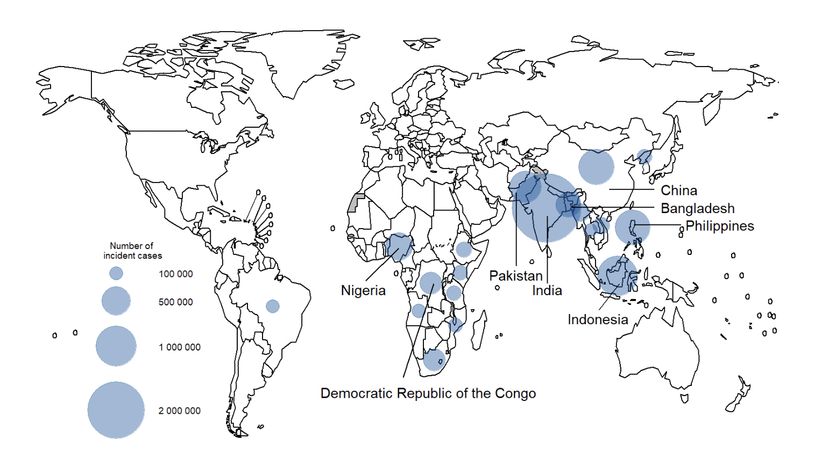
Figure 1: Tuberculosis incidence rates around the world - image by WHO 2021 https://www.who.int/teams/global-tuberculosis-programme/tb-reports/global-tuberculosis-report-2022/tb-disease-burden/2-1-tb-incidence#:~:text=An%20estimated %20global%20total%20of,among%20people%20living%20with%20HIV²
Globally, the case fatality ratio (CFR) for TB was 16% in 2016. Between 2000 and 2016, TB treatment saved an estimated 44 million deaths among HIV–negative and 9 million deaths among HIV–positive in support with anti–retroviral therapy (ART).
Pulmonary TB has conventionally been the most common form in children. During the last few years, EPTB cases especially tuberculous lymphadenitis have surpassed cases of pulmonary TB in children21.
EPIDEMIOLOGY OF CUTANEOUS TUBERCULOSIS

CTB is a less common clinical form of TB which accounts for approximately 1–2% of the total number of EPTB cases but significantly contributing to morbidity22,23. Global resurgence of CTB is in line with the increasing pulmonary TB incidence and emergence of multidrug resistance (MDR)24. The prevalence of CTB among Indian dermatology outpatients has ranged from 0.1– 0.9% over the last few decades8,12,23. Kumar et al reported 280 patients suffering from CTB of the total 2,67,420 patients from a tertiary care hospital in India; giving a prevalence of 0.1% among dermatology patients23.
EPIDEMIOLOGY OF CHILDHOOD CUTANEOUS TUBERCULOSIS
Childhood CTB is mostly studied from developing countries and the reported prevalence varies a lot25. It has ranged from 82% in Pakistan, 24.3% in Ethiopia, 50% in Hong Kong with a downward trend over time of all CTB cases6,26. In India, the prevalence has ranged from 18% to 54%, out of which state wise distribution being 18.7% in Chandigarh, 20.4% in Varanasi, 24.41% in Chennai and 31.7%-53.9% in Delhi7,8,25,27,28,29. CTB is common in children aged 10 –14 years, although no age group is resistant. A significant gender predilection is not apparent. The clinical spectrum of CTB in children is comparable to that in adults, except for a higher likelihood of disseminated and systemic involvement21. Childhood CTB has been often reported to develop following BCG vaccination30.
While lupus vulgaris (LV) remains the commonest form of CTB seen in most countries, tuberculids especially lichen scrofulosorum (LS), have recently emerged as the commonest variant in many regions like Hong Kong6. Tuberculids are also rapidly becoming one of the most common manifestations of CTB in India. Scrofuloderma (SFD), once reported to be the commonest form in certain populations (e.g., in mexicans), is relatively less frequently encountered now12.
IMMUNOLOGY IN CUTANEOUS TUBERCULOSIS
Just as in leprosy and pulmonary TB, a varied immunological spectrum is seen in CTB ranging from higher cell-mediated immunity (CMI) pole in LV, with active cellular immunity and normal levels of immunoglobulins, to SFD and cutaneous miliary TB, with relatively less active CMI and high humoral response (high levels of immunoglobulins)31.
Immunosuppression from any reason represents the main driving force for active disease development of the disease32.
TABLE 1: Types of Cutaneous Tuberculosis (CTB) tabulated on the basis of their properties and diagnostic interpretations.
 | Exogenous Cutaneous TB |  | Endogenous Cutaneous TB
 | Tuberculosis Verrucosa Cutis (TBVC) | Tuberculous Chancre | Lupus Vulgaris | Scrofuloderma | Orificial TB | Tuberculous Gumma | Acute Miliary TB
Prevalence | Common | Rare | Most common form in adults, 2nd most common in children | Most common form in children | Relatively rare | Rare | Rare and severe
Mode of Infection | Inoculation | Inoculation/  trauma | Hematogenous/  Lymphatic spread | Contiguous spread from underlying focus | Self-inoculation | Hematogenous spread | Hematogenous spread
Prior sensitisation | Present | Absent | - | - | - | - | -
Immunity against MTB | Moderate – High | Initially none | Moderate | Weak | Immuno-compromised | Immuno-compromised | Poor immune status
Location | Foot, buttocks | Local trauma | Head and Neck | Skin over cervical lymph nodes | Mucocutaneous junctions of orifices | Single multiple lesions on limbs | Generalised
PPD | Strongly positive | Initially negative | Positive | Positive | Negative | Negative | Negative
HPE General | Epidermal hypertrophic changes: pseudo epitheliomatous hyperplasia | Acute neutrophilic inflammation | Typical Epithelioid granulomas + Langhans Giant cell without caseous necrosis | Non Specific ill-formed granulomas with intense caseous necrosis | Necrosis and ulceration | Widespread caseation necrosis | Necrosis and ulceration
Tuberculoid  Granulomas | Sparse | Granulomas + | Granulomas ++++ | Granulomas + | Granulomas ++ | Granulomas ++ | Granulomas ++
Bacillary load | Paucibacillary | - | Paucibacillary | Multibacillary | Multibacillary | Multibacillary | Multibacillary
AFB | Rarely detected | - | Rarely detected | Detected | Detected | Detected | Detected
Course | Slow | Chancre heals within 3-12 months | Deep tissue destruction | May heal spontaneously over months-years | Resistant to ATT | Widespread involvement | Poor prognosis
Complication | Elephantiasis, Secondary bacterial infection | LV, Scrofuloderma or miliary TB | Small cell carcinoma | Scars | Fatal | - | -

CLASSIFICATION OF CUTANEOUS TUBERCULOSIS
(A) EXOGENOUS CTB
1. Tuberculosis verrucosa cutis (TBVC)
Pathogenesis: TBVC is the most common form of inoculation CTB. It occurs as a result of primary inoculation in immunocompetent individuals who are previously sensitized to M. tuberculosis. In tropical zones, TBVC often occurs over the foot and buttocks of children, on account of their habit of walking/sitting naked on sputum contaminated soil33,34. Extremities and other trauma prone sites are typically involved. Occupational exposure due to self–inoculation possibilities in cases like dentist treating the mouth of a pulmonary TB patient or a butcher handling M. bovis contaminated meat. Purified Protein Derivative (PPD) test is strongly positive in this case35,36,37.
Clinical features: Lesions are usually solitary and painless verrucous papules or plaques, with fissures/clefts that may exude pus and, often, erythema or purplish inflammatory halo25,38. Peripheral extension results in gradual expansion of the lesion that may lead to a serpentine outline with involution at the center. Sometimes extensive form of the disease may result in limb deformities. Lymphadenopathy is less common when compared to SFD and LV.
Laboratory diagnosis: On histology, it shows striking epidermal hypertrophic changes like pseudo epitheliomatous hyperplasia, the presence of acute neutrophilic abscess formation and sparse tuberculoid granulomas7. TBVC is a paucibacillary form of CTB, with AFB being rarely detected35,39.
Course: Without treatment, extension of CTB is slow and the lesions persist indefinitely, spontaneous resolution occurs rarely40. Complications like secondary bacterial infection and elephantiasis of extensive lesions affecting extremities41.
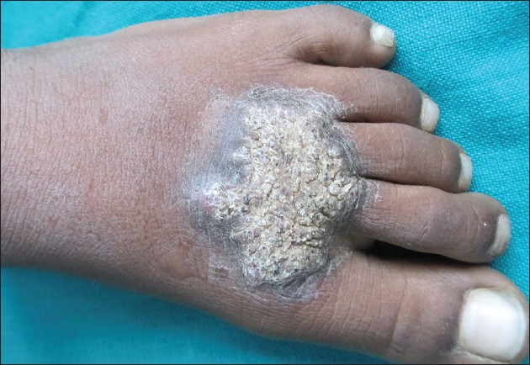

Figure 2: Tuberculosis verrucosa cutis - image by Rao AG via “https://ijdvl.com/scrofuloderma-associated-with-tuberculosis-verrucosa-cutis/”
2. Tuberculous chancre (Primary inoculation tuberculosis)
Pathogenesis: It is rare form of inoculation CTB that develops in adults without previous sensitization to the bacillus21. It is rare in children, though frequent in unvaccinated having contact with pulmonary TB patients35,42. Inoculation occurs during local trauma, which may be trivial (often unnoticed), may occur during tattooing, ritual circumcision or ear–piercing, or from exposure to unsterilized material during surgical procedures38,43.
Clinical features: After 2–4 weeks of inoculation, a firm more than 1 cm sized painless, reddish–brown papule or nodule arises, which evolves into a shallow friable ulcer with undermined bluish margins and a coarse granular base. It is typically painless but tends to bleed. Trauma prone sites like face, extremities are most frequently involved. Lymphatic dissemination occurs resulting in regional lymphadenopathy which may break to present as a discharging sinus39,40.
Laboratory diagnosis: On histopathology, early changes show acute neutrophilic inflammation. After 3–6 weeks, caseous granulomas develop and bacilli begin to disappear. Course: The chancre tends to heal with atrophic scarring between 3 and 12 months. Spontaneous regression may occur along with scarring and calcification at the level of regional lymph nodes or the patient may develop LV17.
PPD initially being negative might later become positive as the disease progresses (usually post 15 days)17. However, ATT is strongly recommended, since untreated chancre may become complicated with development of LV or SFD or may lead to dissemination resulting in acute miliary TB.
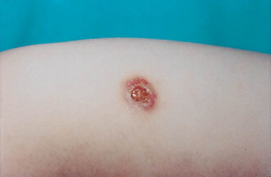
Figure 3: Tuberculous chancre – image by Mariano A “https://www.sciencedirect.com/science/article/abs/pii/S0190962200762189”
(B)ENDOGENOUS CTB
1. Lupus Vulgaris (LV)
Pathogenesis: LV is the commonest CTB in adults, and 2nd common type after Scrofuloderma in children25. LV is a chronic form of CTB that occurs in immunocompetent previously sensitised individuals. Women are more commonly affected. Although the most common mode of infection is hematogenous or lymphatic dissemination from an endogenous source, it may also develop from direct inoculation, at site of BCG vaccination, or over the drainage scar of SFD30,44. The most common sites are the head and neck (disseminating disease), and lower limb and gluteal region (secondary to inoculation).
Clinical features: LV is highly variable with diverse morphology in the lesions. Typical lesions (also called “classical plaque”) consist of papules and well–defined reddish plaques. The plaque expands with serpentine borders, reaching a diameter of over 10 cm with central discolouration. Presence of involution and scarring in one area and simultaneous progression in another area of the lesion resulting in a geographic or gyrate appearance is characteristic of classical LV21,25. Diascopy of the lesion has classically been described to reveal soft reddish–brown “apple jelly” nodules that represent the micro-granulomatous papules that combine to form plaques of LV. However, the ‘apple jelly’ appearance is not specific for LV; it may be seen in other granulomatous diseases34,40. Other morphological variants of LV include hypertrophic, ulcerative and mutilating, vegetative and tumour like, atrophic and planar. Systemic involvement in LV is less compared to SFD25. Systemic tubercular foci have been reported in the lymph nodes, lungs, and liver. LV may also present with nodules, psoriasiform lesions, vegetating lesions, sporotrichoid lesions, kissing lesions around the gluteal cleft^{12,21,25,45,46.}
Laboratory Diagnosis: Histopathology of LV lesions shows typical epithelioid granulomas with lymphocytes and langhans giant cells in most of the cases7,8,23. The hypertrophic form also shows epidermal hyperkeratosis, acanthosis and papillomatosis. Necrosis is absent and fibrosis occurs following healing. AFB is scanty and difficult to diagnose. Thus, LV is considered a paucibacillary form of CTB.
The use of dermatoscopy in the diagnosis has been recently suggested, in which linear telangiectasias seen on a yellow–golden background and white streaks. Although it is non-specific, but it may be helpful in combination to other findings47.
Course: Untreated LV lesions may grow to become gigantic and often lead to deep tissue destruction with significant aesthetic alterations33,34,40. Malignant transformation into squamous cell carcinoma, due to untreated LV for long term, has ranged from 0.5–10.5%48,49.
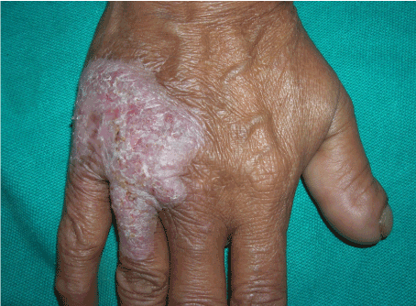
Figure 4 : Lupus Vulgaris- Image by Thomas M “https://www.oatext.com/Cutaneous-lupus-vulgaris-Bringing-the-wolf-out-of-the-darkness.php”
2. Scrofuloderma (SFD)
Pathogenesis: SFD is the most common form of CTB in children. SFD can affect any age, extremes of age are commonly affected, owing to relatively weaker immune responses7. SFD occurs due to contiguous spread from an underlying primary tubercular focus, usually a lymph nodes or bone, and sometimes joints or testicles39. Involvement of overlying skin from an underlying tubercular focus disease causes SFD. The underlying foci can be tuberculous lymphadenitis or tuberculous bone infection. PPD test is usually positive. The most common source of SFD lesions is the cervical group of lymph nodes, which then involves the overlying skin. This might be due to prevalent habit of drinking unpasteurized milk8. Other groups of lymph nodes can also be involved which then affect the overlying areas respectively. In addition, tuberculous affliction of bones, joints, testes, and breasts may also give rise to SFD8,23,50.
Clinical features: SFD is characterized by the formation of painless, gradually expanding cold abscesses overlying lymph nodes or bone/joint, followed by the formation of ulcerated plaques and fistula that may discharge caseous material. Ulcers are shallow with undermined edges and blue oedematous margins. In children and immunosuppressed patients, the lesions can be widespread and multiple. Often, a patient presents with active draining lesions of SFD over a background of puckered scarring, reminiscent of previous healed lesions. Uncommon variants of SFD include multifocal lesions, linear sporotrichoid lesions, scrofulous gumma and SFD at the site of BCG vaccination27,45,50. Other variants of CTB, most commonly LV, have been reported to develop over and adjacent to the sinuses and scars of SFD38. PPD is strongly positive17,51.
SFD is more often than not, associated with an underlying systemic tuberculous focus, most commonly pulmonary, followed by bone, and abdominal TB23.
Laboratory Diagnosis: Diagnosis is usually evident on clinical examination. Biopsy from the margins of lesion may show tubercular granulomas, the histopathology is non–specific in many cases8,23. Caseous necrosis, ulcers and abscess are commonly found. Compared to other forms of CTB, SFD shows extensive granulomatous involvement and predominantly with giant cells. SFD is a multibacillary form with abundant AFB as well as positive culture findings compared to other types of CTB7,23,27. The tuberculin test is usually positive.
Course: SFD runs a very protracted course, though it tends to heal spontaneously over months and years, leaving behind cerebriform or bridging scars and pockets of retraction.
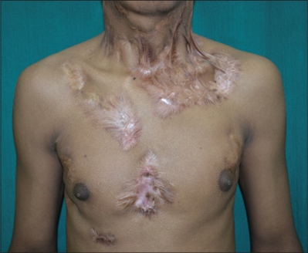
Figure 5 : Image by Rambhia KD “https://ijdvl.com/multifocal-tuberculous-gummas-and-bilateral-scrofuloderma-followed-by-papulonecrotic-tuberculids-developing-during-anti-tubercular-therapy/”
3. Orificial Tuberculosis
Pathogenesis: Extension of TB infection at the mucocutaneous junction of orifices (mouth, palate, vulva, anus and urethra), in patients with severe TB on the contiguous area (eg. Intestine for mouth and anus or urogenital tract for urethra). It usually affects immunocompromised patients with well propagated TB and is rare. Clinical features: Lesions consist of 1–3 cm sized erythematous–to–yellowish, friable and painful papules and nodules developing more commonly in or around mouth and less commonly surrounding genital or anal mucosa21. They progress to painful ulcers with undermined edges perilesional edema.
Laboratory diagnosis: On histopathology, tubercular granulomas with necrosis/ulceration, but with profound AFB is seen. Pain at the orifices with advanced TB disease is hallmark feature. It is a multibacillary form of CTB so the culture is generally positive17.
Course: The severity of the underlying visceral disease renders a poor prognosis. Resistance to ATT has been reported in some. Unimpeded progression may result in fatality34.
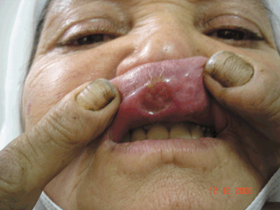
Figure 6 : Orificial Tuberculosis – image by Arzu Kilic “https://onlinelibrary.wiley.com/doi/abs/10.1111/j.1365-4632.2009.03942.x”
4. Tuberculous Gumma
Pathogenesis: Tuberculous gumma, occurs from hematogenous dissemination of TB during low immunity periods resulting in multiple lesions21,34. It typically affects immunocompromised adults, malnourished children. Tuberculous abscesse is also seen in patients with acute miliary TB52.
Clinical features: Lesions involve are characterized by subcutaneous nodules that are non-tender that may form sinuses or undermined ulcers. Nodules may ulcerate and drain caseous material. Lesions with overlapping features of SFD and gumma have been called scrofulous gumma. In fact, TB gumma is considered by some to be a severe variant of SFD21. Regional lymphadenopathy is usually not present. Laboratory diagnosis: Presence of tubercular granulomas with extensive caseous necrosis and profuse amounts of AFB is seen on histopathology.
Course: In immunocompetent individuals, without treatment, the abscess may persist for years followed by spontaneous resolution with scarring. Patients with compromised immunity tend to have a poor prognosis.
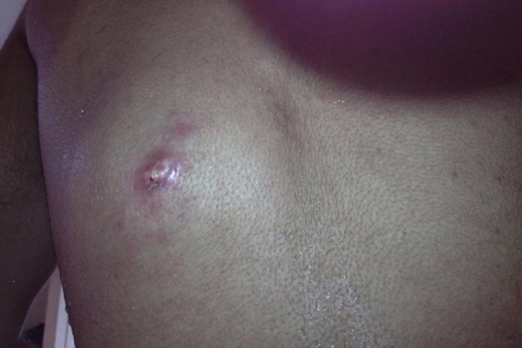
Figure 7 : Tuberculous gumma – image by Parker Louise “https://casereports.bmj.com/content/2013/bcr-2013-010462”
5. Acute Miliary Tuberculosis

Pathogenesis: Miliary TB of skin follows generalized miliary TB which occurs after haematogenous dissemination of bacilli into the skin. It is a rare and severe form of TB and affects children with poor immune status25. Disseminated miliary TB of the skin has been reported in AIDS patients, and this presentation may become more common owing to the TB–HIV co–epidemic53.
Clinical features: Widespread erythematous to purplish papules, pustules, or vesicles develop that break down forming umbilication and crust. Lesions regress in 1– 4 weeks, resulting in depressed and hypopigmented scars. Affected individuals are seriously ill with severe constitutional symptoms like fever, anorexia, asthenia, and weight loss. Affection of internal organs is common, especially the lungs and meninges. The tuberculin skin test is almost always negative, demonstrating energy resulting from severe immunosuppression.
Laboratory diagnosis: It is characterized by tubercule granulomas with necrosis/ulceration, with copious amounts of AFB on histopathology17,54.
Course: Poor prognosis is seen although may respond to treatment.
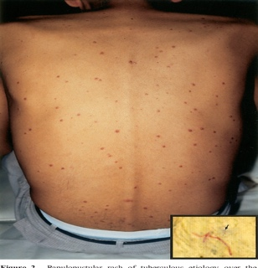
Figure 8 : Acute miliary TB – image by Daikos G “https://www.semanticscholar.org/paper/Disseminated-miliary-tuberculosis-of-the-skin-in-of-Daikos-Uttamchandani/282cacd268131e9e17f1d470a15b41e8e64aa46e”
TUBERCULIDS
Tuberculids are cutaneous representations of immunologic reaction to the presence of M. tuberculosis or their products in immunocompetent patient. Their development and presentation fluctuates on the basis of underlying host immune status. There are certain diagnostic features of tuberculids21,25,38:
• Skin shows tuberculoid picture on histopathology,
• No AFB in smears,
• No mycobacterial growth on culture,
• Evidence of tubercular focus elsewhere (concurrent or past),
• A Strong positive PPD test and
• Lesions resolve with ATT.
Types of tuberculids – 1) Papulonecrotic tuberculid (PNT), 2) Erythema induratum of Bazin (EIB), 3) Lichen scrofulosorum (LS) and 4) Phlebitic tuberculid.
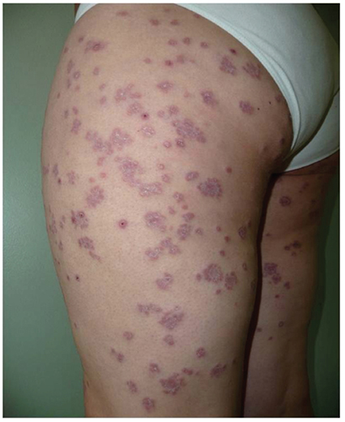
Figure 8 : Tuberculid – image by Brinca A “https://www.pagepress.org/journals/index.php/dr/article/view/dr.2011.e29/4865”
HIV AND CUTANEOUS TUBERCULOSIS
Concomitant HIV infection has been found to be a predisposing factor for acquiring severe pulmonary and extra–pulmonary forms of TB. However, the relationship of HIV infection and cutaneous TB is not very clear, but it may be more severe in patients with HIV43. In various Indian case studies, all children with cutaneous TB tested negative for HIV by enzyme–linked immunosorbent assay (ELISA)7,23,27. A single case series of 231 patients from South India reported only two HIV positive cases28.
LABORATORY DIAGNOSIS OF CUTANEOUS TUBERCULOSIS
Diagnosis of CTB is primarily based on the clinical appearance of the skin lesions supported by various laboratory tests. The diagnostic accuracy of any single lab test in confirming the diagnosis of CTB is low, therefore it becomes mandatory for the physician to order different tests in order to support positive evidence for the diagnosis and avoid giving empirical treatment.
MANTOUX TEST
Mantoux test also called tuberculin skin test (TST), is a widely used screening test performed to identify sensitized individuals to M. tuberculosis. The test involves injection of 5 tuberculin units (0.1 mL) of PPD derived from M. tuberculosis, using 26 or 27 gauze needle, on the volar aspect of left forearm about 2 inches lower than elbow. The reaction, a classical delayed hypersensitivity reaction, results in induration that is read after 48–72 hours.
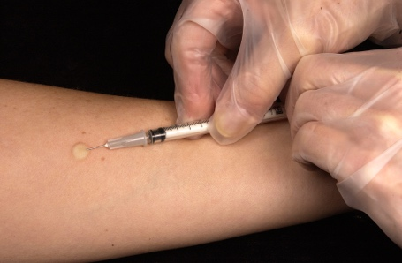
Figure 9 : Mantoux test
An induration measuring ≥10 mm is considered significant and indicates infection (i.e. previous sensitization to Tubercle bacilli) but not necessarily the disease. If vesicle or bulla formation or necrosis occurs, it indicates high degree of tuberculin sensitivity and presence of an active infection. A false–positive result may also occur in case of nontuberculous mycobacteria infection or post BCG vaccination78.
For cutaneous tuberculosis, TST has sensitivity ranging from 33%-96%, specificity of 62.50% with a cut–off of 10 mm and thus has low accuracy in doubtful cases of CTB. It has also been suggested that for patients with clear evidence of immunosuppression, a lower cut–off of 5 mm may be more suitable. The impact of BCG vaccination on TST positivity in endemic populations cannot be ignored. In unvaccinated individuals, the sensitivity is much higher, reaching 97%55. A high mantoux positivity ranging from 91.8% to 97% has been reported in patients with localized CTB in contrast to 50% in those with disseminated disease8,23. Tuberculin test shows highest positivity in tuberculids, with common occurrence of exaggerated reactions, as reported by Singal et al in 100% cases of lichen scrofulosorum56.
HISTOPATHOLOGY
The hall mark of histology of classic CTB lesion is the presence of characteristic granuloma composed of epithelioid cells, lymphocytes and langhans giant cells. Other features like distribution of granulomas in dermis, their compactness, and presence of caseous necrosis, cellular infiltrate, and epidermal changes varies with different clinical types of CTB. Based on the host immune response, histology of CTB may be grouped into three groups38: (1) Well– formed tubercle granulomas without caseous necrosis: LV and LS, (2) Granulomas with caseous necrosis: TBVC, tubercular chancre, acute military TB, tuberculosis orificialis and PNT (3) Presence of poorly formed tubercle granulomas with intense caseation necrosis: SFD and tubercular gumma. The most common histological feature is the presence of tuberculoid granuloma in dermis (57-96% of biopsy samples) followed by epithelial hyperplasia in 57-86% and caseous necrosis in 11.8-57%28,56,57. Classical tubercular histopathology is seen more often in LV lesions as compared to SFD. A clinico–histopathological concordance was observed in 64-85.6% of the cases of paediatric cutaneous TB7,23,29. Histopathology becomes of prime importance for diagnosis of tuberculids where bacilli cannot be isolated by culture or demonstrated by AFB staining. In 10% of LV cases, superinfection with TB elsewhere will lead to an active disease58.
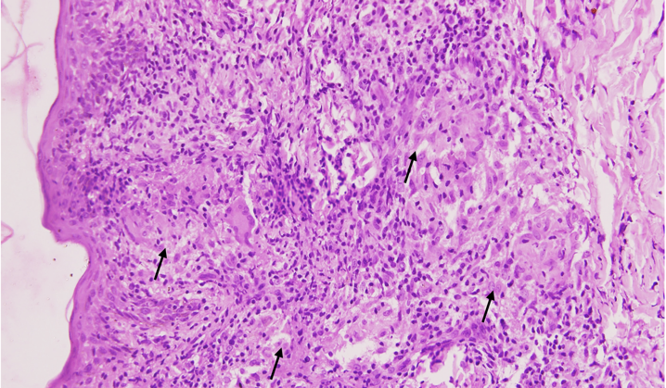 | 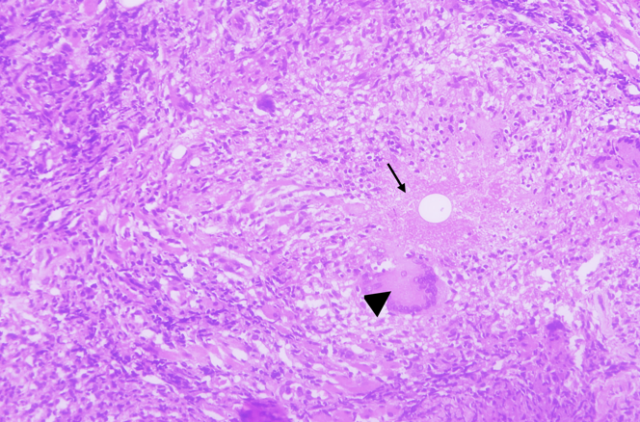

Figure 10 A (Left) : Intact epidermis with mild irregular acanthosis. Multiple epithelioid cell granulomas (arrows) in the upper and mid dermis on Haematoxylin & Eosin staining (x 200).

Figure 10B (Right): Deeper dermis showing epithelioid cell granuloma with caseation (arrow) and langhan’s giant cell (arrow head) on Haematoxylin & Eosin staining (x 400).
MICROBIOLOGICAL TESTS
1. Demonstration of Acid–Fast Bacillus (AFB) in the Stained Smear
Direct demonstration of AFB, on Ziehl–Neelsen staining, in the tissue smear from exudative skin lesions, lymph node aspirates or biopsy specimens, gives faster results than culture although sensitivity gets compromised. The detection sensitivity of smears is higher for exudative lesions of CTB, especially the multibacillary forms because of the obvious higher bacterial load, as in the cases of primary inoculation, SFD, tuberculosis orificialis, or metastatic tuberculous abscess. A higher AFB positivity has been reported in SFD cases (36.8%) as compared to LV lesions (13.6%).
2. Mycobacterial culture:
As for any infection, the definitive diagnosis of Tuberculosis continues to depend on the culture of microorganism. Another advantage of culture is that it can distinguish mycobacterium subspecies and allow drug susceptibility testing. CTB in general is regarded as a paucibacillary infection, therefore mycobacterial isolation from smears and lesion biopsy, on the conventional Lowenstein– Jensen (LJ) medium is reported to be as low as 8.8% and 10.7% in two different studies involving CTB cases exclusively7,23. In addition, the time for final negative growth result on LJ medium is 6–8 weeks.
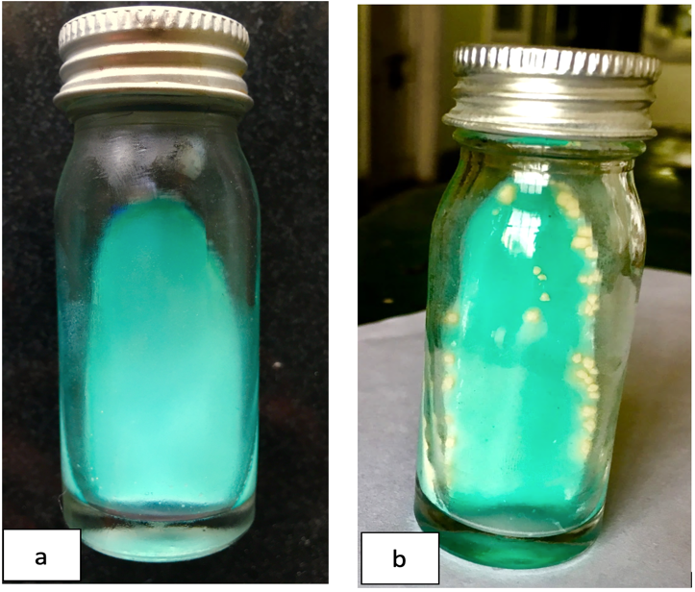  Figure 11 : Lowenstein-Jensen medium showing: a) No growth, b) Colonies of Mycobacterium tuberculosis. | 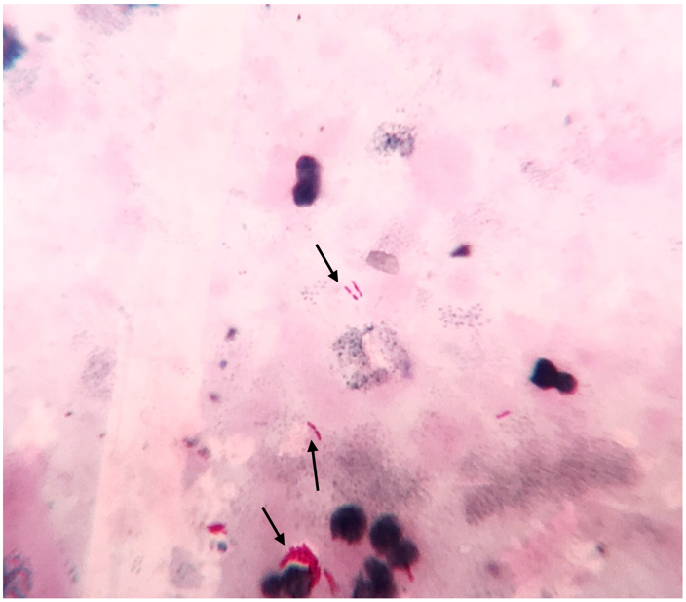  Figure 12 : Acid fast bacilli (arrows) seen on the direct smear made from processed skin biopsy sample on Ziehl-Neelsen staining (x 1000).
The culture methods are more sensitive than AFB staining and can be positive even with low bacterial load (10–100 bacilli/mL) with sensitivity of 80–85% and specificity of 98%, required for identification of causative organisms. Growth is very slow and usually takes 6–8 weeks. Post growth the same amount of time is required for antimicrobial sensitivity testing. Most commonly used solid culture medium is LJ medium. Other solid media that can be used are Petragnini (egg based) medium, Dorset’s medium (egg based), Pawlowsky (potato based), Middlebrook 7H10 and 7H11medium (agar based).
The inoculated LJ media are incubated at 37oC. The bacilli grow very slowly and colonies appear in about 2 weeks and sometimes upto 6–8 weeks. In positive culture, characteristic colonies appear dry, rough, buff coloured, raised, with a wrinkled surface. They are tenacious and not easily emulsified. M. tuberculosis has a luxuriant growth (eugonic growth)59.
Liquid culture media media reduces the growth time for isolation of tubercle bacilli to approximately 10 days. Growth of mycobacterium in liquid medium requires 5 % 10% CO2. Besides solid media, liquid media available are Middlebrook 7H9, Dubo’s medium, Sula’s medium, Proskauer and Becks’s medium.
Mycobacteria growth indicator tube (MGIT)
MGIT is a type of liquid culture method. It is a rapid method which consists of tubes having 4 mL of modified Middlebrook 7H9 broth which has an fluorescent sensor at the bottom which is sensitive to oxygen in the medium60. When mycobacteria grow, they use up the dissolved oxygen in the broth, thus reducing the oxygen content which thus allows the indicator to produce fluorescence under UV light. Generally with this method, positive signals are obtained within 10–12 days. MGIT can also be used for antimicrobial susceptibility testing. An advantage over BACTEC is its lower cost and has no radioactivity issues61. MGIT gives higher yield and faster results although it incurs a relatively higher cost62.
3. Serological tests:
Most serological tests have lower turnaround time. However, the utility of antibody detection frequently appears compromised, firstly due to BCG vaccination and secondly due to immunological sensitization by environmental mycobacteria.
i) Antigen Detection
Quantitative tests and dipstick method (semiquantitative) to detect lipoarabinomannan (LAM) in pulmonary and extra–pulmonary specimens have been developed. Their utility in the diagnosis of CTB remains to be explored.
ii) Interferon Gamma Release Assays (IGRA’S) – Quantiferon TB Gold and T–SPOT TB These two tests are commercially available, FDA approved, in vitro serological assays that quantify the amount of interferon–gamma released by blood monocytes upon their stimulation by highly specific M. tuberculosis antigen. Both assays have higher sensitivity and specificity compared to the traditional TST. However, previous exposure to atypical mycobacterial infections such as M. marinum and M. kansasi may give false positive results. The likelihood of indeterminate results is higher (to the tune of 30%) in elderly population (>65 years old), compared to other age groups (3.1%)38.
Indeterminate results are also seen in patients with immunosuppression, low CD4 counts, severe systemic diseases, malnourishment with low serum proteins, and increased C–reactive serum proteins. The utility of these assays lies as a screening tests for latent TB especially in patients with kidney disease, planned transplant, under treatment with anti–TNF–alpha therapies, contacts of AIDS patients38.
4. Molecular tests (NAAT- Nucleic Acid Amplification Test):
A large number of sample organism load of M. tuberculosis was required by the above diagnostic methods. Molecular tests comes into the picture which can amplify the genome, even if the sample contains a single organism, which is required for paucibacillary TB cases.
Such tests are real time PCR, LCR (Ligase Chain reaction), CBNAAT (Cartridge Based NAAT), LAMP (Loop Mediated Amplification), LPA(Loop Mediated Amplification).
GeneXpert NAAT test boasts a 100% sensitivity and 91.6% specificity for extra–pulmonary specimens63. Molecular tests are more so uselful in EPTB cases and those cases which have a high clinical suspicion but conventional diagnostic methods have failed.
Systemic Screening for Tubercular Focus
Coexistent systemic focus of TB has been observed in about one fourth of all patients with cutaneous lesions12. The range is reportedly higher in paediatric population (21.3–53.4%)7,8,23,29. Thus, it becomes mandatory to screen all patients of CTB carefully.

References:

- Global tuberculosis report: Epidemiology, strategy, financing: WHO report 2022. Geneva, World Health Organization, 2022.
- Global tuberculosis report: Epidemiology, strategy, financing: WHO report 2022. Geneva, World Health Organization, 2022.
- Fitzgerald DW, Sterling TR, Haas DW. Mycobacterium tuberculosis. In: Mandell GL, Bennett JE, Dolin R, editors. Principle and practice of infectious diseases. 8th ed. USA, Philadelphia: Churchill Livingstone;2015.p.2787–818.
- Varshney A, Goyal T. Incidence of various clinico–morphological variants of cutaneous tuberculosis and HIV concurrence: a study from the Indian subcontinent. Annals of Saudi Medicine. 2011 Mar 1;31(2):134–9.
- Ramam M, Tejasvi T, Manchanda Y, Sharma S, Mittal R. What is the appropriate duration of a therapeutic trial in cutaneous tuberculosis? Further observations. Indian J Dermatol Venereol Leprol. 2007 Jul 1;73(4):243–6.
- Chong LY, LO KK. Cutaneous tuberculosis in Hong Kong: a 10–year retrospective study. Int J Dermatol 1995 Jan 1;34(1):26–9.
- Vashisht P, Sahoo B, Khurana N, Reddy BS. Cutaneous tuberculosis in children and adolescents: A clinicohistological study. J Eur Acad Dermatol Venereol. 2007 Jan 1;21(1): 40–7.
- Kumar B, Rai R, Kaur I, Sahoo B, Muralidhar S, Radotra BD. Childhood cutaneous tuberculosis: A study over 25 years from northern India. Int J Dermatol. 2001 Jan 1;40(1):26–
- Sehgal VN, Srivastava G, Khurana VK, Shanma CK, Bhalla P, Beohar PC. An appraisal of epidemiologic, clinical, bacteriologic, histopsthologic, and immunologic parameters in cutaneous tuberculosis. Int J Dermatol. 1987 Oct 1;26(8):521–6.
- Tan SH, Tan HH, Sun YJ, Goh CL. Clinical utility of PCR in the detection of Mycobacterium tuberculosis in different types of cutaneous tuberculosis and tuberculids. Ann Acad Med Singapore 2001 Jan;30(1):3–10
- Ogusku MM, Sadahiro A, Hirata MH, Hirata RD, Zaitz C, Salem JI. PCR in the diagnosis of cutaneous tuberculosis. Braz J Microbiol. 2003 Jun;34(2):165-70
- Kumar B, Muralidhar S. Cutaneous tuberculosis: A twenty–year prospective study. Int J Tuberc Lung Dis. 1999;3(6):494–500.
- Iftikhar U, Nadeem M, Aman S, Kazmi AH. Scrofuloderma: A common type of cutaneous tuberculosis. A case report. J Pak Assoc Dermatol 2011;21:61–5.
- Boire NA, Riedel VA, Parrish NM, et al Tuberculosis: from an untreatable disease in antiquity to an untreatable disease in modern times. J Anc Dis Prev Rem 2013;1(2):1–11.
- Kakakhel KU, Fritsch P. Cutaneous tuberculosis. Int J Dermatol. 1989 Jul 1;28(6):355–62.
- Tappeiner G. Tuberculosis and infections with atypical Mycobacteria. In: Fitzpatrick TB, Eisen AZ, Wolff K, Freedberg IM, Austen KF, editors. Dermatology in general medicine. 7th ed. New York: McGraw–Hill;2008.p.1768–78.
- Ramos–E–Silva M, Castro MCR. Cutaneous tuberculosis. In: Bolognia JL, Jorizzo JL, Rapini RP, editors. Dermatology. 2nd ed. New York: Mosby Elsevier;2008.p.1114–9.
- Ara M, Seral C, Baselga C, Navarro M, del Pilar Grasa M, Carapeto FJ. Primary tuberculous chancre caused by Mycobacterium bovis after goring with a bull's horn. J Am Acad Dermatol. 2000 Sep 1;43(3):535–7.
- Bricks LF. Percutaneous or intradermal BCG vaccine?. J Pediatr (Rio J).2004 Apr;80(2):93–8.
- McShane H. Tuberculosis vaccines: beyond bacille Calmette–Guerin. Philos Trans R Soc Lond B Biol Sci. 2011 Oct 12;366(1579):2782–9.
- Sethuraman G, Ramesh V. Cutaneous tuberculosis in children. Pediatr Dermatol. 2013 Jan 1;30(1):7–16.
- Zouhair K, Akhdari N, Nejjam F, Ouazzani T, Lakhdar H. Cutaneous tuberculosis in Morocco. Int J Infect Dis. 2007 May 1;11(3):209–12.
- Pandhi D, Reddy BS, Chowdhary S, Khurana N. Cutaneous tuberculosis in Indian children: the importance of screening for involvement of internal organs. J Eur Acad Dermatol Venereol. 2004 Sep 1;18(5):546–51.
- Hamada M, Urabe K, Moroi Y, Miyazaki M, Furue M. Epidemiology of cutaneous tuberculosis in Japan: a retrospective study from 1906 to 2002. Int J Dermatol. 2004 Oct 1;43(10):727–31.
- Singal A, Sonthalia S. Cutaneous tuberculosis in children: the Indian perspective. Indian J Dermatol Venereol Leprol. 2010 Sep 1;76(5):494–503.
- Wong KO, Lee KP, Chiu SF. Tuberculosis of the skin in Hong Kong: a review of 160 cases. Br J Dermatol. 1968 Jul 1;80(7):424–9.
- Ramesh V, Misra RS, Beena KR, Mukherjee A. A study of cutaneous tuberculosis in children. Pediatr Dermatol. 1999 Jul 1;16(4):264–9.
- Umapathy KC, Begum R, Ravichandran G, Rahman F, Paramasivan CN, Ramanathan VD. Comprehensive findings on clinical, bacteriological, histopathological and therapeutic aspects of cutaneous tuberculosis. Trop Med Int Health. 2006 Oct 1;11(10):1521–8.
- Singal A, Mohanty S, Gandhi V, Bhattacharya S. Cutaneous tuberculosis in paediatric age group. In: Proceedings, 7th Congress of European Society for Paediatric Dermatology; 2002.p.33–4.
- Singal A, Sonthalia S, Pandhi D. Ulcerated lupus vulgaris at the site of Bacille Calmette–Guérin vaccination. Pediatr Dermatol. 2013 Jan 1;30(1):147–8.
- Sehgal VN, Wagh SA. Cutaneous tuberculosis. Current concepts. Int J Dermatol. 1990 May;29(4):237–52.
- Teixeira HC, Abramo C, Munk ME. Immunological diagnosis of tuberculosis: problems and strategies for success. J Bras Pneumol. 2007 Jun;33(3):323–34.
- Lai–Cheong JE, Perez A, Tang V, Martinez A, Hill V, Menagé HD. Cutaneous manifestations of tuberculosis. Clin Exp Dermatol. 2007 Jul 1;32(4): 461–6.
- Abebe F, Bjune G. The protective role of antibody responses during Mycobacterium tuberculosis infection. Clin Exp Immunol. 2009 Aug 1;157(2): 235–43.
- Bravo FG, Gotuzzo E. Cutaneous tuberculosis. Clin Dermatol. 2007 March 1;25(2):173–80.
- Rajan J, Mathai AT, Prasad PV, Kaviarasan PK. Multifocal tuberculosis verrucosa cutis. Indian J Dermatol. 2011 May;56(3):332–4.
- Kakakhel K. Simultaneous occurrence of tuberculous gumma, tuberculosis verrucosa cutis, and lichen scrofulosorum. Int J Dermatol. 1998 Nov 1;37(11):867–9.
- Santos JB, Figueiredo AR, Ferraz CE, Oliveira MH, Silva PG, Medeiros PG. Cutaneous tuberculosis: epidemiologic, etiopathogenic and clinical aspects: part I. An Bras Dermatol. 2014 Apr;89(2):219–28.
- Frankel A, Penrose C, Emer J. Cutaneous tuberculosis: a practical case report and review for the dermatologist. J Clin Aesthet Dermatol. 2009 Oct;2(10):19–27.
- MacGregor RR. Cutaneous tuberculosis. Clin Dermatol. 1995 May 1;13(3):245–55.
- Arnadottir T, Rieder HL, Trébucq A, Waaler HT. Guidelines for conducting tuberculin skin test surveys in high prevalence countries. Tuber Lung Dis. 1996 Jun 1;77 Suppl1:1–19.
- Liang MG, Rooney JA, Rhodes KH, Calobrisi SD. Cutaneous inoculation tuberculosis in a child. J Am Acad Dermatol. 1999 Nov 1;41(5):860–2.
- Wong HW, Tay YK, Sim CS. Papular eruption on a tattoo: a case of primary inoculation tuberculosis. Australas J Dermatol. 2005 May 1;46(2):84–7.
- Motta A, Feliciani C, Toto P, De Benedetto A, Morelli F, Tulli A. Lupus vulgaris developing at the site of misdiagnosed scrofuloderma. J Eur Acad Dermatol Venereol. 2003 May 1;17(3):313–5.
- Ramesh V. Sporotrichoid tuberculosis. Clin Exp Dermatol. 2007 Nov 1;32(6):680–2.
- Saritha M, Parveen BA, Anandan V, Priyavathani MR, Tharini KG. Atypical forms of lupus vulgaris: a case series. Int J Dermatol. 2009 Feb 1;48(2):150–3.
- Micali G, Lacarrubba F, Massimino D, Schwartz RA. Dermatoscopy: alternative uses in daily clinical practice. J Am Acad Dermatol. 2011 Jun 1;64(6):1135–46.
- Zawirska A, Adamski Z, Stawicka E, Schwartz RA. Cutaneous squamous cell carcinoma developing in lupus vulgaris exfoliativus persistent for 40 years. Int J Dermatol. 2009 Feb 1;48(2):125–7.
- Gooptu C, Marks N, Thomas J, James MP. Squamous cell carcinoma associated with lupus vulgaris. Clin Exp Dermatol. 1998 May 1;23(3):99–102.
- Singal A, Pandhi D, Agrawal SK. Multifocal scrofuloderma with disseminated tuberculosis in a severely malnourished child. Pediatr Dermatol. 2005 Sep 1;22(5):440–3.
- Angel DI, Alfonso R, Faizal M, Ricaurte O, Baez JA, Rojas A, et al Cutaneous tuberculosis diagnosis in an inhospitable Amazonian region by means of telemedicine and molecular biology. J Am Acad Dermatol. 2005 May 1;52(5):S65–8.
- Almagro M, Del Pozo J, Rodriguez–Lozano J, Silva JG, Yebra–Pimentel MT, Fonseca E. Metastatic tuberculous abscesses in an immunocompetent patient. Clin Exp Dermatol. 2005 May 1;30(3):247–9.
- Daikos GL, Uttamchandani RB, Tuda C, Fischl MA, Miller N, Cleary T, Saldana MJ. Disseminated miliary tuberculosis of the skin in patients with AIDS. Clin Infect Dis. 1998 Jul 1;27(1):205–8.
- High WA, Evans CC, Hoang MP. Cutaneous miliary tuberculosis in two patients with HIV infection. J Am Acad Dermatol. 2004 May 1;50(5):S110–3.
- Ramam M, Malhotra A, Tejasvi T, Manchanda Y, Sharma S, Mittal R, et al How useful is the Mantoux test in the diagnosis of doubtful cases of cutaneous tuberculosis. Int J Dermatol. 2011 Nov 1;50(11):1379–82.
- Singal A, Bhattacharya SN. Lichen scrofulosorum: a prospective study of 39 patients. Int J Dermatol. 2005 Jun 1;44(6):489–93.
- Thakur BK, Verma S, Hazarika D. A clinicopathological study of cutaneous tuberculosis at Dibrugarh district, Assam. Indian J Dermatol. 2012 Jan;57(1): 63–5.
- Barnes PF, Bloch AB, Davidson PT, Snider DE Jr. Tuberculosis in patients with human immunodeficiency virus infection. N Engl J Med. 1991 Jun 6;324(23):1644–50.
- Baveja CP, Mycobacterium Tuberculosis. In: Textbook of Microbiology. 4th ed.Arya publication;2014.p.334–7.
- Hanna BA, Ebrahimzadeh A, Elliott LB, et al Multicenter evaluation of the BACTEC MGIT 960 system for recovery of mycobacteria. J Clin Microbiol. 1999 Mar 1;37(3):748–52.
- Gerdes SR, Domehl C, Nardi G, et al Multicenter evaluation of the mycobacteria growth indicator tube for testing susceptibility of Mycobacterium tuberculosis to first–line drugs. J Clin Microbiol. 1999 Jan 1;37(1):45–8.
- Chihota VN, Grant AD, Fielding K, Ndibongo B, van Zyl A, Muirhead D, Churchyard GJ. Liquid vs. solid culture for tuberculosis: performance and cost in a resource–constrained setting. Int J Tuberc Lung Dis. 2010 Aug 1;14(8):1024–31
- Ioannidis, P., Papaventsis, D., Karabela, S., Nikolaou, S., Panagi, M., Raftopoulou, E., Kanavaki, S. (2011). Cepheid GeneXpert MTB/RIF Assay for Mycobacterium tuberculosis Detection and Rifampin Resistance Identification in Patients with Substantial Clinical Indications of Tuberculosis and Smear–Negative Microscopy Results. J Clin Microbiol. 49(8), 3068–70.

