Structural, Thermal and Electrical Studies ON PVA: PVP: CH₃COONH₄ POLYMER GEL ELECTROLYTES
¹R.P. Kumhar, Kavita Krashnamoorti
Department of Physics MCB University, Chhatarpur (M.P.) India
¹Email: rpk1972ssi@gmail.com,
Abstract
An attempt has been made to cast a stable free standing PVA: PVP blend based polymer gel electrolyte film using ammonium acetate salt (CH₃COONH₄) and characterize them. Optical and XRD studies show improvement in amorphous nature of the present system. Formation of blend as well as composite polymer electrolyte is assured by DSC and XRD studies. Ionic conductivity of PVA: PVP blend based polymer gel electrolyte, namely, PVA: PVP: CH₃COONH₄ is seen to improve by an order of magnitude at room temperature with an optimum 1.34×10⁻³ S/cm for 0.4 mole ammonium acetate concentration. I-t measurement (t_{ion}~0.9) establish dominance of ionic charge transport in synthesized electrolytes. Combination of Arrhenious and VTF behavior is reflected during temperature dependent conductivity analysis. Jonscher Power law seems to be obeyed according to ac conductivity measurement.
Keywords: Blend based polymer electrolyte, PVA, PVP, ammonium acetate, XRD, DSC.
1. Introduction

Recently, polymer electrolytes have become materials of great interest for use in different electrochemical devices, such as batteries, supercapacitors, fuel cells etc due to their unique properties like ease mouldability into any shape, light weight, flexibility adhesive property and good electrode- electrolyte contact. However these polymer electrolytes exhibit low ionic conductivity in comparison to liquid electrolytes [1-3]. Over the years, a number of methods (addition of plasticizer, use of copolymer, formation of polymer gel electrolyte etc) have been tried to enhance the ionic conductivity to achieve a value close to that of liquid electrolytes [4-5]. Among these approaches, blending of two polymers leading to formation of blend based polymer gel electrolyte has emerged as one of the attractive way for conductivity improvement in polymer electrolytes [6]. Among the various host polymers used in electrolyte development, PVA exhibits excellent physical properties such as mechanical strength, electrochemical stability, non toxicity, good film forming capability and biocompatibility [7]. Further, it is a semicrystalline polymer where crystalline behavior can be suppressed by addition of amorphous natured PVP to great extent [8]. Further PVA based gel electrolyte system with ammonium salt has been shown to yield high electrical conductivity [9-10]. Prompted by these considerations, an attempt has been made in the present work to synthesize PVA: PVP blend based electrolyte namely, PVA: PVP: CH₃COONH₄ system and characterize their free standing films using DSC, optical microscopy, electrochemical measurements and conductivity measurements for device applications namely, solid state batteries.
2. Experimental
PVA (average molecular weight 124,000- 186,000 Aldrich make), PVP (average molecular weight 360,000 Aldrich make), ammonium acetate (CH₃COONH₄), AR grade sd fine chem make and aprotic solvent dimethyl sulphoxide (DMSO) Merk make, were used for synthesis of blend based polymer electrolyte. Both polymers PVA and PVP in the ratio (PVA: PVP) of 80:20 were dispersed in different molar salt solution of CH₃COONH₄ in DMSO and stirred for 8-10 h at 50⁰C to attain homogeneous mixing. The final viscous solution was poured in a poly carbonate pettri dish to obtain thick films of blend based electrolyte. Morphological behavior of as synthesized composite films was studied using XRD (RIGAKU JAPAN MINIFLEX-II in the range 2θ= 5⁰ to 70⁰ with wavelength λ= 1.5406 Ǻ) and optical polarizing microscope (Carl Zies- Germany model-HAL100). C-V and I-t measurements were performed on a CH- electrochemical workstation (CH instruments model CH608) to determine electrochemical window and nature of charge transport. Differential scanning calorimetry (DSC) runs were carried out at 10⁰C min⁻¹ heating rates to measure glass temperature (T_{g}) and melting temperature (T_{m}) in the temperature range 25- 330⁰C to asses morphology of resulting system. Electrical characterization of electrolyte sample was carried out using impedance spectroscopy technique. Complex impedance parameters were measured with a Hioki impedance analyzer (model 3520) in the frequency range 40 Hz- 100 KHz at different temperatures using platinum electrodes for electrical contact.
3. Result and discussion
3.1 XRD Studies
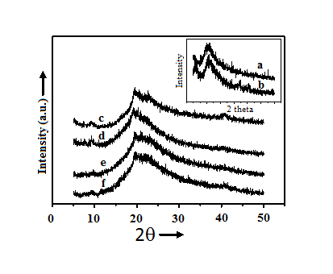
Figure 1 depicts the XRD pattern of DMSO casted PVA, PVP, PVA: PVP blend and PVA: PVP: CH₃COONH₄ complex for different salt concentrations. In the diffraction pattern of DMSO casted PVA gel film (inset a of fig 1) two convoluted
Figure 1. XRD pattern of DMSO casted PVA: PVP: CH₃COONH₄ blend based electrolyte containing (c) 0, (d) 0.2, (e) 0.4 and (f) 0.6 M CH₃COONH₄ salt. Inset shows XRD pattern of (a) DMSO casted PVA and (b) PVP.

peaks at 2θ= 19.6⁰ and 21.8⁰ are observed. The characteristic peak at 2θ= 19.6⁰ corroborates the result of Awadhia and Agrawal [11]. Broad XRD peaks located at 2θ=11⁰ and 22⁰ in diffractogram (inset b of fig. 1) correspond to PVP and conform to the result of Sivaiah et al [12]. Also, secondary reflections (relatively broad) observed at 44.7⁰ and 51⁰ (on 2θ scale) ascertain polycrystalline/semi-amorphous nature of the polymer. When the two polymer components are added to form PVA: PVP blend (80: 20 ratio), the characteristic peak of PVA shifts toward lower diffraction angle (19.44⁰) and characteristic peak related to PVP shifts toward higher 2θ value at 22.72⁰ fig. 1(c). Further 44.7⁰ and 51⁰ diffraction peaks vanish and a new peak is observed around 40.8⁰. These observations suggest formation of new material viz. PVA: PVP blend. In the diffraction pattern of PVA: PVP: CH₃COONH₄ blend based electrolyte (curve d, e, and f) the characteristic peaks of PVA (19.6⁰) and PVP (22⁰) seen to merge and result in a broad peak centered around 2θ=19.18⁰. The broadening of peak signifies enhanced amorphous nature of gel film. The broadening of intense peak can be correlated to the presence of excess liquid trapped within polymer blend matrix. It is being further noticed that as the fraction of salt in electrolyte increase, there is a small variation in the value of 2θ corresponding to characteristic peak of blend with increasing broadness which signifies change in the morphology of system. Low value of crystallite size clearly advocates for amorphous behavior of gel electrolytes under investigation (table 1).
Table 1. Average crystallite size, change in enthalpy and ionic transference number of blend based polymer electrolytes.
S.N. | Samples Name | Average Crystallite size (nm) | Change in enthalpy (J/g) | Ionic transference number t_{ion}
1. | PVA:PVP:DMSO | ~41.35 | - | -
2. | PVA: PVP: 0.2 M CH₃COONH₄ | ~36.21 | 24.68 | 0.89
3. | PVA: PVP: 0.4 M CH₃COONH₄ | ~32.40 | 8.7 | 0.94
4. | PVA: PVP: 0.6 M CH₃COONH₄ | ~37.12 | 98 | 0.94

3.2 Optical Studies

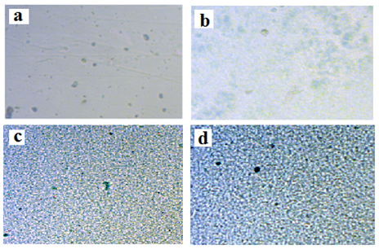
Optical micrographs of PVA, PVA: PVP blend and PVA: PVP: CH₃COONH₄ complex for two different salt concentrations are shown in figure 2. In the optical image of pure PVA: DMSO film (figure 2a) the dark regions symbolize the presence of porous structure - a feature well known [13]. Though the surface is uniform in physical appearance, the pores are heterogeneously distributed in the microstructure. The appearance of pores might be due to the interconnected network of polymer which are created due to solvent evaporation.
Figure 2. Optical Micrograph of DMSO casted (a) PVA, (b) PVA: PVP and PVA: PVP: CH₃COONH₄ electrolytes containing (c) 0.2 and (d) 0.4 mole ammonium acetate.

When PVP is added to PVA to form a blend the pores seem to fade out indicating improvement in system morphology (figure 2b). Upon addition of salt in PVA: PVP blend to form its gel electrolyte, morphology of blend is disturbed with enhancement in micropores and pore density on increasing salt content owing to better compatibility in presence of salt and change in system morphology (figure 2 c&d).
3.3 DSC Studies
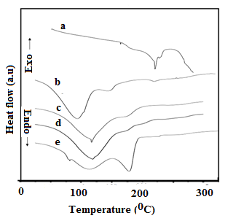
Figure 3 represent the thermal scan for pure PVA, PVA: PVP blend and PVA: PVP blend based electrolytes for different salt concentrations. PVA being a partially crystalline polymer exhibits both glass transition and melting transition. The glass transition, phelton melting and melting temperature of PVA are seen to occur at 88⁰C, 170⁰C and 216⁰C, respectively (scan a) and correspond with earlier
Figure 3. DSC thermograms of (a) PVA and PVA: PVP: CH₃COONH₄ containing (b) 0, (c) 0.2, (d) 0.4 and (e) 0.6 mole CH₃COONH₄ salt

reported data [13-14]. Intense and relatively broad endothermic transitions observed in the thermogram of PVA: PVP (80: 20) blend (scan b) around 94⁰C followed by a kink around 105⁰C is linked to water evaporation formed during PVA- DMSO interaction and humidity. Appearance of broad endothermic peak at 144⁰C in DSC profile (b), is correlated to melting of PVA: PVP blend while a small endotherm at 219⁰C corresponds to melting temperature of uncomplexed PVA. The presence of later endotherm suggests partial compatibility among polymer components. Besides these prominent peaks a broad shoulder endothermic transition in the range254⁰C-273⁰C is also seen in DSC profile. This transition can be correlated to melting of uncomplexed PVP. Moreover, this peak is extremely small in magnitude as compared to other transitions and also reflects partial compatibility as stated earlier. In the DSC thermogram of blend based electrolyte containing 0.2 M ammonium acetate (scan c) endothermic transitions are observed around (114⁰C, 162⁰C and 166⁰C) and correspond to melting point of un- reacted salt (mp= 114⁰C) the glass transition of un-complexed PVP and melting of blend- salt complex respectively. The melting temperature of composite electrolyte observed at 166⁰C (scan c) shifts towards higher temperature with enhancement in salt concentration (scan c-e). This is possibly due to improved interaction among polymer components in the presence of added salt. Melting temperature related to un-reacted PVP or its complex with salt and PVA salt complex are also evidenced in DSC thermogram. The enthalpy of melting temperature has also been calculated (table 1) and it is seen to decrease continuously till 0.4 mole salt content which indicates improvement in amorphous behavior of system. On increasing salt concentration beyond 0.4 M, degree of crystallinity enhances owing to formation of ion agglomerates.
3.4 Wagner’s Polarization
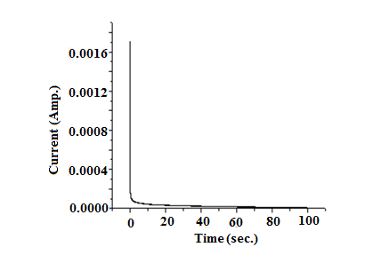
The total ionic transport number (t_{ion}) was evaluated using the well known d.c. polarization technique [15]. In this technique, as synthesized blend electrolyte samples were polarized by applying a step potential across cell configuration SS| electrolyte |SS and the resulting potentiostatic current measured as a function of time. The variation of current with time for electrolyte samples is shown in figure 4. Polarisation behavior is reflected in all these curves as per expectation. The calculated values of t_{ion} for different composite films varies from 0.9 to 0.96
Figure 4. I-t polarization curve of DMSO casted PVA: PVP: CH₃COONH₄ blend based polymer electrolyte containing 0.4 mole of salt.

(table 1) with varying molar concentration of salt which ascertains predominance of ionic charge transport over electronic transport in polymer electrolyte samples.
3.5 C-V Studies
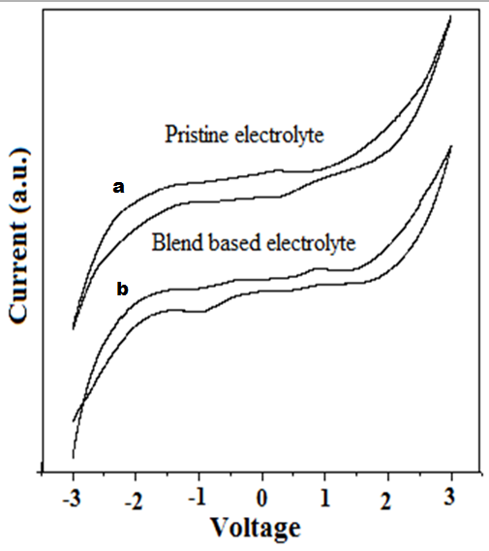
Figure 5 compares the cyclic voltagrams of PVA: CH₃COONH₄ pristine polymer gel electrolyte system and blend based polymer gel electrolyte system viz. PVA:PVP: CH₃COONH₄. It is apparent from this figure that electrochemical stability and electrochemical window (-1.5 to 0.9 V) is moderately good in pristine electrolyte and they improve in blend based electrolyte system with optimum window (-1.7 to +1.5). This type of behavior has also been recently reported by Agrawal and Kumhar in PVA: PVK: CH₃COONH₄ electrolyte system [16]. A single prominent oxidation/reduction peak for composite system is noticed in cyclic voltametry of all electrolyte systems, around -0.9V and +0.2 V which is possibly due to NH₄⁺ ions that contributes to ionic conduction. Comparison of C-V data indicates best
Figure 5. Cyclic voltagrams of DMSO casted (a) PVA: CH₃COONH₄ and (b) PVA: PVP: CH₃COONH₄ containing 0.4 mole of salt respectively.

Figure 5. Cyclic voltagrams of DMSO casted (a) PVA: CH₃COONH₄ and (b) PVA: PVP: CH₃COONH₄ containing 0.4 mole of salt respectively.
cyclic reversibility for composite system containing 0.4 M salt with optimum, improvement in electrochemical stability. Large electrochemical window in blend based electrolyte reassert its application in electrochemical devices.
3.6 Electrical Conductivity
The ionic conductivity of blend based electrolyte for different wt% of PVP at 0.4 mole CH₃COONH₄ concentration is shown in figure 6. The observed overall conductivity response is different from earlier reported reports on blend
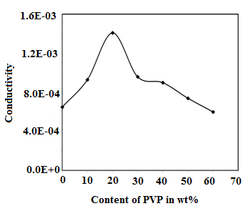
based electrolytes [17]. Here the conductivity of electrolyte increases upon increasing the PVP content till 20 wt% and thereafter it falls till 30 wt% followed by a flatting between 30 to 40 wt%. When PVP content in blend exceeds 40 wt% conductivity finally decreases rapidly. The initial rise of ionic conductivity can be described by the
Figure 6. Ionic conductivity of blend based electrolyte for different wt% of PVP at 0.4 mole CH₃COONH₄ concentration

argument that as PVP (< 20 wt%) is introduced in pristine electrolyte, interaction among polymer component takes place leading to improvement in compatibility and morphology of system in the presence of salt. Subsequently formation of PVA-PVP-CH₃COONH₄-DMSO complex take place. This has also been evidenced in optical, XRD, DSC studies. Improvement in morphology leads to enhancement in mobility of the system. Simultaneously greater dissociation of salt takes place in the presence of improved compatibility which coerces greater dissociation of salt (increase in carrier concentration). Both these factors tend to increase the overall conductivity response. However, on increasing the concentration of PVP beyond 20 wt% viscosity of system is increased thereby creating tortuous pathways for ion migration which causes ionic conductivity to diminish in accordance with Walden’s rule. Flattening between 30-40 wt% PVP content in blend can be rationalized by breathing chain model. According to this model polymer chain breathes while it opens up or folds, occupying different volumes in the process. This leads to localized pressure change or fluctuation in surrounding volume. The localized turbulent pressure wave can either assist in dissociation of the ionic pair resulting in an increase in number of mobile charge carrier ions or in enhancing mobility. In either case, ionic conductivity of gel electrolyte is bound to augment which tends to counterbalance the viscosity effect. When PVP content is enhanced further, viscosity effect again dominants leading to fall in conductivity.
3.7 Temperature Dependence of Conductivity
Temperature dependence of electrical conductivity of PVA: PVP: CH₃COONH₄ system at different salt concentration was studied and the results have been shown in figure 7. The variation of conductivity is seen to change slowly with temperature. At low
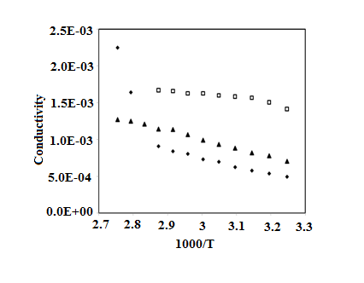
Figure 7. Temperature dependence electrical conductivity of PVA: PVP: CH₃COONH₄ system at () 0.2, () 0.4 and (▲) 0.6 mole Ammonium acetate concentration

Figure 7. Temperature dependence electrical conductivity of PVA: PVP: CH₃COONH₄ system at () 0.2, () 0.4 and (▲) 0.6 mole Ammonium acetate concentration
temperature (around room temperature) the conductivity response is essentially dictated by the trapped liquid electrolyte within the polymer matrix and hence Arrhenius behavior is noticeable. However, as the temperature approaches the glass transition temperature of polymer PVA (75⁰ C) in polymer composite system, the matrix becomes flexible giving rise to change in conductivity values. The enhancement in conductivity with increasing temperature can be rationalized with free volume model [18]. The behavior of conductivity at 0.2 mole shows combination of two Arrhenius curves. As the salt concentration enhances the overall behavior is best described by combination of Arrhenius and VTF behavior and finally at high concentrations (0.6 M) the behavior becomes VTF type. The Arrhenius and VTF type relationship has been described elsewhere [16].
4. Conclusions

Polyvinyl alcohol: polyvinyl pyrrolidone blend based polymer gel electrolytes were prepared by solvent casting technique and characterized thermally, structurally and electrically. Complex formation of PVA: PVP: CH₃COONH₄ system has been confirmed through optical microscopy. Thermal studies reveal improvement in amorphous nature of system upon addition of salt. Ionic conductivity of blend electrolyte system is seen to improve at room temperature with an optimum value 1.34x10⁻³ S.cm⁻¹ for 0.4 mole ammonium acetate concentration. Temperature dependence of conductivity reflects combination of Arrhenius and VTF behavior. C-V data indicates best cyclic reversibility for composite system containing 0.4 M salt besides, improvement in electrochemical stability with optimum electrochemical window ranging from -1.7 V to + 1.5V.
Acknowledgements
Authors are thankful to Prof. Ravindra Dhar, Department of Material Science, Allahabad University, Allahabad and Dr. Kamlesh Pandey, National Centre of Experimental Mineralogy and Petrology, University of Allahabad, Allahabad for providing DSC and XRD facilities respectively.
References:
- F. M. Gray, Solid Polymer electrolytes- Fundamentals and Technological Application, ed., VCH: New York (1991).
- W. Wieczorek, Z. Florjancayk and J. R. Stevens, Electrochim Acta 40 (1995) 2327.
- S. S. Sekhon, Bull. Mater. Sci. 26 (2003) 321.
- B. Scrosati, J. Electrochem. Soc. 139 (1992) 2776.
- D. W. Xia, D. Soltz, J. Samid, Solid State Ionics 14 (1984) 221.
- C. C. Caravanier, B. C. Montigny, D. Lemordant and G. Bosser, Solid State Ionics 156 (2003) 113.
- C. A. Finch, Polyvinyl Alcohol properties and applications, Ed., John Wiley & Sons: Bristol (1973).
- R. Bhattacharya, T. N. Phaniraj and D. Shailaja, Journal of Membrane Science 227 (2003) 23.
- A. Awadhia and S. L. Agrawal, Solid State Ionics 178 (2007) 951.
- S. K. Patel, A. Awadhia and S. L. Agrawal, Phase Transition 82 (2009) 421.
- S. L. Agrawal and A. Awadhia, Bull. Mater. Sci. 27 (2004) 523.
- K. Sivaih, K. N. Kumar, V. Naresh and S. Buddhudu, Material Sciences and Applications 2 (2011) 1688.
- N. Chand, N. Rai, S. L. Agrawal S. K. Patel, Bull. Mater. Sci. 34 (2011) 1297.
- P. K. Shukla and S. L. Agrawal, Ionics 6 (2000) 312.
- S. A. Hashmi and S. Chandra, J. Mater. Sci. Eng. B 34 (1995)18.
- S. L. Agrawal and R. P. Kumhar, Int. J. of Materials Science and Applications 3 (2014) 129.
- F. F. Hatta, M. Z. A. Yahya, A. M. M. Ali, R. H. Y. Subban, M. K. Harun and A. A. Mohammad, Ionics 11 (2005) 418.
- T. Miyamoto and K. Shibayama, J. Appl. Phys. 44 (1973) 5372.

