**Title: Microgreens an emerging superfood packed with health promoting nutrients**

**Sibani Das**

Assam Agricultural University, Horticultural Research Station, Kahikuchi, Guwahati,17Assam India

**Corresponding author ph no : 9706692785 and email: sibanidas01@gmail.com**

**Abstract**

Microgreens are the next generation smart food products that are growing in popularity over time as food ingredients in recent years due to their high nutritional value and diverse organoleptic characteristics. Microgreens are edible fresh greens obtained from various vegetables, herbs and plants. Microgreens have become popular with chefs and are gaining popularityin upmarket grocery outlets. The growth of microgreens therefore presents tremendous market opportunities worldwide. Nutritional benefits, simple production methods and short production cycles are some of the reasons that make them attractive to growers. Microgreen can provide higher amounts of phytonutrients (ascorbic acid, β-carotene, α-tocopherol, and phylloquinone) and minerals (Ca, Mg, Fe, Mn, Zn, Se, and Mo), compared with their mature- leaf counterparts. Microgreens do not require specific nutrients for growth and can be grown year round. Microgreens have a short shelf life and therefore require better storage and transportation strategies. They are very soft and easily bruised, so biodegradable clamshell containers are used to pack the greens. When microgreens are packed in bags, there should be enough space at the top of the bag to protect the delicate young shoots. The consistency and quality of cut microgreens can be preserved by packing them in modified atmosphere packaging and storing them at low temperatures. Microgreens of different species are stored at different temperatures depending on their sensitivity or temperature tolerance.

One of the major limitations to the growth of the microgreen industry is the rapid deterioration in quality that occurs immediately after harvest when they are ready to be harvested 7-14 days after germination, which makes the price high and commercial restrictions on local sales. After being harvested, microgreens are prone to dehydration, wilting, decomposition, and rapid lose of certain nutrients. Research has explored preharvest and postharvest interventions, such as calcium treatment, modified atmopsphere packaging, temperature and light control, to maintain quality, increase nutritional value and extend shelf life. However,further research is needed to optimize both production and storage conditions to improve the safety, quality, and shelf life of microgreens, thereby expanding the potential market.

**Key words:** Microgreens, greem leafy vegetables, growing media, nutrition facts.

.

**What are Microgreens:**

Microgreens are immature edible green leafy vegetables of about two inches tall consisting of the stem, cotyledons and first pair of fully grown or partially developed true leaves. Like sprouts microgreens are young vegetables. However sprouts and microgreens are not the same. In general sprouts are the germinated seeds which are consumed with the embryonic root and the seeds. In contrast microgreens grow from sprouts and they have leaves. Microgreens differ from baby greens in their size and much smaller than baby greens. They are classified according to the degree of development between “sprouts” and “baby greens”. It is smaller than baby greens because they are consumed very soon after sprouting rather than after the plants have matured to produce multiple leaves. Sprout, Microgreen, and babygreen are simply greens that are harvested and eaten in their immature form. Sprouts are the smallest and the youngest, microgreens are slightly larger and older usually 1- 3 in. tall (2.5 to 7.6 cm). Larger than this size it is called petite greens (Oh, M. M, 2010; Anonymous, 2013). It is also known as vegetable confetti. Compared to sprouts microgreens are harvested(Anonymous, 2014; Millard, E. 2014). Microgreens tender green shoots are harvested for consumption within 10 to 20 days of seedlings emergence. Development of cotyledon leaves done between 10 to 14 days from seedlings.

In contrast to sprouts which are taken along with the embryonic root and the seeds it is different in that sprouts are germinated seeds. Baby greens are substantially larger than microgreens which are significantly smaller. Their status remains in between sprouts and baby greens.

 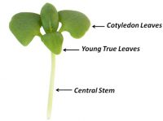

Fig 1:Source: Riggio et al. (2019). Fig 2: The 3 edible components: the

Central stem, the cotyledon

leaves and the young true leaves.

Over the few past years using microgreens in cooking has become increasingly popular. Microgreens despite their size, may deliver unexpectedly potent flavors, a varietyof colors, and a crisp texture. They can be used as a fresh salad item or a tasty garnish.It is alsoused to improve the appearance feel color, or flavour of salads and major courses, as well as to flavour food by adding sugar and spices.

**List of the various crops grown as Microgreen**

Microgreens can be obtained from different sorts of seeds. The well known species are harvested using seeds from the following plant families (View & Club, 2019).

|  |  |  |  |
| --- | --- | --- | --- |
| **SL.No** | **Common Name** | **Scientific Name** | **Family** |
| 1. | Broccoli | *Brassica oleracea var. italica* | Brassicaceae |
| 2. | Cabbage | *Brassica oleracia L. var capitata L.* |
| 3. | Cauliflower | *Brassica oleracia L. var botrytis L.* |
| 4. | Raddish | *Raphanus sativus* |
| 5. | Carrot | *Daucus carota* | Apiaceae |
| 6. | Beet | *Beta vulgaris L.* | Amaranthaceae |
| 7. | Chick pea | *Cicer arietium L.* | Fabaceae |
| 8. | Fenugreek | *Trigonella foenicum-graecum L.* |
| 9. | Green gram | *Vigna radiata* |
| 10. | Pea | *Pisum sativum* |
| 11. | Spinach | *Spinacia oleracea L.* | Chenopodiaceae |

Sometimes, Legumes like chickpeas, beans and lentils as well as grains like rice, oats, wheat, corn are grown as microgreens.Depending on the type of microgreen the flavor might range from plain to spiced, tangy or even bitter. As one of the healthiest varieties of microgreens pea shoots are occasionally included in our Seasonal Microgreens from time to time. Beta-carotene found in pea shoots is converted by our bodies into vital vitamins A, C and folate as well as fibre..

**Production of Microgreens**

In small space microgreens are simple to grow and cultivate in farm or. Microgreens can be grown in soil or soilless media outdoor or indoor under natural or artificial light sources. Microgreens can be grown on small or large scale or in industrial production systems by individuals for personel use or for commercialization.

Microgreens are adaptable to a variety of temperatures. Usually a temperature range of 20 to 22°C is ideal for the growth of all summer and winter species. *Brassica* species seeds, however can germinate at a slightly lower temperatures. As the temperature drops, it takes the seedlings longer to reach the marketable stage. Microgreens develop more quickly in warmer conditions. In order to produce higher quality microgreens, a farmer first choice for microgreensis is to decide whether the outdoor or the indoor conditions are ideal for the production which can be accomplished by creating a perfect and controlled environment. As per the experienced farmers, indoor conditions are far better for the production of superior quality microgreens because they can be readily managed and the temperature, humidity and light levels can be kept according to the needs of the microgreens. From seedling to harvest, different crops require very different amounts of time.

When seeding a mixture of crops in a single planting flat, growers should select crops with a similar growth rate so the entire flat can be harvested at the same time. Alternatively, growers can sow different crops one at one time and mix them after harvest. It can be grown in a standard sterile, loose, soilless germinating media, which can be successfully used with peat moss, vermiculite, perlite, coconut fiber, and the other half of the tray is filled with the media of choice to a depth of 1or 2 in., depending on irrigation programs. Generally, this media system uses overhead mist irrigation. Uses one of several materials such as mat or lining, which is placed on the bottom of the base or expanded with an alternative production system. Generally, these materials are fibrous and provide an excellent seed medium. For certain crops, the mat may be sufficient on its own or may require a light covering with a media after seeding. Sowing can be done by broadcast method or in rows. The frequency of sowing is difficult to accept. Most growers note that they want to plant as thickly as possible to maximize production, but not too thick as compactness promotes stem elongation and increase the risk of disease. Therefore the seeding rate per unit area is the most important factor in the production of microgreens, since the seeding frequency affects the yield of microgreens. As the seeding rate increases, the weight of an individual seedling decreases due to competition between seedlings, but the total yield per unit area increases. In general, microgreen seeds do not require much nutrients to germinate, although they only ideal environmental conditions (temperature and adequate humidity) for further germination and growth. However, providing mineral nutrients in solution increases the yield of microgreens.

**Growing Media**

Media like soil, tissue paper, hydroponics, etc. can be used for raising microgreens. However a mixture of cocopeat, vermiculite and perlite in a ratio of 5:2:1, can be used for growing microgreens because it releases nutrients very slowly. As a result the same medium can be reused several times for raising young greens.

**Health Benefits and nutrition facts**

1. **Microgreens provide more nutrition than mature leaves** and has been found to be four to six times more nutrient rich than their mature counterparts. Microgreens with bright-coloured have been proven to be more nutrient dense than those with milder hues.
2. Microgreen peas are rich in **phytoestrogens** which have been reported to lessen the risk of heart disease, cancer and osteoporosis.They are also loaded with vitamin C and contain significant Iron**.**
3. In comparison to sprouts, microgreens have a higher content of protein, iron, zinc, α-carotene, β-carotene, violaxanthin, lutein and neoxanthin.
4. Microgreens are good source of vitamins A, B, C, E & K. Broccoli contains vitamins A and C, calcium, phosphorous, iron, and is a great source of the phytochemical sulforaphane, which is a sulfur-rich compound that reduces inflammation.
5. Microgreens are an essential source of fiber and roughage.
6. Chlorophylls, which are another major group of antioxidants in microgreens, have been reported to exhibit chemoprotective activity in carcinogenic conditions

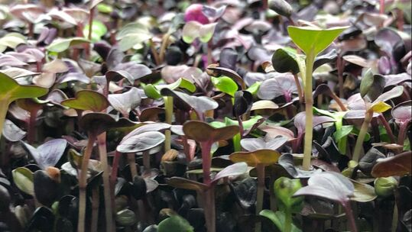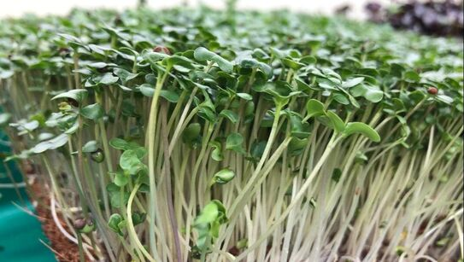 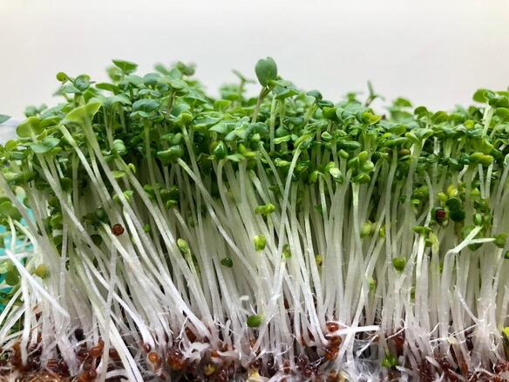

**Pea Raddish Broccoli**

**Harvesting of Microgreens**

Microgreens become ready for harvest 7-14 days after germination under tropical and somewhat longer (14-28 days) under temperate conditions, depending on kinds of crop and other environmental conditions. Microgreens when attain a height of 2.5 to 7.6 cm are cut just above the surface of media using a sharp knife. Microgreens have a short time span of usability, thus, require better strategies for storage and transport. Microgreens are tender and susceptible to bruising, therefore, biodegradable clamshell containers are used for the packaging of microgreens. When microgreens are packed in bags, ample air space is left in top of the bags to protect the fragile shoots. The consistency and quality of cut microgreens can be preserved by packing in modified atmospheric packaging and storing at low temperature. Microgreens of different species are stored at different temperature based on their susceptibility or tolerance to temperature.

**Benefits of Growing Microgreens as a business:**

The advantages of integrating leafy greens and microgreens into their food plan are regularly being understood through humans worldwide, making sure that demand continues to grow. And we are also seeing increasingly troubles and crop failure of greens grown outdoors, so there is an indoor future for agriculture.

**Low start-up costs :**

Farmers may start their business with very low investment by simply supplying one restaurant with their greens or producing enough microgreens to sell at a farmer's market once a week and rising production according to customer demand.

**Quick turnaround time** :

Microgreens from seed to harvest take around 7-14 days. A farmer doesn't have to wait for a whole season or more to harvest.

**Year-round growing** :

Microgreens can be grown round the year and a farmer can use microgreens to earn extra money and diversify their business for more profit.

**Higher nutrition** :

Microgreens are ‘functional foods’. They are a complete pack of different vitamins and nutrients.

**High-value crop :**

A farmer can sell their microgreens to top restaurants and food stores to get higher prices and

as a local producer they can also charge a premium for their microgreens.

**Some examples of Microgreen start ups**

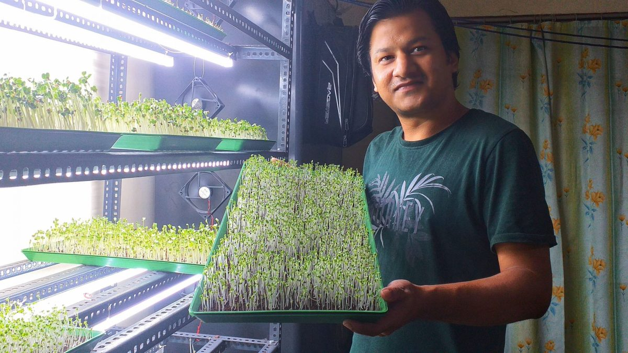

* Rahul Sharma runs a microgreen startup called “**Guwahati Microgreens**”. It is grown hydroponically in a controlled environment using a coco-peat medium and just clean filtered water. They grow microgreen on a pre-order basis and distributes them to the people of Guwahati to improve the immunity and health of people in his community.
* **Farm 2 Fam** is a Mumbai based starup which grows microgreens. The microgreens are free from pesticides, herbicides and chemicals and delivered straight to the customers doorstep.It was founded in Jan 2019.

**Summary**

Microgreens are new generation of smart foods, that are growing in popularity. They are edible forms of small immature green leafy vegetables obtained from different kinds of vegetable, herbs and plants and popularized as new culinary ingredients, having a high content of minerals, vitamins and many compounds non-nutritive bioactive substances are higher and are more nutritious than their mature counterparts. These fresh and healthy microgreens have a high market acceptance due to their attractive appearance, rich flavor flavour texture and essential nutrient content. So they can be summarized as follows

1. Microgreens can help ensure global nutrition security.
2. The microgreens have become popular among consumers due to their nutritional composition and high content of antioxidant compounds.
3. Consumers can produce microgreens at home using simple tools available in the home with ease.

**Reference**

View, M. and Club, G. 2019. *Microgreens What Will We Cover/?*

Manish Reddy, Krishna Vadlamudi, Anjali, and Bagathi Ganesh.Role of Microgreens and their potential health benefits : A Review 2021 JETIR May 2021, Volume 8, Issue 5.

Riggio GM, Wang Q, Kniel KE and Gibson KE (2019) Microgreens—A review of food safety considerations along the farm to fork continuum. International Journal of Food Microbiology 290, 76–85.

Kalpana Yadav, May- June 2021. Microgreens An ultimate Superfood:Indian Horticulture 26-28

Deepika kalal, 2Sandhya Verma and 3Dr. Hitesh A. Solanki (2021). Microgreen -as a potential food source: A ReviewIJCRT | Volume 9, Issue 3 March 2021 | ISSN: 2320-2882