SMART TRAFFIC LIGHT CONTROL SYSTEM FOR EMERGENCY VEHICLES USING RF MODULE
BA. Anandh¹, A. Shankar Ganesh^{1*} and P Nandakumar¹
¹ Department of Electronics, PSG College of Arts & Science, Coimbatore.
*Corresponding author email: shankar.psgcas@gmail.com

ABSTRACT

Traffic congestion is a growing concern for everyone, but it is extremely hard for emergency vehicles which are forced to waste important time in traffic which could be detrimental whether a life lives or not. Manual control of traffic has not proved to be efficient, also a predefined signal timing for the signal at all circumstances whether high or low traffic has not done any ease to the problem. Existing systems that use RF modules can only be used for one system at a time. A model to effectively solve the above-mentioned problems using the RF module and prioritizing algorithm is proposed. Every emergency vehicle is tagged with an RF transmitter with two priority options which can be changed based on the emergency. When the vehicle reaches a signal, the RF receiver attached to the traffic signal post receives the signal. The system is made to handle multiple emergency vehicles with different priorities in different lanes to be able to pass effectively in a junction. The system will also control the traffic light in the absence of emergency vehicles.
Index terms- 16×2 LCD Display, LED’S, ATmega2560 Microcontroller, RF Transmitter and Receiver Module.

INTRODUCTION

Traffic congestion is a growing concern for everyone, but it is extremely hard for emergency vehicles which are forced to waste important time in traffic which could be detrimental whether a life lives or not. Manual control of traffic has not proved to be efficient, also a predefined signal timing for the signal at all circumstances whether high or low traffic has not done any ease to the problem. Existing systems that use RF modules can only be used for one vehicle system at a time. A model to effectively solve the above-mentioned problems using the RF module and prioritizing algorithm is proposed. Every emergency vehicle is tagged with an RF transmitter with three priority options which can be changed based on the emergency. When the vehicle reaches a signal, the RF receiver attached to the traffic signal post receives the signal. The system is made to handle multiple emergency vehicles with different priorities in different lanes to be able to pass effectively in a junction.
The system will also control the traffic light in the absence of emergency vehicles. All the traffic lights are controlled by the central unit. In the central unit, we use Arduino mega microcontroller to control the system. The RF receivers are connected to the control unit, with uses the input signals to identify the priority of the vehicles. The RF receivers attached to each lane in a junction identify the emergency vehicle on each lane and the control unit uses the prioritizing algorithm to arrange the priority in descending order to efficiently allow the highest priority to pass through first.

LITERATURE REVIEW

Traffic congestion has made life harder for many in the metropolitan cities, of India with the increase in ownership of vehicles increasing traffic congestion has gone from bad to worst [1] talks about the costs of traffic congestion in India. To solve the problem of ambulance being struck in traffic many have researched on it and many efforts have been made to help ease the problem of ambulance being struck in traffic congestions. Solutions are designed to make the passage of ambulances easy using embedded systems, algorithms and image recognition to help ambulances pass through traffic.

The model [2] talks about prioritizing vehicles by sending signals from the vehicle, and allowing them to pass according. [3][4] uses the global positioning system to identify the location of the ambulance and clear the path based on their location.[5][6] uses embedded systems for controlling the traffic signals and [7][8][9] uses image processes to identify the ambulance using Open CV from the images captured by the camera and allows the ambulance to pass.[10][11][12][13][14][15] uses an RF module to identify the presence of ambulances on the road and allows them to pass once they are identified. [16] Uses Arduino Mega for a smart traffic control system based on sensors. [17][18][19][20][21][22] . Proposes IOT based system for smart traffic control in smart cities, a prediction mechanism and [23] traffic automation by using IR sensors. [24] An emergency vehicle can request the approaching traffic controller to preferably give a green signal over a web application. [25] Uses sound sensors to identify the frequency of the ambulance approaching traffic and allowing them to pass. The problem with these systems is that when multiple ambulances are found, these systems cannot determine which ambulances should be allowed first or the order in which they should be allowed.
This project is capable of handling multiple ambulances at different roads in a four-way road junction and allows them to pass accordingly based on timing and priority. The system also takes into account the identification of high-priority ambulance, when other ambulances are also present. The system then pauses the process and allows the high-priority ambulances to pass first and then restores the paused process once the high-priority ambulance passes. This system can be implemented universally and is cost002Deffective since the system does not need external connections to work.

PROPOSED MODEL

The proposed model aims to prioritize ambulances in a four-way traffic junction. It is a user interactive system where the ambulance driver has to attach or enable the signal to send the signal for turning the traffic light green. The system calculates the number of signals received their priority and the timing of each identified signal, then allows the first identified ambulance or the ambulance with the highest priority to pass through first.
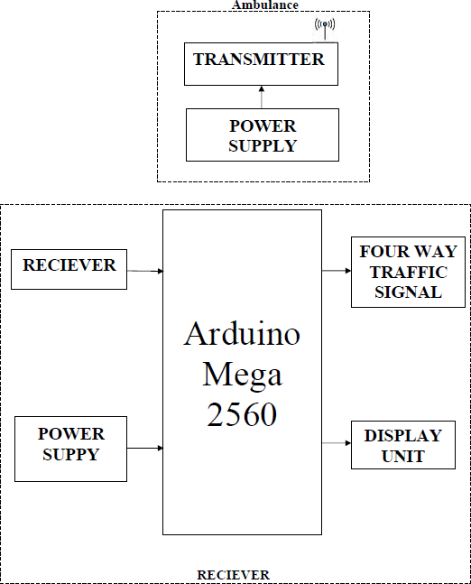

BLOCK DIAGRAM

The model considers three scenarios, one is where no ambulance is found on any lane, and then the system runs the traffic lights in a default manner. Then there are scenarios where multiple ambulances are present, the system then calculates

the timing and allows them to pass accordingly. Then the scenario where a high-priority ambulance is identified when the second scenario is still running, the system stops the latter and allows the ambulance to pass through, after the high-priority ambulance has passed, the system then restores the flow of ambulances. The signal is sent and received using a 433MHZ RF module mounted on encoder and decoder circuits, where the decoders are then connected to the Arduino mega board and are used as the inputs to identify the presence of the ambulance.
The list of components used in this system is Arduino Mga 2560, 433 MHz RF module, encoder (HT12E) decoder (HT12D).

Arduino mega 2560
Arduino Mega is an Atmega2560-based microcontroller board. It is used in this project because it has 70 pins including Analog and digital, since this project requires many pins as the traffic light control alone requires 12 pins and many smaller boards would have their I/O pins maxed out by now. It has four UARTs and a 16MHz oscillator and a USB interface. The mega board is used as the main controller unit in this project, all four receivers and four traffic lights are all connected to the board. The mega board has enough computational power to control the lights and run the priority algorithm when an ambulance in found and also has inbuilt regulators to supply 5V voltage to the receivers.

433MHz RF module
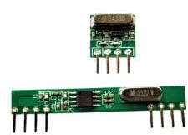
433MHz RF module is used in this project to identify ambulances and thier priority. The ambulance is fitted with the transmitter and the traffic lights are equipped with receivers. They are better than other conventional types like Bluetooth or IR because RF has a range of nearly 100 meters which is apt to identify the ambulance from a distance. The RF signals can pass through blocks and they have compatibility with most microcontrollers, the data can be sent directly from the microcontroller or an encoder can be used to send the signal. They are easy to use, cheap and readily available, so they can be easily implemented.

433 MHz RF module

- Encoder and Decoder
HT12E and HT12D are the encoder and decoder used in this project. The RF module can be set up with microcontrollers to send and receive the message, but the encoder-decoder setup is easy to use and cost-effective. In this project, four encoders and four decoders are configured so that each encoder signal is received by a single decoder since the signals will interfere in a confined space. In open space only one configuration is used and since the RF signal can be identified from a distance of 100 meters once it won’t interfere with receivers at other posts. The Encoder-Decoder module is used because using a microcontroller will require programming it and transmitting messages that need to be read and decoded by another microcontroller, since microcontrollers are of many different types and their efficiency varies, using the encoder-decoder module makes it easy to be implemented universally. The encoder setup requires only 5V to operate. They are also cheap and readily available to be implemented.

EXPERIMENTAL SETUP
In this project, there are two modules. One is with the ambulance, the transmitter and the other is attached to a four-way traffic light junction, the receiver.

TRANSMITTER

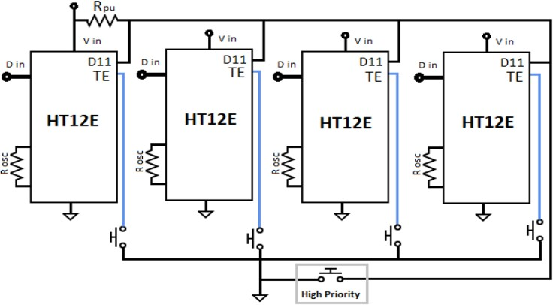
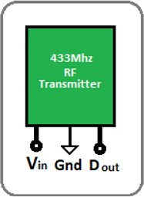

Transmitter

The RF transmitter is connected to the ambulances and is used to send signals about the presence and the priority of the ambulance. The driver needs to manually operate the transmitter to send the request to the receivers asking them to turn the traffic light green.
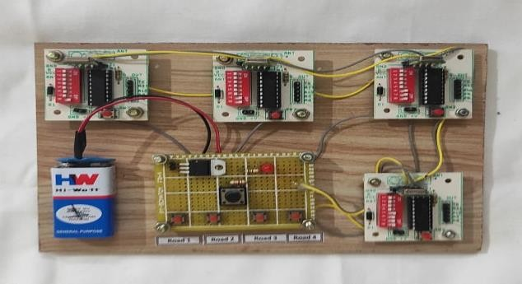

Transmitter

RECEIVER
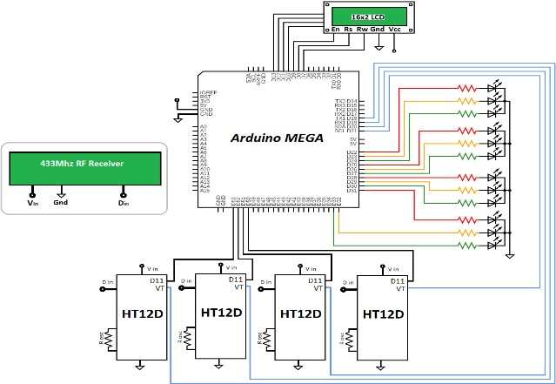

Receiver

The receiver is connected to four-way traffic light, the receivers are connected to the decoder and the VT and D8 pins are connected to the Arduino board. The receiver part also controls the traffic lights. The receiver decodes the signal and sends the output is sent to the Arduino board as the input. The priority algorithm then identifies the lane and priority of the ambulance if only one is found or the timing and priority, if more than one is identified. The program then allows them to pass based on their priority.
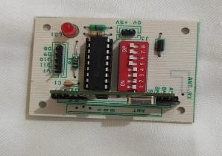
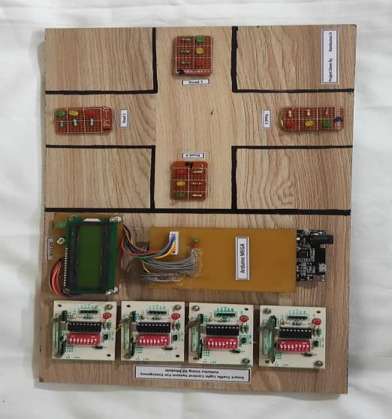

FOUR-WAY JUNCTION RECEIVER MODEL

FLOW CHART
start
Automated four-way traffic light control
Ambulance
identified
More than
one ambulance
Turn green based on priority

Turn green for the ambulance

RESULT AND ANALYSIS

The system aims to provide mobility to ambulances in traffic congestion. The system was tested on multiple scenarios, with multiple ambulances and different priorities.
Case 1: only one ambulance is present, the system turns green for the road with the ambulance identified. After a delay of eight seconds, the automatic traffic light signals are restored
Case 2: multiple ambulances of the same priority are found. The system orders them based on the timing they were identified and allows them to pass based on a first come first serve basis. The system then restores the automated traffic light control.
Case 3: high-priority ambulance is identified while Case 2 is running. The system pauses Case 2 and allows the high-priority ambulance to pass first and then restores the Case 2 loop. The system then restores the automated traffic light control.

CONCLUSION

With automated four-way traffic light control the manual effort and need for traffic policeman in a junction is nullified. As the entire system is automated human interaction is less to nil as the only need of human intervention is in case of physical damage to the system. By using this system, the impact of traffic on the service time of ambulances can be reduced. Since the transmission part of the system is connected to the ambulance and all ambulances can be fitted with the same transmitter configuration, it is easy to implement on all ambulances regardless of their configuration. In conclusion, the smart traffic light control system for emergency vehicles could handle multiple ambulances at a four-way junction and allow them to pass based on their priority and also restore traffic control after the ambulance has passed. This system can be implemented universally and with minor modification, the four-way junction control can be changed to a single or multiple-road intersection. Since the system is of low cost to produce and implement, developing countries can easily implement it on a large scale.

REFERENCES

  - Chakrabartty, A. and Gupta, S. (2015) Estimation of Congestion Cost in the City of Kolkata—A Case Study. Current Urban Studies, 3, 95-104. doi: 10.4236/cus.2015.32009.
  - D. Dang, J. Tanwar and S. Masood, "A smart traffic solution for High Priority Vehicles," 2015 1st International Conference on Next Generation Computing Technologies (NGCT), 2015, pp. 466-470, doi: 10.1109/NGCT.2015.7375162.

  - K. Sangeetha, P. Archana, M. Ramya, P. Ramya “Automatic Ambulance Rescue With Intelligent Traffic Light System,” IOSR Journal of Engineering (IOSRJEN) ISSN (e): 2250-3021, ISSN (p): 2278-8719 Vol. 04, Issue 02 (February. 2014),
||V5|| PP 53-57

  - Prof. Deepali Ahir, Saurabh Bharade, Pradnya Botre, Sayali Nagane, Mihir Shah , “Intelligent Traffic Control System for Smart Ambulance,” International Research Journal of Engineering and Technology (IRJET) e-ISSN: 2395-0056 p-ISSN: 2395-0072Volume: 05 Issue: 06 | June-2018

  - A. A. Krishna, B. A. Kartha and V. S. Nair, "Dynamic traffic light system for unhindered passing of high priority vehicles: Wireless implementation of dynamic traffic light systems using modular hardware," 2017 IEEE Global Humanitarian Technology Conference (GHTC), 2017, pp. 1-5, doi: 10.1109/GHTC.2017.8239237.

  - SaujanyaMukkawar, Suraj Rathod, ShivshankarGawai, Mayuri Magar, “Smart Ambulance With Traffic Control Ability,” International Research Journal of Engineering and Technology (IRJET) e-ISSN: 2395-0056 p-ISSN: 2395-0072Volume: 06 Issue: 03 | Mar 2019

  - R Vani et al 2018 IOP Conf. Ser.: Mater. Sci. Eng. 455 012023

  - M. S. Uddin, A. K. Das and M. A. Taleb, "Real-time area based traffic density estimation by image processing for traffic signal control system: Bangladesh perspective," 2015 International Conference on Electrical Engineering and Information Communication Technology (ICEEICT), 2015, pp. 1-5, doi: 10.1109/ICEEICT.2015.7307377.
  - K. Choudhury and D. Nandi, "Detection and Prioritization of Emergency Vehicles in Intelligent Traffic Management System," 2021 IEEE Bombay Section Signature Conference (IBSSC), 2021, pp. 1-6, doi: 10.1109/IBSSC53889.2021.9673211.
  - Krishnan, S., Thangaveloo, R., Bin Abd Rahman , S.E., & Sindiramutty, S. R. (2021). Smart Ambulance Traffic Control System . Trends in Undergraduate Research, 4(1), c28-34.
https://doi.org/10.33736/tur.2831.2021

  - R. Sundar, S. Hebbar and V. Golla, "Implementing Intelligent Traffic Control System for Congestion Control, Ambulance Clearance, and Stolen Vehicle Detection," in IEEE Sensors Journal, vol. 15, no. 2, pp. 1109-1113, Feb. 2015, doi: 10.1109/JSEN.2014.2360288.

  - A. Al-Husseiny and M. Youssef, "RF-Based Traffic Detection and Identification," 2012 IEEE Vehicular Technology Conference (VTC Fall), 2012, pp. 1-5, doi: 10.1109/VTCFall.2012.6399360.

  - Gargi Beri , Ashwin Channawar, Pankaj Ganjare, Amruta Gate , Prof. Vijay Gaikwad ,” Intelligent Ambulance with Traffic Control,” International Journal of Latest Research in Engineering and Technology (IJLRET) ISSN: 2454-5031 www.ijlret.com || Volume 02 - Issue 05 || May 2016 || PP. 74-80

  - M. H. A. Ilmudin, N. M. Z. Hashim, A. S. Ja’afar, A. Salleh, A. Jaafar, M. F. M. Sam,” Traffic Light Control System using 434 MHz Radio Frequency,” International Journal of Research in Advent Technology, Vol.2, No.8, June 2014 E-ISSN: 2321-9637

  - N. Prakash, E. Udayakumar and N. Kumareshan, "Arduino Based traffic congestion control with automatic signal clearance for emergency vehicles and Stolen Vehicle Detection," 2020 International Conference on Computer Communication and Informatics (ICCCI), 2020, pp. 1-6, doi: 10.1109/ICCCI48352.2020.9104120.

  - Ravish, R., Shenoy, D.P., Rangaswamy, S. (2020). Sensor-Based Traffic Control System. In: Mandal, J., Mukhopadhyay, S. (eds) Proceedings of the Global AI Congress 2019. Advances in Intelligent Systems and Computing, vol 1112. Springer, Singapore.
https://doi.org/10.1007/978-981-15-2188-1_17

  - Suresh Kumar, S., Rajesh Babu, M., Vineeth, R., Varun, S., Sahil, A.N., Sharanraj, S. (2019). Autonomous Traffic Light Control System for Smart Cities. In: Peng, SL., Dey, N., Bundele, M. (eds) Computing and Network Sustainability. Lecture Notes in Networks and Systems, vol 75. Springer, Singapore.
https://doi.org/10.1007/978-981-13-7150-9_35

  - Banerjee, S., Chakraborty, C., Chatterjee, S. (2019). A Survey on IoT Based Traffic Control and Prediction Mechanism. In: Balas, V., Solanki, V., Kumar, R., Khari, M. (eds) Internet of Things and Big Data Analytics for Smart Generation. Intelligent Systems Reference Library, vol 154. Springer, Cham. https://doi.org/10.1007/978-3-030-04203-5_4

  - Vardhana, M., Arunkumar, N., Abdulhay, E. et al. Iot based real time trafic control using cloud computing. Cluster Comput 22, 2495–2504 (2019). https://doi.org/10.1007/s10586-018-2152-9

  - M. I. Mahali, E. Marpanaji, S. A. Dewanto, B. Wulandari, U. Rochayati and N. Hasanah, "Smart Traffic Light based on IoT and mBaaS using High Priority Vehicles Method," 2018 5th International Conference on Electrical Engineering, Computer Science and Informatics (EECSI), 2018, pp. 703-707, doi: 10.1109/EECSI.2018.8752694.

  - A. Kadar Muhammad Masum, M. KalimAmzad Chy, I. Rahman, M. Nazim Uddin and K. Islam Azam, "An Internet of Things (IoT) based Smart Traffic Management System: A Context of Bangladesh," 2018 International Conference on Innovations in Science, Engineering and Technology (ICISET), 2018, pp. 418-422, doi: 10.1109/ICISET.2018.8745611.

  - P. Manikanta, S. S. K. Hussian and R. Tamil Kodi, "Iot Ambulance With Automatic Traffic Light Control," 2019 International Conference on Vision Towards Emerging Trends in Communication and Networking (ViTECoN), 2019, pp. 1- 3, doi: 10.1109/ViTECoN.2019.8899469.

[23] Parekh, S., Dhami, N., Patel, S., Undavia, J. (2019). Traffic Signal Automation Through IoT by Sensing and Detecting Traffic Intensity Through IR Sensors. In: Satapathy, S., Joshi, A. (eds) Information and Communication Technology for Intelligent Systems . Smart Innovation, Systems and Technologies, vol 106. Springer, Singapore. https://doi.org/10.1007/978-981-13-1742-2_6
- Ramani, A. B., and Amruta Jeyakumar. "Smart Ambulance Guidance System." International Journal of Advanced Research in Computer Science and Electronics Engineering (2018).

- GowramIswarya , Bharath H P , V. Viharika Reddy “Sound Sensors to Control Traffic System for Emergency Vehicles,” International Journal of Applied Engineering Research ISSN 0973-4562 Volume 13, Number 7 (2018) pp. 184-186.

