Biomedical Applications of Biomarkers in Current trends & futuristic Perspectives
Dr.B.Durga ¹ & Dr.D.Anandhi²
1.Faculty of Allied Health Sciences, Meenakshi Academy of Higher Education & Research
2. Department of Biochemistry, Meenakshi Ammal Dental College & Hospital
Introduction:
Biomarkers have acquired huge precise and scientific importance with attention in the performance of medicinal field. The biomarker is a biological molecule which is present in body fluids like blood or tissues which are indicator for sign of a usual or unusual function of a condition. Hence biological marker helps to assess about the cell or an organism for diagnosis the disease. Even, prior to identification of the diseases, the biomarkers are perhaps used for the screening and risk assessment associated with the staging and grading of the disease condition. The biomarkers potentially helped for the evaluation of stages of severity of the diseased condition for the proper selection of treatment to overcome or avoid the progression of the disease. Similarly the biomarkers possibly utilize to found the effect of treatment for a disease based on the body response hence it is known as molecular marker and signature molecule.
The “biological or molecular markers” are the wide-ranging pointer of several compounds of cell or biogenic compound such as genetic and epigenetic molecule found in body systems, for example cells or tissues or body fluids.
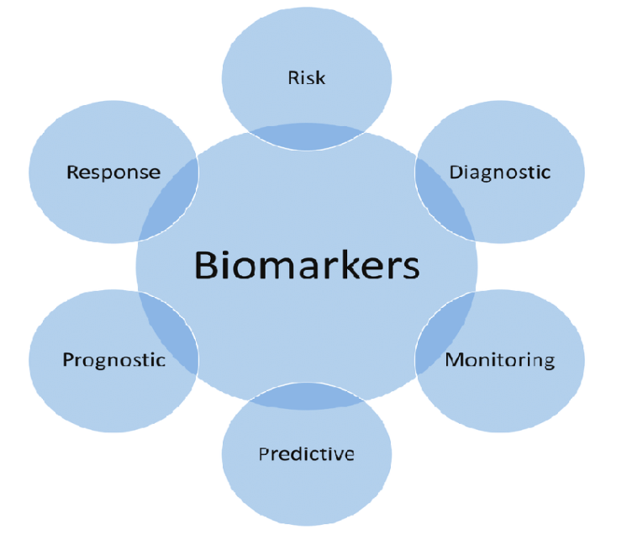
Image.1: Types of Biomarkers
Certainly, biological markers are focused to use as an indicator of a normal condition or abnormal condition or Pathogenicity condition of an individual. Therefore, identification of this distinctiveness is a significant pace in medical and mainstream medical field for their applications in screening, prognosis, early cancer diagnosis, tracking treatment response, or recurrence of the disease (Image 1). Throughout the treatment, the biomarkers can be utilized for monitoring of a patient response or further requirement of supplementary therapy, or observe re-episode of diseases. In advances the genomics, proteomics and changes at gene level during the pathology condition have generated many candidate biomarkers with potential clinical value. In future, integration of biomarkers are identified using emerging high-throughput technologies into medical practice will be necessary to achieve ‘personalization’ of treatment and disease prevention.
Biomarkers Strategies & classifications:
A biomarker is a defined that it is tested as an indicator of routine biological processes, pathogenic processes, or reactions to an exposure or intervention, including therapeutic interventions, according to the Biomarkers, EndpointS, and other Tools (BEST) terms. Biomarkers might be molecular, histologic, radiographic, or have physiological properties.
Currently, an extensive variety of signature markers are accepted to be utilized for the analysis of medical antidote against the diseases (Image 2). Based on the characteristics factor they are classified into two types i) biomarkers imaging are designated for the analysis of structural, functional and molecular process of biological molecule through the scanning Image instrument such as positron emission tomography (PET-Scan), computed tomography (CT-scan) and Magnetic resonance imaging (MRI scan) ii) Non-Imaging biomarkers or molecular biomarkers or nucleic acid based biomarkers are designated for the quantitative analysis of gene expression, macromolecules or other inorganic molecules. An evaluation of an individual's feelings, abilities, or chance of survival is not possible with a biomarker.
Biomarkers were utilized as i) Disease target discoveries, including identification and prognosis, and their validation in preclinical investigations ii) lead identification and optimization iii) in clinical trials for its function in connection with a certain disease problem iv) the diagnosis and treatment of disorders such sepsis, systemic sclerosis, respiratory ailments, osteoarthritis, and cancer.

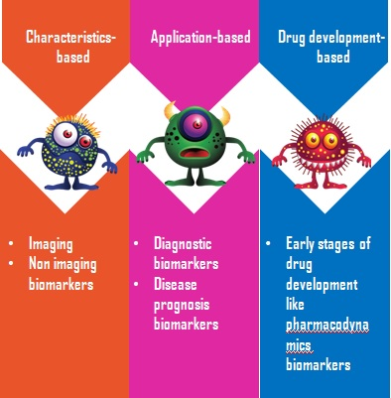
Image 2: Biomarkers classifications
Biomarkers have greater potential to significantly impact clinical trial success rates, find new therapeutic targets, and create diagnostic tools for early illness diagnosis. The existing research has been influenced by the expanding potential applications of biomarkers. The number of scientific documentation has dramatically increased over the course of the last 20 years.
Toxicology, drug discovery, clinical markers of therapeutic index and efficacy, diagnostic test development, and exposure to biological toxins are now included in the current research topics of biomarkers. Protein biomarkers contribute to the enhancement and growth of proteomic techniques, which enable the identification of a wide variety of biomarkers. Additionally, they assist in identifying specific post-translational protein alterations that are particularly noticeable in the diseased condition (Vanarsa and Mohan, 2010). Pharmacogenomics, bioinformatics, the microbiome, and others add new dimensions to the study of biomarkers besides proteomics.
The combination of modern treatment technology with biomarkers has the potential to revolutionize how medicine is done. In-depth research is now being done in the subject of biomarkers, therefore the best is yet to come.
Types of Biomarkers:
In accordance with their potential applications, various biomarker subtypes have been identified (Image 3). Importantly, a single biomarker may satisfy different criteria for several uses, but it is crucial to establish proof for each definition. As a result, although definitions may overlap, they also have distinct characteristics that indicate specific purposes.
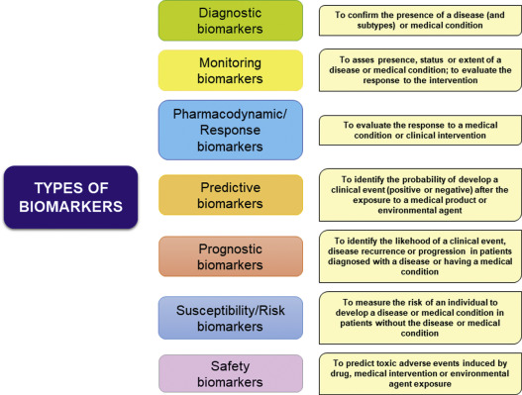
Image 3: Subtypes of biomarkers and its targets
- Diagnostic biomarkers:
A biomarker used to identify individuals suffering from a particular disease subtype or to detect or confirm the presence of a medical condition or disorder of interest. Diagnostic biomarkers are essential for determining whether a patient has a certain medical condition for which treatment may be appropriate or whether they may be included in a clinical trial investigating into a certain illness.
These biomarkers may be used to redefine the classification of the disease as well as to identify individuals who have it (Figure 1). For instance, rather than relying primarily on an organ-based categorization system, the diagnosis of cancer is moving quickly toward a molecular and imaging-based classification. This kind of biomarker will develop significantly as we enter the era of precision medicine.
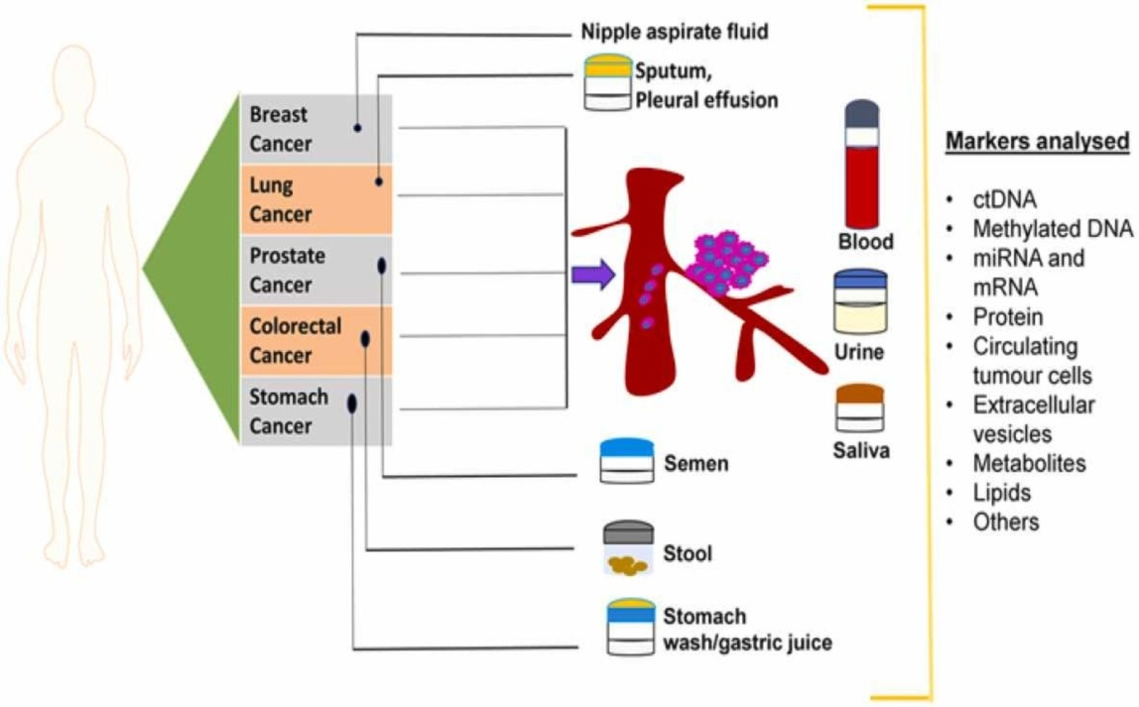
Figure 1: Biomarkers analysis for cancer.
Cancer biomarkers are molecules like DNA, RNA, enzymes, metabolites, or transcription factors that are produced either by the cancerous tumor itself or by the host as a reaction to the malignancy and provide the biomaterials important to stratify patients, anticipate, identify and evaluate the illness early as well as determine the prognosis of the disease(T. Muinao et al 2018).
- Monitoring Biomarkers:
A biomarker is considered to be a monitoring biomarker when it can be evaluated repeatedly to determine the progression of a disease or medical condition, to look for signs of exposure to a medical product or environmental agent, or to identify about effect of medical product's or biological agents. Monitoring biomarkers is beneficial for determining pharmacodynamic effects, noticing early indications of a therapeutic response, and recognizing side effects of a condition or treatment. Hence clinical treatment utilizes monitoring biomarkers extensively.
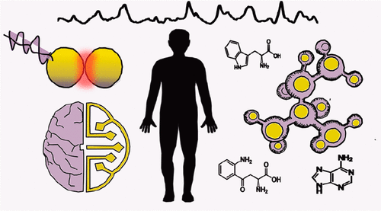
Figure 2: Monitoring Biomarkers
New generations of biomarker detection technologies need to be created in order to regularly merge molecular techniques, such as metabolomics, into clinical diagnostics (Figure 2). Due to its high sensitivity and label-free operation, surface-enhanced Raman scattering (SERS) spectroscopy has been identified as a promising technology for clinical monitoring (Testa-Anta et al 2019). This should help to expedite the discovery of biomarkers and the corresponding screening in a simpler, quicker, and more inexpensive manner. Numerous researches have shown how well SERS performs in biomedical applications.
- Pharmacodynamics Biomarkers:
Pharmacodynamic/response biomarkers are those whose levels alter as a result of exposure to a medication or an environmental factor. When a therapy is administered, a pharmacodynamic/response biomarker is assessed and used to calculate the dosage of various medications. The primary goal of these biomarkers is to create preliminary evidence that patients with the target ailment can use the medicine without developing any adverse effects. Both in clinical practice and in the early stages of pharmaceutical development, this kind of biomarker is extremely beneficial. Combining clinical examination and quantitative hypotheses has been the most popular diagnostic technique for personalizing medicine (Lackland DT et al 2016).
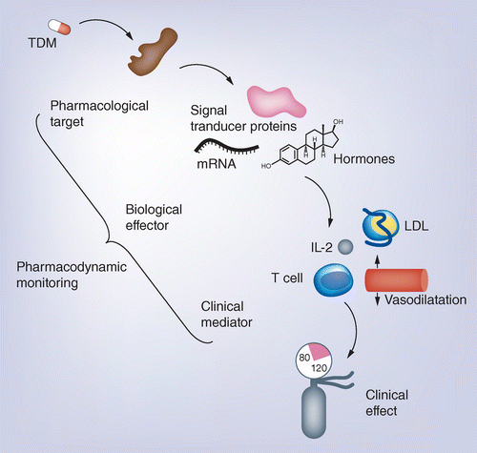
Figure 3: Pharmcodynamics Biomarkers
Biomarkers are being used in personalized medicine to some extent, following Human Epidermal Growth factor Receptor 2 (HER2) characterization as a driver of cancer disease and pharmacological target, HER2 testing resulted in such individualization of carcinoma of the breast therapy (Figure 3). However, the majority of biomarkers are employed in grading of therapy, risk estimation, or contraindication indication. Contrarily, there is an excellent reason why biomarkers for medication dose individualization or pharmacological impact monitoring are common because doses can frequently be adjusted based on the clinical effect, which then translates into benefit. Therapeutic drug monitoring allows for the adjustment of drug doses in accordance with predetermined plasma levels for improved efficacy and safety.
- Predictive Biomarkers and Prognosis Biomarkers:
In the era of personalized medicine, finding predictive biomarkers of systemic therapy response has grown to be an urgent issue. Large-scale clinical investigations frequently investigate predictive biomarkers in order to identify patient populations who will respond to medical care the best. Predictive biomarkers have the potential to be utilized as therapeutic decision support tools. They are frequently referred to as "companion diagnostics" when they are used to help patients choose their course of therapy (Abuodeh, Y et al 2016). The predictive biomarker to help patient make informed decisions about their care by highlighting the likely outcomes of a certain therapy. These biomarkers help to identify those who are more likely to have a beneficial or detrimental effect (Figure 4).
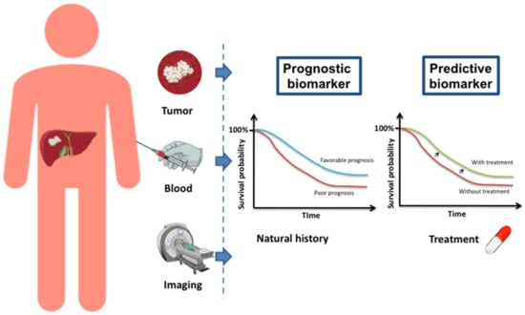
Figure 4: Predictive and Prognostic Biomarkers
They are distinct from predictive biomarkers as well, which highlight variables linked to the outcome of an intervention or exposure. Prognostic biomarkers are frequently used to establish trial admission and exclusion criteria in clinical trials to identify higher-risk individuals. In regardless of the treatments used, prognostic biomarkers that are linked to a more or less favorable disease course in terms of overall survival and/or progression-free survival ("natural history"). Prognostic biomarkers are particularly crucial for estimating an individual's risk of an event or a negative outcome. Making decisions regarding how long to stay in the hospital or in intensive care units requires knowledge of these information. Identification of biomarkers thus becomes vital for optimizing patient care and prognosis. Numerous studies are being conducted to assist in patient diagnosis, prognosis, and therapy response predicting.
V) Risk Biomarkers:
A susceptibility/risk biomarker is one that predicts the possibility of getting a disease or medical condition in a person even when they don't yet have a clinically obvious case of illness or the ailment. The idea is identical to prognostic biomarkers, however here the major concern is the correlation with the onset of a disease rather than the prognosis after a diagnosis. In order to identify populations for chemoprevention, risk biomarkers can be used (Figure 5). These kinds of biomarkers are essential for carrying out epidemiological investigations on illness risk.
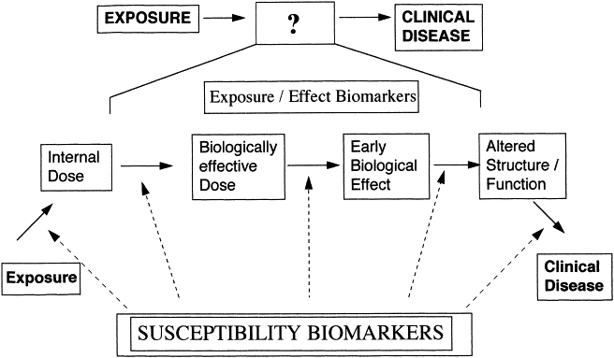
Figure 5: Susceptibility Biomarkers
Typically, the risk biomarkers fall into the following criteria based on Hulka's categories: 1) Carcinogen exposure 2) Carcinogen exposure/effect; 3) Genetic Predisposition; 4) Intermediate Biomarkers of Cancer and 5) Prior Cancers. Some risk biomarkers can be manipulated by chemopreventive medicines in addition to being used to characterize partners for chemoprevention trials (Kelloff GJ et al 2015). The assumption that a correlation between a biomarker's measured level and a clinical result suggests that the biomarker forms a reliable replacement is the single most frequent and significant error in the evaluation of biomarkers. In chemoprevention research, the parameters which are regulated by chemopreventive drugs can also be used as an endpoints.
Vi) Safety Biomarkers:
Patients who are suffering negative side effects from a medication can be identified using safety biomarkers (Schomaker S et al 2019). To determine the possibility, occurrence, or extent of toxicity as an adverse event, a safety biomarker is assessed prior to or following exposure to a medical procedure or natural contaminant. Biomarkers can be used as standard vital organ function tests across several treatment fields or as specialized testing to identify specific toxicities. The right tests must be carefully chosen, and that decision should be based on the drug profile and preclinical toxicity data.
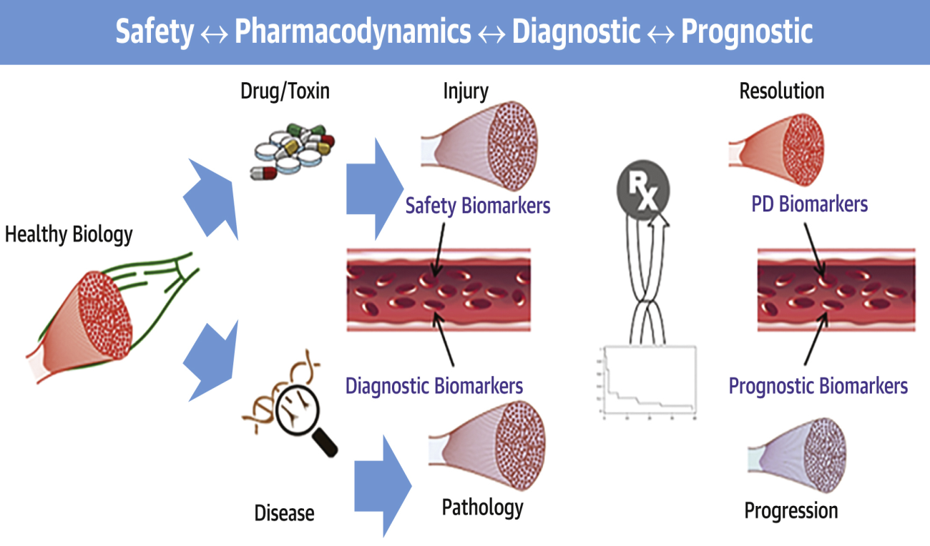
Figure 6: Safety Biomarkers
Monitoring for hepatic, renal, or cardiovascular toxicity is essential for many medicines in order to ensure that a given therapy can be continued in a safe manner (Figure 6). Safety biomarkers will be increasingly used in early clinical trials as they gain regulatory agency acceptance and qualification (Januzzi J et al 2021). They will also play a significant role in decision-making and facilitate the progression of potential therapies from experimental through clinical development. The balance that must be maintained among health and possible therapeutic benefits is an interesting aspect of determining safety biomarkers.
Uses of Biomarkers:
- To determine and support therapeutic targets.
- To locate potential leads and assess the outcomes of developing molecularly customized medicines.
- Results those are quickly available to allow for early therapy beginning and monitoring of effectiveness to allow for additional treatment modification.
- Development and validation of new animal disease models.
- To evaluate the drug's toxicity and safety.
- To assess the efficacy and safety of medications.
- Extremely reproducible across a range of clinical laboratories.

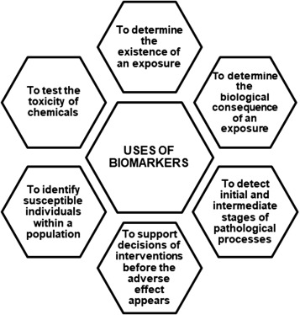
Image 4: Uses of biomarkers
Functions of Biomarkers:
Biomarkers can be categorized based on their functions in the body such as biomarkers of exposure, biomarkers of susceptibility and biomarkers of effect (Image 5).

Biomarkers of Exposure:
The substance that is measured in an organism, whether it be the substance itself, a byproduct, or the end result of a reaction between the substance and a target molecule or cell. The three requirements that any biomarker of exposure must satisfy are as follows:
- A biomarker of exposure ought to be unique to the substance under investigation.
- The biomarker needs to stay in the body for a sufficient amount of time to ensure that its measurement is accurate.
- The biomarker should be easy to quantify and collect, such as being found in urine, blood, or saliva.
Biomarkers of Susceptibility:
Markers of vulnerability give information to categorize populations and identify people at high risk. Once a high-risk group has been identified, it will be possible to keep tabs on these people in case cancer spreads. The issue with biomarkers of risk and exposure is that just because a biomarker is present does not guarantee that a person will go on to acquire cancer.
Biomarkers of Effect:
A detectable biochemical, physiological, behavioral changes in an organism depending on its severity can be linked to a known about potential of health condition.
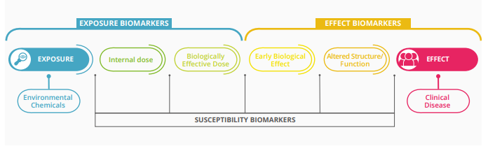
Image 5: Functions of Biomarkers
Utilization of Biomarkers in Medical Field:
A biomarker can be any substance that aids in the diagnosis of a condition, such as a metabolite, alteration in biological processes or structure, or distinguishing quality. Biomarkers can be any type of biomolecule from genes, DNA, RNA, platelets, enzymes, hormones, or even based on carbohydrates, proteins, and lipids (Image 6).
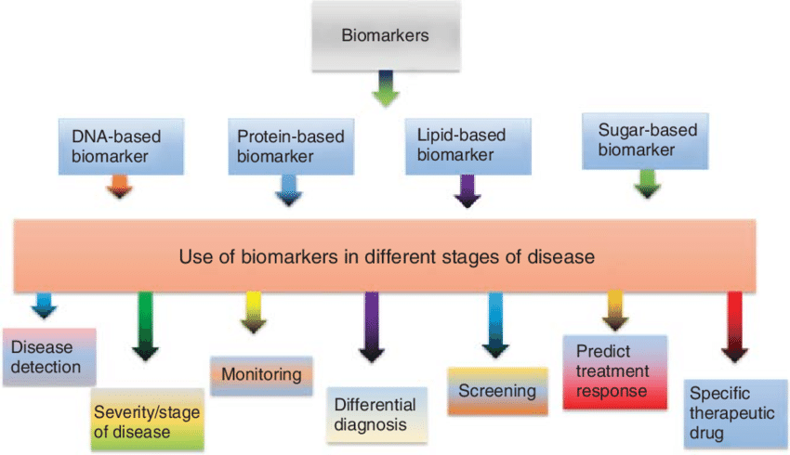
Image 6: Specific Biomarkers for Different Targets.
MOLECULAR BIOMARKERS:
DNA /RNA Biomarker:
Many genetic tests are currently used to detect mutations in DNA for cancer risk assessment and for genes that predispose an individual to inherited cancer syndromes Today, a variety of diseases are diagnosed and prognoses are assessed by using DNA and RNA as biomarkers. A biological marker detected in the germ line, such as SNPs, STRs, deletions, insertions, or other changes to the DNA sequence. These nucleic acids are therefore regarded as common biomarkers for cancer diagnosis, monitoring of tumor growth, and prediction of therapy response, such as response or resistance to a chemical. They can be detected in tissues or fluids (liquid biopsies: saliva, urine, serum, or blood) Image 7.
Clinical trials utilizing biomarkers or biomarkers capable of categorizing individuals have been effective in the development of novel medications during the past few decades. To find the people most likely to benefit from these new treatments, more than 30 medications have been created since the end of 2018. These medications work in tandem with diagnostic exams. Today, scientists and business professionals working in precision medicine use this strategy.
More specifically, RNA analysis (or gene expression analysis) is a very pertinent method for diagnosis and prediction diagnosis with excellent experimental findings in a variety of disorders, particularly in cancer. RNA analysis has the benefit of being performed on a liquid biopsy, especially a blood sample. This non-invasive method is ideal for routine clinical use because it is simple, safe, high throughput, and affordable to utilize.
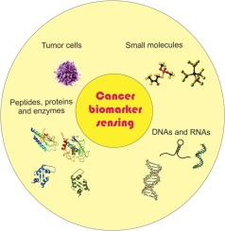
Image 7: Molecular Biomarkers
Liquid Biopsy:
Circulating tumor DNA (ctDNA) is a subset of DNA that is derived from cancer cells. CtDNA is a small (100 bp) fragment that is primarily released from cells in the tumor bed. It is thought that tumor-associated macrophages are crucial in the digestion of tumor-cell DNA, its fragmentation into smaller pieces, and their release into the bloodstream (Figure 7) The successful sequencing of the human genome, followed by the development of new sequencing technologies, made it possible to detect and sequence ctDNA with ease in a real-world context, and this non-invasive method is now widely utilized in modern oncology (Thierry A.R et al 2016).
Monitoring early tumor response could also be done via liquid biopsy. Monitoring early tumor response and identifying resistance mechanisms are two of the primary functions of liquid biopsy, and they can both inform treatment plans for many malignant cancers that are at an advanced stage.
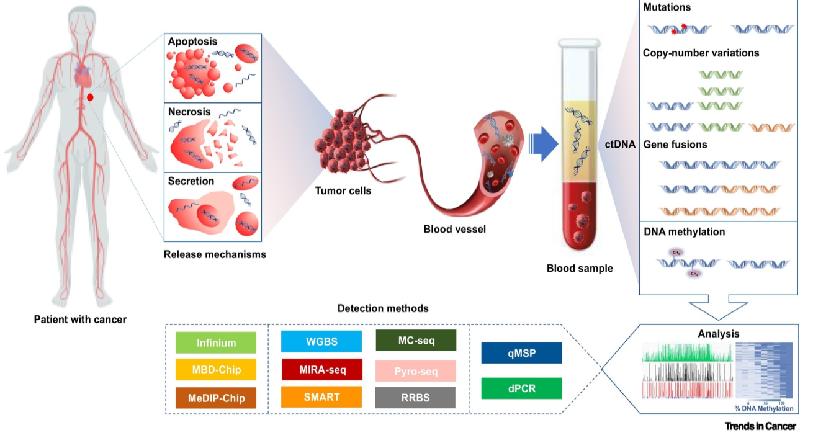
Figure 7: Liquid biopsy in Cancer
Protein Based Biomarkers:
Proteins are predominantly positive molecules to utilize as biomarkers as they are frequently diseases causing effectors released by the pathogenic organism and serve as the targets of medical interventions. Healthcare professionals can accomplish precise illness diagnosis through practical non-invasive testing using panels of protein biomarkers. Early disease diagnosis is made possible by such screening in donor samples from people who wouldn't normally manifest peculiar symptoms.
However, protein biomarkers present enormous potential for individualized therapeutics in beyond early illness recognition. Protein biomarkers are now being utilized to direct therapy decisions in the treatment of cancer (Li D et al 2014). The specific type of therapy that may be most successful may currently be predicted by investigating proteins linked to tumor drug resistance or sensitivity to chemotherapy, hormone therapy, or immunotherapy.
The use of proteomics in precision medicine has attracted a lot of interest since proteins are a direct reflection of cellular biological processes and can alter dynamically in real time. Targeted proteomics, when combined with genome and transcriptome sequencing, can aid medical professionals in providing more individualized and effective care. (Figure 8)
The primary goals of proteomics research were basic medical science, health screening, disease prevention, prognosis prediction, patient stratification, and the discovery of novel targets. Proteomics technology has been used in recent years by researchers to examine the expression of proteins in tumor tissue and plasma during radiation therapy. This will make it easier to find proteins that are essential for radiotherapy and biomarkers that can anticipate radiotherapy sensitivity in the early stages of treatment. (Walker MJ et al 2015). Tumor radiation therapy has entered the modern era in the context of precision health care with the emergence of proteomics.
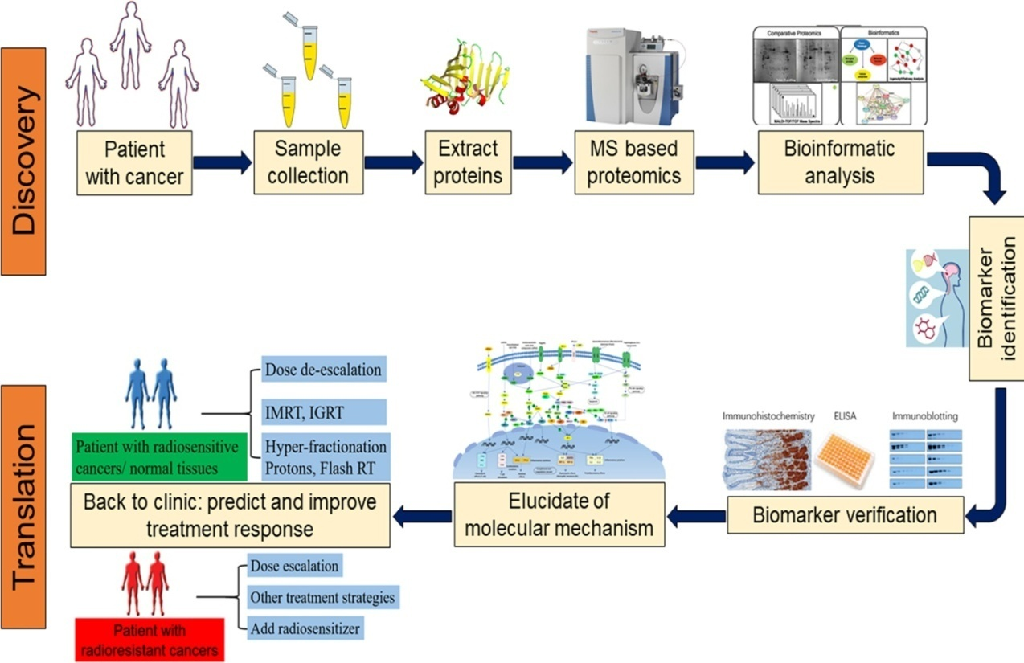
Figure 8 Proteomics approaches in clinical application of biomarkers for cancer.
Body Fluid Protein as Non-Invasive Biomarkers:
The proteins have a great deal of potential as tumor biomarkers ( Figure 9) and have a variety of clinical uses for the treatment of pancreatic cancer patients, including screening in high-risk populations for pancreatic cancer, early diagnosis, disease staging, evaluation of tumor resectability and prognosis, prediction of therapy response to inform treatment choices, and real-time patient monitoring.
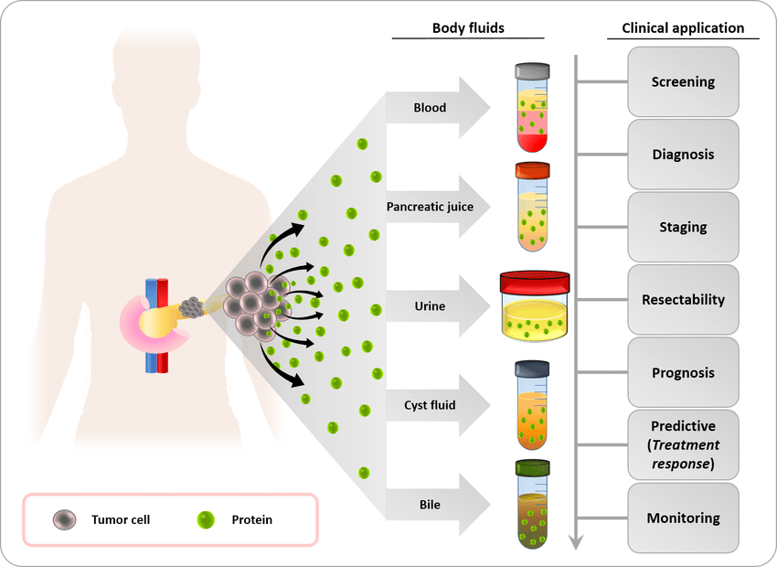
Figure 9: Protein in Body fluids as biomarkers.
Peripheral blood provides a cheap, highly reproducible, and less distracting source of circulating proteins for the research of tumor biomarkers. There have been significant efforts to find new PC biomarkers in serum or plasma, but this work is challenging due to the abundance of proteins in blood. Example Ferritin, LDH, CRP.
Urine may be collected non-invasively, which is a big benefit as a source of biomarkers; nevertheless, the kidneys and circulation can separate urine from the tumor, which is an important hurdle. The following biomarkers were chosen as potential candidates for the early-stage Pancreatic Cancer (PC) identification in a study of urine proteomes in samples from patients with PC or chronic pancreatitis and healthy controls (Radon TP et al 2015). Example: LYVE-1 biomarker (lymphatic vessel endothelial hyaluronan receptor), REG 1-alpha (regenerating gene) biomarker. These markers were suggested as part of a new panel of biomarkers for detecting early stage of Pancreatic Cancer in urine samples. For diagnostic screening tests, urine is the perfect fluid because patients may easily provide a significant volume of it in an entirely non-invasive way. Therefore, more investigation is needed to identify and confirm potential urine PC biomarkers.
The collection of pancreatic juice is an invasive procedure, making it a poor choice for diagnostic screening in general populations. However, it contains a significant amount of pancreatic proteins, which are possible biomarkers, and could thus be helpful for predicting and managing PC in people who are at high risk (Pan S et al 2015). Proteins are potential pancreatic cancer indicators may be abundant in some body fluids but not in others because the proteome of body fluids differs significantly based on the fluid's physiological makeup and proximity to the pancreatic cancer. Proteomic research have discovered proteins with a significant potential diagnostic and/or prognostic utility in cancer and have published an extensive amount of data on proteome abnormalities that may one day serve as therapeutic targets.
Lipid Based Biomarkers:
Medical conditions such as cancer and cardiovascular issues tend to be brought due to anomalies in regular physiological functions. It is therefore extremely difficult to find specific biomarkers for the diagnosis of non-infectious disorders. The detection of non-infectious disorders frequently involves monitoring variations in the expression of host-derived molecules rather than focusing on a foreign molecule that fails to appear in a healthy patient (Henry, N.L et al 2012) Numerous lipid and amphiphilic compounds that are connected to human metabolism can be employed as biomarkers when they are identified differently in people with disease compared to those who are healthy. Identifying these biomarkers may help with prognosis, recurrence monitoring, disease assessment, and predicting a patient's likelihood of contracting a specific disease (Figure 10).
Genetic anomalies and subsequent cellular and noncellular host responses play a role in the complicated disease of cancer. Numerous cell types can be found inside tumors, and they interact dynamically to support signaling networks that are particular to cancer. Extracellular vesicle (EV) formation and exchange are a part of the process of cellular communication Figure 11(a). Exosomes are tiny EVs that are increasingly understood to have a part in the development of cancer and the development of therapeutic resistance. Exosomes distinct biogenesis, ubiquity of production across all cell types, and biological characteristics in liquid biopsies has prompted interest in their potential as cancer biomarkers.
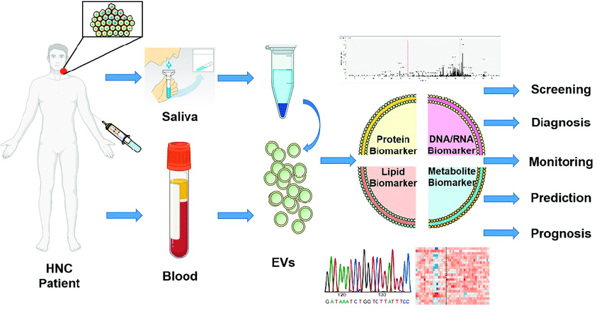
Figure 10 Lipid based Biomarkers
Exosome involvement in complex cellular interactions between tumor cells and the tumor microenvironment (TME) at every stage of cancer development is now well recognized (Berchem G et al 2015).In the beginning tumor-derived exosomal miRNA alters the gene expression of fibroblasts or epithelial cells, increasing the malignant transformation of these cells. Exosomes also transfer additional soluble growth factors to the tumor-associated cells, which activate additional signaling pathways including the PI3K/AKT pathway or the Akt and ERK pathway and promote cell proliferation in the receiving cells (Richards KE et al 2017). Second, tumor-derived exosomes might encourage tumor metastasis and epithelial-to-mesenchymal transition (EMT) by triggering cancer cells that are dormant to aggressively spread via a number of inducible signaling molecules such Notch1 and HIF1. Exosomes produced by tumors can help tumor cells gain chemo resistance and help them evade immune system detection, both of which accelerate the growth of tumors Figure 11 (b).
a)
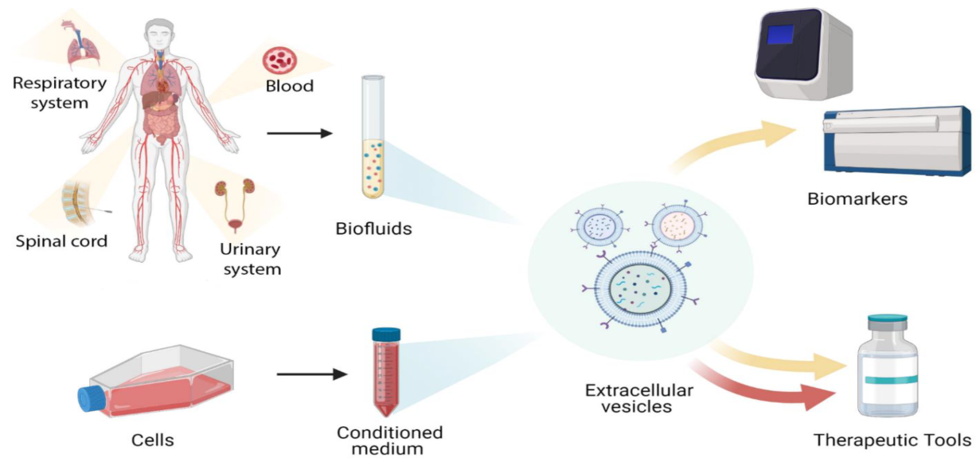
b)
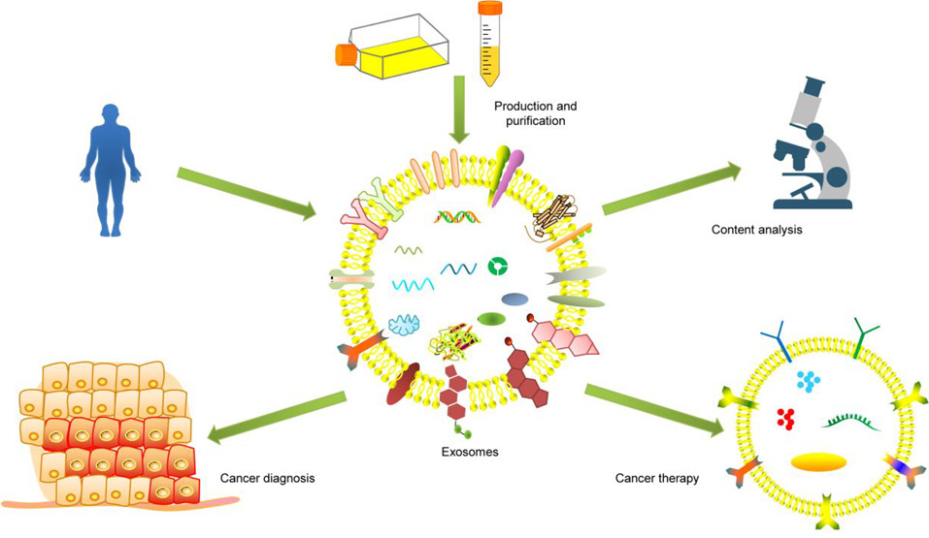
Figure 11 a) Exosomes as Biomarkers b) Exosomes Performance as tool for Cancer.

Sugar Based Biomarkers:
Indeed, biological biomarkers are a useful tool for assessing the health of patients. The sugar based biomarkers used to assess therapy results or disease prognosis in an accurate manner. Physiological fluid such as saliva, urine, and blood may also contain biomarkers (Figure 12). Among the several diverse stages of disease, biomarkers may be utilized for disease detection, differential diagnosis, disease severity, monitoring, screening, predicting therapy response, and individually customized therapeutic prescription regimens. Effective and trustworthy biomarkers can be utilized to decide on precision medicine for a person when new treatments frequently enter the market. In assessing a patient's status, biological indicators are undoubtedly used as an important tool (Chen P et al 2020).
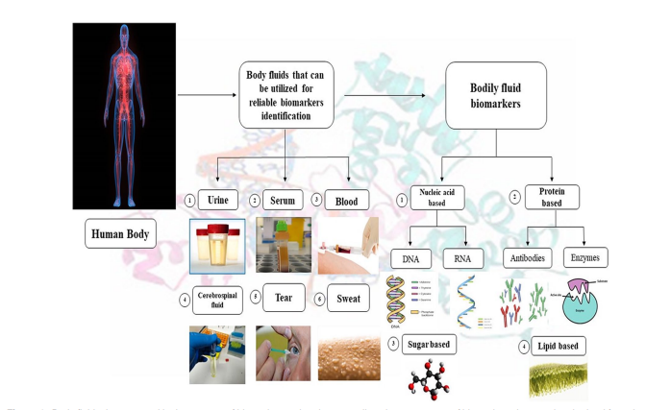
Figure 12 Sugar Based Biomarkers.
It is recognized that early-stage malignancies in living humans produce biomarkers in the peripheral blood that act as reliable reporters for monitoring the progression and aggressiveness of the malignancy. Equally important is preventing repeated blood draws and inappropriate treatment for non-life-threatening cancer diagnoses. However, existing clinical screening techniques often struggle to achieve adequate sensitivity and specificity at the same time, particularly in situations when resources are limited. One of the most widely used methods for clinical cancer diagnosis is the quantitative fluorescence-based assessment of the abundance of biomarkers.
Cancer is characterized by abnormal glycosylation. These have made it easier to create effective and novel analytical techniques for glycosylation. Several abnormal glycosylations linked to tumor development and progression (Image 8). The aberrant occurrence of O-glycan truncation, sialylation, fucosylation, and N-linked glycan branching promotes the growth and metastasis of cancer. Lectins were utilized to analyze the differences in glycosylation between breast cancer and normal cells. It proved that tumor cells exhibited a better binding affinity for lectins, indicating that tumor cells have a greater abundance of certain mucopolysaccharides. Similarly (Song K et al 2015) 90% of breast tumors include shortened O-glycans, and mucin is one of the earliest breast cancer serum indicators.
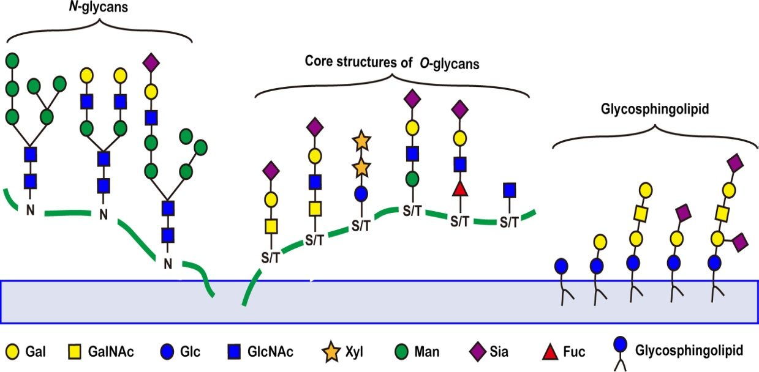
Image 8 Abnormal glycosylation linked to tumors
Many efforts have been made recently to discover, categorize, and establish glycosylation since tumor-associated glycosylation changes are a distinctive aspect of cancer diagnosis and prognosis. Immunochemical techniques, lectin recognition-based techniques, mass spectrometry (MS)-related techniques, and fluorescence imaging-based in situ analysis techniques are the four main categories of glycosylation research tool that have been established.
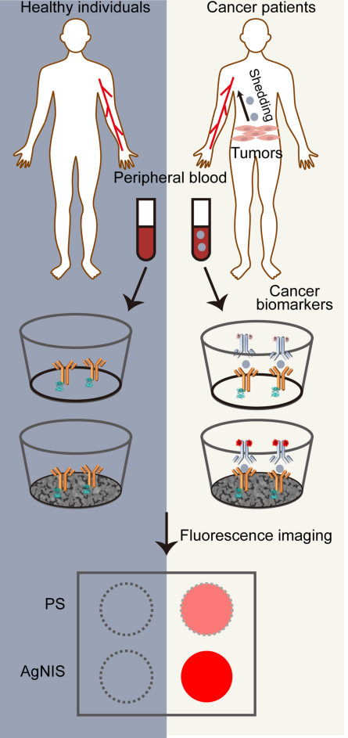
Figure 13: Sugar biomarkers for cancer diagnosis.
By carefully evaluating a panel of reducing monosaccharide and optimizing the redox methods with varying catalyst densities and precursor concentrations, the plasmonic substrate was chemically synthesized in place at the solid-liquid interface (Yang J, et al 2021). Electrochemistry and Benedict's assay were used to research the redox characteristics. We observed that effective multiplexed fluorescence enhancement resulted from both an acceptable reducing power and a constant reduction rate by examining the effects of reducing monosaccharides on the seed-mediated chemical synthesis of plasmonic Ag structures (Figure 13). Its potential clinical application for extensive cancer biomarker analysis is supported by its clinically validated diagnostic and prognostic properties, low sample volume, smart phone point-of-care capability, and microwave-shortened assay time.
Futuristic Approaches of Biomarkers:
Cancer still has a great deal of unresolved concerns, and the limits of the tools for detecting tumors that are now in significant obstacle to research and surveillance. Although improvements in cancer treatment and research, invasive and possibly procedures like biopsies, venous blood testing, imaging, colonoscopies, and Pap smear examinations are still predominantly utilized for screening, staging, and evaluating therapeutic response. The knowledge we have regarding this challenging group of ailments will be enhanced by the application of biomarkers acquired through techniques that are minimally invasive (Eick GN et al 2019). More extensive cancer screening and data collecting for population-based research and public health objectives may be possible employing validated biomarker sample types obtained using minimally invasive techniques. "Minimally invasively collected biomarkers" are those found in urine, feces, saliva, exhaled breath, and finger prick capillary blood measurements.
Although population-based research and cancer therapies are just currently beginning to explore and create these approaches, they have the potential to completely change both of these fields. It may be possible to reduce the number of cancer fatalities by making screening for progression easier to access by using biomarker testing on samples obtained using minimally invasive techniques, particularly in places without easy access to healthcare services. Current restrictions on biomarker sensitivity and specificity, which refer to the capacity to identify true positives and true negatives, respectively, may be improved by the use of biomarker panels.
In a few years, it will be necessary to do recurrent biomarker monitoring during all therapy steps and the identification of anticipated biochemical recurrence. For diagnostic or patient monitoring purposes, particularly for localized disorders, biomarkers collected from the adjacent (interstitial fluid) ISF may be more helpful. The biomarker concentration will typically be larger in the diseased tissue than in the systemic level comparable in patients with non -systemic disorders while sick organs or tissues actively create metabolites that are specific to pathophysiological processes.
A biomarker's utility is assessed by contrasting it with an ideal biomarker to understand more about its characteristics. Similar traits can be seen in promising biomarkers and ideal markers. Numerous attempts have been undertaken to investigate the biomarker frontier in quest of novel and/or improved biomarkers in an effort to enhance healthcare and create innovative therapies. Among the most significant challenges in the field of biomarkers is determining the difference between a possible biomarker and a reliable biomarker that can be used universally to guide important clinical and commercial choices. Future medical practice will need to incorporate biomarkers discovered with innovative high-throughput techniques in order to "personalize" treatment and disease prevention. Cancer biomarkers significantly contribute to improving our awareness and understanding of the cancer process in clinical practice, enabling the creation of more accurate diagnostics and the mitigation of undesirable systemic toxicity
Reference:
- Tsimberidou AM, Iskander NG, Hong DS, et al. Personalized medicine in a phase I clinical trials program: the MD Anderson Cancer Center Initiative. Clin Cancer Res. 2012;18(22):6373-83.
- Von Hoff DD, Stephenson JJ Jr, Rosen P, et al. Pilot study using molecular profiling of patients’ tumors to find potential targets and select treatments for their refractory cancers. J Clin Oncol. 2010;28(33):4877-83.
- Arrowsmith, J. and Miller, P. (2013) ‘Trial Watch: Phase II and Phase III attrition rates 2011-2012’, Nature Reviews Drug Discovery, p. 569. doi: 10.1038/nrd4090.
- Atala, A. and Allickson, J. G. (2014) Translational Regenerative Medicine, Translational Regenerative Medicine. doi: 10.1016/C2012-0-06956-6.
- Atkinson, A. J. et al. (2001) ‘Biomarkers and surrogate endpoints: Preferred definitions and conceptual framework’, Clinical Pharmacology and Therapeutics, pp. 89–95. doi: 10.1067/mcp.2001.113989.
- Chau, C. H. et al. (2008) ‘Validation of analytic methods for biomarkers used in drug development’, Clinical Cancer Research, pp. 5967–5976. doi: 10.1158/1078-0432.CCR-07-4535.
- FDA (2017) Current Biomarker Qualification Submissions. Available at: https://www.fda.gov/Drugs/DevelopmentApprovalProcess/DrugDevelopmentToolsQualificationProgram/BiomarkerQualificationProgram/ucm535881.htm (Accessed:21 March 2018).
- Vanarsa, K. and Mohan, C. (2010) ‘Proteomics in rheumatology: the dawn of a new era.’ F1000 medicine reports, 2(December), p. 87. doi: 10.3410/M2-87
- FDA-NIH Biomarker Working Group. BEST (Biomarkers, EndpointS, and other Tools) Resource. Silver Spring (MD): Food and Drug Administration (US); Bethesda (MD): National Institutes of Health (US), www.ncbi.nlm.nih.gov/books/NBK326791/ (2016, accessed 22 September 2017)
- Yancy CW, Jessup M, Bozkurt B, Butler J, Casey DE Jr, Drazner MH, Fonarow GC, Geraci SA, Horwich T, Januzzi JL, Johnson MR, Kasper EK, Levy WC, Masoudi FA, McBride PE, McMurray JJ, Mitchell JE, Peterson PN, Riegel B, Sam F, Stevenson LW, Tang WH, Tsai EJ, Wilkoff BL. 2013 ACCF/AHA guideline for the management of heart failure: a report of the American College of Cardiology Foundation/American Heart Association Task Force on practice guidelines. Circulation. 2013 Oct 15; 128:e240–327.
- T. Muinao, H.P. Deka Boruah, M. Pal Diagnostic and Prognostic Biomarkers in ovarian cancer and the potential roles of cancer stem cells - An updated review Exp. Cell Res., 362 (1) (2018), pp. 1-10, 10.1016/j.yexcr.2017.10.018
- Testa-Anta, Martin; Ramos-Docampo, Miguel A.; Comesana-Hermo, Miguel; Rivas-Murias, Beatriz; Salgueirino, Veronica Nanoscale Advances (2019), 1 (6), 2086-2103CODEN: NAADAI; ISSN: 2516-0230. (Royal Society of Chemistry)
- Lackland DT, Voeks JH, Boan AD. Hypertension and stroke: an appraisal of the evidence and implications for clinical management. Expert Rev. Cardiovasc. Ther. 14(5), 609–616 (2016)
- Abuodeh, Y.; Naghavi, A.O.; Ahmed, K.A.; Venkat, P.S.; Kim, Y.; Kis, B.; Choi, J.; Biebel, B.; Sweeney, J.; Anaya, D.A.; et al. Prognostic Value of Pre-Treatment F-18-FDG PET-CT in Patients with Hepatocellular Carcinoma Undergoing Radioembolization. World J. Gastroenterol. 2016, 22, 10406–10414.
- Progress in cancer chemoprevention: perspectives on agent selection and short-term clinical intervention trials. Kelloff GJ, Boone CW, Steele VE, Crowell JA, Lubet R, Sigman CC.Cancer Res. 1994 Apr 1;54(7 Suppl):2015s-2024s.
- Schomaker S, Ramaiah S, Khan N, Burkhardt J. Safety biomarker applications in drug development. J Toxicol Sci. 2019;44(4):225-235. doi: 10.2131/jts.44.225. PMID: 30944276.
- Januzzi J, Canty J, Das S, et al. Gaining Efficiency in Clinical Trials With Cardiac Biomarkers. J Am Coll Cardiol. 2021 Apr, 77 (15) 1922–1933.https://doi.org/10.1016/j.jacc.2021.02.040
- Papadopoulos N. Pathophysiology of ctDNA release into the circulation and its characteristics: what is important for clinical applications? Recent Results Cancer Res. 2020;215:163–180
- Thierry A.R., El Messaoudi S., Gahan P.B., Anker P., Stroun M. Origins, structures, and functions of circulating DNA in oncology. Cancer Metastasis Rev. 2016;35:347–376.
- Li D, Chan DW. Proteomic cancer biomarkers from discovery to approval: it’s worth the effort. Expert Rev Proteomics. 2014;11(2):135-136. DOI: 10.1586/14789450.2014.897614
- Walker MJ, Zhou C, Backen A, Pernemalm M, Williamson AJ, Priest LJ, et al. Discovery and Validation of Predictive Biomarkers of Survival for Non-Small Cell Lung Cancer Patients Undergoing Radical Radiotherapy: Two Proteins With Predictive Value. EBioMedicine (2015) 2:841–50. doi: 10.1016/j.ebiom.2015.06.013
- Radon TP, Massat NJ, Jones R, Alrawashdeh W, Dumartin L, Ennis D, Duffy SW, Kocher HM, Pereira SP, Guarner posthumous L, Murta-Nascimento C, Real FX, Malats N, et al. Identification of a Three-Biomarker Panel in Urine for Early Detection of Pancreatic Adenocarcinoma. Clin Cancer Res. 2015; 21: 3512-21. https://doi.org/10.1158/1078-0432. CCR-14-2467.
- Henry, N.L.; Hayes, D.F. Cancer biomarkers. Mol. Oncol. 2012, 6, 140–146.
- Pan S, Brentnall TA, Chen R. Proteomics analysis of bodily fluids in pancreatic cancer. Proteomics. 2015; 15: 2705-15. https://doi.org/10.1002/pmic.201400476.
- Berchem G, Noman MZ, Bosseler M, Paggetti J, Baconnais S, Le Cam E, et al. Hypoxic Tumor-Derived Microvesicles Negatively Regulate NK Cell Function by a Mechanism Involving TGF-Beta and Mir23a Transfer. Oncoimmunology (2016) 5(4):e1062968. doi: 10.1080/2162402X.2015.1062968
- Richards KE, Zeleniak AE, Fishel ML, Wu J, Littlepage LE, Hill R. Cancer-Associated Fibroblast Exosomes Regulate Survival and Proliferation of Pancreatic Cancer Cells. Oncogene (2017) 36(13):1770–8. doi: 10.1038/onc.2016.353
- Chen P, Zhou G, Lin J, et al. Serum biomarkers for inflammatory bowel disease. Front Med. 2020;7:123
- Yang J, et al. Structurally symmetric near-infrared fluorophore IRDye78-protein complex enables multimodal cancer imaging. Theranostics. 2021;11:2534–49.
- Song K, Herzog BH, Fu J, Sheng M, Bergstrom K, McDaniel JM, et al. Loss of core 1-derived O-glycans decreases breast cancer development in mice. J Biol Chem (2015) 290(33):20159–66. doi: 10.1074/jbc.M115.654483.
- Eick GN, Devlin MJ, Cepon-Robins TJ, Kowal P, Sugiyama LS, & Snodgrass JJ (2019). A dried blood spot-based method to measure levels of tartrate-resistant acid phosphatase 5b (TRACP-5b), a marker of bone resorption. American Journal of Human Biology, 31(3), e23240. 10.1002/ajhb.23240

