Nutritional psychiatry – essential for fostering mental health
U.Suhasini, Nursing faculty* Mail.id : umapathihasini007@gmail.com
Dr. B.Ganga Bhavani , Principal* Mail.id :-gangabhavani259@gmail.com
*College of Nursing
Sri Padmavati Mahila VisvaVidyalayam,(Womens’ University )
Tirupati, Andhra Pradesh
India-517502

Abstract
Right food is equal to right mood is the notion that we hear. In this chapter how nutrition impact ones mental wellbeing and mental illness were discussed. .Oxidants, which has been demonstrated to have a detrimental influence on mood and mental health, can harm the brain if it isn't fed with a diet that can promote good neurotransmitter function. Many recognized mental health issues, including depression, schizophrenia, dementia, anorexia nervosa, and attention deficit hyperactivity disorder (ADHD), are strongly influenced by nutrition.
Key words diet, dietary factors, lifestyle, nutritional psychiatry, mental health, sleep, cognitive; mood, anxiety
Introduction
Psychiatric disorders have usually been considered diseases of the brain, with modest part of the body or individual organs in their pathophysiology. Exceptions to this brain-focused approach have been pre-scientific concepts in Traditional Chinese Medicine, Ayurvedic Medicine, and Hippocratic Medicine, all of which attributed a significant role of the body, in particular the digestive system and diet, in modulating mental processes. 1 in every 8 people in the world live with a mental disorder.
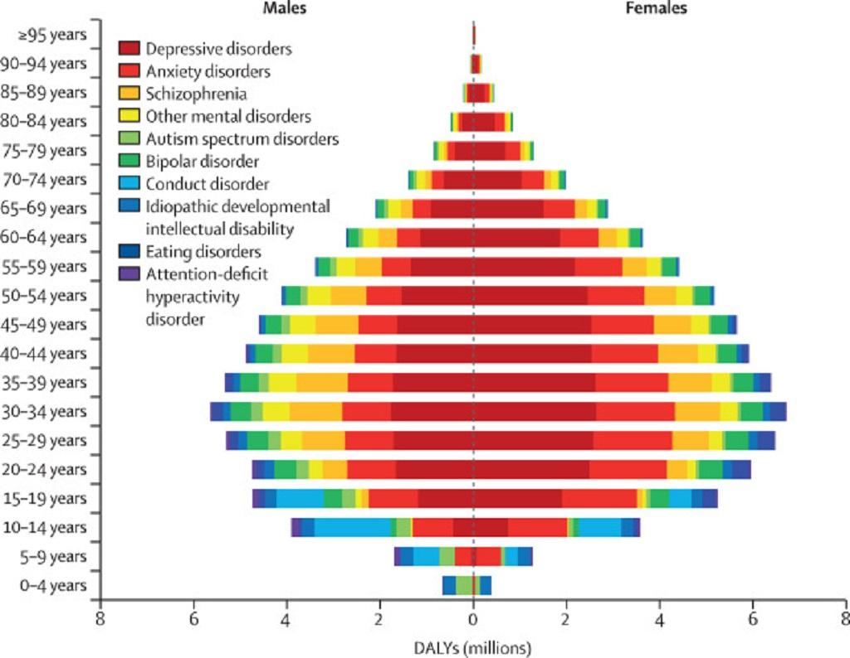
Source: Lancet Psychiatry
- An array of disordered ideas, perceptions, emotions, behavior, and interpersonal interactions often describe mental illnesses. Depression, bipolar illness, schizophrenia, dementia, and developmental diseases like autism are all examples of mental disorders.
- Mental disorders involve significant disturbances in thinking, emotional regulation, or behavior.

5 Nutrients Needed for Optimal Brain Function
nutrient | Brain Function | deficiency | Foods recommended
Vitamin D | As a crucial hormone for brain function, vitamin D controls the synthesis of dopamine, noradrenaline, and adrenaline. | Fatigue, muscular weakness, hair loss, back pain, slow skin healing, bone discomfort, and mood swings are just a few symptoms of vitamin D deficiency. | eggs, fatty fish (like sock-eyed salmon or trout), mushrooms, fortified foods (like brown rice), goat cheese, and gluten-free oats.
Vitamin B | The major supplement for mood regulation is B12, and B9. | Vitamin B comlex deficiency causes depression, anxiety, and mood swings. It is associated with a disruption in the nervous system as well as the circulatory system | dark green vegetables, beans, peas, citrus fruits, and legumes (such as lentils and garbanzo beans).
magnesium | Magnesium acts as a mood booster, muscle relaxer, stress reducer, and sleep aid. | The deficiency of magnesium increases symptom such as agitation, anxiety, irritability, confusion, insomnia, headache, hallucinations, and depression. | pumpkin seeds, dark organic chocolate (plus 72%), and almonds, into the diet at least three times a day to help alleviate some stress.
Omega-3 fatty acids | Omega-3 fatty acids are essential for brain function, supporting mental sharpness, and positive mood. | Symptoms of omega-3 fatty acid deficiency include fatigue, poor memory, dry skin, heart problems, mood swings or depression, and poor circulation. | Oily fishes are great sources of omega-3 fatty acids. These healthy fats can also be found in flaxseeds and walnuts
Probiotics | Probiotics are a live bacterial and yeast mixture that naturally inhabit the human gastrointestinal system and help with good digestion, stress management, mood enhancement, and emotional stability | An unhealthy gut has been associated with probiotic disorders such as ADD/ADHD, anxiety, depression, schizophrenia, and Alzheimer's disease. | Probiotic foods are organic yogurt, kefir, sauerkraut, kimchi, non-GMO miso, and pickles.
Selenium | Selenium contains potent antioxidants, which can protect our brain cells and tamp down inflammation. | • Irritability  • Depression | Fish, garlic, sunflower seeds, brazil nuts  Whole grains, , eggs, legumes etc.
Amino acids | Amino acids are required for the production of proteins that assist your brain in controlling your mood. | Glutathione is an antioxidant that defends against cellular harm brought on by free radicals and environmental heavy metals. | Amino acids rich foods like meats, eggs, nuts, legumes, and seafood.
Zinc | Zinc helps in regulating mood and cognition | • Confusion  • Blank mind  • Depression  • Loss of appetite  • Lack of motivation | Oysters, nuts, seeds  Fish, legumes, whole grains.

The six cornerstones of nutritional psychiatry provide the basis for treating mental illness with diet.
- Be Whole, Eat Whole: In accordance with the 80/20 guideline, 80% of your diet should consist of whole, wholesome foods that are high in fiber. This contains entire grains, legumes, nuts, seeds, fruits, vegetables, and protein. 20% of the meal provides some leeway.

- Eat a Rainbow diet: Eat a rainbow of colorful plant foods to maximizes nutritious content. Different colored plant foods provide various nutrients that are beneficial to the brain. Aim to have 75% whole, low-glycemic-index vegetables, which includes leafy greens, cucumbers, radishes, eggplant, mushrooms, and tomatoes. The remaining 25% meal should consist of high-quality protein sources like salmon, grass-fed beef, sardines, chickpeas, and lentils, as well as healthy fats like olive oil, walnuts, or hemp seeds. These meals are crucial for tissue maintenance, reducing inflammation, and promoting mental wellbeing.

- The Greener, the Better: In nutritional psychiatry, it is know that greens are healthy for the mind as well as the body. Folate is a crucial nutrient found in greens that helps keep our neurons functioning properly and reduces the occurance of depression symptoms . leafy greens include spinach, swiss chard, collard greens, arugula, romaine, and dandelion greens.

- Tap Into Your Body Intelligence: One should probably avoid anything if it doesn't make them feel good after consuming it. Pay attention to how certain meals affect your mental health symptoms, and follow your body's wisdom.

- Consistency and Balance is the Key: We carry our brains with us for the duration of our lives. Instead of relying on fast cures or miraculous diets, it is crucial to make long-lasting dietary and lifestyle adjustments in order to improve our mental health.

- Avoid Anxiety-Inducing Foods: This is crucial for making the preceding activities effective. meals that cause inflammation and anxiety, such as those with added or refined sugars, industrial seed oils (soy, maize, and grapeseed), processed meals with nitrates, and meats, are not good for mental health.

Adopting nutritional psychiatry and its principles can assist a great number of individuals achieve or sustain positive mental health in the face of enormous hurdles as the silent and parallel pandemic persists and rates of COVID-19 linked bad mental health grow.

References
- Abou-Saleh MT, Coppen A. Folic acid and the treatment of depression. J Psychosom Res. 2006;61:285–7.
- Available from: http:/diet.hajimeru.biz/category/health/nutritionj/
- Bell IR, Edman JS, Morrow FD, Marby DW, Mirages S, Perrone G, et al. B Complex vitamin patterns in geriatric and young adult inpatients with major depression. J Am Geriatr Soc. 1991;39:252–7.
- Benton D. Selenium Intake, mood and other aspects of psychological functioning. Nutr Neurosci. 2002;5:363–74.
- Black, M.M. , 2008. Effects of vitamin B12 and folate deficiency on brain development in children. Food Nutr. Bull. 29, S126–S131 .
- Bourre JM. Effect of nutrients (in food) on the structure and function of the nervous system: Update on dietary requirements for brain, Part 1: Micronutrients. J Nutr Health Aging. 2006;10:377–85.
- Brouwer-Brolsma, E.M. , Dhonukshe-Rutten, R.A. , van Wijngaar- den, J.P. , van de Zwaluw, N.L. , In ’t Veld, P.H. , Wins, S. , Swart, K.M. , Enneman, A.W. , Ham, A.C. , van Dijk, S.C. , van Schoor, N.M. , van der Velde, N. , Uitterlinden, A.G. , Lips, P. , Kessels, R.P. , Steegenga, W.T. , Feskens, E.J. , de Groot, L.C. , 2015. Cognitive performance: a cross-sectional study on serum vitamin D and its interplay with glucose homeostasis in Dutch older adults. J. Am. Med. Dir. Assoc .
- Chouinard G, Young SN, Annable L. A controlled clinical trial of L-tryptophan in acute mania. Biol Psychiatry. 1985;20:546–7.
- Davison K, Abraham KM, Connor, McLeod MN. Effectiveness of chromium in atypical depression: A placebo-controlled trial. Bio Psychiatry. 2003;53:261–4.
- Del-Ponte et al., 2019 B. Del-Ponte, G.C. Quinte, S. Cruz, M. Grellert, I.S. SantosDietary patterns and attention deficit/hyperactivity disorder (ADHD): a systematic review and meta-analysis J. Affect. Disord., 252 (2019), pp. 160-173
- Docherty J, Sack DA, Roffman M, Finch M, Komorowski JR. A double-blind, placebo-controlled exploratory trial of chromium picolinate in atypical depression: Effect on carbohydrate craving. J Psychiat Pract. 2005;11:302–14.
- Eby GA, Eby KL. Rapid recovery from major depression using magnesium treatment. Med Hypotheses. 2006;67:362–70.
- Enderami, A. , Zarghami, M. , Darvishi-Khezri, H. , 2018. The effects and potential mechanisms of folic acid on cognitive function: a comprehensive review. Neurol. Sci. 39, 1667–1675 .
- Gaudio, S. , Wiemerslage, L. , Brooks, S.J. , Schioth, H.B. , 2016. A systematic review of resting-state functional-MRI stud- ies in anorexia nervosa: evidence for functional connec- tivity impairment in cognitive control and visuospatial and body-signal integration. Neurosci. Biobehav. Rev. 71, 578–589 .
- GBD 2017 Disease and Injury Incidence and Prevalence Collaborators. (2018). Global, regional, and national incidence, prevalence, and years lived with disability for 354 diseases and injuries for 195 countries and territories, 1990–2017: a systematic analysis for the Global Burden of Disease Study 2017. The Lancet. DOI:https://doi.org/10.1016/S0140-6736(18)32279-7
- Giannunzio, V. , Degortes, D. , Tenconi, E. , Collantoni, E. , Solmi, M. , Santonastaso, P. , Favaro, A. , 2018. Decision-making impair- ment in anorexia nervosa: new insights into the role of age and decision-making style. Eur. Eat. Disord. Rev. 26, 302–314 .
- Gröber U., Schmidt J., Kisters K. Magnesium in prevention and therapy. Nutrients. 2015;7:8199–8226. doi: 10.3390/nu7095388.
- Health Canada. About Natural Health Product Regulation in Canada. Accessed 5 March 2018. www.canada.ca/en/health-canada/services/drugs-health-products/natural-non-prescription/regulation.html.
- Healy-Stoffel, Michelle; Levant, Beth, N-3 (Omega-3) Fatty Acids: Effects on Brain Dopamine Systems and Potential Role in the Etiology and Treatment of Neuropsychiatric Disorders CNS & Neurological Disorders - Drug Targets (Formerly Current Drug Targets - CNS & Neurological Disorders),Bentham Science Publishers Volume 17, Number 3, 2018, pp. 216-232(17)
- Hegyi, J. , Schwartz, R.A. , Hegyi, V. , 2004. Pellagra: dermatitis, de- mentia, and diarrhea. Int. J. Dermatol. 43, 1–5 .
- Levenson CW. Zinc, the new antidepressant? Nutr Rev. 2006;6:39–42.
- McLean A, Rubinsztein JS, Robbins TW, Sahakian BJ. The effects of tyrosine depletion in normal healthy volunteers: Implications for unipolar depression. Psychopharmacology. 2004;171:286–97.
- Rayman MP The importance of selenium to human health. Lancet 2000; 356: 233-241
- Smith, A.D. , Warren, M.J. , Refsum, H. , 2018. Vitamin B12. Adv. Food Nutr. Res. 83, 215–279 .
- Tangney, C.C., Aggarwal, N.T., Li, H. , Wilson, R.S. , Decarli, C. , Evans, D.A. , Morris, M.C. , 2011. Vitamin B12, cognition, and brain MRI measures: a cross-sectional examination. Neurology 77, 1276–1282 .
- Wallace CJK, Milev R. The effects of probiotics on depressive symptoms in humans: A systematic review. Ann Gen Psychiatry 2017;16:14.
- Wurtman R, O'Rourke D, Wurtman JJ. Nutrient imbalances in depressive disorders: Possible brain mechanisms. Ann NY Acad Sci. 1989;575:75–82.

