“Things” and Communication Trends in IoT
Manjuanath R¹  Professor, CSE Department  R R Institute of Technology, Bengaluru,  Karnataka, India, drmanjunath.raj@gmail.com | Sowmya Naik P²  Professor, CSE Department  City Engineering College, Bengaluru  Karnataka, India, sowmya.vturesearch@gmail.com
Shivashankar³  Professor, ECE Department  R R Institute of Technology, Bengaluru,  Karnataka, India, drmanjunath.raj@gmail.com | Sumanth V⁴  Assistant Professor, Manipal Institute of Technology, Manipal Academy of Higher Education, Bengaluru,  Karnataka, India, ssumanth6@gmail.com
ABSTRACT
As of now, there is an overabundance of IoT correspondence conventions, the advances used to interface IoT gadgets to the web, utilized across the world. The broad assortment of correspondence conventions can prompt issues with interoperability between and inside IoT biological systems. There is as of now no worldwide IoT correspondence guidelines, making enormous scope IoT appropriation more complicated than it wants to be. A consolidated "Things" and Correspondence Patterns in IoT principles are fundamental to understand the involved capability of IoT. The primary focal point of IoT innovation is endpoint security, for example alludes to the security of related figuring gadgets. The focal reason of IoT is the expression "network Sensors and Actuators". The IoT gadgets are related to Web over a wide variety of correspondence innovation. This book section depicts the few advances elaborate in IoT correspondence. The variety in correspondence builds the enquiry to choose for the future and proposed application. The fundamental target of the application prerequisites to characterize obviously. The elements applications, for example, range, recurrence groups, power utilization, geography, obliged gadgets, compelled hub and organizations impact the decision of picking at least one IoT correspondence innovation.

- INTRODUCTION
The Web of Thing (IoT) depicts the association of genuine articles "things" are embedded with sensors, actuators, programming, and various advancements for the objective of partner and trading information with other passing devices and structures on through the web. These IoT passing devices range from normal local things on to complex current instruments.
IoT is the frameworks organization of genuine things that contain equipment implanted inside their design to bestow and distinguish relationship between each other or with reverence to the periphery environment. In the next few years, IoT-based advancement will offer significant level levels of organizations and basically affect how people continue with their ordinary presences. Types of progress in prescription, power, quality medicines, cultivating, canny metropolitan networks, and wise homes are just a not a great a large number of the out and out models where IoT is decidedly settled.
Unequivocal sensors will in like manner be ready inside existing spaces to screen the prosperity and comprehensive thriving of senior occupants, while furthermore guarding that sensible treatment is being directed and assisting public people with recovering lost flexibility through treatment as well. These sensors structure an association of shrewd sensors which can accumulate, cycle, move and study regarded data in different conditions, for instance, communicating in-home checking devices to clinical center based systems. Other client devices to stir strong living which are related scales or wearable heart screens, are in like manner an opportunity with the IoT. The uses of Correspondence Examples in IoT are beginning to end prosperity checking using IoT arranges similarly open for pre-birth and solid patients, helping them with regulating prosperity vitals and rehashing medication necessities.
- SENSORS IN INTERNET OF THINGS
A sensor does precisely as its name demonstrates: It detects. All the more explicitly, A sensor estimates some actual amount and converts that estimation adding something extra to a computerized portrayal. That computerized portrayal is normally passed to one more gadget for change into helpful information that can be consumed by savvy gadgets or people. Sensors can be promptly implanted in any actual articles that are effortlessly associated with the Web by wired or remote organizations. Since these associated have actual items with complex detecting abilities speak with one another and outside frameworks, they can decipher their current circumstance and pursue shrewd choices.

- Applications For Sensors
Sensors have been around starting from the start of force and have been being utilized in an extraordinarily broad assortment of uses. We use sensors in contraptions projects, mechanical innovation, industry, and essentially more. Table 1 is a short rundown of run of the mill uses of sensors.
Table 1: List of Sensor Applications
Automation  Robotics  Embedded Systems  Computers  Smart Cars  Avionics  Satellites | Smart Homes  Smartphones  Smart Watches  Energy plants  Remote Sensing  Communications  Medical domain

- Sensors Classifications
Dynamic or dormant: Sensors can be arranged considering whether they produce an energy yield and usually require an external power supply (dynamic) or whether they basically get energy and consistently require no external power supply (reserved).
Prominent or innocuous: Sensors can be characterized considering whether a sensor is fundamental for the environment it is assessing (prominent) or external to it (easy).
Contact or no-contact: Sensors can be arranged considering whether they require genuine contact with what they are assessing (contact) or not (no contact). By and large or relative: Sensors can be arranged considering whether they measure on an absolute scale (through and through) or taking into account a differentiation with a fixed or variable reference regard (relative).
Area of usage: Sensors can be arranged considering the specific business or vertical where they are being used.
How sensors measure: Sensors can be sorted out considering the real framework used to check unmistakable data. What sensors measure: Sensors can be sorted out considering their applications or what genuine elements they measure.
- Sensor Types
The most helpful order plot for the even minded use of sensors in an IoT organization, is to just group in view of what actual peculiarity a sensor is estimating. This sort of arrangement is shown in Table 2.

Table 2: Different Types of Sensors
Temperature Sensor |  | One of the most generally perceived and most notable sensors is the Temperature Sensor. A Temperature Sensor, as the name proposes, resources the temperature i.e., it gauges the movements in the temperature.
Proximity Sensors |  | Proximity Sensor is a non-contact type sensor that recognizes the presence of a thing. Closeness Sensors can be completed using different strategies like Optical (like Infrared or Laser), Sound (Ultrasonic), Alluring (Anteroom Effect), Capacitive, etc.
Infrared Sensor (IR Sensor) |  | IR Sensors or Infrared Sensor are light based sensor that are used in various applications like Proximity and Article Revelation. IR Sensors are used as closeness sensors in essentially all mobile phones.
Ultrasonic Sensor |  | A Ultrasonic Sensor is a non-contact type device that can be used to check distance as well as speed of a thing. A Ultrasonic Sensor works considering the properties of the sound waves with repeat more critical than that of the human discernible reach.
Light Sensor |  | A direct Light Sensor open today is the Light Dependent Resistor or LDR. The property of LDR is that its hindrance is conversely comparative with the force of the encompassing light i.e., when the power of light extends, its resistance lessens and tight cinch versa.
Smoke and Gas Sensors |  | One of the very supportive sensors in prosperity related applications are Smoke and Gas Sensors. For all intents and purposes all work environments and ventures are outfitted with a couple of smoke alerts, which recognize any smoke (in light of fire) and sound a wariness.
Alcohol Sensor |  | As the name recommends, a Liquor Sensor identifies liquor. Typically, liquor sensors are utilized in breathalyzer gadgets, which decide if an individual is tanked or not. Policing utilizes breathalyzers to get intoxicated and-drive guilty parties.
Touch Sensor |  | We don't give a ton of importance to contact sensors yet they transformed into a fundamental piece of our life. Whether or not you know, all touch screen contraptions (Phones, Tablets, laptops, etc) have contact sensors in them. Another average utilization of touch sensor is trackpads in our PC.
Color Sensor |  | A variety Sensor is a useful device in building assortment distinguishing applications in the field of picture dealing with, assortment ID, current thing following, etc. The TCS3200 is an essential Assortment Sensor, which can recognize any tone and result a square wave comparative with the recurrence of the recognized assortment.
Humidity Sensor |  | If we can see Weather patterns Checking Structures, they regularly give temperature as well as dampness data. Thusly, assessing sogginess is a huge task in various applications and Moisture Sensors help us in achieving this.
Tilt Sensor |  | Regularly used to recognize inclination or heading, Inclination Sensors are perhaps of the most direct and modest sensor out there. In advance, incline sensors are involved Mercury (and therefore they are on occasion called as Mercury Switches) but latest inclination sensors contain a roller ball.
Radiation Sensor |  | A radiation sensor is a contraptions instrument that resources and measures the radiation particles like alpha, beta, gamma, neutrons, X-radiates.
Level Sensor |  | The principal job of the level sensor is to quantify the level or level of various materials like strong, fluid, and vaporous.
Vibration Sensor |  | The vibration sensor distinguishes and records any turn of events or activities. Moreover, it offers data or hints to related machines or structures.
Image Sensor | The image sensor is an electronic device that is used to recognize the image pixels and give information to the show contraptions.
Flame Sensor | The fire sensor successfully distinguishes fire or fire of adjoining materials. These recognized signs are passed to the related control contraptions.
Leak Sensor | A leak sensor is used in a shut vessel or vacuum for perceiving water spillage, fluid spillage, air spillage, etc.
Mark Sensor | Mark sensor measures and perceives in every way that really matters, any cycle fluid. Mark sensor functions as a photoelectric kind of sensor.
Flow Sensor or Float Sensor | It is utilized to detect variety marks within the sight of articles. This perceived data will be given to the controller system. It is used in present day areas, power making instruments, power plants, etc.

- How To Choose The Right Sensor?
There are numerous components to consider while picking a sensor for any endeavor. However, all starting points by picking the genuine limit we will evaluate. Then, it's an optimal chance to consider perhaps a couple components to get the best sensors for best results and inside the given restrictions like spending plan, accuracy, etc. Down underneath are likely the principal factors to consider.
Range of Operation: The fundamental variable to consider in a sensor is the functioning reach.
Accuracy (Resolution): Choose the important objective (precision) of the sensor your applications need prior to picking a sensor.
Total Cost: Electronic sensors range broadly in cost. We can without much of a stretch conjecture that high precision sensors are in every case far more costly than low exactness ones. The working wide powerful fury likewise assumes a part in deciding the cost of the sensor, and so forth.
Interfacing Method: As we've expressed prior, a few sensors are simple and others are computerized. Thus, there are various approaches to communicate and peruse these sensors utilizing simple information pins of a MCU.
Data Rate (For Modernized Sensors): High level sensors can send you readings (data) at a rate we call the testing rate. Commonly sensors' rate is described by ksp/s (kilo tests each second) which is 1,000 model centers (readings) in a second. A couple of sensors can supply up to two or three Msp/s.More often than not, it's a programmable element in sensor modules. Documentation: Great documentation is key regardless of whether to pick a sensor
Example: Advanced mobile phones.
In excess of a billion PDAs are sold every year, and every one has above and beyond twelve sensors inside it (displayed in Figure 1), and that number keeps on developing every year. Envision the outstanding impact of stretching out sensors to for all intents and purposes each innovation, industry, and vertical.

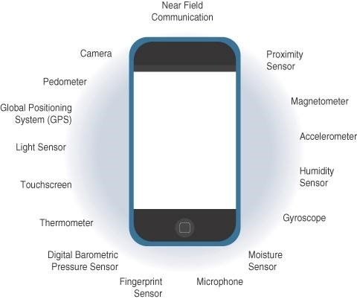

Figure 1: Sensors in a Smart Phone

- ACTUATORS IN INTERNET OF THINGS
Actuators are normal supplements to sensors. Sensors are expected to distinguish and measure essentially any quantifiable variable in the genuine world. They convert their assessments (consistently straightforward) into electric signs or mechanized depictions that can be consumed by a sharp trained professional (a device or a human). Actuators get some kind of control signal (regularly an electric sign or mechanized request) that sets off a genuine effect, by and large a development, force or some likeness thereof, and so on. Figure 2 shows the evenness and reciprocal nature of these two sorts of gadgets.

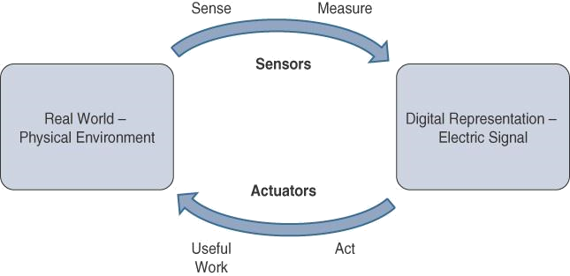

Figure 2 : How Sensors and Actuators Interact with the Physical World.

Figure 3 presents examination of Sensor and Actuator Usefulness with People. People utilize their five faculties to detect and quantify their current circumstance. The material organs convert this unmistakable information into electrical inspirations that the tactile framework ships off the psyche for dealing with. In like manner, IoT sensors are devices that sense and measure the genuine world and (regularly) signal their assessments as electric signs delivered off a chip or some likeness thereof or microcontroller for additional dealing with. A processor can pass an electric message on to an actuator that makes an understanding of the sign into an improvement or the like (immediate, rotational, and so forth) or important work that changes or quantifiably influences the genuine world.
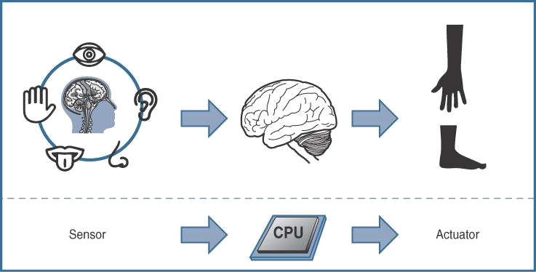

Figure 3: Comparison of Sensor and Actuator Functionality with Human

- Classification of Actuators
Similar as sensors, actuators likewise change extraordinarily in capability, size, plan, etc. A few familiar ways that they can be grouped incorporate the accompanying:
Type of motion: Actuators can be characterized in view of the sort of movement they produce (for instance, straight, rotational, one/two/three-tomahawks).
Power: Actuators can be grouped in view of their power yield (for instance, high power, low power, miniature power).
Paired or ceaseless: Actuators can be portrayed considering the amount of stable-state yields.
Area of utilization: Actuators can be described considering the specific business or vertical where they are used.
Type of energy: Actuators can be assembled considering their energy type.

- Types of Actuators
The various sorts of actuators are displayed in underneath Table 3.
Table 3: Types of Actuators
Types of Motion and functions
Linear Actuators | Linear actuators, as their name suggests, are contraptions that move in a precise style. They are usually found in water controlled and pneumatic stuff and can be mechanical or electrical.
Rotary Actuators | Rotating actuators, rather than straight kinds of actuators, produce a round development. Most machines, as the saying "rotating" derives, use turning parts to accomplish a turning improvement. If a machine needs to push ahead, in converse, up, or down, they are a significant part of the time utilized in regards to a straight actuator.
Types of Energy
Hydraulic Actuators | Hydraulic actuators use a fluid filled chamber with a chamber arranged in the middle to work. Water powered actuators conventionally make direct turns of events, with a spring associated with one end for bring development back. These actuators can be found in an arrangement of rec center hardware, including steppers and vehicle transport carriers
Pneumatic Actuators | Pneumatic actuators are one of the most dependable machine development decisions. To make mechanical turn of events, they use compacted gases. Various associations slant toward pneumatic actuators since they can perform extremely precise exercises, particularly while starting and ending machines.
Electric Actuators | Electrical actuators, as you could expect, rely upon ability to work. Electric vehicles, creating stuff, and high level mechanics equipment are outstanding models. They produce definite development likewise that pneumatic actuators truly do considering the way that the movement of electrical power is consistent.

- Applications for Different Types of Actuators
In planning, actuators are constantly used to introduce development. They can, in any case, be fastened to a decision to stop development. Actuators are used in various applications which are presented in Table 4.
Table 4: Types of Actuators
Hydraulic piston  Comb drive  Relay  Electric motor  Digital micromirror device | Thermal bimorph  Electroactive polymer  Piezoelectric actuator  Servomechanism

- SMART OBJECTS IN INTERNET OF THINGS
Smart objects are the structure blocks of IoT. They change regular items into an organization of wise articles that can gain from and collaborate with their current circumstance in a significant manner. The capacity to impart over an organization makes a multiplicative difference and considers exceptionally refined relationship and cooperation between divergent shrewd items.

- Smart Objects: A Definition
Smart objects is frequently utilized conversely with terms like brilliant sensor, shrewd gadget, IoT gadget, insightful gadget, thing, brilliant thing, clever hub, keen thing, universal thing, and wise item. A savvy object, as depicted all through this book, is a gadget that has, at the very least, the accompanying four main qualities (introduced in figure 4).
The fundamental parts of "Things" and Communication Trends in IoT are Handling unit, specialized gadgets, Sensor(s) or potentially actuator(s) and power sources.
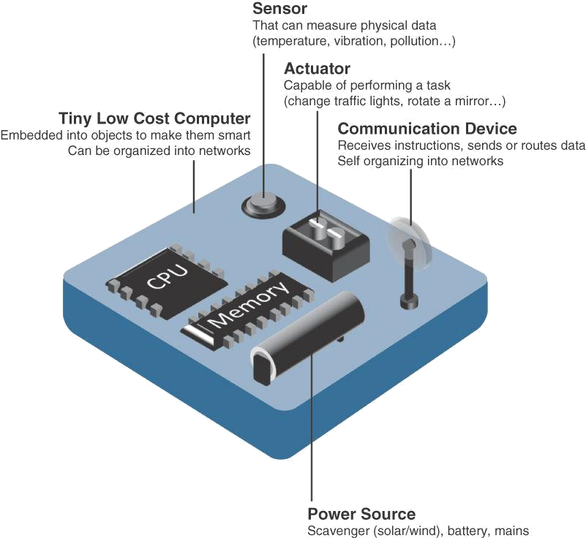

Figure 4 : Characteristics of a Smart Objects
- Trends in Smart Objects
Size is decreasing: A couple of smart items are so little they are not even observable to the independent eye. This decreased size makes keen articles more clear to embed in standard things.
Power consumption is decreasing: The different gear portions of a shrewd item interminably consume less power.
Processing power is increasing: Processors are unendingly getting even more noteworthy and more unassuming to Deal with power. This is a crucial movement for splendid things, as they become continuously muddled and related.
Communication capacities are getting to the next level: IoT is driving the improvement of progressively more specific correspondence shows covering a more significant assortment of direction cases and conditions.
Communication is progressively normalized: There is significant solid areas for an in the business to cultivate open rules for IoT correspondence shows.

- COMMUNICATION CRITERIA
Interfacing "things," countless wired and remote access advancements are accessible or a work in progress. Prior to exploring a portion of these entrance advances, it means quite a bit to discuss the standards to use in assessing them for different use cases and framework arrangements. Measures' are utilized in assessing access advancements of different use cases and framework arrangements.
Range: How far does the sign ought to be incited? What will be the area of consideration for a picked distant development? Should indoor versus outside courses of action be isolated?All the time, these are the primary inquiries posed while examining wired and remote access innovations. The easiest way to deal with responding to these sorts of inquiries is to arrange these advancements in to short, medium and long reach.
Short reach: The old style wired model is a sequential link. Remote short reach innovations are in many cases considered as an option in contrast to a sequential link, supporting several meters of greatest distance between two gadgets. Medium reach: This reach is the primary classification of IoT access advances. In the extent of tens to many meters, various specifics and executions are open. The most outrageous distance is overall under 1 mile between two devices, in spite of the way that RF propels don't have certified most prominent distances portrayed, as long as the radio transmission is imparted and gotten in the degree of the relevant detail.
Long reach: Distances more imperative than 1 mile between two devices require long-range advancements. Remote models are cell (2G, 3G, 4G) and a couple of usages of outside IEEE 802.11 Wi-Fi and Low-Power Wide District (LPWA) developments. LPWA correspondences can pass on over a gigantic district without consuming a ton of power. These advances are thus perfect for battery-controlled IoT sensors.
Frequency Bands: Radio range is managed by nations and additionally associations, like the Worldwide Telecom Association (ITU) and the Government Correspondences Commission (FCC). These social affairs describe the rules and transmission essentials for various repeat gatherings. For example, pieces of the reach are appropriated to sorts of media interchanges like radio, television, military, and so on. Approved range is overall relevant to IoT long-range access advancements and allotted to exchanges establishments sent by organizations providers, public organizations, broadcasters, and utilities.
Unlicensed Reach: The ITU has furthermore portrayed unlicensed reach for the cutting edge, sensible, and clinical (ISM) portions of the radio gatherings. These frequencies are used in various correspondences headways for short-range contraptions (SRDs). Unlicensed suggests that no certificates or confirmations are introduced in the ISM bunches for device correspondences.
Power Utilization: While the significance of IoT device is incredibly broad, there is a sensible layout between Energized centers and Battery-controlled centers. A filled center has a quick relationship with a power source, and correspondences are by and large not limited by power use norms. In any case, straightforwardness of association of filled center points is limited by the openness of a power source, which makes transportability more convoluted. Battery-controlled center points convey considerably greater flexibility to IoT devices. These hubs are much of the time characterized by the necessary lifetimes of their batteries. For gadgets under customary support, a battery duration of 2 to 3 years is a choice.

Topology: For connecting IoT contraptions, three principal geology plans are winning: star, cross segment, and shared. For long-reach and short-range developments, a star topography is prevalent, as seen with cell, LPWA, and Bluetooth associations. Star geologies utilize a single central base station or controller to allow correspondences with endpoints. For medium-range developments, a star, shared, or network topography is typical. Conveyed geologies license any device to talk with another contraption for whatever length of time they are in extent of each other.

Constrained Devices: obliged gadget as a rule has exceptionally restricted power, memory, and handling cycles. The IoT is to a great extent comprised of obliged gadgets, like brilliant sensors and implanted gadgets. They are intended for use in an extremely unpleasant climate. To decrease potential assaults to a base, they have only a couple of correspondence interfaces. They are situated in an exceptionally gotten climate.

Constrained-Node Networks: Constrained center point networks are oftentimes implied as low-power and lossy associations (LLNs). Low-power concerning LLNs insinuates the way that centers ought to adjust to the necessities from controlled and battery-filled constrained centers. Lossy associations exhibits that network execution could encounter the evil impacts of check and capriciousness in light of awful radio circumstances. Layer 1 and Layer 2 shows that can be used for obliged center point organizations ought to be evaluated with respect to the going with characteristics for use-case relevance: Data rate and throughput, Inactivity and determinism, or more and payload.

- CONCLUSION
This chapters gives prologue to correspondence of IoTs, sensors, sensor applications, sensor characterizations and types. Then we have examined about actuators, actuators applications, actuator groupings and types. It likewise introduced the shrewd articles and patterns in brilliant articles. In this section, we have bantered about the ongoing correspondence patterns, for example, range, recurrence groups, power utilizations, geography, obliged gadgets, and compelled hub network advances which are famously utilized in assessing access advances of different use cases and framework arrangements. IoT correspondence and advancements alludes to the arrangement of interconnected processing gadgets which can impart and move of information with no prerequisite of clear humanoid or PC associations. "Things" and Correspondence Patterns in IoT patterns has projected the world elements and standpoint with regards to both exploration development and business world. With various kinds of sensors, gadgets, and applications, IoT pattern enables more straightforward existing, yet in addition extra efficient and genuine one. For instance, a voice partner will assist the costumer with turning on or switch off lights and fans, yet additionally "sense" when there isn't being used and change off the machines to save power. IoT-drove applications to appreciate clients' traditions and ingesting designs utilizing complex projects or calculations and afterward apply them to tweak the application yields.

Reference:

- Rajesh Kumar Kaushal, Rajat Bhardwaj, Naveen Kumar, Abeer A. Aljohani, Shashi Kant Gupta, Prabhdeep Singh and Nitin Purohit,
“Using Mobile Computing to Provide a Smart and Secure Internet of Things (IoT) Framework for Medical Applications”, Wireless Communications and Mobile Computing-Hindawi, Volume 2022 | Article ID 8741357 | https://doi.org/10.1155/2022/8741357, 2023.
- Rajesh Kumar Kaushal, Rajat Bhardwaj, Naveen Kumar, Abeer A. Aljohani , Shashi Kant Gupta, Prabhdeep Singh and Nitin Purohit, “Using Mobile Computing to Provide a Smart and Secure Internet of Things (IoT) Framework for Medical Applications”, Hindawi- Wireless Communications and Mobile Computing Volume 2022, Article ID 8741357, pp.13-22, https://doi.org/10.1155/2022/8741357, 2022.
- Ebenezer Esenogho, Karim Djouani and Anish M. Kurien , “Integrating Artificial Intelligence Internet of Things and 5G for Next-Generation Smartgrid: A Survey of Trends Challenges and Prospect”, IEEE Access, DoI 10.1109/ACCESS.2022.3140595, Volume- 10, 2022.
- K. Shafique, B. A. Khawaja, F. Sabir, S. Qazi, and M. Mustaqim, ‘‘Internet of Things (IoT) for next-generation smart systems: A review of current challenges, future trends and prospects for emerging 5G-IoT scenarios,’’ IEEE Access, vol. 8, pp. 23022–23040, 2020.
- Accessed: Jul. 10, 2021. [Online]. Available: https://siliconsemi conductor.net/article/106227/AI_In_Sensors_For_IoT
- P. P. Raya and N. Kumar, ‘‘SDN/NFV architectures for edge-cloud oriented IoT: A systematic review,’’ Comput. Commun., vol. 169, pp. 129–153, Jan. 2021.
- K. Shafique, B. A. Khawaja, F. Sabir, S. Qazi, and M. Mustaqim, ‘‘Internet of Things (IoT) for next-generation smart systems: A review of current challenges, future trends and prospects for emerging 5G-IoT scenarios,’’ IEEE Access, vol. 8, pp. 23022–23040, 2020.
- P. P. Raya and N. Kumar, ‘‘SDN/NFV architectures for edge-cloud oriented IoT: A systematic review,’’ Comput. Commun., vol. 169, pp. 129–153, Jan. 2021.
- Z. Wang, Y. Liu, Z. Ma, X. Liu, and J. Ma, ‘‘LiPSG: Lightweight privacypreserving Q-learning-based energy management for the IoT-enabled smart grid,’’ IEEE Internet Things J., vol. 7, no. 5, pp. 3935–3947, Jan. 2020.
- Z. Wang, Y. Liu, Z. Ma, X. Liu, and J. Ma, ‘‘LiPSG: Lightweight privacypreserving Q-learning-based energy management for the IoT-enabled smart grid,’’ IEEE Internet Things J., vol. 7, no. 5, pp. 3935–3947, Jan. 2020.
- Akshi Kumar, Danda B. Rawat, Neeli Rashmi Prasad and Sumarga Kumar Sah Tyagi, “AI-Integrated Wireless Communications and Computing Trends for Next-Generation IoT”, Wireless Communications and Mobile Computing-Hindawi, 2023.

