FUTURE TRENDS IN RENEWABLE AND SUSTAINABLE ENERGY RESOURCES: USING ESSENTIAL MICROBES FROM INDUSTRIAL SECTOR
Yaser Arafath A¹, Aifa Fathima S¹, Saqib Hassan^{2,3}, Prathiviraj R¹, George Sehgal Kiran⁴, Joseph Selvin¹*

¹Department of Microbiology, School of Life Sciences, Pondicherry University, Puducherry, India-605014

² Assistant Professor, Department of Biotechnology, School of Bio and Chemical Engineering, Sathyabama Institute of Science and Technology, Chennai, Tamil Nadu, India - 600119

³Future Leaders Mentoring Fellow, American Society for Microbiology, Washington, United States of America-20036

⁴Department of Food Science and Technology, School of Life Sciences, Pondicherry University, Puducherry, India- 605014.

*-Corresponding author:

Prof. Joseph Selvin: E-Mail: josephselvinss@gmail.com

Contents
S. No. | Name | Page No.
1 | Introduction | 4
2 | Microbes and Biofuel | 4
 | 2.1 Methane | 5
 | 2.2 Methanogens | 7
 | 2.3 Bioethanol | 7
 | 2.4 Biodiesel | 9
 | 2.5 Hydrogen | 10
3 | Cyanobacteria | 12
4 | Microbial fuel cells | 13
5 | Conclusion | 14-15
6 | References | 16-24
List of Tables
Table No. | Title | Page No.
1 | Types of biofuel substances produced by beneficial microbes | 4-5
List of Figures
Figure No. | Title | Page No.
1 | Advantages and disadvantages of various biofuels | 7
2 | Production of biofuel from various sources | 8
3 | Process of biodiesel production and recovery of methanol | 12

Abstract

The search for renewable and sustainable energy sources has become imperative as the world continues to grapple with the challenges posed by climate change and the depletion of finite fossil fuel reserves. Biofuels are derived from organic matter and have gained traction as an eco-friendly substitute for conventional fossil fuels. By utilizing feedstocks such as agricultural residues, dedicated energy crops, and even algae, biofuels offer reduced greenhouse gas emissions and can be compatible with existing combustion engines. Researchers are actively investigating methods to enhance biofuel production efficiency and address land-use competition, food security, and biodiversity concerns. Biodiesel, a type of biofuel, is produced through the trans-esterification of vegetable oils or animal fats. It is a renewable and biodegradable alternative to traditional diesel fuel, with the potential to decrease greenhouse gas emissions significantly. Hydrogen is regarded as a versatile, clean energy carrier with zero carbon emissions when utilized in fuel cells. It can be produced through various processes, including water electrolysis using renewable energy sources like wind, solar, or hydropower. Developing hydrogen infrastructure and storage solutions is vital to unlock its potential as a mainstream fuel for vehicles, industrial applications, and power generation, aiming to create a sustainable and emissions-free energy landscape. Cyanobacteria, represent a promising avenue for sustainable energy and chemical production. These microorganisms can efficiently convert sunlight and carbon dioxide into biofuels and valuable biochemical through photosynthesis. While each renewable resource offers distinct advantages and challenges, they share the common goal of fostering a sustainable energy transition. Continued research, technological advancements, and supportive policies are essential to realizing the full potential of biofuel, biodiesel, hydrogen, and cyanobacteria as key components of a cleaner and more environmentally conscious energy future. Embracing these renewable alternatives presents a promising pathway to mitigate climate change and promote global energy security. This review focuses on promising alternatives that have garnered significant attention recently: microbial fuel cells, biofuel, biodiesel, hydrogen, and cyanobacteria.
Keywords: Biofuels; Sustainable; Cynobacteria; Renewable; Microbial.

1. Introduction
The consumption of energy increased in recent years. In developed countries, 28% of world’s population uses 77% of energy production (Desa, 2019). By 2050 it was estimated that the population will reach 9.7 billion, and developing countries witness 90% of the population growth. Microbes produce energy from organic and inorganic substances through various metabolic pathways to produce different types of biofuels. Apart from photosynthesis, certain microbes like cyanobacteria decompose water into desirable oxygen and hydrogen (Agyekum et al., 2022). Some of the microbes have the ability to break down environmental pollutants into valuable energy compounds (methane and alcohol) (Teng et al., 2019). By understanding the metabolic pathway and phenotypic makeup of a particular microbe the desirable end product can be obtained through efficient technologies (Fabris et al., 2020). The selection of desirable substrates plays a vital role in microbial biofuel production. Present energy production involves financial support, remediation strategies, and initial research. Natural pollutants affect the benefits of fossil fuel energy where CO₂, NO₂, and SO₂ become harder to remediate (ÓhAiseadha et al., 2020).
To overcome environmental pollution like soil, air, and water cost-effective biorefineries must be produced (Zetterholm et al., 2020). The optimal production of biofuel depends on the selection of particular microbes and their suitable substrate. Microalgae and Cyanobacteria reduce atmospheric CO₂ into biofuels photosynthetically whereas methanotrophs utilize methane to produce methanol (Liao et al., 2016). Bacteria like Geobacter sulfurreducens and Shewanella oneidensis transfer an electron to other conductive surfaces via the outer membrane which is useful in bioelectricity generation (Kracke, 2015). In the absence of oxygen metal-reducing microbes use metal salts as electron acceptors. The present chapter demonstrates how microbes can be utilized for clean energy production which can be renewable and sustainable in the future.
Rather than using a single microbe a group of microbes can be used to produce sustainable energy (a) Trichoderma reesei and Saccharomyces cerevisiae to hydrolyze lignocellulosic biomass,(b) Scheffersomyces stipitis to utilize hexose and pentose sugar (Rastogi and Shrivastava, 2017) (c) Penicillium echinulatum produces Cellulase and xylanase in the presence of Cellulose and sorbitol in the growth medium, (d) Xylanase obtained from Anoxybacillus flavithermus strain TWXYL3 is thermostable in nature which is renewable and in expensive in nature (Ellis et al., 2012) (e) Aspergillus spp. Secretes inulinases enzyme (exo and endo) enhances the formation of fructose from inulin (Ricca et al., 2007).
2. Microbes and Biofuel
Biofuel having more positive net energy is considered for commercialization. Biomass with higher lignocellulose content (plant biomass) is an efficient substrate for microbes. Saccharomyces cerevisiae cannot degrade lignocellulose completely (Chang et al., 2013). The processing of lignocellulolytic plant biomass starts with pre-treatment followed by enzymatic bioprocessing (Kumar et al., 2009). The cellulolytic breakdown of plant biomass can be by physical, biological, or chemical means. The pretreated biomass undergoes hydrolysis by using microorganisms or a mixture of enzymatic treatments (Lynd et al., 2002). Gases like methane are emitted in lesser quantities compared to other greenhouse gases and are more potent than CO₂ (Yvon-Durocher et al., 2014).
2.1. Methane
Methane forms the major component in natural gas which can be transformed into biofuel (methanotrophs) or into methanol (Liao et al., 2016). A current advantages and disadvantages of various biofuels production was schematically represented in Figure 1. Methane gas can be produced either biologically or non-biologically. Most of the methane is produced in a biological way with the help of microorganisms, especially methanogenic archaea via the methanogenesis pathway (Conrad, 2009; Prathiviraj et al., 2019; Chellapandi and Prathiviraj, 2020; Prathiviraj and Chellapandi, 2020a). The end product of industrial microbes for biofuel productions was detailed infer in the Table 1.
Table 1 Types of biofuel substance produced by beneficial microbes (Kumar and Kumar, 2017).
Biofuel | Microorganism
Ethanol | Escherichia coli
 | Zymomonas mobilis
 | Caldicellulosiruptor bescii
 | Trichoderma reesei
 | Saccharomyces cerevisiae
 | Candida shehatae
 | Fusarium oxysporum
Butanol | Clostridium acetobutylicum
 | Escherichia coli
 | Pseudomonas putida
Isobutanol | Clostridium thermocellum
2, 3-butanediol | Zymomonas mobilis
Fatty acid | Yarrowia lipolytica
 | Saccharomyces cerevisiae
Isoprenoid based-biofuel | Saccharomyces cerevisiae
Limonene | Synechococcus sp.
1, 3-propanediol | Synechococcus elongates
Lipids | Cryptococcus vishniaccii
 | Acinetobacter calcoaceticus
 | Arthrobacter sp.
 | Bacillus alcalophilus
 | Rhodococcus opacus
 | Candida curvata
 | Cryptococcus albidus
 | Lipomyces starkeyi
 | Rhodotorula glutinis
 | Trichosporon oleaginosus
 | Aspergillus oryzae
 | Humicola lanuginosa
 | Mortierella isabellina
 | Mortierella vinacea

2.2. Methanogens
Methanogens lack peptidoglycan in the cell wall structure. Alternatively, they possess heteropolysaccharide (Methanosarcina), pseudomurein (Methanobacterium and Methanobrevibacter) (Hook et al., 2010). Methanobacteriales ruminantium found in ruminants produce methane in the presence of coenzyme M (terminal methyl carrier), Coenzymes F₄₂₀ (dehydrogenase enzyme) hydrogen, and carbon dioxide (Chellapandi et al., 2018; Prathiviraj and Chellapandi, 2019; Prathiviraj and Chellapandi, 2020b; Srivastava et al., 2020). One billion tons of methane was produced and consumed by microorganisms each year. The removal of methane occurs in Earth’s atmosphere (troposphere and stratosphere) with the help of ultraviolet radiation in a non-biological way (Wang et al., 2021). In the catalytic steam reforming process methane is turned into synthetic gas containing hydrogen and carbon monoxide in the presence of nickel as the catalyst at 700 – 1100 ℃. Which can be used as a raw material for the production of hydrogen and methanol (Meloni et al., 2020). The enzyme monooxygenase reduces the oxygen to peroxide and then to methanol in the presence of methane (de Souza et al., 2022). The conversion of coal into methane is carried out synergistically by a syntrophic community of microorganisms Clostridium, Enterobacter, Klebsiella, and Citrobacter (Rodríguez-Reyes et al., 2021).
2.3. Bioethanol
The most common biofuel available today is bioethanol which is produced through the fermentative pathway. Ethanol can be produced by various types of microorganisms. Globally 29 billion gallons were produced by the year 2019. The United States and Brazil were the top producers of bioethanol (84%) (Tse et al., 2021). In the presence of yeast, the biomass undergoes an oxidation reaction followed by decarboxylation of pyruvate to form ethanol (Lin et al., 2018). Saccharomyces cerevisiae is much more efficient compared to Escherichia coli in producing ethanol through direct decarboxylation. The most efficient way of producing ethanol is in the absence of Co-enzyme A (CoA), which is possible in genetically engineered microorganisms. Artificial metabolic pathway designing requires specific tools to help the mRNA and proteins to be functional in the designed pathway (Koppolu and Vasigala, 2016). Zymomonas mobilis produces a higher ethanol yield than Saccharomyces cerevisiae. Genes encoding for enzymes such as mannose and xylose tend to increase the bio-ethanol yield to 89.9% in 72 hrs (Yang et al., 2016). Bio-ethanol production from lignocellulosic raw material is high so microorganisms that can synthesize ethanol from glucose and xylose are used (Ruchala et al., 2020).
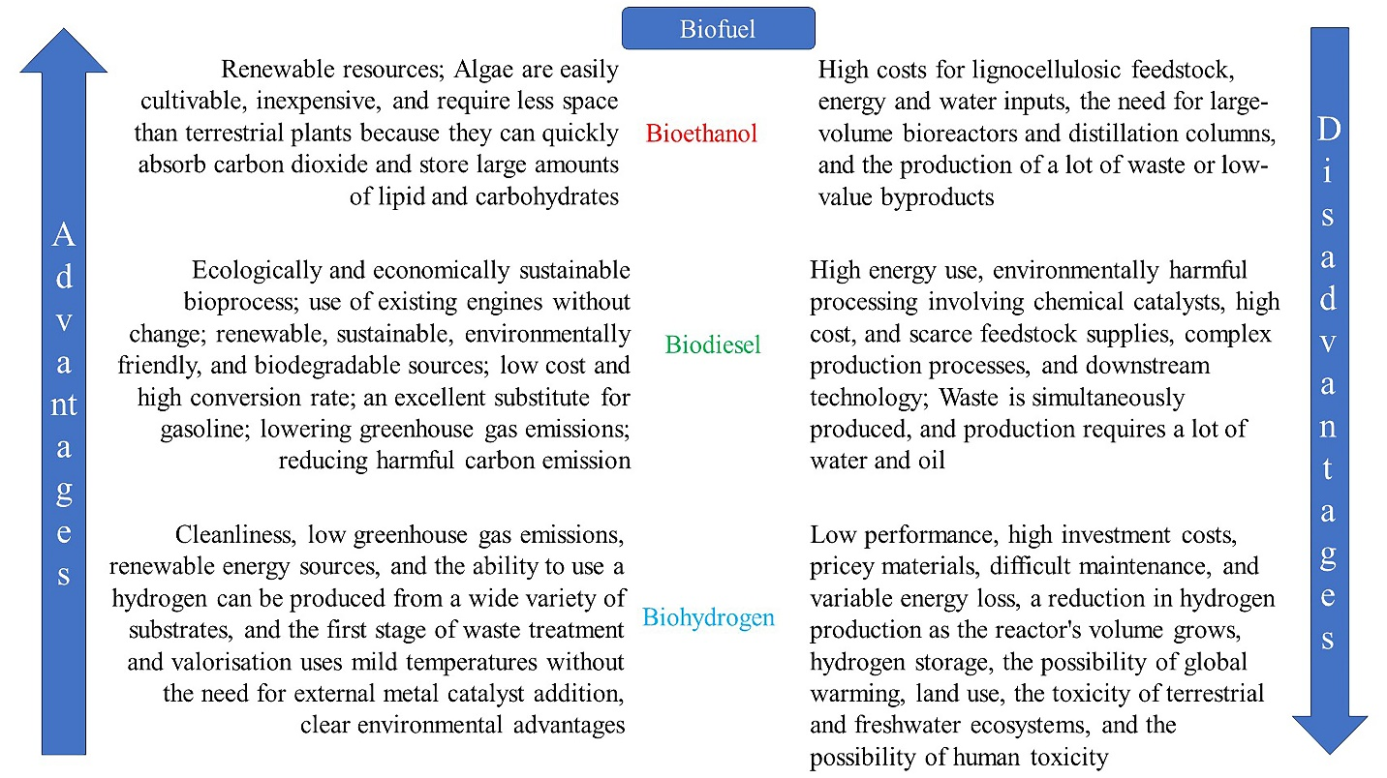
Figure 1 Advantages and disadvantages of various biofuels (Talapko et al., 2022).
The biomass of microalgae is converted into a gaseous state known as syngas, which is a mixture of methane, CO, CO₂, nitrogen, and hydrogen (Chellapandi et al., 2017; Poudel et al., 2019). Syngas is used for producing methanol, ethanol and synthetic hydrocarbons, butanol, methane, butyric, and acetic acid. It is also used as a turbine fuel (Ciliberti et al., 2020; Sangavai et al., 2020). Metals like Zinc, Iron, Magnesium, and nickel can be found in microalgal bio-oils which are removed by heat treatment (Znad et al., 2022). A schematic representation of production of biofuel from various sources was depicted in Figure 2.
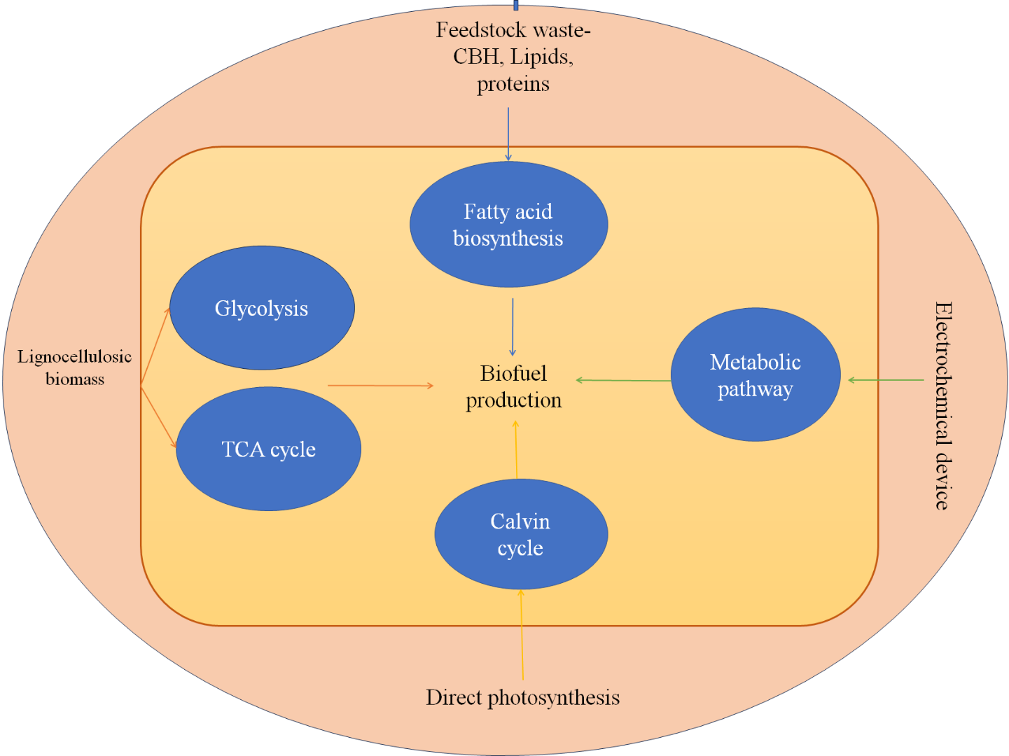
Figure 2 Production of biofuel from various sources (Kumar et al., 2017).
2.4. Biodiesel
The first alternative and well-known biofuel is biodiesel. Which is obtained by the transesterification of oil and fat (Knothe and Razon, 2017). Due to the increased consumption of energy (directly or indirectly) and to reduce the emission of CO₂ usage of biodiesel is preferred (Leach et al., 2020). About 53% (105 billion liters) of the total consumption of biodiesel in the world comes from European Union (Popp et al., 2016). Plants like grape and soybeans contain different types of nitrogen fixatives like Azotobacter sp. and Azospirillum sp., Acinetobacter junii and Pseudomonas fluorescens act as phosphofixatives. They benefit the plant through the rhizome system (Hindersah et al., 2020). Through nitrogen fixation, the plants produce lipids and triglycerides as end products (Liu et al., 2018). Microbial oil can be produced from Rhodotorula glutinis and Yarrowia lipolytica by transesterification. Certain types of bacteria and fungi have a greater tolerance for higher triacyl glycerol (Caporusso et al., 2021). Bacteria are more efficient than fungi in microbial oil production due to their adaptations and easy maintenance. E.coli synthesis biodiesel in the form of fatty acid esters also ferments biomass that is from carbon sources that are renewable (Zabermawi et al., 2022).
Biodiesel serves as the replacement for petroleum-based fuels. Fatty acids undergo transesterification of fatty acids with short-chain alcohols and form long-chain fatty acids with long-chain esters (Jafarihaghighi et al., 2020). Genetic engineering techniques can assist in the production of biodiesel with higher efficiency. Microalgae are the major raw material for the production of biodiesel due to their higher fatty acid content (Gouveia and Oliveira, 2009). The process of pyrolysis is applied to remove extra residues (pollutants) of microalgae after lipid extraction at a temperature of (~700℃) (Huang et al., 2022). Some of the common microalgaes were Botryococcus braunii, Chlorella vulgaris, Crypthecodinum cohnii, Dunaliella primolecta, Navicula pelliculosa, Scenedsmus acutus, Crypthecodinium cohnii, Monallanthus primolecta, Monallanthusocornussel olia, and Teallanthus chlorideasul. Their lipid content varies from low 1% to high 70%. The growth medium consists of fixed pH, speed, mixing, dissolved oxygen and CO₂, intensity, and wavelength of the light source (Dolganyuk et al., 2020). Depending upon the bioprocess in the bioreactor the lipid production by the microalgae is determined (Subramaniam et al., 2020). The microalgal residues contain carbohydrates that can be used for ethanol production through fermentation (Ebhodaghe et al., 2022). A detailed schematic representation was represented for the process of biodiesel production and recovery of methanol in Figure 3.
The shortest way to produce biodiesel is by a chemical catalyst, which comes with the limitations such as recycling, recovery (downstream) and wastewater (alkaline). Using waste resources, efforts have been made to incorporate enzymatic or chemical esterification reactions into new-generation biofuel production. Biodiesel obtained from Garcinia gummi-gutta, water hyacinth, and palm biodiesel was directly injected and mixed with alternative fuels into engines to investigate the combustion performances (Ananthi et al., 2021). Biofuel has better benefits than fossil fuels due to its flexibility as feedstock for cattle. They also have added benefits like free-form sulfur, richer oxygen content, better manufacturing process, its biodegradable, non-toxic, and lesser aromatic content (Esmaeili, 2022). There are huge benefits when using biofuel as an alternative fuel (Singh et al., 2020).
2.5 Hydrogen
Biohydrogen can be used as a substitute for fossil fuels. During combustion the produces water rather than carbon monoxide and carbon-di-oxide (Osman et al., 2022). Biohydrogen has an energy value of 142 MJ/kg, higher than natural gas 52 MJ/kg, and petrol 44 MJ/kg (Osman et al., 2022). By 2024 the demand for hydrogen fuel will increase to 120 million tons and it also fulfills the goal of clean and affordable energy (Sharma et al., 2021). In anaerobic conditions, microorganism uses oxidation-reduction potential, which produces sulfides, nitrides, and phosphides from hydride, producing enough energy to initiate a reaction process (Chen et al., 2020). By creating joint metabolism between syntrophic communities better microbial refineries can be produced. Methanogenic bacteria transfer hydrogen and formate between syntrophic partners (Greening et al., 2019). Carbon-based biogas protects the environment from unwanted gases like sulfur.
The process of production of biohydrogen can be from organic matter or wastewater (Moussa et al., 2022). Electron transfer to conductive surfaces can be initiated by creating an electro-biofilm where the gathered electrons can produce hydrogen and electricity. Under anaerobic conditions, microalgae convert water into hydrogen and oxygen (photolysis) (Wang et al., 2021). Hydrogen ions can be produced in two ways by photosynthesis, one is through separate acid and hydrogen production. In the second method, microalgae are forced to survive in the presence of starch rather than sulfur which produce hydrogen ions (Burlacot and Peltier, 2018). The net production of hydrogen is less through this process yet zero harmful byproducts are produced. Raw materials like cotton-sludge hydrolates and lignocellulosic materials were commonly used for biohydrogen production. The starter cultures for these raw materials were isolated from fish and termites (Bhardwaj et al., 2021). Microorganisms like Enterobacter, Klebsiella, Clostridium, and Citrobacter were commonly used (Bhatia et al., 2021).
Microorganisms like Geobacter sulfurreducens and Shewanella oneidensis have a unique molecular mechanism that pulls electrons from the outer membrane to the surface. Bioelectrochemical cells (BECs) produce bioenergy from bioenergy from biomass and wastewater (Li et al., 2015). The energy released from microbial electrolysis cells (MECs) and microbial fuel cells (MFCs) is not sufficient for commercialization (Santoro et al., 2020). Bio-hydrogen can be produced fermentatively by strict anaerobes like Clostridium sp., methanogenic facultative anaerobes. Hydrogen produced by the fermentative pathway is more efficient and profitable when compared with the photosynthetic pathway (Santoro et al., 2020). This is due to the rapid growth of fermentative bacteria under anaerobic conditions and the presence of oxygen doesn’t affect higher levels of hydrogen production (Vardar‐Schara et al., 2008). One mole of glucose yields 12 moles of hydrogen but practically 3.8 moles of hydrogen can be yielded. By using mixed starter cultures and combined metabolic pathways the yield can be increased (Wang et al., 2021).
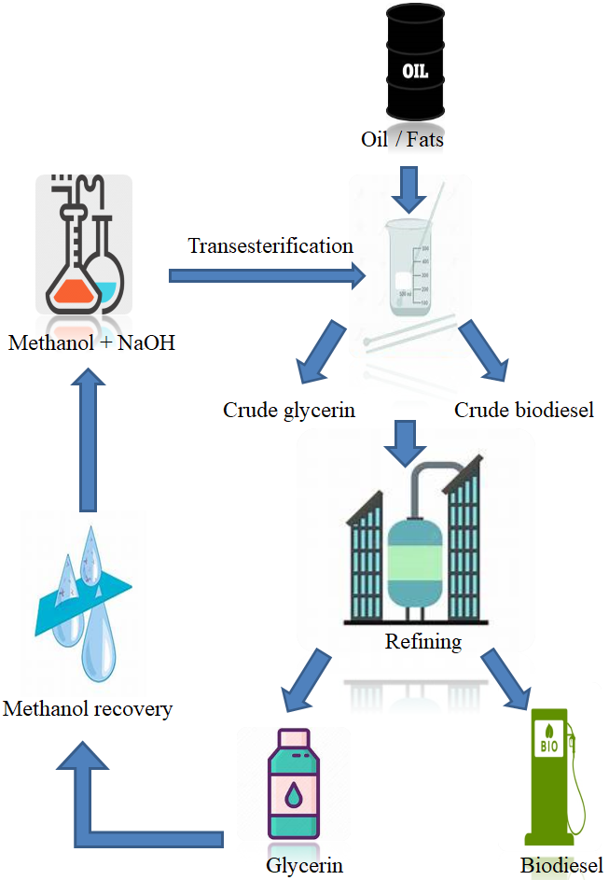
Figure 3 Process of biodiesel production and recovery of methanol (Talapko et al., 2022).
3. Cyanobacteria
Cyanobacteria are photosynthetic prokaryotic organisms that produce biofuels and biodegradable plastics. Due to the presence of fatty acid content and growth rate, they can be used as a better alternative to other resources (Gouveia and Oliveira, 2009). Cyanobacteria produces diacylglycerol (DAG) and triacylglycerol (TAG) which acts as the precursor for biofuel production. The cyanobacterial genetic sequence was well known which makes them more efficient for the production of biofuels (Savakis and Hellingwerf, 2015). 10% of the solar energy can be stored in the form of biomass whereas eukaryotic algae store 5% and 1% by energy crops (Parmar et al., 2011). Photosynthetically cyanobacteria outperform plants and algae. Synechococcus elongatus PCC 7942 and Synechocystis sp. PCC 6803 is commonly used as a biofuel source. The lipids present in the cyanobacteria are present in the thylakoid membranes. The cyanobacterial strain Synechococcus elongatus PCC 7942 contains genes encoding for alcohol dehydrogenase and pyruvate decarboxylase which helps the cyanobacteria to transfer carbon from pyruvate to ethanol (Deng and Coleman, 1999).
Hydrogen ion that is produced during photosynthesis is not taken up by the bacteria rather it is retained (Marshall et al., 2012). Cyanobacteria utilize the energy from hydrogenase present in the sugar molecule that is used in the photolysis of water molecules (Veaudor et al., 2020). The electron produced by various pathways can be diverted to synthesize more biohydrogen molecules by hydrogenase to photosystem. Extremophiles use hydrogen and oxygen from the atmosphere to produce water for their use (Gregory, 2009). By evolutionary adaptation, 400 species of microorganisms use energy sources like hydrogen and carbon monoxide for their metabolism. Bacteria like Rhodobacteraceae, Flavobacteriaceae, and Sfhingomonodaceae utilize CO and hydrogen in the seawater for their energy sources (Jordaan et al., 2020). Sfinopyxis alascensis utilizes hydrogen ions with the help of NiFe hydrogenase (Kruse et al., 2017).
Cyanobacteria have a better photosynthesis system, transforming 10% of solar energy into biomass formation. Which is higher when compared to traditional crops like sugarcane and corn, and has a relative conversion of 1%. Two main species useful in biofuel production: Synechococcus elongatus PCC 7942 and Synechocystis sp. PCC 6803 (Farrokh et al., 2019). Cyanobacteria produces other valuable products like pigments, vitamins and enzymes. The two important cyanobacterial pigments are phycobiliproteins and carotenoids. Other cyanobacterial pigments such as canthaxanthin, beta-carotene, nostoxanthin, and zeaxanthin were used as additives, feed, and as colorants. It also has therapeutic effects against diseases like cataracts, heart disease and cancer (Torregrosa et al., 2018).
4. Microbial fuel cells
Microbial fuel cells use chemical energy present in the organic substrates and convert it to electrical energy (Idris et al., 2016). Wastewater can be used in this process for creating electrical energy and also helps in wastewater management. Some of the microorganisms are known as “Exoelectrogens” where the bacteria act as a biocatalyst that produces electrons (Juan, 2014). The electrons thus formed move towards the cathode along with hydrogen ion which comes into contact with oxygen to form water molecule resulting in the production of green electricity (Zhang et al., 2016).
When acetate is used as the basic substrate in MFC, acetate undergoes an oxidation reaction in the anode region to produce electrons and protons. An electrochemically active carrier transfers electrons into the cathode through the cell membrane (Li, 2013). An external integrated circuit takes the electron from the anode to the cathode (Kim et al., 2008). The neutrality of the charge is sustained due to the migration of the proton across the proton permeable membrane. Whereas the membrane is not permeable to electrons. The Proton exchange membrane separates the anode and the cathode compartments. This membrane also prevents the diffusion of oxygen from the anode to the cathode (Flimban et al., 2018). The substrate acetate is broken down into CO₂ and water molecules. The potential of the anode is -0.300 V and the cathode is 0.805 V so the maximum cell potential theoretically is 1.105 V (Barua et al., 2018).
Based on the transportation of electrons to the electrode there are two types of MFCs. In mediator MFCs the corresponding bacteria activity mediates the transfer of electrons to anode (Dharmalingam et al., 2018). Some of the chemicals that help in the flow of electrons to anode are neutral red, humic acid, and anthraquinone-2, 6-disulphonate. Such chemicals are known as “electroactive metabolites” (Flimban et al., 2018). The presence of oxygen hinders the process of electron formation so it is highly recommended to go with anaerobic reaction in mediator MFCs. In mediator-less MFCs, there is no need for an external mediator. The help of nanowires that is seen in most of the bacteria present in the wastewater transports electrons to the electrodes (Logan et al., 2006). The mediator-less MFCs are comparatively non-toxic and less expensive. When mediator-less MFCs are operated there are certain things to be considered such as the application of redox enzyme for better electron transfer, a circuit with external resistance, an anode that bears fuel oxidation, the microbial activity must be reduced, and membrane-assisted transfer of proton towards the cathode (Flimban et al., 2018). Most of the mediator-less MFCs are designed based on microbial fuel cell-based and soil-based microbial fuel cells.
Different cyanobacterial species possess electricigens that function as photosynthetic microbial fuel cells PMFCs. Synechocystis PCC-6803 was used in dual chamber PMFC the measured current density was 72.3 mW/m² (Ma et al., 2012). While using Spirulina platensis as bio catalyst can attain current density of about 6.5 mW/m², when Nostoc sp. ATCC 27893 was used in the PMFC cells they generate power density of about 250 mA/m² and 35 mW/m2. By adding 1,4-benzoquinone as electron mediator the current density was 2300 mA/m² and the power density was 100 mW/m² (Sekar et al., 2014)
5. Conclusion
Sustainable energy resources are essential for addressing the environmental challenges associated with traditional fossil fuels. Four promising sustainable energy technologies are biodiesel, microbial fuel cells, cyanobacteria, and hydrogen. Biodiesel is a renewable and environmentally friendly alternative to conventional diesel fuel. It is produced from vegetable oils, animal fats, or recycled cooking oil, making it a sustainable choice. Biodiesel reduces greenhouse gas emissions and dependence on fossil fuels, making it an attractive option for transportation and some stationary power applications. However, its widespread adoption still faces challenges related to feedstock availability, land use, and competition with food production. MFCs are a fascinating technology that utilizes microorganisms to convert organic matter into electricity. They offer a sustainable approach to wastewater treatment and energy production simultaneously. MFCs hold significant potential in low-power applications, such as remote sensing devices or small-scale energy generation. Nevertheless, their scalability and efficiency remain areas of ongoing research, and further development is required to make them commercially viable for larger energy demands. Cyanobacteria are photosynthetic microorganisms capable of harnessing solar energy to produce biomass and, potentially, biofuels. They offer a sustainable and renewable resource for energy production. Researchers are exploring ways to enhance their efficiency in converting sunlight into usable energy by genetically modifying cyanobacteria. However, challenges such as cost-effectiveness, scalability, and ethical considerations regarding genetic engineering must be addressed before widespread implementation. Hydrogen is considered a versatile and clean energy carrier, producing only water when used in fuel cells or combustion processes. It can be produced through various methods, such as electrolysis using renewable electricity or from bio-derived sources, ensuring sustainability. However, hydrogen faces challenges related to storage, transportation, and cost-effectiveness. Moreover, the energy required for large-scale hydrogen production should come from renewable sources to achieve its full sustainability potential. In conclusion, sustainable energy resources like biodiesel, microbial fuel cells, cyanobacteria, and hydrogen hold promise for a cleaner and more environmentally friendly future. However, their widespread adoption requires further research, technological advancements, and policy support to overcome current limitations and fully realize their potential to meet global energy needs while reducing environmental impact.
List of abbreviations
BECs: Bioelectrochemical cells
CO: Carbon monoxide
CO₂: Carbon dioxide
CoA: Coenzyme A
DAG: Diacylglycerol
MECs: Microbial electrolysis cells
MFCs: Microbial fuel cells
NO₂: Nitrogen dioxide
SO₂: Sulfur dioxide
TAG: Triacylglycerol

Reference
Agyekum EB, Nutakor C, Agwa AM, Kamel S (2022) A critical review of renewable hydrogen production methods: factors affecting their scale-up and its role in future energy generation. Membranes (Basel), 12(2), 173. doi: 10.3390/membranes12020173
Ananthi V, Raja R, Carvalho IS, Brindhadevi K, Pugazhendhi A, Arun A (2021) A realistic scenario on microalgae based biodiesel production: Third generation biofuel. Fuel, 284, 118965. https://doi.org/10.1016/j.fuel.2020.118965
Barua E, Hossain MS, Shaha M, Islam E, Zohora FT, Protity AT, Mukharjee SK, Sarker PK, Salimullah Md, Hashem A (2018) Generation of electricity using microbial fuel cell (MFC) from sludge. Bangladesh Journal of Microbiology, 35(1), 23-26. doi: 10.3329/bjm.v35i1.39800
Bhardwaj N, Kumar B, Agrawal K, Verma P (2021) Current perspective on production and applications of microbial cellulases: A review. Bioresources and Bioprocessing, 8, 1-34. https://doi.org/10.1186/s40643-021-00447-6
Bhatia SK, Jagtap SS, Bedekar AA, Bhatia RK, Rajendran K, Pugazhendhi A, Rao CV, Atabani AE, Kumar G, Yang YH (2021) Renewable biohydrogen production from lignocellulosic biomass using fermentation and integration of systems with other energy generation technologies. Science of the Total Environment, 765, 144429. doi: 10.1016/j.scitotenv.2020.144429
Burlacot A, Peltier G (2018) Photosynthetic electron transfer pathways during hydrogen photoproduction in green algae: mechanisms and limitations. Microalgal Hydrogen Production: Achievements and Perspectives, 189-212. doi: 10.1039/9781849737128-00189
Caporusso A, Capece A, De Bari I (2021) Oleaginous yeasts as cell factories for the sustainable production of microbial lipids by the valorization of agri-food wastes. Fermentation, 7(2), 50. https://doi.org/10.3390/fermentation7020050
Chang JJ, Ho FJ, Ho CY, Wu YC, Hou YH, Huang CC, Shih MC, Li WH (2013) Assembling a cellulase cocktail and a cellodextrin transporter into a yeast host for CBP ethanol production. Biotechnology for Biofuels, 6(1), 1-13. doi: 10.1186/1754-6834-6-19
Chellapandi P, Bharathi M, Sangavai C, Prathiviraj R (2018) Methanobacterium formicicum as a target rumen methanogen for the development of new methane mitigation interventions-A review. Veterinary and Animal Science, 6: 86-94. https://doi.org/10.1016/j.vas.2018.09.001
Chellapandi P, Mohamed Khaja Hussain M, Prathiviraj R (2017) CPSIR-CM: a database for structural properties of proteins identified in Cyanobacterial C1 metabolism. Algal Research, 22: 135–139. (IF: 5.276) http://dx.doi.org/10.1016/j.algal.2016.12.005
Chellapandi P, Prathiviraj R (2020) A systems biology perspective of Methanothermobacter thermautotrophicus strain ΔH for bioconversion of CO₂ to methane. Journal of CO₂ Utilization, 40: 101210. https://doi.org/10.1016/j.jcou.2020.101210
Chen H, Simoska O, Lim K, Grattieri M, Yuan M, Dong F, Lee YS, Beaver K, Weliwatte S, Gaffney EM, Minteer SD (2020) Fundamentals, applications, and future directions of bioelectrocatalysis. Chemical Reviews, 120(23), 12903-12993. doi: 10.1021/acs.chemrev.0c00472
Ciliberti C, Biundo A, Albergo R, Agrimi G, Braccio G, de Bari I, Pisano I (2020) Syngas derived from lignocellulosic biomass gasification as an alternative resource for innovative bioprocesses. Processes, 8(12), 1567. https://doi.org/10.3390/pr8121567
Conrad R (2009) The global methane cycle: recent advances in understanding the microbial processes involved. Environmental Microbiology Reports, 1(5), 285-292. doi: 10.1111/j.1758-2229.2009.00038.x
de Souza RF, Florio DZ, Antolini E, Neto AO (2022) Partial methane oxidation in fuel cell-type reactors for co-generation of energy and chemicals: A short review. Catalysts, 12(2), 217. https://doi.org/10.3390/catal12020217
Deng MD, Coleman JR (1999) Ethanol synthesis by genetic engineering in cyanobacteria. Applied and Environmental Microbiology, 65(2), 523-528. doi: 10.1128/AEM.65.2.523-528.1999
Desa UN (2019) World population prospects 2019: Highlights. New York (US): United Nations Department for Economic and Social Affairs, 11(1), 125.
Dharmalingam S, Kugarajah V, Sugumar M (2018) Membranes for microbial fuel cells: Microbial electrochemical technology: Sustainable platform for fuels, chemicals and remediation. Editor(s): Venkata Mohan S, Varjani S, Pandey A, Biomass, Biofuels, Biochemicals, 143-194: ISBN: 9780444640529.
Dolganyuk V, Belova D, Babich O, Prosekov A, Ivanova S, Katserov D, Patyukov N, Sukhikh S (2020) Microalgae: A promising source of valuable bioproducts. Biomolecules. 10(8):1153. doi: 10.3390/biom10081153.
Ebhodaghe SO, Imanah OE, Ndibe H (2022) Biofuels from microalgae biomass: A review of conversion processes and procedures. Arabian Journal of Chemistry, 15(2), 103591. https://doi.org/10.1016/j.arabjc.2021.103591
Ellis JT, Magnuson TS (2012) Thermostable and Alkalistable xylanases produced by the thermophilic bacterium Anoxybacillus flavithermus TWXYL3. ISRN Microbiol., 2012, 517524. doi: 10.5402/2012/517524
Esmaeil H (2022) A critical review on the economic aspects and life cycle assessment of biodiesel production using heterogeneous nanocatalysts. Fuel Processing Technology, 230, 107224. https://doi.org/10.1016/j.fuproc.2022.107224
Fabris M, Abbriano RM, Pernice M, Sutherland DL, Commault AS, Hall CC, Labeeuw L, McCauley JI, Kuzhiuparambil U, Ray P, Kahlke T, Ralph PJ (2020) Emerging technologies in Algal biotechnology: Toward the establishment of a sustainable, Algae-based bioeconomy. Front Plant Sci. 11:279. doi: 10.3389/fpls.2020.00279.
Farrokh P, Sheikhpour M, Kasaeian A, Asadi H, Bavandi R (2019) Cyanobacteria as an eco-friendly resource for biofuel production: A critical review. Biotechnol Prog., 35(5), e2835. doi: 10.1002/btpr.2835
Flimban SGA, Kim T, Ismail IMI, Oh S (2018) Overview of microbial fuel cell (MFC) Recent advancement from fundamentals to applications: MFC designs, major elements, and scalability. Preprints.org 2018, 2018100763. https://doi.org/10.20944/preprints201810.0763.v1
Foley AM, Leahy PG, Marvuglia A, McKeogh EJ (2012) Current methods and advances in forecasting of wind power generation. Renewable energy, 37(1), 1-8.
Gouveia L, Oliveira AC (2009) Microalgae as a raw material for biofuels production. Journal of Industrial Microbiology and Biotechnology, 36(2), 269-274.
Greening C, Geier R, Wang C, Woods LC, Morales SE, McDonald MJ, Rushton-Green R, Morgan XC, Koike S, Leahy SC, Kelly WJ, Cann I, Attwood GT, Cook GM, Mackie RI (2019) Diverse hydrogen production and consumption pathways influence methane production in ruminants. ISME J. 13(10):2617-2632. doi: 10.1038/s41396-019-0464-2.
Gregory TR (2009) Understanding natural selection: Essential concepts and common misconceptions. Evo Edu Outreach, 2, 156–175 (2009). https://doi.org/10.1007/s12052-009-0128-1
Hindersah R, Kamaluddin NN, Samanta S, Banerjee S, Sarkar S (2020) Role and perspective of Azotobacter in crops production. SAINS TANAH-Journal of Soil Science and Agroclimatology, 17(2), 170-179.
Hook SE, Wright ADG, McBride BW (2010) Methanogens: methane producers of the rumen and mitigation strategies. Archaea, 2010:945785. doi: 10.1155/2010/945785
Huang Z, Zhang J, Pan M, Hao Y, Hu R, Xiao W, Li G, Lyu T (2022) Valorisation of microalgae residues after lipid extraction: Pyrolysis characteristics for biofuel production. Biochemical Engineering Journal, 179, 108330. https://doi.org/10.1016/j.bej.2021.108330
Idris SA, Esat FN, Abd Rahim AA, Rizzqi WZ, Ruzlee W, Razali WZ (2016) Electricity generation from the mud by using microbial fuel cell. 5th International Conference on Chemical and Process Engineering (ICCPE 2016). MATEC Web of Conferences 69, 02001. Bioenergy & Chemistry, https://doi.org/10.1051/matecconf/20166902001
Jafarihaghighi F, Ardjmand M, Salar Hassani M, Mirzajanzadeh M, Bahrami H (2020) Effect of fatty acid profiles and molecular structures of nine new source of biodiesel on combustion and emission. ACS Omega, 5(26), 16053-16063. doi: 10.1021/acsomega.0c01526
Jordaan K, Lappan R, Dong X, Aitkenhead IJ, Bay SK, Chiri E, Wieler N, Meredith LK, Cowan DA, Chown SL, Greening C (2020) Hydrogen-oxidizing Bacteria are abundant in desert soils and strongly stimulated by hydration. mSystems. 5(6):e01131-20. doi: 10.1128/mSystems.01131-20.
Juan AD (2014) Microbial Fuel Cell-Literature review. Technical evaluation of the microbial fuel cell technology in wastewater applications. Project Report, 1-18. doi: 10.13140/2.1.4481.0569.
Kim IS, Chae K-J, Choi M-J, Verstraete W (2008) Microbial fuel cells: Recent advances, bacterial communities and application beyond electricity generation. Environ. Eng. Res., 13 (2) (2008) 51–65. https://doi.org/10.4491/eer.2008.13.2.051
Knothe G, Razon LF (2017) Biodiesel fuels. Progress in Energy and Combustion Science, 58, 36-59. https://doi.org/10.1016/j.pecs.2016.08.001
Koppolu V, Vasigala VK (2016) Role of Escherichia coli in biofuel production. Microbiology Insights, 9, MBI-S10878. doi: 10.4137/MBI.S10878
Kracke F, Vassilev I, Krömer JO (2015) Microbial electron transport and energy conservation - the foundation for optimizing bioelectrochemical systems. Front Microbiol. 6:575. doi: 10.3389/fmicb.2015.00575.
Kruse S, Goris T, Wolf M, Wei X, Diekert G (2017) The NiFe hydrogenases of the tetrachloroethene-respiring Epsilonproteobacterium Sulfurospirillum multivorans: biochemical studies and transcription analysis. Frontiers in Microbiology, 8, 444. doi: 10.3389/fmicb.2017.00444
Kumar P, Barrett DM, Delwiche MJ, Stroeve P (2009) Methods for pretreatment of lignocellulosic biomass for efficient hydrolysis and biofuel production. Industrial & Engineering Chemistry Research, 48(8), 3713-3729. doi: 10.1021/IE801542G
Kumar R, Kumar P (2017) Future microbial applications for bioenergy production: A perspective. Front Microbiol. 8:450. doi: 10.3389/fmicb.2017.00450.
Leach F, Kalghatgi G, Stone R, Miles P (2020) The scope for improving the efficiency and environmental impact of internal combustion engines. Transportation Engineering, 1, 100005. https://doi.org/10.1016/j.treng.2020.100005
Li X, Abu-Reesh IM, He Z (2015) Development of bioelectrochemical systems to promote sustainable agriculture. Agriculture, 5, 367–388.
Li Y (2013) The current response of a mediated biological fuel cell with Acinetobacter calcoaceticus: the role of mediator adsorption and reduction kinetics. University of Canterbury, (Thesis).
Liao JC, Mi L, Pontrelli S, Luo S (2016) Fuelling the future: microbial engineering for the production of sustainable biofuels. Nature Reviews Microbiology, 14(5), 288-304. doi: 10.1038/nrmicro.2016.32
Lin PP, Jaeger AJ, Wu TY, Xu SC, Lee AS, Gao F, Chen PW, Liao JC (2018) Construction and evolution of an Escherichia coli strain relying on nonoxidative glycolysis for sugar catabolism. Proc Natl Acad Sci USA. 115(14):3538-3546. doi: 10.1073/pnas.1802191115.
Liu A, Contador CA, Fan K, Lam HM (2018) Interaction and regulation of carbon, nitrogen, and phosphorus metabolisms in root nodules of legumes. Frontiers in Plant Science, 9, 1860. doi: 10.3389/fpls.2018.01860
Logan BE, Hamelers B, Rozendal R, Schröder U, Keller J, Freguia S, Aelterman P, Verstraete W, Rabaey K (2006) Microbial fuel cells: methodology and technology. Environ Sci Technol. 40(17):5181-92. doi: 10.1021/es0605016.
Lynd LR, Weimer PJ, Van Zyl WH, Pretorius IS (2002) Microbial cellulose utilization: fundamentals and biotechnology. Microbiology and Molecular Biology Reviews, 66(3), 506-577. doi: 10.1128/MMBR.66.3.506-577.2002
Ma M, Cao L, Ying X, Deng Z (2012) Study on the performance of photosynthetic microbial fuel cells powered by synechocystis PCC-6803. Kezaisheng Nengyuan/Renewable Energy Resources, 30(5), 42-46.
Marshall IP, Berggren DR, Azizian MF, Burow LC, Semprini L, Spormann AM (2012) The hydrogenase chip: a tiling oligonucleotide DNA microarray technique for characterizing hydrogen-producing and-consuming microbes in microbial communities. The ISME Journal, 6(4), 814-826. doi: 10.1038/ismej.2011.136
Meloni E, Martino M, Palma V (2020) A short review on Ni based catalysts and related engineering issues for methane steam reforming. Catalysts, 10(3), 352. https://doi.org/10.3390/catal10030352
Moussa RN, Moussa N, Dionisi D (2022) Hydrogen production from biomass and organic waste using dark fermentation: an analysis of literature data on the effect of operating parameters on process performance. Processes, 10(1), 156. https://doi.org/10.3390/pr10010156
ÓhAiseadha C, Quinn G, Connolly R, Connolly M, Soon W (2020) Energy and climate policy-An evaluation of global climate change expenditure 2011-2018. Energies, 13(18), 4839. https://doi.org/10.3390/en13184839
Ortiz-Martínez VM, Salar-García MJ, De Los Ríos AP, Hernández-Fernández FJ, Egea JA, Lozano LJ (2015) Developments in microbial fuel cell modeling. Chemical Engineering Journal, 271, 50-60. https://doi.org/10.1016/j.cej.2015.02.076
Osman AI, Mehta N, Elgarahy AM, Hefny M, Al-Hinai A, Al-Muhtaseb AAH, Rooney DW (2022) Hydrogen production, storage, utilisation and environmental impacts: a review. Environmental Chemistry Letters, 1-36. https://doi.org/10.1007/s10311-021-01322-8
Parmar A, Singh NK, Pandey A, Gnansounou E, Madamwar D (2011) Cyanobacteria and microalgae: A positive prospect for biofuels. Bioresource technology, 102(22), 10163-10172. doi: 10.1016/j.biortech.2011.08.030
Popp J, Harangi-Rákos M, Gabnai Z, Balogh P, Antal G, Bai A (2016) Biofuels and their co-products as livestock feed: global economic and environmental implications. Molecules, 21(3), 285. doi: 10.3390/molecules21030285
Poudel J, Choi JH, Oh SC (2019) Process design characteristics of syngas (CO/H₂) separation using composite membrane. Sustainability, 11(3), 703. https://doi.org/10.3390/su11030703
Prathiviraj R, Chellapandi P (2019) Functional annotation of operome from Methanothermobacter thermautotrophicus ΔH: An insight to metabolic gap filling. International Journal of Biological Macromolecules, 123: 350-362. https://doi:10.1016/j.ijbiomac.2018.11.100
Prathiviraj R, Chellapandi P (2020) Comparative genomic analysis reveals starvation survival systems in Methanothermobacter thermoautotrophicus ΔH. Anaerobe, 64: 102216. https://doi.org/10.1016/j.anaerobe.2020.102216
Prathiviraj R, Chellapandi P (2020) Modeling a global regulatory network of Methanothermobacter thermautotrophicus strain ∆H. Network Modeling, Analysis in Health Informatics and Bioinformatics, 9: 17. https://doi.org/10.1007/s13721-020-0223-3
Prathiviraj R, Sheela Berchmans and Chellapandi P (2019) Analysis of modularity in proteome-wide protein interaction networks of Methanothermobacter thermautotrophicus strain ΔH across metal-loving bacteria. Journal of Proteins and Proteomics, 10: 179-190. https://doi.org/10.1007/s42485-019-00019-5
Rangel-Martinez D, Nigam KDP, Ricardez-Sandoval LA (2021) Machine learning on sustainable energy: A review and outlook on renewable energy systems, catalysis, smart grid and energy storage. Chemical Engineering Research and Design, 174, 414-441. https://doi.org/10.1016/j.cherd.2021.08.013
Rastogi M, Shrivastava S (2017) Recent advances in second generation bioethanol production: An insight to pretreatment, saccharification and fermentation processes. Renewable and Sustainable Energy Reviews, 80, 330-340. https://doi.org/10.1016/j.rser.2017.05.225
Ricca E, Calabrò V, Curcio S, Iorio G (2007) The state of the art in the production of fructose from inulin enzymatic hydrolysis. Crit Rev Biotechnol., 27(3), 129-45. doi: 10.1080/07388550701503477
Rodríguez-Reyes JJ, García-Depraect O, Castro-Muñoz R, León-Becerril E (2021) Dark fermentation process response to the use of undiluted tequila vinasse without nutrient supplementation. Sustainability, 13(19), 11034. https://doi.org/10.3390/su131911034
Ruchala J, Kurylenko OO, Dmytruk KV, Sibirny AA (2020) Construction of advanced producers of first-and second-generation ethanol in Saccharomyces cerevisiae and selected species of non-conventional yeasts (Scheffersomyces stipitis, Ogataea polymorpha). Journal of Industrial Microbiology and Biotechnology, 47(1), 109-132. doi: 10.1007/s10295-019-02242-x
Sakurai H, Masukawa H, Kitashima M, Inoue K (2013) Photobiological hydrogen production: bioenergetics and challenges for its practical application. Journal of Photochemistry and Photobiology C: Photochemistry Reviews, 17, 1-25. https://doi.org/10.1016/j.jphotochemrev.2013.05.001
Sangavai C, Prathiviraj R and Chellapandi P (2020) Functional prediction, characterization and categorization of operome from Acetoanaerobium sticklandii DSM 519. Anaerobe, 61:102088. https://doi.org/10.1016/j.anaerobe.2019.102088
Santoro C, Arbizzani C, Erable B, Ieropoulos I (2017) Microbial fuel cells: From fundamentals to applications. A review. Journal of power sources, 356, 225-244. doi: 10.1016/j.jpowsour.2017.03.109
Santoro C, Salar-Garcia MJ, Walter XA, You J, Theodosiou P, Gajda I, Obata O, Winfield J, Greenman J, Ieropoulos I (2020) Urine in bioelectrochemical systems: An overall review. ChemElectroChem, 7 (6): 1312-1331. doi: 10.1002/celc.201901995
Savakis P, Hellingwerf KJ (2015) Engineering cyanobacteria for direct biofuel production from CO₂. Current Opinion in Biotechnology, 33, 8-14. doi: 10.1016/j.copbio.2014.09.007
Sekar N, Umasankar Y, Ramasamy RP (2014) Photocurrent generation by immobilized cyanobacteria via direct electron transport in photo-bioelectrochemical cells. Phys Chem Chem Phys., 16(17):7862-71. doi: 10.1039/c4cp00494a
Sharma S, Agarwal S, Jain A (2021) Significance of hydrogen as economic and environmentally friendly fuel. Energies, 14(21), 7389. https://doi.org/10.3390/en14217389
Singh R, Singh S, Kumar M (2020) Impact of n-butanol as an additive with eucalyptus biodiesel-diesel blends on the performance and emission parameters of the diesel engine. Fuel, 277, 118178. https://doi.org/10.1016/j.fuel.2020.118178
Somu N, Gauthama Raman MR, Krithi R (2021) A deep learning framework for building energy consumption forecast. Renewable and Sustainable Energy Reviews, 137, 110591. https://doi.org/10.1016/j.rser.2020.110591
Sonawane JM, Yadav A, Ghosh PC, Adeloju SB (2017) Recent advances in the development and utilization of modern anode materials for high performance microbial fuel cells. Biosensors and Bioelectronics, 90, 558-576. doi: 10.1016/j.bios.2016.10.014
Srivastava P, Marjo C, Gerami A, Jones Z, Rahman S (2020) Surface analysis of coal indicating neutral red enhances the precursor steps of methanogenesis. Frontiers in Microbiology, 11, 586917. doi: 10.3389/fmicb.2020.586917
Subramaniam R, Dufreche S, Zappi M, Bajpai R (2010) Microbial lipids from renewable resources: production and characterization. Journal of Industrial Microbiology and Biotechnology, 37(12), 1271-1287. doi: 10.1007/s10295-010-0884-5
Talapko J, Talapko D, Matić A, Škrlec I (2022) Microorganisms as new sources of energy. Energies, 15(17), 6365.
Teng Y, Xu Y, Wang X, Christie P (2019) Function of biohydrogen metabolism and related microbial communities in environmental bioremediation. Frontiers in microbiology, 10, 106. doi: 10.3389/fmicb.2019.00106
Torregrosa-Crespo J, Montero Z, Fuentes JL, Reig García-Galbis M, Garbayo I, Vílchez C, Martínez-Espinosa RM (2018) Exploring the valuable carotenoids for the large-scale production by marine microorganisms. Mar Drugs, 16(6), 203. doi: 10.3390/md16060203
Tse TJ, Wiens DJ, Reaney MJ (2021) Production of bioethanol-A review of factors affecting ethanol yield. Fermentation, 7(4), 268. https://doi.org/10.3390/fermentation7040268
Vardar‐Schara G, Maeda T, Wood TK (2008) Metabolically engineered bacteria for producing hydrogen via fermentation. Microbial Biotechnology, 1(2), 107-125. doi: 10.1111/j.1751-7915.2007.00009.x
Veaudor T, Blanc-Garin V, Chenebault C, Diaz-Santos E, Sassi JF, Cassier-Chauvat C, Chauvat F (2020) Recent advances in the photoautotrophic metabolism of cyanobacteria: Biotechnological implications. Life, 10(5), 71. doi: 10.3390/life10050071
Wang H, Peng X, Zhang H, Yang S, Li H (2021) Microorganisms-promoted biodiesel production from biomass: A review. Energy Conversion and Management: X, 12, 100137. https://doi.org/10.1016/j.ecmx.2021.100137
Wang K, Khoo KS, Chew KW, Selvarajoo A, Chen WH, Chang JS, Show PL (2021) Microalgae: the future supply house of biohydrogen and biogas. Frontiers in Energy Research, 9, 660399. https://doi.org/10.3389/fenrg.2021.660399
Wang Y, Hu P, Yang J, Zhu YA, Chen D (2021) C-H bond activation in light alkanes: a theoretical perspective. Chemical Society Reviews, 50(7), 4299-4358. doi: 10.1039/d0cs01262a
Wang Z, Wang L, Tan Y, Yuan J (2021) Fault detection based on Bayesian network and missing data imputation for building energy systems. Applied Thermal Engineering, 182, 116051. https://doi.org/10.1016/j.applthermaleng.2020.116051
Yang S, Fei Q, Zhang Y, Contreras LM, Utturkar SM, Brown SD, Himmel ME, Zhang M (2016) Zymomonas mobilis as a model system for production of biofuels and biochemicals. Microbial Biotechnology, 9(6), 699-717. doi: 10.1111/1751-7915.12408
Yvon-Durocher G, Allen AP, Bastviken D, Conrad R, Gudasz C, St-Pierre A, Thanh-Duc N, Del Giorgio PA (2014) Methane fluxes show consistent temperature dependence across microbial to ecosystem scales. Nature, 507(7493), 488-491. doi: 10.1038/nature13164
Zabermawi NM, Alsulaimany FA, El-Saadony MT, El-Tarabily KA (2022) New eco-friendly trends to produce biofuel and bioenergy from microorganisms: An updated review. Saudi Journal of Biological Sciences. https://doi.org/10.1016/j.sjbs.2022.02.024
Zetterholm J, Bryngemark E, Ahlström J, Söderholm P, Harvey S, Wetterlund E (2020) Economic evaluation of large-scale biorefinery deployment: A framework integrating dynamic biomass market and techno-economic models. Sustainability, 12(17), 7126. https://doi.org/10.3390/su12177126
Zhang Q, Hu J, Lee DJ (2016) Microbial fuel cells as pollutant treatment units: Research updates. Bioresource Technology, 217, 121-128. doi: 10.1016/j.biortech.2016.02.006
Zhao Y, Li T, Zhang X, Zhang C (2019) Artificial intelligence-based fault detection and diagnosis methods for building energy systems: Advantages, challenges and the future. Renewable and Sustainable Energy Reviews, 109, 85-101. https://doi.org/10.1016/j.rser.2019.04.021
Znad H, Awual MR, Martini S (2022) The utilization of algae and seaweed biomass for bioremediation of heavy metal-contaminated wastewater. Molecules, 27(4), 1275. doi: 10.3390/molecules27041275

