BLUEBEERIES AS NATURAL ANTIOXIDANTS
Chorage C.A*
PhD Scholar Department of Processing & Food Engineering SHUATS, Prayagraj
INTRODUCTION

The importance of the antioxidants contained in foods is well appreciated for both preserving the foods themselves and supplying essential antioxidants. With increasing experimental, clinical and epidemiological data which show the beneficial effects of antioxidants against oxidative stress-induced degenerative and age-related diseases, cancer and ageing, the importance and role of antioxidants have received renewed attention. We are protected from oxidative stress by various antioxidants which have different functions. Some are enzymes and proteins and others are small molecule antioxidants. Foods are important as an essential source of such antioxidants, components and trace elements. In addition, numerous synthetic antioxidants have been developed and some of them have been used in practice as, for example, food additives, supplements and drugs.

Antioxidants are substances that can prevent or slow damage to cells caused by free radicals, unstable molecules that the body produces as a reaction to environmental and other pressures. They are sometimes called "free-radical scavengers." The sources of antioxidants can be natural or artificial. Certain plant-based foods are thought to be rich in antioxidants. Plant-based antioxidants are a kind of phytonutrient, or plant-based nutrient. The body also produces some antioxidants, known as endogenous antioxidants. Antioxidants that come from outside the body are called exogenous.
Free radicals are waste substances produced by cells as the body processes food and reacts to the environment. If the body cannot process and remove free radicals efficiently, oxidative stress can result. This can harm cells and body function. Free radicals are also known as reactive oxygen species (ROS). Factors that increase the production of free radicals in the body can be internal, such as inflammation, or external, for example, pollution, UV exposure, and cigarette smoke. Oxidative stress has been linked to heart disease, cancer, arthritis, stroke, respiratory diseases, immune deficiency, emphysema, Parkinson's disease, and other inflammatory or ischemic conditions. Antioxidants are said to help neutralize free radicals in our bodies, and this is thought to boost overall health.

BENEFITS
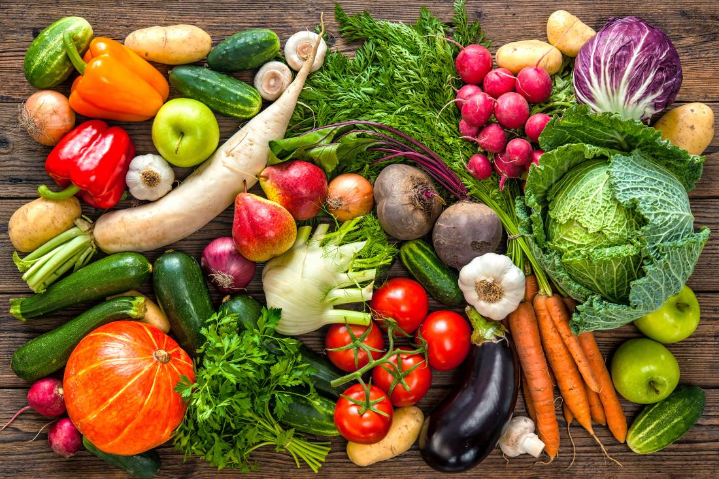
Colorful fruits and vegetables can offer a range of antioxidants.
Antioxidants can protect against the cell damage that free radicals cause, known as oxidative stress.
Activities and processes that can lead to oxidative stress include:
- mitochondrial activity
- excessive exercise
- tissue trauma, due to inflammation and injury
- ischemia and reperfusion damage
- consumption of certain foods, especially refined and processed foods, trans fats, artificial sweeteners, and certain dyes and additives
- smoking
- environmental pollution
- radiation
- exposure to chemicals, such as pesticides and drugs, including chemotherapy
- industrial solvents
- ozone

Such activities and exposures can result in cell damage as follow:
- An excessive release of free iron or copper ions
- An activation of phagocytes, a type of white blood cell with a role in fighting infection
- An increase in enzymes that generate free radicals
- A disruption of electron transport chains

The damage caused by antioxidants has been linked to cancer, atherosclerosis, and vision loss. It is thought that the free radicals cause changes in the cells that lead to these and possibly other conditions. An intake of antioxidants is believed to reduce these risks. According to one study: "Antioxidants act as radical scavenger, hydrogen donor, electron donor, peroxide decomposer, singlet oxygen quencher, enzyme inhibitor, synergist, and metal-chelating agents." Other research has indicated that antioxidant supplements may help reduce vision loss due to age-related macular degeneration in older people. Overall, however, there is a lack of evidence that a higher intake of specific antioxidants can reduce the risk of disease. In most cases, results have tended to show no benefit, or a detrimental effect, or they have been conflicting.

TYPES
There are thought to be hundreds and possibly thousands of substances that can act as antioxidants. Each has its own role and can interact with others to help the body work effectively."Antioxidant" is not really the name of a substance, but rather it describes what a range of substances can do.
Examples of antioxidants that come from outside the body include:
- vitamin A
- vitamin C
- vitamin E
- beta-carotene
- lycopene
- lutein
- selenium
- manganese
- zeaxanthin

Flavonoids, flavones, catechins, polyphenols, and phytoestrogens are all types of antioxidants and phytonutrients, and they are all found in plant-based foods.Each antioxidant serves a different function and is not interchangeable with another. This is why it is important to have a varied diet.

BLUEBERRIES
Fresh blueberries are a popular summer treat. They have a sweet flavor, and they are succulent and nutritious. Blueberries can be eaten freshly picked or incorporated into a variety of recipes. They can also be purchased frozen. They have been shown to protect against heart disease and cancer, and can also help maintain bone strength, mental health, and healthful blood pressure.

Fast facts on blueberries
- Blueberries contain a plant compound called anthocyanin. This gives blueberries both their blue color and many of their health benefits.
- Blueberries can help heart health, bone strength, skin health, blood pressure, diabetes management, cancer prevention, and mental health.
- One cup of blueberries provides 24 percent of a person recommended daily allowance of vitamin C.
- Use blueberries to top waffles, pancakes, yogurt, oatmeal, or cereal, blend them in a smoothie or syrup, or fold them into muffins and sweet breads.
- People who use blood-thinners, such as warfarin, should speak to their doctor before increasing their intake of blueberries, as the high vitamin K content can affect blood clotting.

Benefits
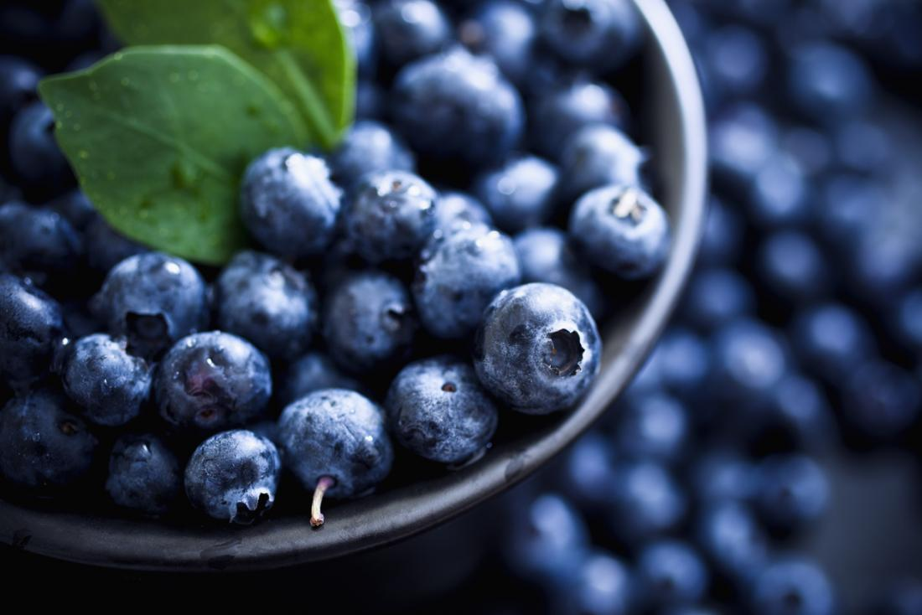Blueberries are a nutritious, delicious berry that can be used in a variety of meals.
A type of flavonoid called anthocyanin gives blueberries many of their health benefits. Flavonoids are plant compounds that often have a powerful antioxidant effect.
Anthocyanin is responsible for the blueberry's characteristic blue color. It also contributes to the numerous advantages of blueberries.
Consuming a variety of fruits and vegetables has long been associated with a reduced risk of many lifestyle-related health conditions.
Many studies have suggested that increasing consumption of plant foods such as blueberries decreases the risk of obesity, diabetes, heart disease, and overall mortality. Plant foods may also promote hair and skin health, increased energy, and overall lower weight.
Freezing blueberries is often discussed by experts. It is often said that the freezing process can diminish the potency of the blueberry's health benefits. One study showed that over the course of 6 months in storage, the anthocyanin degraded by 59 percent.
However, this is not confirmed, and different sources take different stances on whether freezing blueberries reduces their impact on health. When in doubt, buy fresh, organic blueberries.
Although more research is needed, blueberries are strongly linked to various different elements of healthful living.

1) Maintaining healthy bones
Blueberries contain iron, phosphorous, calcium, magnesium, manganese, zinc, and vitamin K. Each of these is a component of bone. Adequate intake of these minerals and vitamins contributes to building and maintaining bone structure and strength. Iron and zinc fulfil crucial roles in maintaining the strength and elasticity of bones and joints. Low intakes of vitamin K have been linked to a higher risk of bone fracture. However, adequate vitamin K intake improves calcium absorption and may reduce calcium loss.
2) Skin health
Collagen is the support system of the skin. It relies on vitamin C as an essential nutrient, and works to help prevent skin damage caused by the sun, pollution, and smoke. Vitamin C may also improve collagen's ability to smooth wrinkles and enhance overall skin texture. One cup of blueberries provides 24 percent of the recommended daily allowance of vitamin C.

3) Lowering blood pressure
Maintaining low sodium levels is essential to keeping blood pressure at a healthful level. Blueberries are free of sodium. They contain potassium, calcium, and magnesium. Some studies have shown that diets lows in these minerals are associated with higher blood pressure. Adequate dietary intake of these minerals is thought to help reduce blood pressure. However, other studies have counteracted these findings. For example, a 2015 study of people with metabolic syndrome found that daily blueberry consumption for 6 weeks did not affect blood pressure levels.

4) Managing diabetes
Studies have found that people with type 1 diabetes who consume high-fiber diets have low blood glucose levels, and people with type 2 diabetes who consume the same may have improved blood sugar, lipid, and insulin levels. One cup of blueberries contributes 3.6 grams (g) of fiber.Over the course of the study, 6.5 percent of the participants developed diabetes. However, the researchers found that consuming three servings per week of blueberries, grapes, raisins, apples or pears reduced the risk of type 2 diabetes by 7 percent.

5) Prevention against heart disease
The fiber, potassium, folate, vitamin C, vitamin B6, and phytonutrient content in blueberries supports heart health. The absence of cholesterol from blueberries is also beneficial to the heart. Fiber content helps to reduce the total amount of cholesterol in the blood and decrease the risk of heart disease. Blueberries can help to preserve cardiovascular health. Vitamin B6 and folate prevent the buildup of a compound known as homocysteine. Excessive buildup of homocysteine in the body can damage blood vessels and lead to heart problems. According to a study from the Harvard School of Public Health and the University of East Anglia, in the United Kingdom (U.K.) regular consumption of anthocyanins can reduce the risk of heart attack by 32 percent in young and middle-aged women. The study found that women who consumed at least three servings of blueberries or strawberries per week showed the best results.

6) Preventing cancer
Vitamin C, vitamin A, and the various phytonutrients in blueberries function as powerful antioxidants that may help protect cells against damage from disease-linked free radicals. Research suggests that antioxidants may inhibit tumor growth, decrease inflammation in the body, and help ward off or slow down esophageal, lung, mouth, pharynx, endometrial, pancreatic, prostate, and colon cancers. Blueberries also contain folate, which plays a role in DNA synthesis and repair. This can prevent the formation of cancer cells due to mutations in the DNA.

7) Improving mental health
Population-based studies have shown that consumption of blueberries is connected to slower cognitive decline in older women. Studies have also found that in addition to reducing the risk of cognitive damage, blueberries can also improve a person's short-term memory and motor coordination.

8) Healthy digestion, weight loss, and feeling full
Blueberries help to prevent constipation and maintain regularity for a healthful digestive tract because of their fiber content. Dietary fiber is also commonly recognized as an important factor in weight loss and weight management by functioning as a "bulking agent" in the digestive system. High fiber foods increase satiety, or the feeling of being full, and reduce appetite. Feeling fuller for longer can reduce a person's overall calorie intake.

Nutrition
100 gm of fresh blueberries contains:
- 84 calories
- 0 g of cholesterol
- 1.1 g of protein
- 0.49 g of fat
- 21.45 g of carbohydrate
- 3.6 g of dietary fiber
- 14.74 g of total sugars

That same 100gm serving provides:
- 24 percent of daily vitamin C
- 5 percent of daily vitamin B6
- 36 percent of daily vitamin K

Blueberries also provide:
- 9 milligrams (mg) calcium
- 0.41 mg of iron
- 114 mg of potassium
- 9 mg of magnesium
- 18 mg of phosphorus
- 1 mg of sodium
- 0.24 mg of zinc
- 9 mg of folate

Blueberries also contain copper, beta-carotene, folate, choline, vitamins A and E, and manganese. As well as anthocyanins, vitamins, and minerals, blueberries contain a diverse range of phenolic compounds such as quercetin, kaempferol, myricetin, and chlorogenic acid. These contribute to the antioxidant capacity of blueberries. The large quantities of bioactive compounds place blueberries high on the Aggregate Nutrient Density Index (ANDI). This index rates foods based on their vitamin and mineral content, phytochemical composition, and antioxidant capacity.

Diet
Blueberries are available fresh, frozen, freeze dried, and in jellies, syrups, and jams. Be sure to check the label of frozen and dried blueberries for added sugars. When selecting jellies or jams, choose all-fruit spreads without added sweeteners, juices, or fillers.
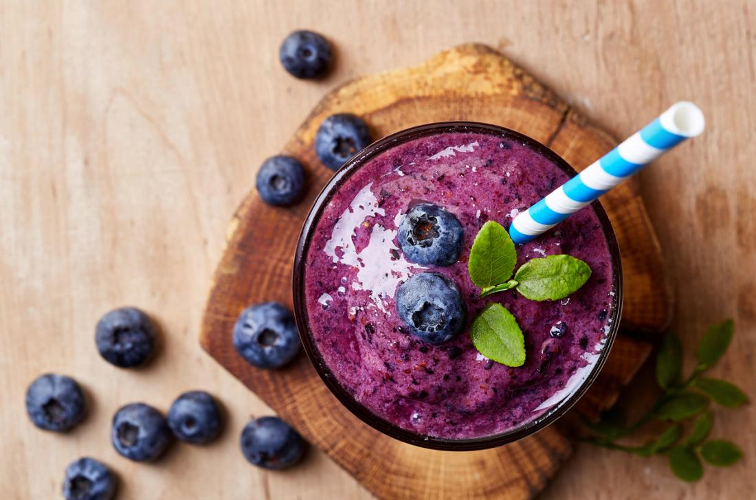
Blueberries can be made into a smoothie or used as a topping on a range of different meal and snack options.
Here are some quick tips on including blueberries in meal options:
- Use blueberries as fresh toppings on oatmeal, waffles, pancakes, yogurt, or cereal for an extra burst of flavor and nutrition in your breakfast.
- Whip up a quick and easy smoothie using frozen berries, low-fat milk, and yogurt.
- Mix fresh or dried blueberries into a spinach salad with walnuts and feta cheese.
- Fold blueberries into muffins and sweet breads.
- Blend them in a food processor with a little water, as part of a fresh syrup to top desserts or breakfast foods.
You may want to try these healthful and simple recipes:
- blueberry almond bread
- blueberry pumpkin oat muffins
- blueberry chia smoothie
- wild blueberry turkey burgers

Risks
People who are taking blood-thinners, such as warfarin, must not suddenly change their intake of blueberries or other sources of vitamin K. Vitamin K plays a key role in blood clotting, and it could affect the blood-thinning action of the drug.The overall diet is more important than any single food in preventing disease and achieving good health. It is better to eat a varied diet as the key to healthful living, rather than to concentrate on individual foods.
REFRENCES
- Antioxidants. (2018, March 1). Retrieved from https://medlineplus.gov/antioxidants.html
- Antioxidants and cancer prevention. (2017, February 6). Retrieved from https://www.cancer.gov/about-cancer/causes-prevention/risk/diet/antioxidants-fact-sheet
- Antioxidants: Beyond the hype. (n.d.). Retrieved from https://www.hsph.harvard.edu/nutritionsource/antioxidants/
- Antioxidants: In depth. (2016, May 4). Retrieved from https://nccih.nih.gov/health/antioxidants/introduction.htm
- Antioxidants: What you need to know. (2017, February 15). Retrieved from https://familydoctor.org/antioxidants-what-you-need-to-know/
- Lobo, V., Patil, A., Phatak, A., & Chandra, N. (2010, July-December). Free radicals, antioxidants, and functional foods: Impact on human health. Pharmacognosy Review, 4(8), 118-126. Retrieved from https://www.ncbi.nlm.nih.gov/pmc/articles/PMC3249911/

