HYDROGEN ENERGY STORAGE: POTENTIAL APPROACHES AND APPLICATIONS

Shrishti Verma¹,
Prabhat Singh²,
Sagarika Kabra³,
Prakash Deep⁴,
Deepika Saini⁵
^{1,2,3,4}Maharishi School of Pharmaceutical Sciences, Maharishi University Information Technology, Lucknow, Uttar Pradesh
⁵Department of Zoology, Chaman Lal Mahavidyalaya, Landhora, Haridwar, Uttarakhand

INTRODUCTION:
in our daily lives, energy is essential subject. The use of energy has increased as a result of population growth and technological advancements. The main issue is the struggle between rising energy demand and the limited supply of fossil fuels currently available, as well as issues related to the use of typical fossil fuels, including the release of greenhouse gases contributing to climate change and the detrimental effects of other associated pollutants on human health.
The development of energy production from renewable sources to displace fossil fuels has accelerated in recent years; at the end of 2018, it is generated 2351 G, or about one-third of the world’s installed electrical capacity.
However, there are a lot of drawbacks with renewable energy sources. Transporting renewable energy offers a challenge because, in most cases, renewable energy sources are located distant from the place of consumption. Renewable energy sources are inherently intermittent and fluctuate, which suggest that power production is unpredictable and that there is natural imbalance between renewable energy generation and load demand. Therefore, adding more localised renewable power plants, such as solar, PV arrays and wind farms, would have a substantial impact on the grid’s stability given the current centralised power generating and distribution networks. Curtailment, a costly solution that hinder the further adoption of renewable energy, is hence the current method employed to address these issues, Energy preservation is a way to deal with it.
Hydrogen is a promising candidate among the different energy storage systems, including batteries, compressed air, pumped hydro, flywheels, capacitors, and others, to help build our future energy system. The Hydrogen Economy, as it is commonly known, is a lo carbon energy system that may use hydrogen as a source of energy for all economic sectors, including transportation, buildings, and industry.
The utilisation of hydrogen as a form of renewable energy is examined in this chapter, starting with the synthesis of hydrogen from various renewable sources and moving on to various kinds of storage that includes compressed gas, cryogenic liquid, and solid materials. The technologies that are available for utilising hydrogen to generate electricity are also discussed.

FIGURE 1: Large scale applications of Hydrogen in Industries.
NEED OF ENERGY STORAGE WITH HYDROGEN:
To meet energy demands, renewable and clean energy sources are necessary due to the finite nature of fossil fuels and current environmental issues. Despite the advantages of renewable energy like wind and solar, there are some challenger that prevent their widespread usage, which makes the current electrical system more vulnerable. These challengers include their inherent intermittency and dispersion. In addition, its incorporation into the current electricity grid could result in serious issues for end consumers, such a voltage drops, frequency changes, poor power factor, etc. due to the lack of reliable predictive models for power generation using this type of energy.
Hydrogen is recognised as a potential energy source. Comparing hydrogen to other fuels, there are several benefits. Because hydrogen is the lightest element, it is capable of being carried and stored in a variety of ways with ease. For instance, due to its high specific energy, 9.5 kg of hydrogen and 25 kg of gasoline have an energy content that is equivalent (Das, 1996).
Hydrogen is a flexible form of energy that can be created from a variety of main and secondary energy source. Moving from centralised to distributed generation with the use of hydrogen storage has several advantages., including improved performance, dependability, availability and security of energy in remote place.
Primary energy

Secondary energy
Conversion
Final energy
carrier
Intermediate
Product
Solar, wind
Algae
Biomass
Natural gas
Oil
Coal
Electricity

Biomethanol
Biogas
Ethanol
Electrolysis
Biochemical
Conversion
Thermochemical
Conversion
SMR
(steam methane reforming)
POX
(Partial oxidation)
ATR
(autothermal reforming)
Syngas
HYDROGEN

FIGURE 2: Processes Involved in Hydrogen Production
TECHNOLOGIES INVOLVED IN HYDROGEN PRODUCTION
Hydrogen production must originate from affordable and renewable sources in order for it to be taken into consideration as a viable energy source to replace fossil fuels. Different technology gaps that prevent specific size of hydrogen generation, storage, distribution, and usage from being viable have opened up chances for technology and innovation breakthrough in various nations.
- Biomass process
In comparison to fossil fuels, producing hydrogen from renewable biomass has a number of benefits, including reducing CO2 emission, raising the value of agricultural products, and being source. Hydrogen may be produced from of biomass using thermochemical techniques like gasification, pyrolysis, and fermentation.
- Gasification
It is a thermochemical process in which synthetic gas (a mixture of hydrogen and carbon monoxide) is obtained from a solid fuel such as biomass or solid waste. The subsequent simplified net reaction can be used to describe the gasification process.
C_{x} H_{y} +XH₂O $→$[$\frac{Y}{2}$ + x] H2 + xCO
By using a catalytic interaction between water and gas at a temperature lesser then that of gasification, the carbon monoxide generated by the process can be converted into hydrogen gas, or H2. The carbon dioxide and any other leftover impurities can then be separated from the generated H2 product.
- Pyrolysis
This method involves quickly heating biomass to a high temperature without any air. The resulting products are shown in solid, liquid, and gaseous phases, and they are created by:
- Gaseous substances, including hydrogen, methane, carbon monoxide, and other gases.
- Product that are liquid at room temperature, such as acetone, acetic acid, and tar oil that is still liquefied.
- Solid products: primarily coal, carbon dioxide, and other insert substances.

- Fermentation
In this kind of procedure, organic waste is used to produce hydrogen via biological process. According to turner et al. (2008), anaerobic bacteria carry out the fermentation reaction, which transform the rich matter in sugar, hydrogen, CO2, and other acidic end products.
C₆ H₁₂0₆ + 2 H₂ O + 2 CH₃ COOH + 2COOH + 4 H₂
It has been thought that biological process offers a viable option to create hydrogen with little pollution and great productivity.
- Water Electrolysis
In the presence of a constant electrical current provide by renewable energy sources, hydrogen can be created by the electrolytic division of water. To create hydrogen and oxygen gas, an electrolyser combines the oxidation and reaction. In theory, any source of electricity production, such as solar power plants, wind farms, and other sources, might be utilised.
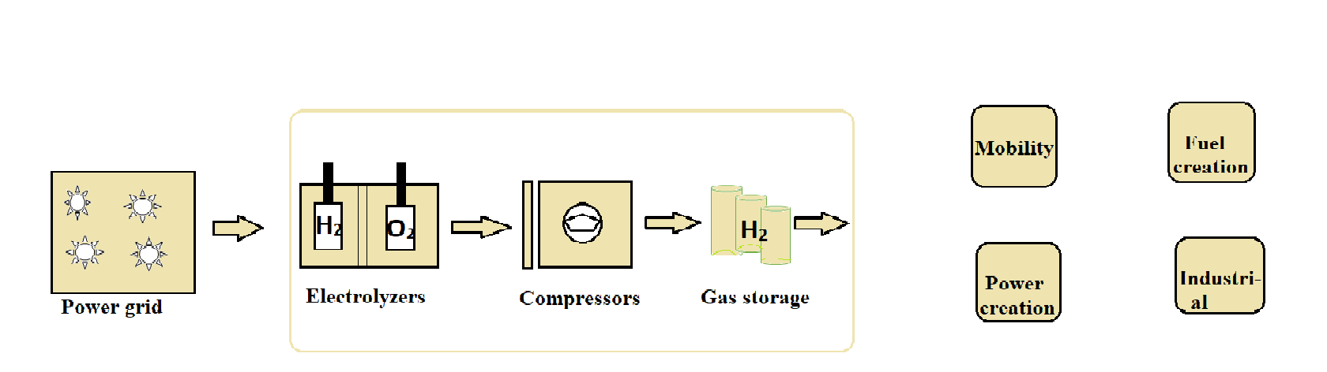
FIGURE 3: An illustration for hydrogen synthesis by water electrolysis
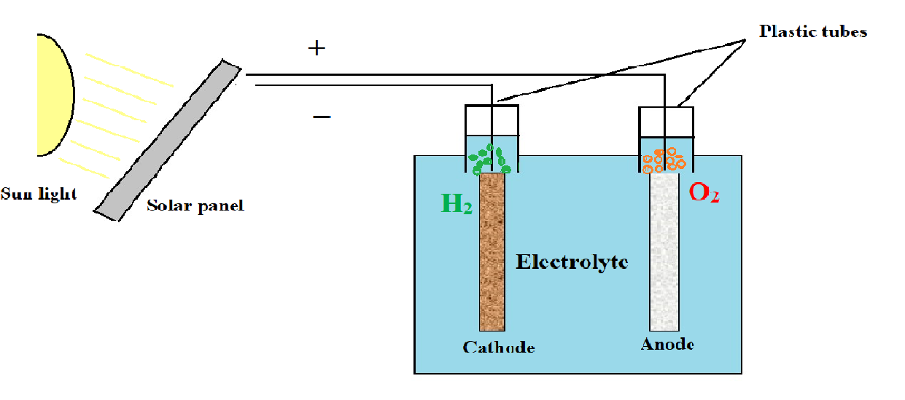
FIGURE 4: Water electrolysis by photovoltaic solar energy
- Photochemical Reactions
Hydrogen is produced through the electrolysis of water by the photolytic process, which harness the energy of water, the photoelectrochemical separation of water, and bio photolysis.
- Photocatalytic water separation
In the procedure, water molecules absorb energy at a rate of 285.57 kJ/mole of UV ration. The energy of the photons can be converted using a variety of supramolecular complexes, such as Ti02 and CuO, to liberate the gases created from the water. The following reaction serve as representations for the two process that take place in following reactions:
Photo-reduction : 2 H₂ O + 2e⁻ $→$ H₂ + 2 OH⁻
Photo-oxidation : 2 H₂O $→$ 4H⁺ + 4e⁻ + O² (g)
A direct technique of producing hydrogen from any source of water is thought separating photocatalytic water. However, the production efficiency of this approach is low.
- Photoelectrochemical water separation
Using photoelectrochemical cells (pec), the photoelectrochemical separation of water, also known as photo electrolysis employs sun illumination to produce an electric current that powers the water electrolysis is one of the PEC cell’s key Characteristics. In the laboratory, an efficiency of 18.3% has been attained for a single bond system, while dual-bond system is capable of converting efficiency of 30%.
TECHNIQUES FOR HYDROGEN STORAGE:

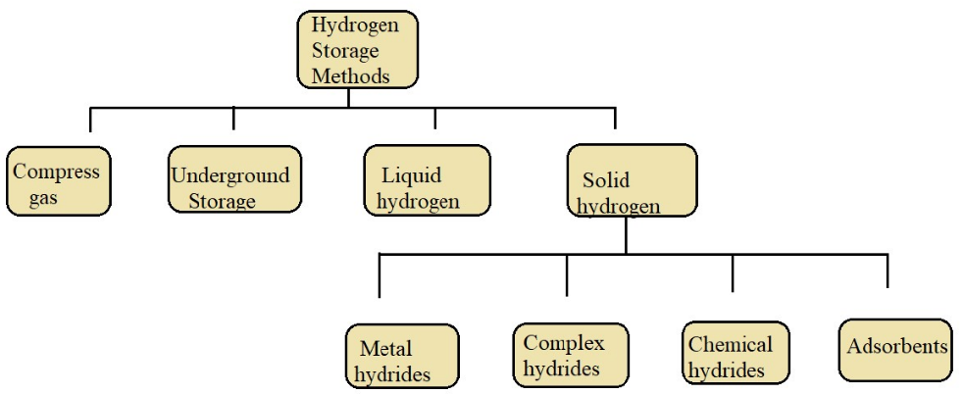
Figure 5: Various Methods f or Hydrogen Energy Storage
- By Compressed Gas:
Compression is an option to store more hydrogen in a smaller volume. The best way to store hydrogen is to compress it in cylinders at pressures of up to 700 bar. When the compression of hydrogen at 700 bar, its density reaches 36 kg/m³. Compressed hydrogen storage system is mainly used to transport hydrogen through hydrogen pipelines, but transport is severely limited because weight of the cylinder. Lightweight materials that can be used to make hydrogen at high temperatures are under development. Another technical problem to be addressed may be the compression heat transfer process. As the temperature in the tank rises, composite materials can deteriorate with serious consequences. To improve the heat transfer performance, research has been developed on the design of materials and structures with high thermal conductivity.

- Underground Storage:
In addition to buried storage tanks that compress hydrogen in gaseous and liquid form, underground hydrogen storage solutions such as aquifers, depleted deposits and oil-salt caves are the main options for medium and long-term large-scale hydrogen. to store. Underground Hydrogen Storage (UHS) is specifically designed for medium and long-term storage of bulk hydrogen products made from raw materials or seasonal additives. Salt caves have a volume of 100,000 to 1,000,000 cubic meters and operate at a maximum pressure of 200 bar. However, the development of hydrogen storage in salt caves is limited by some methods where the sealing of boreholes and the transmission capacity of the surface setup are crucial.
- Liquid Hydrogen Storage:
Liquid hydrogen is another way to store small amounts of hydrogen, as it can be converted to a liquid at low temperatures (20-21 K) and ambient pressure, and volumetric densities as high as 70.8 kg/m³ can be achieved. For solid hydrogen, that is greater than 70.6 kg/m³. The energy required for liquefaction of hydrogen is about [10 kWh/kgH₂ in an existing 5 tons per day (tpd) plant] is relatively high, so liquefaction losses are high. Due to economies of scale, large systems have much higher efficiencies and inherent costs, making them more likely to outperform the competition. Cryogenic Liquid hydrogen tanks are well documented in the cryogenic literature, and its sizes vary from a few litres to 3,800 m³. Evaporation loss normally ranges from 0.1%-1% a day, depending on the tank size.

- Solid Hydrogen Storage:
The compound can be physically or chemically combined with hydrogen, and the resulting compound is stable in the same storage, and can release hydrogen at low temperature, can be used as a medium to store hydrogen in solid form. Obviously, solid state hydrogen storage is the safest and can reach the highest storage capacity. Through absorption, hydrogen is directly stored in the bulk of the material to form compounds. Among them, metal hydrides are gaining popularity due to their high hydrogen storage capacity. For example, palladium can absorb 900 times its own volume of hydrogen at room temperature and atmospheric pressure.
In addition, there are complex hydrides (Mg₂NiH₄, LiAlH₄, NaBH₄, etc.) and chemical hydrides (LiH, NaH, etc.) that store hydrogen by absorption, but they lack reversibility and are dominated by complex hydrogen extraction reactions. Another option for hydrogen storage is adsorption, in which hydrogen is physically absorbed using porous materials such as organometallic scaffolds and carbon materials. The advantage of this option is that temperature control can be avoided during charging and discharging.

HYDROGEN RE-ELECTRIFICATION:
Re-electrification of hydrogen means using hydrogen to generate electricity. Hydrogen can first be recharged by combustion. Compared to hydrogen combustion engines, using fuel cells is the preferred way to use hydrogen efficiently, because fuel cells convert the chemical energy of hydrogen directly into electricity with 60% to 80% efficiency using only water. from the oil product.

- Fuel Cells:
A fuel cell is a device that converts chemical energy into electricity by performing an electrochemical reaction using hydrogen and oxygen. It contains an anode, cathode, and electrolyte. Oxidation occurs in the anode section, releasing protons and electrons, which then pass through the electrolyte and external circuit to the cathode. Different types of fuel cells have different charge, direction of movement, and different charge carriers in the electrolyte, so water can form on either side. This process is facilitated using a catalyst, which is usually a carbon material coated with platinum. Hydrogen fuel cell vehicles can also be seen as an attractive alternative to other zero-emission vehicles, such as battery-powered vehicles, because the chemical consumption of hydrogen is much higher than that of a fuel lamp. Hydrogen fuel cells can also provide longer life than batteries while providing the same specific energy as internal combustion engines.

2H₂ + O₂ 2H₂O + electricity + ( heat)
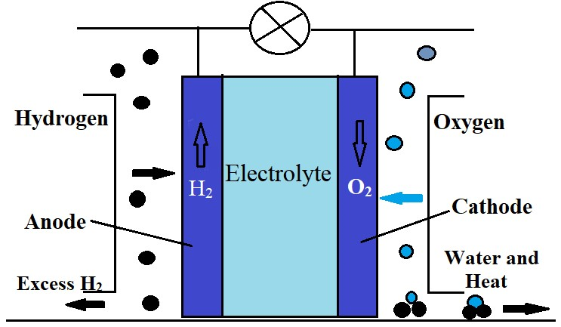

Figure 6: Diagrammatic view of Fuel Cell
- Power to Gas:
The concept of Fuel-to-Energy is to provide an inexpensive energy source to power plants to produce hydrogen and feed it into natural energy systems. There are two methods: direct injection and methanation.
2.1) Direct Injection
This includes supplying hydrogen directly to the natural gas network. The advantage is that no further investment is required. No energy loss and no additional storage required. At normal temperature and pressure, the gas network can easily handle up to 17%volume percent hydrogen. In addition, some countries have laws limiting the hydrogen content within natural gas networks. Injecting 1% by volume of hydrogen into the average annual flow of natural gas would consume more energy than the current combined installed capacity of wind and solar power and would require the production of large wind farms. has been shown to likely mitigate the instability.
2.2) Methanation
The methanization process is the reaction of CO₂ and H₂ on a metal catalyst to make methane. The most important advantage of hydrogen methanation is that the methane mixture can be fed directly into the electricity distribution grid without any restrictions. Due to the need for CO₂, it must be located near the CO₂ source, such as a methanation plant, fossil fuel power plant, industry, or biomass plant, to generate more CO₂ using less money. These systems can recover CO₂ emissions from existing CO₂ sources.

CO₂ + 4H₂ CH₄ + 2H₂O

Economic status in Hydrogen Energy System

- Construction Cost
The construction cost, including the cost of electrolysis hydrogen equipment, hydrogen storage equipment, and fuel cells, is one of the investments before hydrogen energy commissioning.
  - Electrolyzer cost
Overall, there are three categories of water electrolysis, with alkaline electrolyzers costing around 400-600 USD/kW, proton exchange membrane electrolyzers costing around 2000 USD/kW, and solid oxide electrolysers costing around 400-600 USD/kW. It is about 1000-1500 USD/kW.
  - Transmission equipment cost
Different transfer methods vary considerably in cost. Pipeline transportation cost is about USD0.1-1.0/kg of 100km, transportation cost by cryogenic liquid hydrogen truck is USD0.3-0.5/kg of 100km, transportation cost by compressed air truck is up to 0.5 -2.0 USD/kg/100km.
  - Fuel cell cost
A fuel cell micro-CHP plant for private homes and small buildings with an installed capacity of 0.3 to 5 kW now costs around EUR 10,000/kW. Some medium-sized power plants for large buildings from 5 to 400 kW currently cost between 4500 EUR/kW and 7500 EUR/kW, while large power plants from 0.4 to 30 MW cost between 2000 and 3000 EUR/kW for certain industrial applications.

- Hydrogen Production Cost
The price of the hydrogen conversion unit is mainly determined by the price of the gas, which is currently 1.4 to 1.8 EUR/kg with CO2 capture. However, due to declining fossil fuels and falling costs of renewable energy, electrolytic hydrogen has become competitive and will be used soon. Currently, hydrogen production cost from AEL is 3.2-5.2 Euro/kg, while hydrogen production cost from PEMEL is 4.1-6 Euro/kg. Regarding the compression, storage and distribution of hydrogen, the condition of the pipeline is 1.8-2.6 EUR/kg, and the distribution cost is 2.1-3 EUR/kg. This price is expected to eventually drop to 1.6 EUR/kg.

CONCLUSION AND FUTURE ASPECTS:
Growing interest is being shown in using hydrogen as a fuel for various applications, either through direct combustion or via a fuel cell, as a result of increasing environmental concerns around the world alongside the scarcity and geographic distribution of fossil fuel supplies. A wide range of applications, from small-scale ones like electronic device charging systems to a large-scale one like trains and automobiles, can be powered by hydrogen technologies. The sole approach to support the switch to a world powered by hydrogen is to develop large-scale hydrogen production and storage systems. The cleanest method of producing hydrogen is from renewable raw materials like biomass and alternative sources of energy like wind and solar. However, at this time, a production route of this kind can only discharge modest quantities.
Although it has begun, the transition to the hydrogen age is still in its early phases and the final terminal won’t be accomplished in the near future. Despite recent advancements in fuel cell and hydrogen technology, substantial government and research is still required to enable large-scale hydrogen generation and storage technologies, which are essential for establishing the Hydrogen-based economy.

REFERENCES:
- Renewable Energy Now Accounts for a Third of Global Power Capacity. Available from: https://www.irena.org/newsroom/ press releases/2019/Apr/Renewable-Energy-Now-Accounts-for-a
- Albadi, M., El-Saadany, E. (2010). Overview of wind power intermittency impacts on power systems. Electric Power Systems Research, 80(6), 627-632.
- Kaur, M., Pal, K. (2019), Review on hydrogen storage materials and methods from an electrochemical viewpoint. Journal of Energy Storage, 23, 234-249
- Das, L. (1996), On-board hydrogen storage systems for automotive application. International Journal of Hydrogen Energy, 21(9), 789-800.
- Wen Li, H., Hayashi, A., Yamabe, J., & Ogura, T. (2016). Hydrogen Energy Engineering. K. Sasaki (Ed.). Springer.
- Kırtay, E., (2011). Recent advances in production of hydrogen from biomass. Energy Conversion and Management, 52(4), 1778-1789.
- Zhang, F., Zhao, P., Niu, M., Maddy, J. (2016), The survey of key technologies in hydrogen energy storage. International Journal of Hydrogen Energy, 41(33), 14535-14552.
- Wietschel, M., Ball, M. (2009), The hydrogen economy: Opportunities and challenges.
- Jalan, R., Srivastava, V. (1999), Studies on pyrolysis of a single biomass cylindrical pellet—kinetic and heat transfer effects. Energy Conversion and Management, 40(5), 467-494
- Chaubey, R., Sahu, S., James, O., Maity, S. (2003). A review on development of industrial processes and emerging techniques for production of hydrogen from renewable and sustainable sources. Renewable and Sustainable Energy Reviews, 23, 443-462.
- Mohammadi, P., Ibrahim, S., Mohamad Annuar, M. (2014), High-rate fermentative hydrogen production from palm oil mill effluent in an up-flow anaerobic sludge blanket-fixed film reactor. Chemical Engineering Research and Design, 92(10), 1811-1817.
- De Gioannis, G., Muntoni, A., Polettini, A., Pomi, R. (2013), A review of dark fermentative hydrogen production from biodegradable municipal waste fractions. Waste Management, 33(6), 1345-1361.
- Kwak, B., Chae, J., Kang, M. (2014), Design of a photochemical water electrolysis system based on a W-typed dye-sensitized serial solar module for high hydrogen production. Applied Energy, 125, 189-196.
- Dincer, I., Acar, C. (2015), Review and evaluation of hydrogen production methods for better sustainability. International Journal of Hydrogen Energy, 40(34), 11094-11111.
- Kothari, R., Buddhi, D., Sawhney, R. (2008), Comparison of environmental and economic aspects of various hydrogen production methods. Renewable and Sustainable Energy Reviews, 12(2), 553-563.
- Licht, S., (2001). Over 18% solar energy conversion to generation of hydrogen fuel; theory and experiment for efficient solar water splitting. International Journal of Hydrogen Energy, 26(7), 653-659
- Riis T, Sandrock G, Ulleberg Ø, Vie PJ. Hydrogen storage–gaps and priorities. In: HIA HCG storage paper, Vol. 11. 2005, p. 1–11.
- Tarkowski R. Underground hydrogen storage: Characteristics and prospects. Renew Sustain Energy Rev 2019; 105:86–94. 2019.01.051
- Dagdougui H, Sacile R, Bersani C, Ouammi A. Chapter 4 - Hydrogen storage and distribution: Implementation scenarios. In: Dagdougui H, Sacile R, Bersani C, Ouammi A, editors. Hydrogen infrastructure for energy applications. Academic Press; 2018, p. 37–52.
- Moradi R, Groth KM. Hydrogen storage and delivery: Review of the state of the art technologies and risk and reliability analysis. Int J Hydrogen Energy 2019;44(23):12254–69.
- Connelly K, Wahab A, Idriss H. Photoreaction of Au/TiO 2 for hydrogen production from renewables: a review on the synergistic effect between anatase and rutile phases of TiO 2. Mater Renew Sustain Energy 2012;1(1):3.
- Guandalini, G., Campanari, S., Romano, M. (2015), Power-to-gas plants and gas turbines for improved wind energy dispatchability: Energy and economic assessment. Applied Energy, 147, 117-130.
- Zhang, F., Zhao, P., Niu, M., Maddy, J. (2016), The survey of key technologies in hydrogen energy storage. International Journal of Hydrogen Energy, 41(33), 14535-14552.
- Parks G, Boyd R, Cornish J, Remick R. Hydrogen station compression, storage, and dispensing technical status and costs. 2014,

.

