IMPLEMENTATION OF DIGITIZATION IN P&O CLINIC PROCEDURE; E-PRD

Author details-
1.Soubhagya Samantaray,BPO
Department of Prosthetics and Orthotics
NIRTAR, Odisha
Mail id-soubhagya989@gmail.com
Phone no-9692405114
1. Sushree Sangita Nayak,PhD Scholar
Lecturer
Department of Prosthetics and Orthotics
NIRTAR, Odisha
Mail id-lollybpo@gmail.com
Phone no-9438117407

Abstract
Background: Digitization in prosthetic & orthotic clinic procedure is the systematic application of information science, computer science and technology to public health practice, research and learning. It is an evolving concept defined as a systematic collection of electronically generated or computerized health information about individual patient or population. It is a record in digital format that is theoretically capable of being shared across different health care settings.
Objective: To create new treatment models and a sense of awareness among people about prosthetics and orthotics, keep pace with the fast advancing competitive world, improve services provided to the patient and increase internal collaboration.
Method: This website is a platform in which admin can collect, analyze record, summaries data and create content for other users. Mainly three groups of people can be the potential users for this website. As this is an application based upon healthcare services the first and foremost user can be (1) Patients, (2) Healthcare professionals and (3) Depository Manager. For running our website we used a server named XAMMP, in which our database is stored. XAMPP is a free and open-source cross-platform web server solution stack package developed by Apache Friends, consisting mainly of the Apache HTTP Server, MariaDB database, and interpretees for script written in the PHP and Perl programming languages. XAMPP and WordPress serves as a backend software which could be accessed by a frontend software such as web browser i.e. Google chrome, internet explorer etc.
Results: It empowers patient in self-management of chronic illness via collaboration between patient and rehabilitation professional. This creates general awareness among the population and the collected data can be used for survey and research.
Conclusion: The implementation of digitization in prosthetics and orthotics has marked a transformative leap forward in patient care and to the ease of access at their fingertip. The ability to customize and integrate advanced functionalities has opened a new era of opportunities and possibilities.
Introduction
Digitization process was started in 1679 with the advent of computers Gottfried Wilhelm Leibniz developed the first ever binary system, which set a remarkable footprint in digitization world. The digital revolution became truly global in this time as well after revolutionizing society in the developed world in the 1990s, the digital revolution spread to the masses in the developing world in the 2000s. This was the marking of initiation of the digitization era- A period in human history characterized by the shift from traditional industry to an economy based on information and communications technology. In July 2015, the Indian government launched the “Digital India” initiative to improve online infrastructure and increase internet accessibility among citizens, thereby empowering the country to become more digitally advanced. The initiative encompasses the following three key objectives: Establish a secure and stable digital infrastructure, Deliver digital services, Ensure that every citizen has access to the internet facility. Digitalization has been incorporated in every field of the society and world to keep in pace with the rapid changing, revolutionized world and technological advancement. It has revolutionized communication and commerce and has a profound effect on nearly every aspect of modern life. It has a wide range of application, starting from small scale industry, govt. and non-govt. organizations to a very narrow use in household works. The process of digitalization has successfully taken over in the following industries; they are manufacturing industry, transportation, hospitality/ tourism, healthcare, financial services, education, energy, media and retail. With the introduction of digitalization into health care it also slowly creeped into rehabilitation sector in the late 20th century. The technologies of digitization enable the conversion of traditional forms of information storage such as paper and photographs into the binary code (ones and zeros) of computer storage. Digitization of documents is a must in this digital age, people share files on digital platforms rather than physical papers. By digitization we simply mean converting all your medical records (old& new) present in tangible form into digital format. Any written or printed documents will be digitized by using document management solutions. Digitization in prosthetic & orthotic clinic procedure is the systematic application of information science, computer science and technology to public health practice, research and learning. It is an evolving concept defined as a systematic collection of electronically generated or computerized health information about individual patient or population. It is a record in digital format that is theoretically capable of being shared across different health care settings. The term digitization is often used when diverse forms of information, such as an object, text, sound, image, or voice, are converted into a single binary code and the advantage of digitization is the speed and accuracy in which this form of information can be transmitted with no degradation compared with analog information. Thus, digitization of healthcare allows for care beyond the bounds of the healthcare or rehabilitation institutions and into the limits of your own home. Future of digital health service in India looks very strong and vivid.

Use of Blockchain
Digitalization of P&O clinic procedure can be achieved through blockchain application. With the ability to reduce costs, protect patient data and improve patient and health workers overall experience, blockchain is a powerful solution to various persistent problems in health care industry. Blockchain is a decentralized and public digital ledger that records transactions on many computers so that no record involved can be altered retroactively without altering any blocks afterwards. Blockchain is verified and linked to the preceding ‘block,’ forming a long chain. Blockchain ledger architecture ensures that data is not processed in any centralized venue, making it accessible and accountable to all network users. This decentralized system avoids a single attack, strengthening and securing the system. Blockchain offers an excellent forum to develop and compete with traditional companies for modern and creative business models. It facilitates better control of health records and patient care by minimizing twice the amount of medical practice and monitoring, saving both practitioners and patients time and resources.
Benefits of Blockchain
- Encrypts data for data integrity.
- Protects patient information with secure standards.
- Creates ownership through transparency and enables consistency.
- Lowers transaction cost.
- Provides real time updates of shared data.
- Ensures distributed and secure access.
- Guarantees system efficiency and removes vulnerable points.
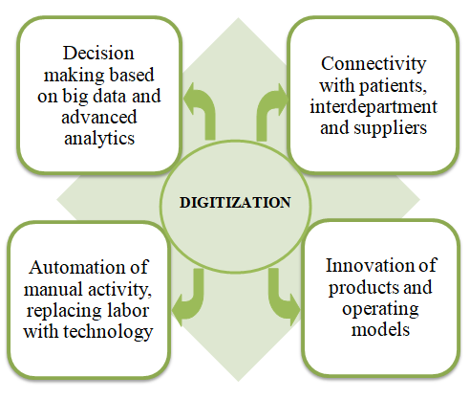
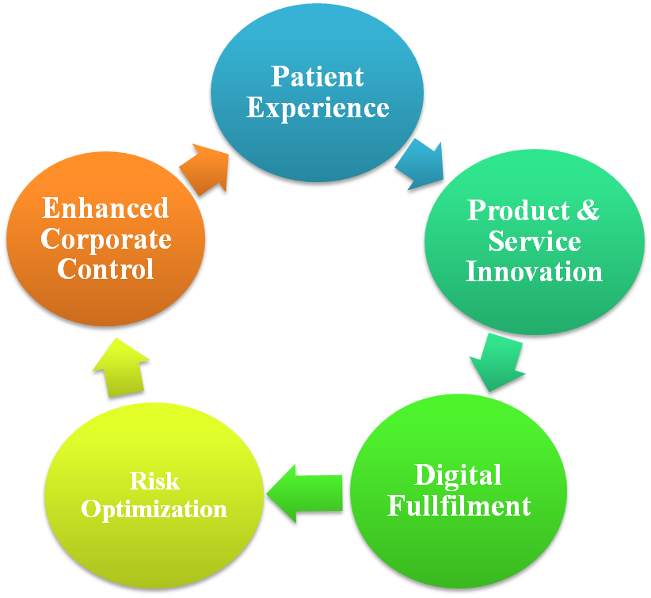

Need of Blockchain in Healthcare
Today the need is for quality health facilities supported by advanced and newer technologies. Here, Blockchain would play a critical role in transforming the healthcare sector. The landscape of the health system is moving towards a patient centered approach focusing on two main aspects: accessible services and appropriate healthcare resources at all times. In addition, better research and shared data on public wellbeing will enhance treatment for different communities. Some healthcare companies leading the way in blockchain are BrustIQ, WholeCare, Nebula Genomics, Medicalchain, Gem, MedRec, Patientory.
.

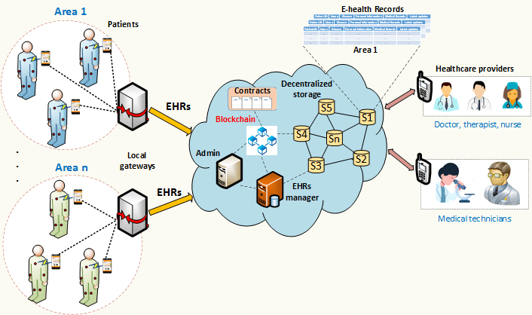

Digitization of p & o clinic procedure is required as
- Reports may be lost in theft.
- Loss of medical transcripts in fire.
- Medical reports like X-Rays and MRI scans can decay after a certain period of time.
- Absence of these necessary records may lead to destruction of the treatment process.
- Paper charts or records are neither interactive nor intuitively designed.
- Printed reminders and cautions can be easily overlooked.
- All the physically written medical charts cannot be vividly read.
- No data sharing can be done in case of written records.
- Disorganization or disaster in office can result in information loss.
- Misplaced or lost reports can spoil a case due to absence of certain important documents.
- Patients don’t always carry all the required documents.
- Once assessment is done, the records are always saved for future use.

Aim and Objective
To digitalize the P&O clinic procedure with the prime objective of:
- Improving services provided to the patient.
- Increasing internal collaboration.
- Optimizing processes and increasing efficiency.
- Becoming more agile and providing easy access to patient about the disease and treatment plan.
- Creating new treatment models and a sense of awareness among people about prosthetics and orthotics.
- Complying with data security.
- Keeping pace with the fast advancing competitive world.
Methodology
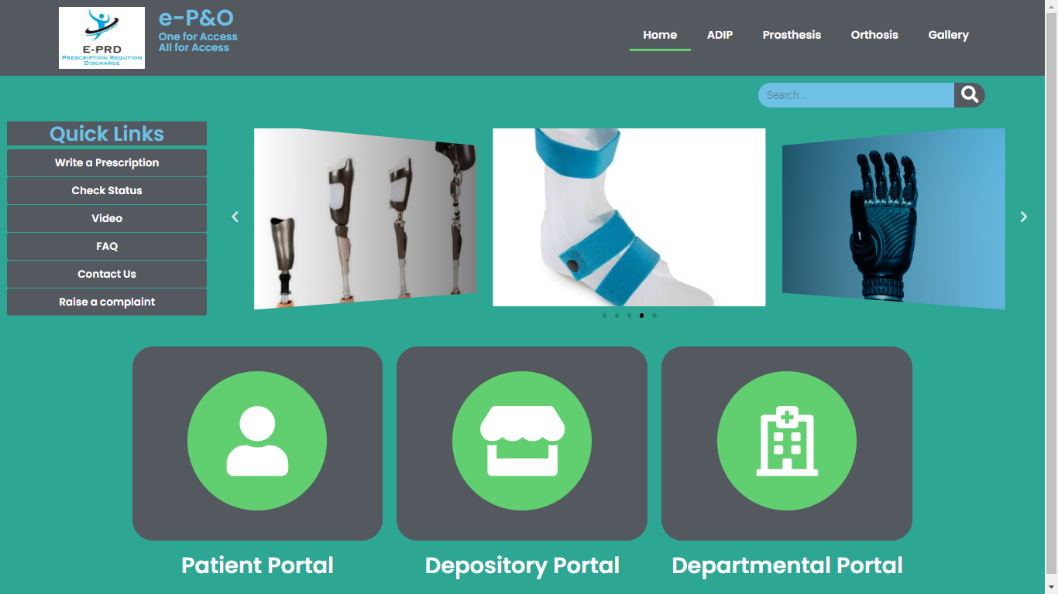
This website is a platform in which admin can collect, analyze, record, summaries data and create content for other users. Mainly three groups of people can be the potential users for this website. As this is an application based upon healthcare services and the first and foremost user can be (1) Patients, (2) Healthcare professionals and (3) Depository Manager. For running our website we used a server named XAMMP, in which our database is stored. We have selected WordPress as a content management system through which contents such as media file, photo and videos, articles, forms, table etc are managed. XAMPP and WordPress serves as a backend software which could be accessed by a frontend software such as web browser i.e. Google chrome, internet explorer etc.

Patient portal
Patient portal serves as an interface for interaction of the patient with the platform. The patient solely can assess the information and data by simply entering their registration details. They can upload documents, view/download prescription and invoice, track the status of appliance, raise complaint and give feedback.
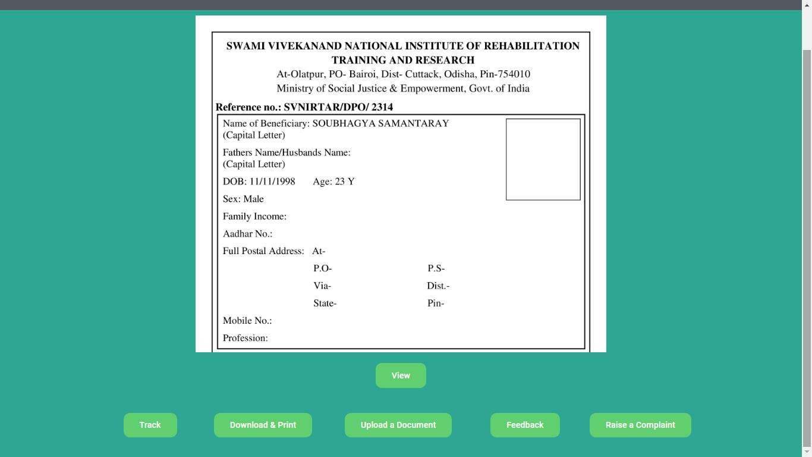

Depository portal
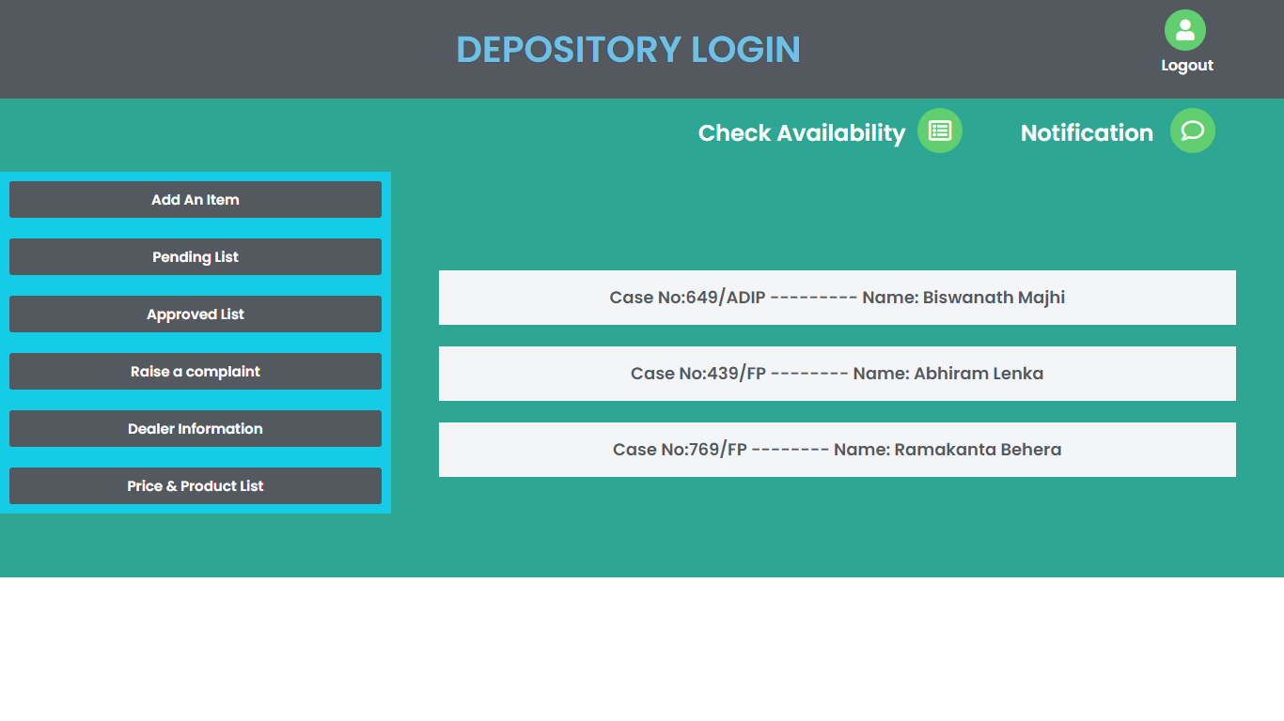
This portal is accessed by the store manager, who keeps a precise look on the availability of raw material, components, etc. The manager is responsible for approving or disapproving the requisition, checking the pending list, ordering items and raising a complaint against the damaged product provided. This portal serves as the medium for performing all these activities through a single window. Receiving and storing are the key considerations in the materials management.

Departmental portal
The rehabilitation professionals along with some other service providers in collaboration with the accounts department have access to his portal. This portal houses a wide range of services in a single window which is assessable to multiple users at a time. The generation of workorder number has a crucial role to play prior to prosthetic and orthotic fabrication. The workorder number helps in inter and intra departmental services to run smoothly and for record keeping of the patients. The professionals have the right to edit or add any information related to the case. This portal serves the professionals not only to prescribe and record data digitally but also to update and view a case in future, which may be a principal tool for research and development.
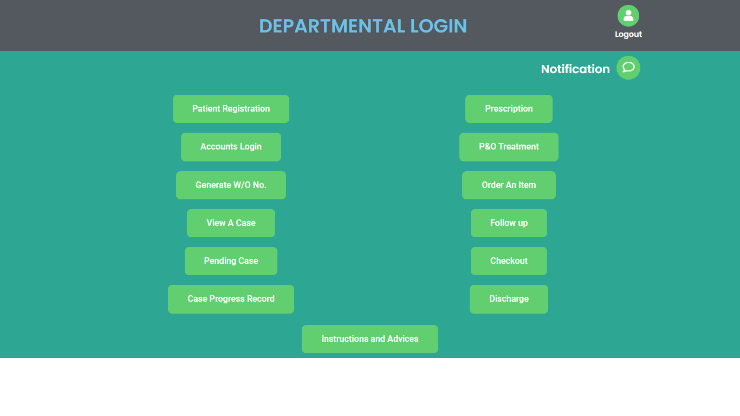

Tools used in digitization
- INFO- BUTTONS
- Contact specific links from one information system to another resource. Provide relevant contextual information. Significantly increase the percentage of net information needs at that point of care.
- COMPUTERIZED PROVIDER ORDER ENTRY (CPOE)
- Allows the provider orders to be written electronically either in the rehabilitation centre or outpatient settings. Eliminates hand writing misinterpretation.
- CLINICAL DECISION SUPPORT (CDS)
- Provides intelligently filtered clinical knowledge and patient related information. Improves patient care. CPOE and CDS often work in tandem to ensure patient is being treated appropriately.
- PERSONAL HEALTH RECORD (PHR)
- Enables the patient to keep track of their own personal health information. Provides educational material to assist in self-management of chronic disease.
- It allows communication of rehabilitative information to remote provider for consultation. Frequency of required appointments for a patient can be determined. Improves quality of care. Reduces cost through cost avoidance.
- CLINICAL DATA REPOSITORY (CDR)
- The database that stores all the health information of the electronic health records.

Results
The implementation of digitization in prosthetics and orthotics clinic procedure has brought about significant improvements and advancements in patient care, workflow efficiency and overall outcomes. Below are some benefits of incorporating digitization:
- Access from anywhere at any time.
- The ability for more than one person to access records at once.
- Makes your records copied and protected forever.
- Money is saved by using electronic medical records; not just the cost of paper and file folders, but the cost of labour and space too.
- The application of classification and indexing methods consistent for document retrieval.
- Quick access to records can be lifesaving if an emergency occurs and answers to those questions are needed during the emergency decision making process.
- Provides alerts to the rehabilitation professional to health needs or relevant research.
- Helps in tracking prior rehabilitation or medical history and treatment of the patient.
- Greater co-ordination and data sharing.
- No data loss.
- Early intervention.
- Serves one single platform for all programmes.

Despite these positive results, it is essential to acknowledge that challenges may arise during the process; the related issues may need to be addressed to ensure smooth transition and optimum utilization of digital tools.
- Loss of revenue due to expensive software and computer purchase and their maintenance expense.
- Dependent upon reliable operating source for smooth functioning.
- Data security is the biggest threat in the process of digitization.
- Slow learning curve in persons acquainted to older methods.

Discussion
Digitization will dramatically change the way in which the Rehab professionals and other clinicians practice. Enable creation for more legible records helpful for multiple practitioners. CDR and RHIO (Regional Health Information Organization) will act as a bridge enabling team work in patient care, safeguarding populations from outbreaks. Digitization has many advantages such as accessibility to information, easy and immediate communication, etc. However, there are also downsides to this such as dependence on unreliable source, the risk of being hacked and the misuse of information. Technology dominates almost every aspect of our lives. Today we are witnessing an increasing shift towards digitization as it makes lives much more comfortable and convenient. Digitization is bringing about a new revolution in healthcare industry. The transformation of the “Indian Healthcare System” has already begun. While government is increasingly encouraging digitization with initiatives such as DIGITAL INDIA and AADHAR, the private sector has launched various mobile applications, telemedicine, tools and innovation centres throughout the country. Therefore, India urgently needs to be a part of the digital revolution in healthcare.

Conclusion
The implementation of digitization in prosthetics and orthotics clinic procedure has fundamentally reshaped the way we live, work and interact. It’s potential for creating efficiencies, fostering innovation and improving lives is unparalleled. It has led to improved outcomes, increased accessibility and greater patient satisfaction. As we move forward, it is crucial to strike a balance between embracing technological advancements and addressing the ethical, social, and environmental implications they entail. It is crucial for the healthcare industry to adopt digitization fully, fostering continued innovation and enhancing the lives of differently able. By doing so, we can harness the full potential of digitization to build a brighter and more sustainable future for all.

References
- O&P clinical and business forms, American Orthotic and Prosthetic Association.
- Atlas of Amputations and Limb Deficiencies: Surgical, Prosthetic and Rehabilitation Principles.
- Atlas of Orthotics: Biomechanical Principles and Application.
- www.svnirtar.nic.in
- https://svnirtar-opac.l2c2.co.in
- www.guidemytreatment.com
- www.medtech.com/ind/
- https://socialjustice.nic.in
- www.rehabcouncil.nic.in
- www.opai.org.in
- www.sciencedirect.com
- journals.uic.edu
- www.researchgate.net

