DEVELOPMENT OF A DEEP-LEARNING
NEURAL
NETWORK MODEL FOR TRANSIENT
AND SMALL
SIGNAL STABILITY ASSESSMENT

John Obiajulu Onyemenam  Department of Electrical and Information  Engineering,  Landmark University, Omu-Aran, Nigeria john.obiajulu@lmu.edu.ng  Folashade Ariba  Department of Electrical and Information  Engineering,  Landmark University, Omu-Aran, Nigeria ariba.folashade@lmu.edu.ng | Paul Kehinde Olulope  Department of Electrical and Information  Engineering,  Ekiti State University, Nigeria  paulade001@yahoo.com  Yusuf Isaac Onimisi  Department of Electrical and Information  Engineering,  Landmark University, Omu-Aran, Nigeria yusuf.isaac@lmu.edu.ng

ABSTRACT
This research recommends employing a deep learning neural network (DLNN) technique to analyze both transient and small signal stability, in contrast to other studies that only looked at transient stability. The complexity of power system dynamic features has increased due to the introduction of new components like power electronics, electric vehicles, and renewable energy generation, making TSA and SSA essential considerations. Today, the stability and security of the electrical network are impacted by the growing development of renewable energy sources. This study's objective is to evaluate the numerous stability issues relating to the electrical system using feature selection and DLNN methodology. The 28-bus test case power system's dynamic simulations were used to provide Nigerian time-domain data. A data processing pipeline for feature selection is built using the Relief-F feature selection approach. Calculations are made to determine the proper amount of adjustment, the correct minimum damping ratio, and system stability under the constraints of stability and power balance. The DIgSILENT/Python tool, which is powered by an Intel Pentium core i5 2GHz CPU, is used to carry out this study. The better performance of the proposed model is tested on the Nigeria 28 bus system, and confirmed on the IEEE 9 bus system.

Keywords- Small Signal stability assessment, Transient stability assessment, Deep Learning Neural Network, Long Short-Term Memory, Transient stability, Power system stability, Relief F, Recurrent Neural Network

I. INTRODUCTION
The capacity of a power system to recover from a disturbance, find equilibrium, and resume regular operations is referred to as power system stability. Rotor angle instability caused by synchronism loss has long been linked to the instability issue [7]. The instability problem has long been associated with rotor angle instability brought on by synchronism loss [7]. Depending on the intensity of the disturbance, rotor angle stability can also be divided into small signal and transient signal stability. A power system's ability to maintain synchronism in the face of slight and major interruptions is referred to as small signal stability and transient stability, respectively [2]. A group of highly nonlinear Differential and Algebraic Equations (DAE) [2], [7] describe the behavior of synchronous generators in respect to their related control systems, loads, renewable energy output, flexible AC transmission devices (FACTs), and the transmission network. The DAE model can be linearized all the way around the equilibrium point when the power system undergoes minimal modification. Small-signal stability is made possible by electrical torque changes in synchronous machines with the proper synchronizing and dampening torque component. Each condition must be dealt with numerically using time domain simulations because the DAE model cannot be linearized around an operating point when a power system encounters major variations [7]. If there is not enough synchronizing and damping force, the rotor angle of a synchronous generator may occasionally drift and oscillate [2]. Transient instability, which has the potential to reduce a power system's overall performance, is the main reason for power outages [4]. TSA, a kind of time domain simulation, is expensive and computationally difficult, especially for large power systems with an almost limitless number of operating points and scenarios. The prediction model is trained utilizing a Deep Learning technique (LSTM) and a data set for a range of operating circumstances in order to accomplish these goals. The Long Short-Term Memory (LSTM), which is trained to remember the oscillatory response of a projected stable system, progressively captures the significant weekly damped low frequency oscillation. The TSA, SSA, and LSTM all have gradually decreasing computing complexity that increases prediction accuracy. The enhanced performance of the proposed model is demonstrated using the Nigeria 28 Bus System, and details on how the IEEE 9 Bus system supports it are given.

II. TRANSIENT AND SMALL SIGNAL STABILITY OF A POWER SYSTEM
In this study, deep learning neural network approaches are used to build a prediction model for the transient and small signal stability issues in Nigeria's 28 bus system. This section explains the mathematical procedure for transient and small signal stability.

A. Transient Stability
The ability of a synchronous machine to maintain synchronism in a power system following a disruption is referred to as rotor angle stability. Due to the variable impact of power system disruptions on generation, some generators will slow down as a result of an increase in load from adaptive operation, while the other generators would speed up to maintain grid frequency. The tilt of the rotor with respect to the stator changes as the generator speed rises [6]. The rotor continuously accelerates and decelerates alternatively to maintain balance between the mechanical input torque and electrical output torque. The generator's ability to produce power is decreased by this action, which also harms the transformers, prime mover, and generator as a whole. Consequently, it is essential to protect the synchronous machine. [8].
The dynamic reaction of a power system to disturbances is controlled by a collection of DAE, and their compact form is:

The algebraic variables x and y are displayed together with the state. Additionally, the appropriate DAE's vectors are shown in h and g. The algebraic variables y, such as bus voltages and active power injections, and the state variables x, such as rotor angles and frequencies, are solved to provide time-varying trajectories. Numerical techniques, such as the trapezoidal approach (1), are used to discretize the set of differential equations in order to achieve this. The new algebraic equations and the remaining algebraic equations are solved using Newton's method at each time step (2). To evaluate transient stability, the dynamic trajectories over the simulation time window are monitored. This method provides an accurate assessment of the temporary for a specific situation [1].

B. Small signal stability
Inadequate oscillation Voltage stability, rotor angle, and damping in frequency are all signs of small signal stability. When damping is zero, oscillatory activity's amplitude remains constant across time. No matter what the initial disturbance was, negative damping increases the oscillations' amplitude. High damping ratios increase the size of the critical mode in the power system and lessen oscillation behavior. This is due to the fact that it is the least stable part of the system [7]. The stability of tiny signals can be evaluated using the smallest damping ratio. Small signal stability issues may be localized or global in nature. Local mode oscillations, which are smaller disturbances brought on by a single producing station, are smaller than interarea mode oscillations, which are larger disturbances produced by a collection of generating stations. To increase oscillation stability in multi-machine power systems, controllers for the Power System Stabilizer (PSS) and Flexible AC Transmission System (FACTS) are frequently utilized. These devices [5], [7] lessen damping by producing additional signals to counter oscillations in generator excitation systems. Electrical torque of synchronous machines is the primary determinant of how they react to oscillations. The two parts of electrical torque are the synchronizing torque (TS), which oscillates in phase with the rotor angle deviation, and the damping torque (TD), which oscillates in phase with the parts that affect the speed deviation. The stability of small signals is impacted by both types of torques [5]. Equation (3) – (5) demonstrate how the set of algebraic and differential equations presented in eq (1) – (2) can be linearized around an equilibrium point for small perturbation.

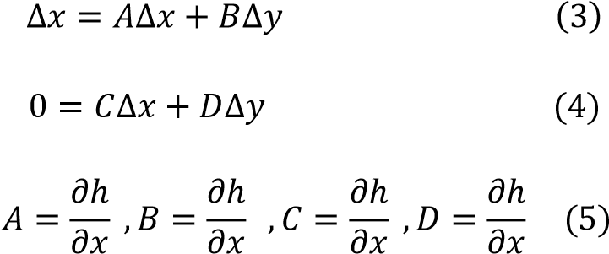

The linearized model in (3) - (6) is used to examine small signal or local stability at an equilibrium point in the presence of a slight disturbance in a power system. The Lyapunov first technique is used to accomplish this, which calls for figuring out the eigenvalues of the characteristic equation in the manner described below [3].

det(𝐴_{𝑠𝑦𝑠} − 𝐼) = 0 (6)
Where, ^{𝐴}𝑠𝑦𝑠=𝐴−𝐵 (𝐷⁻¹)𝐶 𝑎𝑛𝑑 =(1, 2…………………………….𝑛)

Responses are either non-oscillatory or oscillatory depending on the real or complex calculated eigenvalues. There are also conjugate pairs of complex eigenvalues that each show an oscillatory mode [5].

C. LSTM NETWORK FOR TSA AND SSA
The LSTM RNN variations have the ability to extract historical data from time series data. The network learns by storing incremental temporal domain inputs into durable internal hidden states. It's common behavior to recall facts from the past over time. Because they can recall previous inputs, LSTMs are useful for time-series prediction [7]. Thanks to their chain-like structure and four interacting layers, LSTMs interact in a number of ways. In addition to time-series predictions, LSTMs are frequently used in voice recognition, music creation, and pharmaceutical research [7], [10]. The concerns with long-term reliance are addressed via LSTM. The LSTM provides the option to read, write, or reset the sale at each stage [10]. The LSTM's mathematical computations are shown in equation (7).

(
7)

The operator stands for the pointwise multiplication of two vectors, with Wi, Wc, and Wo standing in for the weights and ct for the state of the LSTM cell. The output gate chooses what information can be output based on the cell state, whereas the input gate chooses what new information can be entered while updating the cell state. Based on the connections, the LSTM cell represented in (8) can be mathematically described as follows:

(
8
)

The forget gate makes decisions based on the state of the damaged cell. When the value of the forget gate, ft, is 1, the information is maintained; when it is 0, the information is completely discarded [10]. Figure 1 depicts the LSTM's internal structure.

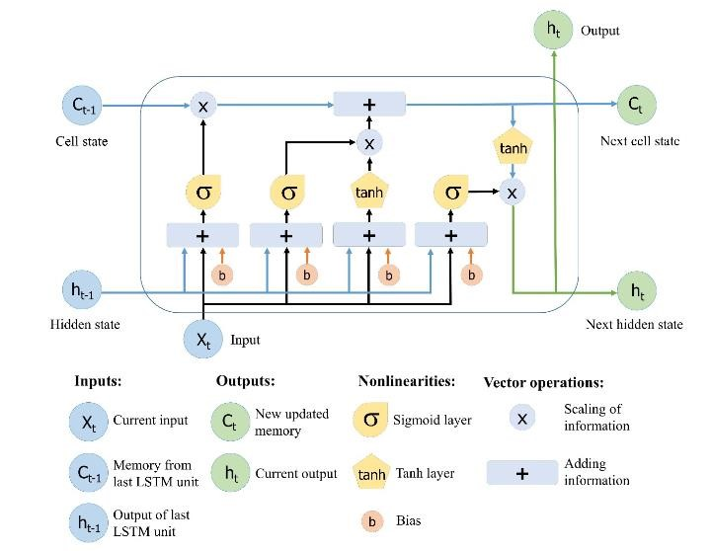

Figure 1: LSTM Network Diagram [11].

III. NETWORK STRUCTURE OF THE MODEL
In order to create a Deep learning NN for TSA and SSA, this paper builds the six-layer network model are explained below
- Data collection: The National Control Center (NCC), Oshogbo, is where appropriate data for modeling the 28-bus Nigeria network are acquired.
- Using DIgSLIENT, the Nigeria 28 bus system was network modeled.
- Data collection for DLNN: The Relief-F technique is applied to remove unusual data from redundant ones.
- DLNN (LSTM): A DLNN based on LSTM is modelled using the data that is available, trained, tested, and confirmed to complete the required TSA and SSA evaluation.
- Performance evaluation: The effectiveness of the LSTM model is then assessed using the Root Mean Squared (RMS), Specificity, Accuracy, and Precision metrics.
- Compare outcomes: The results are evaluated against the IEEE 9 bus system.

Figure 2, shows the proposed model for assessing Transient and Small signal stability. It is made up of two different model. The two model contains four inputs namely, voltage, rotor angle, active power and reactive power.

In

TS
A
SSA

X
1

X
2

X
3

X
4

Y
1

Y
2

Y
3

Y
4

Stable/

unstable

Stable/

unstable

Bias=1
Figure 2: Schematic design model of TSA & SSA

IV. DATA PREPARATION
The 330KV, 28 bus networks in Nigeria that served as the case study (TCN) received the bus and transmission line data from the NCC. The 28-bus power network, which includes 28 buses, 9 generation stations, and 52 transmission lines, is depicted in Figure 3. The transmission line and bus data are shown in Table 1. The DIgSILENT power facility is where the modeling is carried out. Depending on where the load and generator were located, the bus bars for the transmission lines were either PV or PQ versions. Based on PQ data, the loads were grouped into loads. The generators were accurately modeled using the necessary data and synchronous generator characteristics.

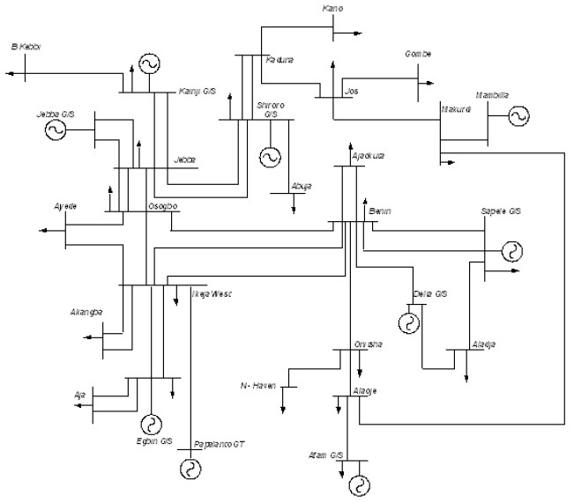

Figure 3: The Nigerian 28 bus power system [9].

Table 1: Network Data of the Nigerian 28 Bus Power System [9].
Bus Identification |  | Bus Loads |  | Transmission Lines Data
NO | Name | MW | MVAR | Bus |  | R(pu) | X(pu)
1 Egbin |  | 68.90 | 51.70 | FROM | TO
- Delta 0.00 0.00 1 3 0.0006 0.0044
- Aja 274.40 205.80 4 5 0.0007 0.0050
- Akangba 244.70 258.50 1 5 0.0023 0.0176
- Ikeja-West 633.20 474.90 5 8 0.0110 0.0828
- Ajaokuta 13.80 10.30 5 9 0.0054 0.0405
- Aladja 96.50 72.40 5 10 0.0099 0.0745
- Benin 383.30 287.50 6 8 0.0077 0.0576
- Ayede 275.80 206.8 2 8 0.0043 0.0317
- Osogbo 201.20 150.90 2 7 0.0012 0.0089
- Afani 52.50 39.40 7 24 0.0025 0.0186
- Alaoji 427.00 320.20 8 14 0.0054 0.0405
- New-Heaven 177.90 133.40 8 10 0.0098 0.0742
- Onitsha 184.60 138.40 8 24 0.0020 0.0148
- B/Kebbi 114.50 85.90 9 10 0.0045 0.0340
- Gombe 130.60 97.90 15 21 0.0122 0.0916
- Jebba 11.00 8.20 10 17 0.0061 0.0461
- Jebba G 0.00 0.00 11 12 0.0010 0.0074
- Jos 70.30 52.70 12 14 0.0060 0.0455
- Kaduna 193.00 144.70 13 14 0.0036 0.0272
- Kanji 7.00 5.20 16 19 0.0118 0.0887
- Kano 220.60 142.90 17 18 0.0002 0.0020
- Shiroro 70.30 36.10 17 23 0.0095 0.0271
- Sapele 20.60 15.40 17 21 0.0032 0.0239
- Abuja 110.00 89.00 19 20 0.0081 0.0609
- Makurdi 290.10 145.00 20 22 0.0090 0.0680
- Mambila 0.00 0.00 20 23 0.0038 0.0284
- Papalanto 0.00 0.00 23 25 0.0038 0.0284
12 26 0.0071 0.0532
19 26 0.0059 0.0443
26 27 0.0079 0.0591
5 28 0.0016 0.0118

V. RESULT AND DISCUSSION
The LSTM and Relief-f algorithms are used to execute the test. The implementation of this study is carried out using Python/DIgSLIENT. Figure 4 below uses a DIgSILENT model to show the Nigerian 28-bus power system for TSA and SSA. For TSA and SSA objectives, information from DigSILENT was gathered in a variety of circumstances.

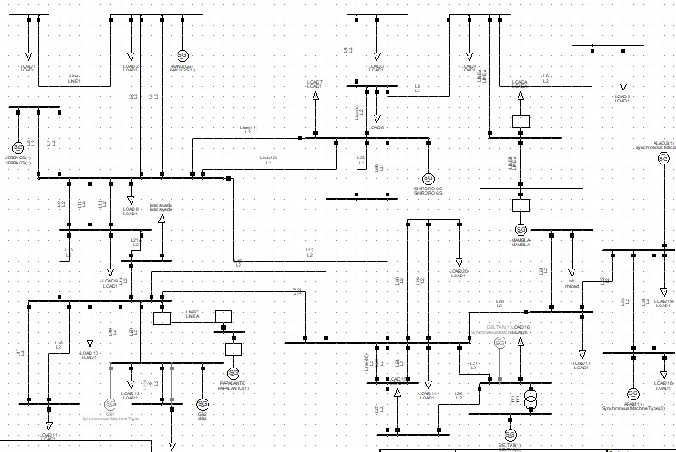

Figure 4: Modelling of Nigerian 28-Bus System

The user interface in this study allows users to load several datasets and, using the Relief-F feature selection algorithm, select pertinent data from the vast amount of data. Data loaded is displayed in Table 2

.

Table 2: Loaded Data Nigerian 28-Bus System
V(p.u) | P(KW) | Q (KVAr | (ϴ) | TSA  Targ | SSA Targ
0.388583 | -271.618 | 0.454232 | -63.3957 | 0 | 1
0.469965 | 563.2468 | -306.641 | 97.48929 | 0 | 1
0.255932 | -209.335 | 151.7141 | -102.012 | 0 | 1
0.533196 | 409.5992 | -385.232 | 58.1159 | 0 | 1
0.147646 | 19.65125 | 190.0627 | -142.138 | 0 | 1
0.540542 | 127.6128 | -338.973 | 17.22918 | 0 | 1
0.220532 | 318.4933 | 72.08323 | 176.2186 | 0 | 1
0.484492 | -151.327 | -180.955 | -25.1795 | 0 | 1
0.370508 | 535.4349 | -148.529 | 133.0507 | 0 | 1
0.366197 | -274.478 | 26.74668 | -69.1091 | 0 | 1
0.489727 | 539.7334 | -341.938 | 88.36538 | 0 | 1
0.209501 | -156.153 | 174.4907 | -114.545 | 0 | 1
0.543035 | 309.6819 | -389.185 | 42.17829 | 0 | 1
0.154649 | 150.4527 | 153.4337 | -161.475 | 0 | 1
0.514599 | -27.5849 | -260.075 | -5.50633 | 0 | 1
0.310105 | 458.6298 | -49.8561 | 150.0938 | 0 | 1
0.403731 | -252.811 | -30.6135 | -54.6958 | 0 | 1
0.465345 | 553.8266 | -304.05 | 100.1514 | 0 | 1
0.233219 | -197.255 | 154.0606 | -105.39 | 0 | 0.135
0.54455 | 350.7548 | -412.666 | 48.70475 | 0 | 0.135
0.261644 | -207.228 | 163.5346 | -100.006 | 1 | 1
0.533944 | 476.4872 | -393.262 | 69.36015 | 1 | 1
0.18805 | -114.21 | 196.6741 | -121.668 | 1 | 1
0.558244 | 357.5287 | -423.106 | 46.91436 | 1 | 1
0.143834 | 28.34095 | 192.7953 | -144.893 | 1 | 1
0.557052 | 193.1078 | -381.217 | 22.91489 | 1 | 1
0.174444 | 207.5377 | 142.6571 | -169.663 | 1 | 1
0.529761 | 5.899559 | -279.595 | -2.62709 | 1 | 1

The loaded data in this study includes 81,802 instances and 6 attributes, with the targets Stable/Unstable and Eigen value. The loaded data is preprocessed and analyzed using Relief-f with DLNN. Relief-F is used to preprocess the loaded data before passing the chosen or pertinent feature to DLNN. The DLNN consists of input layers, hidden layers, and LSTM-based output layers. The ANN Fitting perspective for the data is shown in Figure 5.

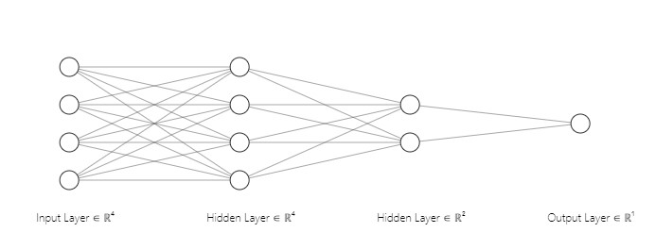

X
1

X
4

Y

X
3

X
2

Figure 5: Fitting Layers of the Data

TSA and SSA results can be either stable or unstable. The TSA is represented as 1 for a stable system and 0 for an unstable system. In contrast, for SSA, if the damping ratio is positive and the real part of the eigenvalue is negative, the system is stable or oscillatory free; but, if the real part of the eigenvalue is positive, the system is unstable. Table 3 shows the deep learning neural network architecture of the TSA and SSA.

Table 3: Deep learning Neural Network Data and Structure of TSA & SSA
Feature and Structure of LSTM | TSA AND SSA
Number of inputs | 4
Number of neurons in the hidden layer | 6
Output | 1 each
Training data | 66560
Testing data | 8256
Validation data | 6273
Training algorithm | LSTM
Epoch | 31
Transfer function Relu and Sigmoid

The model confusion matrix utilized to determine the evaluation performance of the developed model, including accuracy and precision, using the DLN technique is shown in Figure 6. After 10 epochs, the system converges, and the model accuracy for TSA and SSA achieves 90.16 percent and 100 percent, respectively. Tables 4 and 5 display the model evaluation performance of the methodology.

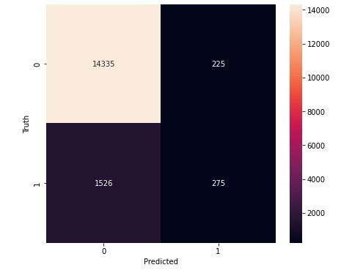
Figure 6: Confusion Matrix for the TSA Developed Model. TP=14335; TN=275; FP=225; FN=1526

Table 4: Evaluation Performance for TSA
Measure | Evaluation (%) | Derivations
Sensitivity | 90.38 | TRP=TP/(TP+FN)
Precision | 98.45 | PPV=TP/(TP+FP)
Accuracy | 90.16 | ACC+(TP+TN)/(P+N)

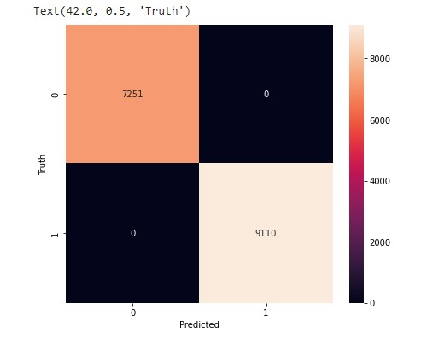

Figure 7: Confusion Matrix for the SSA Developed Model. TP=7251; TN=9110; FP=0; FN=0

Table 5: Evaluation Performance for SSA
Measure | Evaluation (%) | Derivations
Sensitivity | 100 | TPR=TP/(TP+FN)
Precision | 100 | PPV=TP/(TP+FP)
Accuracy | 100 | ACC=(TP+TN)/(P+N)

A. Results compared on IEEE 9 Bus System
This section uses modeling of the IEEE 9 bus system in the DIgSILENT power plant to evaluate the results of the TSA and SSA assessments. It is depicted in Figure 8. DIgSILENT is used to run time-domain simulations and compute eigenvalues for these systems. Along with the oscillation modes, the generator's rotor angle, voltage level, active power, and reactive power at each bus are also given. The simulations are conducted for 10 seconds with a timing difference of 0.3 seconds. Given that neural networks need a lot of data to train, Table 6 shows loaded data for the IEEE 9 bus system that was created and used for training and testing, consisting of 62,500 target values. With the proper target values, recovered samples for the IEEE 9-Bus system contained 43,750 training samples and 18,750 testing samples. This system displays oscillations with eigenvalues appropriate for both inter-area and local modes. The SSA simulation revealed substantial eigenvalue errors. In contrast to the TSA, whose LSTM predictions produced simple evaluation performance estimates, the LSTM forecasts for this system were precise and closely matched the dynamics of the simulated oscillatory modes.

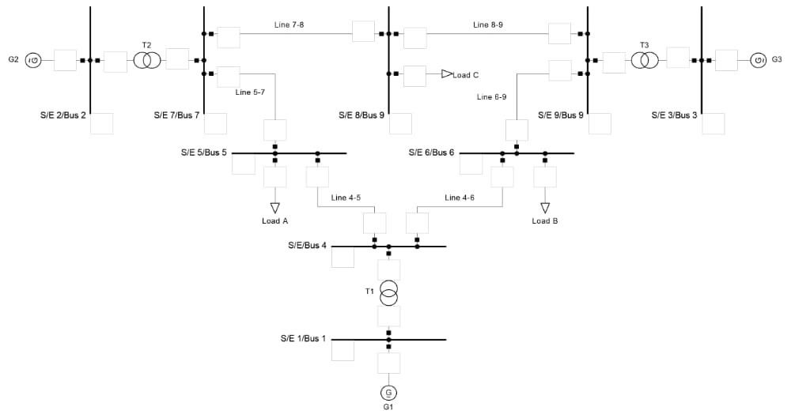

Figure 8: Modelling of IEEE 9 Bus System in DIgSILENT

Table 6: Loaded data for IEEE 9 bus system
V(p.u) | P(KW) | Q (KVAr) | (ϴ) | TSA  Target | SSA  Target
0.17958 | -123.513 | 171.9536 | -121.034 | 0 | 1
0.541271 | 191.1149 | -377.243 | 26.03689 | 0 | 1
0.21862 | 312.9513 | 61.45572 | 172.7484 | 0 | 0
0.437684 | -202.49 | -101.296 | -40.9198 | 0 | 0.982346655
0.441616 | 528.1544 | -257.218 | 105.0707 | 0 | 0.982346655
0.210953 | -162.216 | 160.9706 | -109.329 | 0 | 0.10730671
0.542129 | 238.5471 | -392.568 | 35.91947 | 0 | 0.10730671
0.194307 | 277.8757 | 75.5049 | -179.199 | 0 | 0.085283166
0.459572 | -195.994 | -154.359 | -34.6968 | 0 | 0.085283166
0.428978 | 542.6657 | -250.911 | 109.4685 | 0 | 0
0.228289 | -186.864 | 148.0511 | -106.753 | 0 | 0
0.534469 | 254.3771 | -375.392 | 36.6825 | 0 | 0
0.198982 | 272.5964 | 83.33363 | 179.7563 | 0 | 0
0.441242 | -197.513 | -114.59 | -37.5489 | 0 | 0
0.445292 | 530.6067 | -272.797 | 104.8101 | 0 | 0
0.194562 | -150.778 | 160.4638 | -113.223 | 0 | 0
0.542532 | 191.7196 | -392.29 | 28.39765 | 0 | 0
0.227462 | 338.5404 | 33.06602 | 169.661 | 1 | 0.982346655
0.418274 | -235.976 | -78.9364 | -49.4565 | 1 | 0.982346655
0.468614 | 509.4048 | -308.579 | 91.10054 | 1 | 0.10730671

Figure 9 and Table 7 both display the TSA model confusion matrix, which was constructed using the DLNN technique to assess the evaluation performance of the created model, including accuracy and precision. The TSA's confusion matrix model produces the values TP=2300, TN=5900, FP=4000, and FN=370. The system converges after 82 epochs, and the model accuracy for TSA is 65%.

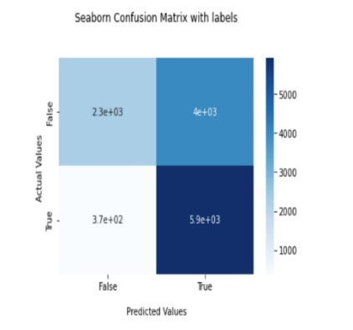

Figure 9: Confusion matrix for the TSA IEEE 9 bus system

Table 7: Evaluation Performance for TSA of IEEE 9 bus system
Measure | Evaluation (%) | Derivations
Sensitivity | 94 | TPR=TP/(TP+FN)
Precious | 86 | PPV=TP/(TP+FP)
Accuracy | 65 | ACC=(TP+TN)/(P+N)

The SSA result is a Regression approach since the goal values contain a large number of floats and a small number of integers. A Mean Squared Error of 0.183 and a Root Mean Squared Error of 0.4277849927 are the results of the system's convergence after 40 epochs. Because the majority of the estimated values fall between -0.5 and 0.5, Figure 10 shows the Residual Distribution Curve, where the prediction is both over and under estimated.
print (‘MSE: ‘ + str(mse) ) print (‘MSE: ‘ + str(rmse) ) print (‘Epochs: ‘ + str(5) )
MSE: 0.183
RMSE: 0.4277849927

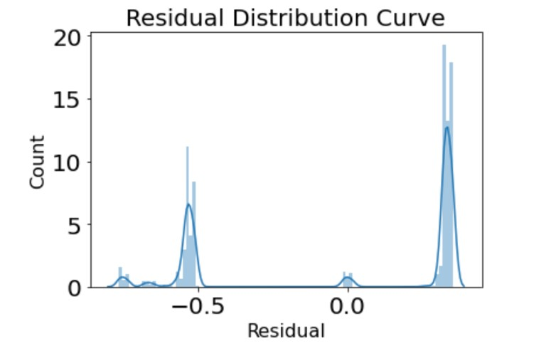

Figure 10: Residual Distribution Curve
Comparing the results of numerous studies on TSA and SSA using various machine learning techniques. Table 8 compares the efficacy of several techniques for forecasting TSA and SSA. After being compared to CNN and LSTM in Table 8, the suggested solution is tested using the IEEE 58, IEEE 60, and New England 39 bus systems to account for TSA and SSA. The main comparative metrics are MSE, RMSE, Accuracy, Sensitivity, and Precision. Due to the application of LSTM to improve accuracy, sensitivity, and precision, the Nigeria 28 bus system has flawless assessment performance for both TSA and SSA. TSA's accuracy was poor since the supplied data had a large number of floats. When employing the IEEE 9 bus system, the evaluation performance's accuracy was 65%. Random hyperparameter tweaking can be used in this situation to increase TSA accuracy, but a longer training period is needed. While in SSA, the MSE can be enhanced by LSTM layer addition and random search hyperparameter tweaking to ensure that it won't overfit the data.

Table 8: Comparison of performance with TSA and SSA methods
Related works on (TSA and  SSA) | Method | Accuracy  (  )  % | Sensitivit  y  (  )  % | Precision  (  )  % | MSE | RMSE
Nigeria 28 Bus  System (proposed work) | LSTM | 90.16  100 | 90.8  100 | 98.45  100 | _ | _
IEEE 9 Bus  System (proposed work) | LSTM | 65 | 94 | 86 | 0.183 | 0.42778
IEEE 50 Bus System[7]. | CNN and  LSTM | 98.31 | _ | _ | 0.00000016 | 0.0004
New England 39 Bus System[7]. | CNN  and  LSTM | 94.5 | _ | _ | 0.00001024 | 0.0032
IEEE 68 Bus System[7]. | CNN and LSTM | 97.22 | _ | _ | 0.00001681 | 0.0041

VI. CONCLUSION
It has become easier to upgrade existing power systems to a new generation that incorporates a significant amount of renewable energy and power electronics. This advancement is made possible by the combination of power electronics technology and renewable energy sources. However, this modification poses challenges to accurately assess the transient and small signal stability of electrical networks. To overcome this obstacle, data-driven Transient Stability Analysis (TSA) employing Small Signal Assessment (SSA) methods has been developed. These methods establish a correlation between the operational parameters of the system and its stability status, eliminating the need for a physical model or parameter information, unlike traditional time domain simulation and energy function methods. The reliable and secure operation of energy networks relies on the stable performance of small signals and transients. To evaluate the small signal stability and transient stability, this research introduces feature-based deep learning methods, specifically Long Short-Term Memory (LSTM) networks. The outcomes of this study provide valuable insights into how LSTM effectively assesses the stability of transient and small signals. This research will prove beneficial to individuals interested in this subject matter, as it offers a deeper understanding of LSTM's role in stability assessment for transient and small signals.

REFERENCES
- BIN, Z., & XUE, Y. (2019). A method to extract instantaneous features of low frequency oscillation based on trajectory section eigenvalues.
Journal of Modern Power Systems and Clean Energy, 7(4), 753–766. https://doi.org/10.1007/s40565-019-0556-z
- Lim Zhu Aun, S., Bte Marsadek, M., & K. Ramasamy, A. (2017). Small Signal Stability Analysis of Grid Connected Photovoltaic. Indonesian Journal of Electrical Engineering and Computer Science, 6(3), 553. https://doi.org/10.11591/ijeecs.v6.i3.pp553-562
- Liu, X., Ding, C., Wang, Z., & Zhou, P. (2011). Direct method to analyze small signal stability of electric power systems. Dianli Zidonghua Shebei/Electric Power Automation Equipment, 31(7), 1–4.
- Nikolaev, N., Dimitrov, K., & Rangelov, Y. (2021). A Comprehensive Review of Small-Signal Stability and Power Oscillation Damping through Photovoltaic Inverters. Energies, 14(21), 7372. https://doi.org/10.3390/en14217372
- Prasertwong, K., Mithulananthan, N., & Thakur, D. (2010). Understanding Low-Frequency Oscillation in Power Systems. The International Journal of Electrical Engineering & Education, 47(3), 248–262. https://doi.org/10.7227/IJEEE.47.3.2
- Sarajcev, P., Kunac, A., Petrovic, G., & Despalatovic, M. (2022). Artificial Intelligence Techniques for Power System Transient Stability Assessment. Energies, 15(2), 507. https://doi.org/10.3390/en15020507
- Syafiq, K. A., Younes,J. I., Mohamed, S. El., Khaled, E. (2020). A Unified Online Deep Learning Prediction Model for Small Signal and Transient Stability. IEE Transactions on Power Systems, 35(6).
- Krištof, V., & Mešter, M. (2017). Loss of excitation of synchronous generator. Journal of Electrical Engineering, 68(1), 54–60. https://doi.org/10.1515/jee- 2017-0007
- Source: National Control Center (NCC), Power Holding Company of Nigerian,2012. Available at: www.nerc.gov.ng
- Mikolov, T., Joulin, A., Chopra, S., Mathieu, M., & Ranzato, M. ’A. (2015). Learning longer memory in recurrent neural networks. 3rd International Conference on Learning Representations, ICLR 2015 - Workshop Track Proceedings.
- Ren, C., Xu, Y., & Zhang, Y. (2018). Post-disturbance Transient stability assessmentof power system towards optimal accuracy-speed tradeoff. Protection and control of Modern Power Systems, 3(1), 19. https://doi.org/10.1186/s41601-018-0091-3

