Introduction to Internet Technology

Dr R Poornima,

Associate Professor, Department of Mathematics, Hindusthan College of Engineering and Technology,

Coimbatore-32
- Introduction
A collection of computers make up the Internet that are located all over the world and are linked to one another by a high-speed network. The primary means of transmitting knowledge and exchanging cultures are now the Internet.

All connected networks and computers exchange information and use various services. The World Wide Web that is WWW is not the Internet, as a result. The World Wide Web is only one of the services that the Internet offers to its users, while being the one that is used the most frequently.

The global network of connected computer networks is known as the Internet. The Web's interconnected hypertext pages and applications, email, phone calls, and file sharing are just a few of the numerous information resources and services available on the Internet.

Web Concepts

The Web was developed to allow remote team members to communicate and exchange ideas on all aspects of a single project since it serves as a storehouse for human culture and information. The Hyper Text Markup Language (HTML), which tells browsers how to display the data, is used to write a large range of files and documents that are stored on these machines. The machines that hold the data are referred to as servers since they can manage requests from several users at once. To access these HTML files and documents, users must utilise applications known as browsers. The key ideas on the web are:
Web Page
A Web page is an online informational area where details on a certain person, company, organisation, or cause are presented.
• Web pages (docs) are files that make up the Web.
• It contains links to online resources, including text, photos, audio files, videos,
and other types of data.

Web Site
A website is a collection of internet pages that are frequently linked to one another using various technologies. formally known as a "web site" or just a "site." The website often offers information on a certain person, business, group, or cause.
The two primary types of website styles are static and dynamic websites:
A dynamic website is one that doesn't save its web pages on the server in precisely the same way that users will see them, whereas a static website stores its web pages on the server exactly as the user will see them. Instead, the frequency and/or automaticity of the web page content changes are decided using a set of parameters. A dynamic website could signify one of two things. The first is that the coding for web pages is generated randomly. The second is that various web page content is shown based on particular factors. The standards may be pre-established criteria or they may be subject to change based on input from users.
Web Terms
Uniform Resource Locator (URL)

The entire address of a World Wide Web page consists of three pieces that indicate where the web page is located on the Internet. As shown in the example below, these elements are the protocol, site name, and absolute path to the file or resource.
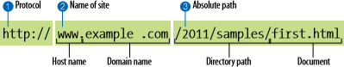

The name of the protocol, such as HTTP; http:// The initial thing that the Uniform Resource Locator (URL) does is determine the protocol that will be used for that particular transaction. The letters HTTP tell the server to switch to "web mode," or to make use of the Hypertext Transfer Protocol.
The hostname or domain name of the server, such as www.google.com, to which a user wants to connect. www.example.com
The next portion of the URL reveals the domain name of the website. In this example, the website address is example.com. The "www." prefix at the beginning denotes the specific host name at that domain. Examples are development.example.com, clients.example.com, and so on. Access to a file or directory on the main webpage is indicated by the file name, which is optional./2012/samples/first.html this is the server's absolute path to the first.html HTML file that was requested. The directory names are words separated by slashes, starting with the root directory of the host.
Example: http://www.ecampus.org/faculty/dashboard.html.

    - Here the Protocol is “ http”.

    - The name of the Host computer is ” www”.

    - The domain name of the Second-level is” ecampus”.

    - The domain name of the Top-level is “org”.

    - The name of the Directory is “ faculty”.

    - The name of the File is “ dashboard.html”.

Different Top-level domains are typical.

Web hosting

A website must be kept in a location where users can access it constantly once it has been created. For this, we make use of web hosting services and businesses. They are the owners of content-storage web servers.

Search engine
Search engines enable us to look up data, photos, and other sorts of items on the Internet that are spread across a number of different locations. Search engines operate in accordance with specific algorithms that present the user with pertinent search results. In order to organise and save the data in the database for later use, the data from the many websites is initially collected, stored, and then analysed. The information in the database is processed when a user enters a query into the search engine, and the user is then shown the results that most closely match the search terms they entered. It is important to understand that using a search engine only searches the database of the search engine, not the whole web. As a result, every time we utilise a different web engine, we can get a different set of results.4. Internet protocols

- TCP/IP protocol: TCP/IP is the main protocol used for Internet communication. In order to communicate with one another through a network, it specifies the rules that computers must follow.
- A network protocol known as HTTP enables the exchange of almost any sort of resource on the internet. Documents, web pages, images, search results, and other materials are resources. It is essentially the language that web browsers use to speak to servers. There is also an encrypted and secure version of HTTP for communications.
- FTP (File Transfer Protocol): This protocol is used to move files between online computers or between clients and servers. In other words, Internet file transfers are handled by this protocol.
- The Internet and other related services, such as e-mail, are made available to people and other businesses by a corporation called an Internet Service Provider (ISP).

Client-Server Design in Web Development
- Client-Server Interface
Client/server interface is used by computers on the Internet. This indicates that the user's local client system receives files and services from the faraway server computer.

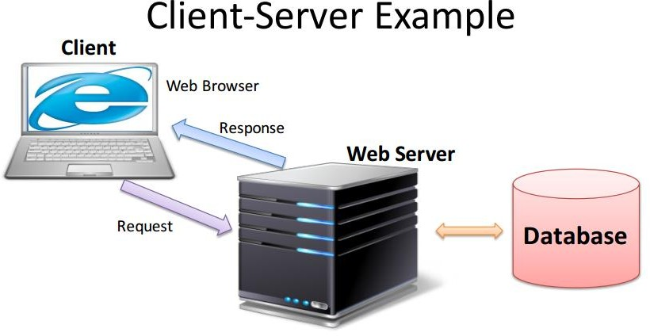

Web Server

A machine designed to run specialised serving software is called a web server. When a client, typically a Web browser, requests them, that software "serves" the HTML pages the client requests along with any files that go with themA user may be able to save the data directly onto the Web Server computer (if authorised) if they are on the same network as the Web Server. To prevent unauthorised users from accessing the computer and changing the data, it is secured.

Server-side:

- ASP.NET, the following generation of ASP,
- JSP (Java Server Pages),
- ASP (Active Server Pages),
- PHP
- Python

Client

The client or user side of the Web refers to the Web browser running on a user's computer. It might also relate to browser extensions and support packages that enhance browser capabilities to enable particular website services. The phrase can either refer to the entire user machine or a mobile device with Web connectivity.

Client-side:

• JavaScript / VBScript (client-side scripting)
• CSS (Cascading Style Sheets)
• HTML / XHTML (Extensible Hyper Text Markup Language)

Web Browsers

An application or program known as a web browser is used to locate, display, and access information sources on the World Wide Web. Any type of information resource, including web pages, photos, videos, and other media, can be identified using a URI, or Uniform Resource Identifier.
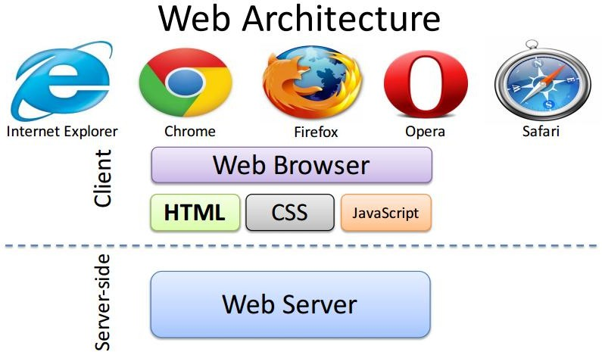

Online Services

Employing client-server technology, the Web is managed. The steps for using the internet are as follows:
1. The user enters the web page's address (for instance, http://www.tutorialspoint.com) into the browser's address bar.
2. The browser then requests the IP address for www.tutorialspoint.com from the Domain Name Server.
3. After obtaining the IP address, the browser transmits the request for a web page to the web server using the HTTP protocol, which describes how the browser and web server communicate.
4. After receiving the HTTP protocol request, the web server checks its search for the requested web page. If so, it closes the HTTP connection and delivers the data back to the browser.
5. Following that, the website has been received, interpreted, and shown in the browser window, it is displayed by the web browser.
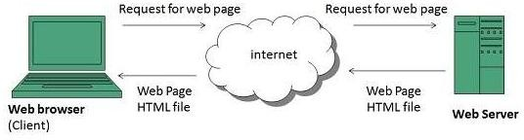
3. Website Organisation

Every Web page was built with a pre-existing organisation that it must preserve; this framework is referred to as the site structure. A site is a collection of documents, photos, and HTML files that are all housed in a single root folder. Using subfolders that make sense to you and other department members who might need to change the material, you can structure your papers in this root folder.As a result, the following elements are advised for the website's structure:
1. A directory that serves as the website's root.
2. The default home page of the website, which may be found inside the root folder and is called
index.htm (or index.html).
3.The pictures directory, which is where the images, graphics, and other media used in internet
pages are kept.
4. Further folders for content organisation.

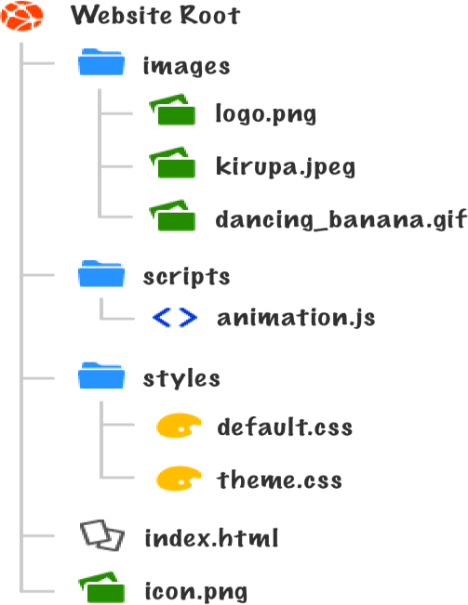

Hyperlinks

Links Hyperlinks are the primary means of navigating between webpages and websites. Links can point viewers in the direction of other web pages, websites, photos, documents, audio files, email addresses, and other parts of the same web page. Text that is a hyperlink is often underlined and a distinct colour. There are four main types of links.

• Text hyperlinks point visitors to various files, websites, or documents by using certain words or phrases.

• Image hyperlink - Users can access another page, file, or document with this form of link by following an image.

• Bookmark hyperlink - Uses text or an image to direct users to another portion of a website.

Users can send emails to the displayed email address using the email hyperlink feature.

How Web pages are Displayed in Browsers

When a Web page is opened, a browser first reads and examines the HTML file before putting the Web page in display-ready condition. A browser window loads the requested file for display when a reference to an external file, such as an image or multimedia file, is found. The server then downloads the file. HTML files are text files that merely include references to the outside resources; you do not "embed" these files within the Web page.

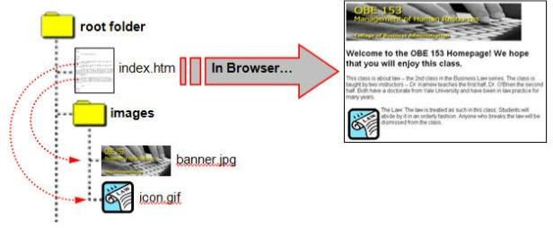
4. Categories of Websites
Websites can be of many various types, each of which caters to a particular usage or type of information. So, below are a few examples that are representative but not exhaustive:
1) Blog (Web Log): Website that primarily hosts online journals and occasionally has forums.
2) Social networking site: a location where users could communicate and exchange media, such as
photos, videos, music, and blogs. Games and apps on the web might be included.
3) Wiki websites, such as Wikipedia and Wikihow, let users collaborate on content editing.
4) Web portal: a starting point or entrance to other Internet resources.
5) Search engine sites, which provide general information, are where sites like Google, Yahoo, and
Bing are meant to be reached.
6) Teachers, students, or administrators may submit information about current events at or
concerning their school on an educational website.

5.Website Design Issues

The design of a website involves several considerations that one should bear in mind. Following are some factors that make a website user-friendly and simple to access for visitors:
1) Information Availability - The website ought to have all the data necessary for a visitor to decide on their course of action. 80–90% of what a user or visitor is seeking for should generally be available on a good website, according to the common standard.
2) Page design: How information is displayed on the page -- If the page is laid out properly, people should have no trouble finding the necessary information.Otherwise, people become bored and quit the website. To improve the page's usability, it should be straightforward.
3)Conventional colours ought to be used since they have an impact on how usable a website is. For instance, to prevent visitor confusion, it is advisable to adhere with the standard link colours of blue for links, violet for visited links, and red for active links.
4)Web usability: The ability of all users, including those with disabilities (such as those limiting their ability to see, hear, move, or speak), to interact with or contribute to the Web is referred to as web accessibility. With the availability of more and more accessible Web sites and applications, people with disabilities should be better able to use and contribute to the Web.
5)A user-friendly website should be developed based on the needs of the target audience.
6)Download Speed: A web designer cannot predict the download speed. Making smaller pages, avoiding nested tables, and optimising the graphics (pictures no more than 10 kb) are a few things to think about.
References
- Amogh Dhamdhere. "Internet Traffic Characterization". Retrieved 6 May 2022.
- Jump up to:ª ^{b} "A Flaw in the Design". The Washington Post. 30 May 2015. Archived from the original on 8 November 2020. Retrieved 20 February 2020. The Internet was born of a big idea: Messages could be chopped into chunks, sent through a network in a series of transmissions, then reassembled by destination computers quickly and efficiently. Historians credit seminal insights to Welsh scientist Donald W. Davies and American engineer Paul Baran. ... The most important institutional force ... was the Pentagon's Advanced Research Projects Agency (ARPA) ... as ARPA began work on a groundbreaking computer network, the agency recruited scientists affiliated with the nation's top universities.
- Stewart, Bill (January 2000). "Internet History – One Page Summary". The Living Internet. Archived from the original on 2 July 2014.
- Wright, Edmund, ed. (2006). The Desk Encyclopedia of World History. New York: Oxford University Press. p. 312. ISBN 978-0-7394-7809-7.
- The ARPANET community grows" in 40 maps that explain the internet Archived 6 March 2017 at the Wayback Machine, Timothy B. Lee, Vox Conversations, 2 June 2014. Retrieved 27 June 2014.
- Strickland, Jonathan (3 March 2008). "How Stuff Works: Who owns the Internet?". Archived from the original on 19 June 2014. Retrieved 27 June 2014.
- Hoffman, P.; Harris, S. (September 2006). The Tao of IETF: A Novice's Guide to Internet Engineering Task Force. IETF. doi:10.17487/RFC4677. RFC 4677.
- "New Seven Wonders panel". USA Today. 27 October 2006. Archived from the original on 15 July 2010. Retrieved 31 July 2010.
- "Internetted". Oxford English Dictionary (Online ed.). Oxford University Press. (Subscription or participating institution membership required.) nineteenth-century use as an adjective.
- "United States Army Field Manual FM 24-6 Radio Operator's Manual Army Ground Forces June 1945". United States War Department.
- Jump up to:ª ^{b} Cerf, Vint; Dalal, Yogen; Sunshine, Carl (December 1974). Specification of Internet Transmission Control Protocol. IETF. doi:10.17487/RFC0675. RFC 675.
- Jump up to:ª ^{b} ^{c} ^{d} Corbett, Philip B. (1 June 2016). "It's Official: The 'Internet' Is Over". The New York Times. ISSN 0362-4331. Archived from the original on 14 October 2020. Retrieved 29 August 2020.
- Jump up to Herring, Susan C. (19 October 2015). "Should You Be Capitalizing the Word 'Internet'?". Wired. ISSN 1059-1028. Archived from the original on 31 October 2020. Retrieved 29 August 2020.
- Coren, Michael J. (2 June 2016). "One of the internet's inventors thinks it should still be capitalized". Quartz. Archived from the original on 27 September 2020. Retrieved 8 September 2020.
- "World Wide Web Timeline". Pews Research Center. 11 March 2014. Archived from the original on 29 July 2015. Retrieved 1 August 2015.

