Utility of Solar energy in Sustainable Development

Harlal Singh, Preeti Sharma*and Sarita Khaturia
Department of Chemistry, School of Liberal Arts and Sciences, Mody University of Science and Technology, Lakshmangarh, Sikar 332311, Rajasthan, India.

Table of contents:

1. Abstract
2. Introduction
3. Solar energy's contribution to sustainable development
4. Application of solar energy
5. Conclusions

1. Abstract
One of the most important renewable and green energy sources, solar energy is a technology that is kind to the environment, a reliable source of electricity. It contributes significantly to finding energy solutions for sustainable development. As a result, the enormous amount of solar energy that may be produced each day makes it a particularly appealing resource for producing power. To meet our energy needs, both technologies—solar photo-voltaic and applications of concentrated solar power—are constantly being improved. Therefore, in the same context, a high installed capacity of solar energy applications promotes the energy sector and meets the employment market to acquire enough development. This essay highlights the employment possibilities of renewable energy and discusses how solar energy applications contribute to sustainable development. As a result, it offers perspectives and analysis on the sustainability of solar energy, including environmental and economic development. Additionally, it has been noted how solar energy applications contribute to sustainable development by meeting energy needs, generating employment possibilities, and improving environmental protection. Last but not least, a view of future progress in this field is provided by the implementation of solar energy technology in the energy industry.
Keywords: Sustainable development, green energy sources, environmentally friendly, solar energy

2. Introduction
Energy is a necessity for the survival and development of human communities. Consequently, as human civilization has developed, the demand for energy has gradually grown. Energy demands have also increased over the past few decades as a result of the world's population's fast growth and its reliance on technology advancements. Additionally, green technology sources are crucial for delivering energy supplies in a sustainable manner, particularly for reducing climate change [1-3]. Demand for cleaner energy sources has increased over the last few decades. Based on it, decision-makers from all nations have developed long-term strategies that rely on renewable energy sources. Because of this, such programs lessen reliance on conventional energy sources and replace them with alternative energy technology. As a result, the global world is beginning to rely less on conventional fossil fuels as a source of energy and move toward using sustainable energy sources [4, 5].
Interestingly, renewable energy should play a crucial part in the future of global energy. At the moment, fossil fuels are still the predominant source of large-scale energy and will stay so for the next few decades. More sustainable energy sources are being included into the global energy system [6, 7].Solar energy is produced by absorbing the Sun's heat and light. Solar energy is the name for energy that comes from the Sun. There are many methods to make use of this plentiful resource thanks to technology. Because it doesn't release greenhouse emissions, it is regarded as a green technology. Solar energy is widely accessible and has been used for a long time as a source of heat and electricity.Solar power, solar radiation with the potential to generate heat, energy, or chemical reactions. Solar radiation is captured and transferred as heat to a carrier fluid using solar collectors, such as those used for solar water heating. After then, it can be heated. Through the photovoltaic effect, solar cells convert solar energy directly into electricity. Solar energy is limitless and non-polluting, but the process of turning light into power is inherently inefficient. Solar energy is anticipated to gain popularity as a sustainable energy source and a valuable weapon in the fight against anthropogenic global warming in the twenty-first century.The benefits of solar energy technology are therefore, based on the information provided above, a renewable and clean energy source that is abundant, less expenses, fewer maintenance, and environmental friendliness, to name a few. It is crucial for academics, engineers, and customers alike that solar energy applications are highlighted in this study in order to ensure sustainable development. Our main goal is to increase public knowledge of solar energy usage in daily life and to spread this culture because it is the greatest option going forward.

Figure 1: Solar energy and economic development

Solar energy capture: Flat-plate collectors are the most popular tools used to capture solar energy and transform it into thermal energy [8, 9].Solar ponds, saltwater bodies intended to capture and store solar energy, are another source of thermal energy conversion. Solar energy can also be used to cook food in specially constructed solar ovens, which typically focus sunlight from a vast area to a central point. Solar energy can also be transformed directly into electricity via photovoltaic or solar cells.

Solar Energy Types
Depending on how it is transformed and the sort of energy it produces, solar energy can be divided into two types. The conversion processes for solar thermal energy, photovoltaic solar power, and concentrating solar power include passive and active solar energy.
The term "passive solar energy" describes the process of storing solar energy without the use of any machinery.
Mechanical devices are used by active solar energy to gather, store, and distribute energy.
Solar energy is transformed into heat to produce solar thermal energy.
The energy produced by transforming solar energy into electricity is known as photovoltaic solar power.
Solar electricity is produced by concentrating solar energy, a type of thermal energy.

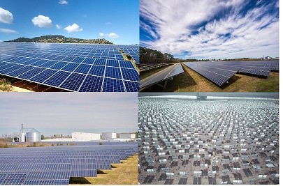
Figure 2: Solar Energy Types

Sustainable Solar Power
Sustainable development, in the words of the UN, is "development that meets the needs of the present without compromising the ability of future generations to meet their own needs." Because solar energy may be used continuously without affecting its supply in the future, it embodies this generally accepted concept of sustainability [10, 11]. The sun is the most significant source of renewable energy, according to the majority of specialists.
Solar Energy Uses [12-17]
- Water heating: Solar energy replaces gas and electric heaters since it is 15–30% more efficient.
- Swimming pool heating: To keep the pool heated, solar blankets are utilized. The water can also be kept heated by utilizing a solar water heater.
- Solar cookers are used to prepare food for consumption. Food is heated, cooked, and pasteurized using solar energy. A solar cooker has a raised heat sink so that food cooks properly when placed inside.
- Renewable: Contrary to non-renewable energy sources like fossil fuels, which have a limited supply, solar energy is seen as a renewable resource. Even if the Earth's population continues to increase and its energy consumption increases, there will still be more than enough solar power to meet all of the planet's energy needs, making it a crucial part of the fight against climate change.
- Non-Polluting: Solar energy also reflects sustainability ideals because it does not contribute to pollution like fossil fuels do when they are used. Solar panels produce only clean electrical energy as they idlely sit on rooftops or in vast solar arrays, emitting no waste materials, noise, or any other outputs.
Benefits of solar energy [18-20]
- Clean: Since it doesn't emit carbon dioxide like fossil fuels do, which is one of the factors contributing to global warming; it is regarded as the cleanest kind of energy.
- Renewable: As long as the sun is present, there will be plenty of energy on earth.
- Reliable: There is no unreliability because the energy can be stored in the batteries.
- Cost savings on utilities.
- Free energy because it is easily captured.
Solar energy's drawbacks:
- Production is lower in the winter and on overcast days.
- Both the original cost of the components and the installation are pricey.
- More space is being consumed.

3. Solar energy's contribution to sustainable development
The definition of sustainable energy development is the growth of the energy sector in terms of energy production, distribution, and use that is based on sustainability principles [21]. Environmental effects from energy systems will be felt in both industrialized and emerging nations. In order to maximize efficiency and lower emissions, the global sustainable energy system must be developed [22].The economic viewpoint serves as the foundation for the sustainable development scenario. Additionally, it looks at the actions that must be taken to achieve common long-term climate benefit, clean air, and energy access goals. The IEA's sustainable recovery plan, which aims to foster economies and employment by creating a cleaner and more dependable energy infrastructure, is the foundation for the short-term details [23]. Utilizing renewable energy applications, smart grid technology, energy security, energy pricing, and having a strong energy policy are other aspects of sustainable development
4. Application of solar energy
1. Sun-powered water heating
Traditional water heaters are increasingly being replaced by environmentally friendly solar water heaters. Direct circulation systems and indirect circulation systems are both active water systems in solar water heating. A chapter alternative for solar water heating's passive water systems uses thermo siphon and integral collector-storage systems.Additionally, hotels, hospitals, guest houses, and other buildings frequently use solar water heaters.
2. Building Solar Heating
Whether or not a huge building needs heat in its interior spaces will determine whether or not it has to be space heated. Solar heating must be provided via fans, ducts, radiators, or some other means for buildings that have heat.Use an exterior, insulated water tank as the heat source for structures that don't require heating.
3. Solar-distillation
Saline water must be exposed to enough sunshine for the solar-distillation process to produce distilled water. When solar radiation is converted to heat, it produces purified water that can be used as a cooling agent.In other electrical sources, distilled water is typically expensive, but solar distillation lowers the cost of this kind of electrical energy.
4.Solar-pumping
Water is used in solar pumping to boost irrigation and power. The harvest and warmer months, when crops need more water, are when this solar energy use is most effective.
5. Using Solar Energy for Agriculture
Improved airflow and fruit quality, protection from strong sunshine and reduced moisture are all benefits of using solar energy to dry agricultural and animal products.
6. Solar heaters
Extremely high temperatures are required for solar furnace operation. This technology uses revolving, tilted mirrors to produce a lot of heat from solar light.
7. Solar-powered cooking
Solar cooking is becoming more essential as the energy market continues to be vulnerable to supply-side threats. Coal, kerosene, and cooking gas are unfortunately fairly scarce. Through an airtight box, the flat plate solar cooker prevents convectional heat loss.Solar cooking has the advantage of low maintenance expenses, but it cannot be used to cook food in erratic weather or at night.
8. Solar-powered electricity production
Direct sunlight is used to produce power through photovoltaic (PV) cells. Solar electric power generation has a number of advantages over conventional power sources, including dependability, low maintenance requirements, durability, and environmental friendliness.The most advantageous uses of solar electric power generation include public transit, business grid power systems, and irrigation.

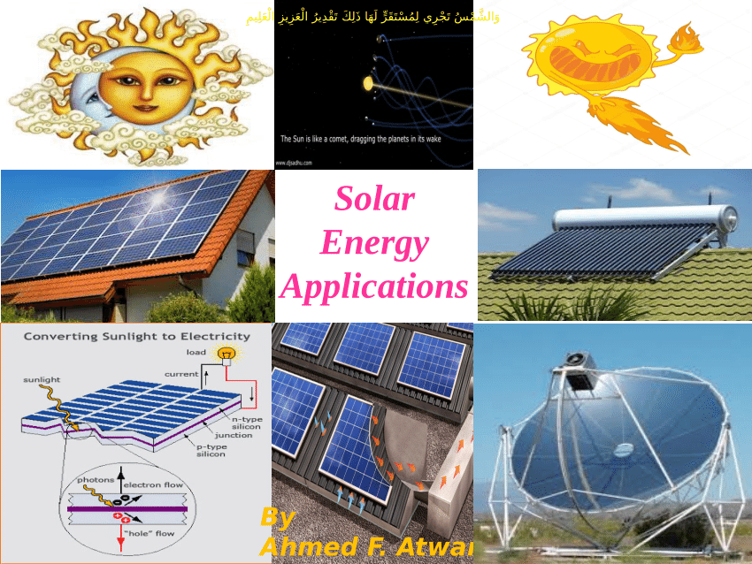

Figure 3: Solar energy applications

9. Thermal Solar Power Generation
A technique for converting sun energy into electricity is called solar thermal power generation. By heating fluids through a turbine and creating steam, it stores thermal energy in order to produce electricity. The most prevalent bodies of water that store thermal energy from solar radiation are ponds. Solar ponds use simmering liquids to produce power while providing excellent industrial and area heating.
10. Solar Greenhouses
Solar greenhouses bring in CO₂ positive air to protect plants from hazardous outside factors. The greenhouse's roof is made of glass or plastic, which helps to regulate the temperature inside and give plants the perfect conditions for growth all year round.
11. Solar-powered outdoor lighting
Additionally, solar lighting systems are capable of producing enough electricity for outside landscapes. Each solar outdoor lighting system includes a rechargeable battery so that it may work all night long.
12. Solar Applications ingenuity
There are many inventive solar applications to take into consideration applying in daily life, in addition to the conventional solar energy applications we stated. We are beginning to see how these enhanced materials may benefit our lives as more solar advancements enter the market.
13. Solar textiles
Various textiles and electronics now have flexible solar panels for extra warmth, which is an intriguing fashion advancement. Solar textiles can be sewed into heavy winter coats, scarves, and sweaters. Portable gadgets are also powered by solar textiles.
14. Sun Skins
Customizable patterns known as solar skins conceal solar panel systems. Solar skins can display an advertisement or any other bespoke picture of your choice onto the solar panels, giving them a different appearance from conventional solar panels on your roof.
15. Sun Roads
Solar-powered roadways can be used for a variety of purposes because they produce clean energy for a wider market. Solar highways run at night and lessen hazardous aspects in erratic weather, such as snow and ice on the road. Solar-powered highways are already being investigated by numerous transportation businesses as a potential energy source for our requirements.
16. Solar Farms on the Water
Floating solar farms, also known as floatovoltaics, are used to produce energy efficiently on a vast scale. By obstructing direct sunlight and lessening frequent air circulation, this invention decreases water evaporation. By producing more power and cooling the water, additional floating solar farms could help reduce the cost of water treatment.
17. Sun Storage
The invention we require to store electricity on a broader power grid may be solar storage. Systems that use molten salt storage technology are a very creative way to generate heat from molten salt.
18. Noise-reducing solar barriers (PVNB)
Inconvenient traffic noise from crowded areas is reduced using PV solar noise barriers. PV solar noise barriers are already being built in several locations since they are affordable and sustainable.
19. The Sun at Night
Due to their need on direct sunshine, solar panels cannot function at night. However, work is currently being done on a new solar panel.An enormous advance for the energy sector, this nighttime solar panel stores energy during the day using infrared light and runs a massive power grid at night.
20. Lightweight Solar Power
Portable solar PV chargers are convenient, eco-friendly, and can quickly recharge a variety of electrical gadgets.

5. Conclusions
The importance of developing sustainable energy sources is highlighted in this chapter. Solar energy would provide various social, environmental, and economic benefits while helping to stabilize energy prices. The fact that solar energy helps to achieve sustainable development by supplying energy needs, generating jobs, and preserving the environment is evidence of this. Therefore, it is important to look into a crucial aspect of long-term sustainability.

References
- Rabaia, M. K. H., Abdelkareem, M. A., Sayed, E. T., Elsaid, K., Chae, K. J., Wilberforce, T., & Olabi, A. G. (2021). Environmental impacts of solar energy systems: A review. Science of The Total Environment, 754, 141989.
- Hernandez, R. R., Easter, S. B., Murphy-Mariscal, M. L., Maestre, F. T., Tavassoli, M., Allen, E. B., ... & Allen, M. F. (2014). Environmental impacts of utility-scale solar energy. Renewable and sustainable energy reviews, 29, 766-779.
- Al-Shetwi, A. Q. (2022). Sustainable development of renewable energy integrated power sector: Trends, environmental impacts, and recent challenges. Science of The Total Environment, 822, 153645.
- Lamnatou, C., & Chemisana, D. (2022). Solar thermal systems for sustainable buildings and climate change mitigation: Recycling, storage and avoided environmental impacts based on different electricity mixes. Solar Energy, 231, 209-227.
- Lucchi, E., Lopez, C. P., & Franco, G. (2020). A conceptual framework on the integration of solar energy systems in heritage sites and buildings. In IOP Conference Series: Materials Science and Engineering (Vol. 949, No. 1, p. 012113). IOP Publishing.
- Tsalikis, G., & Martinopoulos, G. (2015). Solar energy systems potential for nearly net zero energy residential buildings. Solar Energy, 115, 743-756.
- Herrando, M., Elduque, D., Javierre, C., & Fueyo, N. (2022). Life Cycle Assessment of solar energy systems for the provision of heating, cooling and electricity in buildings: A comparative analysis. Energy Conversion and Management, 257, 115402.
- Kelly, N. A., & Gibson, T. L. (2011). Increasing the solar photovoltaic energy capture on sunny and cloudy days. Solar Energy, 85(1), 111-125.
- Zheng, Z., Shi, T., Liu, H., Wu, D., & Wang, X. (2022). Polyimide/phosphorene hybrid aerogel-based composite phase change materials for high-efficient solar energy capture and photothermal conversion. Applied Thermal Engineering, 207, 118173.
- Khan, J., & Arsalan, M. H. (2016). Solar power technologies for sustainable electricity generation–A review. Renewable and Sustainable Energy Reviews, 55, 414-425.
- Ali, S., Yan, Q., Sajjad Hussain, M., Irfan, M., Ahmad, M., Razzaq, A., ... & Işık, C. (2021). Evaluating green technology strategies for the sustainable development of solar power projects: evidence from Pakistan. Sustainability, 13(23), 12997.
- Mekhilef, S., Saidur, R., & Safari, A. (2011). A review on solar energy use in industries. Renewable and sustainable energy reviews, 15(4), 1777-1790.
- Jamar, A. M. Z. A. A., Majid, Z. A. A., Azmi, W. H., Norhafana, M., & Razak, A. A. (2016). A review of water heating system for solar energy applications. International Communications in Heat and Mass Transfer, 76, 178-187.
- Williams, J. R. (1974). Solar energy: technology and applications. NASA STI/Recon Technical Report A, 75, 12425.
- Mahian, O., Kianifar, A., Kalogirou, S. A., Pop, I., & Wongwises, S. (2013). A review of the applications of nanofluids in solar energy. International Journal of Heat and Mass Transfer, 57(2), 582-594.
- Blaga, A. (1978). Use of plastics in solar energy applications. Solar Energy, 21(4), 331-338.
- Blanco, J., Malato, S., Fernández-Ibañez, P., Alarcón, D., Gernjak, W., & Maldonado, M. I. (2009). Review of feasible solar energy applications to water processes. Renewable and Sustainable Energy Reviews, 13(6-7), 1437-1445.
- Kalogirou, S. A. (2004). Environmental benefits of domestic solar energy systems. Energy conversion and management, 45(18-19), 3075-3092
- Chinnammai, S. (2014). A study on energy crisis and social benefit of solar energy. International Journal of Environmental Science and Development, 5(4), 404.
- Devabhaktuni, V., Alam, M., Depuru, S. S. S. R., Green II, R. C., Nims, D., & Near, C. (2013). Solar energy: Trends and enabling technologies. Renewable and Sustainable Energy Reviews, 19, 555-564.
- Maka, A. O., & Alabid, J. M. (2022). Solar energy technology and its roles in sustainable development. Clean Energy, 6(3), 476-483.
- Salvarli, M. S., & Salvarli, H. (2020). For sustainable development: Future trends in renewable energy and enabling technologies. In Renewable energy-resources, challenges and applications. IntechOpen.
- Cozzi, L., Gould, T., Bouckart, S., Crow, D., Kim, T. Y., McGlade, C., ... & Wetzel, D. (2020). World energy outlook 2020. International Energy Agency: Paris, France, 1-461.

