Cyclodextrins and Inclusion Complexes: Formation, Methods, and Diverse Applications

Dolly Baghel and Dr. Manoj Kumar Banjare*
MATS School of Sciences, MATS University, Pagariya Complex, Pandari, Raipur (C.G.), 492001, India.
Email: dolly54us@gmail.com drmanojkb@matsuniversity.ac.in

Abstract

The investigation and application of inclusion complexes represent a crucial and captivating field of study. Cyclodextrins, known for their exceptional capabilities, form inclusion complexes with a diverse array of guest molecules, encompassing solids, liquids, and even gaseous compounds. This paper aims to provide a comprehensive overview of the methodologies employed in creating inclusion complexes, encompassing the co-precipitate method, slurry complexation, paste complexation, moist mixing and heating, and extrusion techniques. Furthermore, this research delves into different advanced techniques utilized for the confirmation of inclusion complexes, such as ultraviolet (UV) spectroscopy, phase solubility, and differential scanning calorimetry (DSC). Additionally, this paper illuminates the far-reaching applications of inclusion complexes across multiple domains. Their significance extends to medicinal biodistribution, the enhancement of food and fragrances, formulation of beauty products, and advancements in the agricultural and chemical industries. The versatility of inclusion complexes, facilitated by cyclodextrins, opens new doors to innovation and possibilities in various scientific and practical realms.

Keywords: Cyclodextrin, Inclusion complex, Formation of IC’s, IC’s Confirmation methods, IC’s Applications.

Introduction
Ionic liquids represent a distinctive class of liquids composed entirely of ions, which are charged atoms or molecules. Typically, they consist of large, asymmetrical organic cations and small inorganic or organic anions (1-4). In contrast to conventional molecular liquids, ionic liquids boast remarkable traits such as high thermal stability, low volatility, and non-flammability. Among their defining attributes is the notably low melting point, rendering them liquid at or near room temperature, even as low as -100°C. This sets them apart from most ionic compounds, which tend to be solid at room temperature. (5-8)
The applications of ionic liquids span a broad spectrum, ranging from their use as solvents(9), electrolytes(10), and reaction media in chemical synthesis to their potential as eco-friendly(11) alternatives to traditional organic solvents, known for their volatility and hazards. Furthermore, ongoing investigations explore their suitability in energy storage and conversion, as well as their diverse roles in pharmaceuticals (12-16), electrochemistry, and catalysis. The versatility and unique properties of ionic liquids present promising opportunities for ground breaking advancements in various domains. (17)

Amidst the numerous advantages that ionic liquids offer, their widespread use has been hindered by the high cost of production and limited availability (18-21). Nevertheless, the scientific community continues to actively explore novel synthesis and purification methods, paving the way for a promising future where ionic liquids are expected to assume an increasingly pivotal role across diverse industries.
Ionic liquids exhibit remarkable diversity, allowing them to be classified based on the structure of their cation, anion, or overall properties (22-27). Below are several distinctive examples:
- Imidazolium-based ionic liquids: Among the most extensively researched and utilized variants, imidazolium-based ionic liquids feature an imidazolium cation and can be combined with various anions, broadening their applicability.
- Pyridinium-based ionic liquids: These closely resemble imidazolium-based ionic liquids with a pyridinium cation, offering versatile functionalities in various applications.
- Phosphonium-based ionic liquids: With a phosphonium cation, these variants find widespread use in separations, catalysis, and energy storage applications, contributing significantly to these fields.
- Ammonium-based ionic liquids: Featuring an ammonium cation, these ionic liquids prove invaluable in gas separation and electrochemistry, supporting advancements in these domains.
- Choline-based ionic liquids: Utilizing a choline cation, these ionic liquids find applications in biocatalysis and bioprocessing, presenting a greener approach to various processes.
- Anion-based ionic liquids: Some ionic liquids are distinguished based on their anion rather than their cation. For example, chloride-based ionic liquids excel in electrochemistry and CO2 capture applications, highlighting their relevance in addressing environmental challenges.
- Task-specific ionic liquids: Tailored for specific applications, task-specific ionic liquids are engineered to possess desired properties, such as high conductivity or low viscosity, making them exceptionally suited to their designated tasks.
Through continual research and innovation, the future of ionic liquids is set to transcend the limitations of the present, unlocking their full potential to revolutionize industries and fuel scientific advancements in countless domains.

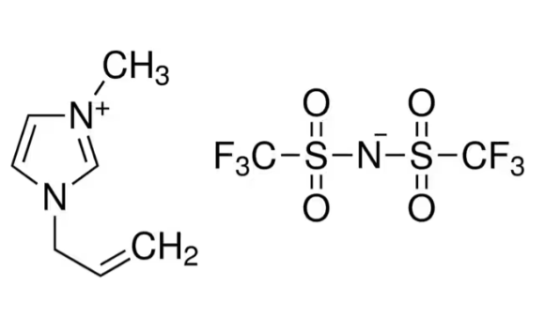

1-Allyl-3-methylimidazolium bis(trifluoromethylsulfonyl)imide

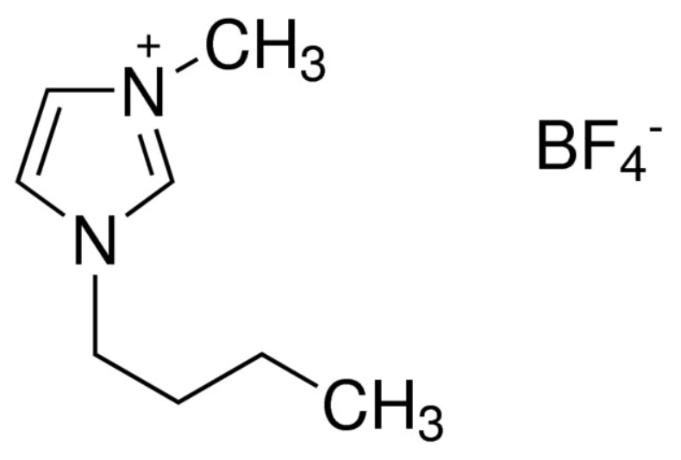

1-Butyl-3-methylimidazolium tetrafluoroborate
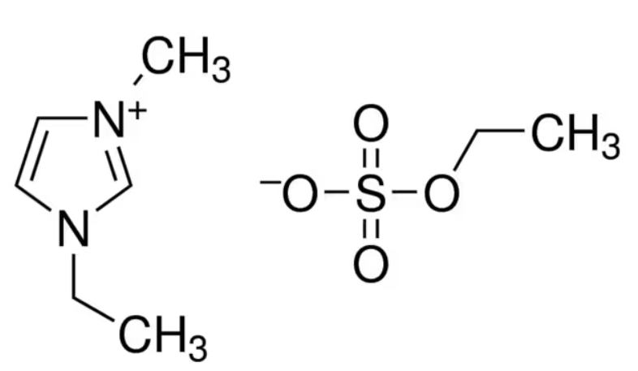

1-Ethyl-3-methylimidazolium ethyl sulfate
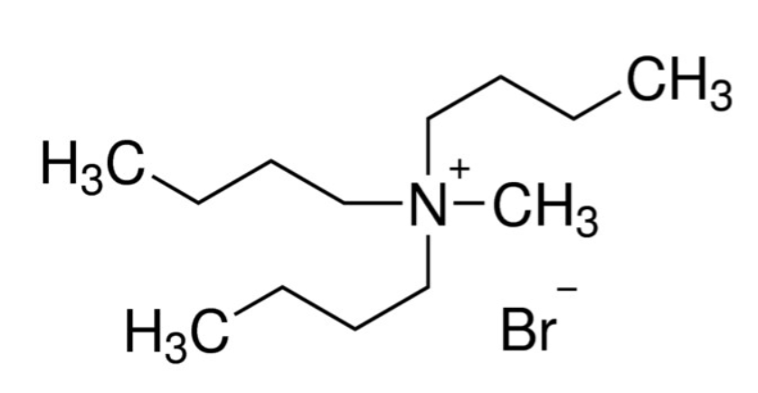

Tributylmethylammonium bromide

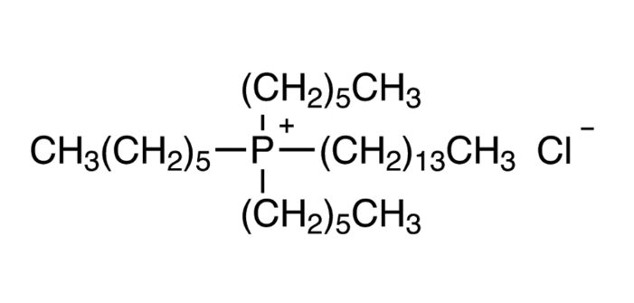

Trihexyl(tetradecyl)phosphonium Chloride

Scheme 1. Examples of Ionic Liquid

In the captivating realm of host-guest complexation, a host molecule forms a chemical alliance with a guest molecule, with Cyclodextrins assuming a prominent role in this fascinating phenomenon. Acting as versatile hosts, Cyclodextrins exhibit the exceptional ability to create inclusion complexes with an extensive range of solid, liquid, and gaseous compounds [28]. Within these complexes, the guest molecule finds shelter within the cavity of the Cyclodextrin host, engaging in a harmonious structural fit [29].
Crucially, the lipophilic chamber of Cyclodextrin molecules engenders an environment conducive for non-polar components of sufficient size to permeate and partake in inclusion complexes [30]. During the intricate process of developing the inclusion complex, no covalent bonds are forged or broken [31]. The primary driving force behind complex formation lies in the release of enthalpy-rich water molecules from the Cyclodextrin's cavity.
The strength of the binding hinges on the harmonious fit between the 'host-guest' complex, as well as unique local interactions among surface atoms, facilitated by van der Waals bonding. The capability of Cyclodextrins to foster inclusion complexes relies on two main factors: (A) the steric factor, contingent upon the relative sizes of the Cyclodextrin and the guest molecule, and (B) thermodynamic interactions [32-35]. Notably, the characteristics of the active substance, equilibrium kinetics, and other formulation ingredients and processes exert a significant influence on the formation of inclusion complexes [36-39].
Intriguing and dynamic, the world of host-guest complexation, orchestrated by Cyclodextrins, unravels possibilities for a myriad of applications, paving the way for transformative innovations in diverse fields.
Cyclodextrins, fascinating cyclic oligosaccharide molecules, are composed of several dextrose units, namely α-, β-, and γ-cyclodextrins, each encompassing 6, 7, or 8 dextrose units, respectively [40]. Characterized by their cyclic nature, cyclodextrins exhibit a hydrophilic outer surface, complemented by a lipophilic inner cavity, granting them remarkable properties [41,42].
These unique characteristics have paved the way for a plethora of applications in diverse industries. From the realms of food, pharmaceuticals, and drugs to the chemical sector, and even extending to agriculture and environmental engineering, cyclodextrins have demonstrated their versatility and significance in countless ways [43,45]. Their ability to form inclusion complexes with various guest molecules further enhances their value in facilitating drug delivery systems, enhancing solubility, and serving as effective encapsulating agents, amongst many other functionalities.
In conclusion, the dynamic world of cyclodextrins holds immense potential for transformative advancements, fuelling innovation across multiple domains and promising exciting possibilities in the fields of science, technology, and industry.
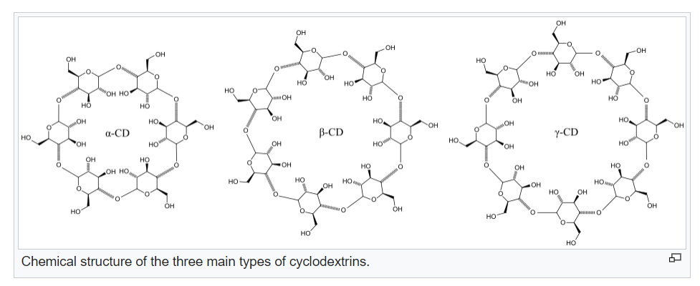

In recent years, cyclodextrin and ionic liquid-based inclusion complexes have captivated the scientific community with their potential applications spanning a wide array of fields, including drug delivery, catalysis, separation, and sensing. These complexes come into existence as the cyclodextrin cavity engulfs the ionic liquid molecule, leading to an encapsulation effect that holds significant promise [46]. The interactions driving this unique inclusion phenomenon stem from a combination of hydrophobic and hydrogen bonding interactions between the cyclodextrin and ionic liquid molecules. This intricate interplay between the two entities brings forth numerous advantages with far-reaching implications across various domains [47].
In the realm of drug delivery, the inclusion complex plays a pivotal role in enhancing the solubility, stability, and bioavailability of drugs. By offering protection against degradation and improving targeted delivery, these complexes unlock new possibilities for more efficient and effective pharmaceutical formulations [48]. In catalysis, the inclusion complex has shown its potential in elevating the catalytic activity and selectivity of catalysts. This improvement is achieved by augmenting their solubility and accessibility, thereby opening avenues for superior and finely-tuned catalytic processes [49]. Moreover, in separation applications, the inclusion complex emerges as a powerful tool for selectively extracting target molecules from intricate mixtures. This selectivity holds great promise in advancing separation methodologies and addressing complex challenges in the purification of various substances [50]. As a vibrant field of research, the development of cyclodextrin and ionic liquid-based inclusion complexes continues to evolve with ongoing efforts to optimize their properties and applications. Innovative strategies are being explored to unlock the full potential of these complexes, propelling them toward revolutionary breakthroughs [51].
The formation of inclusion complexes with cyclodextrins is a powerful approach to enhance the solubility of poorly aqueous soluble drugs. Through this process, the drug molecules become encapsulated within the hydrophobic cavity of cyclodextrins, modifying their physicochemical properties and resulting in increased solubility in water. This improved solubility offers several advantages in drug development and formulation. It leads to enhanced bioavailability after oral administration, facilitating better drug absorption and efficacy. Moreover, inclusion complexes simplify the formulation of oral or injectable dosage forms, enabling the development of more efficient drug delivery systems.[56] These complexes can also be tailored to control the release rate of the drug, allowing for sustained and controlled drug delivery. Additionally, inclusion complexes can effectively mask the bitter taste of certain drugs, making them more palatable, particularly for paediatric patients, thus improving patient compliance.[57] Overall, the use of inclusion complexes is a valuable strategy to overcome the solubility challenges of poorly aqueous soluble drugs, opening new possibilities in drug development and optimizing therapeutic outcomes. There are some poorly soluble drugs. [58-60]
Fenofibrate: Used to lower cholesterol and triglyceride levels, fenofibrate is known for its poor water solubility.
Ketoconazole: An antifungal medication, ketoconazole has low aqueous solubility, which can affect its absorption and bioavailability.
Danazol: This drug is used to treat endometriosis, fibrocystic breast disease, and hereditary angioedema, but it has limited water solubility.
Itraconazole: Another antifungal medication, itraconazole is poorly soluble in water, which can impact its effectiveness.
Griseofulvin: Used to treat fungal infections of the skin, hair, and nails, griseofulvin has poor solubility in water.
Carbamazepine: An anticonvulsant drug, carbamazepine is poorly soluble in water, affecting its dissolution and absorption.
Ritonavir: An antiretroviral drug used in the treatment of HIV infection; ritonavir has limited water solubility.
Paclitaxel: A chemotherapeutic drug used to treat various cancers; paclitaxel is known for its poor water solubility.
Cinnarizine: Used to treat motion sickness and vertigo, cinnarizine has low solubility in water.
Prednisone: A corticosteroid drug used to treat various inflammatory conditions; prednisone has limited water solubility.
Roy et al.,[61] studied the Insertion behaviour of imidazolium and pyrrolidinium based ionic liquids into α and β-cyclodextrins: mechanism and factors leading to host–guest inclusion complexes by 1H NMR, 2D ROESY NMR, FT-IR and ESI MS. they reveal that the surface tension and conductivity studies indicate a 1: 1 stoichiometry of the inclusion complexes. The formation of the inclusion complexes was elucidated by hydrophobic effects, structural effects, electrostatic forces, and H-bonding interactions.Ghose et al., studied the Inclusion complexation of imidazolium-based ionic liquid and β-cyclodextrin: A detailed spectroscopic investigation.The stoichiometric inclusion complex is confirmed by using the BH equation. The FTIR, 1H NMR analysis confirmed the inclusion complex formation.Negative values of ΔG, ΔH show that the binding process of ICs is spontaneous and exothermic in nature.Roy et al.,[62] studied the Investigation of an inclusion complex formed by ionic liquid and β-cyclodextrin through hydrophilic and hydrophobic interactions by Surface tension and conductivity measurements. Surface tension and conductivity measurements showed that a 1: 1 host–guest inclusion complex was formed and is favourable in the above system. Density, viscosity, and refractivity measurements were also employed to study the same. The limiting apparent molar volume, viscosity B-coefficient, and molar refraction data have been used to characterize the solute–solvent interactions between the IL and cyclodextrin in the experimental ternary solution system.Gardas et al.,[63] studies the Poly (alkyl ether) based ionic liquid–γ-cyclodextrin based inclusion complex and antibacterial activity of the inclusion complex by ESI-MS, 1H NMR, 2D NMR, FT-IR, UV–Vis, surface tension, and TGA techniques. they used Escherichia coli and Bacillus subtilis bacteria for antibacterial activity. The results of this work deliver the proof of concept that studied pyridinium based ILs-γ-CD host–guest ICs might act as a possible applicant in sustainable drug delivery system as well as further biomedical purposes.Ribeiro et al., [64]have investigated the Host-guest paracetamol/cyclodextrin complex formation evaluated 2 from coupled diffusion measurements. The result shows that the β-CD forms the complex (HPA–β-CD) with paracetamol molecules, so it is indicative that the molecule of paracetamol may be encapsulated within the cyclodextrin which, therefore, acts as a carrier for this drug.

Synthesis of Inclusion Complexes
The use of cyclodextrins in the production of inclusion complexes is a hot topic. Below are a few approaches to form Inclusion complexes. [65-67]

Co-precipitate Method
The co-precipitation method is employed to synthesize inclusion complexes. Initially, 1.14 g of Cyclodextrins (CD) is dissolved in 10 mL of distilled water within a water bath, maintaining a temperature of 353 K for optimal dissolution. Subsequently, 0.2 g of the desired Ionic Liquid is carefully introduced into 5 mL of methanol, forming an Ionic Liquid solution with a precise concentration. A meticulous 1:1 molar concentration ratio of Ionic Liquid to CD is maintained.
To ensure a controlled and homogenous reaction environment, the container holding the solution is covered with aluminum foil, while continuous stirring is carried out for 48 hours at 353 K. Following this, the solution undergoes refrigeration overnight at 278 K, inducing the precipitation of the desired Inclusion Complex. The resulting precipitate is then separated and purified through filtration, followed by a thorough washing process involving a precise mixture of methanol and water, effectively eliminating any unbound Ionic Liquid and CD remnants.

Slurry complexation
In this method, Cyclodextrin is mixed with water having a solids content of 50-60% and stirred. The presence of Cyclodextrin in the solution leads to saturation of the aqueous phase. As Cyclodextrin forms complexes with the guest molecules, the aqueous phase becomes further saturated, resulting in the formation of crystals or precipitates. Like the co-precipitation approach, the formed complex can be collected. This method offers a key advantage by reducing both the water requirement and the size of the reactor, making it a more efficient and practical option.

Damp mixing and heating
This approach necessitates minimal or negligible additional water. The guest molecules and Cyclodextrin are thoroughly mixed before being introduced into a tightly sealed container. Subsequently, the contents within the sealed container undergo heating at approximately 100 degrees Celsius, followed by removal and drying. To ensure optimal results, the amount of water added, the extent of mixing, and the duration of heating must be carefully optimized for each specific guest molecule. This precise optimization process ensures the efficiency and effectiveness of the method in creating the desired inclusion complexes.
.

Paste complexation
In this method, a small quantity of water is added to create a paste using a mortar and grinder. For large-scale production, a kneader is utilized. The required duration of the process varies depending on the guest molecules involved. Once the process is complete, the resulting complex can be dried directly or rinsed with a minimal amount of water before being recovered through filtration or centrifugation. To achieve a powdered form of the complex, the hardened complex is thoroughly dried and subsequently milled to attain the desired powdered consistency.

Extrusion
Extrusion represents a continuous system that employs a modified version of the heating and mixing procedure. Pre-mixed Cyclodextrin, guest molecules, and water can be directly added to the extruder or combined as needed. Within the extruder's barrel, the extent of mixing, heating, and time can be precisely controlled. Subsequently, the extruded complex may either dry naturally as it cools or be placed in an oven for drying, depending on the water content involved. The advantageous aspect of extrusion lies in its continuous process, which minimizes water consumption while efficiently producing the desired inclusion complexes.

Inclusion Complex Confirmation
The creation of the inclusion complex can be confirmed using numerous approaches that examine the interaction between a guest molecule and cyclodextrin. Few techniques are discussed below. [68-70]

Phase solubility
The presence of an inclusion complex in aqueous solution does not automatically imply its existence in crystalline form. It becomes imperative to ascertain whether the obtained powder from the inclusion complexation truly constitutes an inclusion complex or merely represents a physical mixture of guest and Cyclodextrin molecules [71]. This uncertainty arises due to the formation of water-soluble complexes between the dissolved Cyclodextrin and the guest molecule, particularly beneficial in enhancing the water solubility of limited water-soluble chemical compounds [72]. This unique characteristic finds practical applications in controlling the release of drugs [73] or perfumes [74], especially in cases requiring delayed release control mechanisms.

Differential scanning calorimetry (DSC)
Thermal stability comparison between the free and enclosed components using Differential Scanning Calorimetry (DSC) serves as an indirect confirmation of the inclusion complex [75]. While both the compound and its physical mixture exhibit an endothermic peak, the inclusion complex, on the other hand, does not display this characteristic [76]. This distinction observed in DSC analysis provides valuable insights into the formation and existence of the inclusion complex, contributing to a deeper understanding of its unique properties and behavior.

Visible and Ultraviolet (UV) spectroscopy
The process of developing complexes with Cyclodextrin can lead to alterations in the initial visible or ultraviolet absorption spectra of the guest molecules, often manifesting as shifts or band broadening [77]. To visualize and demonstrate the formation of the inclusion complex, UV-vis spectrophotometers are employed, providing valuable data and insights into the interaction between Cyclodextrin and the guest molecules. This analytical technique proves instrumental in confirming and characterizing the inclusion complex formation, aiding researchers in further understanding the intriguing phenomena associated with these complexation processes.

Other Methods
In addition to UV-vis spectra, phase solubility studies, and Differential Scanning Calorimetry (DSC), several alternative approaches are utilized to characterize cyclodextrin inclusion complex formation. These include Infrared Spectroscopy, Vacuum Methods [78], X-ray Diffraction [79], Chromatography [80], Mass Spectrometry, Nuclear Magnetic Resonance Spectroscopy [81], Fluorescence Spectroscopy [82], and Optical Methods [83]. Each of these diverse analytical techniques offers unique insights and perspectives into the intricate interactions and structural changes occurring during the formation of inclusion complexes. By employing this comprehensive array of methods, researchers can gain a comprehensive understanding of the complexation phenomena, unraveling the complex behavior of cyclodextrin and guest molecule interactions in aqueous solutions and solid states.

Applications of Cyclodextrin based Inclusion complex

Because guest molecules are trapped within the host cavity, encapsulation in cyclodextrins has a profound effect on their physicochemical properties. Following are the application of cyclodextrin based inclusion complexes.

Foods and Flavours
Cyclodextrins play a crucial role in preserving flavors, extending their shelf life and enhancing their stability [84]. They have been utilized effectively to remove cholesterol from animal products such as eggs and dairy goods, promoting healthier food options [85]. Additionally, cyclodextrins are employed to remove bitter components from citrus fruit juices, resulting in improved taste and quality, particularly in alcoholic beverages like whiskey and beer [86]. These diverse applications demonstrate the versatility and significance of cyclodextrins in the food and beverage industry, contributing to enhanced consumer experiences and product innovation.

Cosmetics, personal care, and toiletry
Cyclodextrin-based inclusion complexes find valuable applications in the fragrance industry, room fresheners, and detergents, where they effectively control the release of fragrances, ensuring long-lasting and controlled scent diffusion [87]. Additionally, in diapers, menstruation products, paper towels, and washed objects, cyclodextrins play a crucial role in keeping unwanted odors at bay, contributing to enhanced hygiene and comfort [89].
Furthermore, cyclodextrins are utilized in silica-based toothpaste formulations to improve the availability of triclosan, an antibacterial ingredient, thereby enhancing its efficacy in maintaining oral hygiene [90]. In sunscreen lotions, cyclodextrins and their derivatives, such as hydroxypropyl-CD, serve as key ingredients to limit the contact between the UV filter and the skin, reducing potential adverse effects and offering effective sun protection.
The diverse applications of cyclodextrins in various products underscore their significance in improving consumer experiences, promoting hygiene, and enhancing the performance of essential everyday items. As a versatile ingredient, cyclodextrins continue to contribute to advancements in the cosmetic, personal care, and household product industries, driving innovation and meeting evolving consumer needs.

Application in environment protection
Inclusion complexes offer a promising solution for the removal of highly hazardous chemicals from industrial wastewater. The antibacterial activity and antioxidant properties of chlorogenic acid and its complex were carefully studied, revealing valuable insights into their potential applications [92]. The investigation of antimicrobial activity against three microorganisms, namely Staphylococcus aureus, Bacillus subtilis, and Escherichia coli, did not demonstrate any significant differences between the chlorogenic acid inclusion complex and the free form. This research highlights the potential benefits of inclusion complexes in environmental remediation and antimicrobial applications, underscoring their importance in addressing critical challenges in industrial wastewater treatment and healthcare sectors.

Application in pharmaceuticals
The addition of α- or β-cyclodextrin to various poorly water-soluble compounds presents a valuable strategy to enhance their water solubility. This approach has proven effective in formulating aqueous dermal products, nasal medication delivery systems, and a wide range of eyedrop solutions, significantly improving their effectiveness. Furthermore, cyclodextrins can effectively mitigate the unpleasant taste or odor associated with certain medications, making them more palatable and tolerable for patients. This versatile application of cyclodextrins demonstrates their potential in enhancing pharmaceutical formulations and improving patient compliance, contributing to advancements in drug delivery and therapeutic outcomes.

Agricultural and chemical industries
Cyclodextrins play a significant role in forming complexes with various agricultural compounds, including herbicides, insecticides, fungicides, repellents, pheromones, and growth regulators. In agricultural applications, cyclodextrins have been shown to slow down seed germination by suppressing certain amylases responsible for degrading the seeds' starch supply. This intentional delay in the plant's initial growth is compensated by the subsequent increase in plant yields. The strategic use of cyclodextrins in agriculture showcases their potential in optimizing plant growth and enhancing crop productivity, contributing to sustainable and efficient agricultural practices.

Conclusion
The synthesis and characterization of inclusion complexes formed by cyclodextrins hold paramount importance in the realm of host-guest chemistry. Cyclodextrins exhibit a remarkable ability to form inclusion complexes with a wide range of solid, liquid, and gaseous substances. In these complexes, guest molecules are entrapped within the cavity of the cyclodextrin host, resulting in a precise structural fit between the host and guest. The lipophilic chamber of cyclodextrin molecules creates an environment conducive for accommodating non-polar components of sufficient size, facilitating the formation of inclusion complexes.
Due to their propensity for complexation, cyclodextrins have the remarkable ability to significantly alter the properties of the materials with which they interact. Consequently, cyclodextrins find widespread application in various commercial products, investigative processes, and diverse technologies. As a result, inclusion complexes have garnered increasing importance in fields such as food, pharmaceuticals, agriculture, and chromatographic techniques.
To produce inclusion complexes, various methods are employed, including the co-precipitate method, slurry complexation, paste complexation, damp mixing and heating, and the extrusion method. To analyze the interaction between guest molecules and cyclodextrins, a range of techniques is utilized, such as ultraviolet (UV) spectroscopy, phase solubility studies, differential scanning calorimetry (DSC), X-ray diffraction (XRD), Fourier-transform infrared spectroscopy (FTIR), and nuclear magnetic resonance (NMR).
The multifaceted nature of inclusion complexes and their diverse applications make cyclodextrins indispensable tools in advancing scientific research and technology across numerous domains, unlocking new possibilities, and fostering innovation in various industrial sectors.

BIBLIOGRAPHY
1.Subramaniam P, Mohamad S and Alias Y (2010). Synthesis and characterization of the inclusion complex of dicationic ionic liquid and β-cyclodextrin Int. J. Mol. Sci., 11(10), 3675-3685.
2.Shimpi S, chauhan B and Shimpi P. (2005). Cyclodextrins: Application in different routes of drug administration. Acta Pharm. 55 139–156.
3.Cal K and Centkowska K (2008). Use of cyclodextrins in topical formulations: Practical aspects. Eur. J. Pharm. Biopharm. 68, 3, 467-478.
4.Yan'an Gao, Xueyan Zhao, Bin Dong, Liqiang Zheng, Na Li, and Shaohua Zhang. (2006). Inclusion Complexes of β-Cyclodextrin with Ionic Liquid Surfactants J. Phys. Chem. B 110, 17, 8576–8581.
5.Subramaniam P, Mohamad S, and Alias Y. (2010). Synthesis and Characterization of the Inclusion Complex of Dicationic Ionic Liquid and β-Cyclodextrin. Int J Mol Sci. 11(10): 3675–3685.
6.Banjare M, Behera K, Banjare R, Pandey S and Ghosh K (2020). Inclusion complexation of imidazolium-based ionic liquid and β-cyclodextrin: A detailed spectroscopic investigation. J. Mol. Liq.302, 112530.
7.Chaudhary V and Patel J. (2013). Cyclodextrin inclusion complex to enhance solubility of poorly water soluble drugs: a review. IJPSR, Vol. 4(1): 68-76 0975-8232.
8.Ketan T. Savjani, Anuradha K. Gajjar, and Jignasa K. Savjani (2012). Drug Solubility: Importance and Enhancement Techniques. ISRN 2012, 195727, 10 10.5402/2012/195727.
9.E.M. Martin Del Valle (2004). Cyclodextrins and their uses: a review. Prc Biochem. Takahashi A, Veiga F, Ferraz H. (2012). A literature review of cyclodextrins inclusion complexes characterization - part i: phase solubility diagram, dissolution and scanning electron microscopy. Int J Pharm Sci Rev.
10.Banjare M K, Behera K, Satnami M L, Pandey S, Ghosh K .(2017). Supra-molecular inclusion complexation of ionic liquid 1-butyl-3-methylimidazolium octylsulphate with α-and β-cyclodextrins. Chem. Phys. Lett.
11.Sunil S.Jambhekar, Breen P (2016). Cyclodextrins in pharmaceutical formulations I: structure and physicochemical properties, formation of complexes, and types of complex. Drug Discov. Today 21, 2, 356-362.
12.Saha B, Saha S, Das K, Basak S and Prof. M N Roy. (2018). Investigation of inclusion complexes of sodium valproate inside into α and β-cyclodextrins. AJST.
13.Werner S, Haumann M, and Wasserscheid P (2010). Ionic liquids in chemical engineering Annual Review. 1:203-230.
14.João M. P. França, Carlos A. Nieto de Castro, Manuel Matos Lopes, and Valentim M. B. Nunes (2009). Influence of thermophysical properties of ionic liquids in chemical process design J. Chem. Eng. Data, 54, 9, 2569–2575.
15.Edward W. Castner Jr. ,Margulis C, Maroncelli M, and Wishart J (2011). Ionic liquids: structure and photochemical reactions. Annual Review. 62:85-105.
16.Pópolo M and Voth G (2004). On the Structure and Dynamics of Ionic Liquids J. Phys. Chem. B,108, 5, 1744–1752.
17.Aparicio S, Atilhan M, and Karadas F (2010) Thermophysical properties of pure ionic liquids: review of present situation. Ind. Eng. Chem. Res. 249, 9580–9595.
18.Mary E.Heckenbach, Felicia N.Romero , Matthew D.Green, Rolf U.Halden (2016). Meta-analysis of ionic liquid literature and toxicology Chemosphere 150, 266-274.
19.Hodyna D, Bardeau J, Metelytsia L, Riabov S, Kobrina L, Laptiy S, Kalashnikova L, Parkhomenko V, Tarasyuk O, Rogalsky S (2016). Efficient antimicrobial activity and reduced toxicity of 1-dodecyl-3-methylimidazolium tetrafluoroborate ionic liquid/β-cyclodextrin complex. Chem. Eng. J.
20.Liu H, Yang G, Tang Y, Cao D, Qi T, et al. (2013) Physicochemical characterization and pharmacokinetics evaluation of ß-caryophyllene/ß-cyclodextrin inclusion complex. Int J Pharm 450: 304– 310.
21.Szejtli J (1998) Introduction and General Overview of Cyclodextrin Chemistry. Chem Rev 98: 1743-1754.
22.Marques, HMC (1994) Structure and properties of cyclodextrins. Inclusion complex formation. Rev. Port. Farm. 44: 77-84.
23.Numanoglu U, Sen T, Tarimci N, Kartal M, Koo OM, et al. (2007) Use of cyclodextrins as a cosmetic delivery system for fragrance materials: linalool and benzyl acetate. AAPS Pharm Sci Tech 8: E85.
24.Pereva S, Sarafska T, Bogdanova S, Spassov, (2016) Efficiency of “cyclodextrin-ibuprofen” inclusion complex formation. J Drug Delivery Sci Technol 35: 34-39.
25.Karathanos VT, Mourtzinos I, Yannakopoulou K, Andrikopoulos NK (2007) Study of the solubility, antioxidant activity, and structure of inclusion complex of vanillin with beta-cyclodextrin. Food Chem. 101: 652-658.
26.Hill LE, Gomes C, Taylor TM (2013) Characterization of beta-cyclodextrin inclusion complexes containing essential oils (trans-cinnamaldehyde, eugenol, cinnamon bark, and clove bud extracts) for antimicrobial delivery applications. LWT – Food Sci Technol 51: 86-93.
27.Miller LA, Carrier RL, Ahmed I (2007) Practical considerations in development of solid dosage forms that contain cyclodextrin. J Pharm Sci 96: 1691-1707.
28.Waleczek KJ, Marques HM, Hempel B, Schmidt PC (2003) Phase solubility studies of pure (-)-alpha-bisabolol and camomile essential oil with beta-cyclodextrin. Eur J Pharm Biopharm 55: 247-251
29.Fernandes LP, Ehen ZS, Moura TF, Novak CS, Sztatisz J (2004) Characterization of Lippia sidoides oil extract – ß-cyclodextrin complexes using combined thermoanalytical techniques. J Therm Anal Calorim. 78: 557.
30.Ikeda Y, Kimura K, Hirayama F, Arima H, Uekama K (2000) Controlled release of a water-soluble drug, captopril, by a combination of hydrophilic and hydrophobic cyclodextrin derivatives. J Controlled Release 66: 271-280.
31.Locci E, Lai S, Piras A, Marongiu B, Lai A (2004) 13C-CPMAS and 1H-NMR study of the inclusion complexes of beta-cyclodextrin with carvacrol, thymol, and eugenol prepared in supercritical carbon dioxide. Chem. Biodivers 1: 1354-1366
32.Cox GS, Hauptman PJ, Turro NJ (1984) Dialkylaminobenzonitriles as fluorescence polarity probes for aqueous solutions of cyclodextrins. Photochem Photobiol 39: 597-601
33.Bergeron RJ, Channing MA, Gibeily GJ, Pillor DM (1977) Disposition requirements for binding in aqueous solution of polar substrate in the cyclohexaamylose cavity. J Am Chem Soc. 99: 5146.
34.Muñoz-Botella S, del Castillo B, and Mart?yn MA (1995) Cyclodextrin properties and applications of inclusion complex formation. Ars Pharm 36: 187–198.
35.Hedges AR (1998) Industrial Applications of Cyclodextrins. Chem Rev 98: 2035-2044.
36.Parrish MA (1987) Cyclodextrins, a review. Spec Chem 7: 366.
37.Foley PR, Kaiser CE, Sadler JD, Burckhardt EE, Liu Z (2000) Detergent composition with cyclodextrin perfume complexes to mask malodours. PCT Int.Appl WO 01 23, 516
38.Angell WF, France PA (2001) Detergent composition having granular cyclodextrin. PCT Int Appl WO 01 18,163.
39.Lo3ftsson T, Leeves N, Bjornsdottir B, Duffy L, Masson M (1999) Effect of cyclodextrins and polymers on triclosan availability and substantivity in toothpastes in vivo. J Pharm Sci 88: 1254-1258.
40.Raza A, Sun H, Bano S, Zhao Y, Xu X, Tang J (2017) Preparation, characterization, and in vitro anti-inflammatory evaluation of novel water soluble kamebakaurin/hydroxypropyl-ß-cyclodextrin inclusion complex. J Mol Structure. 1130: 319-326
41.Del Valle EMM (2004) Cyclodextrins and their uses: a review. Process Biochem. 39: 1033-1046.
42.Jarho P, Urtti A, Pate DW, Suhonen P, Järvinen T (1996) Increase in aqueous solubility. Int. J. Pharm 137: 209–217.
43.Loftsson T, Stefánsson E (1997) Effect of cyclodextrins on topical drug delivery to the eye. Drug Dev Ind Pharm 23: 473–481.
44.Cai M, Yu Q, Liu W and Zhou F (2020). Ionic liquid lubricants: When chemistry meets tribology Chem. Soc. Rev. 49, 7753-7818.
45.Smiglak M, Metlen A, and Rogers R (2007). The Second Evolution of Ionic Liquids: From Solvents and Separations to Advanced Materials Energetic Examples from the Ionic Liquid Cookbook Acc. Chem. Res. 40, 11, 1182–1192.
46.Gehlot P, Kulshrestha A, Bharmoria P, Damarla K, Chokshi K, and Kumar A (2017). Surface-active ionic liquid cholinium dodecylbenzenesulfonate: self-assembling behavior and interaction with cellulase ACS Omega 2, 10, 7451–7460.
47.Qingrun Li, Shenghan Song, Zhenyu Feng, Juan Qiu, Meng Sun, and Xiao Chen (2020). Luminescent vesicles self-assembled directly from an amphiphilic europium complex in an ionic liquid, Langmuir 36, 11, 2911–2919.
48.Demirci S and Sahiner N (2014). PEI-based ionic liquid colloids for versatile use: Biomedical and environmental applications J. Mol. Liq.
49.Schneiderman E and Apryll M.Stalcup (2000). Cyclodextrins: a versatile tool in separation science. J. Chromatogr. A B: B Biomed. Sci. Appl 745, 1, 4 83-102.
50.Jiang L, Deng M, Wang Y, Liang D, Yan Y, and Huang J (2009). Special Effect of β-Cyclodextrin on the Aggregation Behavior of Mixed Cationic/Anionic Surfactant Systems. J. Phys. Chem. B 113, 21, 7498–7504.
51.Pal M, Rai R, Yadav A, Khanna R, Baker G. A, Pandey S. (2014). Self-Aggregation of Sodium Dodecyl Sulfate within (Choline Chloride + Urea) Deep Eutectic Solvent. Langmuir, 30, 13191-13198.
52.Hargreaves W, Deamer D (1978), Liposomes from ionic, single-chain amphiphiles Biochemistry, 17, 3759-3768.
53.Kumar P, Rani A, Olasunkanmi L, Bahadur I, Venkatesu P, Ebenso E. (2016). Probing Molecular Interactions between Ammonium-Based Ionic Liquids and N,N-Dimethylacetamide: A Combined FTIR, DLS, and DFT Study. J. Phys. Chem. B, 120, 12584-12595.
54.Rita L, Amit T and Chandrashekhar G (2011). Current trends in β-cyclodextrin based drug delivery systems IJRAP, 2 (5) 1520-1526. 2229-3566.
55.Banjare M, Behera K, Satnami M , Pandey S, Ghosh K (2018) Host–guest complexation of ionic liquid with α- and β-cyclodextrins: a comparative study by 1H-NMR, 13C-NMR and COSY New J. Chem 42, 14542-14550.
56.Anjana. M. N, Nair S, Joseph J (2013). An updated review of cyclodextrins –an enabling technology for challenging pharmaceutical formulations. Int. J. Pharm. Pharm. Sci. ssn- 0975-1491 5, 3.
57.Pessine F. B. T., Calderini A and Alexandrino G L. (2012) Review: Cyclodextrin Inclusion Complexes Probed by NMR Techniques. intechopen: 10.5772/32029.
58.Bhadoriya S, Madoriya N, Shukla K and Parihar MS (2013). Biosurfactants: A New Pharmaceutical Additive for Solubility Enhancement and Pharmaceutical Development. Biochemistry & Pharmacology Bhadoriya et al., Biochem Pharmacol, 2:2.
59.Pal A and Chaudhary S (2014). Ionic liquids effect on critical micelle concentration of SDS: Conductivity, fluorescence, and NMR studies. Fluid Phase Equilibria 372, 100-104.
60.Anderson J, Pino V, Hagberg E, Sheares V and Armstrong D (2003). Surfactant solvation effects and micelle formation in ionic liquids. Chem. Commun. 2444-2445.
61. Noël, S., Léger, B., Ponchel, A., Philippot, K., Denicourt-Nowicki, A., Roucoux, A., & Monflier, E. (2014). Cyclodextrin-based systems for the stabilization of metallic(0) nanoparticles and their versatile applications in catalysis. Catalysis Today, 235, 20–32.
62. Roy, M. N., Roy, M. C., & Roy, K. (2015). Investigation of an inclusion complex formed by ionic liquid and β-cyclodextrin through hydrophilic and hydrophobic interactions. RSC Advances, 5(70), 56717–56723.
63.Bhaswati Sarkar a, Koyeli Das a, Amlan JyotiGhosh b, Rejuan Islam b, Tilak Saha b, Edamana Prasad a, Ramesh L. Gardas a Poly(alkyl ether) based ionic liquid–γ-cyclodextrin based inclusion complex and antibacterial activity of the inclusion complex Journal of Molecular Liquids 361, 2022, 119571.
64. Ribeiro, A. C. F., Musilová, L., Mráček, A., Cabral, A. M. T. D. P. V., Ana Santos, M., Cabral, I., … Leaist, D. (2021). Host-guest paracetamol/cyclodextrin complex formation evaluated from coupled diffusion measurements. The Journal of Chemical Thermodynamics, 161, 106551.
65. Saalfrank, R. W., Dresel, A., Seitz, V., Trummer, S., Hampel, F., Teichert, M., … Trautwein, A. X. (1997). Topologic Equivalents of Coronands, Cryptands and Their Inclusion Complexes: Synthesis, Structure and Properties of {2}-Metallacryptands and {2}-Metallacryptates. Chemistry - A European Journal, 3(12), 2058–2062.
66. Sambasevam, K., Mohamad, S., Sarih, N., & Ismail, N. (2013). Synthesis and Characterization of the Inclusion Complex of β-cyclodextrin and Azomethine. International Journal of Molecular Sciences, 14(2), 3671–3682.
67. Tao, F., Hill, L. E., Peng, Y., & Gomes, C. L. (2014). Synthesis and characterization of β-cyclodextrin inclusion complexes of thymol and thyme oil for antimicrobial delivery applications. LWT - Food Science and Technology, 59(1), 247–255.
68. Varganici, C.-D., Marangoci, N., Rosu, L., Barbu-Mic, C., Rosu, D., Pinteala, M., & Simionescu, B. C. (2015). TGA/DTA–FTIR–MS coupling as analytical tool for confirming inclusion complexes occurrence in supramolecular host–guest architectures. Journal of Analytical and Applied Pyrolysis, 115, 132–142.
69. Ai, L., Hu, J., Ji, X., & Zhao, H. (2019). Structure confirmation and thermal kinetics of the inclusion of cis-jasmone in β-cyclodextrin. RSC Advances, 9(45), 26224–26229.
70. Pedersen, M., Jacobsen, J., & Sørensen, A. M. (1999). Cyclodextrin Inclusion Complexes of Miconazole and Econazole—Isolation, Toxicity on Human Cells, and Confirmation of a New Interpretation of the Drug Supersaturation Phenomenon. Drug Development and Industrial Pharmacy, 25(4), 463–470.
71. Karathanos, V. T., Mourtzinos, I., Yannakopoulou, K., & Andrikopoulos, N. K. (2007). Study of the solubility, antioxidant activity and structure of inclusion complex of vanillin with β-cyclodextrin. Food Chemistry, 101(2), 652–658.
72. Savic, I. M., Nikolic, V. D., Savic-Gajic, I., Nikolic, L. B., Radovanovic, B. C., & Mladenovic, J. D. (2015). Investigation of properties and structural characterization of the quercetin inclusion complex with (2-hydroxypropyl)-β-cyclodextrin. Journal of Inclusion Phenomena and Macrocyclic Chemistry, 82(3-4), 383–394.
73. Kulkarni, A. D., & Belgamwar, V. S. (2017). Inclusion complex of chrysin with sulfobutyl ether-β-cyclodextrin (Captisol ): Preparation, characterization, molecular modelling and in vitro anticancer activity. Journal of Molecular Structure, 1128, 563–571.
74. Aytac, Z., Ipek, S., Durgun, E., & Uyar, T. (2017). Antioxidant electrospun zein nanofibrous web encapsulating quercetin/cyclodextrin inclusion complex. Journal of Materials Science, 53(2), 1527–1539.
75. Spink, C. H. (2008). Differential Scanning Calorimetry. Methods in Cell Biology, 115–141.
76. Leyva-Porras, C., Cruz-Alcantar, P., Espinosa-Solís, V., Martínez-Guerra, E., Piñón-Balderrama, C. I., Compean Martínez, I., & Saavedra-Leos, M. Z. (2019). Application of Differential Scanning Calorimetry (DSC) and Modulated Differential Scanning Calorimetry (MDSC) in Food and Drug Industries. Polymers, 12(1), 5.
77. Yadav, L. D. S. (2005). Ultraviolet (UV) and Visible Spectroscopy. Organic Spectroscopy, 7–51.
78. Abdelmalek, L., Fatiha, M., Leila, N., Mouna, C., Nora, M., & Djameleddine, K. (2016). Computational study of inclusion complex formation between carvacrol and β-cyclodextrin in vacuum and in water: Charge transfer, electronic transitions and NBO analysis. Journal of Molecular Liquids, 224, 62–71.
79. Mangolim, C. S., Moriwaki, C., Nogueira, A. C., Sato, F., Baesso, M. L., Neto, A. M., & Matioli, G. (2014). Curcumin–β-cyclodextrin inclusion complex: Stability, solubility, characterisation by FT-IR, FT-Raman, X-ray diffraction and photoacoustic spectroscopy, and food application. Food Chemistry, 153, 361–370.
80. Marreto, R. N., Almeida, E. E. C. V., Alves, P. B., Niculau, E. S., Nunes, R. S., Matos, C. R. S., & Araújo, A. A. S. (2008). Thermal analysis and gas chromatography coupled mass spectrometry analyses of hydroxypropyl-β-cyclodextrin inclusion complex containing Lippia gracilis essential oil. Thermochimica Acta, 475(1-2), 53–58.
81. Davis, M. E., & Brewster, M. E. (2004). Cyclodextrin-based pharmaceutics: past, present and future. Nature Reviews Drug Discovery, 3(12), 1023–1035.
82. Tang, W., Zou, C., Da, C., Cao, Y., & Peng, H. (2020). A review on the recent development of cyclodextrin-based materials used in oilfield applications. Carbohydrate Polymers, 240, 116321.
83. He, S., Shi, W., Zhang, X., Li, J., & Huang, Y. (2010). β−cyclodextrins-based inclusion complexes of CoFe2O4 magnetic nanoparticles as catalyst for the luminol chemiluminescence system and their applications in hydrogen peroxide detection. Talanta, 82(1), 377–383.
84. Kang, Y., Guo, K., Li, B.-J., & Zhang, S. (2014). Nanoassemblies driven by cyclodextrin-based inclusion complexation. Chem. Commun., 50(76), 11083–11092.
85. Van de Manakker, F., Vermonden, T., van Nostrum, C. F., & Hennink, W. E. (2009). Cyclodextrin-Based Polymeric Materials: Synthesis, Properties, and Pharmaceutical/Biomedical Applications. Biomacromolecules, 10(12), 3157–3175.
86. Yazdani, M., Tavakoli, O., Khoobi, M., Wu, Y. S., Faramarzi, M. A., Gholibegloo, E., & Farkhondeh, S. (2021). Beta-carotene/cyclodextrin-based inclusion complex: improved loading, solubility, stability, and cytotoxicity. Journal of Inclusion Phenomena and Macrocyclic Chemistry.
87. Vyas, A., Saraf, S., & Saraf, S. (2008). Cyclodextrin based novel drug delivery systems. Journal of Inclusion Phenomena and Macrocyclic Chemistry, 62(1-2), 23–42.
88. LI, J., & LOH, X. (2008). Cyclodextrin-based supramolecular architectures: Syntheses, structures, and applications for drug and gene delivery☆. Advanced Drug Delivery Reviews, 60(9), 1000–1017.
89. Liu, Y., Sameen, D. E., Ahmed, S., Wang, Y., Lu, R., Dai, J., … Qin, W. (2022). Recent advances in cyclodextrin-based films for food packaging. Food Chemistry, 370, 131026.
90. Arora, D., Saneja, A., & Jaglan, S. (2019). Cyclodextrin-based delivery systems for dietary pharmaceuticals. Environmental Chemistry Letters.

