Effect of heat treatment on microstructure and wear behavior of as cast Al-28Si-5Cu-4Fe alloy

Dayanand M.Goudar¹, Basayya K.Belleri², Ishwargouda S.Patil³
¹²³Tontadarya College of Engineering,Gadag-582101,India
Neeraj R. Kurahatti

Smt Kamala and Sri Venkappa M. Agadi College of Engineering &Technology,Laxmeshwar,india
ABSTRACT - The influence aging time on microstructure and the wear behavior of artificial age hardening of as cat cast Al-28Si-5Cu-4Fe alloy was investigated. Alloy was subjected T6 age hardening treatment having sequence of solutionzing at 510°C for 2 h followed by water quenching (25°C) and aging hardening at 220°C for different aging times. The microstructure age hardened alloys revealed the spheridization of Si particles, Fe rich intermetallics and high precipitation of Al₂Cu phases. In contrast the as cast alloy revealed the presence of plate-like morphology of Si phase coexisting with sharp needle like β-Al₄FeSi₂ and Chinese script of Al₂Cu phase. The wear behavior of the age hardened alloy exhibits a maximum wear resistance and minimum coefficient of friction over the entire range of applied load and sliding velocity. The high wear resistance in the age hardened alloys was due to the spheroidization of intermetallic phases and increase in the bonding between intermetallics and matrix results in the increase in the hardness of the alloy. The worn surface of the cast alloy depicted both adhesive and abrasive mode and age hardened alloy depicts abrasive mode of wear which was evidenced by the formation of oxidative patches in the age hardened worn out surfaces.
1.0 INTRODUCTION
Aluminum (Al) is the second most abundant element on Earth and has been used in engineering applications since the late 19th century. With the emergence of three important industrial revolutions, the demand for materials with characteristics consistent with the unique qualities of aluminum and its alloys greatly benefited the production and use of the metal. One of the most notable characteristics of aluminum is its versatility. The range of physical properties that can be developed from refined high-purity Al to complex alloys is remarkable. Aluminum and its alloys are widely used as materials in transportation (aerospace and automobiles), engine components, and structural applications [1]. Therefore, it is essential to study the tribological characteristics of aluminum and its alloys. Aluminum-silicon (Al-Si) alloys especially in the hypereutectic range have created a considerable interest and eventually became the candidate materials for both aircraft and automobile parts [2]. By increasing the Si content further, the alloy exhibits excellent dimensional stability, hardness, low density and improved wear resistance. However, the relatively low wear resistance of Al-Si alloys compared to steels has limited their use in components where high wear resistance is required. It has been reported that increasing the silicon content to a hyper eutectic composition can enhance the wear resistance of these alloys [3].In order to enhance the wear resistance of hyper-eutectic Al-Si alloys, it is necessary to modify their composition by adding alloying elements like Cu, Mg, Fe, and Mn [4]. The addition of Cu and Mg helps to improve the wear properties of the alloy by forming intermetallic phases such as Al₂Cu, Mg₂Si, and Al₂CuMg[3]. Similarly, the addition of Fe contributes to the precipitation of intermetallic phases like δ-Al₄FeSi₂ and β-Al₅FeSi, thus improving the wear properties of the alloy [5].
The coarseness of the microstructure, which includes the fraction, size, and distribution of the silicon phase, intermetallic phases, and the segregation profiles of solute in the α-Al phase, is determined by the solidification rate [6]. If conventional casting processes are used and a slow solidification occurs, coarse plate-like silicon particles and needle-like intermetallic phases are formed, which results in increased wear. The tribological properties of Al-Si alloys depend on the shape and distribution of silicon particles, and the addition of alloying elements such as magnesium, copper, nickel, and zinc, often combined with a suitable heat treatment [6], can affect them.
Improvements in wear resistance have been reported in alloys with silicon content near the eutectic composition [7]. Proper solution treatment modifies the morphology of eutectic silicon particles, resulting in solid solution strengthening and precipitation hardening of the Al-Si alloy matrix. Large flakes of silicon with sharp tips and low bond strength to the matrix may convert to fine spherical particles with better bonding strength after heat treatment [8]. This reduces stress concentration and crack nucleation sites, leading to improved tribological behavior [9]. The addition of elemental iron to Al-Si alloys decreases mechanical and tribological properties due to the formation of long and brittle needles, such as b-Al5FeSi intermetallics. These needles have sharp tips, a high aspect ratio, and low bond strength with the aluminum matrix [10]. Researchers have extensively investigated the beneficial effects of heat treatment on controlling the negative effects of Fe-rich intermetallics on mechanical properties [11].
There has been no systematic work devoted to investigating the effect of heat treatment, copper, and iron-rich intermetallics on the wear properties of Al-Si alloys. Therefore, this study aims to investigate the effect of T6 heat treatment on the wear behavior of as-cast Al-28Si-5Cu-4Fe alloy.
2. THEORY AND LITERATURE REVIEW
2.1 Aluminum and its alloys -Aluminum alloys, steel, and nickel alloys are the three most important alloys used in engineering and aerospace applications. Titanium, magnesium, and copper alloys are also significant. Extruded profiles, rolled sheets, plates, castings, and forgings are some of the forms in which aluminum alloys with great durability and high strength are available. These alloys mainly consist of aluminum with carefully controlled additions of copper, magnesium, silicon, manganese, zinc, and lithium. Airframe structures primarily use aluminum alloys. There are three main classes of aluminum alloys used in aerospace applications, but only the wrought heat-treated alloys have enough strength for structural components. [12]
2.1.1 Casting Alloys: Aluminum and its alloys find application in a multitude of cast and wrought forms, where they can be subjected to different heat treatment conditions. Examples of wrought forms include forgings, extrusions, sections, sheets, plates, strips, foils, and wire, while castings are available as sand, pressure, and gravity die-castings. For instance, alloys such as Al-Si and Al-Mg.
2.1.2 Wrought Aluminum Alloys: Aluminum is often alloyed with copper, manganese, magnesium, zinc, nickel, and silicon to meet various requirements. These alloying elements are added in specific percentages to enhance the properties of aluminum. To classify the wrought aluminum alloys, the Aluminium Association of America (AAA) has developed a four-digit system that is widely adopted by the International Alloy Development System (IADS) and most countries across the globe. Table 1-3 provides the basis for the designation of wrought and cast aluminum alloys in the four-digit system. The first digit represents the alloy type, the second digit indicates the specific alloy modification, and the last two digits signify the particular aluminum alloy or the purity level in the case of pure aluminum.
Table 1- Designation of Wrought Aluminium alloys

Alloy Designation | Alloy
1XXX | 99% pure Aluminium
2XXX | Cu containing alloy
3XXX | Mn containing alloy
4XXX | Si containing alloy
5XXX | Mg containing alloy
6XXX | Mg and Si containing alloy
7XXX | Zn containing alloy
8XXX | Other alloys
9XXX | Unassigned

Table 2- Designation of Cast Aluminium alloys

Alloy Designation | Detail
1XX.X | 99% pure Aluminium
2XX.X | Cu containing alloy
3XX.X | Cu/Mg containing alloy
4XX.X | Si containing alloy
5XX.X | Mg containing alloy
7XX.X | Zn containing alloy
7XXX | Sn containing alloy
9XX.X | Other alloys
6XX.X | Unassigned
The temper condition of aluminum alloys is indicated by specific letters, with numeric additions indicating variations.
Table 3 - Designation heat treatment process
Letter | Conditions of alloy
F | As–fabricated
O | Annealed
H | Strain hardened (Wrought products only)
W | Solution heat treated
T | Thermally treated to produce tempers other than F, O, H
T4 | Solution treated
T6 | Solution treated and aged

2.1.3 Heat Treatable Aluminium Alloys: Heat treating refers to a range of heating and cooling operations carried out on metal products to alter their mechanical properties, metallurgical structure, or residual stress state. With regards to aluminum alloys, heat treating is commonly used to increase the strength and hardness of the precipitation-hardenable wrought and cast alloys, which are often referred to as "heat-treatable" alloys. These alloys form part of systems with limited solubility in the solid state, and are characterized by temperature-dependent equilibrium solid solubility that increases with temperature rise. Other requirements include the ability to maintain a single-phase supersaturated solid solution through quenching, and precipitation of a coherent/partially coherent phase via decomposition of the supersaturated solid solution. Alloys that cannot be significantly strengthened through heating and cooling are distinguished from heat-treatable alloys. [13]. The following are examples of strengthening systems for aluminum alloys:
1. Aluminum-copper systems with strengthening from CuAl₂
2. Aluminum-copper-magnesium systems with intensified precipitation from magnesium
3. Aluminum-magnesium-silicon systems with strengthening from Mg₂Si
4. Aluminum-zinc-magnesium systems with strengthening from MgZn2.
2.1.4 Non-Heat treatable Aluminium alloys: Some alloys are not able to respond to heat treatment due to their composition, which consists of a homogeneous solid solution with or without no coherent precipitates. As a result, these alloys exhibit low strength and high ductility. However, they can be stress-hardened. Examples of such alloys include commercially pure Aluminium (1100), Al-Mn (3003), Al-Mn-Mg, and Al-Si alloys. These alloys are commonly used in the form of sheets, bars, plates, wire, extrusion, etc. They are highly malleable, easy to form, weld and exhibit excellent corrosion resistance.
2.1.5 Age-hardening of aluminum alloys.
Age hardening is a process in which a metal alloy is strengthened and hardened by very small and uniformly dispersed particles that precipitate from a supersaturated solid solution. As the alloy ages, it becomes harder and stronger. The hardness of the quenched alloy increases with the duration of aging. Ageing at room temperature is called natural aging while at elevated temperatures, it is called artificial aging. Precipitation in solid solution occurs when the solubility of the solute decreases with a decrease in temperature. The precipitate of the second phase should be coherent in nature. The objective of age hardening is to create a heat-treated alloy that has a dense dispersion of fine precipitated particles in a deformable metal matrix. These particles act as obstacles to dislocation motion and thereby strengthen the heat-treated alloy.
Aluminum alloys that can be hardened by precipitation undergo a three-step process of heat treatment. The first step is called solution heat treatment which aims to dissolve the soluble phases. The second step is quenching, where the solid solution is preserved by rapidly cooling it to a lower temperature, usually room temperature. The final step is age hardening, which aims to precipitate the strengthening phases. If the solution treatment and age hardening steps are overheated or under heated outside the specified range of temperatures or if the quenching is inadequate, it may cause degradation of mechanical properties [14]. Hardening is achieved by rejecting copper from a supersaturated solid solution in a controlled manner. The solubility of copper in alpha-aluminum increases with increasing temperature up to the eutectic temperature, which is around 540°C. The equilibrium microstructure below the eutectic temperature is a two-phase mixture of alpha-aluminum and the Al2Cu intermetallic phase. Rapid quenching from the solution temperature prevents the kinetically slow precipitation of theta and forms a highly supersaturated solid solution of copper. The temperature versus time plot showing both solution and precipitation heat treatments for age-hardening alloy are shown in the figure.
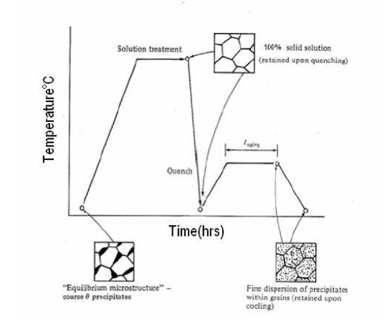
Figure 1. Schematic temperature versus time plot showing the both solution and precipitation heat treatments for age hardening alloys
2.2 Casting process
The casting process is the quickest way to turn molten metal into a nearly finished part. The selection of the casting process is based on various factors, such as the size of the batch, the complexity of the part, and the required mechanical properties. There are many modern casting processes, which are broadly classified based on the type of mold material (such as sand or permanent), the manner in which the molten metal is injected into the cavity (such as gravity, pressure, or vacuum), the state of the metal (the percentage that is liquid), and the state of the mold cavity (such as air, vacuum, solid, or gas). Aluminum alloy castings can be produced using several conventional casting processes, including chill casting, centrifugal casting, and die casting, which are briefly explained in the following sections.
Sand casting process- This process is used predominantly in two fields of application: for prototypes and small-scale production on the one hand and for the volume production of castings with a very complex geometry on the other. For the casting of prototypes, the main arguments in favour of the sand casting process are its high degree of flexibility
in the case of design changes and the comparably low cost of the model. In volume
production, the level of complexity and precision achieved in the castings are its main advantages.
Gravity die casting process- The gravity die casting which includes the well-known low-pressure die casting process is applied. The main fields of application are medium- or high-volume production using high-grade alloys, and also low to medium component weight using heat-treatable alloys. Compared with sand casting, the aluminum castings
display very good microstructural properties as well as good to very good mechanical properties which result from the rapid cooling times and the other easily-controlled operating parameters When higher mechanical properties are required in the cast piece, such as higher elongation or strength, gravity die casting, and to a limited extent pressure die casting, are used. In gravity die casting, there is the possibility of using sand cores. Large differences in wall thick- nesses can be favorably influenced with the help of risers. Cylinder heads for water-cooled engines represent a typical application. In the low-pressure gravity die process with its upward and controllable cavity filling, the formation of air pockets is reduced to a minimum and, consequently ,high casting quality can be achieved. In addition to uphill filling, the over pressure of approx. 0.5 bar has a positive effect on balancing out defects caused by shrinkage. The low-pressure die casting process is particularly advantageous in the casting of rotationally symmetrical parts, e.g. in the manufacture of passenger vehicle wheels.
Pressure die casting- is the most widely used casting process for aluminum casting alloys. Pressure die casting is of particular advantage in the volume production of parts where the requirement is on high surface quality and the least possible machining. Special applications (e.g. vacuum) during casting enable castings to be welded followed by heat treatment which fully exploits the property potential displayed by the casting alloy. This process takes up the largest share. The hydraulically-controlled pressure die casting machine and the in-built die make up the central element of the process. The performance, the precise control of the hydraulic machine, the quality of the relatively expensive tools made from hot work steel are the decisive factors in this process. In contrast, the flow properties and solidification of the aluminum casting alloys play a rather subordinate role in this “forced” casting process. The pouring operation in horizontal pressure die casting begins with the casting chamber being filled with metal. The first movement, i.e. the slow advance of the plunger and the consequent pile-up
of metal until the sleeve is completely filled, is the most important operation. In doing this, no flash over of the metal or other turbulence may occur until all of the air in the sleeve has been squeezed out. Immediately afterwards, the actual casting operation begins with the rapid casting phase. High injection pressure is essential to achieve high fl ow velocities in the metal. In this way, the die can be filled in a few hundredths of a second.
Throughout the casting operation, the liquid metal streams are subject to the laws of hydrodynamics. Sharp turns and collisions with the die walls lead to a clear division of the metal stream. Parts generated using the horizontal pressure die casting process are lightweight as low wall thicknesses can be achieved. They have a good surface finish, high dimensional accuracy and only require a low machining allowance in their design. Many bore holes can be pre-cast. In addition to conventional pressure die casting, thixocasting is worthy of mention since heat-treatable parts can also be manufactured using this process. The special properties are achieved by shaping the metal during the solid liquid phase.
Squeeze-casting- The solidification takes place at high pressure. In this way, an almost defect-free microstructure can be produced even where there are large transitions in the cross-section and insufficient feeding
Centrifugal casting - Centrifugal casting, also known as rotocasting, is a technique used to cast thin-walled cylinders. It is highly regarded for its ability to produce high-quality results, particularly when it comes to precise control of metallurgy and crystal structure. Unlike other casting techniques, centrifugal casting is mainly used to create standard-sized stock materials for further machining, rather than shaped parts tailored for specific needs. In centrifugal casting, a permanent mold is continuously rotated around its axis at high speeds (300 to 3000 rpm) while the molten metal is poured. The molten metal is thrown towards the inside wall of the mold by centrifugal force, where it solidifies after cooling. The casting is usually fine-grained with a smooth outer diameter due to chilling against the mold surface. Impurities and inclusions are thrown to the surface of the inner diameter, which can be machined away. Casting machines can be either horizontal or vertical. Horizontal machines are preferred for long, thin cylinders, while vertical machines are better suited for rings. Most castings solidify from the outside first, which encourages directional solidification and gives useful metallurgical properties to the casting. Often the inner and outer layers are discarded, and only the intermediary columnar zone is used. This technique is most commonly used for cylinders and shapes with rotational symmetry. "Tall" castings (in the direction of the settling force, usually gravity) are always more difficult than short castings. In centrifugal casting, the radius of the rotation replaces the vertical axis along which the centrifugal force acts. The casting machine may be rotated to place this in any orientation that is convenient relative to gravity's vertical. Horizontal and vertical axis machines are both used to place the longest dimension of the casting conveniently horizontal.
2.3 Effect of alloying elements
Several researchers such as Pramila Bai et al.[ ] studied the wear, friction, and seizure properties of a variety of commercial Al-Si alloys containing different alloying elements like Cu, Mg, Ni, etc. These alloys are typically complex compositions of hypo or hypereutectic Al-Si alloys with impurities like Fe, Mn, Zn, etc. The addition of these elements strengthens the Al-Si alloy matrix through solid solution hardening and precipitation hardening. For example, if Cu is present in sufficient concentration, a substantial part of it goes into a solid solution of Al, and a part may appear as an intermediate phase (CuAl₂). Magnesium, if added, mostly forms an intermetallic compound of Mg2Si. Similarly, when Nickel is added to Cu, it may partly go into the solid solution of the Al-rich phase and partly form an intermetallic compound of Cu3NiAl6. These metals can also form other complex compounds in combination with impurities present, such as Al5(FeMn)Si, Al₈Mg₃Si₆Fe, etc. However, the amount of alloying additions made, impurities present, rate of cooling used during freezing of the alloy, and heat treatment carried out (if any) determine all the possibilities mentioned above. A specific Al-Si alloy containing 11Si and 1Cu was developed in the UK to meet the high requirements of turbocharged diesel engines. This alloy had high fatigue strength, good elongation, and wear resistance characteristics, but its hardness and relatively poor embeddability required it to be overlay-plated with a Pb-Sn alloy to minimize scoring and scuffing, leading to better engine performance. In another study, the researchers observed that the seizure resistance of Al-Si-Ni alloys was significantly improved by solid solution strengthening of the Al-rich phase through small additions of Cu and Mg. For a given amount of alloy addition, the improvement in seizure resistance was considerably greater if the solid solution was formed in preference to the hard second phase. However, since the amount of alloying elements present as a solid solution was limited, the best seizure resistance was obtained by the optimum combination of solid solution strengthening of the Al-rich phase and the presence of hard phases.

2.4 Wear
The process of removing material from one or both of two solid surfaces that are in contact with each other is known as wear. This can cause damage to a solid surface by gradually reducing its material due to the movement of two surfaces. This process involves complex time-dependent deformation, failure, and the removal of materials from the counterface. Due to its economic impact, research in this area is vital because it is a significant problem that can cost a nation's Gross National Product between 1% and 4%..
2.4.1 Types of wear
Following are the different types of wear processes based on the types of wearing contacts: (i) Single-phase wear: In this type of wear process, a solid moving relative to a sliding surface causes the removal of material from the surface. The relative motion required for wear to occur can either be sliding or rolling. (ii) Multi-phase wear: In this type of wear process, wear from a solid, liquid or gas acts as a carrier for a second phase that actually produces the wear.
2.4.2 Wear Mechanisms
Common types of wear mechanisms are as listed below
Abrasive wear -Abrasive wear is a type of wear that occurs when a hard and rough surface slides against a softer surface. According to the American Society for Testing and Materials (ASTM), abrasive wear happens when hard particles or hard protuberances move along a solid surface, leading to material loss. Wear, on the other hand, is defined as the damage caused to a solid surface due to relative motion between that surface and a contacting substance or substances, which generally results in a progressive loss of material. The abrasion rate depends on various factors such as the characteristics of each surface, the presence of abrasives between the two surfaces, the speed of contact, and other environmental conditions. It is important to note that loss rates are not intrinsic properties of a material.
Sliding and adhesive wear -When two solid surfaces slide against each other, a type of wear occurs. This is known as sliding wear. However, other types of wear such as erosion, capitation, rolling contact, abrasion, oxidative wear, fretting, and corrosion are not considered to be sliding wear problems, although some sliding may occur in these types of wear. Sliding wear is a residual type of wear that remains when all other types of wear have been identified and categorized. Adhesive wear is also a type of wear that is often confused with sliding wear, but it is not the same. Adhesive wear is defined as a wearing action that occurs without a specific cause of wear being identified. It is said to occur when no abrasive substances are present, the amplitude of sliding is greater than that in fretting, and oxidation does not take place..
Fretting wear -Fretting is a term used to describe the small-amplitude oscillatory movement that occurs between surfaces that are in contact with each other, but are not in motion. This movement can cause the production of oxide debris, leading to what is known as fretting wear or fretting corrosion. External vibration is usually the cause of this movement. However, in certain cases, one of the surfaces in contact may be subjected to cyclic stress, resulting in the initiation of fatigue cracks.
Corrosive wear - When materials come into contact with surrounding media like air or lubricants, they can undergo tribochemical reactions that cause corrosive wear. This results in the formation of thin films. Wear and corrosion can work together to cause greater material losses than either process on its own. This is called synergism. Corrosion is present in all environments, except for inert atmospheres, and accompanies the wear process to some extent.
Impact wear -Impact wear is the result of repetitive exposure of a solid surface to dynamic contact by another solid body. This wear occurs due to percussion, which is a common phenomenon in several industries. Components like machine parts, gears, and cams are expected to mate with dynamic parts, leading to impact wear. Electromechanical printers offer typical applications of this wear, particularly in typefaces, which have to hold definition for high print quality, even for billions of cycles.
2.4.3 Factors influencing of wear
When two surfaces come in contact, wear occurs due to the presence of tiny particles between them. These particles penetrate the metal and cause surface stress cracks, which eventually lead to the breakdown of the surface. There are many factors that contribute to wear and friction, making it a complex phenomenon. Some of the main factors include:
Hardness -The wear rate of a material decreases as its hardness increases, provided that other factors remain constant. To improve wear resistance, the hardness of the material can be increased through alloying or heat treatment. Work hardening, on the other hand, does not improve wear resistance. Torbain et al [21]. conducted a study on Al-Si alloys to investigate the effect of hardness on wear rate under constant applied load and sliding velocity. They varied the silicon content (2-20wt%) of the alloys and found that the wear rate is inversely proportional to the hardness of the softer sliding component.
Normal pressure - According to Torbain et al.[21] the wear of Al-Si alloys containing 2-20wt% was found to increase almost proportionally with normal pressure. They conducted experiments on a pin-on-disc wear testing machine, using normal loads ranging from 5-150 N and sliding velocities between 0.25-3 m/sec, for all alloy compositions. They observed that the wear rate increased as the normal load (normal pressure) was increased.
The equation that represents this relationship is:
P = (W/A) N/mm² . Where:
W = Normal load in Newton.

A = Cross-sectional area of the specimen in mm2 P = Normal pressure (N/mm2)
Sliding distance -Wear rate was found to be linearly proportional to distance run. It is given by the Equation
Sliding distance, L= (π x D x N x T) mm
Where, D= Track diameter in mm
N= Speed of the disc in Rpm
T= Time duration of wear in minutes
Sliding speed -The reduction of friction and wear is observed with an increase in sliding speed. This can be attributed to the steeper temperature gradient that results from the sliding motion. As a consequence, the effective area of contact between the two surfaces decreases, which leaves less time for any yielding under the applied load. This phenomenon is represented by the Equation.
Sliding speed, V = [(π x D x N) / (1000 x 60)] m/sec
Where, D = Track diameter in mm
N = Rotational speed of the disc in Rpm
At high sliding speeds, two factors affect wear: high temperature and plastic deformation..
Surface finish -In general, the rougher the surface, the more likely it is to wear out. However, very smooth surfaces have high molecular interaction forces, and because they lack the "valleys" found between the relatively large asperities of a rough surface, they lose the ability to store contaminants.
Contaminants -Contaminants can have both positive and negative effects. For example, low shear strength, surface films, or lubricants can decrease friction and wear on rubbing surfaces while abrasives can be harmful
Microstructure -The wear of materials is significantly influenced by their microstructure and hardness, which are interrelated based on metallurgical principles. However, there are few reports that have linked changes in microstructure to wear mechanisms.
3.0 EXPERIMENTAL DETAILS
3.1 Materials
Nominal composition of the alloy used in this study is as shown Table , produced by conventional casting route.
Table 1: Chemical composition (wt %) of Al-28-5Cu-4Fe alloy
Alloy | Si | Cu | Fe | Ni | Mg | Al
Al-28Si-5Cu-4Fe | 28 | 5.0 | 4.00 | 0.025 | 0.140 | Bal

3.2 Sample preparation
In order to prepare samples for micro-examination, a series of steps were taken including sampling, flattening, grinding, polishing, and etching. First, each sample was cut to a suitable size of (∅10 mm × 10 mm) using an automatic sample cutter. However, the samples were too small to be handled with ease so they were mounted on Bakelite. The mounted samples were then ground on grinding wheels and subsequently polished with various grades (220, 320, 400, and 600) of emery papers (silicon carbide) that increased in fineness. Final polishing was done on a rotating disc that was covered with Selvyt cloths (3 and 1 microns respectively), soaked in water and sprinkled with alumina slurry. Using a rotating Universal Polishing machine, the polishing was carried out at a speed of 100-400 rpm until the sample surface became scratch-free and mirror-like.
3.3 Microstructural characterization
Microstructural characterization was performed using optical and scanning electron microscopes equipped with EDS. The samples underwent etching with Keller's reagent.

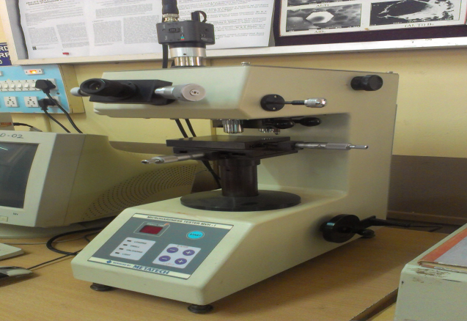
Figure 3.4 Optical microscope (OM).
3.4 T6 heat treatment
The samples underwent T6 heat treatment, which involved a solution treatment at 520°C for 2 hours to create a single-phase solid solution α. The resulting alloy was then quickly quenched in cold water to maintain the high-temperature single-phase supersaturated solid solution at room temperature. The alloy was further subjected to artificial aging by holding it at an elevated temperature of 220°C for varying durations of 1, 2, 4, and 6 hours.
3.5 Wear test
Wear tests were performed on all alloy specimens using a pin-on-disc wear testing machine(Fig.3.30). (Model: TR-20, DUCOM) following the ASTM: G99-05 guidelines. The counterpart disc was made of quenched and tempered EN-32 steel with a surface hardness of 65HRC. Wear specimens of size Ø8×30 mm were machined from both alloys, then polished and cleaned with acetone before testing. The tests were conducted by varying the load from 10-70 N at a sliding velocity of 1.5 m/s and a sliding distance of 1025 m. The mass loss of the specimen after each test was estimated by measuring its weight loss during the experiment. The worn surfaces and debris particles of both alloys after wear testing were examined using Scanning Electron Microscopy.

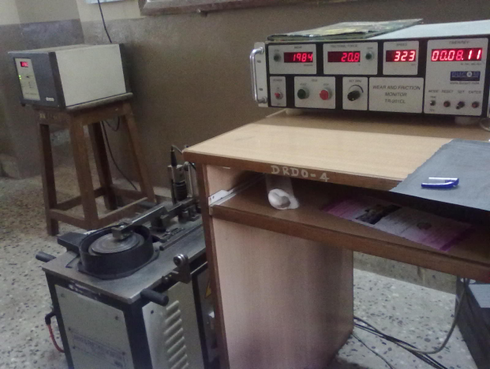

Fig 3.3 DUCOM Wear and Friction Monitor used for the wear tests

4.0 RESULTS AND DISCUSSION

4.1 Microstructure
In Fig. 4.1 we can see the optical microstructure of the Al-28Si-5Cu-4Fe alloy before any modifications. The slow cooling process during casting leads to the development of a coarse microstructure. This microstructure consists of block-like Si particles, sharp-edged needles of ternary β-Al₄FeSi₂ with a length of 150-250 μm, and θ-Al₂Cu phase. In Fig. 4.2(b), we can see the SEM/EDS microstructure of the as-cast alloy. It is made up of a white rod/needle-like phase, a bright white phase, the Al matrix, and grey Si particles. The various phases present in the microstructure are indicated by the following points: α-Al (point 1), primary Si (point 2), θ-Al₂Cu (point 3), and β-Al₄FeSi₂ (point 4). The β-phase is naturally hard and brittle, and it takes on a needle form. It often acts as a stress raiser and causes interference with the flow of liquid in the interdendritic channels during solidification. Furthermore, Cu was found to exist mainly in the interdendritic Al₂Cu phase, which is visible around the Al4FeSi₂ phase, as seen in Chinese script.
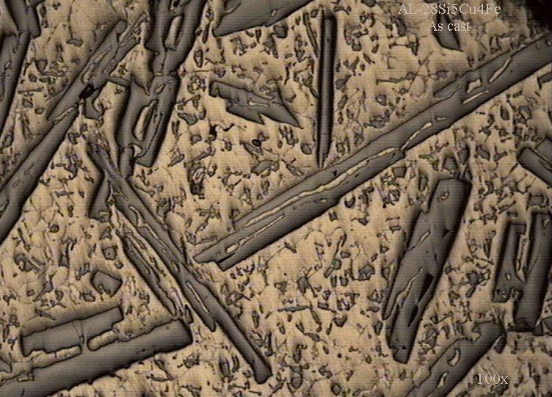

Figure 4.1 Optical Microstructures of as-cast Al-28Si-5Cu-4Fe alloy
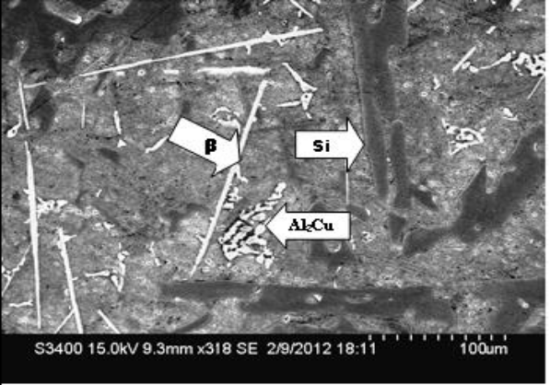

.

Figure 4.2. SEM/EDS microstructures of as-cast Al-28Si-5Cu-4Fe alloy

Table 5- EDS results of as cast Al-28Si-5Cu-4Fe alloy
Composition | Phase | Al-K | Mg-K | Si-K | Fe-K | Cu-k
Al₉₈Si_{1.2} | α-Al | 94.44 | 0.13 | 83.27 | 0.00 | 3.94
Si₉₉ | Si | -- | - | 99.21. | 0.05 | --
Al₆₅Cu₃₃ | Θ- phase | 44.73 | 0.00 | 0.98 | - | 53.56
Al₄Si₂Fe | β- phase | 49.29 |  | 24.53 | 25.04 | --

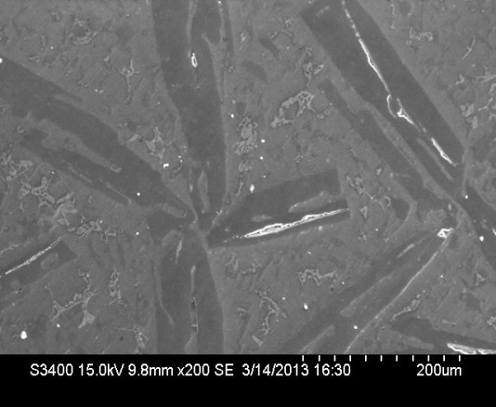

Figure 4.3. SEM micrograph of solution heat treated alloy

Figures 4.3 show SEM images of solution treated alloy. It is observed from the figure that the copper rich phases which have been formed during solidification are dissolved into α-Al matrix during solution treatment. Fragmentation, spherodisation and coarsening occurred for β- phase. Rapid cooling freezes the new created structure and large amount of Al₂Cu phase precipitates were formed. If the quenching rate is sufficiently high, solute is retained in solid solution and large numbers of vacancies remain without any change. On the other hand if the quenching rate is low, particles precipitate heterogeneously at grain boundaries or defects resulting in a reduction in super saturation of solute and thereby a lower maximum strength after aging. The formation of induced residual stresses in the casting is the main drawback associated with the quick cooling.
Figure 4.4 shows the SEM micrograph of solution heat treated and 2hr age hardened alloy. The image shows that the volume fraction and length of iron-rich intermetallics in the matrix have decreased. This reduction is due to the diffusion of elements like iron and silicon out of β-Al5FeSi needle-like compounds into the matrix and precipitation of the Al2Cu phase after age hardening. The lateral surface of flakes appears smooth and faceted due to the heat treatment. Additionally, spheroidization of the silicon particles occurred as eutectic silicon particles diffused into the matrix, changing their morphology from coarse and flaky to finer and rounder eutectic silicon particles [23].
Figure 4.5 shows the SEM micrograph of solution treated and 4hour age hardened alloy. The figure shows that as age hardening increased, the primary silicon particles became more spherical and their volume fraction and aspect ratio in the intermetallic phase of iron content decreased. Additionally, the Al₂Cu phase changed from coarse and flaky to finer and rounder particles. The SEM micrograph of the alloy aged for 4 hours is presented in Figure 4.6. It can be observed that the morphology of primary silicon particles and the intermetallic phase with Iron content remain unchanged. However, the Al₂Cu phase is present in the form of coarse particles.

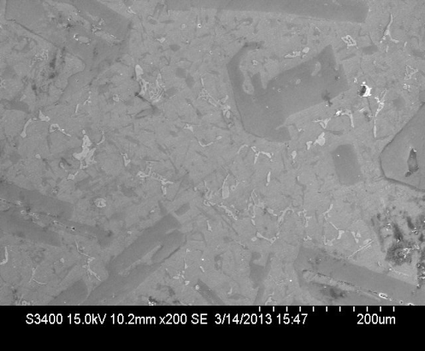
Figure 4.4 . SEM micrograph of solution heat treated and 2hr age hardened alloy

.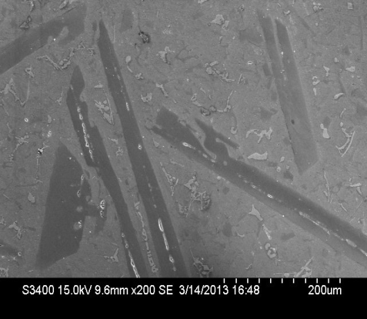
Figure 4.5. SEM micrograph of solution heat treated and 4 hr age hardened alloy

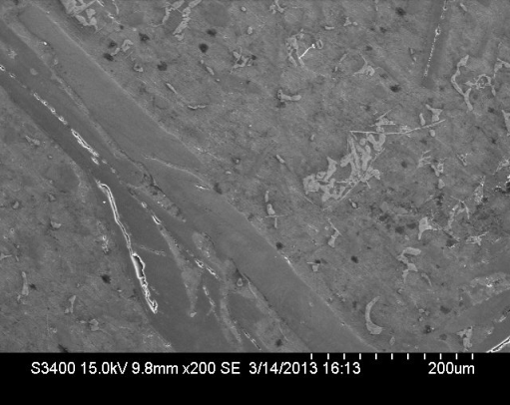
Figure 4.6 . SEM micrograph of solution heat treated and 6 hr age hardened alloy

  - Wear behavior of as-cast and heat-treated alloys
Figure 4.7 depicts the relationship between wear rate and applied load for two alloys at sliding speeds of 1.5, 3.0, and 4.5 m/s and a sliding distance of 2000m. Both alloys showed an increase in wear rate with increasing load. At a sliding speed of 1.5 m/s, the wear rate exhibited a non-linear increase with applied load. At low loads, more time is available for the formation and growth of micro-welds, which increases the force required to shear off the micro-welds and maintain relative motion, thereby leading to an increase in wear resistance. An increase in load results in a rise in interface temperature, which induces oxidation and thermal softening of the material. The brittle oxide film that forms is detrimental because it acts as a hard impurity or third body between mating surfaces [24]. Further increase in load to 50 N shows an abrupt increase in wear rate, indicating a change in the wear mechanism. At high loads, the alloy undergoes thermal softening in the sub-surface region, resulting in large-scale plastic deformation [25]. The results also indicate a decrease in wear rate at a higher sliding speed of 4.5 m/s due to the formation of the oxide film.
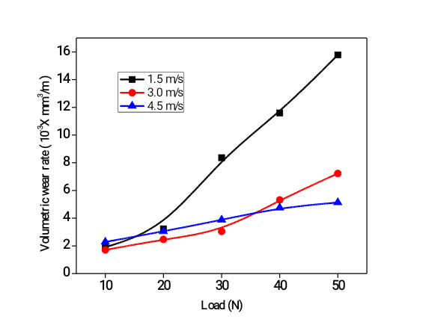
Figure 4.7. Volumetric wear rate with applied load of as cast alloy
In Figure 4.8, the wear rate of cast alloy is shown as a function of the applied load, with heat treatment at a constant sliding velocity of 4.5m/s. The figure indicates that heat-treated samples have better wear resistance than non-heat-treated alloy under all applied loads. Of the three age-hardened alloys (2h, 4h, and 6h), the 4h age-hardened alloy exhibits the best wear resistance across the entire range of applied loads. This is because heat treatment results in a higher roundness of silicon particles and reduces the length, aspect ratio, and volume fraction of β-phase plate-likes. Additionally, heat treatment changes the morphology of the tip of the plates to a more blunt geometry [26].
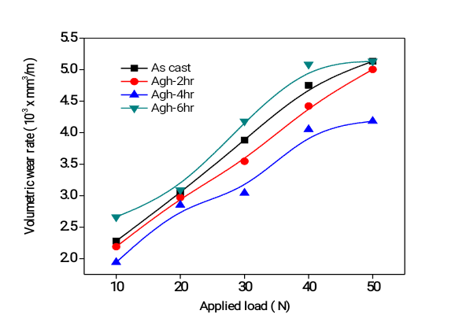

Figure 4.8. Volumetric wear rate with applied load of as cast and age hardened alloys

These changes in the microstructures of the heat-treated samples could lower stress concentration at the interface of the particles and the matrix, thereby reducing the tendency to initiate subsurface cracks. Furthermore, heat treatment could increase the bonding between the secondary phases and the matrix due to diffusion and the alloy precipitation hardening, resulting in a higher resistance of the matrix to plastic flow [27].These overall changes lead to lower wear of the heat-treated samples.
Figure 4.9 illustrates the variation of the coefficient of friction with load. As the load increases, it can be observed that the coefficient of friction decreases. The 4hr age hardened alloy exhibits the lowest coefficient of friction, while the as-cast alloy has the highest. However, the variation of the coefficient of friction with load is very small for all heat-treated alloys across the entire range of load.
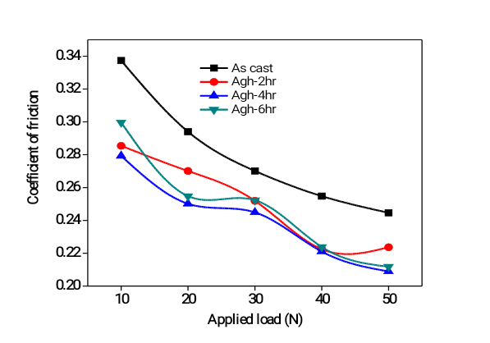

Figure 4.9. Coefficient of friction with applied load of as cast and age hardened alloys

Artificial ageing of a cast alloy leads to precipitation hardening, breaking the as-cast dendritic structure reducing the segregation of alloying elements spheroidizing the silicon crystals and improving bonding between the second phase particles and matrix aluminium. Therefore, heat-treated alloys show enhanced hardness. Diffusion plays an important role in the age hardening of the alloys and microstructure changes, which is largely governed by the ageing temperature besides the materials-related parameters. High temperature promotes the diffusion rate and therefore, enhancement in benefits of artificial aging on wear is obvious[28].
4.3 SEM Study of worn out Surfaces
The worn surfaces of wear samples were examined under SEM to investigate the wear mechanism. The wear surface of all the alloys reveals common surface features like micro grooves, micro-cutting craters, and abrasive scoring marks. The SEM micrographs of worn surface of as-cast alloy after 2 000 m sliding at 4.5 m/s sliding speed is as shown in shown in Figure 4.10 The worn surface of as-cast alloy) consists of ploughing marks, deeper, wider grooves and a large number of pits indicating a high wear rate. The heavy damage may be due to the presence of long needles of β-phase coarse θ-Al₂Cu phase, block-like primary Si particles and their uneven distribution in the alloy. It seems that the course phases are readily fractured and broken off during wear weakening the matrix leading to a high wear rate[29].

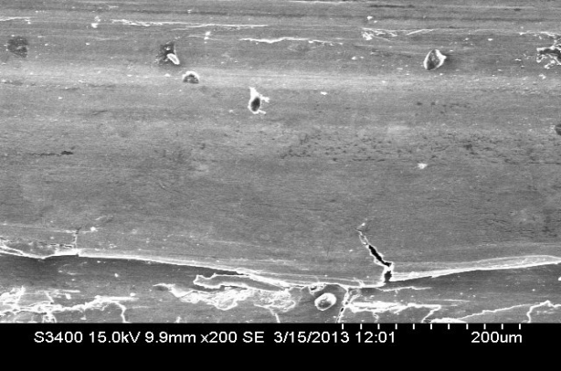

Figure 4.10. Worn out surface of as cast alloy

The worn surface as cast after 2 age hardened alloy is shown in Fig. 4.11. The worn-out surface consists of light scoring marks shallow dimples in one or two regions and a smooth surface and also number and depth of abrasive scoring marks is less as compared to as-cast alloy.
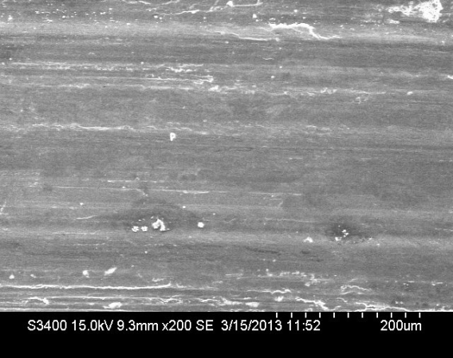

Figure 4.11. Worn out surface of solution heat treated and 2hr age hardened alloy
SEM micrograph of 4age hardened as cast alloy as shown in figure 4.11. It can be observed that the alloy is subjected to shallow and narrow micro-grooves with a fine smooth surface compared to 2h age hardened and as-cast alloys. it was characterized. The worn surface of the alloys. has a rather smooth appearance as a result of homogeneous wear; it indicates that the wear process mainly took place by plastic deformation. The worn surface of 6hr age-hardened alloy (Figure 4. 13) shows more scratches on the surface as compared to 4hr age-hardened alloy probably due to deformation of the alloy surface and oxide film by larger loose Fe-rich intermetallics during wear of the alloy.
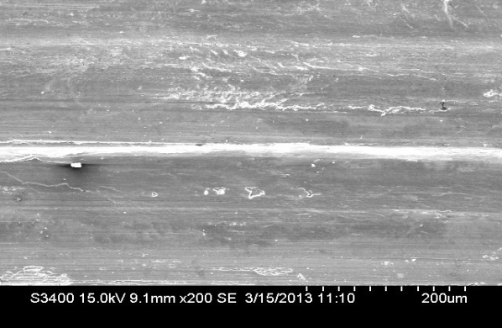

Figure 4.12 Worn out surface of solution heat treated and 4 hr age hardened alloy

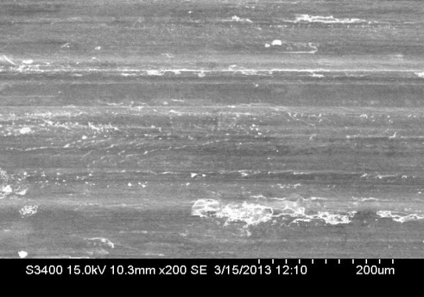

Figure 4.13. Worn out surface of solution heat treated and 6 hr age hardened alloy

4.0 CONCLUSIONS

1. As cast Al-28Si-5Cu-4Fe alloy contain primary block like Si and precipitation strengthening Al₂Cu phases along with needle β-Al₅FeSi intermetallic phases respectively.
2. Heat treatment is effective in refining the microstructures of Al-28Si-5Cu-4Fe alloy. Heat treatment makes the surface more coherent. spheroidized silicon and intermetallic phases
3. Heat treatment of all three alloys showed spheroidization of eutectic silicon crystals. Increase in ageing time, spheroidized silicon particles in the aluminium matrix break down the dendritic structure
4. T6 solution heat treatment increased the wear resistance of Al–Al-Si alloys containing iron and copper under different applied loads._ The results showed that the size, length and shape of the silicon and iron-rich intermetallic particles affected the wear behaviour of Al–Si alloy.
5. Increase in normal load increases the wear rate irrespective of alloy conditions. Heat treatment of all three alloys showed improvement in wear resistance. The cast dendritic structure is destroyed on heat treatment.
6. The results showed that a tribo-layer containing various amounts of oxygen and other elements formed on the worn surfaces during sliding. The lower amount of the intermetallics particles in the layer and the higher strength of the substrate in the heat-treated alloys could increase the durability of the layer and the wear resistance of the alloys.
REFERENCES

[1] Yang CY, Lee SL, Lee GK, Lin JG. Effect of Sr and Sb modifiers on the sliding
behaviour of A357 alloy under varying pressure and speed conditions. Wear2006;261:1348–58.
[2] Harun M, Talib IA, Daud AR. Effect of element additions on wear property of
eutectic aluminium–Silicon alloys. Wear 1996;194:54–9.
[3] Vencel A, Bobic I, Miskovic Z. Effect of thixocasting and heat treatment on the
tribological properties of hypoeutectic Al–Si alloy. Wear 2008;264:616–23.
[4] Dwivedi DK. Wear behaviour of cast hypereutectic aluminum silicon alloys.
Mater Des 2006;27:610–6.
[5] Elmadagli M, Perry T, Alpas AT. A parametric study of the relationship between
microstructure and wear resistance of Al–Si alloys. Wear 2007;262:79–92.
[6] Yasmin T, Khalid AA, Haque MM. Tribological (wear) properties of aluminium–
silicon eutectic base alloy under dry sliding condition. J Mater Process Technol
2004;153–154:833–8.
[7] Wang F, Zhang Z, Ma Y, Jin Y. Effect of Fe and Mn additions on microstructure
and wear properties of spray-deposited Al–20Si alloy. Mater Lett
2004;58:2442–6.
[8] Taghiabadi R, Ghasemi HM, Shabestari SG. Effect of iron-rich intermetallics on
the sliding wear behavior of Al–Si alloys. Mater Sci Eng A 2008;490:162–70.
[9] Wang S, Lee SL, Yang CY, Lin JC. Effect of beryllium and non-equilibrium heat
treatment on mechanical properties of B319 alloy with 1.0%Fe. Mater Sci
Technol 2004;20:539–45.
[10] Narayanan LA, Samuel FH, Gruzleski JE. Dissolution of iron intermetallics in
Al–Si alloys through non-equilibrium heat treatment. Metall Mater Trans A
1995;26A:2161–74.
[11] Samuel FH, Ouellet P, Samuel AM, Doty HW. Effect of Mg and Sr addition on
the formation of intermetallics in Al–6Si–3.5Cu–0.45Mg–0.85Fe 319 type
alloy. Metall Mater Trans A 1998;29:2871–84.
[12] Villeneuve C, Samuel FH. Fragmentation and dissolution of b-Al5FeSi phase
during solution heat treatment of Al–Si–Fe alloys. Int J Cast Metals Res
1999;12:145–60.
[13] Crowell N, shivkumar S. Solution treatment effects in cast Al–Si–Cu alloys. AFS
Trans 1997;107:721–6.
[14] Belov NA, Aksenov AA. Iron in Al alloys; impurity and alloying elements. New
York: Taylor and Francis INC; 2002.
[15] Sharma R, Dwivedi DK. Solutionizing temperature and abrasive wear
behaviour of cast Al–Si–Mg alloys. Mater Des 2007;28:1975–81.
[16] Hutchings IM. Tribology: friction and wear of engineering
materials. Cambridge, London: Edward Arnold; 1992.
[17] A.L. Dons, G Heiberg, J Voje J S Mæland, J OLøland, A. Prestmo, On the effect of additions of Cu and Mg on the ductility of AlSi foundry alloys. Mat Sci and Eng: A 413– 414, 15 (2005) p 561–566
[18] A.M.A. Mohamed and F.H. Samuel, A Review on the Heat Treatment of Al-Si-Cu/Mg Casting Alloys, Heat Treatment – Conventional and Novel Applications.
[19] Kim TS, Hong SJ, Kim WT, Won CW, Cho SS, Chun BS. Mater Trans JIM 1998;39:1214.
[20] Lavernia EJ, Yu W, editors. Spray atomization and deposition. Chichester, UK: Wiley; 1996.
[21] Zhou J, Duszczyk J, Korevaar BM, B. Verlinden. Characterization of the hot working behavior of a P/M Al-20Si-7.5Ni-3Cu-1Mg alloy by hit torsion, J Mater Sci 1992;27:4247.
[22] Sharma R, Dwivedi DK. Solutionizing temperature and abrasive wear behavior of cast Al– Si– Mg alloys. Mater Des 2007;28:1975–81.
[23] Huang LJ, Geng L, Li AB, Cui XP, Li HZ, Wang GS. Characteristics of hot compression behavior of Ti–6, 5Al–3.5Mo–1.5Zr–0.3Si alloy with an equiaxed microstructure. Mater Sci Eng A 2009;505:136–43.
[24] Haque MM, Sharif A. Study on wear properties of Al–Si piston alloy. J Mat Process
Technol 2001;118:69–73.
[25] Anasyida AN, Daud AR, Ghazali MJ. Dry sliding wear behavior of Al–4Si–4Mg alloys by addition of cerium. Int J Mech Mater Eng 2009;4:12–30.
[26] Mohanty PS, Gruzleski JE. Grain refinement mechanisms of hypoeutectic Al–Si alloys. Acta Mater 1996;44:360–74.
[27] Feng Wang, Yajun Ma, Zhengye Zhang, Xiaohao Cui, Yuansheng Jin, A
comparison of the sliding wear behavior of a hypereutectic Al–Si alloy prepared by spray- deposition and conventional casting methods, Wear 256 (2004) 342–345.
[28] A.S. Anasyida, A.R. Daud, M.J. Ghazali, Dry sliding wear behavior of Al–12Si–4Mg alloy with cerium addition, Materials and Design31 (2010) 365–374.
[29] A. Eshaghi, H.M. Ghasemi , J. Rassizadehghani, Effect of heat treatment on microstructure and wear behavior of Al–Si alloys with various iron contents Materials and Design 32 (2011) 1520–1525.

